
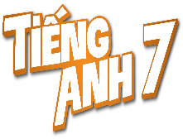
Tiết thứ ......
UNIT 10: ENERGY SOURCES
Lesson 1: Getting started – Types of energy sources
Class | Date of teaching | Attendence
7... | ...../........./202....
7… | ..../......../202...
7…. | ..../......../202....
I. OBJECTIVES: By the end of this unit, students will be able to gain the following things:
1. Knowledge:
- To get the topic energy sources.
- have an overview about the topic energy sources
- To practice listening and reading.
-+ Vocabulary: - to talk about types of energy sources: . energy source (n.phr.), coal (n), renewable (a), run out (phr v).
2. Competence:
a) General competencies:
Students will be able to know more words and phrases about energy resources; Develop communication skills and cultural awareness
Collaborative and supportive in pair work and teamwork; Actively join in class activities.
b) Specific competencies:
- Students will be able to practice listening and reading the conversation between Lan and her father (Mr.Tan); ( They are talking about types of energy resources)
- Develop communication skills.
- Be cooperative and supportive in pair work and teamwork.
- Actively join in class activities.
3. Qualities:
- Develop awareness of travelling in town/city
- Be concerned to the local traffice
- Develop self-study skills.
II. PREPARATIONS
- Teacher: Grade 7 text book, laptop, projector / TV/ pictures and cards.....
- Students : Text books, studying equipment….
III. PROCEDURE:
Notes: In each activity, each step will be represented as following:
* Deliver the task.
* Implement the task.
* Discuss.
* Give comments or feedback.
Activity 1. WARM UP (5’-IW, GW)
* Aim:
To activate students’ knowledge on the topic of the unit
To enhance students’ skills of cooperating with team mates.

* Content:
To have some warm-up activities to create a friendly and relaxed atmosphere to inspire Ss to warm up to the subject and new lesson.
* Product: Having a chance to speak English and focus on the topic of the lesson..
* Implementation: Teacher’s instructions…
Teacher’s & Student’s activities | Content
* Teacher gives instructions  - One of the students in the group go to the board.  - Teacher secretly show 1 picture of a mean of transport to that student. He/She has to mime the picture and the other has to guess. Of course the other groups will also be allowed to guess.  - take turns go to the board until finish all the pictures.  **** Teacher checks and corrects if Ss pronounce the words incorrectly.  SET THE SCENE: PRE- QUESTIONS  * Teacher draws students’ attention to the pictures in the textbook and asks them some questions about the pictures. Teacher don’t confirm whether their answers are right or wrong.  1. Who are they?  2. What are they talking about?  ** Students work out and answer questions in pairs.  *** Students share their answers as a whole class.  **** Teacher asks them to read and listen to the conversation to check their answers. | BRAIN STORMING  Suggested answers:  1. They are Lan and her father / Mr. Tan  2. They are talking about types of enery resources.  3. (Students’ answer)
Activity 2. KNOWLEDGE FORMATION (15'- PW, IW)
* Aim:
- To help students use key language more appropriately before they read and listen
- To get students interested in the topic
- To set the context
- To help Ss understand the main idea of the text
* Content: Teach some new words. Read the conversation and find out new words.
* Product: Knowing more new words. Understanding the conversation; topic of the lesson, grammar points…
* Implementation: Teacher’s instructions…
Teacher’s & Student’s activities | Content
VOCABULARY:  * Teacher introduces the vocabulary by:  + showing the pictures illustrating the words;  + providing the synonym or antonym of the words;  + providing the definition of the words.  ** Students say the words.  *** Other students correct if the previous answers are incorrect.  **** Teacher shows and says the words aloud and asks students to repeat them.  Listen and read.  Task 1. Read for main ideas: What are Lan and her father talking about?  * Teacher asks Ss to look at the picture (p.107), answer the question:  What are Lan and her father talking about?  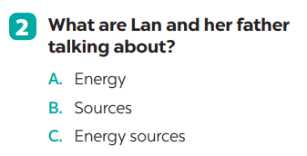  . | 1. Listen and read:  * Vocabulary  1. enery source (n)  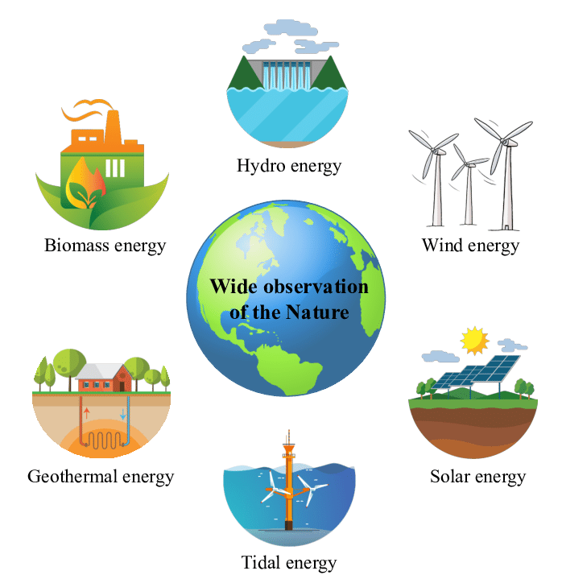  2. coal (n)    3. renewable (a): Can be replaced naturally and can be used without the risk of using it all up  4. run out (phr v): To use up or finish a supply of something  Task 1. Read for main ideas: What are Lan and her father talking about?  Answer: C
Activity 3. PRACTICE (15’-IW, PW, GW)
* Aim:
- To practise reading and listening for specific information
- To practise scanning
- To develop Ss' knowledge of vocabulary
- To help Ss gain more knowledge about the topic
* Product: Ss can learn how to use the words and phrases;
* Implementation: Teacher’s instructions…
Teacher’s Student’s activities | Content
Task 2: Read the conversation again and answer the questions.  * Teacher asks Ss to work individually to read and listen to the conversation and answer the questions and then share their answers with their partners who sit next to them. (peer check)  ** Ss do exercise 3 individually  *** Ss share and discuss with their partners to write all answer down on the notebooks.  **** Teacher corrects their answers as a class | Task 2: Read the conversation again and answer the questions.  Answers  1. Lan is doing a project on energy sources.  2. It’s power that we use to provide us with light, heat or electricity.  3. It comes from many different sources like coal, oil, natural gas, … and renewable sources  4. Renewable sources are those we can easily replace them such as: water, sun,…
Task 3: Match the words / phrases in the box with the correct pictures.  *** Teacher nominates Ss to read the words aloud and  **** Teacher checks and gives the correct answers.  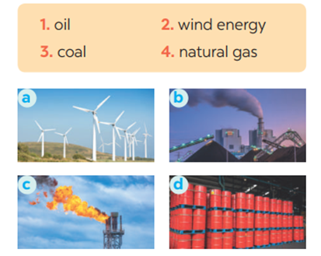 | Task 3: Match the words / phrases in the box with the correct pictures.  Suggested answers:  1. c 2. a 3. b 4. d
Activity 4. APPLICATION (7’-IW, PW, GW)
* Aim:
- To help Ss practice using what they have learnt in sentences.
- To help Ss practising talking about energy
- To practise team working
- To give students authentic practice in using target language
- To help Ss memorise the target language and skills that they have learned
- To help Ss practise the target language
- To consolidate what students have learnt in the lesson.
* Content: Doing the Quiz
* Product: Ss can remember the words. Revise and learn more new words.
* Implementation: Teacher’s instructions
Task 4: Complete each of the sentences with the correct word from the conversation  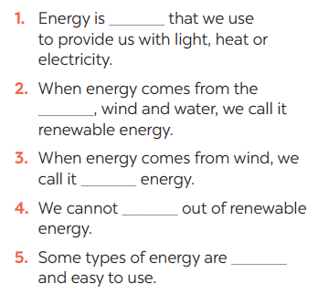  Task 5: Group discussion    * Teacher gives Ss clear instructions in order to make sure Ss know what to do  - ask students to discuss within their groups to answer the questions:  1. What is the best source of energy?  2. Why do you think it is the best one?  + Students discuss with their partners and take notes  - observer Ss while they are talking, note their language errors  ** Ss do as instructed. Then present what they have discussed.  **** Teacher gives Ss feedback.  - choose some useful or excellent words/ phrases/ expressions/ word choices Ss have used to suggest other students use them  - choose some typical errors and correct as a whole class without nominating the students’ names.  Consolidation  - Vocabulary of sources of energy  - Talking about energy sources.  * Home assignment  - Read again the conversation on page 106  - Do more exercises in workbook.  - Prepare new lesson: Lesson 2: A CLOSER LOOK _1 | Answers  1. power  2. sun  3. wind  4. run  Task 5: Group discussion  * Home assignment  - Read again the conversation on page 106  - Do more exercises in workbook.  - Prepare new lesson: Lesson 2: A CLOSER LOOK _1
V. FEEDBACK:
With 7 ……………………………………………………………………………..…
With 7…………………………...……………………………………..……………
With 7 ………………………………………………………………………….……

