Date of preparing: ………………………………….
Date of teaching: ………………………………….

Period……
UNIT 10: CITIES AROUND THE WORLD
Lesson 1 - Part 2 (Page 79) – Grammar

I. OBJECTIVES
By the end of the lesson, Ss will be able to…
1. Knowledge
- use the first Conditional sentences;
2. Ability
- improve the grammar knowledge and use them in communicative situations;
- develop communication and collaboration skills;
3. Quality
- have positive attitude in learning and actively participate in all classroom activities related to the topic “Cities around the World”.
II. TEACHING EQUIPMENT AND LEARNING MATERIALS.
Lesson plan, PPT slides, Student’s book, workbook, notebook, personal computer (if any), projector/ TV, speakers, DCR & DHA on Eduhome, CD player, handouts…
III. PROCEDURES
A. Activity 1: Warm up: (5’)
a) Objective: To introduce a new lesson and to set the scene for students to acquire new language and to develop Ss’ collaboration, communication.
b) Content: reviewing and introducing a new grammatical point
c) Product: Students can understand and use well the first Conditional sentences in their English speaking.
d) Competence: Collaboration and guessing
e) Organization of the activity:
Teacher’s activities | Students’ activities
- Have Ss look at the picture, and answer the question: Who are they?  - Ask students to look at the conversation and guess what they are talking.  - Play the audio and ask students to listen and repeat.  - Ask students to find out the structure in their conversation.  - Lead to the new lesson. | - Look at the picture and answer the question – Who are they?  Keys:  - They are talking about where the girl is visiting.  - Listen and read the speech bubbles.  - Guess possible answers in pairs.  - Exploit the structure conditional sentences.

B. New lesson (35’)
- Activity 1: Introduce and practice new language (25’)
a) Objectives:
- identify forms and the use of the first conditional sentence;
- use the first conditional sentences in communicative contexts;
- develop communication, collabaration, and critical thinking skills.
b) Content: - Learning and using a new grammatical point (Section: Grammar on page 79);
- Completing sentences;
- Listening, thinking, reading, and practicing language skills.
c) Products: Students can produce the English language using the first conditional sentences.
d) Competence: Communication, collaboration, presentation, and imagination
e) Organization of the activity:
Teacher’s activities | Students’ activities
* GRAMMAR  a. Presentation:  - Have Ss read the grammar explanation.  - Ask Ss look at the table with the different use of the first conditional sentences.  - Have some Ss read the sentences aloud.  - Have Ss give the form of the first Conditional sentence.  + On the board:  If clause, main clause  Present simple, Will + bare Inf  Main clause if clause  Will + bare Inf Present simple  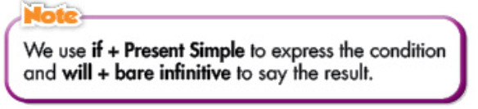  - Ask Ss to write the new language in their notebooks.  - Have Ss read the sentences aloud. | - Look at the grammar explanation.  - Look at the table with the different use of the first condition sentence.  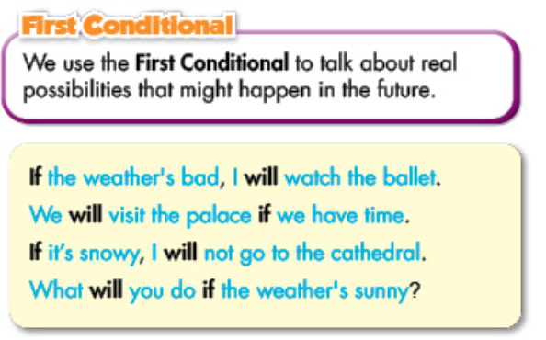  - Gain the structure of First Conditional Sentence.  - Write in their notebooks.  - Illustrate the task in pairs.
b. Fill in the blanks with the correct forms of the verbs: (Controlled-Practice)  * Option 1:  - Delete the structure and ask Ss to retell something about First Conditional Sentence.  - Have Ss do the exercise.  - Demonstrate the activity using the example.  * Option 2:  + Have Ss fill in the blanks with the correct forms of the verbs  - Get them to finish the exercise individually.  - Ask them to check their works in pairs.  - Have some Ss share their answers with the class.  - Have Ss explain their answers.  - Correct and give feedback.  c. Look at Mary’s plan and write sentences. (Less controlled practice)  * Option 1:  + Help students know how to do the exercise in the contexts  - demonstrate the activity using the example.  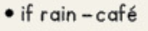  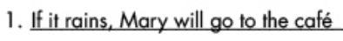  - Ask one or two Ss to retell how to do the task.  * Option 2:  + Help Ss improve the understanding of the first conditional sentence.  - Let them look at Mary’s plan and write sentences.  - Have Ss check their works in pairs.  - Invite some Ss to share their answers with the class.  - Correct and give feedback. | - Retell the forms and the different use of the first conditional sentence.  - Listen to T’s demonstration and write the sentence in notebooks.  - Write sentences using the prompts.  - Work individually to complete the task.  - Work in pairs (have peer correction).  - Share their answers with the class.  + Expected answer:  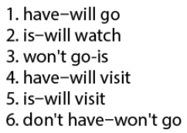  - Listen to T’s explanation.  - Listen to T’s demonstration and write the sentence in notebooks  - Retell how to do the task.  - Write sentences using the prompts.  - Work in pairs (have peer correction).  - Share their answers with the class.  + Expected answer:  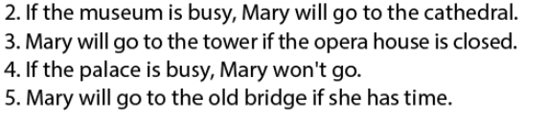  - Check their answers and correct.

- Activity 2: Speaking Skill (Free-Practice) (10’)
a) Objectives: To use the targeted grammar to practise converastion skills and act out the dialogue in close pairs and then in open pairs;
To practice skills in communication, cooperation, and cultural awareness.
b) Content: asking and answering questions
c) Products: Students can know how to use the targeted grammar in their speaking
d) Competence: Collaboration, communication, and imagination
e) Organization of the activity:

Teacher’s activities | Students’ activities
d. Now, practice saying the sentences with your partner:  * Option 1:  + Help Ss enhance the use of targeted grammar.  - Divide the class into pairs.  - Have Ss practice saying the sentences.  - Call on some pairs to demonstrate the activity in front of the class.  * Option 2:  + Help Ss improve the communicative competence.  - Divide the class into pairs or groups.  - Have Ss plan for their vacation to Vung Tau next weekend.  + Contents:  Where to visit  What to do  …  - Encourage Ss to use the imperative and negative form of first conditional sentence.  - Check some pairs/groups to support.  - Call on some pairs/groups to share their plan with the class. | - Work in pairs (open pairs).  - Work in pairs (close pairs).  - Work in pairs (their own conversations).  - Work in pairs/groups (discuss and plan).  - Present in front of the class.

C. Homework (5’)
- Instruct Ss to have a look back on the lesson at home, do exercises on page 59 in workbook and get ready for the next lesson.
- Grammar: First Conditional Sentence
- Practice asking and answering with the First Conditional Sentence to talk about condition and result in the future correctly with a partner.
- Prepare for the new lesson – Pronunciation and Speaking on page 80 (SB).

