

Tiết thứ ....
UNIT 12: ENGLISH-SPEAKING COUNTRIES
Lesson 2: A closer look 1

Class | Date of teaching | Attendence
7A | ..../09/2022
7B | ..../09/2022
7C | ..../09/2022
I. OBJECTIVES: By the end of this unit, students will be able to gain the following things:
1. Knowledge:
- Pronunciation: Ask questions with the correct rising and falling intonation.
+ Vocabulary: Use the words related to people and places in English-speaking countries.
1. native (adj)
2. amazing (adj)
3. unique (adj)
4. local (adj)
5. ancient (adj)
+ Grammar:
2. Competence:
a) General competencies:
- Students will be able to know more words and phrases about English speaking countries.
- Be collaborative and supportive in pair work and teamwork
- Actively join in class activities
b) Specific competencies:
- Group work and independent working, pair work, linguistic competence, cooperative learning and communicative competence.
- Sts can introduce themselves or one another fluently.
3. Qualities: The love of country; The awareness about importance of speaking English; Be ready to talk about English speaking countries.
- Develop self-study skills.
II. PREPARATIONS
Teacher: Grade 7 text book, laptop, TV, pictures and realia, Computer connected to the Internet, Sach mem.vn
Students: Text books, pencils, pics, blank papers, realia,….
III. PROCEDURE:
In each activity, each step will be represented as following:
* Task delivering
** Task performance
*** Report and discussion
 Judgement
Activity 1. WARM UP (5’-IW, GW)
* Aim:
To recall students’ vocabulary on community activities.
* Content: Homework checking:
* Product: Having a chance to speak English and focus on the topic of the lesson.
* Implementation: Teacher’s instructions…
Teacher’s & Student’s activities | Content
Homework checking:
* Teacher divides the class into groups of four and asks them to share their homework.
** Students work in groups to:
- discuss and share names of English-speaking countries.
- list all the names of English-speaking countries in a piece of paper.
*** Teacher asks the groups to swap their pieces of paper and do cross checking. The group with the most correct names of English-speaking countries will be the winner.
 Teacher confirms the answers and give compliments to the winner.

Activity 2. KNOWLEDGE FORMATION (15'- PW, IW)
* Aim:
To introduce the new words.
* Content: Teach some new words, some action verbs go with nouns.
* Product: Ss learn how to use them.
* Implementation: Teacher’s instructions…
Teacher’s & Student’s activities | Content
Vocabulary pre-teach:  * Teacher introduces the vocabulary.  ** Teacher introduces the vocabulary by:  - providing the pictures  - providing the definition of the words.  *** Teacher asks students to repeat.  *** Teacher rubs out and checks | Vocabulary pre-teach:  1. native (adj)  2. amazing (adj)  3. unique (adj)  4. local (adj)  5. ancient (adj)
Activity 3. PRACTICE (15’-IW, PW, GW)
* Aim:
To introduce some key words (nouns) related to people and places through pictures.
To introduce some key words (adjectives) to describe people and places in context.
To introduce some more nouns and phrases through explanations.
To help students recognise and practise the rising and falling intonation with questions.
To provide students with more practice in the intonations of questions.
* Product: Students’ answers.
* Implementation:
Teacher’s Student’s activities | Content
Task 1: Write the words or phrases under the correct pictures. (p. 126)  * Teacher has students read aloud the words in the box and and asks them to match the words with the pictures illustrating them within 3 - 4 minutes.  ** Students read the words and phrases in the box and match them with the pictures.  *** Teacher asks them to share their answers in pairs before checking the answers as a class.   Teacher invites students to take turns to read out their answers and corrects their pronunciation if needed.  Task 2: Use the words in the box to complete the sentences. (p. 126)  * Teacher asks to read the words in the box first, explains their meanings if needed then allows students 5 minutes to do the task.  ** Students do the task individually.  *** Teacher allows students to swap their textbooks to peer check first.   Teacher confirms the answers and gives feedback, if necessary.  Ask Ss to read the words in the box first. Explain their meanings if needed.  Task 3: Work in pairs. Discuss and write the word or phrase in the box next to its explanation. (p. 126)  * Teacher asks students to work in pairs to read the words and phrase first and see if they know any of them.  ** Students have 4 - 5 minutes to discuss and complete the task.  *** Teacher asks students to work in pairs to swap their answers and peer check.   Teacher checks their answers as a class. | Task 1: Write the words or phrases under the correct pictures. (p. 126)  Answer key:  1. kangaroo  2. island country  3. tattoo  4. Scottish kilt  5. castle  6. coastline  Task 2: Use the words in the box to complete the sentences. (p. 126)  Answer key:  1. amazing  2. ancient  3. unique  4. local  5. native  Task 3: Work in pairs. Discuss and write the word or phrase in the box next to its explanation. (p. 126)  Answer key:  1. tower  2. symbol  3. capital  4. boat ride
Pronunciation: Rising and falling intonation for questions  Task 4: Listen and repeat, paying attention to the intonation of the following questions. (p. 126)  * Teacher writes two short questions on the board: a yes / no question and a wh-question. Have some Ss say aloud the questions first, then ask other students to pay attention to the intonation at the end of the questions.  - Can you speak English?  - What is the capital of Scotland?  ** Students look at the questions with the rising and falling already marked, listen and repeat as a class, a group, and finally as individuals.  *** Teacher plays the recording for Ss to listen once, then listen and repeat as a class, a group, and finally as individuals. Teacher can play the recording as many times as necessary.   Teacher elicits the pattern from students: use rising intonation for yes / no questions and falling intonation for wh-questions.  Task 5: Circle the correct intonation. Then listen and repeat. (p. 126)  * Teacher has students circle the correct intonation individually, based on what they have learnt in Task 4.  ** Teacher plays the recording for students to listen and repeat each question and check their answers.  *** Teacher corrects them if needed and calls on some students to read the questions aloud.   Teacher plays the recording again and ask students to repeat each question after the recording. Teacher confirms the answers. | Pronunciation: Rising and falling intonation for questions  Task 4: Listen and repeat, paying attention to the intonation of the following questions. (p. 126)  - Can you speak English?  - What is the capital of Scotland?  Audio script  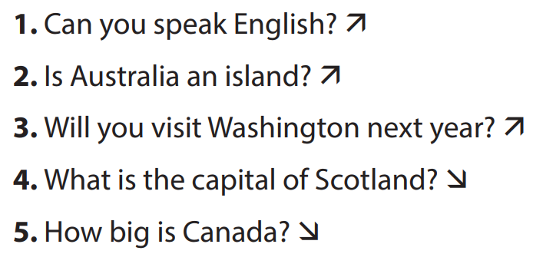  Task 5: Circle the correct intonation. Then listen and repeat. (p. 126)  Audio script  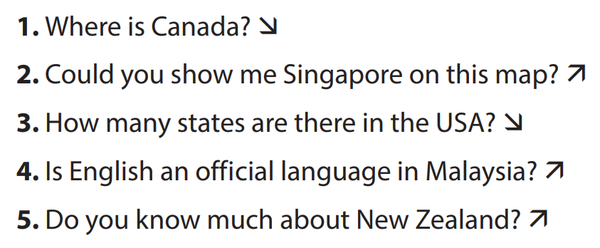
Activity 4. APPLICATION (7’-IW, PW, GW)
* Aim:
To test students' quick reaction to the targeted intonation.
* Content: Game: Up or Down?
* Product: Students’ answer.
* Implementation: Teacher’s instructions
Game: Up or Down?  * Teacher explains the rules:  - Teacher divides the class into 2 teams.  - Students will listen to questions which are made up from the words in the lesson.  - Students will have to stand up if it is a yes / no question and sit down if it is a wh-question.  - The team will receive minus points equivalent to the number of students who pose incorrect actions (stand up or sit down).  - The team with less minus points will be the winner.  ** Students play the game.  *** Teacher helps students in the game.   Teacher gives feedback. | Game: Up or Down?
* Wrap up  - To help Ss memorise the target language and skills that they have learned.  * Homework:  To review the vocabulary in this lesson and prepare for the incoming Project lesson.  - To prepare vocabulary for the next lesson: A closer look 1. | * Wrap up  - Teacher refers to the unit title again then together with students, orally list the names of English-speaking countries and their capital cities in the lesson.  * Homework:  To review the vocabulary in this lesson and prepare for the incoming Project lesson.- Exercises in the workbook
V. FEEDBACK:
With 7A ……………………………………………………………………………..…
With 7B …………………………...……………………………………..……………
With 7C ………………………………………………………………………….……

