Unit 2 | Vietnam and ASEAN

A. VOCABULARY (TỪ VỰNG)
Unit opener
No | Words | POS | Transcription | Meaning
1 | cave | (n) | /keɪv/ | hang động
2 | dune | (n) | /djuːn/ | đụn cát
3 | mountain | (n) | /ˈmaʊntɪn/ | núi
4 | valley | (n) | /ˈvæli/ | thung lũng
5 | waterfall | (n) | /ˈwɔːtəfɔːl/ | thác nước
Lesson 1a
No | Words | POS | Transcription | Meaning
7 | architecture | (n) | /ˈɑːkɪtekʧə/ | công trình kiến trúc
8 | flavour | (n) | /ˈfleɪvə/ | hương vị
9 | stall | (n) | /stɔːl/ | quán, quầy hàng
10 | temple | (n) | ˈtempl/ | đền, miếu
11 | tourist attraction | (n) | /ˈtʊərɪst əˈtrækʃən/ | địa điểm tham quan du lịch
12 | worship | (n) | /ˈwɜːʃɪp/ | nơi thờ cúng, sự thờ cúng
13 | cathedral | (n) | kəˈθiːdrəl/ | nhà thờ lớn, nhà thờ chính toà
14 | citadel | (n) | /ˈsɪtədl/ | thành trì, thành quách
15 | palace | (n) | /ˈpælɪs/ | dinh, cung điện
16 | pagoda | (n) | /pəˈɡəʊdə/ | chùa
17 | tomb | (n) | /tuːm/ | lăng mộ, nơi chôn cất
18 | tower | (n) | /ˈtaʊə/ | tháp, toà tháp
Lesson 1c
No | Words | POS | Transcription | Meaning
18 | take away | (phr v) | /teɪk əˈweɪ/ | mang đi, cất đi
19 | take off | (phr v) | /teɪk ɒf/ | cất cánh
Lesson 1d
No | Words | POS | Transcription | Meaning
22 | crowded | (a) | /ˈkraʊdɪd/ | đông đúc
23 | historical | (a) | /hɪsˈtɒrɪkəl/ | có liên quan đến lịch sử, có thật trong lịch sử (thường dùng để chỉ những công trình nghiên cứu, sách, tài liệu,…
24 | modern | (a) | /ˈmɒdən/ | hiện đại
25 | narrow | (a) | /ˈnærəʊ/ | hẹp, chật hẹp
26 | traditional | (n) | /trəˈdɪʃənəl/ | (thuộc về) truyền thống

Culture corner A
No | Words | POS | Transcription | Meaning
22 | bow | (v) | /baʊ/ | cúi chào, cúi mình
23 | chopsticks | (pl n) | /ˈʧɒpstɪks/ | đũa
24 | etiquette | (n) | /ˈetɪket/ | nghi thức, phép tắc xã giao
25 | handshake | (n) | /ˈhændʃeɪk/ | cái bắt tay
26 | social | (a) | /ˈsəʊʃəl/ | (thuộc) xã hội

CLIL A (PSHE)
No | Words | POS | Transcription | Meaning
22 | accept | (v) | /əkˈsept/ | chấp nhận
23 | annoyed | (a) | /əˈnɔɪd/ | khó chịu, bực mình
24 | anxious | (a) | /ˈæŋkʃəs/ | lo âu, lo lắng
25 | blame | (n) | /bleɪm/ | khiển trách, đổ lỗi
26 | confused | (a) | /kənˈfjuːzd/ | khó hiểu, lúng túng
 | disappointed | (a) | /ˌdɪsəˈpɔɪntɪd/ | thất vọng

* WORD FORMATION
- mountain /ˈmaʊntɪn/ (n): núi
mountainous /ˈmaʊntɪnəs/ (adj): nhiều núi
mountaineer /ˌmaʊntɪˈnɪə/ (n): người miền núi, người leo núi
- architecture /ˈɑːkɪtekʧə/ (n): công trình kiến trúc
architect /ˈɑːkɪtekt/ (n): kiến trúc sư
architectural /ˌɑːkɪˈtekʧərəl/ (n): thuộc kiến trúc
- worship /ˈwɜːʃɪp/ (n): nơi thờ cúng, sự thờ cúng
worship /ˈwɜːʃɪp/ (v): thờ cúng, tôn thờ
worshipper /ˈwɜːʃɪpə/ (n): người thờ cúng, tín đồ
- crowd /kraʊd/ (n): đám đông
crowd /kraʊd/ (v): lấp đầy, xúm lại (một ai đó), tụ tập
crowded /ˈkraʊdɪd/ (adj): đông đúc
- historical /hɪsˈtɒrɪkəl/ (adj): có liên quan đến lịch sử, có thật trong lịch sử (thường dùng để chỉ những công trình nghiên cứu, sách, tài liệu,…
e.g. historical studies/books/information
historic /hɪs ˈtɒrɪk/ (adj): có ý nghĩa lịch sử (thường dùng để chỉ những di tích, công trình xây dựng, khoảnh khắc,…
e.g. a historic building/monument/moment
history /ˈhɪstəri/ (n): lịch sử
- modern /ˈmɒdən/ (adj): hiện đại
modernise /ˈmɒdənaɪz/ (v): hiện đại hóa
modernisation /ˌmɒdənaɪˈzeɪʃən/ (n): sự hiện đại hóa
- narrow /ˈnærəʊ/ (adj): hẹp, chật hẹp
narrow /ˈnærəʊ/ (v): thu hẹp
- picture /ˈpɪkʧə/ (n): bức tranh, bức ảnh, hình ảnh
picture /ˈpɪkʧə/ (v): chụp ảnh, vẽ, hình dung
picturesque /ˌpɪkʧəˈresk/ (adj): đẹp như tranh, đẹp một cách cổ điển, đẹp một cách cổ kính
e.g. I can picture a very bright future for us.
- tradition /trəˈdɪʃən/ (n): truyền thống
traditional /trəˈdɪʃənəl/ (adj): (thuộc về) truyền thống
traditionally /trəˈdɪʃənəli/ (adv): một cách truyền thống
- society /səˈsaɪəti/ (n): xã hội
social /ˈsəʊʃəl/ (adj): (thuộc) xã hội
sociable /ˈsəʊʃəbəl/ (adj): chan hòa, thích kết bạn
≠ unsociable /ʌnˈsəʊʃəbəl/ (adj): khó gần, không thích kết bạn
socialise /ˈsəʊʃəlaɪz/ (v): hòa nhập với xã hội
- accept /əkˈsept/ (v): chấp nhận
acceptance /əkˈseptəns/ (n): sự chấp nhận, sự thừa nhận
acceptable /əkˈseptəbəl/ (adj): có thể chấp nhận được
≠ unacceptable /ˌʌnəkˈseptəbəl/ (adj): không thể chấp nhận được
- annoy /əˈnɔɪ/ (v): quấy rầy, làm phiền
annoyed /əˈnɔɪd/ (adj): khó chịu, bực mình
annoying /əˈnɔɪɪŋ/ (adj): gây khó chịu, bực mình
annoyance /əˈnɔɪəns/ (n): sự quấy rầy
- anxious /ˈæŋkʃəs/ (adj): lo âu, lo lắng
- anxiety /æŋˈzaɪəti/ (n): mối lo âu, sự lo lắng
- confuse /kənˈfjuːz/ (v): làm cho hoang mang, lúng túng
confused /kənˈfjuːzd/ (adj): khó hiểu, lúng túng
confusing /kənˈfjuːzɪŋ/ (adj): gây khó hiểu, lúng túng
confusion /kənˈfjuːʒən/ (n): sự hoang mang, sự hỗn loạn
- disappoint /ˌdɪsəˈpɔɪnt/ (v): làm cho ai thất vọng
disappointed /ˌdɪsəˈpɔɪntɪd/ (adj): thất vọng
disappointing /ˌdɪsəˈpɔɪntɪŋ/ (adj): gây thất vọng
disappointment /ˌdɪsəˈpɔɪntmənt/ (n): sự thất vọng

B. GRAMMAR
I. The past simple
1. Công thức
Động từ tobe | Động từ thường
- Khẳng định: S + was/ were + …..  - Phủ định: S + was/ were not + …..  - Nghi vấn: Was/ Were + S …..? | - Khẳng định: S + V2/ Ved  - Phủ định: S + did not + Vo  - Nghi vấn: Did + S + Vo…..?
2. Cách dùng chính:
- Diễn tả một hành động đã xảy ra và chấm dứt tại một thời điểm nhất định trong quá khứ.
Her father died twelve years ago. (Bố cô ta mất cách đây 12 năm)
- Diễn tả một hành động diễn ra trong suốt thời gian trong quá khứ.
Ex: He lived in Oxford for three years, and then in 1991 he moved to London. (Anh ấy sống ở Oxford được 3 năm thì chuyển đến London vào năm 1991)
- Diễn tả một hành động theo thói quen trong một quãng thời gian quá khứ.
Ex: When I was young, I often went fishing in this lake. (Khi tôi còn nhỏ, tôi thường đi câu cá ở cái hồ này)
- Diễn tả những hành động xảy ra kế tiếp nhau trong quá khứ.
Ex: He parked a car, got out of it, closed all the windows, locked the doors and then walked into the house. (Anh ấy đậu xe, ra xe, đóng tất cả các cửa sổ, khóa cửa rồi sau đó đi bộ vào nhà)
- Diễn đạt một hành động xen vào một hành động khác đang diễn ra trong quá khứ, khi đó, hành động đang diễn ra sẽ chia thì quá khứ tiếp diễn, còn hành động xen vào sẽ chia thì quá khứ đơn.
Ex: While I was having dinner, Tom called me. (Trong khi tôi đang ăn tối thì Tom gọi)
3. Cách thêm đuôi “ ed” trong các động từ có qui tắc.
- Động từ tận cùng đã là “e + d”: hope – hoped, arrive – arrived,…
- Động từ tận cùng là “y” (trước đó là phụ âm) thì “đổi y thành i + ed”: carry – carried,……
- Động từ một âm tiết tận cùng là một phụ âm và trước nó là một nguyên âm ta phải gấp đôi phụ âm trước khi thêm ed: stop – stopped, beg – begged,…
4. Cách phát âm đuôi “ ed”:
- /id/: Khi tận cùng của động từ có chứa “t, d”: want – wanted, decide – decided,…
- /t/ : Khi động từ có tận cùng là: “ k, p, s, gh, ch, sh, f, ce ”: look – looked, stop – stopped,…
- /d/ : Tận cùng là các nguyên âm và phụ âm còn lại trừ hai trường hợp trên: arrive – arrived,…
5. dấu hiệu nhận biết
- Yesterday
- Last (/ week/ month/ year/ night/ summer/ Monday.
- Ago (2 days ago, a year ago)
- In + thời gian trong quá khứ (in 1985)
- Once upon a time: ngày xửa ngày xưa
- In the past
II. The past continuous

Câu khẳng định | Câu phủ định | Câu nghi vấn
- S + was/ were + V-ing (+ O)  Ex: I was thinking about him last night.  We were just talking about it before you arrived. | - S + was/ were + not + V-ing (+ O)  Ex: I wasn't thinking about him last night.  We were not talking about it before you arrived. | - Was/ Were + S + V-ing (+ O)?  Yes, S +was/ were.  No, S+wasn’t/ weren’t.  -Wh +was/ were + S + V-ing (+ O)?  Ex: Were you thinking about him last night?  What were you just talking about before I arrived?
2. Cách dùng chính:
Thì QKTD dùng để diễn tả:
- Một hành động xảy ra (và kéo dài) vào một thời điểm hoặc một thời gian trong quá khứ.
Ex: - She was studying her lesson at 7 last night.
- What were you doing from 3pm to 6 pm yesterday?
- I was practising English at that time yesterday.
- Một hành động đang xảy ra (V-ing) ở quá khứ thì có một hành động khác xen vào (V2/ed).
Ex: - He was sleeping when I came.
- While my mother was cooking dinner, the phone rang.
- Hai hành động diễn ra song song trong cùng một lúc trong quá khứ
Ex: While I was doing my homework, my younger brother was playing video games.
III. Cleft sentences (câu chẻ)
1. Nhấn mạnh chủ từ (Subject focus)
a. It + is / was + Noun / pronoun (người) + who/that + V + O …
Ex: My brother collected these foreign stamps.
→ It was my brother who collected these foreign stamps.
(Chính anh tôi là người đã sưu tầm những cái tem nước ngoài này)
b. It + is / was + Noun (vật) + that + V + O …
Ex: Her absence at the party made me sad.
→ It was her absence at the party that made me sad.
(Chính sự vắng mặt của cô ấy tại buổi tiệc làm tôi buồn)
2. Nhấn mạnh túc từ (Object focus)
a. It + is / was + Noun / pronoun (người) + who(m) + S + V…
Ex: I met Daisy on the way to school.
→ It was Daisy who(m) I met on the way to school.
(Chính Daisy là người tôi đã gặp trên đường đi học)
Note: Khi nhấn mạnh túc từ ta có thể dùng who thay cho whom nhưng khi nhấn mạnh chủ từ thì không dùng whom thay cho who.
b. It + is / was + Noun (vật) + that + S + V …
Ex: My brother bought an old motorbike from our neighbor.
→ It was an old motorbike that my brother bought from our neighbor.
(Chính cái xe máy cũ là cái anh tôi đã mua từ người hàng xóm)
3. Nhấn mạnh trạng từ (Adverbial focus)
It + is / was + Adverbial phrase + that + S + V …
Ex: - We first met in December.
→ It was in December that we first met.
(Chính tháng mười hai là khi chúng tôi gặp nhau lần đầu tiên)
- I was born in this village.
→ It was in this village that I was born.
(Chính ngôi làng này là nơi tôi được sinh ra)
4. Câu chẻ bị động (Cleft sentences in the passive)
a. It + is / was + Noun / pronoun (person) + who + be + P.P…
Ex: Fans gave that singer a lot of flowers.
→ It was that singer who was given a lot of flowers.
(Chính người ca sĩ đó được tặng rất nhiều hoa)
b. It + is / was + Noun (thing) + that + be + P.P…
Ex: People talk about this film.
→ It is this film that is talked about.
(Chính bộ phim này là cái được nói đến)
- Fans gave that singer a lot of flowers.
→ It was a lot of flowers that were given to that singer.
(Chính nhiều hoa đã được tặng cho người ca sĩ)

C. EXERCISE (BÀI TẬP)
❶ PHONETICS
I. Choose the words whose underlined part is pronounced differently from that of the others in each group.
1. A. waterfall B. cave C. bay D. flavour
2. A. modern B. chopsticks C. social D. historical
3. A. citadel B. architecture C. etiquette D. find
4. A. pagoda B. tomb C. social D. global
5. A. tower B. pocket C. bow D. mountain
6. A. body B. hot C. pond D. worship
7. A. stopped B. turned C. stayed D. moved
8. A. school B. church C. architecture D. chemistry
9. A. played B. lived C. cooked D. happened
10. A. watched B. washed C. walked D. waited
II. Choose the word whose main stressed syllable is placed differently from that of the other in each group.
11. A. attitude B. powerless C. pagoda D. difficult
12. A. mountain B. etiquette C. modern D. accept
13. A. behaviour B. architecture C. traditional D. historical
14. A. temple B. annoyed C. narrow D. valley
15. A. confused B. palace C. tower D. crowded
❷ WORD FORMATION
Complete the sentences with the correct form of the words.
- The library has an important collection of_________________ documents. (history)
- In Vietnam, it is _________________ for a bride to wear Ao dai on wedding day. (tradition)
- I tend not to _________________ with my colleagues. (society)
- I will confirm _________________ of your order by email. (accept)
- She was so _________________ with her daughter for turning up late. (annoy)
- To avoid _________________, the twins never wore the same clothes. (confuse)
- I tried my best for the exam but I were deeply _________________ about the result. (disappoint)
- The countryside in this region is very _________________. (picture)
- This city has undergone a major _________________ program in recent years. (modern)
- The main beach can get really _________________ in summer. (crowd)
- They are looking for an IT data _________________ to work for a new project. (architecture)
- The road traverses a wild and _________________ region. (mountain)
- My mother is a regular _________________ at a church. (history)
- I lost my wallet, so I was _________________ to return home. (anxiety)
- He bought this laptop on John's _________________. (recommend)
❸ FURTHER PRACTICE

UNIT OPENER
I. Write the suitable word for each picture.

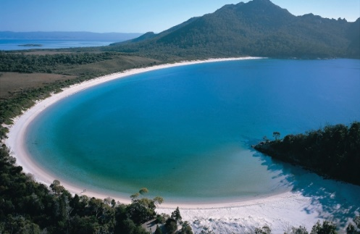 | 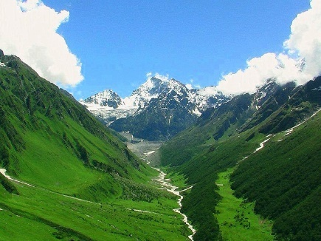 | 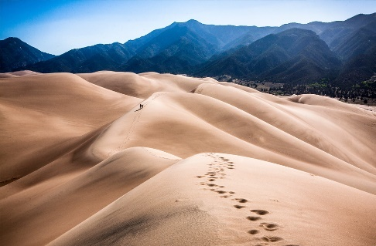
1______________________ | 2______________________ | 3. ______________________
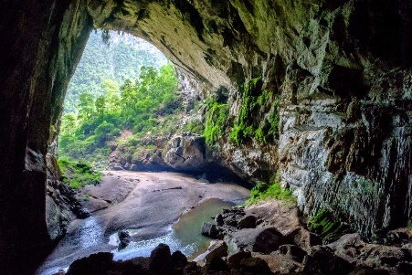 | 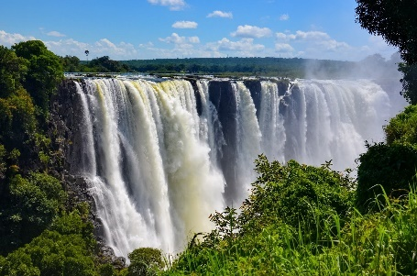 | 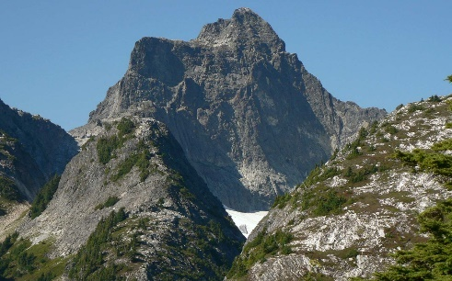
4. ______________________ | 5. ______________________ | 6. ______________________

II. Complete the sentences with the words in exercise I.
- They were trapped in the ______________________for 19 hours.
- The boat struck a rock outside the ______________________and sank.
- The magnificent scene of the ______________________ is pleasant.
- The Andes is the longest ______________________ range in the world.
- People have lived in this ______________________ since ancient times.
- There is only a low ______________________formation along the beach
III. The following words end in ed. How do you pronounce this ending correctly?

1 | climbed → | 11 | smiled →
2 | answered → | 12 | stopped→
3 | decided → | 13 | washed →
4 | helped → | 14 | loved →
5 | asked → | 15 | lived →
6 | cleaned → | 16 | agreed →
7 | escaped → | 17 | believed →
8 | watched → | 18 | invited →
9 | acted → | 19 | liked →
10 | counted → | 20 | moved →

IV. Choose a word that has the final sound(-ed) different from the others.

1. A. worked | B. wanted | C. stopped | D. asked
2. A. opened | B. knocked | C. played | D. occurred
3. A. talked | B. watched | C. lived | D. stopped
4. A. covered | B. installed | C. described | D. decorated
5. A. claimed | B. warned | C. occurred | D. existed
6. A. carried | B. looked | C. managed | D. opened
7. A. pleased | B. smoked | C. stopped | D. missed
8. A. waited | B. mended | C. objected | D. faced
9. A. pleased | B. erased | C. increased | D. amused
10. A. arrived | B. believed | C. received | D. hoped
11. A. opened | B. knocked | C. played | D. occurred
12. A. rubbed | B. tugged | C. stopped | D. filled
13. A. dimmed | B. travelled | C. passed | D. stirred
14. A. tipped | B. begged | C. quarrelled | D. carried
15. A. killed | B. hurried | C. regretted | D. planned
16. A. visited | B. showed | C. wondered | D. studied
17. A. sacrificed | B. finished | C. fixed | D. seized
18. A. needed | B. booked | C. stopped | D. washed
19. A. loved | B. teased | C. washed | D. rained
20. A. packed | B. punched | C. pleased | D. pushed
21. A. painted | B. provided | C. protected | D. equipped
22. A. tested | B. marked | C. presented | D. founded
23. A. used | B. finished | C. married | D. rained
24. A. allowed | B. dressed | C. flashed | D. mixed
25. A. switched | B. stayed | C. believed | D. cleared
26. A. decided | B. waited | C. handed | D. designed
27. A. annoyed | B. phoned | C. watched | D. remembered
28. A. hurried | B. decided | C. planned | D. wondered
29. A. posted | B. added | C. managed | D. arrested
30. A. dreamed | B. neglected | C. denied | D. admired

LESSON 2A. READING
I. Fill in the blanks using the words in the box.
tourist attractions | temple | architecture | symbol | worship | flavour | stall
travellers | site | traditional | culture | crowded | pagoda | handmade

- The company hasn't yet chosen the ______________________for the new hospital.
- Don't forget to save room for one of their ______________________desserts prepared daily.
- Huong ______________________is one of the largest and most unique religious sites in Hanoi.
- We don’t like watching movie on the weekend because the theater is often too ______________________.
- American ______________________ has been exported all over the world.
- The school uses a combination of modern and ______________________ methods for teaching reading.
- This hotel is for serious ______________________, rather than tourists on two-week holidays.
- He runs a fruit and vegetable ______________________ in the market.
- My fish was delicious but her beef had almost no ______________________.
- The church was opened for public ______________________.
- The ______________________ for oxygen is O.
- The ______________________ of the building is modern.
- The ______________________ was built about 206 B.C.
- Ha Long Bay is one of the most popular ______________________in Vietnam.

II. Read the article and correct the sentences.
0. We can save energy by turning on electrical items in our homes.
We can save energy by turning them off.
1. Food grown abroad is polluted.
_________________________________________________________________________________________________________
2. Transporting food a long way can cause traffic jams.
_________________________________________________________________________________________________________
3. Only a small part of the materials we waste can be recycled.
_________________________________________________________________________________________________________
4. Rainforests are home to around 80% of the planet’s plants and animals.
_________________________________________________________________________________________________________
5. Small areas of rainforests get destroyed each year.
_________________________________________________________________________________________________________

Eco-friendlyTeens.com
The big question is: ‘How can we be more environmentally friendly?’ Well, here are some useful tips.
A Electricity
One of the biggest problems on the planet today is the growing need for energy. One of the most common forms of energy is electricity. The more we produce, the more pollution we create. My suggestion is to turn everything off in your house when you’re not using it. This includes light bulbs, TVs and computers. Simple, but effective!
B Food
Have you ever thought, ‘Where does my food come from?’ Well, the answer is… everywhere!
Green beans from Egypt, coffee from South America, and maybe even apples from New Zealand. This food travels with lots of different transport, which means lots of petrol and lots of pollution. So, why not eat food that is produced locally? It’s fresh, it doesn’t have to travel so far and it cuts down on your meal’s carbon footprint.
C Rubbish
‘Reduce, Reuse and Recycle’. Every year we throw away millions of tons of waste – glass, plastic, cans, paper and cardboard. But this can all be recycled.
Don’t just throw rubbish away; see if you can use it again, or if not, recycle it so it can be used
elsewhere.
D Rainforests
Rainforests are some of the most valuable habitats on Earth, and about half of the world’s species of animals and plants live in them. But every year a rainforest the size of Britain is destroyed. Everyone can help reduce this problem by planting more trees, buying eco-friendly paper, recycling anything that’s made of paper and shopping smart. Buy food that doesn’t have lots of packaging!
III. Read the article again and complete the sentences.
0. The growing need for energy, especially electricity, is a big problem nowadays.
1. We can buy food that is ___________________________so it doesn’t need to ______________________________________long distances and cause ___________________.
2. We shouldn’t our waste ___________________but see whether we can it _______________.
3. We should recycle like _____________glass, plastic, ______________ , paper and _________________.
4. We can_____________________more trees to help stop rainforests getting ____________________.
5. We should shop and buy food _________________that doesn’t have a lot of___________________ .

LESSON 2B. GRAMMAR
I. PAST SIMPLE AND PAST CONTINUOUS
Exercise 1: Put the correct form of the verbs in the blanks using the past simple.
1. My sister (get) __________ married last month.
2. Daisy (come) __________ to her grandparents’ house 3 days ago.
3. My computer (be ) __________ broken yesterday.
4. He (buy) __________ me a big teddy bear on my birthday last week.
5. My friend (give) __________ me a bar of chocolate when I (be) __________ at school yesterday.
6. My children (not do) __________ their homework last night.
7. You (live) __________ here five years ago?
8. They (watch) __________ TV late at night yesterday.
9. Your friend (be) __________ at your house last weekend?
10. They (not be) __________ excited about the film last night.

Exercise 2: Put the verbs in brackets into the Past continuous
1. I ___________________down the street when it began to rain. (go)
2. At this time last year, I ___________________an English course. (attend)
3. Jim ________________ under the tree when he heard an explosion. (stand)
4. The boy fell and hurt himself while he _________________ a bicycle. (ride)
5. When we met them last year, they______________ in Santiago. (live)
6. The tourist lost his camera while he________________ around the city. (walk)
7. The lorry _______________ very fast when it hit our car. (go)
8. While I ____________________in my room, my roommate ___________________ a party in the other room. (study/ have)
9. Mary and I___________________in the kitchen when the telephone rang (cook)
10. We __________________ in the café when they saw us. (sit)

Exercise 3: Choose the correct answer for each sentence.

1. I saw/ was seeing the accident when I was waiting for the taxi.
2. What were you doing/ did you do when I phoned?
3. They didn't visit/ weren't visiting their friends last summer holiday.
4. It rained/ was raining heavily last July.
5. While people were talking to each other, he read/ was reading his book.
6. Chris was eating/ ate pizza every weekend last month.
7. While we were running/ run in the park, Mary fell over.
8. Did you find/ Were you finding your keys yesterday?
9. Who was she dancing/ did she dance with at the party last night?
10. They were watching/ watched football on TV all day.

Exercise 4: Find out one mistake in each sentence, then correct it.
1. I was play football when she called me.
2. Was you study Math at 5 p.m. yesterday?
3. What was she do while her mother was making lunch?
4. Where did you went last Sunday?
5. They weren’t sleep during the meeting last Monday.
6. He got up early and have breakfast with his family yesterday morning.
7. She didn’t broke the flower vase. Tom did.
8. Last week my friend and I go to the beach on the bus.
9. While I am listening to music, I heard the doorbell.
10. Peter turn on the TV, but there was nothing interesting.
Exercise 5: Choose the correct answer for each sentence.
1. They__________ the bus yesterday.
A. don’t catch B. weren’t catch C. didn’t catch D. not catch
2. My sister__________home late last night.
A. comes B. come C. came D. was come
3. My father ______ tired when I__________ home.
A. was – got B. is – get C. was – getted D. were – got
4. What__________you__________two days ago?
A. do – do B. did – did C. do – did D. did – do
5. Where__________your family__________on the summer holiday last year?
A. do – go B. does –go C. did – go D. did – went
6. At this time last year, they _________this house
A. built B. is building C. was building D. were building
7. What _________you _________ (do) at 8 pm yesterday?
A. were you doing B. was you doing
8. They (not go) _________ to school when I met them yesterday.
A. didn’t go B. wasn’t going C. didn’t went D. weren’t going
9. At this time last year, they _________ (build) this house.
A. built B. was built C. was building D. were building
10. Friday will be a bad day for me – I have an extra session and maybe a press conference. I wish your mother _________on Saturday or Sunday. But I know it’s not your fault.
A. didn’t come B. were coming C. came D. had come
11. I (drive) _________ my car very fast when you called me.
A. drove B. was driving C. was drive D. were driving
12. I _________ (chat) with my friends while my teacher _________ (teach) the lesson yesterday.
A. was chatting – teaching B. was teaching – was teaching
C. was teaching – taught D. chatted – taught
13. My father _________ (watch) TV when I got home.
A. was watching B. watched C. were watched D. was watched
14. At this time yesterday, I _________ (prepare) for my son’s birthday party.
A. prepared B. was prepared C. was preparing D. were preparing
15. Where _________ (go) when I saw you last weekend?
A. was you going B. were you going C. did you go D. you went
16. They _________ (not go) to school when I met them yesterday.
A. weren’t going B. not going C. didn’t go D. weren’t go
17. My mother _________ (not go) the housework when my father came home.
A. didn’t go B. didn’t doing C. wasn’t doing D. weren’t doing
18. My sister _________ (read) books while my brother _________ (play) football yesterday afternoon.
A. was reading – playing B. was reading – was playing
C. was reading – played D. read – was playing
19. While Henry (play)_________ the piano, his mother (do)________ the washing-up.
A. was playing/ was doing B. were playing/ were doing
C. played/ did D. played/ was doing
20. I (have) _________ dinner when I suddenly__________a loud bang.
A. were having/ hear B. was having/ heard
C. had/heard D. was having/ was hearing

II. CLEFT SENTENCES

Exercise 1: Choose the correct answer.
- ….…. we all look for.
- It is happiness that C. that happiness
- Happiness it is that D. happiness it is
- ….…. my neighbors who rescued me from the fire.
- It is B. It was C. that is D. this is
- ….…… me how to play the drum.
- It was my uncle who taught C. it was my uncle taught
- My uncle who taught D. it is my uncle teaching
- ….…….. I bought the golden fish.
- It was from this shop that C. it was this shop which
- It was from this shop which D. it was this shop that
- ….……. gave me that picture book.
- Mary B. It was Mary C. It was Mary whom D. It was Mary whose
- My new book, …………, is very interesting.
- It is on wild animals C. which is on wild animals
- Is on wild animals D. to be on wild animals
- Two players of our delegation, ……….., are in competition for the gold medal.
- It was Jim and John C. it is Jim and John
- They were Jim and John D. Jim and John
- It was Tom ………..to help us.
- Comes B. that comes C. to come D. who came
- ….……. the police had rescued from the fire.
- The baby B. the baby that C. It was the baby whom D. the baby whom
- ….……. my parents gave me the fish tank.
- It was on my birthday when C. It was my birthday that
- It was my birthday on that D. It was on my birthday that
- ….……. I first met my girlfriend.
- It was in London that C. it was London that
- It was in London where D. it was London which
- It was ……….. the wet and windy day that I drove over the hill to Milland.
- In B. on C. at D. for
- It was my friend, Shona, ………..
- I was at school with whom C. with who I was at school
- I was at school with D. with that I was at school
- ….…… on the phone.
- It is his mother whom is C. It was his mother who is
- It was his mother whom is D. It is his mother who is
- ….…….. those books on the desk?
- Were it you who put C. Was it you that put
- It was you who put D. It is you that put
- ….……. we have to wait.
- It is a long time that C. It is for a long time that
- It is a long time for that D. It is for a long time when
- It is ………. they are going to, not Russia.
- Spain B. Spain that C. Spain where D. in Spain that
- ….…….. he heard the news.
- It was three-week later that C. It was three-week later when
- It was three weeks later when D. It was three weeks later that
- ….……… a high level of blood cholesterol.
- It is eggs that contain C. It is eggs that contains
- Those are eggs it contains D. It is eggs contain
- ….…….. I first met him in that resort.
- It was last winter when C. It was in last winter when
- It was last winter D. It was the last winter which
- ….…….. disappeared when I arrived at the airport.
- My passport C. It is my passport that
- It was my passport D. It is my passport.
- It was the great efforts ……… to complete his study.
- That made B. that he made C. that he made it D. he made it
- It is ……… we will leave for Paris.
- April B. in April that C. April in that D. in April when
- ….…….. on my part that I could not manage to deliver the goods on time.
- An error B. that’s an error C. It was an error D. an error it was
- ….…… in sorrow than in anger that his parents criticized him on his failure.
- It is B. It was C. It was much D. It was more
- ….……. took my document?
- It is Peter that C. Was it Peter that
- It was Peter that D. Was that Peter
- It is ………. I get emotional satisfaction.
- Collecting stamps that C. collecting stamps from that
- From collecting stamps that D. collecting stamps that from
- It is the library ………….
- That I often borrow books C. where I often borrow books from
- That I often borrow books from D. from that I often borrow books
- ….…….. England won the World Cup.
- It was in 1966 that C. It was on 1966 that
- It was in 1966 when D. It was 1966 in that
- ….……… took my car.
- It was you B. It were you C. It was you that D. It was you whom
- It was the stamp collection …………
- About I have ever told you C. about that I have ever told you
- I have ever told you about D. that I have ever told you
- ….……. taught me how to collect butterflies.
- It was my father C. It was my father whom
- It is my father D. My father
- It is ………. that you can leave the exam room.
- Only when have you finished your papers.
- You have finished your papers
- Only have you finished your papers
- Only when you have finished your papers.
- It is ……….. we usually sit in the afternoon reading books.
- on the tree where C. by the tree
- under the tree that D. under the tree which
- It is Tom ……….. the test.
- Who have finished C. that has finished
- That are finishing D. finishing
- It was in 1990 ………… I met my husband.
- When B. which C. that D. Ø
- ….………. invented the telephone.
- He was Marconi that C. He is Marconi who
- It is Marconi that D. It was Marconi that
- ….…….. she was born.
- It is in Paris where C. it was in Paris that
- It is in Paris, that D. it was in Paris where
- ….…….. the nearest the sun.
- It is Mercury who is C. It was Mercury that are
- It is Mercury, which is D. It is Mercury that is
Exercise 2: Rewrite the sentences to focus attention on the underlined information. Using structure” it is / was ... that”
- He is interested in learning English most.
→______________________________________________________________________________________________________
- I heard that news in this morning.
→______________________________________________________________________________________________________
- My aunt lives in Britain for ten years.
→______________________________________________________________________________________________________
- Mary and Peter are my close friends.
→______________________________________________________________________________________________________
- The boat race was held in this river.
→______________________________________________________________________________________________________
- I studied abroad when I was 22.
→______________________________________________________________________________________________________
- They play card during the night.
→______________________________________________________________________________________________________
- He bought a new car yesterday.
→______________________________________________________________________________________________________
- They go camping in the forest.
→______________________________________________________________________________________________________
- My family usually go shopping at weekend.
→______________________________________________________________________________________________________
Exercise 3: Rewrite the sentences to focus attention on the underlined information. Using structure” it is / was ... that + passive voice”
- People talked about the fire last night.
→______________________________________________________________________________________________________
- My mother gave me a nice dress on my birthday.
→______________________________________________________________________________________________________
- We watched TV show yesterday.
→______________________________________________________________________________________________________
- She kept her memento carefully.
→______________________________________________________________________________________________________
- My family bought a new fridge.
→______________________________________________________________________________________________________
- They served a lot of dishes at the party.
→______________________________________________________________________________________________________
- A cat broke the flower vase when it caught a mouse.
→______________________________________________________________________________________________________
- The teacher asked the student to do homework.
→______________________________________________________________________________________________________
- My mother bought foods in the supermarket.
→______________________________________________________________________________________________________
- She held a farewell party yesterday.
→______________________________________________________________________________________________________
Exercise 4. Rewrite the sentences to focus attention on the underlined information. Using structure” it is / was ... that”
1. She bought the car from Tom.
→______________________________________________________________________________________________________
2.The computer gives me a headache.
→______________________________________________________________________________________________________
3. We are coming to stay with Jane this weekend.
→______________________________________________________________________________________________________
4. The president makes the important decisions.
→______________________________________________________________________________________________________
5. I’m looking forward to physics exam.
→______________________________________________________________________________________________________
6. I lost my wallet somewhere in there.
→______________________________________________________________________________________________________
7. I was born and grew up in a small village.
→______________________________________________________________________________________________________
8. My teacher helped me a lot of with my study last semester.
→______________________________________________________________________________________________________
9. The headmaster gave Tam a bicycle as a scholarship.
→______________________________________________________________________________________________________
10. Your carelessness caused the accident
→______________________________________________________________________________________________________
11. The neighbour told them about it.
→______________________________________________________________________________________________________
12. My friend came to see me late last night.
→______________________________________________________________________________________________________
13. That boy scored the goal for his team.
→______________________________________________________________________________________________________
14. The dog grabbed at the piece of meat and ran away.
→______________________________________________________________________________________________________
15. The strong wind blew the roof off.
→______________________________________________________________________________________________________
16. The woman answered the man rudely.
→______________________________________________________________________________________________________
17. The boy played ping pong the whole afternoon.
→______________________________________________________________________________________________________
18. The girl gave the boy a special gift on his birthday.
→______________________________________________________________________________________________________
19. The police arrested the man at the railway station.
→______________________________________________________________________________________________________
20. He borrowed the money from Linda.
→______________________________________________________________________________________________________
21. He bought the book from that corner shop.
→______________________________________________________________________________________________________
22. He got married when he was 26.
→______________________________________________________________________________________________________
23. They were having a barbecue in the park.
→______________________________________________________________________________________________________
24. I met him on the way to school.
→______________________________________________________________________________________________________
LESSON 2C LISTENING
A.Vocabulary
I. Read the description and write the words. The first letter of the word is given.
1. buildings used for religious worship, especially in religions other than Christianity. t_____________
2. feeling or showing surprise. s___________
3. building where objects of historical, scientific, or artistic interest are kept. m___________
4. extremely surprised. a___________
5. upset because something you hoped for has not happened or been as good, successful, etc. as you expected. d___________
6. tall religious buildings in Asia with many levels, each of which has a curved roof. p___________
7. a large house that is the official home of a king, queen, or other person of high social rank. p___________
8. to remove something. t___________ __________
9. to fly. t___________ __________
10. a person who lives in the particular small area that you are talking about. l___________

II. Complete the sentences with the words in exercise I.
1. When I travel, I usually ask a ___________________ about the best places to eat in town.
2. Hurry up! The plane is going to _________________.
3. You need to _________________the garbage every evening.
4. On the first day of Lunar New Year, Vietnamese people often visit _________________and _________________.
5. I was angry, _________________ and upset about his behaviour.
6. Buckingham _________________is open to the public.
7. I was _________________ to hear that my sister had won first prize.
8. She looked at him with a _________________ expression on her face.
9. The _________________ contains one of the best existing collections of Maori art.
B. Listening
I. Listen to the first part of the recording and write True or False.
Cambodia | 1. Travelling to Cambodia is very expensive. ____________  2. The people in Cambodia are very friendly and warm. ____________  3. Anchor Watt is an ancient complex that was hidden from civilization for thousand years. ____________
Singapore | 4. Singapore is perfect for those looking for cheap travelling. ____________  5. Travellers can explore temples, markets, shopping malls, casinos and marina bay sands when they visit Singapore. ____________  6. Southeast Asia is a pretty affordable place to explore. ____________
Philippines | 7. The Philippines offer a mixture of crowded city centres and picturesque beaches. ____________  8. This is a very affordable place to explore. ____________  9. Transport between the cities and different island is faster than the rest of Asia. ____________

II. Listen to the rest of the recording and fill in the gaps.
VIETNAM  Places to visit in Vietnam:  - The war (1)___________________  - Cu Chi (2)___________________  - Halong (3)___________________  Private rooms: around (4)___________________a night.  There are plenty of (5)__________________ and (6)__________________ options for all budgets  Vietnam is actually one of the (7)__________________ places to visit in Southeast Asia. | THAILAND  Climate: (8)____________________________  Places to visit:  - Glorious (9)__________________  - Breathtaking (10)__________________  - Bustling (11)__________________  - Incredible (12)__________________.  Bangkok: to see the (13)_______ _ and visit the (14)____________ journey up north to see the (15)__________________ city of Chiang Mai and make sure to spend some time island hopping in the south.  Food: pad Thai and curries to (16)__________________ and (17)__________________ sticky rice.

LESSON 2D SPEAKING
I. Write the suitable word for each picture.

 | 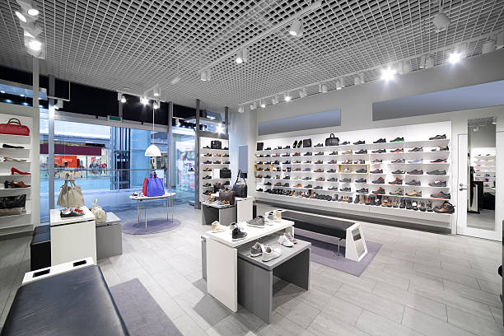 | 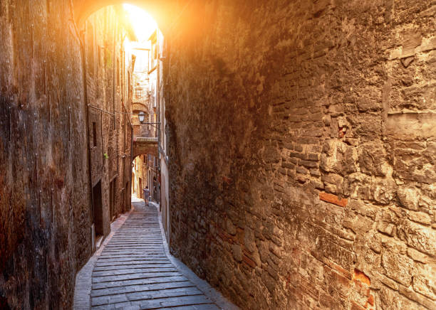
1. _________________ | 2. _________________ | 3. _________________
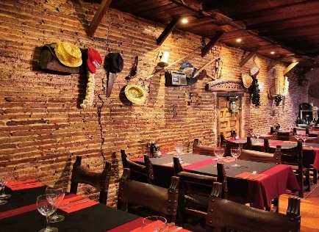  4. _________________ | 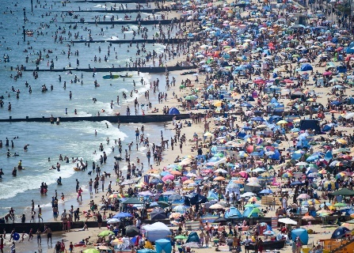  5. _________________ | 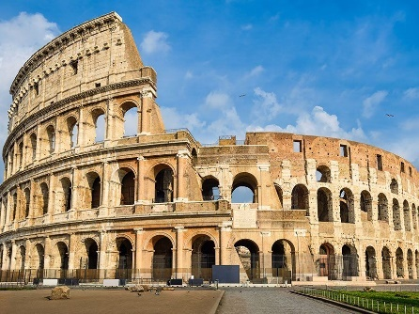  6. _________________
II. Match the sentences with the teenage problems in exercise I.
- Notre-Dame Cathedral is a very famous ______________for Catholics.
- I like to go to the ___________________in this town because they serve great food and we can enjoy country music.
- Last week, I went to a very ___________________. There were many people, so we cannot find any spaces to play volleyball on the sand.
- It is a ________________which used to be congested, and it is now proposed to widen it.
- Let’s go to see _______________ from today's leading brands.
- It is a___________________, with old cottages within its boundaries.

LESSON 2D WRITING & CULTURE CORNER

I. Rewrite the sentences using the given words.
1. The/ Vietnamese/ bow/ people/ heads/ their/ to/ greet/.
______________________________________________________________________________________________
2. rude/ is/ It / refuse/ food/ drinks/and/ to /.
______________________________________________________________________________________________
3. Vietnam, /In/ common/ is / it / oldest / wait/ person/ first/ eat/ to/ respect/ your/ show/ to/ for/ the/ to/.
______________________________________________________________________________________________
4. pagoda/ bell/ a/ this/ has/ tower/ 20/ metres/ height/ at/ a / of/.
______________________________________________________________________________________________
5. city/ ancient/ visit/ didn’t/ I/ the/ yesterday /.
______________________________________________________________________________________________
II. Rewrite the sentences so that it has the same meaning with the provided sentences.
1. We are coming to stay with Jane this weekend.
-> It is _______________________________________________________________________________________________
2. The president makes the important decisions.
-> It was ____________________________________________________________________________________________
3. I’m looking forward to physics exam.
-> It is _______________________________________________________________________________________________4. I lost my wallet somewhere in there.
-> It was ______________________________________________________________________________________________
5. I was born and grew up in a small village.
-> It was ______________________________________________________________________________________________
6. I haven’t met Lucy since we left school.
-> The last time ____________________________________________________________________________________
7. I haven’t seen him since I was a student.
-> I last ________________________________________________________________________________________
8. Shawn has been playing guitar since he was five.
-> Shawn ______________________________________________________________________________________
II. Write an informal email

- This is part of a letter you receive from an English friend.

- Now write a letter to your friend.
- Write your letter in 100 words.
Write an email to Jane. In the email, you should:
- tell her about the problem you had.
- say what you worry about the problem?
- ask Jane for advice
Write your email in about 100 words.

I went to visit a historical building in Paris with my family last week.
Which do you prefer: visting a historical building or a crowded beach?
Tell me about your favourite place to visit.

………………………………………………………………………………………………………………………………
………………………………………………………………………………………………………………………………
………………………………………………………………………………………………………………………………
………………………………………………………………………………………………………………………………
………………………………………………………………………………………………………………………………
………………………………………………………………………………………………………………………………
………………………………………………………………………………………………………………………………
………………………………………………………………………………………………………………………………
………………………………………………………………………………………………………………………………
………………………………………………………………………………………………………………………………
………………………………………………………………………………………………………………………………
………………………………………………………………………………………………………………………………
………………………………………………………………………………………………………………………………

Tài liệu được chia sẻ bởi Website VnTeach.Com
https://www.vnteach.com

