**LỚP HỌC THẦY (CÔ) ___________________________** **ĐỀ ÔN TẬP: READING SIGNS/ NOTICES – A2**

**Test 16**

*Thời gian làm bài: [Time]*

Họ và tên: ________________________________________________ Lớp: 9/___

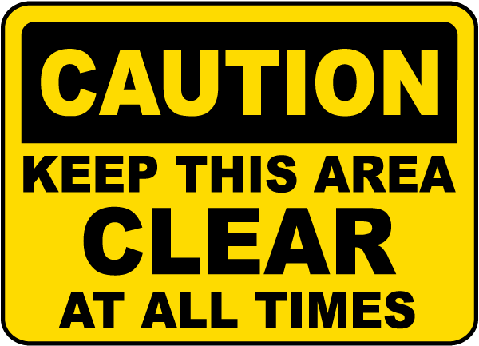**Question 1:** What does this sign mean?

**A.** You are allowed to place objects in this area and block it off.

**B.** This area must be kept clean to ensure that the area is always well ventilated**.**

**C.** This area is not very important and can be used for storage or other purposes.

**D.** This area is not currently in use and does not need to be kept clean.

**Question 2:** Which of the following statements is true?

Speaking Contest

Speaking contest on 20th Oct at auditorium. Open to all students and professionals. Topic: "Future of Technology." Winner gets $150. Register by 15th Oct on website or at auditorium.

**A.** The topic of the speaking contest is "Future of Technology."

**B.** The winner of the speaking contest gets $100.

**C.** The speaking contest is only open to students.

**D.** The speaking contest is on 15th October.

**Question 3:** What does this sign mean?

**A.** There are no children in this area at the moment.  
**B.** Be careful and look out for children who may be in this area**.**  
**C.** Children are not permitted to be in this area**.**  
**D.** Children are playing in this area right now.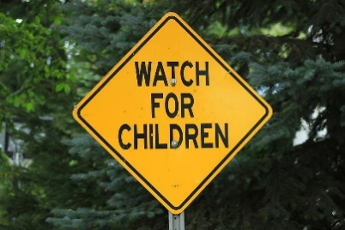

**Question 4:** What should you do according to the notice?

The library will be closed for a special event on Monday. Please return all borrowed items by Sunday.

**A.** Return all borrowed items by Sunday.  
**B.** The library is closed only on public holidays.

**C.** The library will be open on Monday.  
**D.** Return all borrowed items on Monday.  
**Question 5:** What does this sign mean?

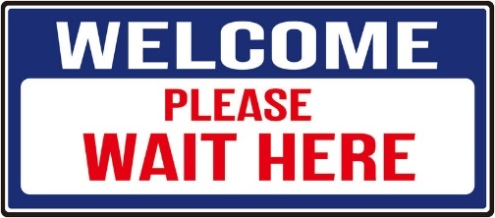**A.** Go to a different place or location.  
**B.** You can leave right away without waiting.  
**C.** There is no need to wait in this area**.**  
**D.** Stay and wait at this specific spot or location.

**Question 6:** Which of the following statements is true?

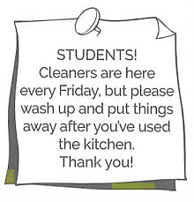

**A.** Students are not required to clean up after using the kitchen because cleaners come every Friday.

**B.** Students should clean up and put things away after using the kitchen, even though cleaners come every Friday.

**C.** Students can leave their things in the kitchen until the cleaners arrive on Friday.

**D.** The kitchen is cleaned every day by the cleaners, so students do not need to clean up after themselves.

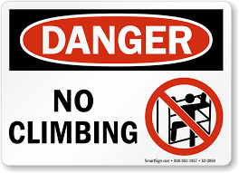**Question 7:** What does this sign mean?

**A.** You are allowed to climb here.  
**B.** Climbing is not suggested or recommended here.  
**C.** Climbing is encouraged and you should do it here.  
**D.** Climbing is not allowed or permitted in this area**.**

**Question 8:** Which of the following statements is true?

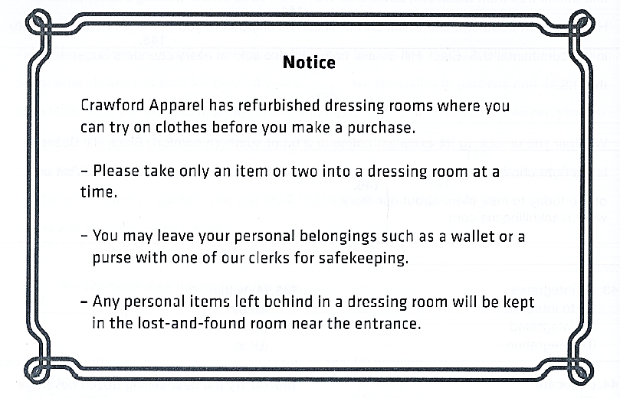

**A.** Customers can take many items into the dressing room at the same time.

**B.** Personal items left in the dressing room will be thrown away.

**C.** Customers should leave their personal items with a clerk for safety.

**D.** The lost-and-found room is in the dressing rooms.

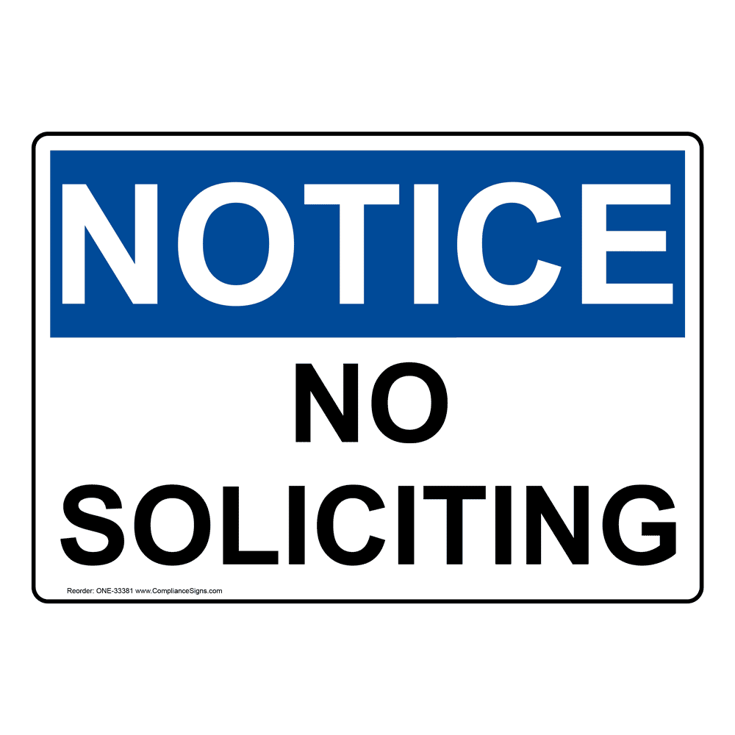**Question 9:** What does this sign mean?

**A.** Soliciting cannot be done in this area without a permit.

**B.** Soliciting is only allowed in some areas.

**C.** Soliciting is not allowed or permitted in this area**.**

**D.** Soliciting is allowed and you can do it here.

**Question 10:** Which of the following statements is true according to the notice?

**Notice**  
The Library has new rules for borrowing books.

* You can borrow up to five books at a time.
* Books must be returned within two weeks.
* Late fees apply if books are returned after the due date.

**A.** You can borrow more than five books at a time.

**B.** Books must be returned within two weeks.

**C.** You do not pay late fees for overdue books.

**D.** You can keep books forever.

**[HẾT]**