UNIT 11 | OUR GREENER WORLD
❖ A. VOCABULARY
No. | Word / Phrase | Type | IPA | Meaning
1 | bin | (n) | /bɪn/ | thùng rác
2 | charity | (n) | /ˈtʃærəti/ | tổ chức từ thiện
3 | clean up | (phr v) | /ˌkliːn ˈʌp/ | dọn sạch
4 | environment | (n) | /ɪnˈvaɪrənmənt/ | môi trường
5 | glass | (n) | /ɡlɑːs/ | thủy tinh
6 | green | (adj) | /ɡriːn/ | thân thiện môi trường
7 | litter | (n/v) | /ˈlɪtə(r)/ | rác; xả rác
8 | natural | (adj) | /ˈnætʃrəl/ | tự nhiên
9 | plastic | (n/adj) | /ˈplæstɪk/ | nhựa
10 | pollute | (v) | /pəˈluːt/ | gây ô nhiễm
11 | recycle | (v) | /ˌriːˈsaɪkl/ | tái chế
12 | reduce | (v) | /rɪˈdjuːs/ | giảm
13 | refillable | (adj) | /ˌriːˈfɪləbl/ | có thể làm đầy lại
14 | reusable | (adj) | /ˌriːˈjuːzəbl/ | có thể tái sử dụng
15 | reuse | (v) | /ˌriːˈjuːz/ | tái sử dụng
16 | rubbish | (n) | /ˈrʌbɪʃ/ | rác thải
17 | save | (v) | /seɪv/ | tiết kiệm, bảo vệ
18 | shopping bag | (n phr) | /ˈʃɒpɪŋ bæɡ/ | túi mua sắm
19 | swap | (v) | /swɒp/ | trao đổi
20 | tap | (n) | /tæp/ | vòi nước
21 | throw away | (phr v) | /ˌθrəʊ əˈweɪ/ | vứt bỏ
22 | water pollution | (n phr) | /ˈwɔːtə pəˌluːʃn/ | ô nhiễm nước
23 | wrap | (v) | /ræp/ | gói, bọc
24 | protect | (v) | /prəˈtekt/ | bảo vệ
25 | electricity | (n) | /ɪˌlekˈtrɪsəti/ | điện
❖ B. WORD FORM
1. recycle (v): tái chế; recycling (n); recyclable (adj); recycled (adj) | 2. pollute (v): gây ô nhiễm; pollution (n); polluted (adj); pollutant (n)
3. environment (n): môi trường; environmental (adj); environmentally (adv) | 4. reuse (v/n): tái sử dụng; reusable (adj); used (adj); useless (adj)
5. protect (v): bảo vệ; protection (n); protective (adj); protector (n)
❖ C. GRAMMAR
1. Articles: a, an, the
• Dùng a/an trước danh từ đếm được số ít khi nhắc lần đầu; a trước âm phụ âm, an trước âm nguyên âm.
• Dùng the khi người nghe biết rõ sự vật hoặc sự vật đã được nhắc đến.
a reusable bag; an old bottle; the bag on the table.
2. First conditional
• Dùng để diễn tả điều kiện có thể xảy ra ở hiện tại hoặc tương lai.
If + S + present simple, S + will / won't + V-inf.

❖ EXERCISES
❖ PHONETICS
Exercise 1: Choose the word whose underlined vowel is pronounced differently (/ɑː/ or /æ/).
1.
A. glass | B. class | C. plant | D. bag
2.
A. car | B. park | C. garden | D. plastic
3.
A. basket | B. natural | C. package | D. large
4.
A. can | B. tap | C. wrap | D. last
5.
A. farm | B. start | C. park | D. can
6.
A. bag | B. can | C. plastic | D. glass
7.
A. plant | B. class | C. after | D. natural
8.
A. car | B. far | C. large | D. map
9.
A. reusable | B. paper | C. save | D. glass
10.
A. bath | B. path | C. half | D. back
Exercise 2: Mark the letter A, B, C, or D to indicate the word that differs in stress pattern.
1.
A. rubbish | B. plastic | C. litter | D. reduce
2.
A. recycle | B. reuse | C. refill | D. charity
3.
A. natural | B. environment | C. pollution | D. electricity
4.
A. shopping | B. water | C. paper | D. protect
5.
A. reusable | B. refillable | C. recyclable | D. garden
❖ VOCABULARY AND GRAMMAR
Exercise 3: Mark the letter A, B, C, or D to indicate the correct answer to each question.
1. Which word or phrase means 'thùng rác'?
A. bin | B. charity | C. clean up | D. environment
2. Which word or phrase means 'tổ chức từ thiện'?
A. glass | B. charity | C. green | D. litter
3. Which word or phrase means 'dọn sạch'?
A. natural | B. plastic | C. clean up | D. pollute
4. Which word or phrase means 'môi trường'?
A. recycle | B. reduce | C. refillable | D. environment
5. Which word or phrase means 'thủy tinh'?
A. glass | B. reusable | C. reuse | D. rubbish
6. Which word or phrase means 'thân thiện môi trường'?
A. save | B. green | C. shopping bag | D. swap
7. Which word or phrase means 'rác; xả rác'?
A. tap | B. throw away | C. litter | D. water pollution
8. Put paper, cans and bottles in the correct recycling _____.
A. wrap | B. protect | C. electricity | D. bin
9. We should _____ plastic bags instead of using new ones.
A. reuse | B. bin | C. charity | D. clean up
10. Turn off the _____ while you brush your teeth.
A. environment | B. tap | C. glass | D. green
11. Do not _____ old clothes; give them to charity.
A. litter | B. natural | C. throw away | D. plastic
12. A _____ bottle can be used many times.
A. pollute | B. recycle | C. reduce | D. refillable
13. The class will _____ the beach on Saturday.
A. clean up | B. reusable | C. reuse | D. rubbish
14. Factories can _____ rivers if they release dirty water.
A. save | B. pollute | C. shopping bag | D. swap
15. We can _____ clothes with friends instead of buying more.
A. tap | B. throw away | C. swap | D. water pollution
16. I bought _____ reusable bag yesterday.
A. a | B. an | C. the | D. no article
17. Please put the bottle in _____ blue bin over there.
A. a | B. an | C. the | D. no article
18. We saw _____ old television beside the road.
A. a | B. an | C. the | D. some
19. If we recycle paper, we _____ save trees.
A. will | B. would | C. did | D. are
20. If people _____ less plastic, the streets will be cleaner.
A. use | B. uses | C. will use | D. used
21. The air will be fresher if more people _____ bicycles.
A. ride | B. will ride | C. rode | D. riding
22. If you leave the tap on, you _____ water.
A. waste | B. will waste | C. wasted | D. are waste
23. _____ Earth is our home.
A. A | B. An | C. The | D. No article
24. Mai gave me _____ useful idea for reducing waste.
A. a | B. an | C. the | D. some
25. If it _____ tomorrow, we will clean the park on Sunday.
A. rain | B. rains | C. will rain | D. rained
26. What will happen if we _____ the lights?
A. don't turn off | B. won't turn off | C. didn't turn off | D. not turn off
27. There is _____ recycling centre near my school.
A. a | B. an | C. the | D. no article
28. I found a glass bottle. _____ bottle was still clean.
A. A | B. An | C. The | D. Some
29. If everyone helps, our neighbourhood _____ greener.
A. becomes | B. will become | C. became | D. become
30. We should use _____ Internet to share green ideas.
A. a | B. an | C. the | D. no article
Exercise 4: Choose the word(s) CLOSEST in meaning to the underlined word(s).
1. We should reduce plastic waste.
A. make less | B. make more | C. collect slowly | D. buy quickly
2. This bottle is reusable.
A. can be used again | B. must be broken | C. is made of paper | D. is very expensive
3. Please throw the rubbish in the bin.
A. waste | B. water | C. food | D. glass
4. The students cleaned up the park.
A. made it tidy | B. built a wall | C. planted rice | D. closed it
5. We must protect wild animals.
A. keep safe | B. throw away | C. pollute | D. swap
Exercise 5: Choose the word(s) OPPOSITE in meaning to the underlined word(s).
1. The river is polluted.
A. dirty | B. clean | C. deep | D. long
2. We need to reduce waste.
A. increase | B. recycle | C. reuse | D. collect
3. This bag is reusable.
A. green | B. single-use | C. large | D. refillable
4. The park is clean.
A. beautiful | B. dirty | C. quiet | D. natural
5. Electricity is expensive.
A. cheap | B. useful | C. limited | D. green
Exercise 6: Complete the sentences with a/an/the or the correct form in the first conditional.
1. I need _____ bag for these bottles.
2. We visited _____ environmental centre yesterday.
3. Please close _____ window near the door.
4. There is _____ old bin behind the school.
5. I bought a bottle. _____ bottle is refillable.
6. If we _____ paper, we will save trees. (RECYCLE)
7. The river will be cleaner if factories _____ it. (NOT POLLUTE)
8. If Lan uses a reusable bag, she _____ plastic waste. (REDUCE)
9. We _____ electricity if we turn off unused lights. (SAVE)
10. If people _____ rubbish in the street, the town will be dirty. (DROP)
11. If it _____ sunny, we will plant trees. (BE)
12. Animals _____ safer if we protect forests. (BE)
13. If you _____ the tap, you will waste water. (NOT TURN OFF)
14. Our school _____ greener if every class grows plants. (LOOK)
15. If we _____ old clothes, fewer things will become waste. (SWAP)
Exercise 7: Combine or rewrite the sentences using the first conditional or articles.
1. Recycle paper. You will save trees. (If)
➜ ________________________________________________________________________________________
2. People use fewer cars. The air will be cleaner. (If)
➜ ________________________________________________________________________________________
3. We do not protect rivers. Fish will die. (If)
➜ ________________________________________________________________________________________
4. Turn off the light. You will save electricity. (If)
➜ ________________________________________________________________________________________
5. I saw a recycling bin. Recycling bin was blue. (Use an article)
➜ ________________________________________________________________________________________
6. She bought reusable bag. (Add an article)
➜ ________________________________________________________________________________________
7. It is old appliance. (Add an article)
➜ ________________________________________________________________________________________
8. Everyone reuses bottles. We will create less waste. (If)
➜ ________________________________________________________________________________________
Exercise 8: Complete each sentence with the correct form of the word in brackets.
1. Glass and paper are _____. (RECYCLE)
2. Air _____ is a serious problem. (POLLUTE)
3. We joined an _____ club. (ENVIRONMENT)
4. This shopping bag is _____. (REUSE)
5. Wild animals need our _____. (PROTECT)
6. The children collected _____ bottles. (PLASTIC)
7. The park became _____ after the clean-up. (CLEAN)
8. Using less water is an _____ habit. (ENVIRONMENT)
9. The factory water is badly _____. (POLLUTE)
10. The campaign successfully _____ plastic use. (REDUCTION)
❖ COMMUNICATION
Exercise 9: Choose the option that best completes each exchange.
1. 'How can we reduce plastic waste?' - '_____.'
A. Use reusable bags | B. At the supermarket | C. Yesterday | D. A blue bin
2. 'What will happen if we plant trees?' - '_____.'
A. The air will be cleaner | B. We planted ten | C. In the park | D. They are tall
3. 'Is this bottle recyclable?' - '_____.'
A. Yes, it is | B. Yes, it does | C. No, I won't | D. It is mine
4. 'Please don't drop litter.' - '_____.'
A. Sorry, I won't | B. Yes, it was | C. No, there isn't | D. At the bin
5. 'Let's clean up the school yard.' - '_____.'
A. Good idea! | B. It's a yard | C. No, it isn't | D. Last Saturday
Exercise 10: Arrange the sentences to make a meaningful conversation.
1.
a. What can we do with these bottles?
b. We can recycle or reuse them.
c. Let's make plant pots.
A. a-b-c | B. b-a-c | C. c-a-b | D. a-c-b
2.
a. Why do you carry that bag?
b. It is reusable.
c. Does it help the environment?
d. Yes. I don't need plastic bags.
A. a-b-c-d | B. a-c-b-d | C. b-a-d-c | D. c-a-b-d
3.
a. The tap is still running.
b. I'll turn it off now.
c. Good. We must save water.
A. b-a-c | B. a-b-c | C. c-b-a | D. a-c-b

❖ READING
Exercise 11: Look at each sign or notice. Choose the best answer.
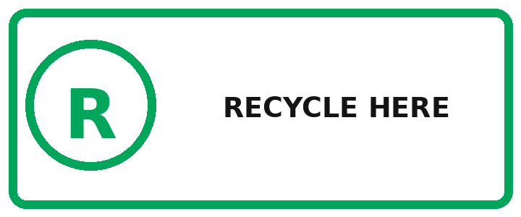 | 1. What should people do here?  A. Put recyclable items in this bin  B. Throw food on the ground  C. Buy new bottles  D. Waste paper
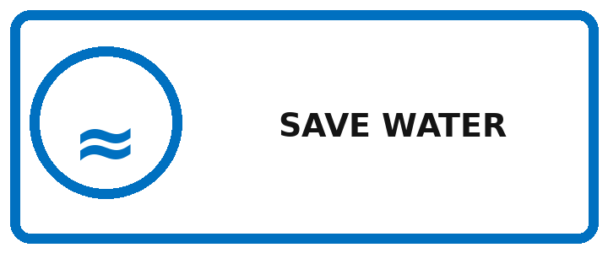 | 2. What does the notice ask people to do?  A. Use more water  B. Use water carefully  C. Swim here  D. Open every tap
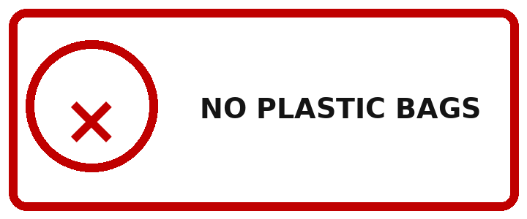 | 3. What is not allowed?  A. Paper  B. Reusable bags  C. Plastic bags  D. Bottles
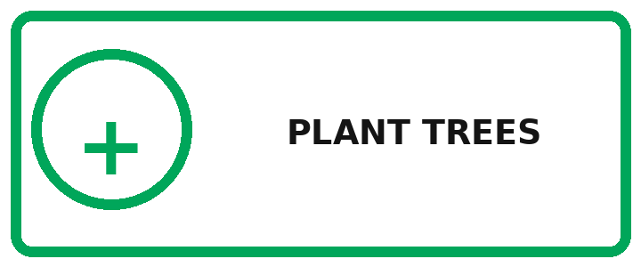 | 4. What activity is encouraged?  A. Cutting trees  B. Growing trees  C. Dropping litter  D. Burning rubbish
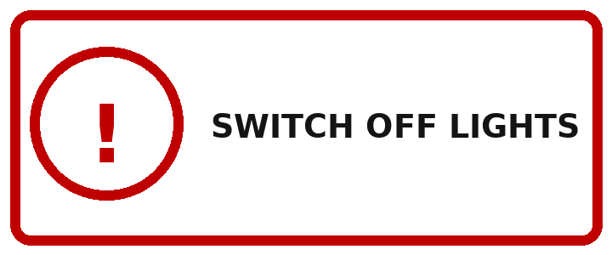 | 5. What should you do when leaving?  A. Turn off the lights  B. Open the tap  C. Use more electricity  D. Leave the door open
Exercise 12: Read the advertisements / announcements and choose the best option for each blank.
1.
GREEN SATURDAY
Join our neighbourhood clean-up this Saturday. Meet at the park entrance at 7.30 a.m. We will collect litter and separate paper, glass (1) _____ plastic. Please bring (2) _____ pair of gloves and a refillable bottle. If everyone helps, the park (3) _____ cleaner by lunchtime. Register (4) _____ Friday.
1.
A. and | B. but | C. so | D. because
2.
A. a | B. an | C. the | D. no article
3.
A. is | B. will be | C. was | D. be
4.
A. before | B. after | C. during | D. between
2.
SWAP, DON'T SHOP
Bring clean clothes and books to our school swap. You can exchange (1) _____ item you no longer use for something useful. If we reuse more things, we (2) _____ create less waste. The event will be in (3) _____ school hall from 2 to 4 p.m. Money is not needed, (4) _____ all items must be in good condition.
1.
A. a | B. an | C. the | D. some
2.
A. will | B. did | C. are | D. have
3.
A. a | B. an | C. the | D. no article
4.
A. but | B. because | C. so | D. and
Exercise 13: Read each passage and choose the correct word for each blank.
1.
A LOW-WASTE LUNCH
Mai brings lunch in a reusable box. She carries water in (1) _____ refillable bottle and uses a metal spoon. If she buys fruit, she chooses pieces without plastic (2) _____. After lunch, she puts food waste in the correct bin. She never (3) _____ litter on the ground. If every student follows these habits, the school (4) _____ produce much less rubbish. The changes are small, (5) _____ they make a real difference.
1.
A. a | B. an | C. the | D. some
2.
A. wrap | B. wrapping | C. wrapped | D. wraps
3.
A. drop | B. drops | C. dropped | D. dropping
4.
A. will | B. did | C. has | D. is
5.
A. but | B. because | C. so | D. or
2.
CLEANER TRANSPORT
Our town has started a bicycle-sharing programme. People can borrow (1) _____ bicycle from stations near schools and markets. If more residents cycle, there (2) _____ be fewer cars on the roads. The air will become cleaner, and people will get more exercise. The town will add more stations if the programme (3) _____ popular. Users must return bicycles on time (4) _____ keep them clean. It is a simple idea for (5) _____ greener town.
1.
A. a | B. an | C. the | D. no article
2.
A. will | B. would | C. did | D. is
3.
A. becomes | B. will become | C. became | D. become
4.
A. and | B. but | C. because | D. so
5.
A. a | B. an | C. the | D. some
Exercise 14: Read each passage and choose the correct answer to each question.
1. THE SCHOOL REPAIR CAFÉ
Once a month, students at River School bring broken objects to a repair café. Parents and local volunteers help them fix lamps, toys, bicycles and small appliances. Before each repair, the students learn how the object works and why it stopped working. Items that cannot be fixed are separated into metal, plastic and electronic waste for safe recycling. Last month, the café repaired thirty-two objects. The activity reduces rubbish, saves families money and teaches practical skills. It also shows students that an old object can still be useful.
1. How often does the repair café happen?
A. Every week | B. Once a month | C. Twice a year | D. Every day
2. Who helps the students?
A. Only teachers | B. Parents and volunteers | C. Tourists | D. Athletes
3. What happens to items that cannot be fixed?
A. They are thrown in a river | B. They are sorted for recycling | C. They are sold | D. They stay in class
4. How many objects were repaired last month?
A. 22 | B. 30 | C. 32 | D. 42
5. What is the main idea?
A. Repairing and reusing reduce waste | B. New products are always better | C. Only bicycles can be repaired | D. Recycling costs too much
2. A RIVER CLEAN-UP
On Sunday morning, fifty volunteers met beside the Hoa River. They worked in teams to collect plastic bottles, food wrappers and old fishing line. One team stayed on the riverbank while another used small boats. After two hours, the volunteers had filled twenty large bags. They also put signs near picnic areas asking visitors to take rubbish home. A local scientist explained that plastic can harm fish and birds for many years. The group plans to return next month and invite more schools to join.
1. When did volunteers meet?
A. Sunday morning | B. Saturday night | C. Monday afternoon | D. Friday evening
2. What did one team use?
A. Buses | B. Small boats | C. Robots | D. Trains
3. How many bags did they fill?
A. Ten | B. Fifteen | C. Twenty | D. Fifty
4. Why did they put up signs?
A. To sell tickets | B. To ask visitors to take rubbish home
C. To mark a race | D. To close the river
5. What will the group do next month?
A. Build a factory | B. Return and invite schools | C. Stop all activities | D. Buy more plastic
Exercise 15: Choose the sentence that best completes each text.
1. Our class wanted to reduce waste. (1) _____. We counted plastic bottles and paper for one week. (2) _____. Next, we placed labelled bins in the classroom. (3) _____. After a month, the amount of mixed rubbish was much smaller. (4) _____.
A. First, we studied what we threw away.
B. The results showed that drink containers were the biggest problem.
C. Students also brought refillable bottles from home.
D. We decided to continue the project all year.
2. My family started a small balcony garden. (1) _____. We used old wooden boxes instead of buying new pots. (2) _____. Rainwater from a bucket helps water the plants. (3) _____. Now we have fresh herbs for our meals. (4) _____.
A. We wanted to grow food and reuse materials.
B. We filled them with soil and planted herbs.
C. If the weather is dry, we use only a little tap water.
D. The garden is green, useful and inexpensive.

❖ WRITING
Exercise 16: Complete the sentences using the guided words and phrases.
1. if / recycle paper / save trees / .
➜ ________________________________________________________________________________________
2. buy / a reusable bag / yesterday / .
➜ ________________________________________________________________________________________
3. turn off / the tap / save water / .
➜ ________________________________________________________________________________________
4. if / people / cycle more / air / cleaner / .
➜ ________________________________________________________________________________________
5. not throw away / old clothes / .
➜ ________________________________________________________________________________________
Exercise 17: Put the words and phrases in the correct order to make meaningful sentences.
1. if / recycle / we / save / trees / will / paper / we / .
➜ ________________________________________________________________________________________
2. a / she / reusable / bought / bag / .
➜ ________________________________________________________________________________________
3. the / put / bottle / bin / in / blue / .
➜ ________________________________________________________________________________________
4. will / if / cleaner / cycle / air / people / be / .
➜ ________________________________________________________________________________________
5. old / don't / clothes / away / throw / .
➜ ________________________________________________________________________________________
6. tap / the / turn off / please / .
➜ ________________________________________________________________________________________
7. park / an / cleaned / we / old / .
➜ ________________________________________________________________________________________
8. recyclable / glass / is / .
➜ ________________________________________________________________________________________
9. will / town / everyone / helps / greener / be / if / the / .
➜ ________________________________________________________________________________________
10. environment / protect / must / the / we / .
➜ ________________________________________________________________________________________
Exercise 18: Rewrite each sentence so that it is closest in meaning to the original one.
1. Recycle bottles and you will create less waste.
➜ ________________________________________________________________________________________
2. Use fewer cars and the air will be cleaner.
➜ ________________________________________________________________________________________
3. I saw old television. (Add an article)
➜ ________________________________________________________________________________________
4. There is reusable bag on the table. (Add an article)
➜ ________________________________________________________________________________________
5. The bin I mean is near the door. (Use 'the')
➜ ________________________________________________________________________________________
6. Do not waste water.
➜ ________________________________________________________________________________________
7. This bottle can be used again.
➜ ________________________________________________________________________________________
8. The river has a lot of pollution.
➜ ________________________________________________________________________________________
9. We use less plastic, so we create less rubbish.
➜ ________________________________________________________________________________________
10. Protect forests or animals will lose their homes.
➜ ________________________________________________________________________________________
Exercise 19: Choose the correct arrangement of the sentences to make a meaningful paragraph / letter.
1.
a. Our family follows three simple green rules.
b. First, we use refillable bottles and reusable bags.
c. Second, we turn off lights and taps when they are not needed.
d. Finally, we sort paper, glass and plastic for recycling.
e. These habits save resources and reduce waste.
A. a-b-c-d-e | B. b-a-d-c-e | C. a-c-b-e-d | D. d-a-b-c-e
2.
a. Dear Class 6A,
b. Our Green Club will clean the park this Saturday morning.
c. Please bring gloves, water and a hat.
d. If you want to join, write your name on the list before Friday.
e. The Green Club
A. a-c-b-d-e | B. a-b-c-d-e | C. b-a-d-c-e | D. a-b-d-c-e
Exercise 20: Choose the best sentence to complete each short text.
1.
WHY REUSE?
Making new products uses energy and natural materials. Reusing a bag, bottle or box keeps it out of the rubbish bin. (1) _____.
1. Which sentence best concludes the text?
A. Therefore, reuse is a simple way to protect resources. | B. The football match was exciting.
C. My city has a palace. | D. Robots can speak.
2.
A GREENER CLASSROOM
Our class uses both sides of every sheet of paper. We switch off the lights during break and bring refillable bottles. (1) _____.
1. Which sentence best completes the text?
A. Together, these small habits reduce our classroom waste. | B. The museum closes on Monday.
C. The television is on Channel 3. | D. A racket is sports equipment.

❖ LISTENING
Exercise 21: Listen to the recording and choose the best answer A, B, C, or D.
1. What is the challenge called?
A. Clean River Day | B. Green Classroom Challenge | C. Future House Contest | D. Sports Week
2. How many jobs does each class have?
A. Two | B. Three | C. Four | D. Five
3. What should students record?
A. Books read | B. Refillable bottles | C. Sports scores | D. TV programmes
4. How long will the challenge last?
A. One week | B. Two weeks | C. Three weeks | D. Four weeks
5. What will the winning class receive?
A. A television | B. Plants | C. New uniforms | D. Tickets
Exercise 22: Listen and decide whether the statements are TRUE (T) or FALSE (F).
1. The family uses cloth shopping bags. _____
2. They throw away all glass jars. _____
3. Mr Tran checks the lights. _____
4. Hoa takes longer showers now. _____
5. The family walks to the market on Sundays. _____
--- THE END ---

