
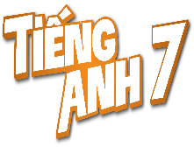
Tiết thứ ......
UNIT 10: ENERGY SOURCES
Lesson 3: A closer look 2

Class | Date of teaching | Attendence
7... | ...../........./202....
7… | ..../......../202...
7…. | ..../......../202....
I. OBJECTIVES: By the end of this unit, students will be able to gain the following things:
1. Knowledge:
Know how to use: THE PRESENT CONTINUOUS

Structure | Examples
1. Affirmative sentences: S + be + Ving | She is playing basketball in the school yard.
2. Negative sentences: S + be not + Ving | They are not using solar energy.
3. Y/N questions: Be + S + Ving? | Are you working on your Project?
4. W questions: W + S + be + Ving? | Where is your brother studying?
2. Competence:
a) General competencies:
Students will be able to know more words and phrases about energy sources; Develop communication skills and creativity; actively join in class activities.
b) Specific competencies:
- Develop communication skills and cultural awareness.
- Be cooperative and supportive in pair work and teamwork.
- Actively join in class activities.
3. Qualities:
- To educate the love of energy sources.
- Be ready to know the words about energy sources.
- Develop self-study skills.
II. PREPARATIONS
- Teacher: Grade 7 text book, laptop, projector / TV/ pictures and cards.....
- Students : Text books, studying equipment….
III. PROCEDURE:
Notes: In each activity, each step will be represented as following:
* Deliver the task.
* Implement the task.
* Discuss.
* Give comments or feedback.
Activity 1. WARM UP (5’-IW, GW)
* Aim:
- To activate students’ knowledge on the topic of the unit
- To enhance students’ skills of cooperating with team mates
* Content:
To have some warm-up activities to create a friendly and relaxed atmosphere to inspire Ss to warm up to the subject and new lesson.
* Product: Having a chance to speak English and focus on the topic of the lesson..
* Implementation:Teacher’s instructions…
Teacher’s & Student’s activities | Content
JUMBLE SENTENCES  * Teacher gives instructions  ** Teacher divides the class into 4 groups. Teacher delivers a set of word cards which are jumble sentences in present continuous to each group.  ** Students will have to work in groups to create as many correct sentences from the word cards as possible. The group with more correct sentences will  Teacher gives feedback, then lead to the new lesson. | Suggested answers:  1. She is learning English now.  2. They are not using solar energy.  3. Are you working on your Project?  4. Where is your brother studying?  5. She is playing basketball in the school yard.
Activity 2. KNOWLEDGE FORMATION (15'- PW, IW)
* Aim:
To introduce students the form of the key grammar and how to use them appropriately
* Content: Teach some new words.
* Product: Knowing more new words. Understanding the conversation; topic of the lesson, grammar points…
* Implementation: Teacher’s instructions…
Teacher’s & Student’s activities | Content
the present continuous  - Teacher says: “This lesson today is going to tell you about “The present continuous”  * Teacher draws students’ attention to the grammar point and the example  . ** Ss read the grammar explicit and study the example.  *** Ss may discuss within groups/pairs before answering.   Teacher shows and says the sentences aloud and asks Ss to make similar sentences. | 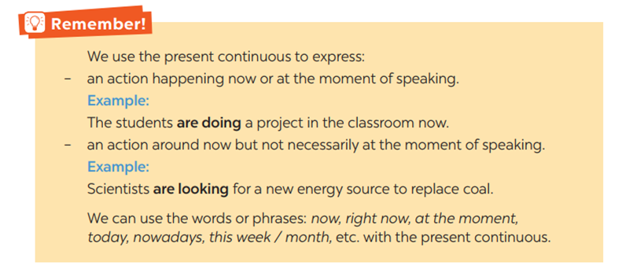
Activity 3. PRACTICE (15’-IW, PW, GW)
* Aim:
- To get students interested in the topic
- To set the context
- To help Ss understand the main idea of the text
- To practise using the present continuous.
- To practise the present continuous
- To practise making sentences using the present continuous
* Product: Ss can learn how to use the present continuous tense to do the exercises.
* Implementation: Teacher’s instructions…
Teacher’s Student’s activities | Content
Task 1. Work in pairs. Tell your partner what the people in the pictures are doing  * Teacher asks Ss to look at the pictures and work in pairs. Teacher asks them how would they ask and answer (using Present continuous)  ** Ss work out and answer questions with a partner.  *** Ss share their answers in pairs.   T asks them to to check their answers.  * Then tell share them to share their sentences as a whole in class and correct for them.  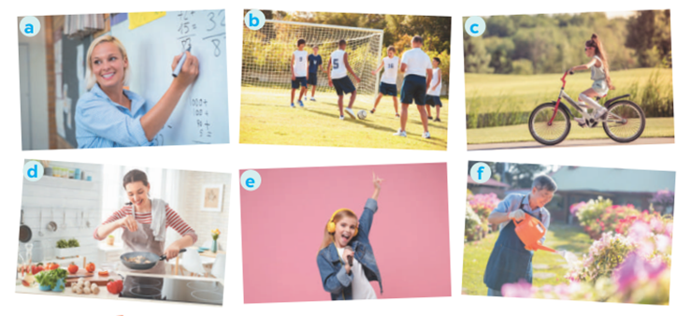 | Task 1. Work in pairs. Tell your partner what the people in the pictures are doing  Answers:  a- She is teaching maths/ is writing on the board.  b- They are play football/soccer.  c- She is riding her bike/bicycle.  d- She is cooking.  c- She is singing.  f- He is watering the flowers/plans/is doing gardening.
Task 2: Complete the sentences, using the present continuous form of the verbs in brackets.  * Teacher asks students to reaf the instructions carefully and do the exercise individually.  ** Ss do exercise then share with their partner.  *** Ss can check and correct for their partner   Teacher corrects their answers as a class.  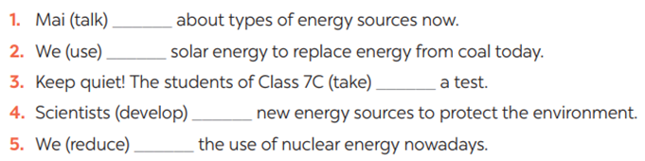 | Task 2: Complete the sentences, using the present continuous form of the verbs in brackets.  Answer:  - is talking  - are using  - are taking  - are developing  are reducing
Task 3: Circle the correct form of the verb in each sentence  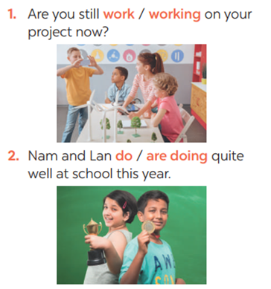  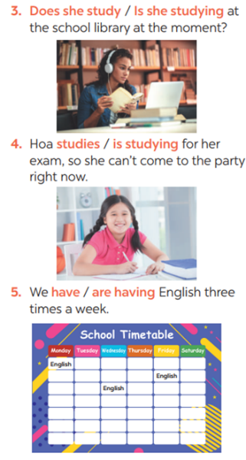  * Teacher asks students questions to make sure students understand the instructions  *** Teacher nominates Ss to read aloud the correct sentences.   Teacher checks and gives the corrections if they have mistakes. | Task 3: Circle the correct form of the verb in each sentence
Task 4: Write sentences about what the people are doing or not doing, using the suggestions.  * Teacher gives Ss time to do the exercise individually and peer check with their partner.  *** Teacher nominates Ss to read aloud the sentences. Then asks them to underline the words/phrases that can be found in Present continuous sentences   Teacher checks and gives the corrections if they have mistakes.  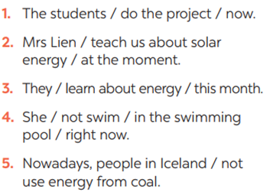 | Task 4: Write sentences about what the people are doing or not doing, using the suggestions.  Answers:  1- The students are doing the project now.  2- Mrs. Lien is teaching us about solar energy at the moment.  3- They are learning about energy this month.  4- She isn’t swimming in the swimming pool right now.  5- Nowadays, people in Iceland aren’t using energy from coal
Activity 4. APPLICATION (7’-IW, PW, GW)
* Aim:
To practise speaking using the present continuous
To help Ss memorise the target language and skills that they have learned
To consolidate what students have learnt in the lesson.
* Content: s +be+ V-ing.
* Product: Ss can know how to use the tense in contexts. Revise and learn more new words.
* Implementation: Teacher’s instructions
Task 5: Work in pairs. Ask and answer the following questions.  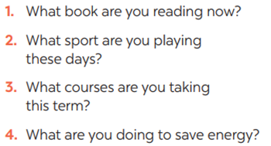  ** Ss work in pairs as instructed. Ss take note while doing the task.   Teacher walks around to give instructions and corrections (if nedded).  ***Teacher calls some students to report their partner’s answers using present continuous. Then gives Ss feedback  - choose some common mistakes and suggest students how to avoid them.  - encourage Ss use present continuous tense freely  - choose some typical errors and correct as a whole class  Consolidation  - The present continuous  * Home assignment  Do exercises in the workbook. | Task 5: Work in pairs. Ask and answer the following questions.  Suggested answers:  * Home assignment  Do exercises in the workbook.
V. FEEDBACK:
With 7 ……………………………………………………………………………..…
With 7…………………………...……………………………………..……………
With 7 ………………………………………………………………………….……

