Full name: .............................................................
School: ..................................................................
Class: .....................................................................
Mark:

End-of-term Test 1 (Semester 2)

Time: 45 minutes
A. WRITTEN TEST (45 minutes; 8 points)
I. LISTENING

(2 points)
Task 1. Listen to Kate and James talking about houses in the future.

Tick (🗸) T (True) or F (False). You will listen TWICE.

 |  | T | F
1. | James wants to live on another planet.
2. | James’ house will have fifteen rooms.
3. | James’ kitchen can give the smell of food.
4. | James’ robot might speak Martian’s language.
Task 2. Listen to Mr. Wilson talking about the Future City competition. Fill in each gap with ONE WORD OR A NUMBER. You will listen TWICE.

FUTURE CITY COMPETITION
Participants | - Grade 6th, 7th, and 8th students  - Compete in (1) teams
Topic | - Living on the (2)
Products | - an essay  - a model of the city  - a (3) plan  - a presentation video
Prize | - a scholarship of (4) $

(2 points)
II. READING
Task 1. Read the text about recycling. Circle the best answer A, B or C.
Recycling is beneficial. First, recycling means less trash, so it saves space in landfills. Second, if we use materials again, we can take fewer resources from the Earth. Third, recycling materials produce less pollution, so it helps to keep our environment clean.
So what can you do? Be sure to recycle everything you can at home and school. Always drop your used aluminum cans and plastic bottles in a recycling bin. Remember to put paper items like the newspaper, cereal boxes, and homework pages into the recycling bin, too. Besides, find creative ways to reuse old items before throwing them away.
Here are some fun facts about recycling. Old paper can be recycled around seven times. Glass is one of the best recycling materials. Clear glass can be recycled over and over again. In 2009, the United States recycled around 30% of all its waste and they found ways to recyle around 7 million tons of metals.
- What is NOT a benefit of recycling?
  - It helps to protect the environment.
  - It saves the Earth’s resources.
  - It makes landfills safer places.
- What can you drop in the recycling bin?
  - Glass bottles.
  - Paper worksheets.
  - Old cereal.
- Which is the best recycling material?
  - Metal.
  - Old paper.
  - Glass.
- What might be the best title for this reading passage?
  - All about recycling
  - Reuse – Reduce – Recycle
  - Advantages and disadvantages of recycling

Task 2. Circle the correct option to complete each blank.
Havana is the capital, and also the largest city (1) Cuba. Havana celebrated its 500th birthday in 2019. There are amazing things to see and (2) in this city. For example, you can visit the National Aquarium and the house of Fuster, a well-known artist in Cuba. He decided to turn his house and the entire (3) into a work of art. Don’t forget to have fun with the street performers. You might even get a free dancing lesson from some local people. Food in Havana is great. Kids might love to try Coppelia Ice Cream and Cuban sandwich. For adults, don’t miss Mojitos and Bucanero Beer, and of course, coffee. It is delicious and a
(4) of daily life here.

1 A. at | B. of | C. on
2 A. do | B. go | C. view
3 A. neighbourhood | B. neighbour | C. area
4 A. thing | B. piece | C. part

(2 points)
III. WRITING
Task 1. Rearrange the sentences. You cannot change the words. Here is an example.
- There/ library/many/ the/ books/ are/ in/.
Answer: 0. There are many books in the library.

- library/ loudly/ speak/ in/ don’t/ the/ .
→ .
- car/ downtown/ An/ yesterday/ ,/ a / and/drove/ it/ rented.
→ .
- might/ do/ you / control/ think / robots/ our world/ future/ in/ the/ ?
→ ?
- one/ largest/ The Mekong River/ of/ the/ the / rivers/ in / is/ world/ .
→ .

Write an email to Linda and tell her about your favourite TV programme. (40-60 words)
You can use the following ideas as cues.
  - What is your favourite TV programme?
  - Which TV channel can you watch it on? When can you watch it?
  - What do you like best about that TV programme?

……………………………………………………………………………………………………………………………………………

……………………………………………………………………………………………………………………………………………

……………………………………………………………………………………………………………………………………………

……………………………………………………………………………………………………………………………………………

……………………………………………………………………………………………………………………………………………

……………………………………………………………………………………………………………………………………………

……………………………………………………………………………………………………………………………………………

……………………………………………………………………………………………………………………………………………

……………………………………………………………………………………………………………………………………………

(2 points)
IV. LANGUAGE FOCUS

Task 1. Choose the word with a different way of pronunciation in the underlined part. Circle A, B or C.

1. A. theatre | B. than | C. think
2. A. contest | B. exercise | C. expensive
3. A. game | B. gateway | C. racket
4. A. grow | B. towel | C. found

Task 2. Put the verbs in brackets in the correct form.
- Refrigerators (be) invented in 1834.
- Space robot can (help) scientists to explore other planets.

- If there is no water, plants (die).
- you (live) on Mars in the future?

Task 3. Choose the best option to complete each sentence. Circle A, B or C.
- When we go out, my dad always carries the bag of all.
  - heavy B. heavier C. heaviest
- I’m writing poem. poem is about 3Rs.
  - a/ The B. a/ A C. an/ The
- Fansipan Peak is than Son Tra Mountain.
  - more high B. higher C. highest
- When you create new products from used materials, you are .
  - recycling B. reducing C. reusing
- My home robot can clothes for me.
  - plant B. water C. iron
- When I have free time, I like to the Internet.
  - go B. surf C. play
- In the future, robots can work as a to keep our house feelings.
  - watch B. guard C. viewer
- If you come to Vietnam, don’t forget to try its street food.
  - tasty B. easy C. helpful

SPEAKING TEST (2 points, approximately 3-5 minutes/ one pair of students)
* Notes: Teacher doesn’t need to ask all questions in task 1.

Task 1. Now let’s talk about your favourite TV programme. Are you ready?
    - Do you like robots? Why/ Why not?
    - What kind of robot will you have in the future?
    - What will your robot look like?
    - What will your robot be able to do?

Task 2: Each of you will now receive a card. On the card there is a picture and clues for five questions. You should use the words to make questions and ask your friends. Your friend will answer the questions based on the picture he/ she has.

Card A  Use the words given below to make questions. Ask your friend about his/ her picture and listen to the answers.  - What/ room?  - How many/ people?  - What/ the woman/ doing?  - What/ in front of/ man?  - What/ kitchen/ your future house/ look like? | 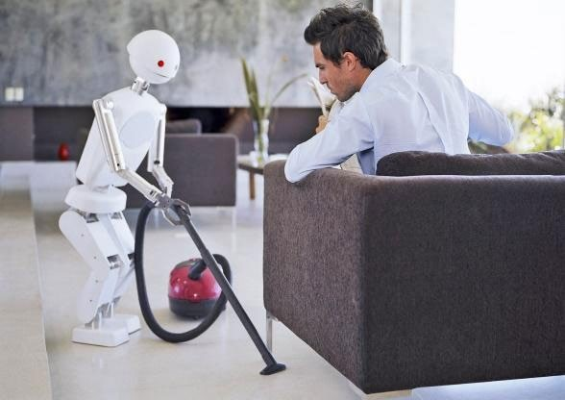  Now, your friends will ask you questions about your picture. Answer his/ her questions.
Card B  Use the words given below to make questions. Ask your friend about his/ her picture and listen to the answers.  - What/ room?  - How many/ people?  - What/ the man/ sitting on?  - What/ the robot/ doing?  - What/you/ think/ robot/ do/ the future? | 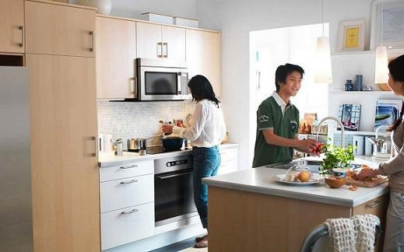  Now, your friends will ask you questions about your picture. Answer his/ her questions.
Giaoandethitienganh.info

