Date of planning: 4/4/2022  Date of teaching: 6/4/2022 | Peroid 87: UNIT 10 : OUR HOUSES IN THE FUTURE  Lesson 6 : SKILLS 2/ Listening and Writing
THIS UNIT INCLUDES:
Vocabulary  - Types of houses and appliances in the house  Pronunciation:  - Stress in two-syllable words.  Grammar  - Future simple.  - Might for future possibility | Skills:  - Reading about houses and appliances in the future  - Talking about different houses in the future.  - Listening to about dream houses  - Writing a paragraph about dream house  Everyday English  Expressing surprise
I. OBJECTIVES: By the end of this lesson, students will be able to gain the following things :
1. Knowledge:
- To teach listening and writing. To develop their listening skills for specific information about their dream houses.Writing a paragraph about dream house.
+ Vocabulary: - Using the words related to types of houses and appliances in the house;
+ Grammar: - The use of future simple and might for future possibility; expressing surprise;
2. Competence: Students will be able to get information about their dream houses.Writing a paragraph about dream house.
3. Quality/ behavior : The love of their own houses and appliances in the house. Having serious attitude to imagining the houses in the future ; Having serious attitude to working in groups, individual work, cooperative learning and working.
II. TEACHING AIDS:
- Teacher: Text book, laptop, louspeaker, projector…
- Students : Text books, studying equipments….
- Work Arrangements: T_Ss , group works; individual ……
III. PROCEDURE:
1. WARM UP & INTRODUCTION (3’-5’)

Aims:
- To develop student’s listening skills for specific information. It also provides input for the writing skills.
* Content: Review the previous leson or have some warm-up activities to creat a friendly and relaxed atmostphere to inspire Ss to warm up to the new lesson. Tell the class about different houses in the future.
* Outcome: Having a chance to speak English and focus on the topic of the lesson..
* Organisation :Teacher’s instructions…

Teacher’s & Student’s activities | Content
+ Greeting  + Revision on the old lesson  - Teacher (T) asks Ss some questions about them and class.  - Invite a few Ss to go to the board and tell the class about different houses in the future.  - Ask Ss to open their book and introduce what they are going to study….  - T leads in the lesson. | + Greeting  + T_ Ss  - Students (Ss) listen and answer the teacher’s or friend’s questions  - Tell about different houses in the future.  - Listen and know what they are going to learn  - Open their book and write the tittle of the lesson
2. PRESENTATION/ NEW LESSON (12’)

ACTIVITY 1: Pre-listening
Aim: To help Ss have the ideas of what the conversation is about.
* Content: Listen and Write the names under correct picture
* Outcome: Ss can get some information the content of the conversation.Choose the correct picture.
* Organisation : Teacher’s instructions…

Teacher’s & Student’s activities | Content
1. Listen to Nick and Linda talking about their dream houses.Which house would each prefers? Write their names under the correct picture.  - T_ Ss  *) Teach vocabulary:  - Teacher uses different techniques to teach vocabulary (situation, realia, translation .....) if have  + Follow the steps to teach vocabulary.  * Ask Ss to look at the pictures and elicit from Ss the details (types of house, surroundings and locations). Ask Ss the houses they like and why they like them.  - Ask Ss to focus on the task they have to do.  - Play the recording. Ask Ss to listen and write the speakers' names under the correct pictures. T checks their answers.  - If it's necessary, play the recording again and pause the recording after each sentence.  - Get feedback. | 1. Listen to Nick and Linda talking about their dream houses. Which house would each prefers? Write their names under the correct picture.  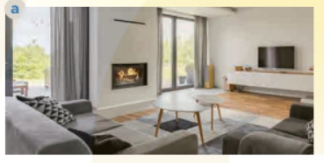  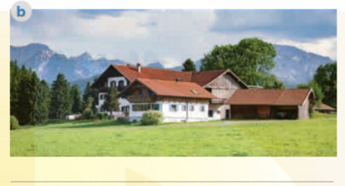    * Key:  Linda: Picture c (a villa by the sea, with a swimming pool and a garden)  Nick: Picture a (a flat in the city)
3. While-listening (18’)

ACTIVITY 2 : While-listening
Aim: To help Ss listen for specific information about dream house.
* Content: Listen conversation and tick the column
* Outcome: To get specific information about dream house.Tick the correct column.
* Organisation : Teacher’s instructions…

Teacher’s & Student’s activities | Content
2. Listen to the conversation again. What is important to Linda? what is important to Nick? Tick (✓) the column.  - Ask Ss to read the information in the first column. Ask them to focus on the information they need only (what are important to Linda and Nick: park view, city view, etc.).  - Play the recording again. Ask Ss to listen and tick what are Important to Linda and Nick.  - Call on some Ss to give the answers to the class and correct mistakes where necessary.  - Check and confirm the correct answers. | 2. Listen to the conversation again. What is important to Linda? what is important to Nick? Tick (✓) the column.  - T_ Ss  - Listen to the teacher’s instructions carefully and learn how to do it.  - Fulfil the tasks  - Give the answers  Key:  Linda: sea view, swimming pool, garden  Nick: park view, city view
ACTIVITY 3 :
Aim: To help Ss listen for specific information about dream houses.
* Content: Listen again and answer the questions about dream houses.
* Outcome: Listen and answer the questions correctly.
* Organisation : Teacher’s instructions…

3. Listen again and answer the questions abot their drean houses.  - Ask Ss to read the questions and underline the key words. Then have them listen to the recording again to answer the questions in pairs or groups.  - Ask a few pairs to role-play in front of the class, one asks the questions and the other answers. Other pairs and T listen and comment.  * Post - listening  Extension: Have some Ss talk about dream houses of Linda or Nick, using the information in 2 and 3.  E.g. Hi. Let me tell you about Linda's dream house. It is a big villa by the sea. It has a view of the sea. There's a swimming pool and a garden around her house... Thank you for listening.  * T may give some clues  - Call on some Ss to speak freely.  - Correct pronunciations, grammar, vocab, intonation. | 3. Listen again and answer the questions abot their drean houses.  - T_ Ss  - Listen carefully to the instructions  - Work individually  * Ss learn how to do the tasks  - Ss’ answers  Key:  1. She has a big villa.  2. Her house / It is by the sea.  3. There's a swimming pool and a garden around her house.  4. He has a flat.  5. It's in the city.  Audio script:  Nick: Can you tell me about your dream house, Linda?  Linda: Well, it's a big villa by the sea. It has a view of the sea. It has a swimming pool and a garden.  Nick: My dream house is different.  Linda: Really? What's it like?  Nick: It's a beautiful flat in the city. It has a parkview in front and a city view at the back.  Linda: Oh, sounds great!  Nick: It has a super smart TV. I can watch films from other planets.  Linda: That sounds great, too. But I think it'll be ….
ACTIVITY 4: Pre - Writing
Aim: to help Ss brainstorm ideas for a dream house.
* Content: Group work to discuss the dream houses and fill the table.
* Outcome: Discussing and Fill the tables correctly.
* Organisation : Teacher’s instructions…

Teacher’s & Student’s activities | Content
4. Work in pairs. Discuss your dream house, and fill the table.  - Have Ss look at the table. Draw their attention to the four pieces of Information. Then have them read the exchange in the example to understand how to do the task.  - Ask Ss to work in pairs to ask and answer the questions and fill the table.  - Call a student to write the answer on the board.  - Others write it in their notebooks.  - T and other Ss listen and make comments. | 4. Work in pairs. Discuss your dream house, and fill the table.  - Work in pairs  - Listen carefullyand learn how to write  - Write themselves  *Sample:  A. What type ofdream house is it?  B. It’s a palace  A. Where it is?  B. It’s in the mountain.  …………..
4. APPLLICATION (8’-10’)

ACTIVITY 5: While - Writing
Aim: To help Ss write a paragraph of about 50 words about a dream house.
* Content: Write a paragraph of about 50 words about your dream house.
* Outcome: Use information in 4 Ss can write a paragraph about your dream house.
* Organisation : Teacher’s instructions…

Teacher’s & Student’s activities | Content
5. Use information in 4 to write a paragragh of about 50 words about your dream house.  - Allow Ss time to write a paragraph (about 50 words) about their dream houses, using the suggested ideas / information in 4.  - When they finish, ask some Ss to explain their dream houses to the class.  - If time allows, call on one student to write his / her answer on the board.  - The class gives their comments.  * Post writing  - T may display all or some of the Ss' writings on the wall / notice board. T and other Ss give comments. Ss edit and revise their writing as homework.  * Post - Writing  - T may collect some Ss'writings and mark them, then give comments to the class. - Remember to tell them how to improve their writings.  - If time is limited,T may ask Ss to write the final version at home.  - Other Ss and T comment on the writing. | 5. Use information in 4 to write a paragragh of about 50 words about your dream house.  - Listen carefully and learn how to write  - Write themselves/ individually  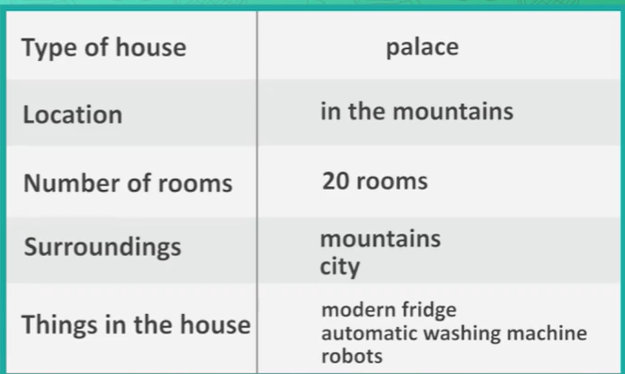  * Sample paragraph:  My dream house is a big palace. It is in the mountains. It is surrounded by lots of trees. It has seven rooms: three bedrooms, two bathrooms, one kitchen and one living room. There is a large swimming pool in front of it. I have some robots in the palace. They help me to clean the floor, cook meals, water flowers...  I am happy to live in my palace
5. WRAP-UP & HOME WORK (2’)

* Have Ss summarise what they have learnt with the two skills.
* HOME WORK.
- Finish writing a diary entry. Copy in the note books.
- Do more exercises in workbook.
- Prepare new lesson.

=========================

