UNIT 8: FESTIVALS AROUND THE WORLD
Lesson 7: Looking back & Project

I. OBJECTIVES
By the end of this lesson, Ss will be able to gain:
1. Knowledge
Review the vocabulary and grammar of Unit 9
Apply what they have learnt (vocabulary and grammar) into practice through a project
2. Core competence
- Develop communication skills and creativity
- Develop presentation skill
- Develop critical thinking skill
- Be collaborative and supportive in pair work and team work
- Actively join in class activities
3. Personal qualities
- Be more creative when doing the project
- Develop self-study skills

II. PREPARATIONS
1. Teacher
- Grade 7 textbook, laptop, TV/Projector/ pictures and cards, speakers, lesson plan, sachmem.vn…
2. Students
- Grade 7 textbook, notebooks, school things….
III. TEACHING PROCEDURES
ACTIVITY 1 – WARM – UP & INTRODUCTION (5’)
a) Aims:
- To revise the vocabulary related to the topic and lead in the next part of the lesson.
- To enhance students’ skills of cooperating with team mates.
b) Contents: Play the game “Brainstorming”
c) Products: Type of festival
d) Teaching steps:
Teacher’s and students’ activities | Content
* Teacher divides the board, and divides the class into 2 teams.  ** Members of each team take turns and write as many types of festivals as possible in 2 minutes.  *** Students cross check their answers first.   Teacher confirms the answers and gives feedback. The group having more correct answers is the winner. | Brainstorming  Type of festivals
ACTIVITY 2 – PRESENTATION (5’)
a) Aims:
- To revise the language focus that students have learnt in Unit 9
b) Content: Complete the chart about language learnt in Unit 9
c) Products: the chart about language learnt in Unit 9
d) Teaching steps:
Teacher’s and students’ activities | Content
*Teacher shows an unfinished chart which summarizes the language that students have learnt in Units 9  - Teacher asks Ss to complete the chart individually.  **Ss do the task and complete the chart  ***Teacher calls some Ss share their answers.  - Ss give their answers   Teacher checks and corrects | 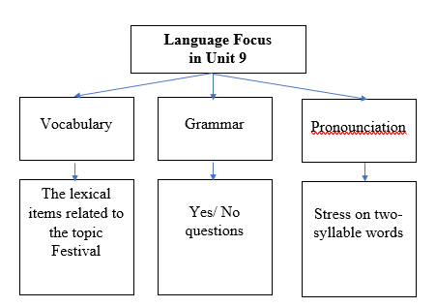  I – LOOKING BACK
ACTIVITY 3 – PRACTICE (15’)
a) Aims:
- To help students revise vocabulary items they have learnt in the Unit 9.
- To help students revise Yes/No questions.
b) Contents:
- Circle the correct words or phrases in brackets
- Complete each sentence by filling in the blank with a word or phrase in the box
- Choose the correct question A or B
- Answer the following questions about yourself.
c) Products:
- Answer key
d) Teaching steps:
Teacher’s and students’ activities | Content
* Teacher encourages students to complete the task individually.  ** Students do the task individually.  *** Students exchange their textbooks with their partners.   Teacher gives feedback as a class discussion.  * Teacher encourages students to complete the task individually.  ** Students do the task individually.  *** Students exchange their textbooks with their partners.   Teacher gives feedback as a class discussion.  * Teacher encourages students to complete the task individually.  ** Students do the task individually.  *** Students exchange their textbooks with their partners.   Teacher calls some Ss to read aloud their answers and gives feedback.  * Teacher encourages students to complete the task individually.  ** Students do the task individually.  *** Students share their answer in groups of 3 of 4.   Teacher calls some Ss to read aloud their answers and gives feedback. | VOCABULARY  Task 1: Circle the correct words or phrases in brackets (p.100)  Answer key:  1. fireworks  2. Cannes Film Festival  3. painting  4. candy apples  5. Thanksgiving  Task 2: Complete each sentence by filling in the blank with a word or phrase in the box (p.100).  Answer key:  1. lion dances  2. floats  3. costumes  4. Bunny  5. gathering  GRAMMAR  Task 3: Choose the correct question A or B (p.100).  Answer key:  1. A  2. B  3. A  4. B  5. B  Task 4: Answer the following questions about yourself.  1. Are you interested in festivals?  2. Do you eat banh chung at Tet?  3. Can you cook any traditional food?  4. Did you see fireworks display last year?  5. Does your family gather together at Tet?
ACTIVITY 4 – PRODUCTION (13’)
a) Aims:
- To allow students to apply what they have learnt (vocabulary and grammar) into practice through a project.
- To develop teamwork skills
- To give students authentic practice in using target language
b) Contents:
- Posters exhibition
c) Products:
- Ss’ posters
d) Teaching steps:
Teacher’s and students’ activities | Content
* Teacher has students work in groups and gives instructions to students as follow:  1. Choose one of your favourite festivals and design a poster for it, including:  – name of the festival  – the time/ place it takes place  – its meanings  – its activities  – pictures or photos to illustrate the festival  2. Organise them into an exhibition.  3. Vote for the best poster.  * Students do the project in groups.  *** Students vote for the best poster.   Teacher gives feedback. | PROJECT  Posters exhibition  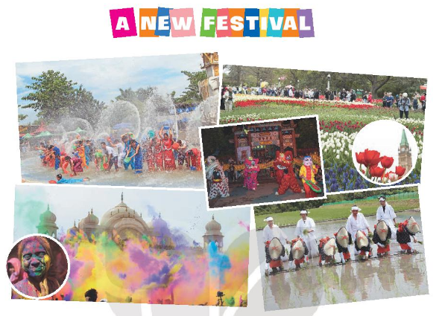
IV. WRAP-UP & HOMEWORK (2’)
- Teacher asks students to talk about what they have learnt in the lesson.
- Prepare for the next lesson: Unit 10 – Lesson 1. Getting started.
V. FEEDBACK

……………………….…, ngày………….tháng…………..năm 2022
Duyệt của Tổ chuyên môn

