School: ……………………………………….. | Date: ………………………………
Class: ……………………………..................... | Period: ……………………….........

UNIT 6: LIFE ON OTHER PLANETS
Lesson 3.1 – Reading & Writing (pages 62 & 63)

I. OBJECTIVES
By the end of the lesson, Ss will be able to ….
1.1. Language knowledge and skills
- practice reading for specific information.
- write narrative passages.
1.2. Competences
- improve Ss’ communication, collaboration, and critical thinking skills.
1.3. Attributes
- be aware of what will happen in the future.
II. TEACHING AIDS AND LEARNING MATERIALS
1. Teacher’s aids: Student book and Teacher’s book, class CDs, Digital Book (DCR phần mềm tương tác SB, DHA (từ vựng/ cấu trúc) phần mềm trò chơi tương tác), projector/interactive whiteboard / TV (if any), PowerPoint slides.
2. Students’ aids: Student’s book, workbook, notebook.
III. ASSESSMENT EVIDENCE
Performance Tasks | Performance Products | Assessment Tools
- Let’s Talk: What is happening in the picture? Do you think there are aliens? Why (not)?  - Watch a video and answer the questions. | - Ss’ answers / presentation.  - Ss’ answers. | - T’s feedback/Peers’ feedback.  - T’s feedback/Peers’ feedback.
- Reading: Read the blog post. Do Andy and his brother agree about what they saw? | - Ss’ answers. | - T’s feedback/Peers’ feedback.
- Read and circle True, False, or Doesn't say.  - Speaking: What do you think Andy and his brother really saw? Why? | - Ss’ answers.  - Ss’ answers. | - T’s feedback/Peers’ feedback.  - T’s feedback/Peers’ feedback.
- Writing: Read about writing narrative passages and read the blog again and underline three sentences. | - Ss’ answers. | - T’s feedback/Peers’ feedback.
- Reorder the narrative passage. | - Ss’ answers. | - T’s feedback/Peers’ feedback.

IV. PROCEDURES
A. Warm up: (5’)
a) Objective: Introduce the new lesson and set the scene for Ss to acquire new language; get students' attention at the beginning of the class by giving enjoyable and short activities as well as to engage them in the follow-up steps.
b) Content: Reading information of seeing UFOs and aliens.
c) Expected outcomes: Ss have general ideas about the topic “Life on other planet”, which they are going to read and write in the new lesson.
d) Organization of the activity:
TEACHER’S ACTIVITIES | STUDENTS’ ACTIVITIES
* OPTION 1: Let’s Talk!  What is happening in the picture?  Do you think there are aliens? Why (not)?  - Use the part “Let’s talk!” in the textbook– page 62 for warm-up activity.  - Ask Ss to work in pairs to answer the questions  - Divide the class into pairs.  - Have Ss discuss the questions.  - Elicit answers from some Ss.  - Call Ss to share their answers with the whole class.  - Give feedback.  - Lead to the new lesson. | - Work in pairs to discuss.  - Present.  - Share the answers.
* OPTION 2:  - Have Ss watch a video about Are Aliens Real?.  https://www.youtube.com/watch?v=Smeg1KUa3qU  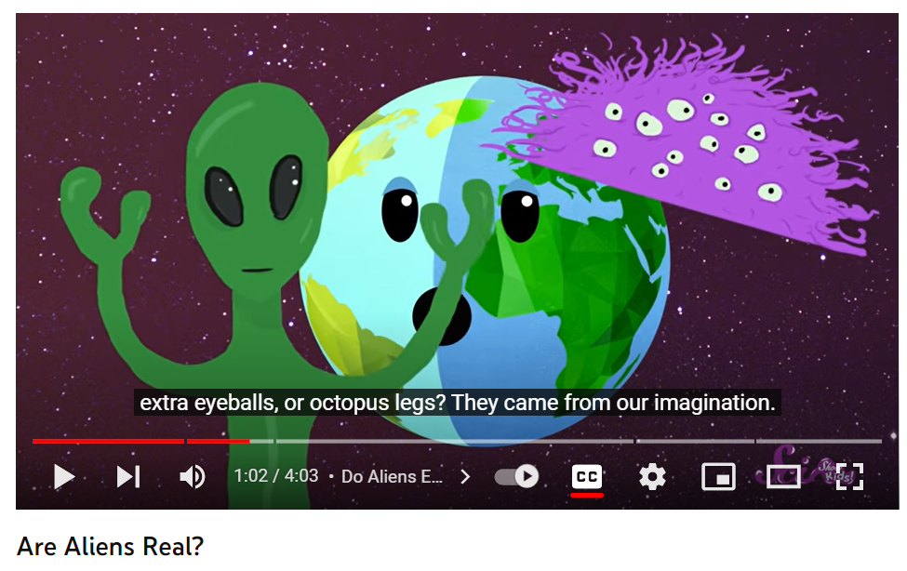 - Ask Ss some questions:  - Do you think aliens are real?  - What are other planets for humans to live?  - Is there any planet with much oxygen as Earth?  - Call Ss to give answers.  - Give feedback and lead to the new lesson. | -Watch a video and answer the questions.  - Answer the questions

B. New lesson (35’)
- Activity 1: Reading (17’)
a) Objective: Students can develop their reading skill.
b) Content: Practicing reading and writing on seeing UFOs and aliens.
- Read the blog post. Do Andy and his brother agree about what they saw?
- Read and circle True, False, or Doesn't say.
- Speaking: What do you think Andy and his brother really saw? Why?
- Underline three sentences Andy used to describe what he saw, heard, and felt.
- Reorder the narrative passage.
c) Expected outcomes: Students can practice reading and understanding general and specific information of UFOs and aliens.
d) Organization of the activity:
TEACHER’S ACTIVITIES | STUDENTS’ ACTIVITIES
*Pre-reading:  Task a. Read the blog post. Do Andy and his brother agree about what they saw?  - Have students read the question.  - Explain the word hover.  Hover /ˈhʌ.vɚ/ (v) to stay in one place in the air, usually by moving the wings quickly (bay lượn)  - Have students read the blog post and circle the correct answer.  - Check the answer as a whole class.  *While-reading:  Task b. Now, read and circle True, False, or Doesn’t say.  - Have Ss read the sentences and then underline the key words in each sentence.  - Have Ss reads the blog post and circle True, False, or Doesn’t say.  * Remind Ss of reading techniques for T/F/DS:  - Ss must search the text for answers and mention relevant sections of the text.  - Ss will check if the questions are in the same order as information in the text.  - Ss won’t use their own knowledge and opinions of the subject and make a decision based only on what the text says, or doesn’t say.  - Have Ss check their answers with a partner.  - Check answers as a whole class.  - Give feedback.  Tasks c. Listen and read.  - Have Ss listen to the audio and read along.  - Give feedback.  *Post-Reading:  Task d. Speaking: In pairs: What do you think Andy and his brother really saw? Why?  - Play audio. Have students listen and read.  - Have Ss discuss the questions in pairs.  - Elicit answers from some Ss.  - Call some Ss to share their answers with the whole class.  - Give feedback. | - Read the question.  - Read the text and choose the correct answer.  - Give answer and explain.  Answer keys  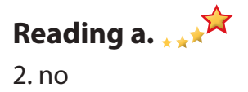  - Read, identify and underline the key words.  - Read and answer the questions.  - Exchange answers.  - Give answers.  Answer keys  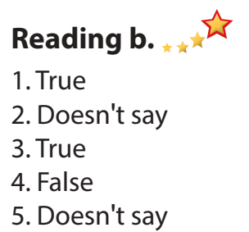  - Listen to the audio and read along.  - Discuss in pairs.  - Present.  Suggested answer  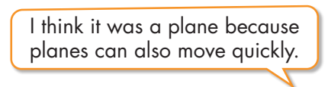

- Activity 3: Writing (18’)
a) Objective: Students can develop their writing skill.
b) Content: Reading the text and Writing skill box and reordering the passage.
- Read about writing narrative passages and the blog again underlining three sentences Andy used to describe what he saw, heard, and felt.
- Reorder the narrative passage, using Writing skill box.
c) Expected outcomes: Students can gain writing skills by working with the narrative passages.
d) Organization of the activity:
TEACHER’S ACTIVITIES | STUDENTS’ ACTIVITIES
Task a. Read about writing narrative passages. Then, read the blog again and underline three sentences Andy used to describe what he saw, heard, and felt.  - Have Ss read the Writing Skill box and Andy's blog again and underline three sentences Andy used to describe what he saw, heard, and felt.  - Have Ss check their answers with a partner.  - Check answers as a whole class.  - Give feedback.  Task b. Reorder the narrative passage below. Use the skill box to help you.  - Have Ss read the sentences.  - Have Ss order the sentences.  - Have Ss check their answers with a partner.  - Check answers as a whole class.  - Give feedback. | - Read the box and the text, underlining the sentences for details.  - Give answer.  Answer keys  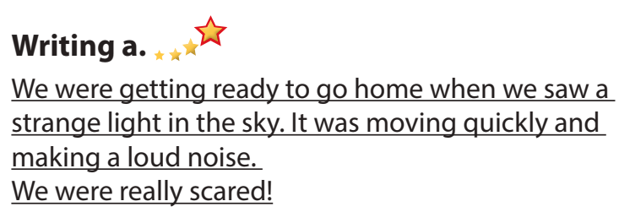  Answer keys  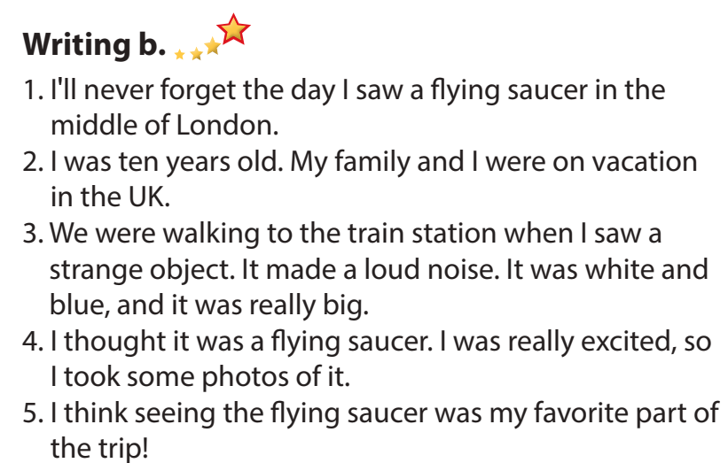
C. Consolidation and homework assignments (5’)
*Consolidation: Reading the subject of UFOs and aliens regarding True, False and Doesn’t say. Reading about writing narrative passages and reordering.
Complete the sentences using words used to describe what the author saw, heard, and felt.
- We were walking to the train station when I _____ a strange object. It made a loud _____.
- I think ______ the flying saucer was my favorite part of the trip!
- It was white and blue, and it ______ really big.
- I thought it was a flying saucer. I was really _____, so I took some photos of it.
Answer keys:
- saw – noise
- seeing
- was
- excited
*Homework
- Do the exercises in WB: Listening and Reading (page 36).
- Do the exercises in Tiếng Anh 8 i-Learn Smart World Notebook (page 52).
- Play the consolidation games in Tiếng Anh 8 i-Learn Smart World DHA App on www.eduhome.com.vn
- Prepare: Unit 6 - Lesson 3 – Speaking and Writing (page 63 – SB).

V. Reflection
a. What I liked most about this lesson today:
…………………………………………………………………………………………
- What I learned from this lesson today:
…………………………………………………………………………………………
c. What I should improve for this lesson next time:
…………………………………………………………………………………………

