|  |  |
| --- | --- |
| SỞ GDĐT TỈNH BÀ RỊA VŨNG TÀU **TRƯỜNG THPT CHUYÊN LÊ QUÝ ĐÔN** -------------------- | **HƯỚNG DẪN CHẤM ĐỀ KIỂM TRA CHUYÊN ĐỀ LẦN I NĂM HỌC 2024 - 2025 MÔN: HÓA HỌC – LỚP 12** |

**PHẦN I**

|  |  |  |  |  |  |  |  |  |  |  |  |  |  |  |  |  |  |  |
| --- | --- | --- | --- | --- | --- | --- | --- | --- | --- | --- | --- | --- | --- | --- | --- | --- | --- | --- |
| **Đề\câu** | **1** | **2** | **3** | **4** | **5** | **6** | **7** | **8** | **9** | **10** | **11** | **12** | **13** | **14** | **15** | **16** | **17** | **18** |
| **101** | D | C | A | C | C | C | D | C | B | A | A | C | B | A | C | B | D | B |
| **102** | C | D | B | B | A | B | A | C | C | C | A | B | D | B | D | B | D | B |
| **103** | D | D | B | C | A | B | B | B | A | D | C | D | A | B | B | D | B | A |
| **104** | C | B | A | B | D | D | D | B | D | D | D | C | D | C | C | B | C | C |

**PHẦN II**

|  |  |  |  |  |  |  |  |  |  |  |  |  |  |  |  |  |
| --- | --- | --- | --- | --- | --- | --- | --- | --- | --- | --- | --- | --- | --- | --- | --- | --- |
| **Đề\câu** | **1a** | **1b** | **1c** | **1d** | **2a** | **2b** | **2c** | **2d** | **3a** | **3b** | **3c** | **3d** | **4a** | **4b** | **4c** | **4d** |
| **101** | S | D | D | D | D | S | S | S | D | D | S | D | D | S | D | S |
| **102** | D | S | S | S | S | D | D | D | D | D | S | D | D | S | D | S |
| **103** | D | S | S | S | D | D | S | D | D | S | D | S | S | D | D | D |
| **104** | D | D | S | D | S | D | D | D | D | S | S | S | D | S | D | S |

**PHẦN III**

|  |  |  |  |  |  |  |
| --- | --- | --- | --- | --- | --- | --- |
| **Đề\câu** | **1** | **2** | **3** | **4** | **5** | **6** |
| **101** | 1,38 | 16,2 | 12 | 76,5 | 21,7 | 3 |
| **102** | 1,38 | 12 | 16,2 | 76,5 | 3 | 21,7 |
| **103** | 76,5 | 16,2 | 3 | 21,7 | 12 | 1,38 |
| **104** | 3 | 76,5 | 1,38 | 21,7 | 16,2 | 12 |

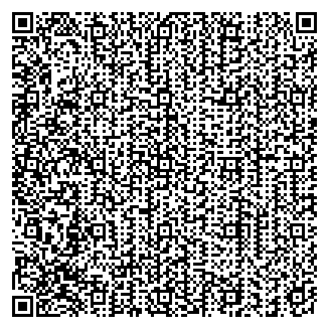

Tài liệu được chia sẻ bởi Website VnTeach.Com

https://www.vnteach.com