ĐỀ SỐ 09
Thời gian làm bài: 120 phút

SECTION A: LISTENING (20 points)
Part I. There are 5 questions in this part, for each question there are 3 pictures and a short recording. Choose the correct picture. Write in capital letters A, B or C in the answer box. (5 points)
1. What music will they have at the party?
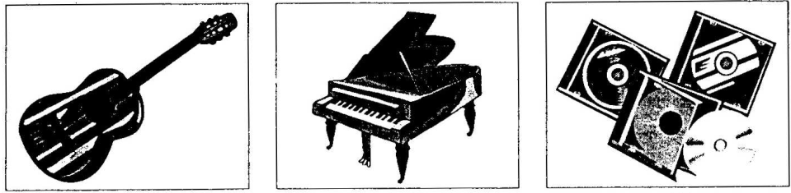
A | B | C
2. When will the man go on holiday?

A | B | C
3. What will the weather be like tomorrow?
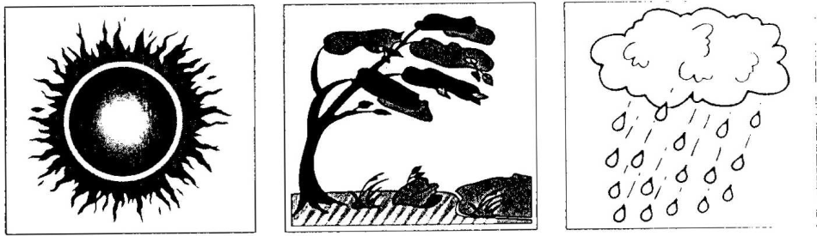
A | B | C
4. What colour is Mary’s coat?

A | B | C
5. What job does Mark’s brother do?
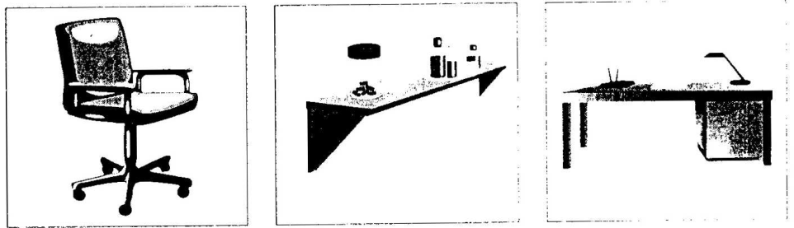
A | B | C
Part II. Listen to Paul talking to a friend about his family. What does each person do? Match the person with the job you hear. (6 points)
PEOPLE | JOB
1. Sally  | A. bank clerk
2. Bill | B. doctor
3. David | C. teacher
4. Paul’s mother | D. student
5. Paul’s father | E. writer
6. Paul | F. stopped worker
Part III. Listen to Philip talking to a friend about his photography course. Choose the correct answer (A, B or C) for each space. (9 points)
1. Where does Philip do the photography classes?
A. Park College B. City College C. South College
2. What time do the photography classes begin?
A. 5.15 p.m. B. 6.00 p.m. C. 6.45 p.m.
3. How much does Philip pay for the photography course?
A. 55 pounds B. 75 pounds C. 95 pounds
4. Philip’s happy with the course because he’s __________.
A. learning about famous photographers
B. using a new camera
C. getting better at photography
5. Philip thinks it’s easy to take photographs of __________.
A. trees B. animals C. children
6. After the course Philip will __________.
A. buy a new camera
B. get a job in photography
C. make photography his hobby
SECTION B: PHONETICS (10 point)
Part I. Choose the word whose underlined part is pronounced differently from the rest. (5 pts)
1. A. other B. leather C. wealthy D. brother
2. A. television B. elephant C. section D. Swedish
3. A. explain B. current C. desire D. electric
4. A. threaten B. thread C. seat D. bread
5. A. deaf B. leaf C. meat D. heat
Part II. Choose the word that has a different stress pattern from the others in the group. (5 points)
1. A. affect B. pollute C. effect D. litter
2. A. cholera B. pollutant C. permanent D. ground water
3. A. radiation B. political C. historical D. contaminant
4. A. seriously B. measurement C. scientific D. logical
5. A. aquatic B. historic C. physic D. botanical
SECTION C: LEXICO AND GRAMMAR (80 points)
Part I. Choose the word, phrase or expression which best completes each sentence. (20 points)
1. It’s recommended that we become more concerned _________ the environment around us.
A. of B. to C. with D. about
2. Air _________, together littering, is cause many problems in our cities today.
A. pollute B. pollution C. polluted D. polluting
3. On Christmas Eve, most big cities, especially London are _________ with coloured lights across the streets and enormous Christmas trees.
A. decorated B. hang C. put D. made
4. In the United, there are 50 _________ and six different time zones across the country.
A. states B. nations C. towns D. show
5. Nowadays you still see the _________ men wear kilts (skirts) to wedding or other formal occasions.
A. Scot B. Scotland C. Scots D. Scottish.
6. What _________ we do to prevent these natural disasters?
A. may B. ought C. should D. be able
7. _________ at someone is usually considered rude.
A. Point B. To point C. To pointing D. Pointing
8. My father shouted at me, _________ made me feel sorrowful.
A. that B. who C. whose D. which
9. I believe that our new manager has the _________ to work well in this business environment.
A. inflexible B. flexibly C. flexibility D. flexible
10. “Are Mary and Peter still living in Paris?” - “No, they _________ to NewYork.”
A. are just moved B. had just moved
C. have just moved D. will just move
11. “What is the _________ of the USA?” - “The dollars.”
A. current B. population C. territory D. currency
12. We can see many international programs _________ different channels.
A. in B. at C. on D. of
13. This hat is different _________ the one I had.
A. for B. to C. from D. at
14. What will happen if the pollution _________ on.?
A. puts B. goes C. keeps D. takes
15. He said he was afraid this article was _________ date.
A. over B. on C. behind D. out of
16. I had to get up early, _________ I would miss the train.
A. otherwise B. if not C. but D. unless
17. Most young people want to _________ more about environmental problems.
A. look after B. find out C. look for D. make out
18. _________ always gives me real pleasure.
A. I arrange flowers B. The flowers are arranged
C. Arranging flowers D. While arranging flowers.
19. Nga had difficulties in bringing the heavy box, and Mai, her friend, offered to help. Mai: “Need a hand with your heavy box, Nga ?” - Nga: “_________”
A. I don’t need B. Not at all
C. That’s very kind of you D. No, thanks
20. Peter: “_________?” - Mary: “Well, I’d like to see that dress.”
A. Do you want anything B. May I help you
C. What would you like D. What do you want to do

Part II. Give the correct form of the words to complete the following sentences. (20 points)
John watched a (1. document) ______________________ on TV last night. It was all about the problems (2. threaten) ______________________ our environment. He was shocked to find out how little he knew about (3. globe) ______________________ warning or acid rain. He had heard the term before but he knew (4. practical) ______________________ nothing about the damage they cause to our planet. He feels he should do something to be (5. help) ____________________. He would like to join an (6. organize) ______________________, but he doesn't know which one to join. He has seen so many (7. advertise) ______________________ in newspapers that he can't make up his mind. However, he believes that it is (8. acceptable) ______________________ not to be environmentally aware and he is (9. hope) ______________________ that one day everyone will be part of a world movement to save the earth. He was sure that in this time of (10. technology) ______________________ advances, we find some way to solve the world's problems.

Part III. Identify the mistake in each sentence below by circling the capital letter. (20 points)
1. It was wrong with (A) you to allow (B) a 4 year-old (C) child to walk (D) home alone.
2. The Smiths are very proud about (A) that their (B) son always gets high marks in (C) his courses (D).
3. We called the baseball park up (A) to ask that (B) when the game was scheduled (C) to begin that afternoon (D).
4. The American Indians killed (A) the buffalo only (B) when necessity (C) to obtain food, clothing (D) and shelter.
5. Some relatives of mine (A) like staying (B) at their cabin on (C) Lake Omega every summer holidays (D).
6. In the United States among (A) 60 percent of the space (B) on the pages of newspapers is reserved (C) for advertising. (D)
7. Gilbert Newton Lewis, a (A) chemist, helped to develop (B) the modem electron theory of valence, a theory explains (C) the forces holding atoms together (D) in molecules.
8. Because of a high birthrate (A) and considered (B) immigration, the United States population in (C) the late nineteenth century increased (D) tremendously from 31 million in 1860 to 76 million in 1900.
9. For most of their (A) history, especially (B) since the (C) 1860's, New York City has been undergoing major ethnic population changes (D).
10. Rocks have forming (A), wearing away (B) and re-forming ever since (C) the Earth took (D) shape.
Part IV. Give the correct tense or form of the verbs in brackets. (20 points)
1. The classroom is still very dirty. I don’t think it (clean) ______________.
2. (Lie) ______________ on the beach on a sunny day is pleasant.
3. After (shout) ______________ for help, she (take) ______________ off her shoes and (jump) ______________ in (save) ______________ him.
4. Once you (try) ______________ Gloswhite toothpaste, you (never use) ______________ anything else.
5. (Write) ______________ the letter, she put it in an envelope.
6. Each July, George together with his family (go) ______________ to Spain for holiday.
SECTION D. READING COMPREHENSION (40 points)
Part I. Fill in each gap with ONE suitable word to complete the following paragraph. (20 points)
Our classes take place for three hours every morning from Monday (1) ________________ Friday. The maximum class size is twelve (2) ________________ the average is ten. We use modem methods of (3) ________________ and learning, and the school has a language laboratory, a video camera and recorders. However, you will only be successful in improving (4) ________________ English if you work hard and (5) ________________ speaking English as much as you can. You will take a short (6) ________________ in English as soon as you arrive. In this way, we can put you in a (7) ________________ at the most suitable level.
There are two classes at the Elementary level; one is for complete beginners and the other is for students who know only a little English. In both classes you will practise simple conversations. In the class (8) ________________ the intermediate level you will have a lot of practice in communication in real-life situations because we help you to use the English you have previously (9) ________________ in your own country, You will also have chances to improve your (10) ________________ of English grammar and to build up your vocabulary.
Part II. Choose the correct answer A, B, C, D that best fits each of the blank spaces. (10 points)
Around the age (1) ________________ sixteen, you must make one of the biggest decisions of your life. Do I stay on at school and hopefully, go on to university later? Do I leave and start work or beginning a training (2) ________________?
The decision is yours, but it may be (3) ________________ remembering two things: There is more unemployment (4) ________________ those who haven’t been to university, and people (5) ________________ have the right skills will have a big advantage in the competition for jobs. If you decide to go straight into a job, there are (6) ________________ opportunities for training. Getting qualifications will (7) ________________ you get on more quickly in many careers, and evening classes allow you to learn (8) ________________ you earn. Starting work and taking a break to study when you are older is (9) ________________ possibility. This way, you can save up money for your student days, as well as (10) ________________ practical work experience.
1. A. at | B. in | C. on | D. of
2. A. school | B. class | C. course | D. term
3. A. worth | B. necessary | C. important | D. useful
4. A. between | B. among | C. with | D. through
5. A. whom | B. which | C. who | D. whose
6. A. much | B. many | C. little | D. few
7. A. permit | B. help | C. let | D. give
8. A. where | B. while | C. when | D. what
9. A. also | B. again | C. another | D. always
10. A. getting | B. making | C .taking | D. doing
Part III. Read the passage below and choose the correct answer A, B, C or D. (10 points)
THE GREAT HANSHIN EARTHQUAKE
The Great Hanshin earthquake, or the Kobe earthquake as it is more commonly known overseas, was an earthquake in Japan that measured 7.3 on the Japan Meteorological Agency magnitude scale. It occurred on January 17th, 1995 at 5:46 a.m. in the southern part of Hyõgo Prefecture, and lasted for approximately 20 seconds. The epicentre of the earthquake was on the northern end of Awaji Island near Kobe, a cosmopolitan city of over 1.5 million people. A total of 6,434 people, mainly in the city of Kobe, lost their lives. Additionally, it caused approximately ten trillion yen in damage. It was the worst earthquake in Japan since the Great Kantõ earthquake in 1923, which claimed 140,000 lives.
1. The word “overseas” in the text is closest in meaning to ________________.
A. abroad B. at sea C. by sea
2. The word “occurred” in the text is closest in meaning to ________________.
A. ended B. happened C. started
3. It is stated in the passage that the number of deaths in the city of Kobe ________________.
A. was greater than that of the Great Kantõ earthquake
B. was not as high as in the Great Kantõ earthquake
C. exceeded that of any known earthquake
4. The northern end of Awaji Island was the place where ________________.
A. the effects of the earthquake were felt most strongly
B. there was no damage to people and property
C. 1.5 million people lost their lives
5. We understand from the passage that the Kobe earthquake ________________.
A. is internationally known as the Great Hanshin earthquake
B. didn’t cause any damage in the neighbourhood of Kobe
C. is not the deadliest earthquake in the history of Japan.
SECTION E: WRITING (50 points)
Part I. Finish each of the following sentences in such a way that it means exactly the same as the sentence printed before it. (10 points)
1. The match couldn’t start because of the heavy snow.
The heavy snow
2. My mother was a worker in a factory when she was young.
My mother used
3. You can improve your English by practicing speaking every day.
If
4. “I really must leave now,” Mr. Fatt said.
Mr. Fatt insists
5. It often took my mom half an hour to get to work by underground every morning last month.
My mom spent
Part II. Rewrite each of the following sentences so that it means exactly the same as the given one. Using the given word in brackets. Do not change the word. (10 points)
1. I’m not you, but I think you should recycle these plastic carrier bags. (if)
________________________________________________________________________________________________
2. Emma came first because she worked hard. (result)
________________________________________________________________________________________________
3. Eating too much sugar can result in health problems. (lead)
________________________________________________________________________________________________
4. All flights had to be cancelled as a result of the pilots’ sudden strike. (so)
________________________________________________________________________________________________
5. If I could swim, I would go scuba diving with Terry. (because)
________________________________________________________________________________________________
Part III. Writing a passage. (30 points)
In 150 - 180 words, write a passage about “the importance of learning English and suggest some effective ways that help us learn English well”.
________________________________________________________________________________________________
________________________________________________________________________________________________
________________________________________________________________________________________________
________________________________________________________________________________________________
________________________________________________________________________________________________
________________________________________________________________________________________________
________________________________________________________________________________________________
________________________________________________________________________________________________
________________________________________________________________________________________________
________________________________________________________________________________________________
________________________________________________________________________________________________
________________________________________________________________________________________________
________________________________________________________________________________________________
________________________________________________________________________________________________
________________________________________________________________________________________________
________________________________________________________________________________________________
________________________________________________________________________________________________
________________________________________________________________________________________________
________________________________________________________________________________________________
________________________________________________________________________________________________
________________________________________________________________________________________________
________________________________________________________________________________________________
________________________________________________________________________________________________
________________________________________________________________________________________________
________________________________________________________________________________________________
________________________________________________________________________________________________
________________________________________________________________________________________________
________________________________________________________________________________________________
________________________________________________________________________________________________
________________________________________________________________________________________________
________________________________________________________________________________________________
________________________________________________________________________________________________
________________________________________________________________________________________________
________________________________________________________________________________________________
________________________________________________________________________________________________
________________________________________________________________________________________________
________________________________________________________________________________________________
________________________________________________________________________________________________
________________________________________________________________________________________________
________________________________________________________________________________________________
________________________________________________________________________________________________
________________________________________________________________________________________________
________________________________________________________________________________________________
________________________________________________________________________________________________
________________________________________________________________________________________________
________________________________________________________________________________________________
________________________________________________________________________________________________
________________________________________________________________________________________________
________________________________________________________________________________________________

