TEST 13

Listening
There are 25 questions
You will need coloured pens and pencils.

My name is…………………………….

Part 1
5 questions

This is an example. Now you listen and draw lines.
Dad | Mom |  | Jacob |  | Anna
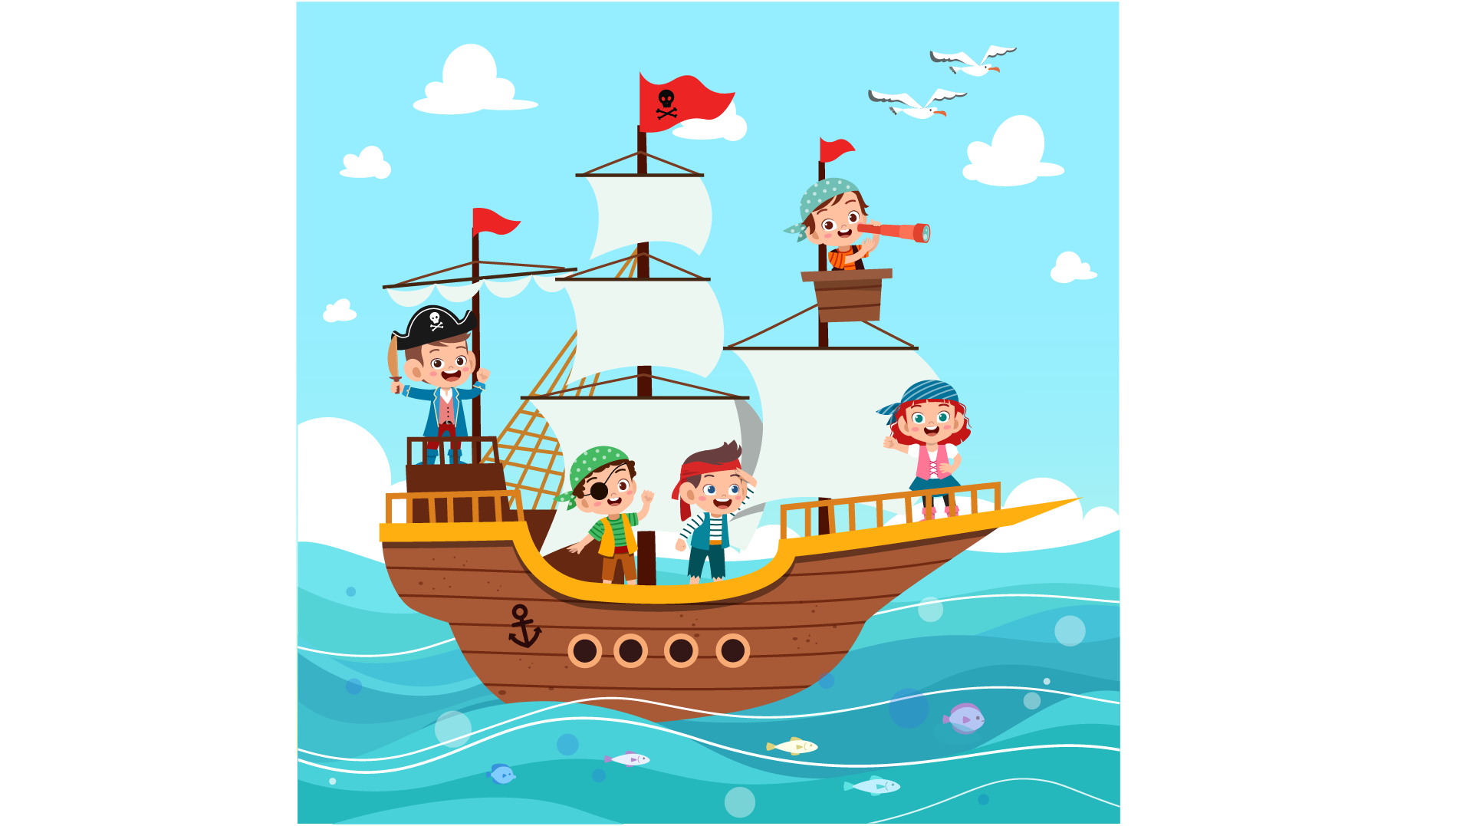

Jack |  | Lucy

PART 2
5 questions

Để một bức tranh 2 bạn gọi điện thoại.
Listen and write. There is one example.
 | 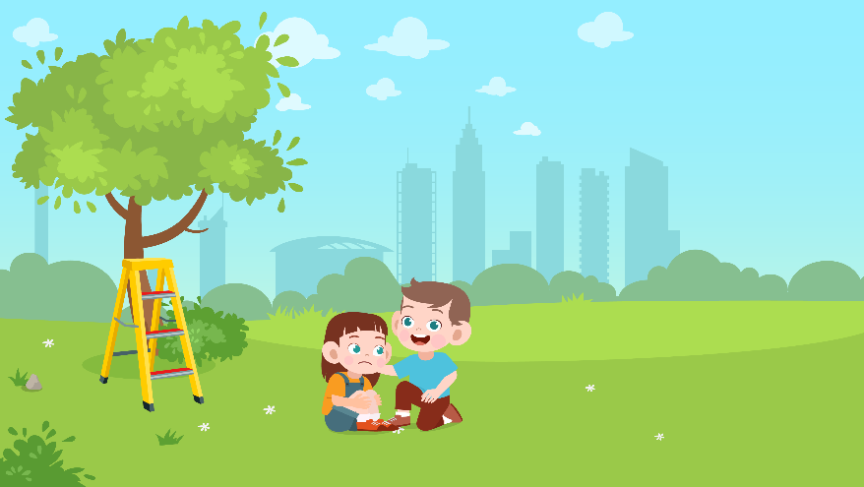
 | A PHONE CALL
0 | Who to call: | …Rose…
1 | Date: | ……
2 | Time: | …….
3 | Address: | ……street
4 | What to bring: | ……
5 | Clothes: | ……

PART 3
5 questions

What do Jamie’s family have for dinner?
Listen and draw a line from the floor to the correct picture.
There is one example

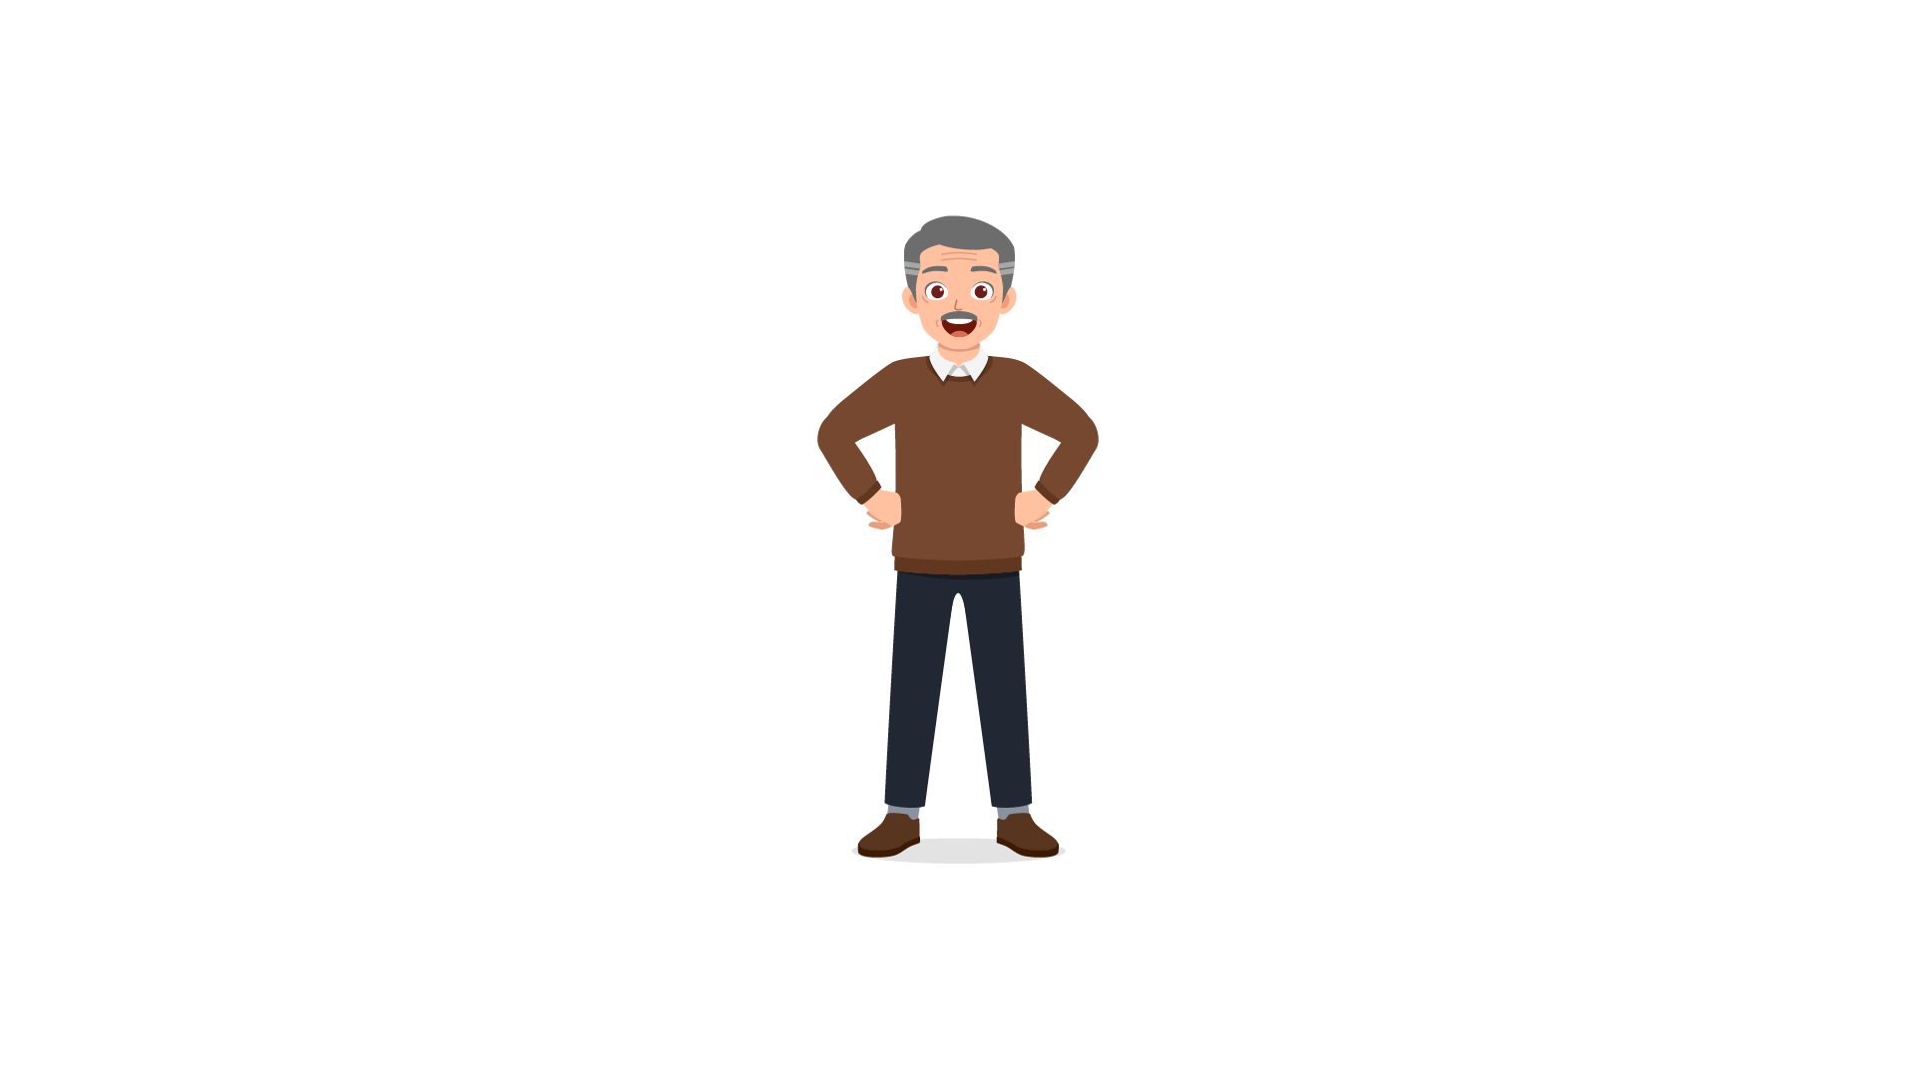 | Her grandfather  Her grandmother  Her father  Her mother  Jamie  Her brother | 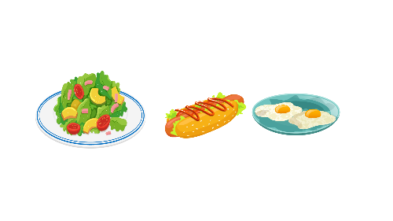
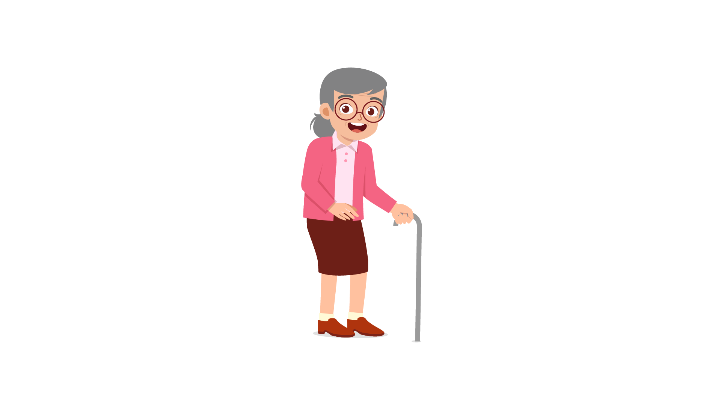 |  | 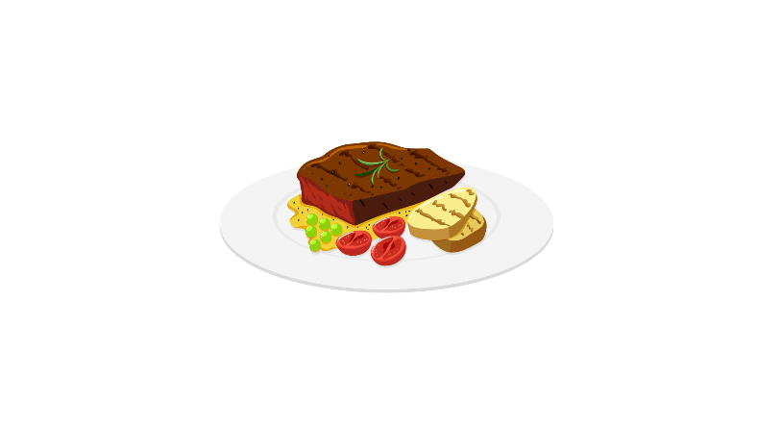
 |  | 

PART 4
5 questions

Listen and tick (✓) the box. There is one example.
What time did Laura go to school?
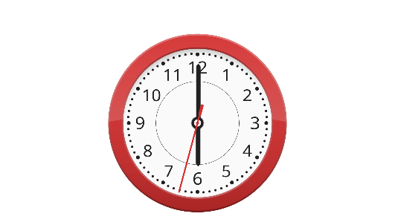 | 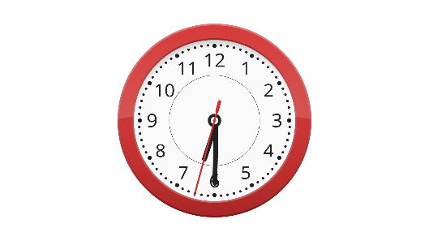 | 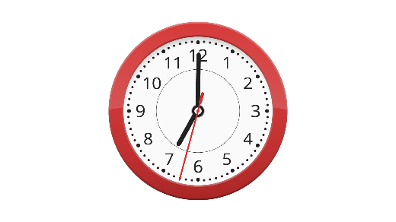
A ⬜ | B ⬜ | C ⬜
- What is Adam’s house like?
 |  | 
A ⬜ | B ⬜ | C ⬜
- What time does the Maths class start on Tuesday?
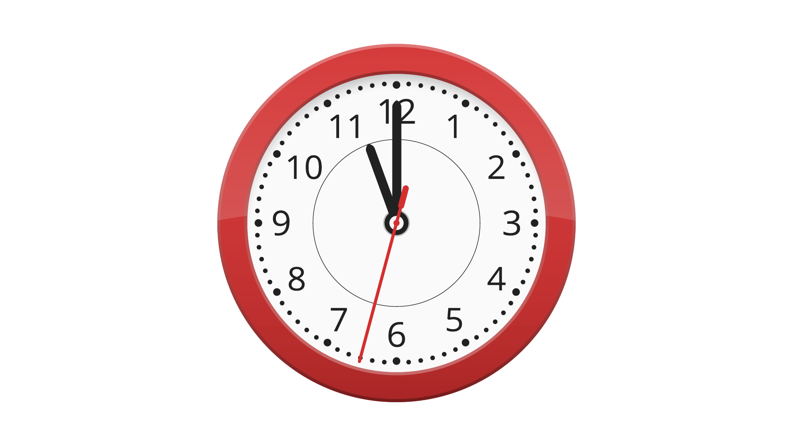 | 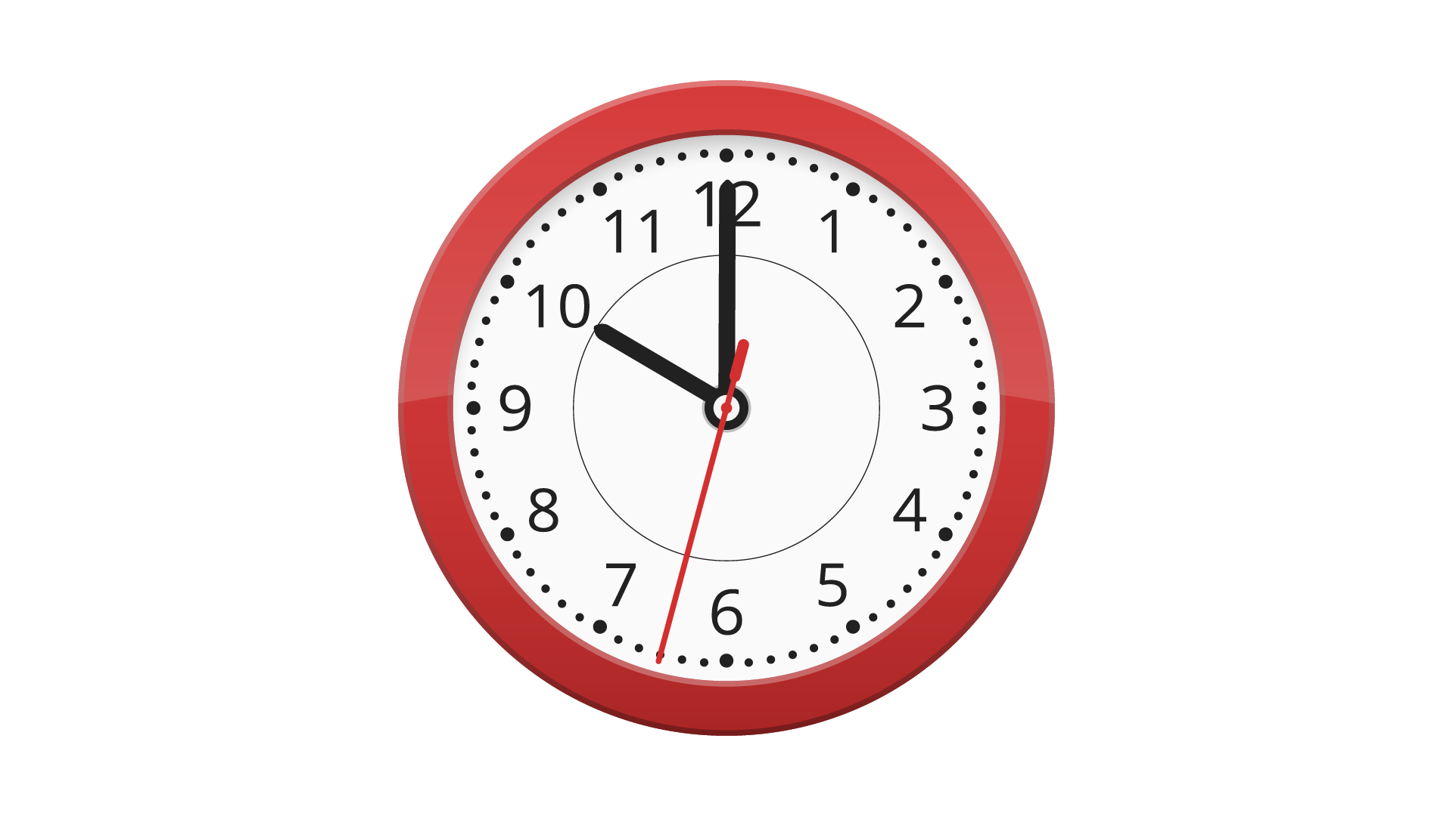 | 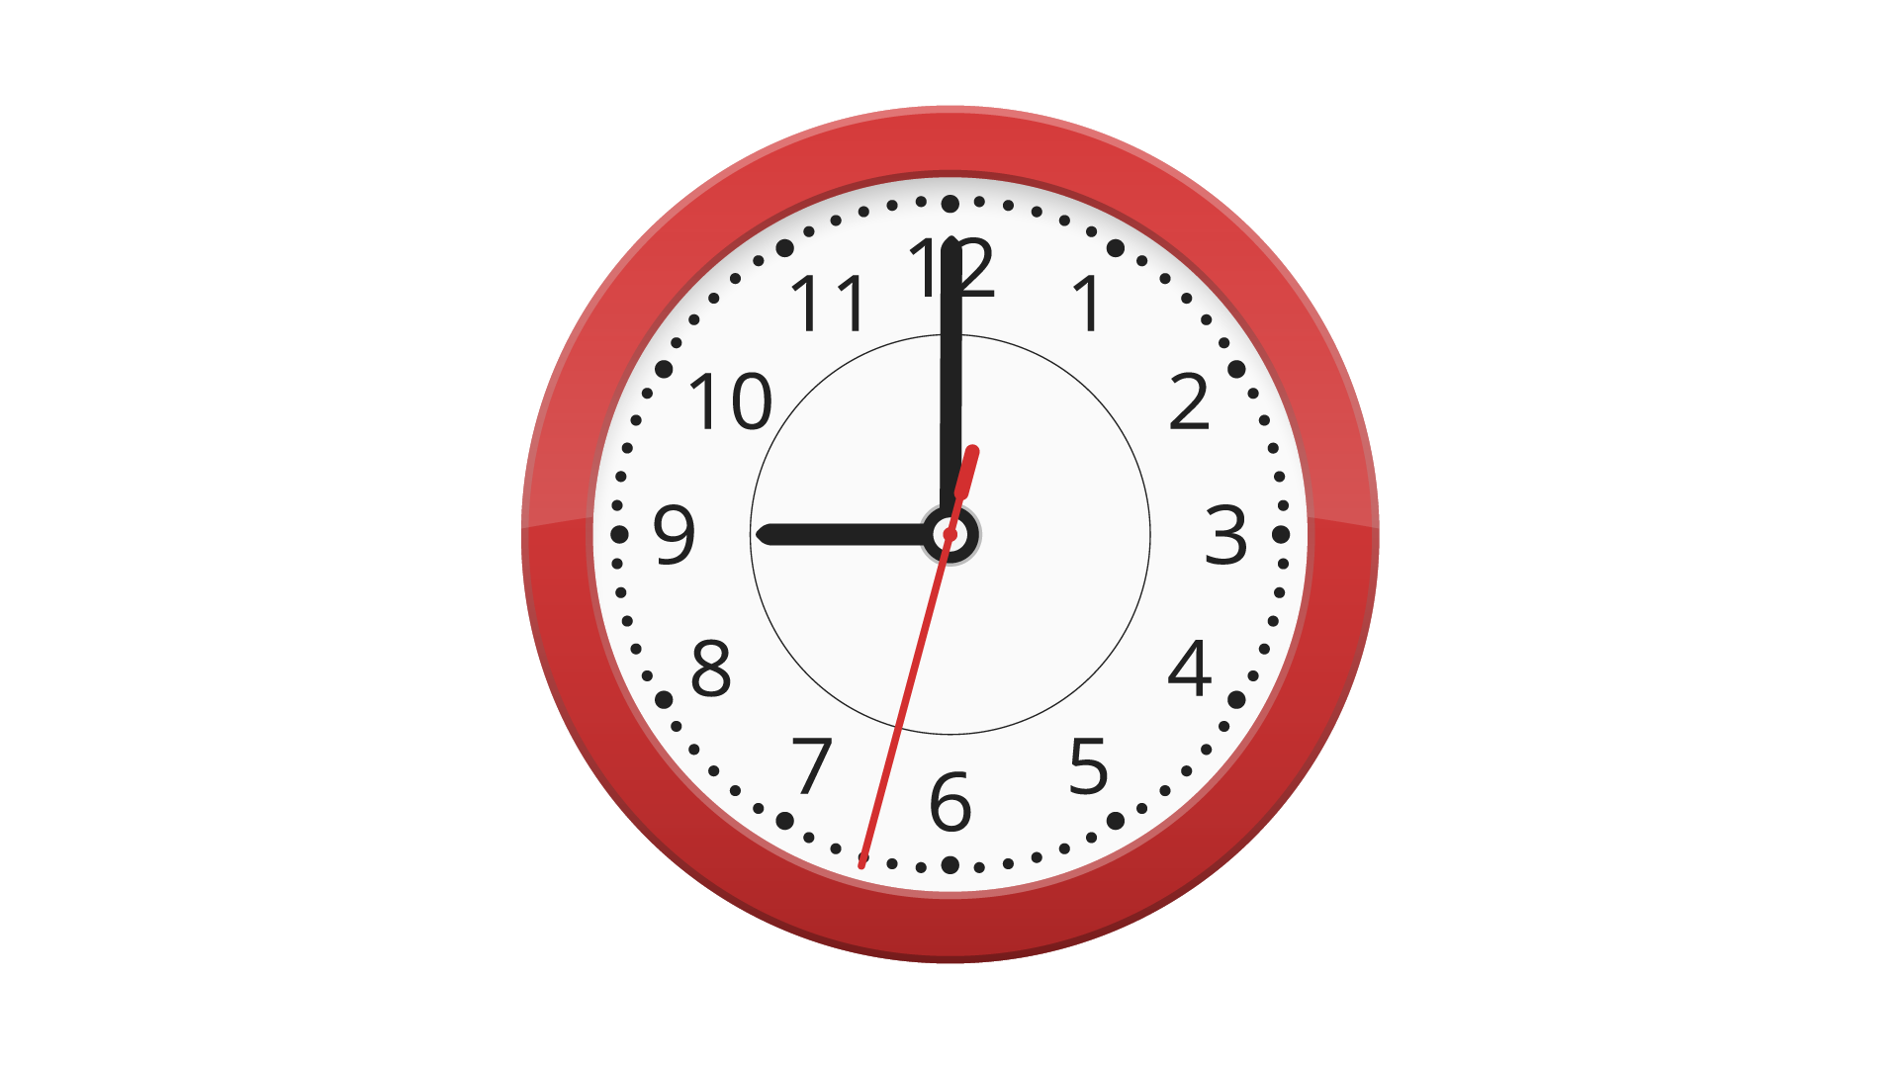
A ⬜ | B ⬜ | C ⬜
- Which animals do they see in Sweden?
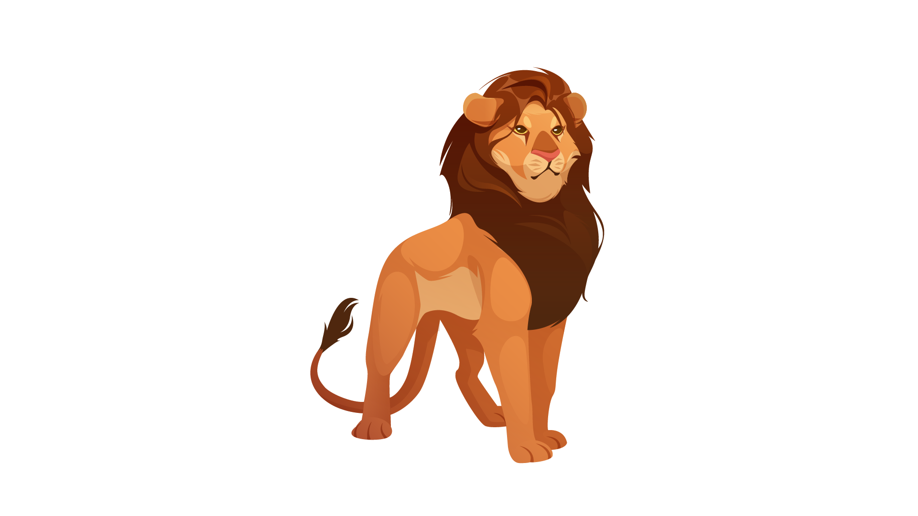 | 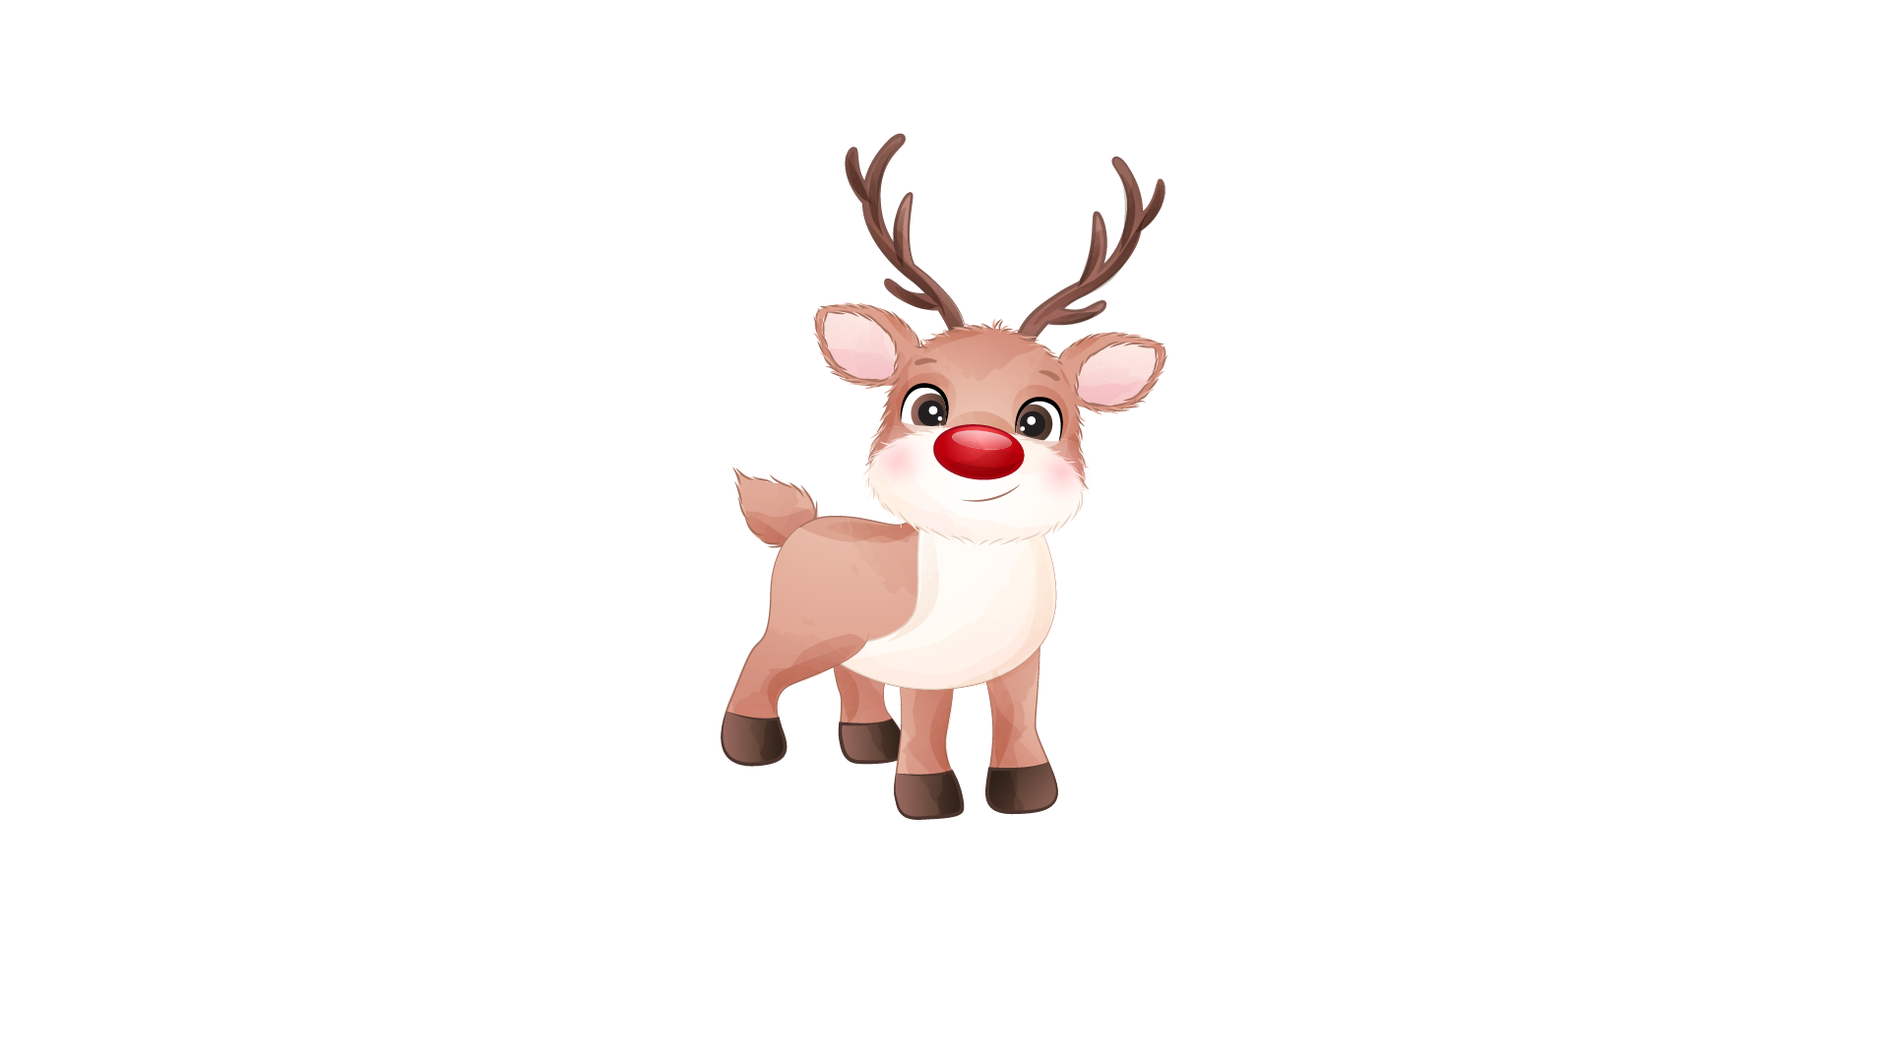 | 
A ⬜ | B ⬜ | C ⬜
- How many students were there in the castle?
 |  | 
A ⬜ | B ⬜ | C ⬜
- What does Maya’s mother do?
 |  | 
A ⬜ | B ⬜ | C ⬜

PART 5
5 questions

Listen and colour and draw.

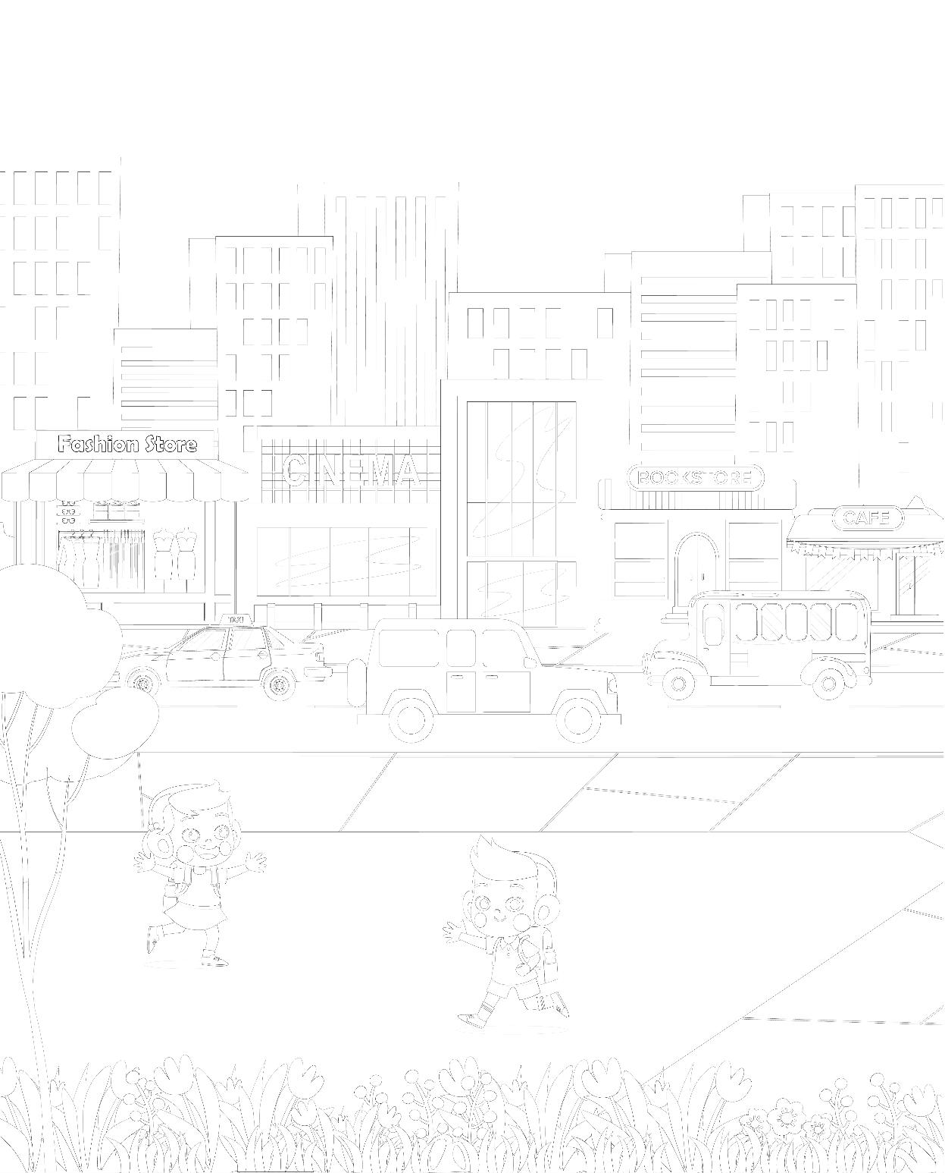

Reading and Writing
There are 35 questions
You have 30 minutes.
You will need a pen or pencil.
My name is…………………………….

PART 1
5 questions

Look and read. Choose the correct word and write them on the lines.

 | 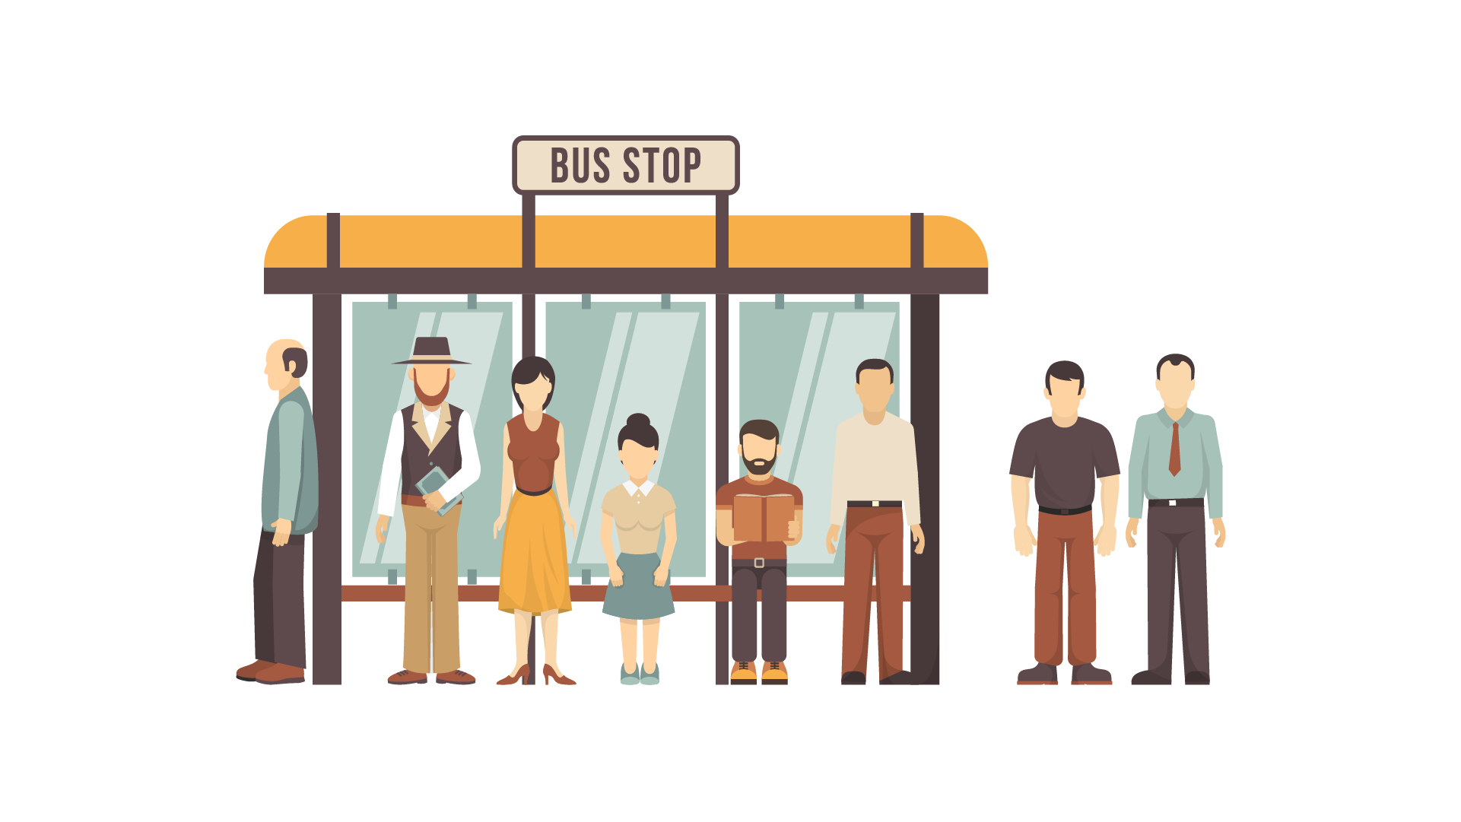
A hospital | A bus stop
 | 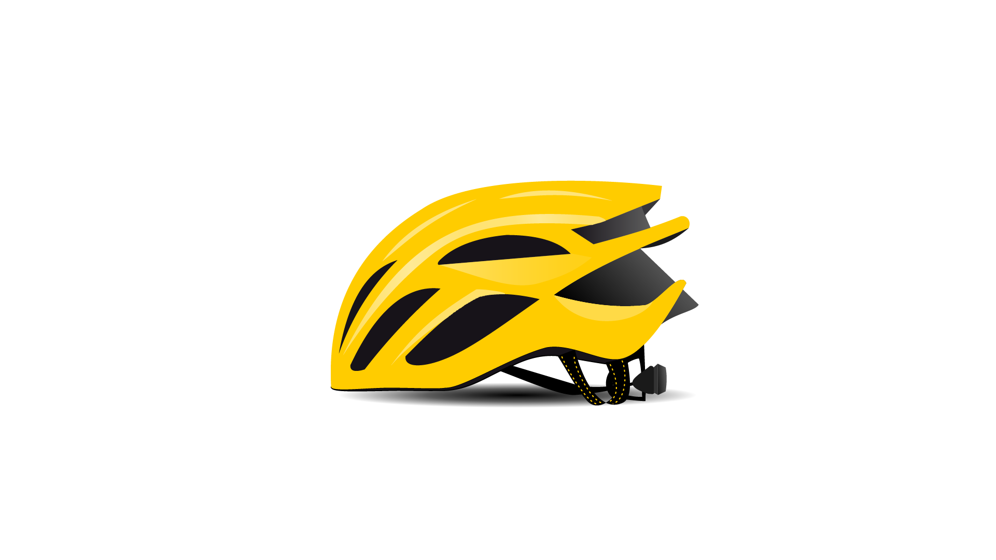
A doctor | A helmet
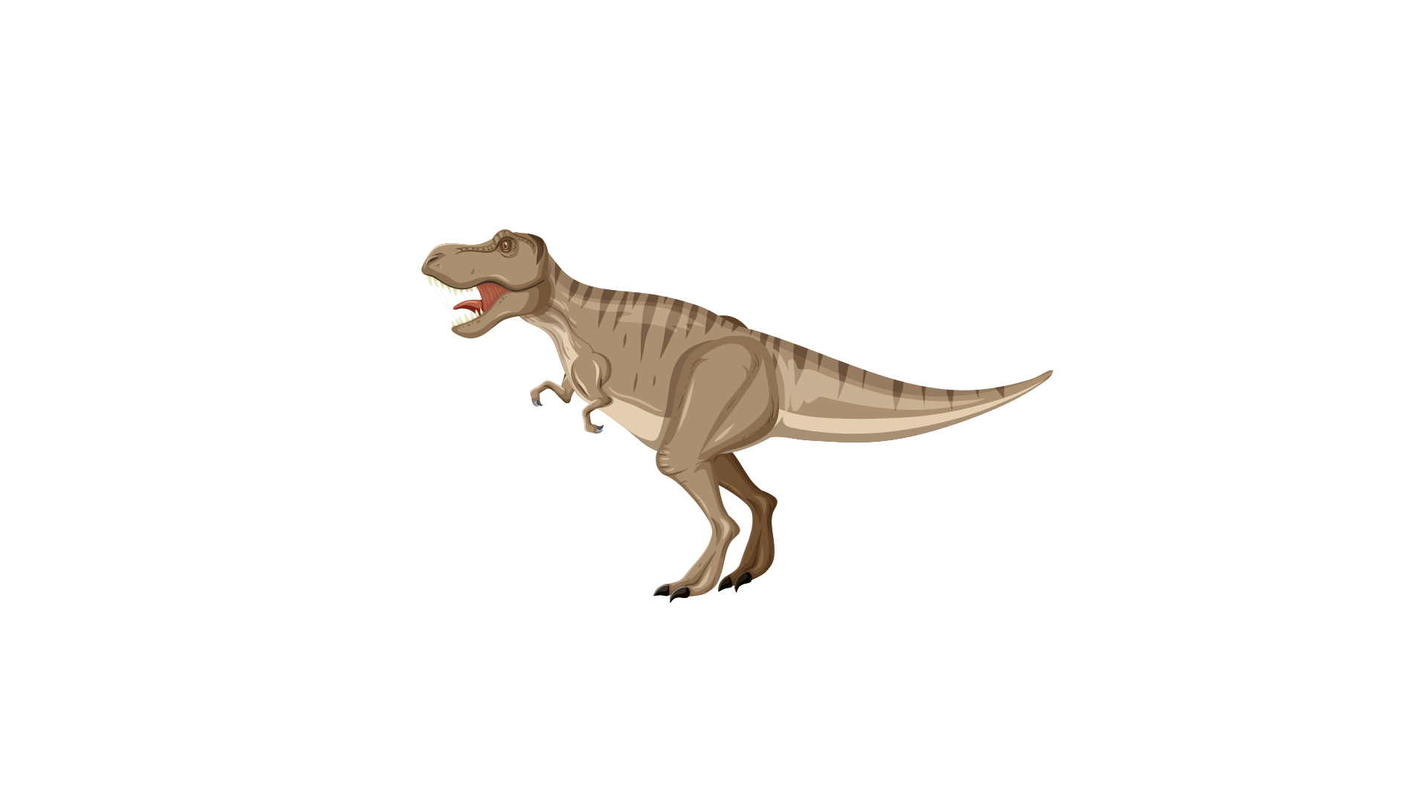 | 
A dinosaur | A nest
 | 
A photographer | A newspaper

Example
(0) | It is a place. A doctor works there. | A hopital
Questions
1 | This is a place. You wait for a bus there. | ___________
2 | It is on the tree. Birds keep their baby here. | ___________
3 | There is a lot of information in it. People usually read it in the morning. | ___________
4 | It is an animal. It lived thousands years ago. | ___________
5 | This person takes photos. This is his job.

PART 2
6 questions

Read the text and choose the best answer.
Anne is talking to her teacher, Susan.
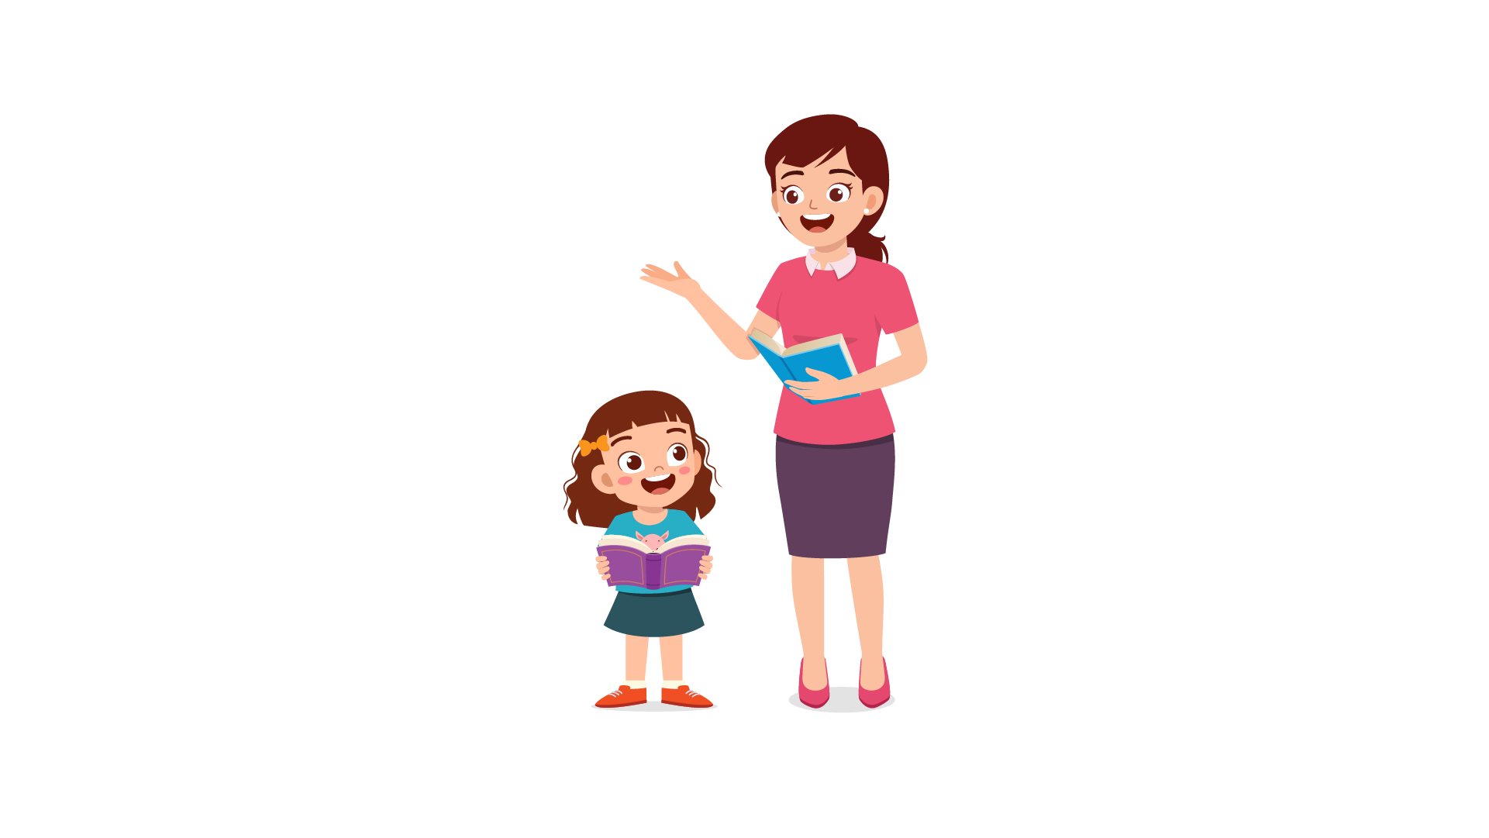

Example:
 | Susan: | You look very tired. Are you okay?
 | Anne: | A. Yes, I am.
 |  | B. No, I am not.
 |  | C. Yes, I do.
Questions:
1 | Susan: | How do you feel?
 | Anne: | A. My stomach is bad.
 |  | B. My ears are red.
 |  | C. My head is hurt.

2 | Susan: | Oh no. Did you sleep well last night?
 | Anne: | A. No. I went to bed late.
 |  | B. Yes. I went to bed late
 |  | C. No. I went to bed early.

3 | Susan: | What did you do last night?
 | Anne: | A. I played video games.
 |  | B. I had breakfast.
 |  | C. I went to school.

4 | Susan: | Who did your play with?
 | Anne: | A. I played with my cat.
 |  | B. I played with my hand.
 |  | C. I played with my brother.

5 | Susan: | What time did you go to sleep?
 | Anne: | A. Twice a week
 |  | B. 11 P.M.
 |  | C. By car

6 | Susan: | I think you should go to bed earlier.
 | Anne: | A. Yes, I will. Thank you.
 |  | B. No, thanks.
 |  | C. Sorry, I’d like more.

PART 3
6 questions

Read the story. Choose a word from the box. Write the correct word next to the numbers 1-5. There is one example.
Welcome to Happy Health Sports Centre!
Please read, so everyone can enjoy their visit.
You must show your member card every time you visit the sports centre. Wear the correct (0) …clothes… and shoes!
You must have sport (1) …. to use the sports centre.
You mustn’t leave your bag on the floor. Other visitors can fall over it. Use the cupboards. Please don’t listen to very loud (2) …...
You must be polite to other (3) …...
Swimmers mustn’t wear outdoor shoes near the swimming (4) …...
You mustn’t use the swimming pool when there are children’s classes. Please look at the (5) …. or ask at reception.

Example
music | pool | car
run | visitors | clothes
lake | shoes | timetable

(6) Choose the best name for the text. Tick one box.
Tick one box.
Sports Centre Rules | ⬜
A happy sports centre | ⬜
Healthy Sports | ⬜

PART 4
5 questions

Choose the right words and write them on the line.
 | My town
 | 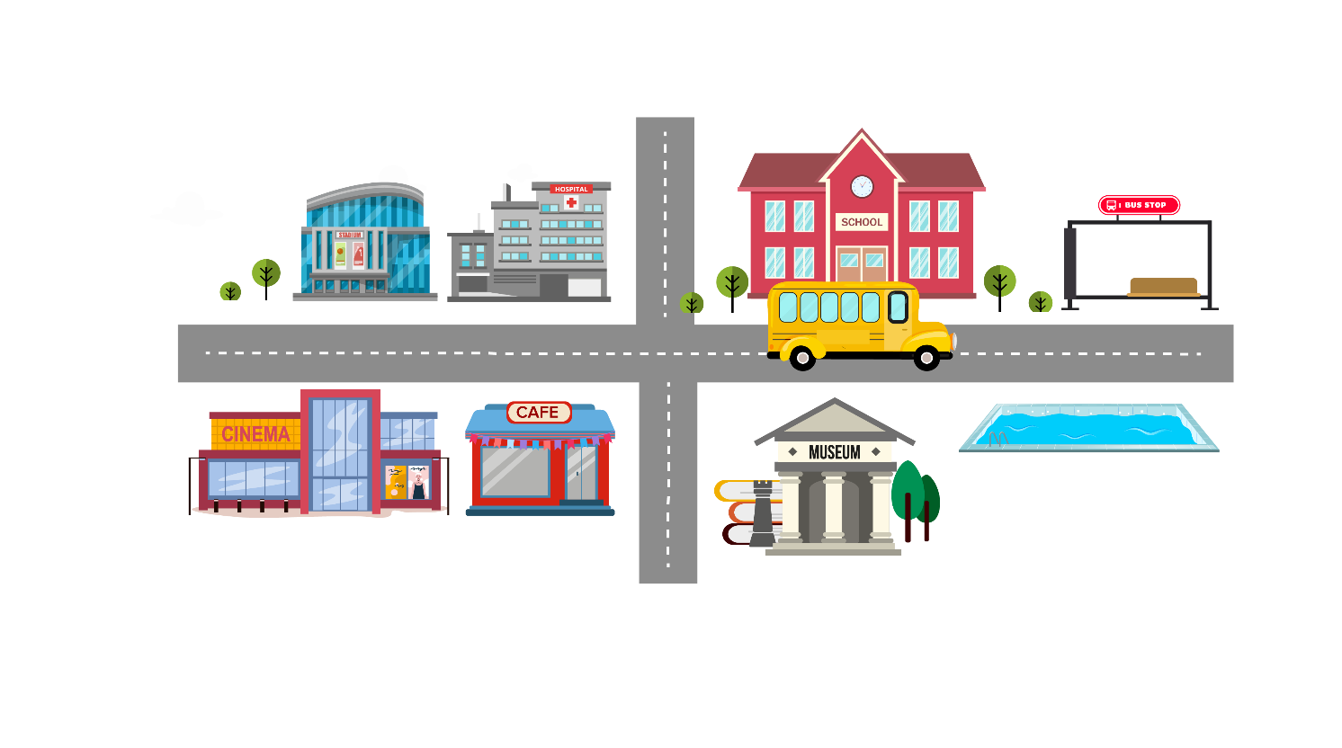
Example  1  2  3  4  5 | In my town, the bus (0) stop at my school is opposite the museum. After school on Fridays, I have Kung Fu (1) … at the sports centre near the hospital. At weekends, my friends and I sometimes (2) … to the cinema near the square. After that we go to our favourite café (3) … to the cinema. In summer, we often go to the open-air (4) … pool.  It (5) … opposite the bus station.

Example: | go | stop | pause
1. | lesson | call | sport
2. | went | go | goes
3. | behind | near | next
4. | swimming | swim | swam
5. | am | is | are

PART 5
7 questions

Look at the picture and read the story. Write some words to complete the sentences about the story. You can use 1, 2 or 3 words.
Pancake Day
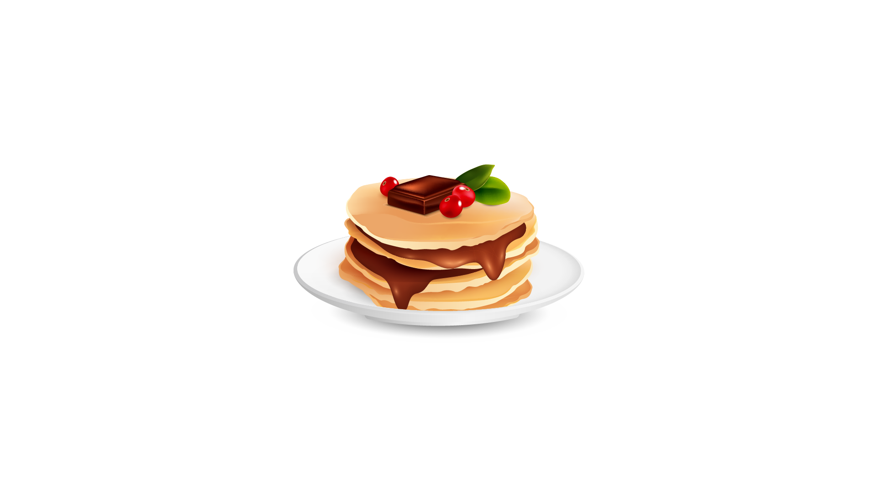
In February, there is a Pancake Day in England. It lasts 47 days. During the festival, people traditionally stop eating delicious food, like cakes and chocolate. So, they make pancakes, and they often eat them with lemon and sugar.

Examples:

UK people celebrate …Pancake…. Day in February.
They do not eat …delicious… food, like cakes and chocolate.

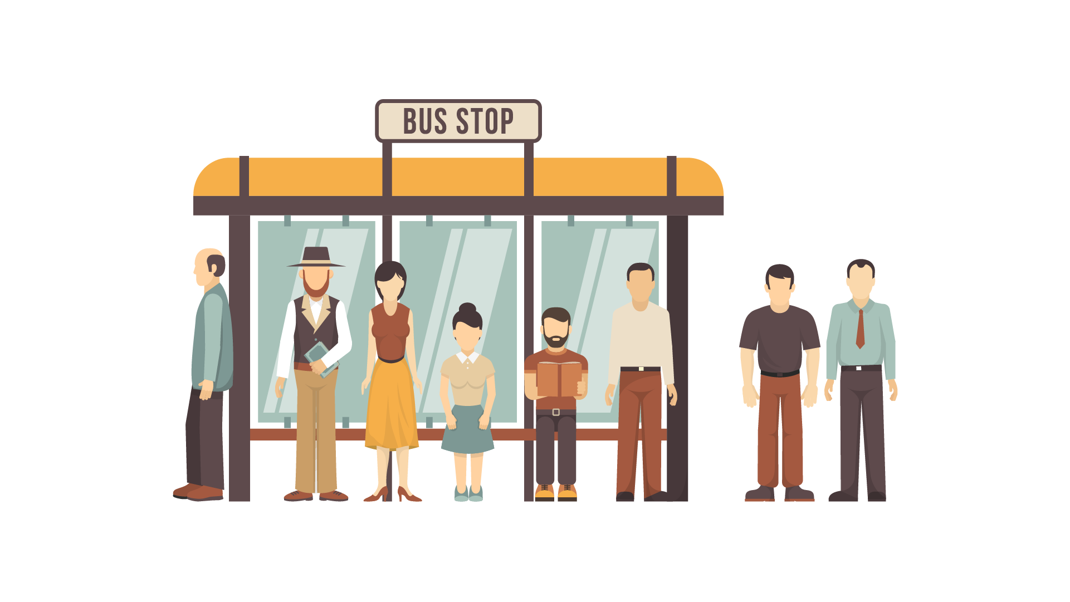
On that day, many British towns have pancake races. People put on colorful clothes and run down the street with a pancake in a pan. They must race while throwing the pancake into the air and catching it in the pan. It cannot drop to the ground.

Questions:

1 | People in British ………. hold pancake races.
2 | UK people wear beautiful ………. and run.
3 | Runners cannot ………. the pancake to the ground while running.

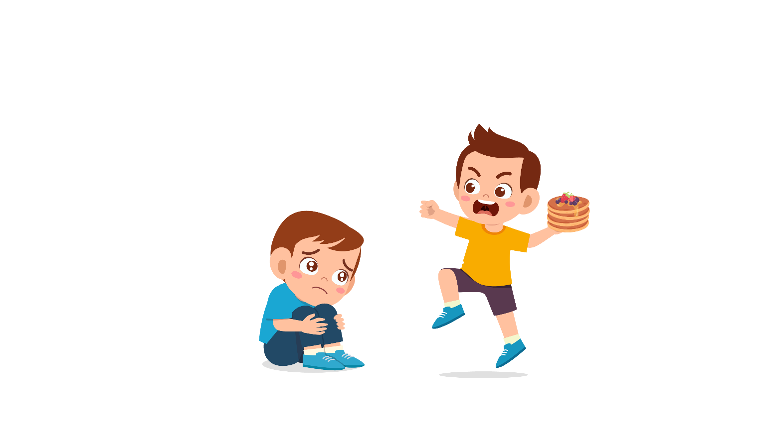
Last February, I joined Pancake Race in England. First, I baked a pancake in a special pan. When I heard the bell, I ran really fast. While running, I had to throw the pancake three times. It was not easy to keep the pancake in the air and catch it with a pan.

Questions:
4 | The Pancake Race in England started in ……….
5 | The pancake was not ………. to keep.
At the end of the race, I gave my pancake to the judges and got a special prize. It was very interesting. Now, some British people don’t eat delicious food for this festival. But most people eat pancakes on Pancake Day.
Questions:
6 | Now, not many people ………. delicious food in the festival.
7 | ………. people have pancakes on Pancake Day.

PART 6
6 questions

Look, read and write.
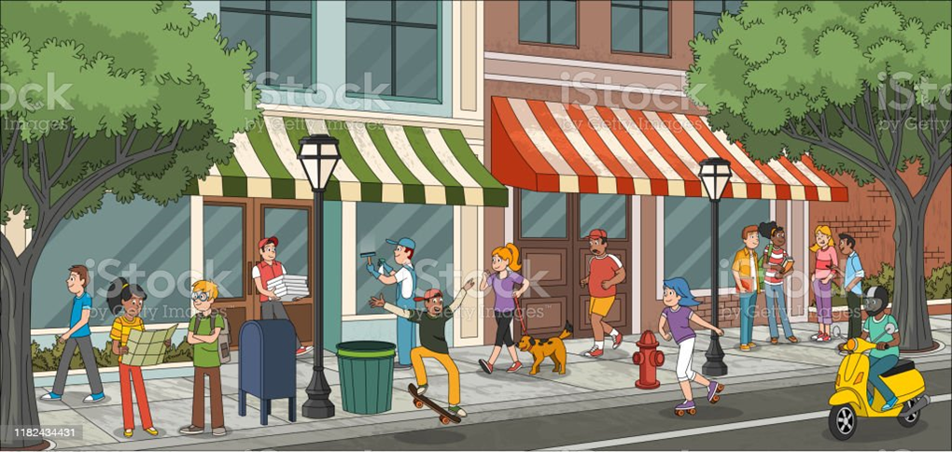

Examples:
There is a yellow spotty …dog…
What is the girl in yellow looking at? …map…
Complete the sentences.
1. The man in green T-shirt is riding ________________.
2. A girl is ______________ with her dog.
Answer the questions.
3. What is the pizza man wearing?
4. Where is the girl with blue hair riding roller skates?
Now write two sentences about the picture.
5. …………………………………….
6. …………………………………….
SPEAKING
My name is…………………………….

Summary of Procedures
The usher introduces the child to the examiner. The examiner asks how old the child is.

- The examiner asks the child to describe several differences between the two Find the Differences pictures, e.g. ‘This cat is black but this cat is yellow’.
- The examiner tells the child the name of the story and describes the first picture, e.g. “Linda gets up at 7:00 a.m. She thinks she is late for school”. The examiner then asks the child to continue to tell the story.
- The examiner shows how to do the task with the first odd-one-out set of pictures. For example: ‘These are all places. But this is a room in a house’. Then the examiner asks the child to choose one picture in the other three sets and say which is different and why.
- The examiner asks questions about the child, e.g. ‘Where do you live?’

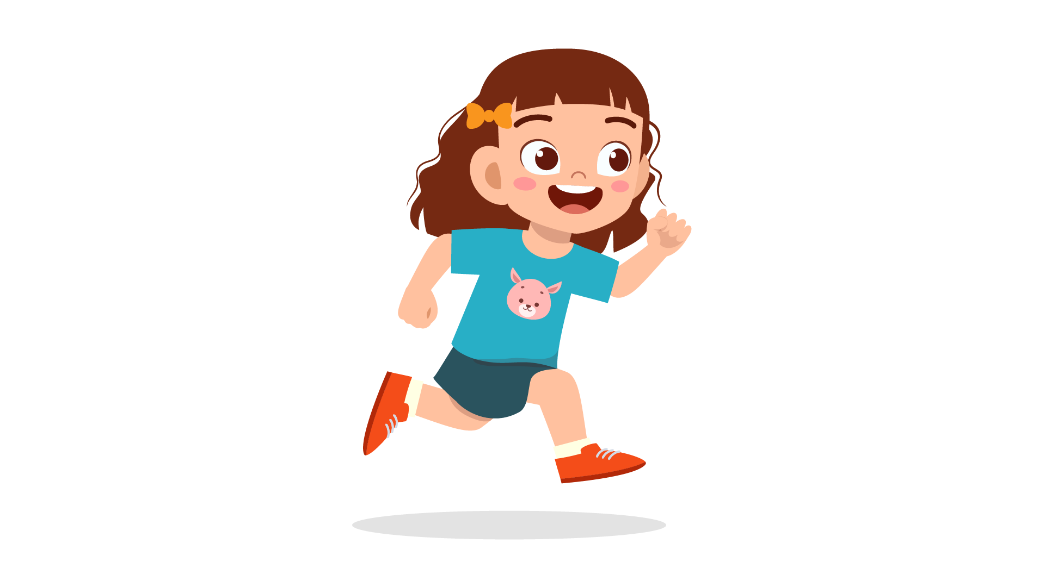 |  | 

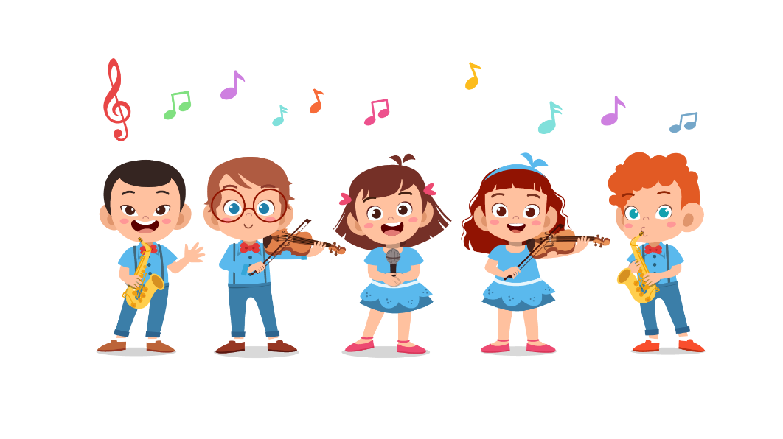 | 
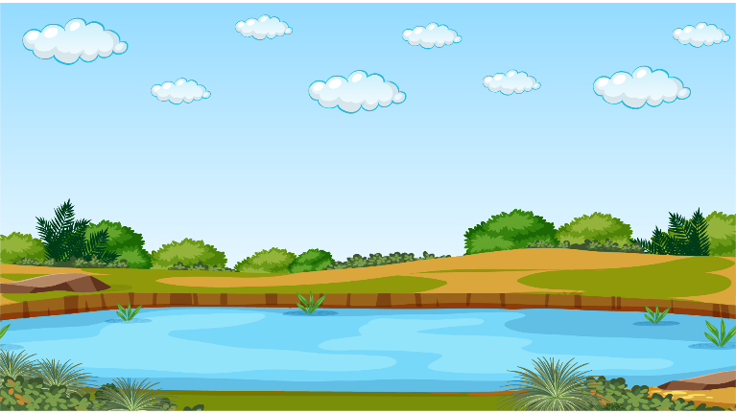 | 

 |  | 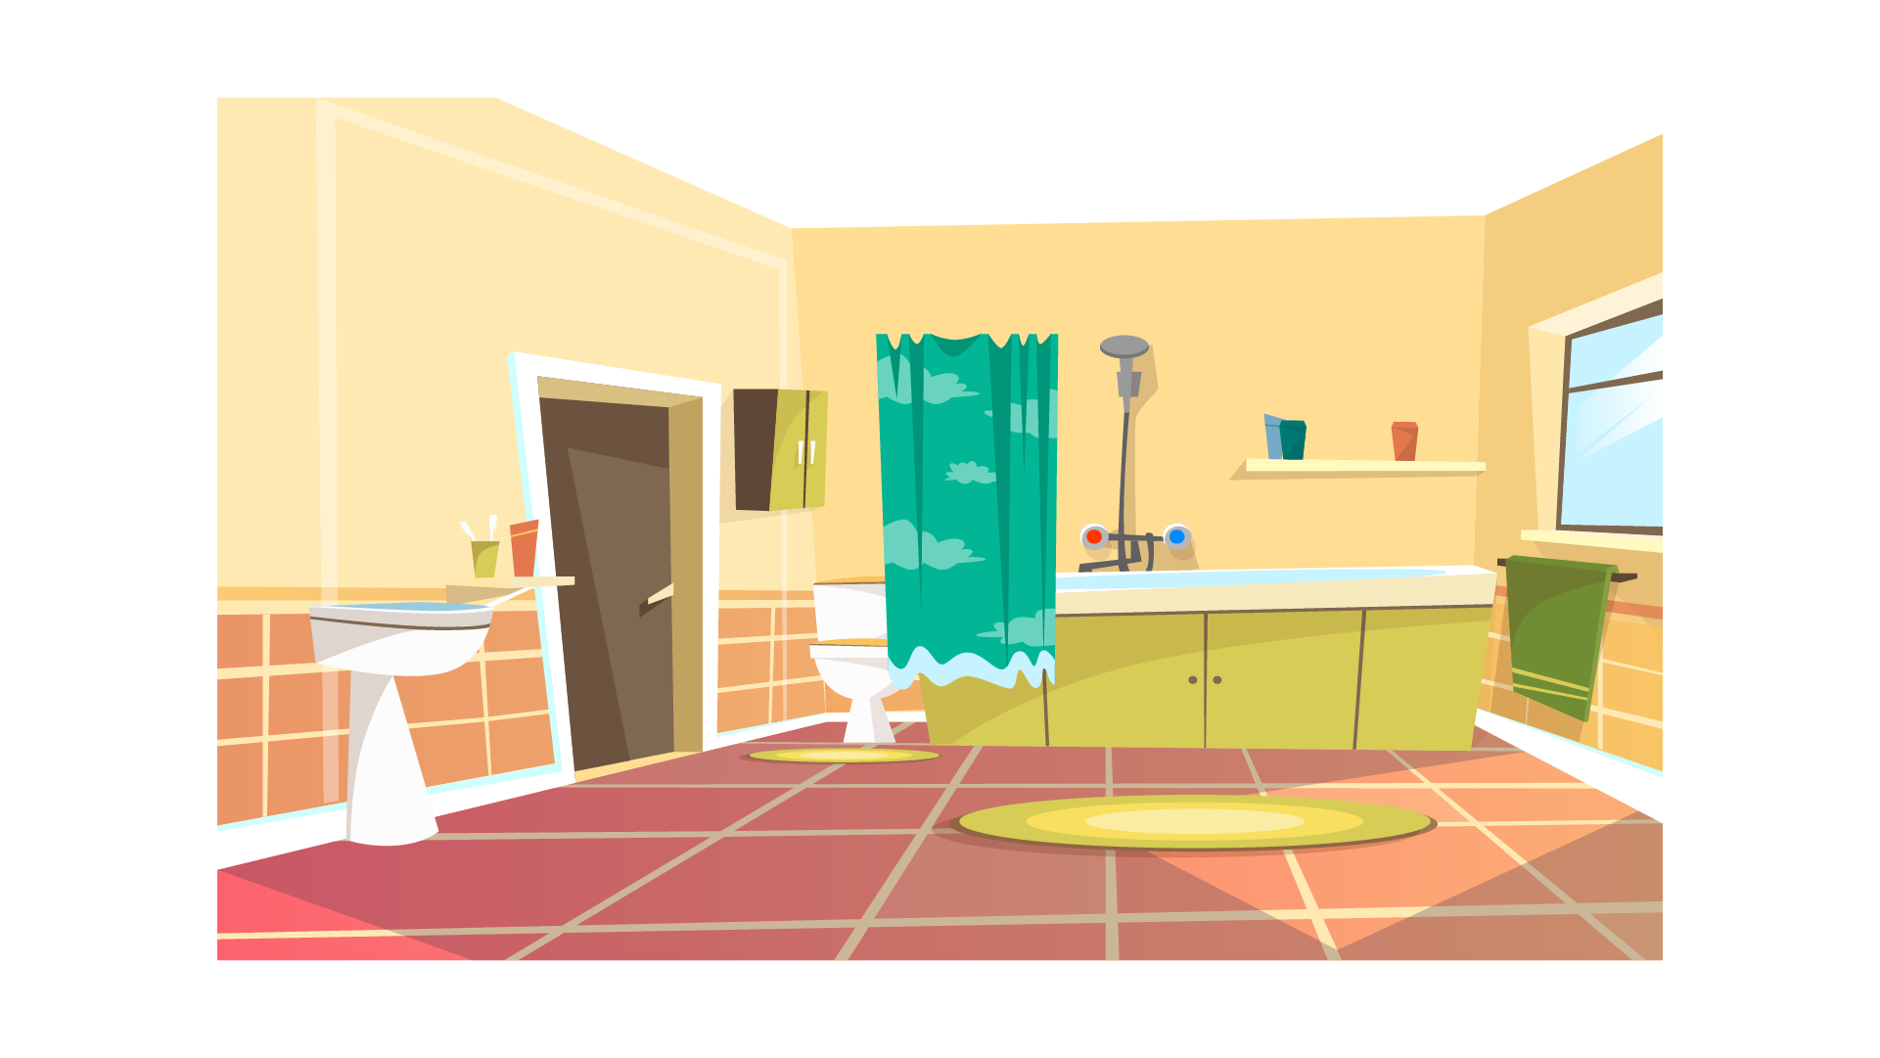 | 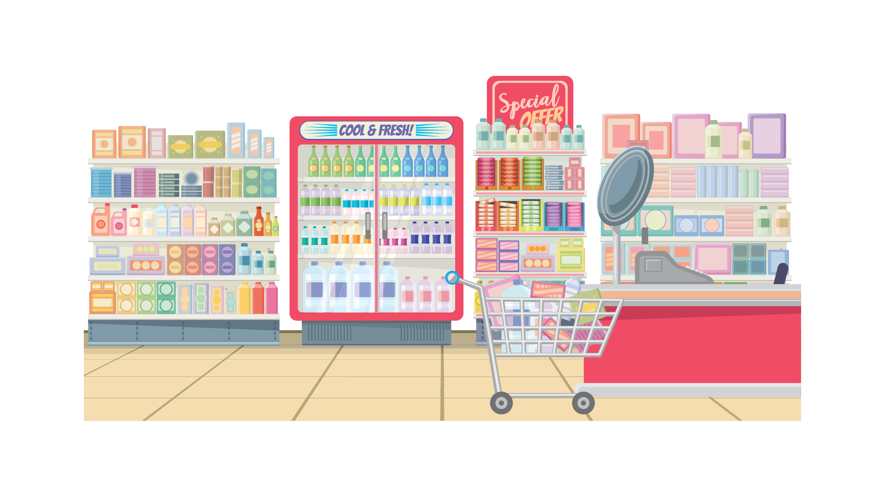
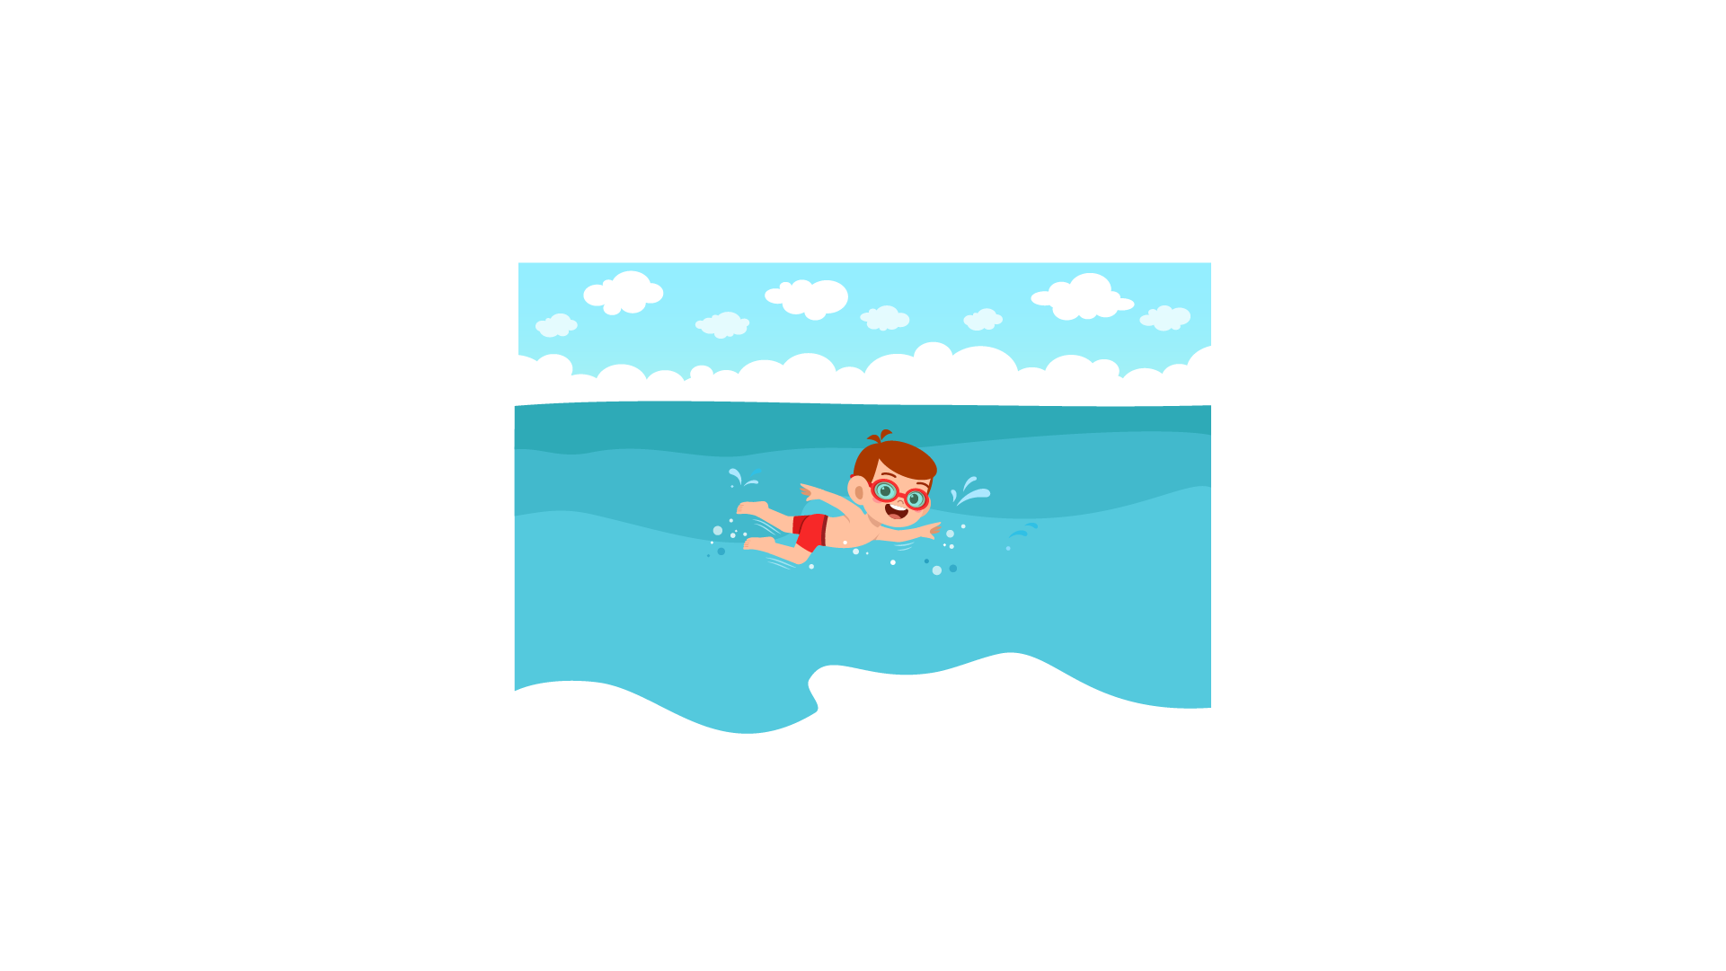 | 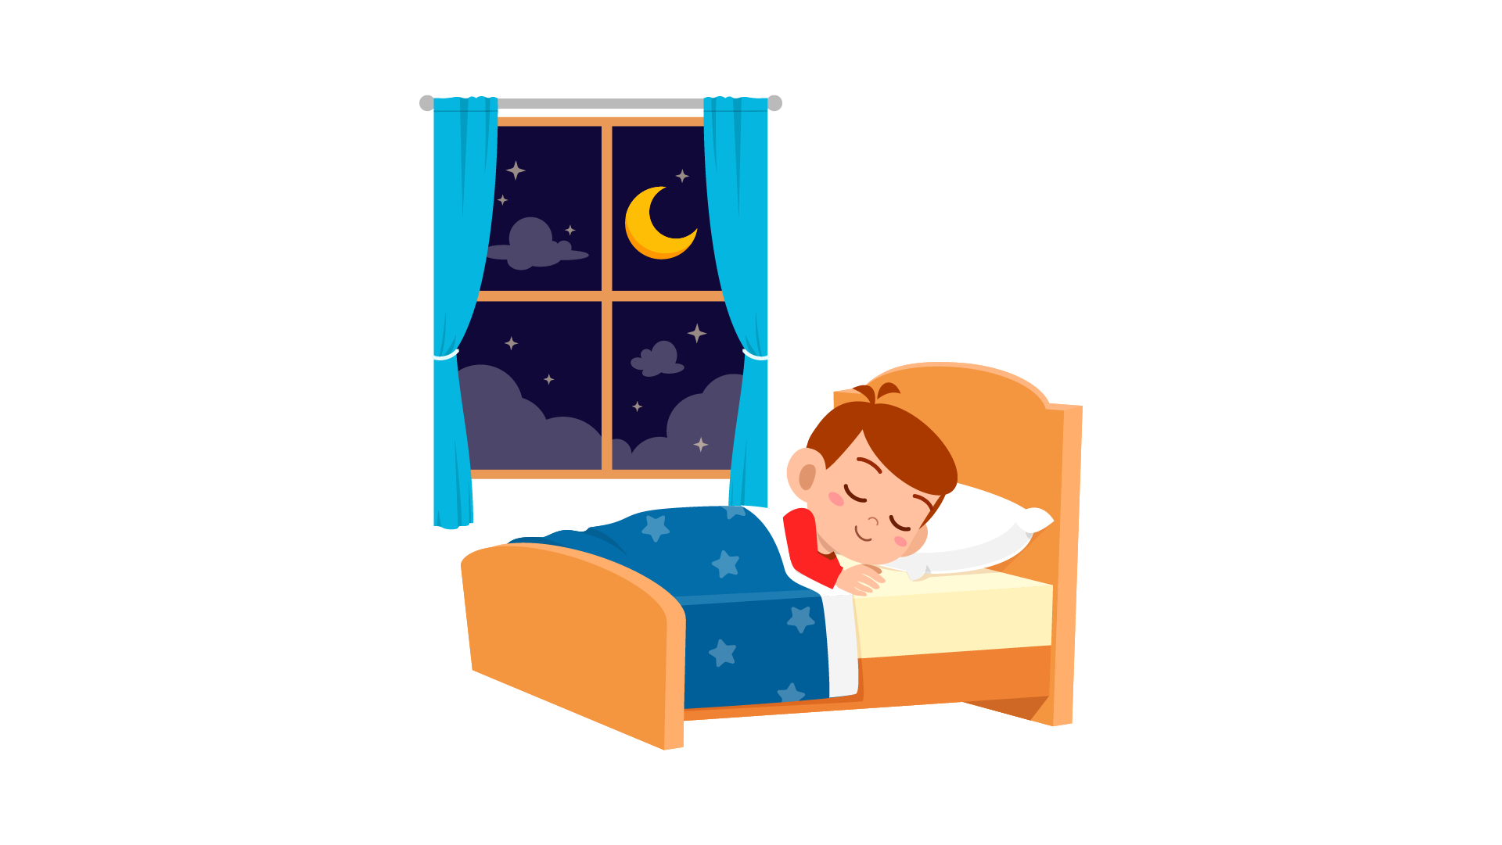 | 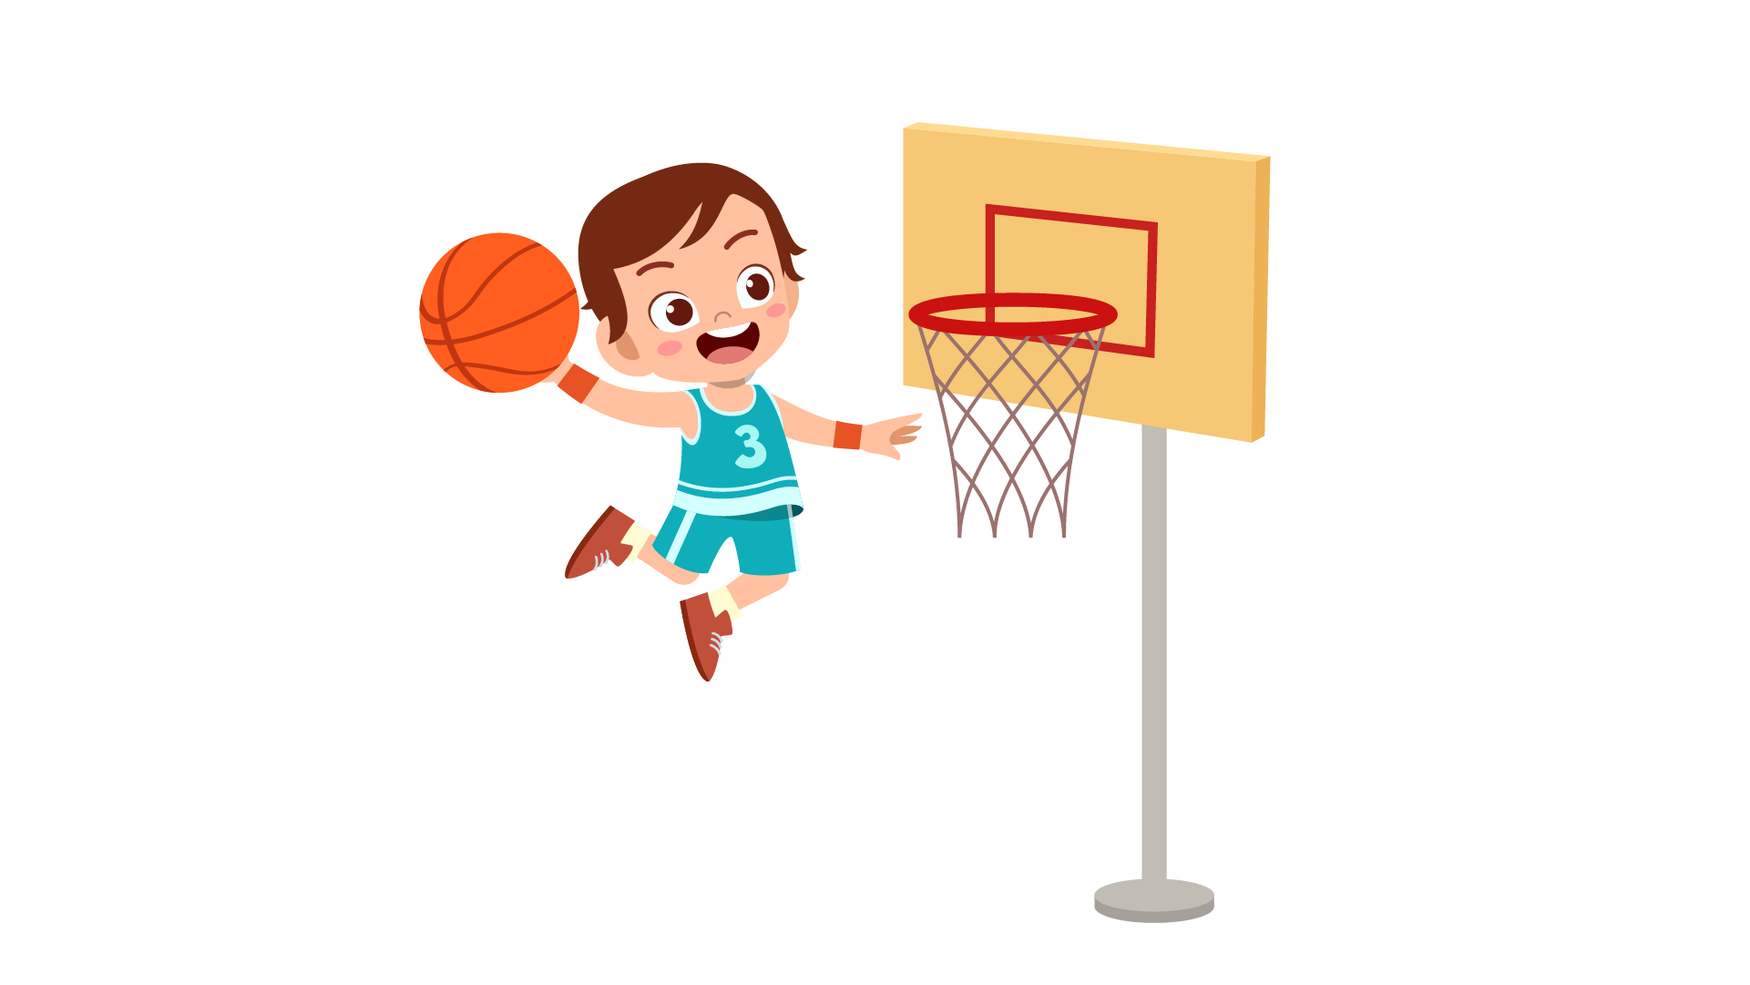 | 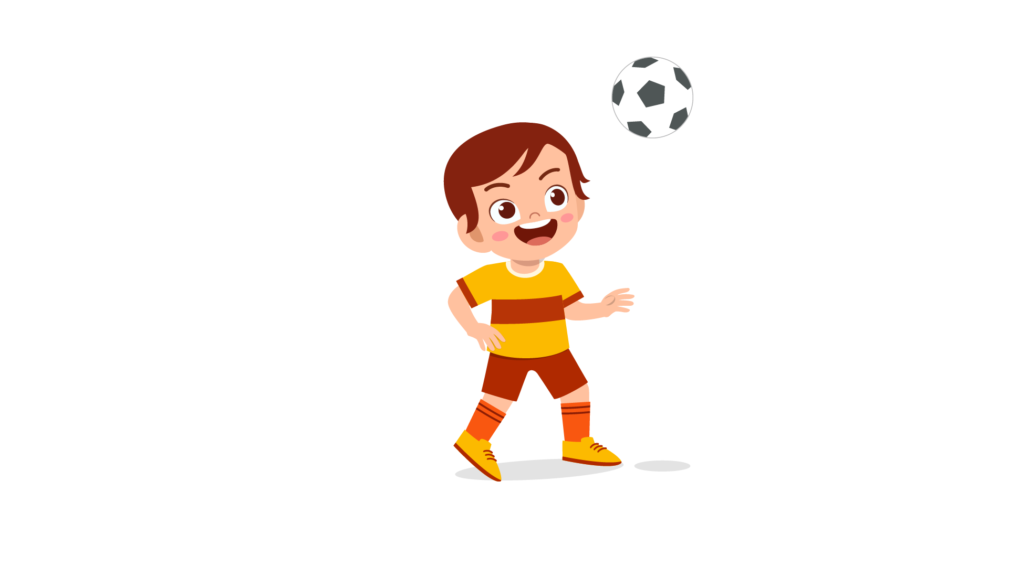

 |  | 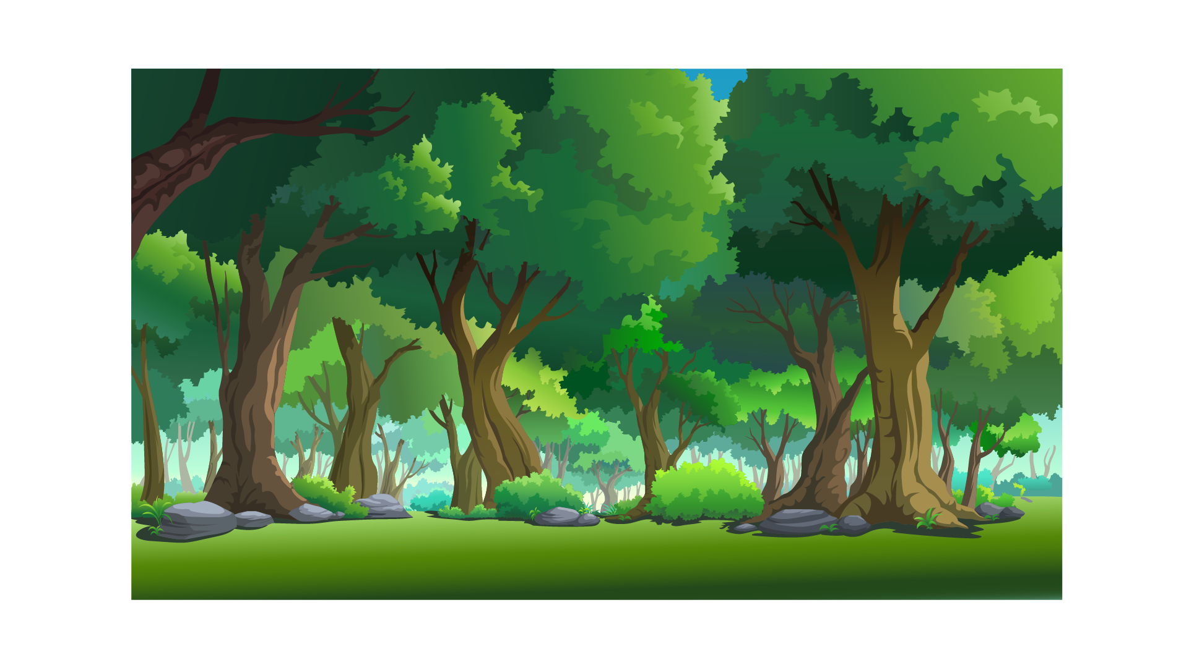 | 
 | 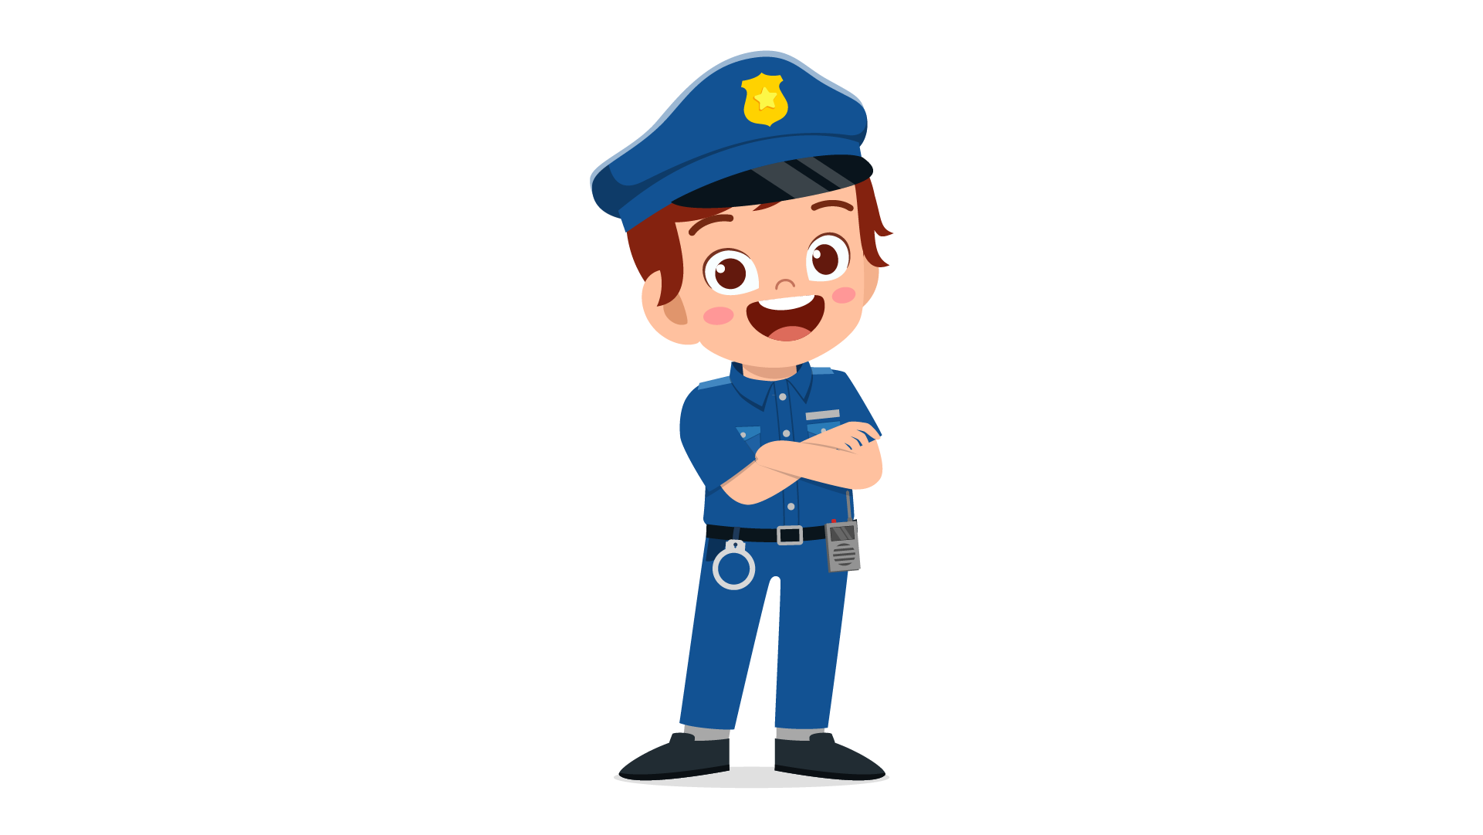 | 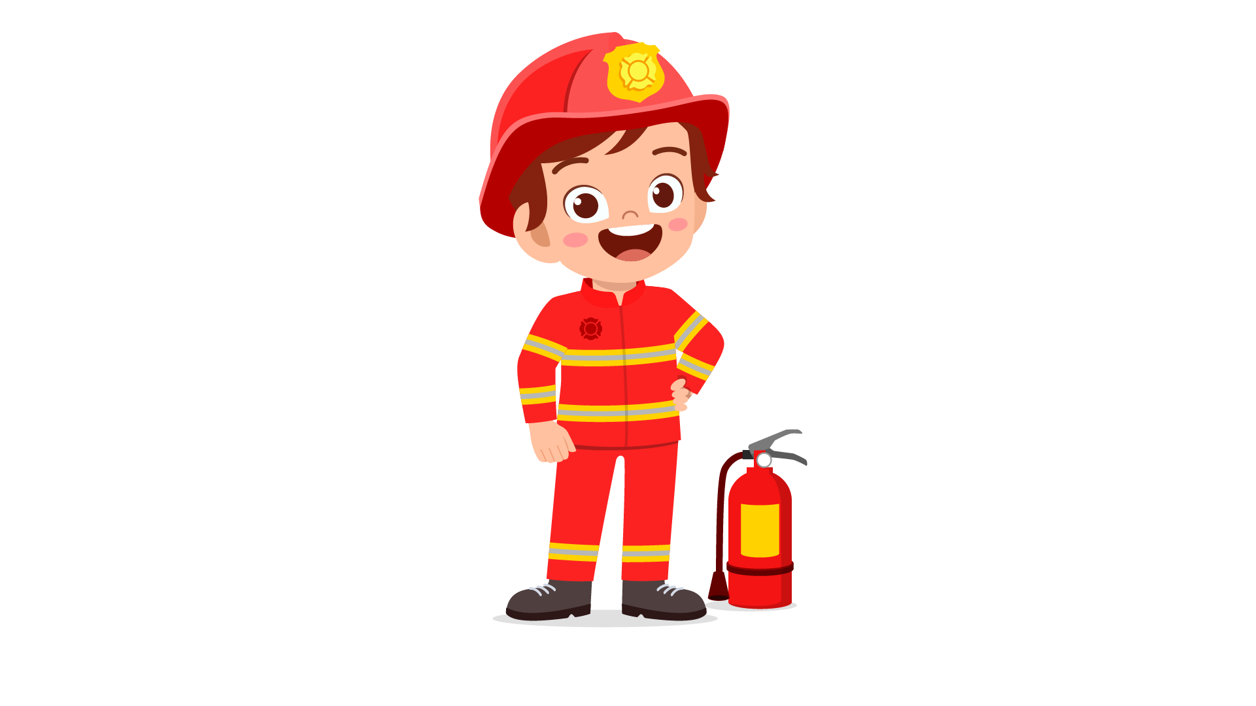 | 

