|  |  |
| --- | --- |
| **Mã đề 6.1.8** | **ĐỀ KIỂM TRA GIỮA HỌC KỲ I**  **NĂM HỌC 2022 - 2023**  **MÔN: TIẾNG ANH LỚP 6**  **Thời gian làm bài 60 phút**  **Đề gồm có 03 trang** |

**A. LISTENING:**

**I. Listen and choose the correct picture. ( 1.0 pt)**

1. What’s Tom playing?

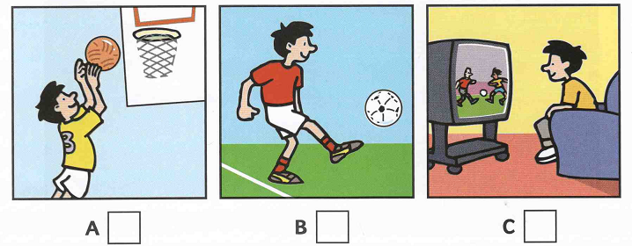

2. What’s Nick doing?

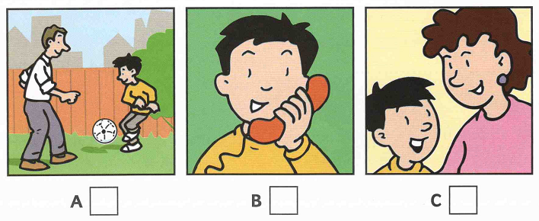

3. What’s Pen doing?

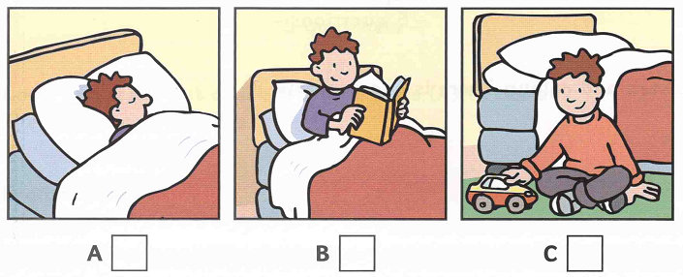

4. What’s Kim doing?

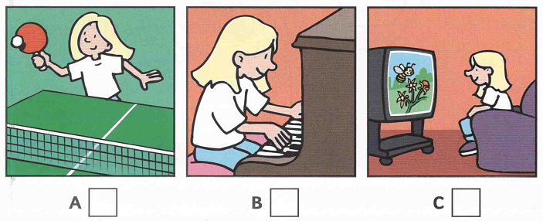

5. What’s Ann painting?

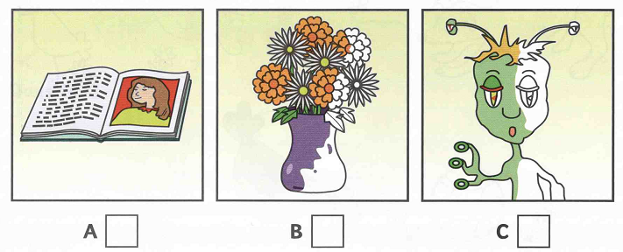

**II. Listen and complete the gaps. (1.0pt)**

What’s the boy’s name: ***Nick***

How old is he? ***9***

6. What is the name of Nick’s dog? ………………………………

7. How old is the dog? ………………………………

8. Where is Nick’s flat? In…………………………Street

9. Where is Nick going now? To………………………..Park

10. What number is Nick’s bus? ………………………………

**B. VOCABULARY – GRAMMAR – LANGUAGE FUNCTION**

**I. Choose the best option A, B, C or D to complete the sentences. (3.0pts)**

11. Is the boy strong or weak? - ________ is weak.

A. He B. She C. It D. They

12. ________ color is your shirt?

A. How B. What C. Where D. When

13. What ________ is your bag? - It's green.

A. size B. color C. date D. money

14. Is she old or ________?

A. tall B. weak C. young D. short

15. Is her face round ________ oval?

A. and B. but C. or D. so

16. They ________ badminton every day.

A. do B. have C. play D. study

17. He ________ an intereting book at the moment.

A. read B. is reading C. are reading D. reads

18. Hoa is very ________. She always does her homework.

A. creative B. hard-working C. kind D. helpful

19. There is a washing machine in the ________.

A. bedroom B. attic C. kitchen D. living room

20. I have ________ hair.

A. black long B. black and long C. a long black D. long black

21. We live in a town house, but our grandparents live in a ________house.

A. villa B. big C. city D. country

22. My car is new but ________ is old.

A. her B. hers C. she D. it

23. Nam: "How are you, Ba and Ha?" Ba and Ha: "________ "

A. I'm fine. Thanks. B. We are fine. Thanks.

C. They are fine. Thanks. D. He's fine. Thanks.

24. Phong: "Let’s go to the bookshop." Mi: “________”

A. Good idea B. No, thanks C. Yes, I can D. No, I don't.

25. Nga: "What is your best friend like?" Lan: “________”

A. She’s tall and slim. B. She’s kind and friendly.

C. She likes reading. D. She is a student.

**C. READING:**

**I. Read the passage and choose the best answer A, B, C or D to complete the passage (1.5pts)**

I live in a small house near the sea. There are two bed rooms upstairs _____ (26) _____ no bathroom. The bathroom is down stairs between the kitchen and there is a living room where there is a lovely old fire place. There is a garden_____ (27) _____ the house. The garden _____ (28) _____ down to the beach and in spring and summer_____ (29) _____flowers everywhere. I love my house for_____ (30) _____reasons: the garden, the flowers in summer, the freeze in winter, but the best thing is the view from my bedroom window.

26. A. and B. but C. so D. or

27. A. in front B. front C. front of D. in front of

28. A. is going B. goes C. going D. go

29. A. these are B. there are C. they are D. those are

30. A. a B. any C. many D. much

**II. Read the passage and choose the best answer A, B, C or D (1.5 pts)**

My name is Nga and my best friend is Lan. She is my classmate. We are twelve years old. We are both in grade 6 at Kim Dong Secondary School. Lan lives next to my house. Every day, my father takes us to school on his motorbike, and we come home on foot in the evening. She is an intelligent girl. Her favourite subject is Math, and she is really good at it. Mine is English. We usually help each other with our homework. Whenever I am sad, Lan always tells me stories to make me happy. I feel really lucky to have a best friend like Lan.

31. How old are Lan and Nga?

A. 10 B. 12 C. 14 D. 16

32. How do they go to school?

A. By bus B. On foot C. By motorbike D. By bike

33. What is NOT TRUE about the passage?

A. They are classmates. B. They are neighbours.

C. English is Lan’s favourite subject. D. Lan is 12.

34. What do they usually help each other?

A. Do their homework B. Do their housework

C. Do their shopping D. Do their gardening

35. What does Lan do to make Nga happy?

A. Sing a song B. Tell stories C. Buy presents D. Talk to her

**D. WRITING**

**I. Rewrite these sentences with the same meaning.(1.0pt)**

36. My school has thirteen classes.

-> There …………………………………………………………….……..

37. Her hair is long and brown.

-> She has………………………………………………………........……..

38. My house is behind the bookshop.

-> The bookshop is ……………………………………………...................

39. There are five rooms in my house.

-> My house………………………………………………..............……….

40. Let’s go swimming this afternoon.

-> How about …………………………………………………………........?

**II. Write a parargraph (40-50 words) about your new school, using these suggested words and phrases. (1.0pt)**

*My school/ Cam Vu Secondary school. It/ Phu Loc.*

*It/ have/ trees/ big yard.*

*There/ 13 classes/ 500 students/ 27 teachers.*

*Students/ study/ hard./ They/ play games/ recess.*

*Thing I like/ the air/ fresh. I/ love/ school.*

**\*\*\*The end\*\*\***