|  |  |
| --- | --- |
| **TRƯỜNG THCS AN ĐỨC** | **ĐỀ THI HỌC SINH GIỎI**  **NĂM HỌC 2024-2025**  **MÔN THI: TIẾNG ANH 6**  *Thời gian làm bài: 120 phút;* |

**PART A. LISTENING. *(20 points)***

***I. Listen and tick the picture to answer the question (5 points)***

**Question 1**: What did Robert give the farmer?

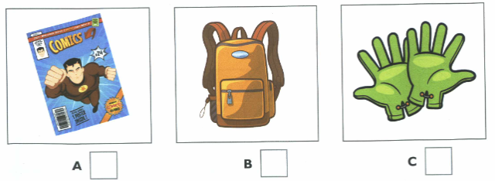

**Question 2**: What animal did Harry’s family film last year?

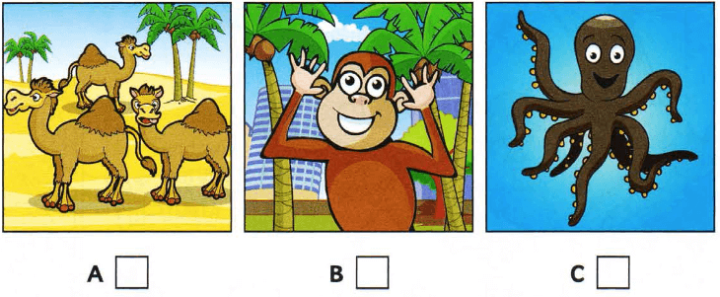

**Question 3**: Where did Sue and her friends play?

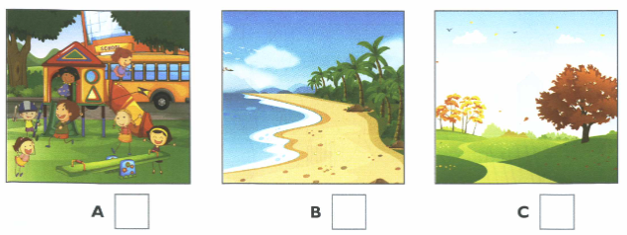

**Question 4**: What’s Peter going to do after lunch?

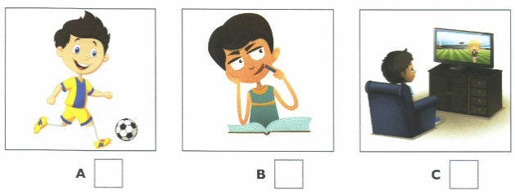

**Question 5**: What did Grace like best in the museum?

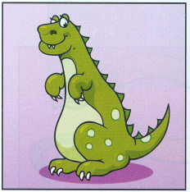  

**A**  **B** **C**

***II. For each question, write the correct answer in the gap. Write one word or a number or a date or time. (5 points)***

You will hear a teacher talking to a group of students about summer jobs.

**Jobs for students with Sunshine Holidays.**

Work in: Children’s summer camps

Dates of jobs: 15th June – 20th (6)___________________

Staff must be: (7)_______________ years old.

Staff must be able to: (8) _____________________

Staff will earn: (9)____________________ per week.

Send: a letter and a (10)_____________________ of the Sunshine Holidays.

***III. Listen to the recording and choose the correct answer. (5 points)***

**Question 11**. Annie saw a film at ____________.

A. two o’clock. B. a quarter past three. C. half past five D. five o’clock

**Question 12**. The film was about ________________.

A. a sports star B. some animals C. history D. biology

**Question 13**. Annie thought the film ____________.

A. was too long B. wasn’t very interesting

C. needed better actors D. was too short

**Question 14**. Annie’s favorite film _____________.

A. makes her laugh. B. is a true story C. is very exciting D. is a fairy tale

**Question 15**. Annie prefers to watch films ___________.

A. at a cinema B. on her laptop C. on TV D. on her smart phone.

**IV. Lisen the conversation between Nga and her dad and decide True (T) or False (F) for each statement. *(5 points)***

**Question 16.** Nga’s Tet holiday starts tomorrow and ends after February 15th.

**Question 17**. Nga will clean, decorate her house and go shopping with her mother.

**Question 18.** Nga’s family will stay home on the second day of Tet.

**Question 19.** Her family will go to pagoda on the first day of Tet.

**Question 20.** They wish fun, laughter and happiness for their family.

**PART B. GRAMMAR, VOCABULARY AND LANGUAGE FOCUS *(25 points)***

***I. Choose the right option A, B, C or D for each blank to finish the sentences: (9 points)***

**Question 21.** The weather is ..................... today than yesterday.

**A.** much better **B.** very better **C.** too better **D.** so better

**Question 22.** The new instructor at the gym is excellent. He is very ……….with us.

**A.**confident **B.**patient **C.**positive **D.**careful

**Question 23.** ......... she plays the piano!

**A.** How beautiful **B.** How beautifully **C.** What good **D.** What well

**Question 24.** “How long does it take to go to the nearest bus station?”  
 - “……………..”

**A.**No, it isn't far. **B.**Yes, it is a long way.

**C.**I'm sorry, I don't know. **D.**Why do you ask me?

**Question 25.** I don’t want much sugar in coffee. Just ........., please.

**A.** little **B.** a little **C.** few **D.** a few

**Question 26.** Do you have any toothpaste? I’d like a large ...................

A. tin B. roll C. bar D. tube

**Question 27.** Don’t ..................... electricity.

A. save B. waste C. use D. leave

**Question 28.** Lan combs her ............ every morning.

A. face B. nose C. hair D. mouth

**Question 29.** I don't feel good. I __________ home from school tomorrow.

A. am staying B. stay C. stayed D. have stayed

**II. Choose the correct answers to complete the conversation. *(3 points)***

Shop Assistant: Hello! How can I help you today?

Customer (Student): Hi, I’m looking for a new backpack for school.

Shop Assistant: Sure! We have different colors and sizes. What (30) ______ do you like?

Customer (Student): I like blue. Do you have a blue backpack?

Shop Assistant: Yes, we do! Here’s a blue one. It’s big enough for your books and it has a water bottle holder.

Customer (Student): That looks great! (31)________is it?

Shop Assistant: It’s $25.

Customer (Student): Okay, I’ll (32)_______ it. Thank you.

Shop Assistant: You’re welcome. Have a nice day!

**Question 30.** A. size B. color C. backpack D. shape

**Question 31.** A. How much B. How many C. How long D. How often

**Question 32.** A. take B. took C. taking D. taken

**III. Choose the correct answers to complete the school announcement. *(3 points)***

Dear Students,

This Friday, we will have a (33)_______ event in the school gym. There will be fun games, music, and snacks for everyone. The event will start from 2:00 PM (34) ______ 4:00 PM. Please (35) _______ your sports clothes and bring a water bottle. We hope to see you there and have a great time together!

Sincerely,

Your School Principal

**Question 33.** A. special B. especially C. specialization D. specialize

**Question 34.** A. in B. on C. to D. about

**Question 35.** A. wearing B. wear C. taking D. take

**IV. Underline 5 words that are incorrect in the following paragraph and correct it. *(5 points)***

The Vietnamese students take part in different after – school activities. Some students plays sports. They often play soccer, table tennis or badminton. Sometimes they go to the swimming pools . Some students like music and movies. They often practice music instruments in the school music room. They join in the school theater group and usually rehearse plays. A lots of them are members of the stamp collector ‘s club. They often get together and talk about his stamps. A few students stay at home and play video games or computer games. Most of them enjoy do their activities after school hours.

**Answer:**

Question 36. ……………………………………………………………………………

Question 37. ……………………………………………………………………………

Question 38. ……………………………………………………………………………

Question 39. ……………………………………………………………………………

Question 40. ……………………………………………………………………………

**V. Supply the correct form of the words in brackets to complete each sentence. *(5 points)***

**Question** 41. There is a……… ……rice paddy near my house. **BEAUTY**

**Question** 42. In the …… there is a museum, a factory and a stadium. **NEIGHBOR**

**Question** 43. The photocopy is between the ………….and the drugstore. **BAKE**

**Question** 44. Minh is ....................... at English than I am**. good**

**Question** 45. I go to visit my grandparents ...................a month. **ONE**

**PART C. READING *(25 points)***

***I. Fill in each blank with a suitable word to complete the letter. (5 points)***

Dear Mai,

I am visiting Ha Long Bay with my family (46)............. June 12th to 20th. Do you have a double room with a shower for these days? How (47)……… is the room? We would like the room facing the sea if it is possible. We do not eat meat but we (48) ……… all other kinds of food. We are arriving in Ha Long Bay at about six o’clock on Monday evening. We plan to leave the hotel (49)………Sunday morning.

I (50)…………..… forward to hearing from you soon.

Love,

Nga

***II. Choose the correct option for each blank to complete the passage. (10 points)***

It’s Sunday morning. The Browns are sitting in (51)……… living room. They are talking (52)…….. the dinner this evening. David likes beef and Susan does, too. He says that beef (53)……..good for children. Their father, Mr. Brown, prefers chicken to beef. He asks his wife to buy (54)…….. for him. Helen, their youngest daughter doesn’t want any meat. She would (55)……….. cakes and sweets. Mrs. Brown doesn’t like beef. She doesn’t like chicken, either. She likes fish, vegetables and fruit. She says that fish and vegetables (56)…………. good for old men and everybody (57)………. to eat fruit. At last they decide to go out (58)…….dinner (59)……….. Mrs. Brown says that she can’t cook so (60)…………food for everybody in the family.

**Question** 51. A. the B. a C. an D. to

**Question** 52. A. with B. for C. about D. to

**Question** 53. A. are B. has C. does D. is

**Question** 54. A. little B. some C. any D. none

**Question** 55. A. like B. likes C.have D. has

**Question** 56. A. is B. have C.are D. do

**Question** 57. A. need B. needs C. are D. have

**Question** 58. A. to B.of C. with D. for

**Question** 59. A. because B. but C. so D. and

**Question** 60. A. many B. little C. much D. lots of

***III. Read the following two passages and answer the questions. (10 points)***

Many countries all over the world celebrate the New Year holiday. In China, **it** is a very happy time. There are parades in the streets, and families gather for big dinners. At these dinners, children get “lucky money” in red envelopes. Before the New Year, the Chinese people always clean their houses to clean out bad luck. Everything must be fresh and clean. People also make sure they have paid all their bills. It is important to start the New Year without owing anyone money.

A lot of countries have holidays to bring good luck. In Thailand, people hold “Water Festival”. The festival takes place everywhere in Thailand, but especially **popular** in the north. Water Festival takes place in the middle of April. It is part of the Thai New Year. People throw buckets of water on each other. There are even parades where people throw water. It is especially important to throw water on older people. It shows respect to them.

**Question 61.** Where do people parade in China on New Year holiday?

|  |  |
| --- | --- |
| A. in the streets | C. in their families |
| B. in their houses | D. in theirs cities |

**Question 62.** What do Chinese children receive in red envelope?

|  |  |
| --- | --- |
| A. books | C. bad money |
| B. coins | D. lucky money |

**Question 63.** Why do the Chinese people clean their houses before the New Year?

|  |  |
| --- | --- |
| A. They welcome New Year | C. Their houses are too dirty |
| B. They wash out bad luck | D. Their houses are bad |

**Question 64.** What do they try to avoid when they start the New Year?

|  |  |
| --- | --- |
| A. paying all their bills | C. owning anyone money |
| B. cleaning their houses | D. bringing good luck |

**Question 65.** To bring good luck, what do many countries have ?

|  |  |
| --- | --- |
| A. holidays | C. envelopes |
| B. wishes | D. bills |

**Question 66.** When is the Water Festival held in Thailand?

|  |  |
| --- | --- |
| A. on April 5th | C. on April 15th |
| B. on April 10th | D. on April 20th |

**Question 67.** The word **“it”** refers to ______.

|  |  |
| --- | --- |
| A. China | C. holiday |
| B. time | D. New Year |

**Question 68.** The word **“popular”** has closet meaning _______.

|  |  |
| --- | --- |
| A. famous | C. peaceful |
| B. crowded | D. noisy |

**Question 69.** Why is it important to throw water on older people?

|  |  |
| --- | --- |
| A. It shows respect to them | C. It brings them good things |
| B. It is the rule | D. It is a beauty |

**Question 70**. What is a key difference between the New Year in China and the Water Festival in Thailand?

A. The New Year in China includes family dinners.

B. The Water Festival involves throwing water.

C. Both celebrations occur in April.

D. Only the Water Festival has parades.

**PART D: WRITING *(30 points)***

***I. Rewrite the sentences, so that their meaning stays the same, using the beginning given for each. (5 points)***

**Question 71.** My mother is always busy from morning till night.

→ My mother is never …………………………………………………………….

**Question 72.** The Red River is 1,149 kilometers long. The Nile River is 6,650 kilometers long.

→ The Nile River is much …………………………………………………………

**Question 73.** The library lends books to both students and teachers.

→ Both students and teachers can ………………………………………………….

**Question 74.** “It would be a good idea to take more exercise”.

→ “You …………………………………………………………………………..”

**Question 75.** The children like to watch dragon dance in the street at Tet.

→ The children enjoy …………………………………………………………

***II. You received an email from your English friend. Read a part of her email below. (10 points)***

*I know that you are having the first summer camp. Please tell me something about it. Who are you staying with? Which activities are you taking part in? how do you feel about it?*

Write a letter to answer your friend’s question.

(you should write 60 – 80 words)

***III. Write a paragraph to talk about a city that you visited in the past****.* ***(15 points)***

(you should write 80-100 words)

**HƯỚNG DẪN CHẤM ĐỀ HSG 6**

**NĂM HỌC: 2024 – 2025**

**MÔN: TIẾNG ANH**

**PART A. LISTENING. (*20 points)***

**I. Listen 5 short conversations and choose the correct pictures.**

1. B 2- B 3- B 4-C 5-C

**II. Listen and write one word or a number or a date or time.**

6. August 7.19/nineteen 8. drive 9. £65 10. photo

**III. Listen to the recording and choose the correct answer.**

11. B

12. A

13. C

14. B

15. A

**IV.** **Lisen the conversation between Nga and her dad and decide True (T) or False (F) for each statement.**

16. F 17. T 18. F 19. T 20. T

**PART B: VOCABULARY AND GRAMMAR *(25 points)***

**I. Circle best option A, B, C or D to complete the following sentences. (20pts)**

21.A 22.B 23.B 24.C 25.B 26.D 27.B 28.C 29. A

**II. Choose the correct answers to complete the conversation.**

30. B 31. A 32. A

**III. Choose the correct answers to complete the school announcement.**

33. A 34. C 35. B

**IV.** **Underline 5 words that are incorrect in the following paragraph and correct it.**

36. plays- play 37. music- musical 38. lots- lot

39. his- their 40. do- doing

**V.** **Supply the correct form of the words in brackets to complete each sentence.**

41. BEAUTIFUL 42. NEIGHBORHOOD 43. BAKERY

44. BETTER 45. ONCE

**PART C. READING *(25 points)***

***I.* Fill in each blank with a suitable word to complete the letter.**

46. from 47. much 48. eat 49. on 50. look

**II. Read the following passage and choose the correct option for each blank to complete the passage.**

51.A 52.C 53.D 54. B 55.A 56.C 57.B 58.D 59.A 60.C

**III.** ***Read the following two passages and answer the questions.***

61.A 62.D 63.B 64.C 65.A 66.C 67. D 68.A 69.A 70. B

**D. WRITING *(30 points)***

**I. Rewrite the sentences, so that their meaning stays the same, using the beginning given for each.**

71. My mother is never free from morning till night

72. The Nile River is much longer than the Red River

73. Both students and teachers can borrow books from the library

74. You should take more exercise

75. The children enjoy watching dragon dance in the street at Tet

**II*.* You received an email from your English friend. Read a part of her email below.**

I know that you are having the first summer camp. Please tell me something about it. Who are you staying with? Which activities are you taking part in? how do you feel about it?

Write a letter to answer your friend’s question.

(you should write 60 – 80 words)

**Tổng 10 điểm. Có phương án chấm phù hợp với nội dung của đề.**

+ Cover all information: 4 points.

+ Grammar and vocabulary: 4 points.

+ Style and format: 2 points.

***III. Write a paragraph to talk about a city that you visited in the past****.*

(you should write 80-100 words)

Chú ý: Học sinh không được giới thiệu tên và thông tin cá nhân của chính mình trong bài viết.

* Viết đúng chủ đề bài viết, nội dung rõ ràng, lôgic (8đ)
* Viết đúng cấu trúc bài viết, sử dụng tốt liên từ (5đ)
* Bài viết không mắc lỗi ngữ pháp, chính tả (2đ)