MOCK TEST 1
Mark the letter A, B, C, or D on your answer sheet to indicate the word whose underlined part differs from the other three in pronunciation in each of the following questions.
1. A. invented B. messaged C. ploughed D. trained
2. A. guitar B. cruel C. truth D. flute
Mark the letter A, B, C, or D on your answer sheet to indicate the word that differs from the other three in the position of primary stress in each of the following questions.
3. A. guarantee B. volunteer C. committee D. awardee
4. A. transmit B. oppose C. display D. feedback
Mark the letter A, B, C, or D on your answer sheet to indicate the correct answer to each of the following questions.
5. She said that she ________ visit me the following day.
A. would B. will C. was D. did
6. My sister arrived ________ Paris on a beautiful morning ________ September.
A. at - on B. in - in C. at - at D. on – in
7. A cousin of ________ has helped with fixing the Internet connection in ________ apartment.
A. ours - our B. our - ours C. her - his D. my – mine
8. Our smart TV might help us ________ food from the supermarket.
A. send B. borrow C. order D. produce
9. "Would you like to join my team?” - “________”
A. Really? What a pity! B. I'd love to. Thank you.
C. No, I wouldn’t. D. I like you said so.
10. There was a small room into ________ we all crowded.
A. which B. where C. that D. whom
11. The company offers its employees free language training but few people ________ advantage of it.
A. make B. take C. do D. keep
12. If she had some more money, she ________ a better car.
A. will buy B. would buy C. buys D. bought
Read the following announcement and mark the letter A, B, C, or D on your answer sheet to indicate the correct option that best fits each of the numbered blanks from 13 to 16.

FLOOD SAFETY INFORMATION
1. Tune in to your local news or radio station (13) ________ weather updates and official advice. If you are advised to evacuate, grab your emergency kit and ID papers and do so immediately.
2. If you have the time and are able to do so safely, unplug appliances and turn off any (14) ________ like electricity, gas and water before evacuating.
3. To avoid standing, flowing or rising water, move to higher ground. Never try to walk, swim or drive through fast-moving flood water. If you are in your vehicle and it is filling with water, get onto (15) ________ roof. If you are trapped in a building, get to the highest level and only go onto the roof if necessary. Do not go into a/an (16) ________ space at the highest level of your home, such as a loft or attic, as this could result in being trapped by rising floodwater.

13. A. from B. about C. for D. of
14. A. appliances B. utilities C. facilities D. services
15. A. ∅ B. a C. an D. the
16. A. enclosed B. close C. closing D. enclose
Mark the letter A, B, C, or D on your answer sheet to indicate the correct answer to the questions from 17 to 18.
17. Put the sentences (a-c) in the correct order, then fill in the blank to make a logical text.
Do you love traveling to cities but can't decide on your next destination? While popular choices like London, Paris, or Rome are often suggested, my personal favorite is Barcelona. ________
a. Can you imagine walking through the historic Gothic Quarter, then relaxing on the Barceloneta beach, and later visiting one of Gaudi’s masterpieces?
b. In addition, the local cuisine, especially the tapas, is one of the best foods I’ve ever tried.
c. This Spanish treasure offers an incredible combination of culture, architecture, and entertainment.
A. c-a-b B. b-a-c C. a-c-b D. c-b-a
18. Choose the sentence that can end the text (in Question 17) most appropriately.
A. However, living in Barcelona can be very hard.
B. In my opinion, it’s an experience you shouldn’t miss.
C. Finally, you strap up your basket and go home.
D. The architecture is breathtaking and memorable.
Mark the letter A, B, C, or D on your answer sheet to indicate the correct answer that best fits each of the numbered blanks.
The high-technology industry was already around San Francisco. Intel was founded in 1968, and in the same year Stanford University built the first computer mouse. In 1970, Xerox opened a research center (19) ________ was located in Palo Alto. There were also other companies, like Hewlett Packard, and Fairchild, the world's first "semiconductor" company. (20) ________, in 1976, an (21) ________ student called Steve Jobs started a small computer company in his garage; he gave it the same name (22) ________ the Beatles' record company: Apple. Very soon, more companies, like Seagate and Google, (23) ________. "Silicon Valley” had arrived. There was even (24) ________ primitive Internet connecting many addresses in Silicon Valley, called the Arpanet.
(Adapted from https://linsuapress.com/intermediate/silicon-valley.htm)
19. A. which B. where C. who D. whom
20. A. Then B. However C. Yet D. Therefore
21. A. electric B. electrical C. electronics D. electricity
22. A. to B. with C. of D. as
23. A. happened B. appeared C. established D. came
24. A. kind of B. a sort of C. a lot of D. a variety of
Mark the letter A, B, C or D on your answer sheet to indicate the sentence that is closest in meaning to the original sentence in each of the following questions.
25. You should study hard, or you won’t pass the exam.
A. If you don’t study hard, you will pass the exam.
B. If you should study hard, or you won’t pass the exam.
C. If you should study hard, you won't pass the exam.
D. If you study hard, you will pass the exam.
26. It takes Lan 15 minutes to travel to work by bike every day.
A. Lan spends 15 minutes to travel to work by bike every day.
B. Lan spends 15 minutes travel to work by bike every day.
C. Lan spends 15 minutes travelling to work by bike every day.
D. Lan takes 15 minutes travelling to work by bike every day.
Mark the letter A, B, C or D on your answer sheet to indicate the sentence that is best written from the words/phrases given.
27. What / he / do / 6 o'clock yesterday morning?
A. What is he doing at 6 o’clock yesterday morning?
B. What does he do at 6 o’clock yesterday morning?
C. What was he doing at 6 o’clock yesterday morning?
D. What did he do at 6 o’clock yesterday morning?
28. By 2030, the way I teenagers / communicate / each other / different I now.
A. By 2030, the way teenagers communicate with each other will be different from now.
B. By 2030, the way teenagers communicate with each other is different from now.
C. By 2030, the way teenagers communicate to each others will be different from now.
D. By 2030, the way teenagers communicate to each other will be different than now.
Read the following sign or notice and mark the letter A, B, C, or D on your answer sheet to indicate the correct answer to each of the following questions.
29. What does the note say?
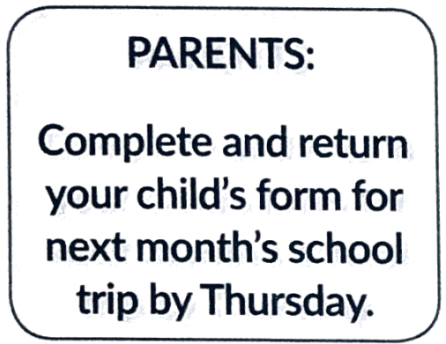 | A. Parents must return forms this week if their child is going on Thursday’s trip.  B. Parents cannot go on next month’s trip unless they return their forms by Thursday.  C. The deadline for submitting the forms for the trip is Wednesday.  D. The last day for returning completed forms for the trip is Thursday.
30. What does the notice say?
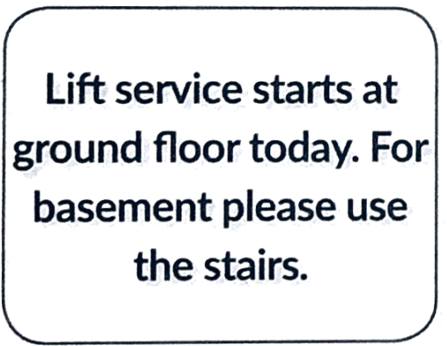 | A. It is not possible to use the lift above the ground floor today.  B. The lift will not be going to the upper floors today.  C. The lift will only operate between the ground floor and upper floors today.  D. The stairs between the basement and the ground floor are closed today.
Read the following passage and mark the letter A, B, C, or D on your answer sheet to indicate the correct answer to each of the following questions from 31 to 36.
Many pre-teens and teenagers enjoy spending their free time doing things like shopping, going to parties, being with friends, gaming and using social media, texting, watching movies, reading and going to the beach or park. Pre-teens and teenagers might also spend their free time doing structured extracurricular activities like arts and sports, community activities or volunteering, or casual work.
Spending some free time together is a great way to stay connected with your child. Doing something one-on-one with parents can be a treat for your child. You could go to a movie or concert, cook a meal together, go for a walk, look through family photos, or work together on a project like redecorating your child’s room. It just depends on what interests you and your child have in common.
These activities might not happen spontaneously. You might need to discuss ideas with your child and plan to spend some time together. If spending free time with you is a new thing, your child might need some encouragement before they're keen. If this is an issue, you could plan short activities you know your child is likely to enjoy to start with. Besides, you could ask your child whether they’d like to invite a friend along. If you spend time together often enough, your child will probably start to feel more enthusiastic, so keep trying. You might need to try a range of activities before you find one you both like.
(Adapted from https://raisin3children.net.au/pre-teens/entertainment-technolo3y/free-time- activities/free-time)
31. What is the main idea of the reading passage?
A. How parents bond with their children in their free time
B. How pre-teens and teens connect with their friends
C. How pre-teens and teens spend their free time at home
D. How parents encourage their children to join activities
32. What is the activity that many pre-teens and teenagers enjoy during their free time?
A. Cleaning their rooms B. Volunteering
C. Attending business meetings D. Going to school
33. Which of the following activities is suggested as a way for parents to spend quality one-on-one time with their child?
A. Going through family photos B. Working alone on a project
C. Attending a professional conference D. Letting their child watch movies with friends
34. The word "treat" in paragraph 2 is CLOSEST in meaning to.
A. pleasure B. bargain C. power D. help
35. The word “spontaneously” in paragraph 3 is OPPOSITE in meaning to _______.
A. readily B. quickly C. naturally D. awkwardly
36. Which of the following activities is NOT true about the way parents can encourage their child to be more enthusiastic about spending free time together?
A. Planning activities the child likes
B. Inviting the child’s friends along
C. Letting the child plan the activities
D. Spending time together often enough
Four phrases/sentences have been removed from the text below. For each question, mark the letter A, B, C, or D to indicate the correct option that best fits each of the numbered blanks from 37 to 40.
Air pollution is a major global health threat, (37) ________. Scientific studies from the World Health Organization show that fine particulate matter (PM2.5) and harmful gases like nitrogen dioxide and sulfur dioxide contribute to respiratory and cardiovascular diseases. Urban areas with high traffic and industrial activities are especially affected, (38) ________. The implications are clear: to protect public health, governments need to implement stricter air quality regulations and invest in cleaner energy sources. (39) ________. On an individual level, people can contribute by reducing car use, supporting clean energy initiatives, and using energy-efficient appliances. (40) ________.
A. leading to increased hospital admissions for conditions like asthma and heart attacks
B. linked to millions of premature deaths each year
C. These actions not only reduce pollution but also improve overall quality of life and help combat climate change.
D. Cities can reduce vehicle emissions by promoting public transportation and creating green spaces.
37. ___________ 38. ___________ 39. ___________ 40. ___________

