SỞ GIÁO DỤC VÀ ĐÀO TẠO | KỲ THI TUYỂN SINH LỚP 10 THPT
KHÁNH HOÀ | NĂM HỌC 2025 - 2026
ĐỀ CHÍNH THỨC | Môn thi: TIẾNG ANH
ĐỀ CHÍNH THỨC | Thời gian làm bài: 60 phút

A. MULTIPLE CHOICE QUESTIONS (8.00 POINTS)
Write the letter A, B, C or D on your answer sheet to indicate the option that best fits each of the following questions from 1 to 10.
Question 1: Going for a walk in nature is ________ relaxing than staying indoors all day.
A. fewer B. the more C. most D. more
Question 2: I ___________ a cartoon when he came last night.
A. am watching B. was watching C. watch D. watched
Question 3: The students are looking forward _______ a break after their exams.
A. to having B. to have C. have D. having
Question 4: The view from the top of the hill was majestic, ________ we stopped to take photos for an hour.
A. so B. but C. as D. or
Question 5: It's important to _______ what measures could help reduce air pollution in our city.
A. hand in B. set off C. find out D. get about
Question 6: To be healthy, try to _________ the amount of fat in your daily diet.
A. rise B. reject C. refuse D. reduce
Question 7: We're planning to visit the museum _________ Sunday mornings to avoid the crowds.
A. over B. on C. in D. at
Question 8: I met Tom two days ago and he said he was going to London ________.
A. yesterday B. tonight C. tomorrow D. the following day
Question 9: Da Nang City, ________ is famous for its international fireworks festival, attracts thousands of visitors every year.
A. where B. that C. what D. which
Question 10: If she ________ up some Spanish, she'll find it easier to communicate during her next trip to Mexico.
A. picks B. pick C. would pick D. picked
Write the letter A, B, C or D on your answer sheet to indicate the underlined part that needs correction in each of the following questions from 11 to 12.
Question 11: Protecting wildlife animals are crucial for maintaining biodiversity.
A. wildlife B. are C. biodiversity D. for
Question 12: What a nice weather! Why don't we go cycling in the park?
A. weather B. in C. a D. go cycling
Write the letter A, B, C or D on your answer sheet to indicate the best arrangement of sentences to make a logical text in each of the following questions from 13 to 14.
Question 13: To choose a career wisely, students must think carefully and plan ahead. __________
a. Finally, getting advice from the teachers or professionals can help students make better career choice.
b. To begin with, students should discover their interests and strengths to find a suitable path.
c. Moreover, researching different careers and their job prospects can help in making an informed decision.
A. b – c – a B. a – b – c C. b – a – c D. c – a – b
Question 14: Our school held a sports day last weekend, and it was an exciting experience for everyone. Each activity was carefully planned. __________
a. After lunch, we enjoyed a friendly football match, with both teams playing very well.
b. At the end of the day, the winners received medals, and we celebrated together.
c. In the morning, we started with a warm-up session followed by a running race.
A. b – a – c B. a – c – b C. c – a – b D. b – c – a
Write the letter A, B, C or D on your answer sheet to indicate the word CLOSEST in meaning to the underlined words in the following question.
Question 15: They agreed to clean up the park for their community service project right away.
A. uncertainly B. immediately C. doubtfully D. unconfidently
Write the letter A, B, C or D on your answer sheet to indicate the word OPPOSITE in meaning to the underlined word in the following question.
Question 16: One major benefit of modern technology is that it allows people to communicate instantly across the globe.
A. opportunity B. advantage C. priority D. disadvantage
Write the letter A, B, C or D on your answer sheet to indicate the most suitable response to complete the following exchange.
Question 17: Nam and Tom are in front of the school gate.
- Nam: "I have just received a scholarship to study abroad."
- Tom: "_____________”
A. Thanks for letting me know. I must go now.
B. Wow. Congratulations on your achievement!
C. No worries, it's just a scholarship.
D. My pleasure. That's the least I can do.
Write the letter A, B, C or D on your answer sheet to indicate the best answer to each of the following questions from 18 to 19.
Question 18: What does the sign say?
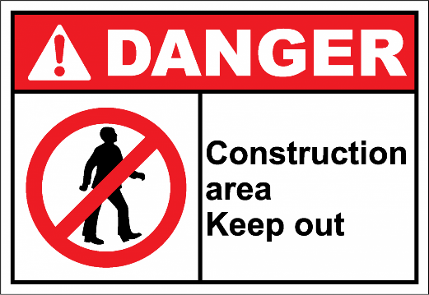
A. Visitors are allowed to access the construction area.
B. You are permitted to enter the construction zone as needed.
C. People are warned to stay out of the construction area.
D. Visitors are encouraged to explore the construction site safely.
Question 19: What does the notice say?
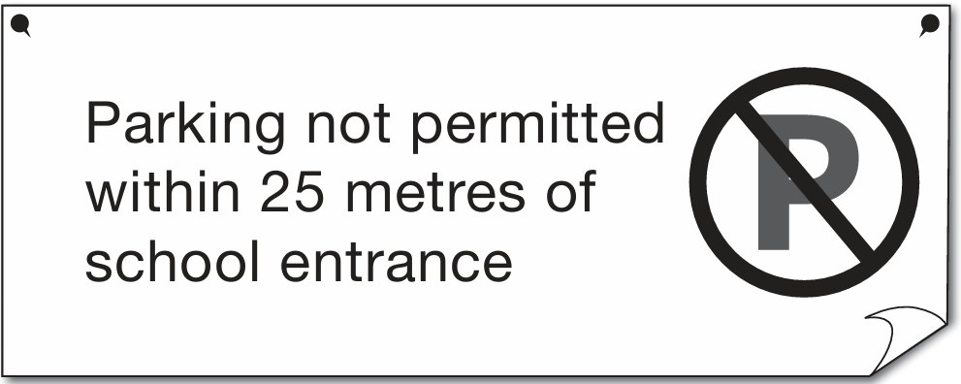
A. You must park inside the school entrance.
B. You can park very close to the school entrance.
C. You must park at least 25 metres away from the school entrance.
D. You can park in front of the school entrance.
Read the following announcement and write the letter A, B, C or D on your answer sheet to indicate the option that best fits each of the numbered blank from 20 to 23.

ANNOUNCEMENT
If You Smell Gas at Home
Do not turn (20) ___________any lights or devices.
Open the windows and doors.
Leave (21) _________ house immediately.
(22) ___________ emergency services or the gas company once you are outside.
Stay away from the house until it is (23) __________.
Question 20:
A. on B. down C. out D. up
Question 21:
A. an B. Ө C. a D. the
Question 22:
A. Listen B. Watch C. Call D. Observe
Question 23:
A. unsafe B. safe C. safety D. safely
Read the following passage and write the letter A, B, C or D on your answer sheet to indicate the correct phrase or sentence that best fits each of the numbered blanks from 24 to 27.
As the COVID-19 pandemic spread around the world in 2020, many governments decided (24)_______. This meant that children had to study at home with the help of their parents and remote-learning tools. Teachers used tools such as Google Meet or Google Classroom (25) __________. However, some children from lesswealthy families did not have access to computers. (26) _________ because libraries were closed. Although children from wealthier families were able to continue their education relatively successfully during the pandemic, (27) _________. And some may even find themselves at a permanent disadvantage.
A. to close schools to help protect their populations
B. it may take years for less-wealthy children to catch up
C. to teach and monitor their students during the closures
D. These children could also not get hold of the books they needed
Question 24: ____ Question 25: ____ Question 26: ____ Question 27: ____
Read the following passage and write the letter A, B, C or D on your answer sheet to indicate the correct answer to each of the questions from 28 to 32.
In recent years, more and more teenagers buy things online. With just a few clicks, they can buy clothes, shoes, gadgets, and more from the comfort of their own homes. This trend is not only convenient but also exciting for many young people.
One of the reasons why teenagers prefer online shopping is the wide variety of choices. They can easily browse through hundreds of websites to find the latest fashion trends or the coolest gadgets. Online stores often offer discounts and promotions, which attract young shoppers who are always looking for a good deal.
Another unique aspect of online shopping for teenagers is the influence of social media. Many teenagers follow fashion influencers and celebrities on platforms like Instagram or TikTok. When they see their favorite influencers wearing certain brands, they want to buy the same items. This has made online shopping a social activity, where teenagers discuss and share their shopping experiences with friends.
However, there are also some concerns. Teenagers may spend too much time shopping online or waste money on things they don't really need. Despite these challenges, online shopping continues to grow in popularity among teenagers, shaping the way they shop in the modern world.
Question 28: What is the main idea of the passage?
A. Instagram and TikTok encourage teenagers to shop online.
B. Online shopping is a social activity.
C. Online shopping is becoming popular with teenagers nowadays.
D. Teenagers buy clothes and gadgets online.
Question 29: The word variety in paragraph 2 is closest in meaning to __________.
A. diversity B. control C. restriction D. limit
Question 30: The word they in paragraph 3 refers to __________.
A. platforms B. many teenagers
C. fashion influencers D. celebrities
Question 31: According to the passage, the effect of social media on teenage shoppers is __________. A. making them buy the same items as their favorite influencers wear
B. helping them realize the challenges of online shopping
C. making them shop in physical stores with celebrities
D. helping them save money on online shopping
Question 32: According to the passage, which of the following is NOT true?
A. Teenagers follow fashion trends of celebrities.
B. Teenagers are attracted by discounts or promotions.
C. Online shopping is an exciting trend for teenagers.
D. Teenagers only spend money buying things they need.
B. WRITTEN TEST (2.00 POINTS)
Complete each of the following sentences with the suitable form of the word in the bracket. Write your answers on your answer sheet.
Question 33: Most endangered species, under ________ by law. (PROTECT)
Question 34: The event was __________ held thanks to her organizational skills. (SUCCESS)
Question 35: That's what makes the game so __________ for the fans. (EXCITE)
Question 36: An adult elephant can _________ up to 6,000 kilos on average. (WEIGHT)
Finish the second sentence in such a way that it means exactly the same as the sentence printed before it, beginning with the words given. Write your answers on your answer sheet.
Question 37: It took me half an hour to wash the dishes yesterday.
→ I spent .
Question 38: If she doesn't watch TV every day, she won't know much news.
→ Unless .
Question 39: Although they have a car, they seldom use it.
→ In spite of .
Question 40: They asked him, "How do Vietnamese people express those words?"
→ They asked him .

