**Tiếng Anh 8 – i-LEARN SMART WORLD**

***MID-SEMESTER 1 TEST - KEYS***

**I. PRONUNCIATION**

***A. Choose the word whose underlined part differs from the other three in pronunciation in each of the following questions.***

1. A. cinemas B. games C. sports D. friends

2. A. chef B. church C. chair D. chore

3. A. Christmas B. stomach C. school D. choose

***B. Choose the word that differs from the other three in the position of the main stress in each of the following questions.***

4. A. entertainment B. transportation C. facility D. conversation

***C. Choose the word whose primary stress is placed on the first syllable.***

5. A. descriptive B. recipe C. supporting D. concluding

**II. USE OF ENGLISH**

***Choose the best option (A, B, C or D) to complete each of the following questions.***

1. We finished third in the tug ______ war competition last year.

A. from B. to C. in D. of

1. You should use ____________ more to save the environment.

A. vehicles B. cars C. airplanes D. public transportation

1. Rock ___________ is her favorite sport.

A. climbing B. fishing C. hanging D. chatting

1. Jess is not an active person, so she hates ___________.

A. playing sports B. watching TV C. reading books D. doing arts and crafts

1. Duc Anh and his friends like to __________ board games in their free time, and he often wins.

A. do B. go C. play D. design

1. I'd like to live in the country because the air is so ________ there.

A. peaceful B. fresh C. exciting D. relaxing

1. There weren't __________ chairs in the room, so some of us had to stand.

A. much B. too much C. enough D. lots

1. They dislike watching a movie ________ because the movie theater is often too crowded.

A. on the weekend B. in the weekend C. in weekend mornings D. at weekend morning

1. Young people in Greenville _________ badminton at the park.

A. often play B. play often C. often playing D. playing often

1. People in the countryside prefer __________ the rice they grow in their fields.

A. eats B. eat C. ate D. to eat

1. We won’t leave the movie theater ________ the action movie ends.

A. during B. until C. to D. from

1. Their flight to Da Lat ________ at 6.50 a.m. tomorrow.

A. is leaving B. leave C. will leave D. leaves

**III. WORD FORMATION**

***Write the correct form of the words in brackets.***

1. Tiktok is a popular source of entertainment among teenagers. (ENTERTAIN)
2. Ms. Trang keeps her rings and necklaces in a jewelry/ jewellery box. (JEWEL)
3. Students should learn to protect the environment and save natural resources. (NATURE)

**IV. ERROR RECOGNITION**

***Find the underlined part that needs correction in each of the following questions.***

1. When I was younger, I played usually spinning tops with my brother.

A B C D

1. Do you want to play shuttlecock on the school yard tomorrow on around 5 p.m.?

A B C D

**V. READING**

***Read the start of a short story and choose the best answer, A, B, C, or D, for each question****.*

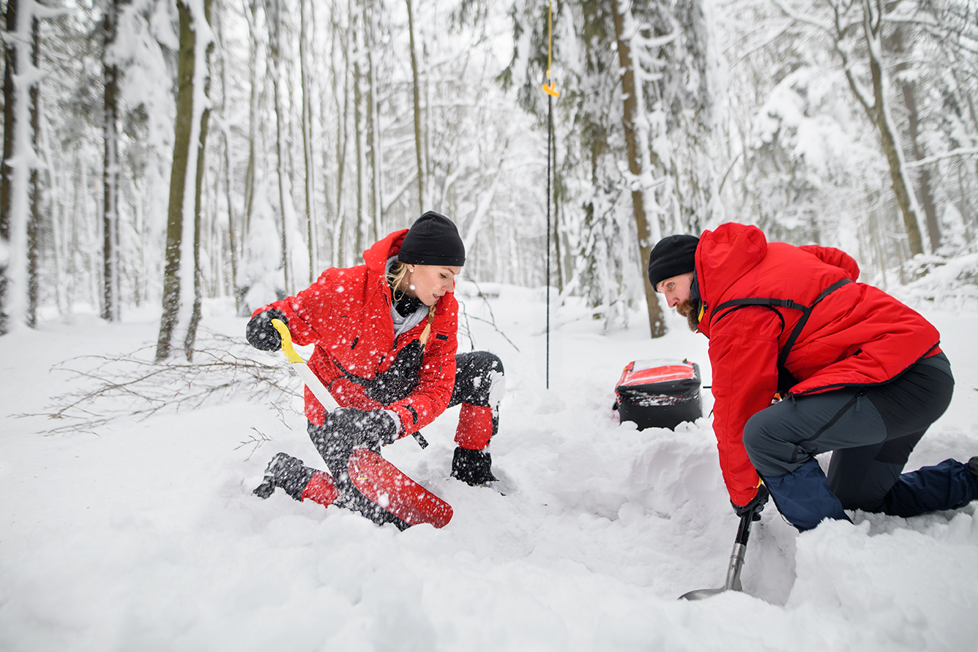

**A long red rope**

|  |
| --- |
| Sarah was ready for her first lesson on the mountain. She knew the basic things about skiing now after spending seven days at the ski camp, but that day, she wanted to come down one of the ski runs just once before the end of her holiday the next day.  She put on her warm jacket and trousers. She had special glasses to stop the sunlight that came from the snow hurting her eyes. Then she made sure her skis were on correctly.  When Sarah’s ski instructor, Kurt, gave Sarah a piece of red rope 10 meters long and said, ‘Put this on your belt,’ she laughed and said, ‘Why do I need that?’ Her instructor did not laugh. ‘It’s the most important piece of equipment for any skier. It may be the difference between life and death.’  Kurt explained that the area had a lot of big avalanches. Sarah said, ‘I know, but if there is a problem, you will save me!’  Kurt explained that sometimes instructors and learners lose each other on the mountain. ‘You can’t ski faster than an avalanche,’ he said. Sarah took out her cell phone and said, ‘I can call you … or somebody … on this.’ Kurt smiled and said, ‘Sometimes cell phones don’t work when you are under four meters of snow. But the red rope will be on the surface, and the rescue teams will see it from a long way away, and they will find you.’ |

23. How long was Sarah’s holiday?

* 1. A week.
  2. Eight days.
  3. Nine days.
  4. Ten days.

24. What was the weather like that day?

1. Cold and cloudy.
2. Warm and sunny.
3. Cold and sunny.
4. It is not clear from the story.

25. The instructor gave Sarah the piece of rope

1. to use as a belt.
2. because it was very cold.
3. to make her laugh.
4. as a piece of safety equipment.

26. Sarah thought

1. avalanches didn’t happen in the area.
2. avalanches in the area were very small.
3. Kurt was a good instructor.
4. she was safe with Kurt.

27. What did Sarah think she could do if there was an avalanche?

1. Call for help on her cell phone.
2. Ski down the mountain before the snow hit her.
3. Contact Kurt.
4. Put the red rope on top of the snow.

**VI. LISTENING**

***You will hear five people talking about living in the country. Match each speaker, 1 to 5, with one of the good things, A to F.***

|  |  |  |  |  |  |
| --- | --- | --- | --- | --- | --- |
| 28. | Speaker 1 |  | E |  | 1. peace and quiet |
| 29. | Speaker 2 |  | F |  | 1. wildlife |
| 30. | Speaker 3 |  | B |  | 1. wildflowers |
| 31. | Speaker 4 |  | A |  | 1. no traffic problems |
| 32. | Speaker 5 |  | C |  | 1. kind people |
|  |  |  |  |  | 1. the sky at night |

**VII. WRITING**

***A. Rewrite the following sentences without changing their meaning. Use the given word(s) if any.***

33. Sewing is Hoa's favorite activity in her free time.

→ Hoa enjoys sewing in her free time.

34. When did you start to bake chocolate cookies? (AGO)

→ zcv did you start to bake chocolate cookies?

35. Mr. Dat prefers going by motorbike to driving a car.

→ . Mr. Dat prefers to go by motorbike rather than drive a car.

36. You can join the lantern parade at the festival. (TAKE)

→ You can take part in the lantern parade at the festival.

***B. Use the given words or phrases to make complete sentences.***

37. John / love / collect / old stamps.

→ John loves collecting old stamps.

→ John loves to collect old stamps.

38. There / a lot / outdoor / activity / for / children / the countryside / .

→ There are a lot of outdoor activities for children in the countryside.

→ There are a lot of outdoor activities for the children in the countryside

***C. Put the words in the correct order to make correct sentences.***

39. Let's / on/ 6.45 a.m./ at/ meet / Saturday morning / .

→ Let's meet at 6.45 a.m. on Saturday morning.

40. There / too / people / in / are / this gym / many / .

→ There are too many people in this gym.

**\*Audio scripts\***

**Speaker 1:**

Are people the same everywhere? Maybe. But I lived in the city for a long time, and I didn’t make friends with anyone, even the people in my apartment building. Here, in this small village, everyone knows everyone else, and everyone helps you if you have a problem.

**Speaker 2:**

Before I came to live in the country, I thought, ‘The best thing will be no traffic!’ Well, it’s true, there is very little traffic here except farm vehicles now and then. But the best thing is actually going out in the evening and looking up at the moon and the stars. The lights of the city hid most things in the night sky.

**Speaker 3:**

I wake up every morning to birdsong, I see rabbits and deer on my way to work and back home, and I go to sleep to the sound of foxes in my garden. I love it!

**Speaker 4:**

Do I need to tell you the best thing? Really? Just listen. What can you hear? Almost nothing. Except for the wildlife and the farm animals, there’s no noise at all. It’s wonderful.

**Speaker 5:**

When I lived in the city, I bought flowers every week. I wanted to bring the country into my apartment. Now, I don’t buy flowers, and I certainly don’t pick them, but they are just there for me, everywhere I go.