UNIT 8. FILMS
PART 1. THEORY
I. VOCABULARY
No. | English | Type | Pronunciation | Vietnamese
1 | action film | n | /'ækʃn fɪlm/ | phim hành động
2 | actor | n | /'æktə(r)/ | diễn viên nam
3 | actress | n | /'æktrəs/ | diễn viên nữ
4 | animation | n | /.ænɪ'meɪʃn/ | phim hoạt hình
5 | bored | adj | /bɔ:d/ | buồn chán (dùng cho người)
6 | boring | adj | /'bɔ:rɪη/ | buồn chán (dùng cho sự vật, sự việc)
7 | cameraman | n | /'kæmrəmæn/ | người quay phim
8 | character | n | /'kærəktə(r)/ | nhân vật
9 | cinema | n | /'sɪnəmə/ | rạp chiếu phim
10 | comedy | n | /'kɒmədɪ/ | hài kịch
11 | critic | n | /'krɪtɪk/ | nhà phê bình
12 | director | n | /də'rektə(r)/ | đạo diễn
13 | documentary | n | /.dɒkju'mentrɪ/ | phim tài liệu
14 | dull | adj | /dʌl/ | ngốc, đần
15 | entertaining | adj | /.entə'teɪnɪη/ | mang tính giải trí
16 | entertainment | n | /,entə'teɪnmənt/ | sự giải trí
17 | excellently | adv | /'eksələntlɪ/ | tuyệt vời
18 | family film | n | /'fæməlɪ fɪlm/ | phim đề tài gia đình
19 | film star | n | /fɪlm stɑ:(r)/ | diễn viên (phim) nổi tiếng
20 | frightened | adj | /'fraɪtnd/ | hoảng sợ (dùng cho người)
21 | frightening | adj | /'fraɪtnɪη/ | đáng sợ (dùng cho sự vật, sự việc)
22 | handsome | adj | /'hænsəm/ | đẹp trai
23 | hilarious | adj | /hɪ'leərɪəs/ | hài hước
24 | horror film | n | /'hɒrə(r) fɪlm/ | phim kinh dị
25 | moving | adj | /'mu:vɪη/ | động, cảm động
26 | must-see (n) | n | /mʌst si:/ | nên xem, phải xem
27 | nightmare | adj | /'naɪtmeə(r)/ | Cơn ác mộng
28 | perform | n | /pə'fɔ:m/ | trình diễn
29 | plot | n | /plɒt/ | cốt truyện, phim
30 | popcorn | n | /'pɒpkɔ:n/ | bỏng ngô
31 | romantic comedy | n | /rəʊ'mæntɪk  'kɒmədɪ/ | phim chủ đề tình yêu, phim lãng mạn
32 | scary | adj | /'skeərɪ/ | đáng sợ
33 | science-fiction, (sci-fi) | n | /'saɪəns 'fɪkʃn/, /saɪ faɪ/ | khoa học viễn tưởng
34 | screen | n | /skri:n/ | màn hình
35 | seat | n | /si:t/ | chỗ ngòi
36 | setting | n | /‘setɪη/ | bối cảnh
37 | shocking | adj | /'ʃɒkɪη/ | gây sốc
38 | success | n | /sək'ses/ | sự thành công
39 | successful | adj | /sək'sesfl/ | thành công
40 | surprised | adj | /sə'praɪzd/ | ngạc nhiên (dùng cho người)
41 | surprising | adj | /sə'praɪzɪη/ | ngạc nhiên (dùng cho sự vật, sự việc)
42 | terrible | adj | /'terəbl/ | kinh khủng
43 | thriller | n | /’θrɪlə(r)/ | truyện (kịch, phim...) giật gân, ly kỳ
44 | violent | adj | /'vaɪələnt/ | bạo lực

II. GRAMMAR
Although, though, however
1. Although, though
ALTHOUGH và THOUGH dùng để chỉ sự tương phản, đối lập giữa hai mệnh đề.
Cấu trúc và vị trí của ALTHOUGH/ THOUGH
Although/ Though + clause, main clause.
Hoặc: Main clause + although/ though + clause.
Ex 1: We enjoyed our holiday although it rained heavily.
(Chúng tôi thích kì nghỉ của mình mặc dù trời mưa to.)
Ex 2: Although he is poor, he studies very well.
(Mặc dù cậu ấy nghèo, cậu ấy học rất giỏi.)
Chú ý: Ta cũng có thể dùng in spite of hoặc despite để chỉ sự tương phản, đối lập.
Cấu trúc và vị trí của in spite of/ despite
In spite of! Despite + N/ Noun phrase/ V-ing, main clause.
Hoặc: Main clause + in spite of/ despite + N/ Noun phrase/ V-ing
Ex 1: We enjoyed our holiday in spite of the heavy rain.
(Chúng tôi thích kì nghỉ của mình mặc dù trời mưa to.)
Ex 2: Despite being poor, he studies very well.
(Mặc dù nghèo, cậu ấy học rất giỏi.)
2. However
a. Cách sử dụng
However được dùng để chỉ mối quan hệ đối lập giữa hai câu.
b. Cấu trúc và vị trí của however.
- Mệnh đề 1. However, mệnh đề 2.
- Mệnh đề 1. Chủ ngữ, however, động từ.
- Mệnh đề 1. Mệnh đề 2, however
Ex 1: I love England. However, the weather is bad.
Ex 2: I love England. The weather, however, is bad.
Ex 3: I love England. The weather is bad, however.
Chú ý: Ta cũng có thể dùng nevertheless thay cho however. 2 từ này có ý nghĩa và chức năng ngữ pháp tương tự nhau.
iii. PHONETICS

Cách phát âm âm /ɪə/ và /eə/
1. Cách phát âm nguyên âm đôi /ɪə/
Cũng như các nguyên âm đôi khác, âm /ɪə/ được tạo thành bởi sự kết hợp giữa 2 nguyên âm là /ɪ/ và /ə/.  Bước 1: Hai khóe miệng hơi kéo sang hai bên, nâng lưỡi cao để phát âm âm /ɪ/  Bước 2: Thu hai khóe miệng lại, hạ lưỡi về vị trí thư giãn. Đồng thời phát âm âm /ə/. | 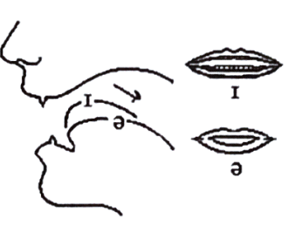
2. Cách phát âm nguyên âm đôi /eɪ/
Âm /eə/ là sự kết hợp giữa /e/ và /ə/. Để phát âm âm này, bạn làm theo hai bước sau:  Bước 1: Hai khóe miệng hơi kéo sang hai bên, lưỡi đặt ở độ cao trung bình đề phát âm âm /e/.  Bước 2: Thu hai khóe miệng lại, lưỡi hơi kéo về phía sau để phát âm âm /ə/. | 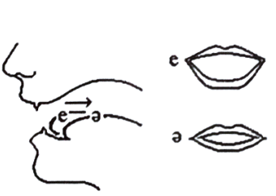
Listen and repeat these words. Track 04
/ɪə/ | fear | deer | hear | beer
 | /fɪər/ | /dɪər/ | /hɪər/ | /bɪər/
/eə/ | care | hair | their | wear
 | /keər/ | /heər/ | /ðeər/ | /weər/
PART 2. LANGUAGE
I. VOCABULARY
Exercise 1. Find the odd one out among A, B, C or D.
1. A. cinema | B. comedy | C. documentary | D. cartoon
2. A. actor | B. actress | C. character | D. audience
3. A. frightening | B. exciting | C. terrifying | D. swimming
4. A. documentary | B. romantic | C. science fiction | D. animation
5. A. enjoy | B. like | C. feeling | D. annoy
Exercise 2. Look at the pictures and put the word/phrase under each sign.
frightened | romantic | funny
surprised | bored | handsome

 | 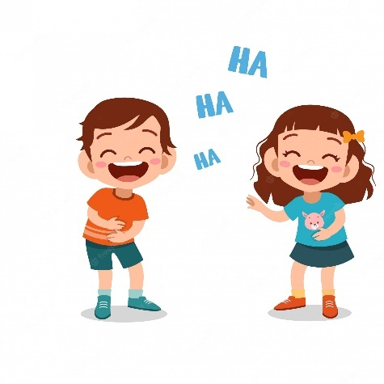 | 
1. | 2. | 3.
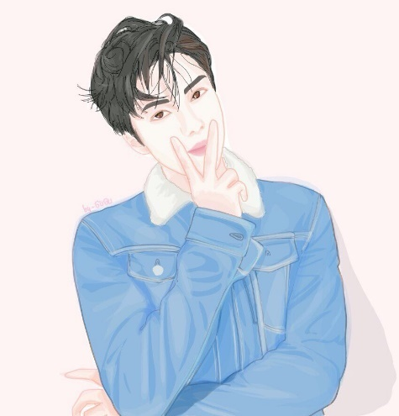 |  | 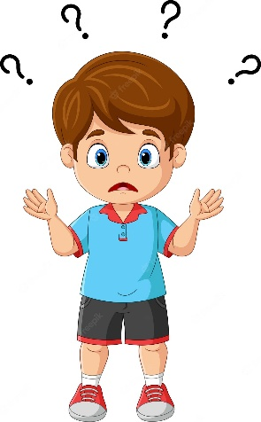
4. | 5. | 6.
Exercise 3. Read and complete with the words/ phrases in the box.
documentary | action film | cameraman | film star | family film
horror film | cinema | science-fiction | character | comedy

1. a man whose job is operating a camera for making films/ movies or television programmes
2. a film with lots of funny scenes
3. a film that both children and adults can enjoy
4. a film that frightens and shocks people
5. a film that's about real people, events or issues
6. one of the people in a story
7. a film with many exciting and violent scenes
8. a place where films are shown on a big screen
9. a very popular film actor or actress
10. a genre with stories set in the future or in outer space
Exercise 4. Put the words in brackets into the correct forms.
1. We were ____________ with the service at the cinema. Everything was terrible. (satisfy)
2. There are always cowboys in a ____________. (west)
3. The film is a big ____________. It is boring from beginning to end. (disappoint)
4. She started her ____________ career while still at school. (act)
5. The film is about two hijackers who ____________ to blow up the plane. (threat)
6. Horror films ____________ my younger sister. (terrible)
7. I don’t think it is good for young kids to see ____________ on TV. (violent)
8. We are going to the cinema to see an ____________ film. (amaze)
9. Although Titanic is a ____________ film, it has a sad ending. (romance)
10. He falls in love with a pretty girl. It’s a beautiful ____________. (romantic)
11. His recent film received a lot of ____________ from the public. (critic)
12. My favourite ____________ -fiction films have been from Mars. (scientist)
13. I don’t like horror films because they are too ____________ for me. (fright)
14. Dracula is the best ____________ film I’ve ever seen. (impress)
15. Do you know Daniel Day-Lewis? He has won three Oscars for best ____________. (act)
Exercise 5. Choose the best answer to complete each of the following sentences.
1. I am very ____________ interested learning English.
A. to B. in C. at D. for
2. At the party last night, she looked ____________ in the red dress.
A. love B. lovely C. loving D. lovelily
3. Is Minh ____________ with the final semester’s result?
A. satisfy B. satisfied C. satisfying D. be satisfying
4. The ending of the film is ____________. All audiences are very sad.
A. disappointed B. satisfying C. disappointing D. satisfied
5. This is a ____________ film and it makes me cry a lot.
A. funny B. moving C. comedy D. excited
6. ____________ he is a CEO and earns a lot of money, he is very mean.
A. Because B. Although C. Despite D. Because of
7. This is a(n) ____________ on real life during wars in our country in 1945.
A. horror film B. sci-fi C. comedy D. documentary
8. In 2002, Halle Berry made history when she became the first Black woman to ____________ the Oscars best actress award.
A. win B. act C. perform D. direct
9. She is hard-working. ____________, she isn’t lucky in examinations.
A. Therefore B. But C. However D. So
10. She decided to quit this job ____________ the low salary.
A. because of B. despite C. because D. although
11. My son feels very happy when he sees that ____________ with a lot of cute animals.
A. horror film B. biopic C. thriller film D. animation
12. Most ____________ say that this film is worth watching.
A. plots B. settings C. critics D. acting
13. He acts very well. I’m sure that yesterday he stayed up all night reading the ____________.
A. acting B. character C. survey D. script
14. Before you go to the cinema, you can watch the trailer and read ____________ of the film.
A. reviews B. disaster C. critic D. character
15. That was a ____________ and boring horror film so I slept from the beginning to the end.
A. shocking B. entertaining C. gripping D. predictable
II. GRAMMAR
Exercise 1. Complete the sentences with although or in spite of/ despite.
1. ____________ she is beautiful, everybody hates her.
2. The children slept deeply ____________ the noise.
3. ____________ earning a low salary, Sara helped her parents.
4. Jane rarely sees Alan ____________ they are neighbors.
5. Kate did not do well in the exam ____________ working very hard.
6. ____________ I was very hungry, I couldn't eat.
7. ____________ the difficulty, they managed to solve the math problem.
8. Liza never talked to him ____________ she loved him.
9. ____________ it was cold, Marie didn't put on her coat.
10. Clara did the work ____________ being ill.
Exercise 2. Match the sentence in column A with the correct answer in column B.
A | B
1. Although I have many friends, | a. However, I admire her courage.
2. I didn’t wake up late | b. Nevertheless, he is good at Literature.
3. I don’t really like Mary. | c. Living in it, however, is very comfortable.
4. Their project was finally successful | d. he didn’t skip the class.
5. Tom is not good at science subjects. | e. although my alarm clock didn’t go off.
6. In spite of his headache, | f. I feel lonely sometimes.
7. My apartment is quite small. | g. despite all the obstacles.
8. I rarely go travelling | h. although many friends like to travel with
Your answer:
1. | 2. | 3. | 4. | 5. | 6. | 7. | 8.
Exercise 3. Combine the two sentences in one using however or nevertheless.
1. Mrs. Smith loves her children so much. She’s sometimes very strict.
___________________________________________________________________________________
2. We can go there by bus. It is not the only way.
___________________________________________________________________________________
3. Jim is good at English. He is not the best student.
___________________________________________________________________________________
4. My new phone costs a lot of money to buy. It isn’t as good as I expected.
___________________________________________________________________________________
5. It’s hard to find a parking lot near here on Sunday. I think we can find one.
___________________________________________________________________________________
6. My mother wants to go to Paris this summer. My dad wants to go to Berlin.
___________________________________________________________________________________
7. Jane doesn’t like salads. She likes vegetables.
___________________________________________________________________________________
8. My father loves watching football match. He never plays football.
___________________________________________________________________________________
Exercise 4. Circle the incorrect part in each sentence.
1. In spite of (A) the weather (B) was bad (C), we had a good time (D).
2. In spite of (A) all (B) our we work hard (C), a lot of things went (D) wrong.
3. Although (A) we had plan (B) everything carefully (C), a lot of things went wrong (D).
4. I went (A) to hospital because of (B) I was feeling (C)very ill (D).
5. I went to work (A) the next day (B) although (C)I was not still feeling (D) ill.
6. She (A) accepted (B) the job in spite of (C)the salary is low (D).
7. She (A) refused (B) the job because (C)the low salary (D).
8. I managed (A) to sleep (B) although (C)the hotel was noise (D).
9. I couldn't (A) get to (B) sleep (C) in spite of (D)it was quite quiet and dark.
10. He run (A) fast (B) in spite of (C) his old age (D).
Exercise 5. Rewrite the following sentences so that it keeps the same meaning.
1. Although Tom was a poor student, he studied very well.
In spite of
2. Although the weather was bad, she went to school on time.
Despite
3. My mother told me to go to school although I was sick.
In spite of
4. Tom was admitted to the university although his grades were bad.
Despite
5. In spite of his good salary, Tom gave up his job.
Although
6. He didn’t win an Oscar for Best Actor although he performed excellently.
Despite
7. The plot wasn’t very interesting, but the special effects were spectacular.
Although
8. Despite his English-sounding name, James Martin is in fact German.
Although
III. PHONETICS
Divide these words into two columns as below. Track 05
beer | air | bear | near | pair | here | easier
chair | area | superior | square | ear | where | upstairs
tear | care | wear | pier | beard | their | tear
hair | clear | stare | parents | deer | prepare

/ɪə/ | /eə/

PART 3. COMMUNICATION SKILLS
I. LISTENING
Listen and do the tasks followed. Track 06
Exercise 1. Listen and decide if each statement is True (T) or False (F).
1. “Marley and me” is based on a book. __________
2. John Grogan is the character of “Marley and me”. __________
3. “Marley and me” seems to be a comedy. __________
4. The book “Marley and me” is based on a bestseller. __________
5. You can find the book “Marley and me” in libraries. __________
Exercise 2. Listen again and answer the questions.
1. “Marley and me” is the story of the connection between a __________ and his owner.
2. “Marley and me” is enjoyed by __________ everywhere.
3. When you see “Marley and me”, you can experience a sea of __________.
4. John is Marley’s __________.
5. One thing that never changes is that __________ is always by Johns side.
II. SPEAKING
Answer the questions. The answer may vary.
1. What film do you like?
___________________________________________________________________________________
2. What kind of film is it?
___________________________________________________________________________________
3. At what time and on what channel do you watch that film?
___________________________________________________________________________________
4. How many times have you seen it?
___________________________________________________________________________________
5. What character do you like?
___________________________________________________________________________________
6. What character do you hate?
___________________________________________________________________________________
7. Why do you like him/her?
___________________________________________________________________________________
8. Why do you hate him/her?
___________________________________________________________________________________
9. What prize does the film win?
___________________________________________________________________________________
10. Why do you like that film?
___________________________________________________________________________________
III. READING

Exercise 1. Fill in the blank with a suitable word from the box.
become | fantastic | such | watching | actor
main | but | to | because | favorite
I like a lot of different actors, (1) ______________ my real favourites are Daniel Craig and Halle Berry.
Daniel Craig is British and he’s a really talented (2) ______________. He’s been in a lot of different kinds of films including action adventure, science fiction, and romantic drama, but he always gives an excellent performance. He was brilliant in Tomb Raider as Alex West, but my (3) ______________ film is Casino Royale, I think Daniel Craig is a (4) ______________ James Bond.
Halle Berry is American. She was a model, but then decided to (5) ______________ an actress, I like her (6) ______________ she’s beautiful. She’s a good actress and I think she has a great sense of humour. I’m not keen on some of her films, (7) ______________ as V Catwoman, but her other films are excellent. My favorite is X-men which is a science fiction film. She plays the (8) ______________ character Storm, who has the ability (9) ______________ change the weather.
Daniel Craig and Halle Berry are both entertaining and talented actors. I love (10) ______________ their films.
Exercise 2. Read the text and choose the best option for each blank.
ACTION SCENES IN FILMS
Modern cinema audiences expect to see plenty of thrilling scenes in action films. These scenes, which are (1) ______________ as stunts, are usually performed by stuntmen who are specially trained to do dangerous things safely. (2) ______________ can crash a car, but if you are shooting a film, you have to be extremely (3) ______________ sometimes stopping right in front of the camera and film crew. At an early (4) ______________ in the production, an expert stuntman is (5) ______________ in to work out the action scenes and form a team. He is the only person who can go (6) ______________ the wishes of the director, although he will usually only do this in the (7) ______________ of safety.
Many famous actors like to do the dangerous parts themselves, which produces better shots, since stuntmen don’t have to (8) ______________ in for the actors. Actors like to become (9) ______________ in all the important aspects of the character they are playing, but without the recent progress in safety equipment, insurance companies would never let them take the risk. To do theirown stunts, actors need to be good athletes, but they must also be sensible and know their (10) ______________. If they were to be hurt, the film would come to a sudden halt.
1. A. remarked | B. known | C. referred | D. named
2. A. Everyone | B. Someone | C. Anyone | D. No one
3. A. detailed | B. plain | C. straight | D. precise
4. A. period | B. minute | C. part | D. stage
5. A. led | B. taken | C. drawn | D. called
6. A. over | B. against | C. through | D. across
7. A. interests | B. needs | C. purposes | D. regards
8. A. work | B. get | C. put | D. stand
9. A. connected | B. arranged | C. involved | D. affected
10. A. limits | B. ends | C. frontiers | D. borders
Exercise 3. Read the passage and answer the questions.
Tom Cruise (born Thomas Cruise Mapother IV; July 3, 1962) is an American actor and filmmaker. Cruise has been nominated for three Academy Awards and has won three Golden Globe Awards. He started his career at the age of 19 in the 1981 film Endless Love. After portraying supporting roles in Taps (1981) and The Outsiders (1983), his first leading role was in the romantic comedy Risky Business, released in August 1983.
Cruise became a full-fledged movie star after starring as Pete "Maverick" Mitchell in the action-drama Top Gun (1986). One of the biggest movie stars in Hollywood, Cruise starred in several more successful films in the 1980s, including the dramas The Color of Money (1986), Cocktail (1988), Rain Man (1988), and Born on the Fourth of July (1989).
In the 1990s, he starred in a number of hit films, including the romance Far and Away (1992), the drama A Few Good Men (1992), the legal thriller The Firm (1993), the romantic horror film Interview with the Vampire: The Vampire Chronicles (1994), the romantic comedy-drama sports film Jerry Maguire (1996), the erotic thriller Eyes Wide Shut, and the drama Magnolia (both 1999). In 1996, Cruise was well known for his role as secret agent Ethan Hunt in the Mission: Impossible film series, whose most recent film, Mission: Impossible - Rogue Nation, was released in 2015.
1. Who is Tom Cruise?
___________________________________________________________________________________
2. When did he start his career?
___________________________________________________________________________________
3. When did he become a full-fledged movie star?
___________________________________________________________________________________
4. What is the type of the film: Interview with the Vampire?
___________________________________________________________________________________
5. What was his latest film series?
___________________________________________________________________________________
IV. WRITING
Exercise 1. Make one sentence from two. Use the word(s) in brackets in your sentences.
1. I enjoyed the film. The story was silly.
In spite of
2. We live in the same street. We hardly ever see each other.
Despite
3. Although Tom was a poor student, he studied very well.
In spite of
4. Mary could not go to school because she was sick.
Because of
5. Although the weather was bad, she went to school on time.
Despite
6. Because there was a big storm, I stayed at home.
Because of
7. In spite of his good salary, Tom gave up his job.
Although
8. He is so young. His acting is excellent.
Although
9. The film poster is fascinating. I don't want to see this film.
In spite of
10. Although our plan is careful, we made some mistakes.
Despite
Exercise 2a. Combine the two sentences using the words in brackets.
1. The new restaurant looks good. It seems to have few customers. (however)
___________________________________________________________________________________
2. We had planned to walk right round the lake. The heavy rain made this impossible. (although)
___________________________________________________________________________________
3. I’ve been too busy to answer my email. I’ll do it soon. (nevertheless)
___________________________________________________________________________________
4. Mary was sick. She didn’t leave the meeting until it ended. (despite)
___________________________________________________________________________________
Exercise 2b. Write a paragraph to describe a film you like.
___________________________________________________________________________________
___________________________________________________________________________________
___________________________________________________________________________________
___________________________________________________________________________________
___________________________________________________________________________________
___________________________________________________________________________________
___________________________________________________________________________________
___________________________________________________________________________________
___________________________________________________________________________________

