|  |  |
| --- | --- |
|  |  |

**Họ tên thí sinh: .................................................................**

**Số báo danh: ......................................................................**

**Mã Đề: 028.**

**Câu 1.** What is Peter asking Helen to bring to the barbecue?

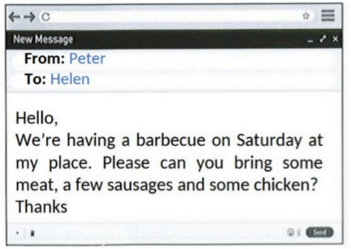

**A.** Dessert and side dishes  **B.** Bread and condiments

**C.** Meat, sausages, and chicken  **D.** Drinks and salad

**Câu 2.** **Look at the signs. Choose the best answer for the question.**



**A.** You don’t need to litter in this place.  **B.** Littering is not good for the environment.

**C.** Waste is not available in this place.  **D.** You mustn’t throw trash on the ground.

**Câu 3.** Which of the following statements is true?

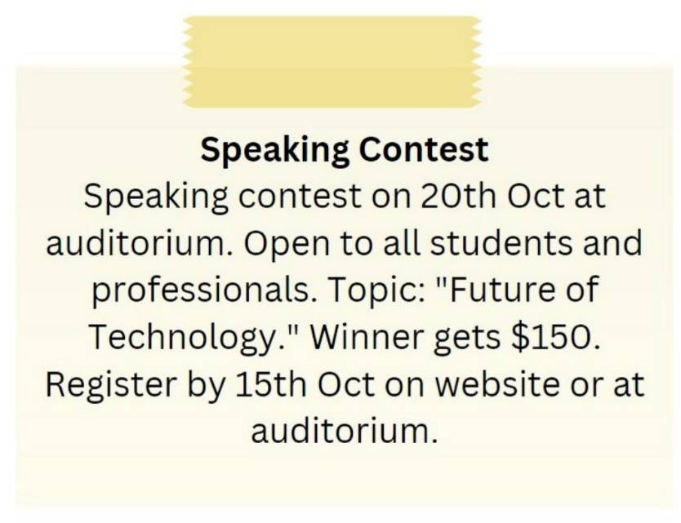

**A.** The topic of the speaking contest is "Future of Technology."

**B.** The winner of the speaking contest gets $100.

**C.** The speaking contest is on 15th October.

**D.** The speaking contest is only open to students.

**Câu 4.** What is the main offer of this Happy Hour promotion?

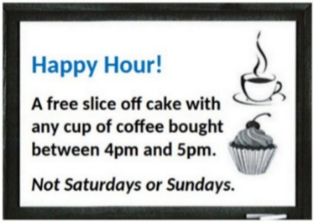

**A.** Free coffee  **B.** Discounted cupcakes

**C.** A free slice of cake with coffee purchase  **D.** Half-price cake

**Câu 5.** **Look at the signs. Choose the best answer for the question.**

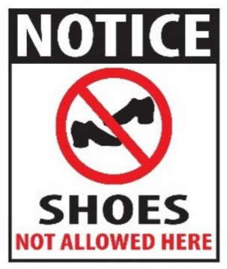

**A.** You don’t have to wear shoes in this place.

**B.** Please put on your shoes when entering this place.

**C.** You can’t buy any shoes in this place.

**D.** Please take off your shoes when entering this place.

**Câu 6.** When does the science club meet?

Science Club Notice:

Science club opening soon! Meets Tues/Thurs after school in room 205. First meeting on Sept. 14th at 3:30 pm.

**A.** Sunday afternoon  **B.** Tuesday and Thursday after school

**C.** Monday and Wednesday after school  **D.** Saturday morning

**Câu 7.** What are the things that Mom asked her kid to pick up?

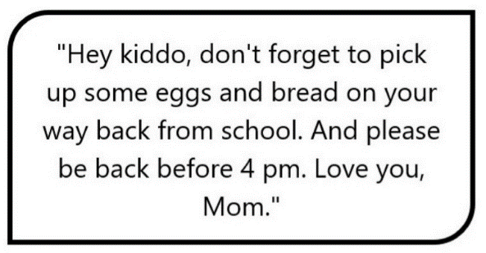

**A.** Eggs and bread  **B.** Eggs, bread, and milk

**C.** Eggs and milk  **D.** Bread and milk

**Câu 8.** **Look at the signs. Choose the best answer for the question.**

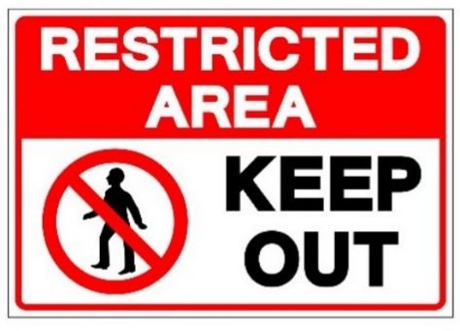

**A.** We should keep this area out.  **B.** People aren’t allowed to enter this area.

**C.** This area is open to everyone.  **D.** This area is kept open.

**Câu 9.** Why does Chloe want Susie to move her work stuff?

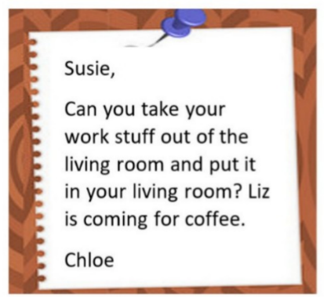

**A.** Because the living room is messy  **B.** Because Susie needs to work in her bedroom

**C.** Because Chloe wants to use the living room  **D.** Because Liz is coming for coffee

**Câu 10.** **Look at the signs. Choose the best answer for the question.**



**A.** You can buy burgers and chips today only.

**B.** Chips and burgers are free - today only.

**C.** If you buy a burger today, you will get chips for free.

**D.** Every burger is served with chips in this restaurant.

**----HẾT---**