ĐỀ VIP 9+ - ĐỀ SỐ 2

Read the following school announcement and mark the letter A, B, C, or D to indicate the correct option that best fits each of the numbered blanks from 1 to 6.
We are excited to announce an upcoming field trip to the (1) on Friday, November 10th! Students will have an opportunity to explore fascinating exhibits and engage (2) hands-on activities. We would like you (3) us for a day filled with learning and fun!
Students will be (4) by the interactive displays and the chance to see real scientific experiments. Please (5) sure to bring a packed lunch and water bottle to stay energised throughout the day.
We will provide each student with a guided tour of the museum, (6) a memorable experience. Don’t miss out on this fantastic opportunity to learn outside the classroom!
Please sign up with your teacher by November 3rd.
Sunflower Administration
Question 1. A. magnificent museum science B. science magnificent museum
C. museum magnificent science D. magnificent science museum
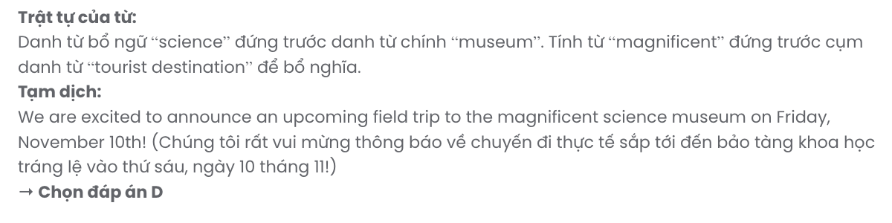
Question 2. A. for B. with C. to D. in
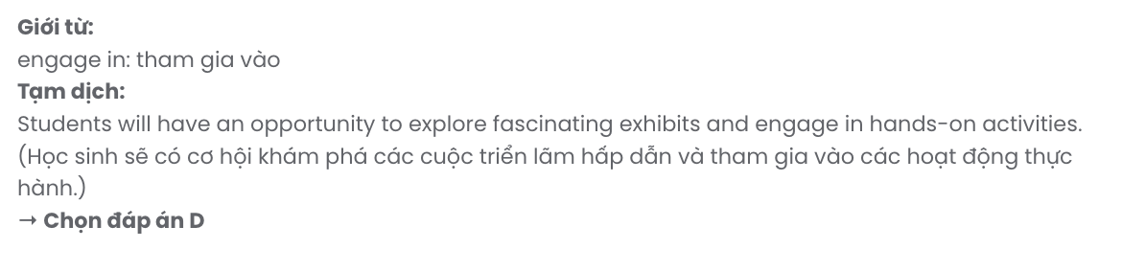
Question 3. A. joining B. to join C. to joining D. join
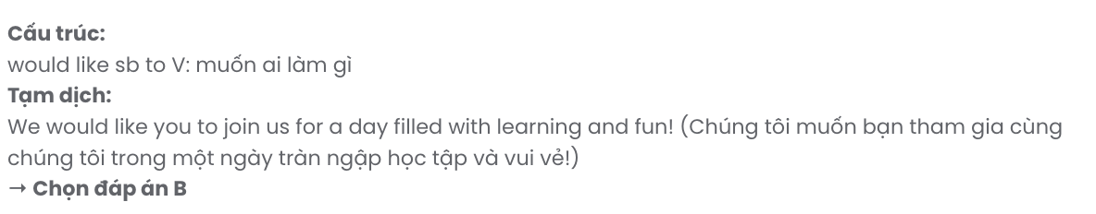
Question 4. A. amazed B. amazement C. amazingly D. amazing
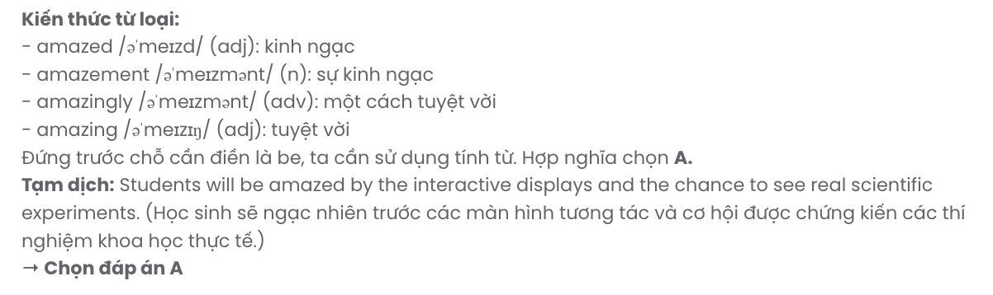
Question 5. A. put B. take C. have D. make
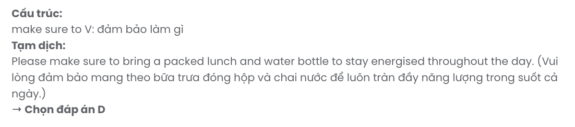
Question 6. A. which ensure B. ensured C. ensuring D. is ensuring
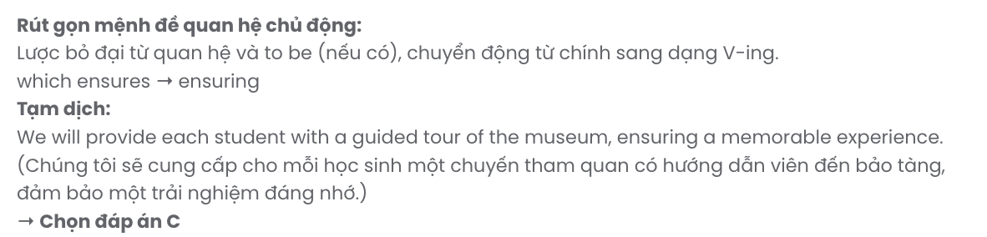
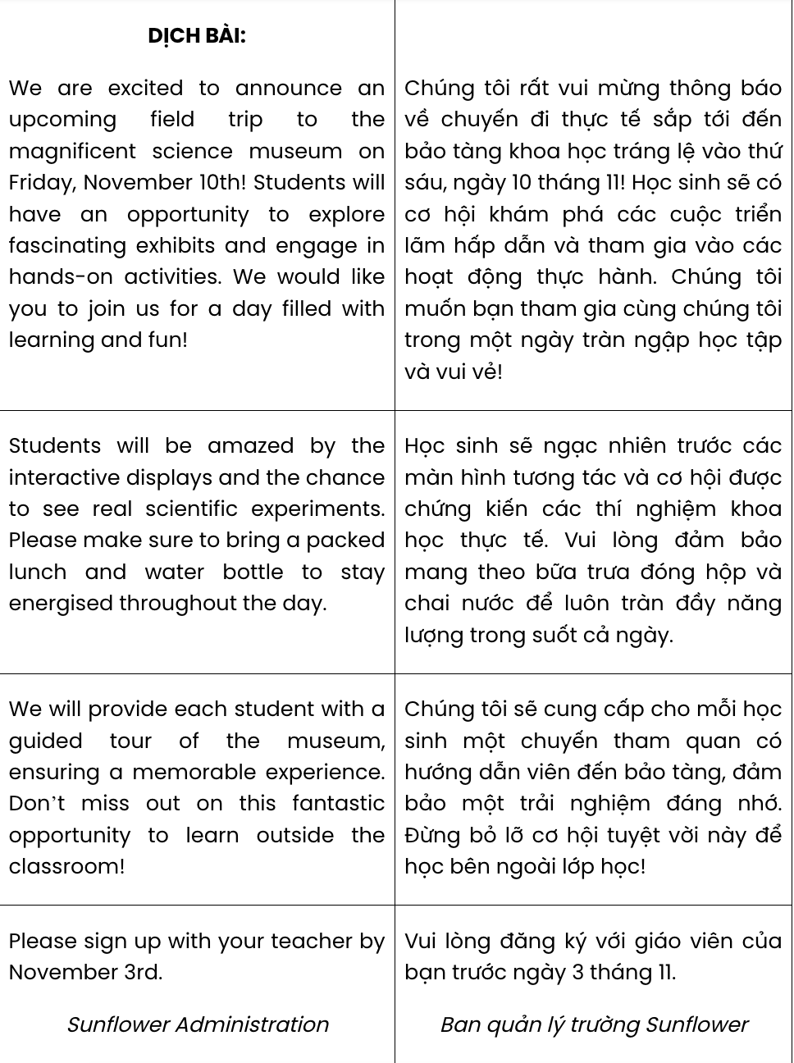

Read the following advertisement and mark the letter A, B, C, or D to indicate the correct option that best fits each of the numbered blanks from 7 to 12.

Discover Your Culinary Passion with Our Online Cooking Course!
Are you tired of the same old recipes and (7) other ways to spice up your meals? Join our online cooking course, where you’ll learn to create delicious dishes using a(n) (8) of ingredients. (9) lesson is designed to give you practical skills that will transform your cooking.
Instead of relying on takeout, you can whip up delightful meals (10) your usual options. Our experienced chefs will guide you through a range of cooking (11) so that you will feel confident in the kitchen.
With easy-to-follow videos and (12) content, you’ll be amazed at how quickly you can improve your skills. Don't wait any longer - sign up today and start your culinary journey!

Question 7. A. looking for B. turning down C. making up D. taking over
Question 8. A. amount B. variety C. deal D. degree
Question 9. A. Other B. Each C. Several D. The others
Question 10. A. in place of B. irrespective of C. in the light of D. apart from
Question 11. A. features B. qualities C. techniques D. resources
Question 12. A. memorable B. dependable C. ordinary D.engaging

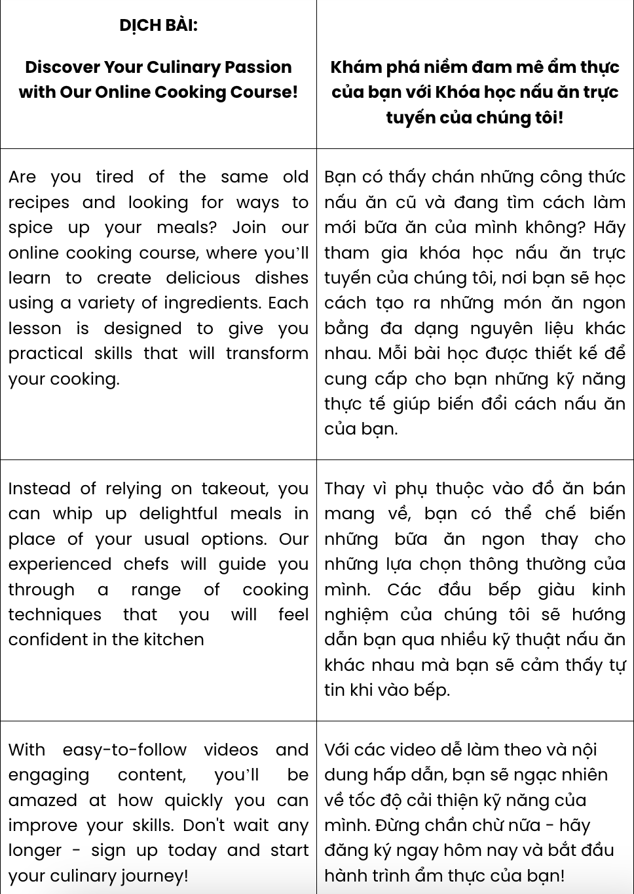
GIẢI CÂU 7
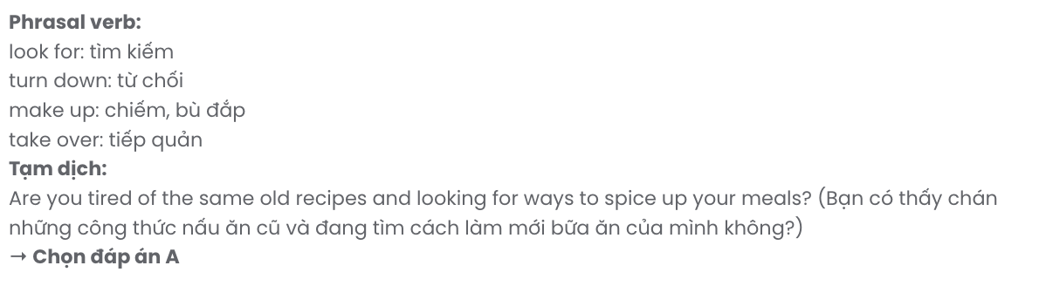
GIẢI CÂU 8
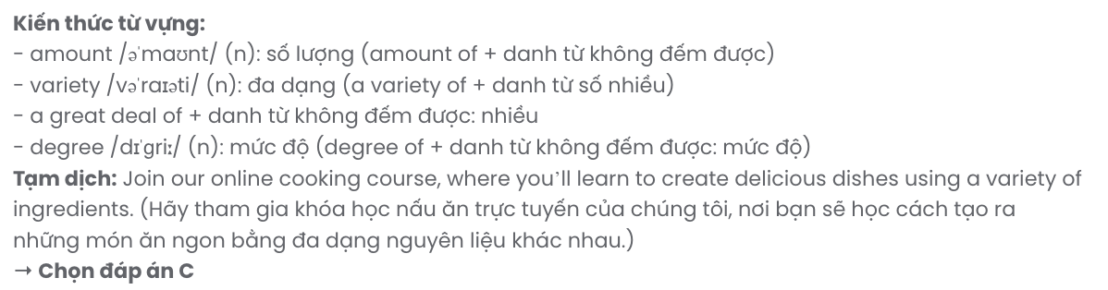
GIẢI CÂU 9
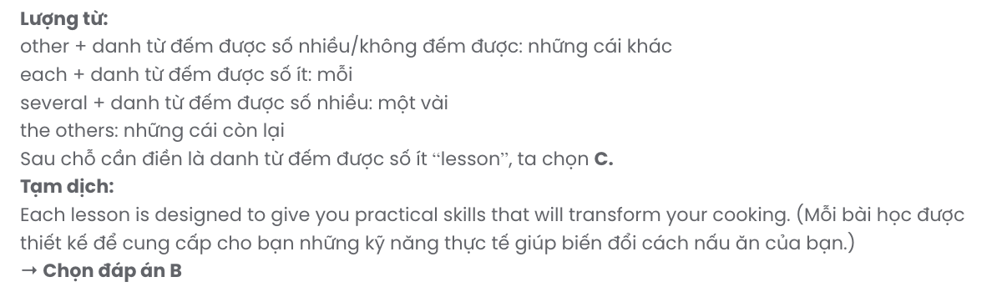
GIẢI CÂU 10

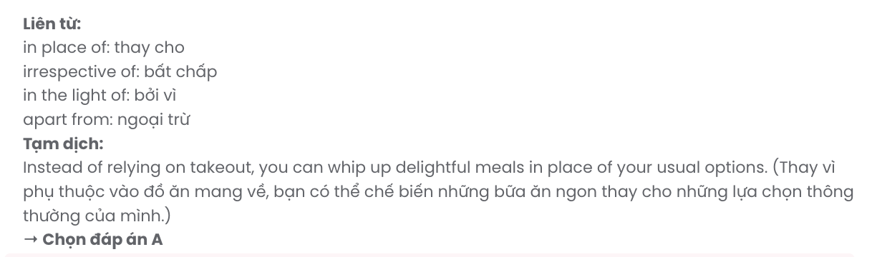
GIẢI CÂU 11
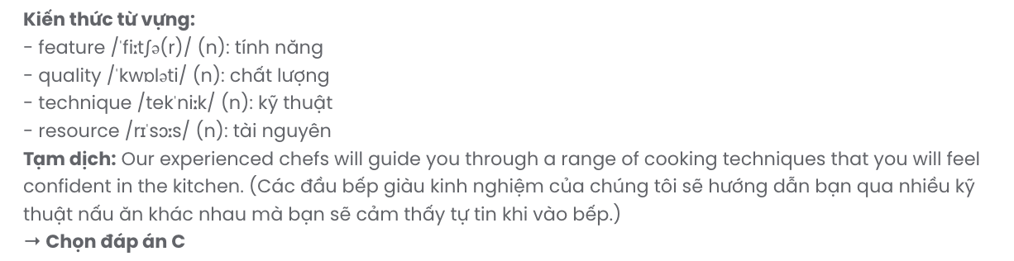
GIẢI CÂU 12
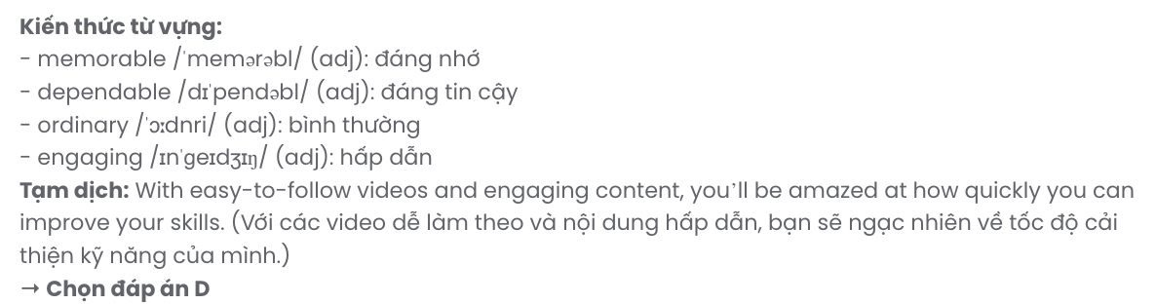
Mark the letter A, B, C or D on your answer sheet to indicate the best arrangement of utterances or sentences to make a meaningful exchange or text in each of the following questions from 13 to 17.

Question 13.
- Nam: Yes, Mai and I did. The fair was great, and we got a lot of useful information.
- Ms Hoa: I'm glad to hear that both of you attended the fair.
- Ms Hoa: Good morning, class. There was an education fair last weekend. Did anyone go?
A. b – a – c B. c – a – b C. a – c – b D. b – c – a
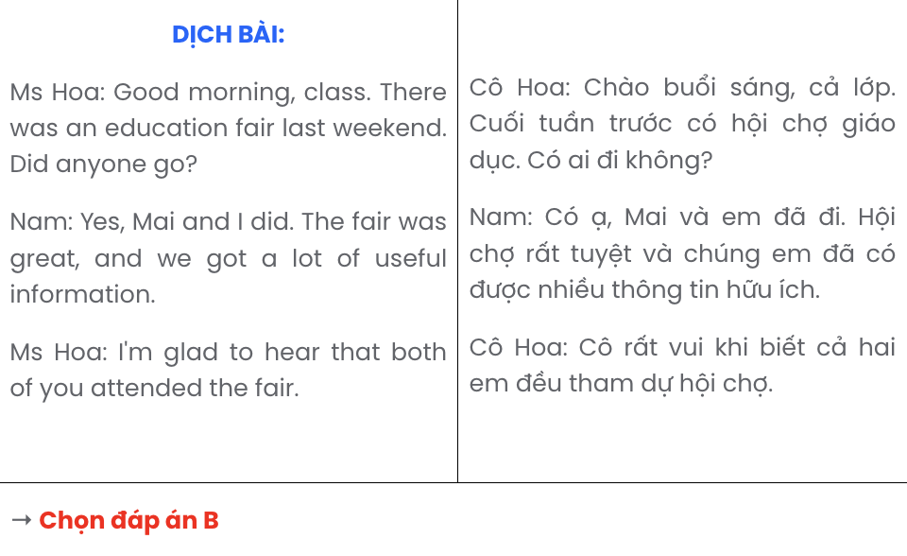

Question 14.
- Leo: I'm going to eat more fruits and vegetables.
- Mia: I find it hard to give up junk food; it’s so tempting!
- Mia: What’s the benefit of focusing on fruits and vegetables?
- Mia: What changes are you making to your diet?
- Leo: They provide essential vitamins and help maintain a healthy weight.
A. d – e – c – a – b B. b – a – c – e – d C. b – e – d – a – c D. d – a – c – e – b
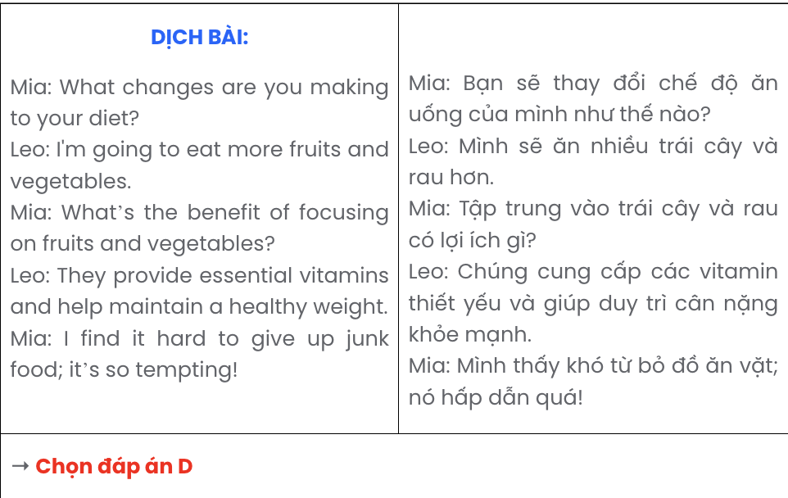

Question 15.
Hi Jamie,
- The recipes are giving me the confidence to try new dishes that I never thought I’d be able to cook.
- I recently started watching the cooking tutorial videos you recommended, and they’ve been amazing!
- Maybe we can try a few of those recipes together next time you visit!
- The instructions from those videos are really clear, and I find it much easier to follow than other videos I’ve tried before.
- It’s exciting to experiment with different techniques, even though some of them can be a bit challenging.
Best. Alex
A. b – d – a – e – c B. d – b – e – a – c C. e – a – d – b – c D. a – d – e – b – c
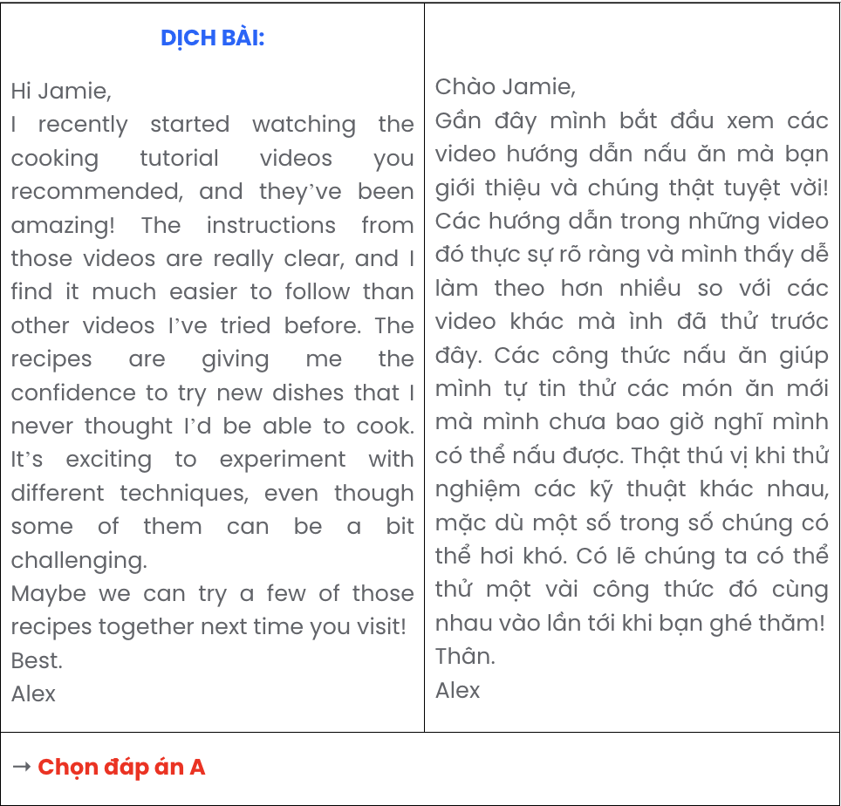

Question 16.
- Working in a dynamic environment enhances my creativity and allows for greater artistic expression.
- Although there are challenges with client requests and project adjustments, the ability to see my concepts come to life makes it worthwhile.
- My enthusiasm for both design and communication naturally guided me to a rewarding career in graphic design.
- In conclusion, I am extremely satisfied with my current position and the possibilities it offers, as it perfectly aligns with my passions and abilities.
- Indeed, for the past two years, I have excelled in this role at a creative agency, where I develop innovative visual content and collaborate with clients.
A. b – e – a – c – d B. a – b – e – c – d C. c – e – a – b – d D. e – b – c – a – d
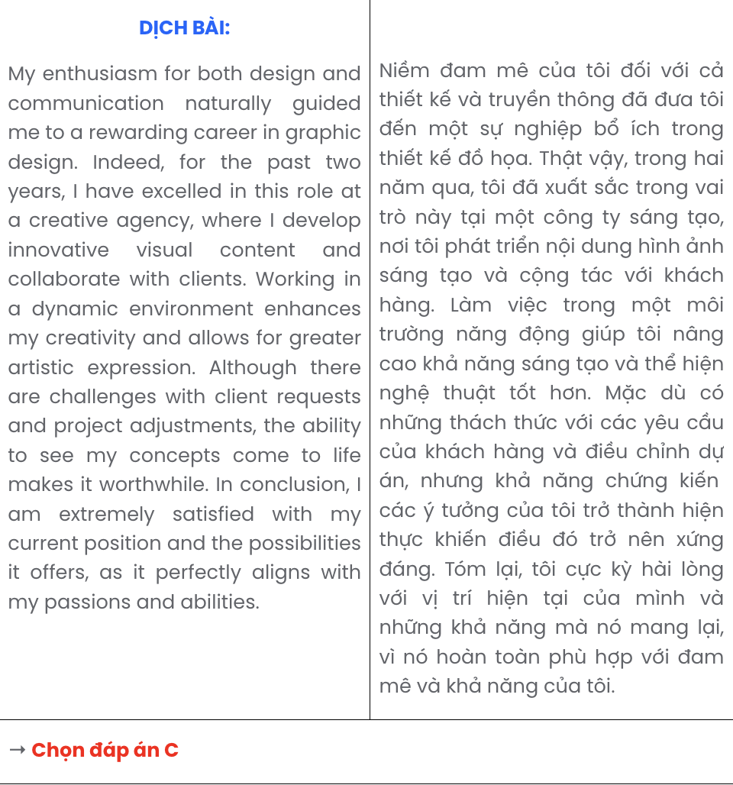

Question 17.
- Nevertheless, despite this development, Maplewood still lacks a community centre, with the nearest one situated over 20 miles away in Hilltown.
- Previously vibrant community gardens along Elm Street and Pine Road have been replaced by parking lots, indicating a shift towards urbanisation.
- This urban shift has also drawn new businesses, from cafés to retail stores and service providers, enhancing the local economy and making Maplewood increasingly bustling.
- Maplewood has undergone remarkable changes in the last few years.
- This commercial expansion has resulted in a 30% increase in the population as more residents move in for job opportunities, leading to higher levels of traffic.
A. d – a – e – b – c B. d – e – b – c – a C. d – c – b – a – e D. d – b – c – e – a
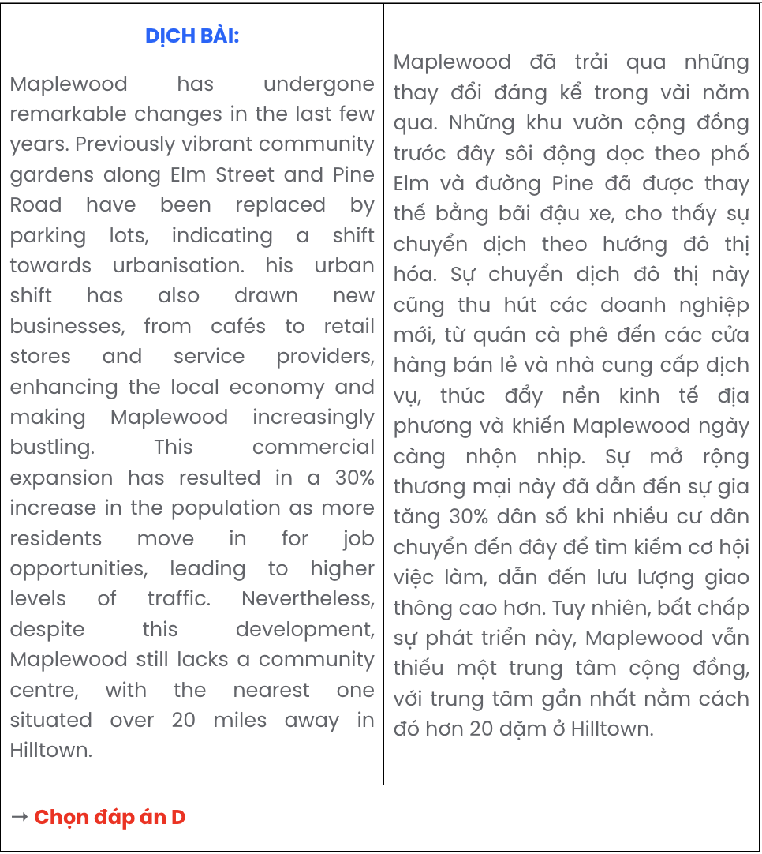

Read the following passage about teen issues and mark the letter A, B, C, or D to indicate the correct option that best fits each of the numbered blanks from 18 to 22.
Teenagers today face a number of challenges that can significantly impact their mental and emotional well-being. One of the most pressing issues is social media, a platform (18) . Many teens struggle with the pressure to present a perfect life online, which can lead to feelings of isolation and depression.
Balancing academic responsibilities with social activities can be overwhelming, leaving little time for self-care. As students navigate their studies, (19) . This intense pressure, coupled with the need to maintain friendships, (20) .
Additionally, peer pressure, an influential force in their lives, can lead teens to make poor choices, such as experimenting with drugs or engaging in risky behaviour. Having experienced these challenges,
(21) . Awareness campaigns and support systems are crucial in guiding them through this tumultuous phase. By addressing these issues, (22) .

Question 18.
  - of which worse feelings of inadequacy and anxiety
  - aggravated feelings of inadequacy and anxiety
  - that often exacerbates feelings of inadequacy and anxiety
  - turns feelings inadequacy and anxiety for the worse
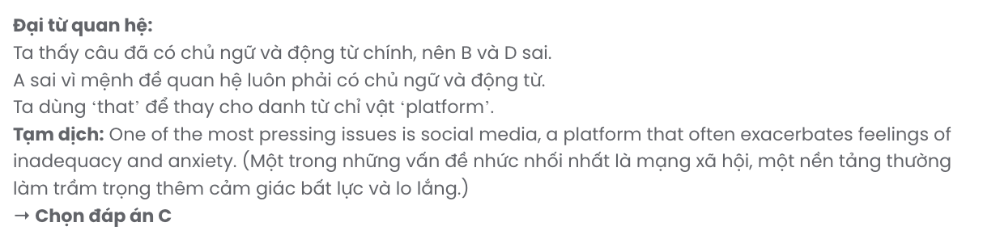

Question 19.
- stress and burnout can result in a heavy workload, causing them to feel overwhelmed
- they find themselves overwhelmed by a heavy workload, leading to stress and burnout
- a heavy workload can cause stress and burnout so that they find themselves overwhelmed
- they are totally overwhelmed by stress and burnout, which brings about a heavy workload
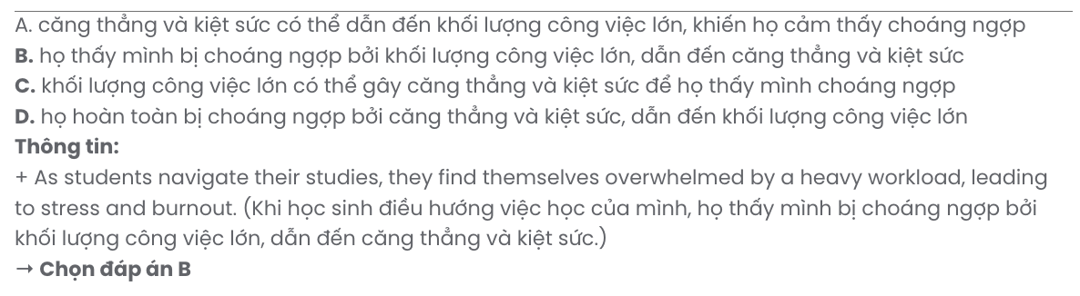

Question 20.
- having put many adolescents in a risky situation
- which triggers a dangerous situation for many adolescents
- that drives many adolescents to an unpleasant situation
- creates a precarious situation for many adolescents

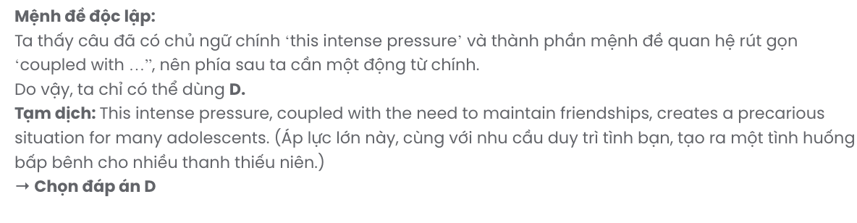

Question 21.
- teens must learn to prioritise their mental health and seek help when needed
- teens’ mental health must be prioritised and they should seek help when needed
- teens must seek help when needed by learning to prioritise their mental health
- prioritising their mental health and seeking help when needed are crucial to teens
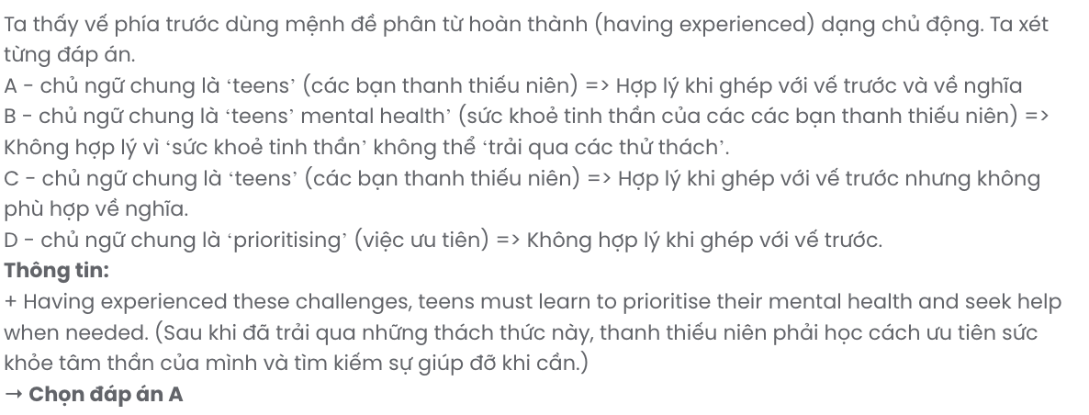

Question 22.
- teenagers who feel supported and understood can foster healthier environments for them
- healthier environments are fostered in case teenagers feel supported and understood
- fostering healthier environments helps teenagers to feel supported and understood
- we can foster healthier environments where teenagers feel supported and understood
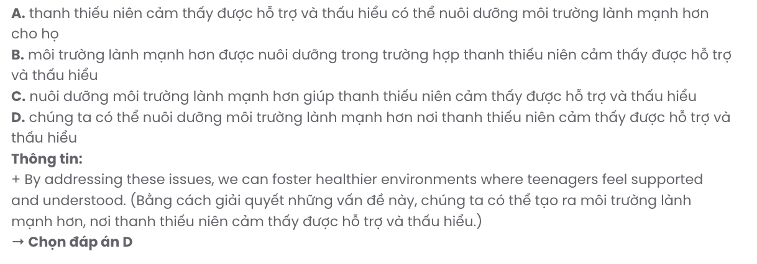
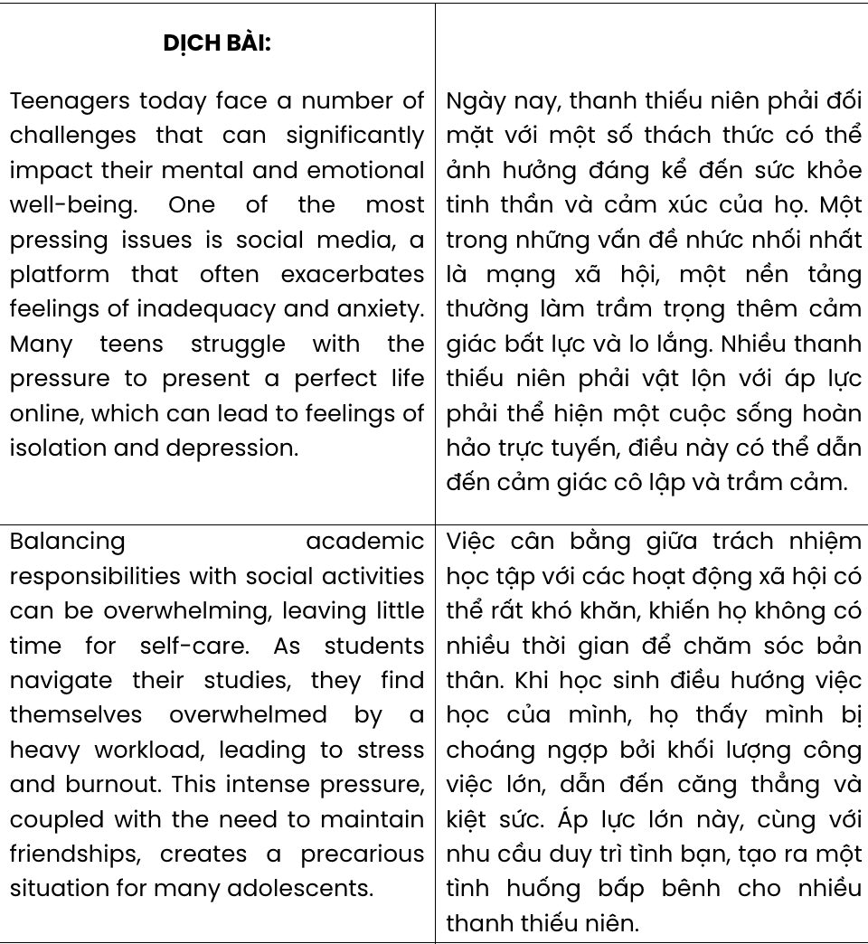

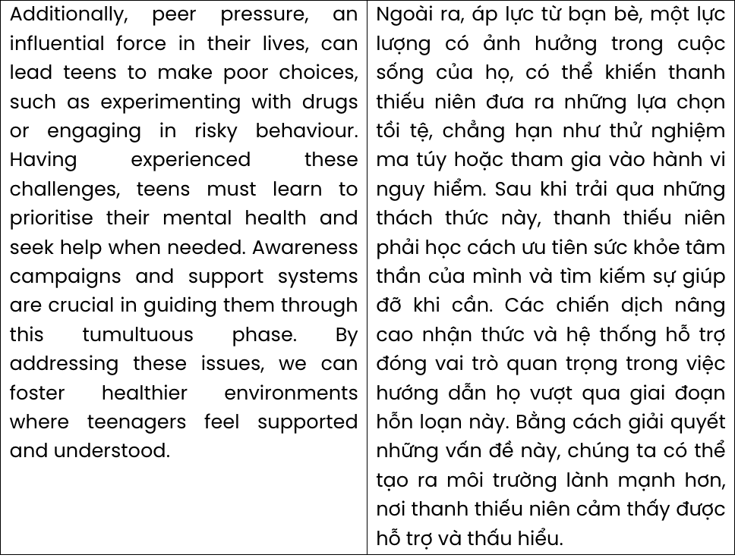

Read the following passage about female scientists changing the world and mark the letter A, B, C, or D to indicate the correct answer to each of the questions from 23 to 30.
In any web search for the world's famous scientists, Marie Curie always receives a mention. Curie, a Polish and naturalised French physicist and chemist, discovered radiation, helped apply it in the field of X-rays and coined the term radioactivity. She made a huge contribution to science, but was one of the very few women who gained the recognition they deserved.
Science was man's world in the nineteenth century. And yet, Mary Anning became an expert in fossils and geology. Coming from a poor family, she collected fossils on the beach and sold them to make a little money. She found fossils of complete marine reptiles that became extinct over 100 million years ago. She gained the respect of scientists, but living in an era when women weren't allowed to vote or attend university, she was not allowed to join the Geological Society of London.
A hundred years later, conditions were still difficult for female scientists. Rosalind Franklin, a chemist born in 1920, was part of a team who discovered the molecular structure of DNA. Tragically, she died aged thirty-seven, four years before her fellow scientists, all men, were awarded the Nobel Prize in 1962. They made no reference to Franklin in their acceptance speech.
In cases where women's achievements were recognised, we still find evidence of discrimination in the way these were reported in the press. When the brilliant chemist Dorothy Hodgkin was awarded the Nobel Prize in 1964 for discovering the molecular structure of penicillin and vitamin B12, the paper headline was Oxford Housewife Wins Nobel. In fact, this housewife was also a professor at Oxford University. Today, the gender gap in the world of science is slowly closing and there are many female scientists inspiring new generations of girls to study scientific subjects. But there are still some ways to go for women to be equally represented in science.
(Adapted from English Discovery)
Question 23. The word coined in paragraph 1 is closest in meaning to .
A. invented B. changed C. illustrated D. described
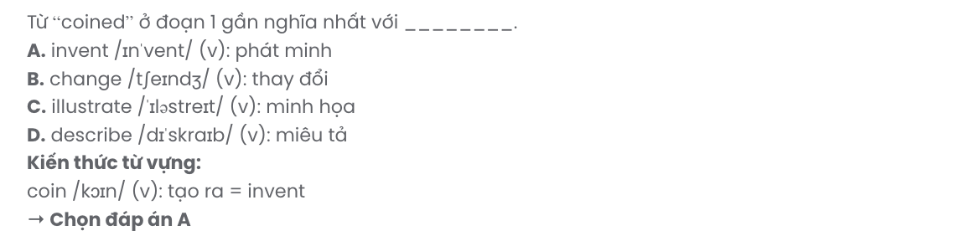
Question 24. Which of the following is NOT mentioned about Marie Curie?
- Her discovery made a large contribution in the field of X-rays.
- She is one of the most famous female scientists in the world.
- She wasn’t recognised widely despite her contribution.
- She was one of the very few women recognised for their efforts.
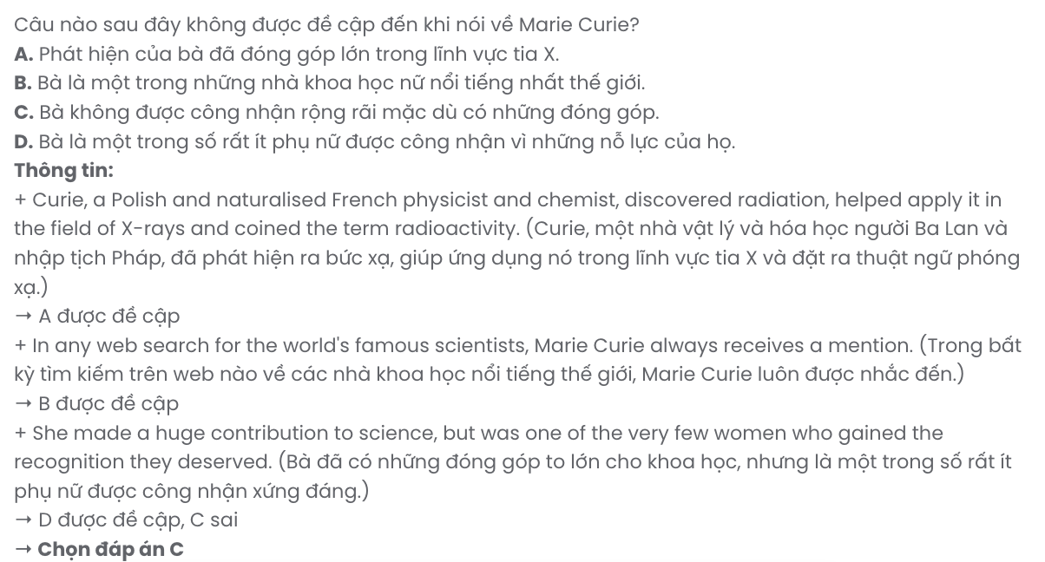
Question 25. The word them in paragraph 2 refers to .
A. reptiles B. fossils C. women D. scientists

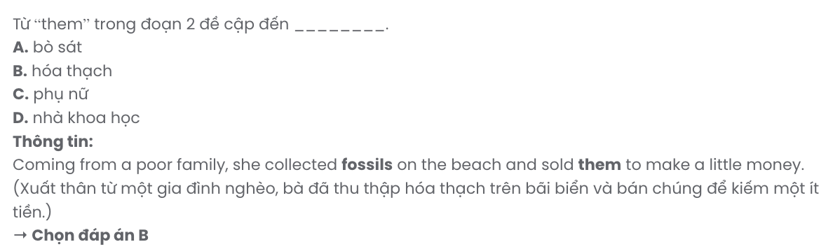
Question 26. Which of the following best paraphrases the underlined sentence in paragraph 3?
- They mentioned Franklin briefly in their acceptance speech.
- In their acceptance speech, they completely ignored Franklin.
- They hardly acknowledged Franklin in their acceptance speech.
- Franklin refused to be mentioned in their acceptance speech.

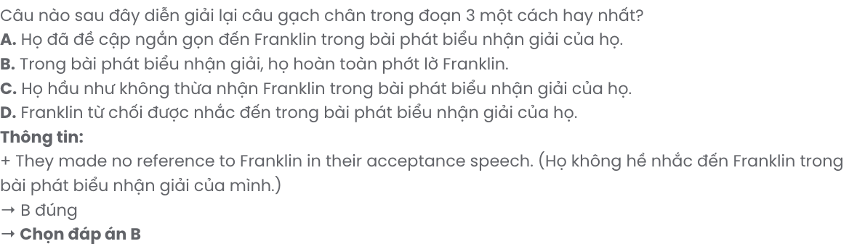Question 27. The word discrimination in paragraph 4 is OPPOSITE in meaning to .
A. difference B. willingness C. bias D. recognition
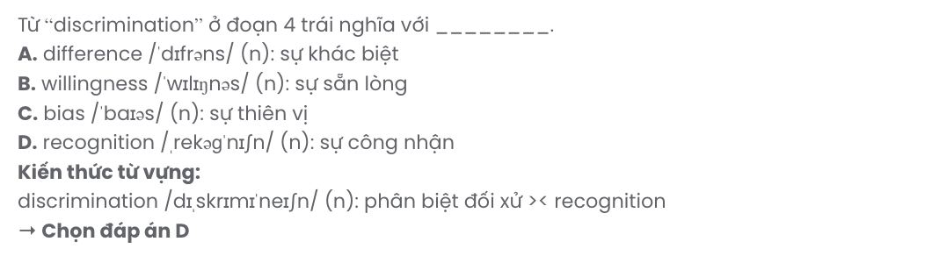
Question 28. Which of the following is TRUE according to the passage?
- Rosalind Franklin was recognised for her contribution after her death.
- Dorothy Hodgkin was not held in high esteem at Oxford University.
- Mary Anning couldn’t join the Geological Society of London due to poverty.
- A struggle for gender equality in the world of science still continues.
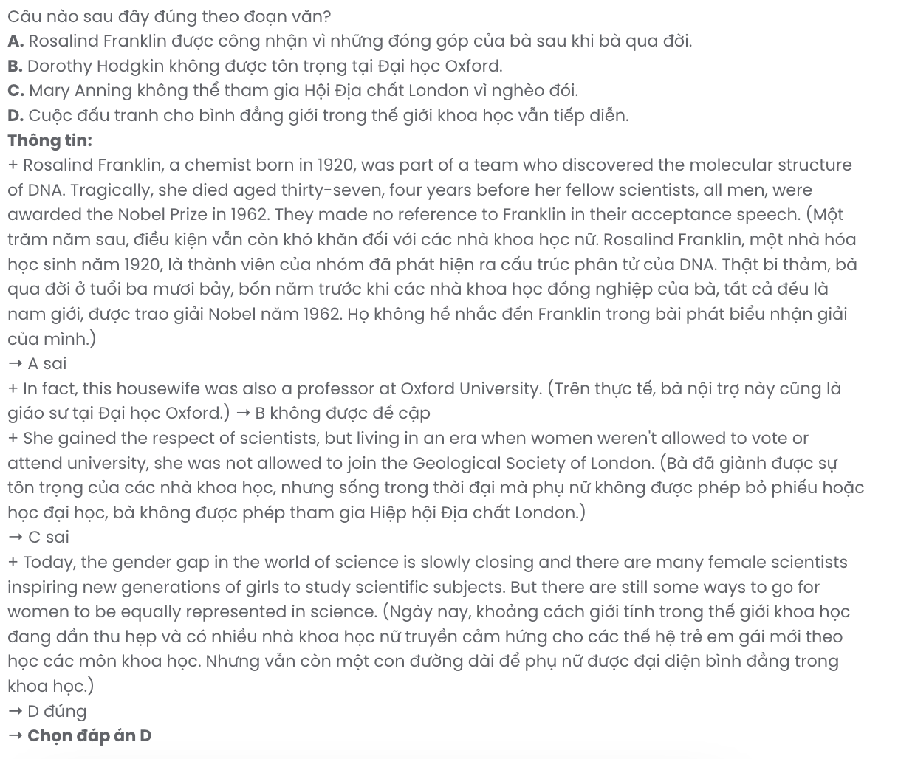
Question 29. In which paragraph does the author explore the societal limitations placed on women?
A. Paragraph 1 B. Paragraph 2 C. Paragraph 3 D. Paragraph 4
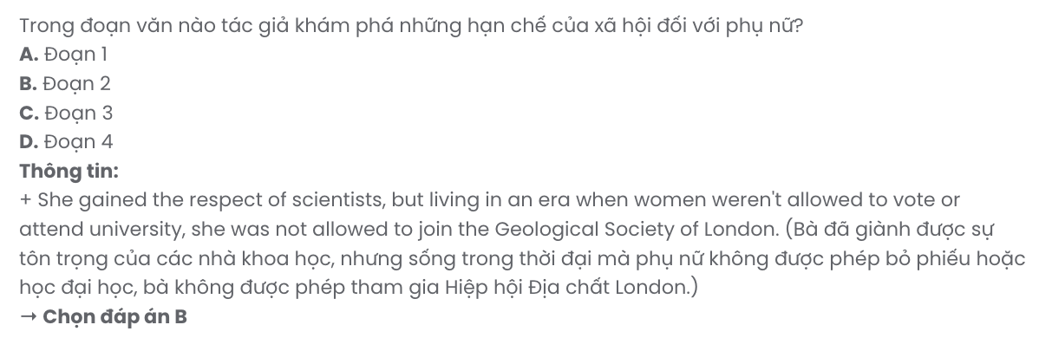
Question 30. In which paragraph does the author mention a present concession relationship?
A. Paragraph 1 B. Paragraph 2 C. Paragraph 3 D. Paragraph 4
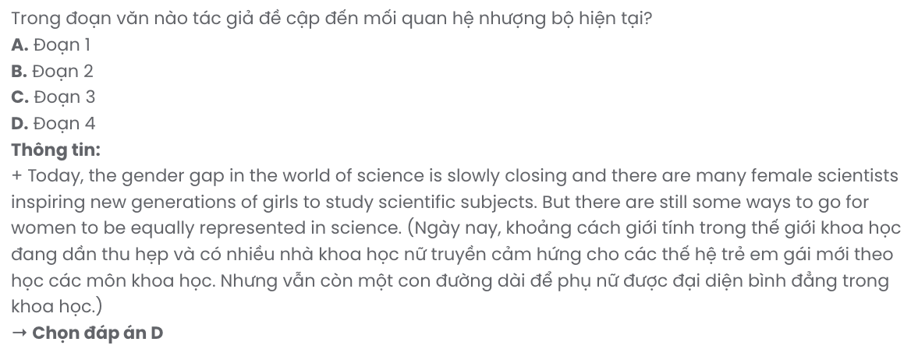
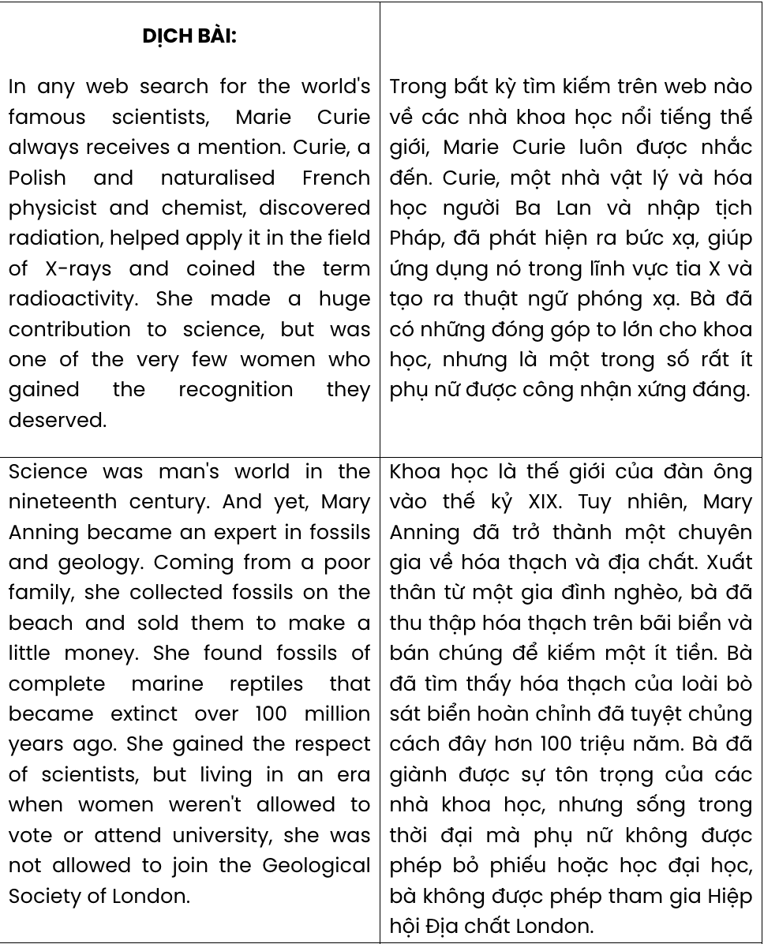
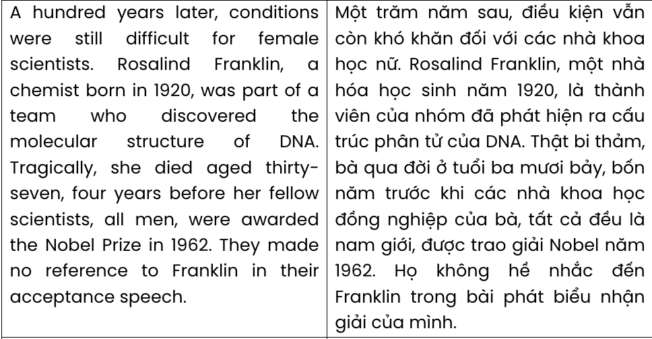
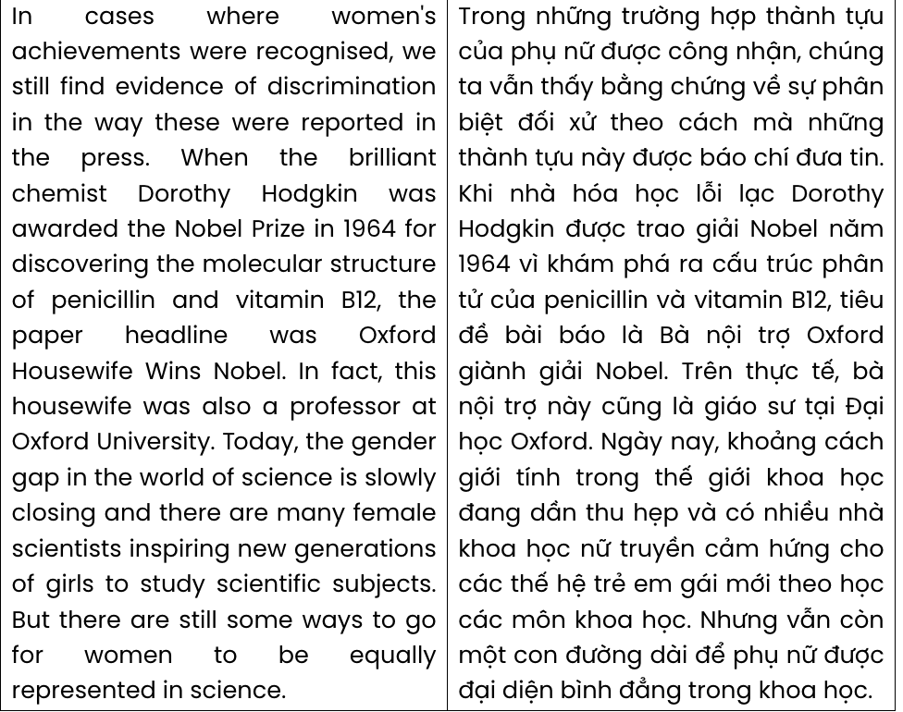

Read the following passage about testing intelligence and mark the letter A, B, C, or D to indicate the correct answer to each of the questions from 31 to 40.
  - Fifty or sixty years ago, computers were very simple machines, but even then scientists believed that one day machines would be able to 'think' and that they would probably be as intelligent as humans.
  - Alan Turing, who had helped to break the German Enigma code during the Second World War, came up with an answer. [III] In a Turing test, judges sit at a screen and have a chatroom conversation with the chatbot programme. They don't know if they are chatting with another person or with a chatbot. After exchanging messages for five minutes, the judge decides if he or she is chatting with a human or a machine. [IV]
An American called Hugh Loebner was fascinated by Turing's idea, and in the early 1990s he offered a prize of $100,000 to the creator of the first chatbot to pass the Turing test. In order to win the
$100,000, a chatbot must convince at least 30% of the judges that it is human. Many chatbots have entered the competition, but so far no chatbot has won the big money prize. Mitsuku, however, came very close. In the conversation at the beginning of this article, Mitsuku is A and the real human is B. You can tell that A is not human because at one point in the conversation, A says ‘Humans are not too intelligent at times’. Although Mitsuku failed to win the $100,000, it certainly won't be long before a chatbot is able to fool the Loebner judges into thinking that it is a real person.
But is the Turing test a good way to decide if a machine is intelligent? Critics argue that the chatbots in the competition are merely imitating humans. Humans are the only animals on Earth that can speak, and that's why Turing chose to focus on it. But what is really impressive, critics say, is machines that do things that we can't do. For example, it is amazing that Google can search hundreds of millions of websites for a single word in a matter of seconds, or that a NASA computer can control a rocket on a journey from Earth to Jupiter.
Fans of the Turing test, on the other hand, feel that humans are themselves machines. It's just that our brains are far more complex than computers. As philosopher and scientist Daniel Dennett said in a recent interview, ‘It's not impossible to have a conscious robot. You're looking at one.’
(Adapted from Solutions)

Question 31. Where in paragraph 1 does the following sentence best fit?

The question was, 'How can we measure the intelligence of a machine?'
A. [I] B. [II] C. [III] D. [IV]
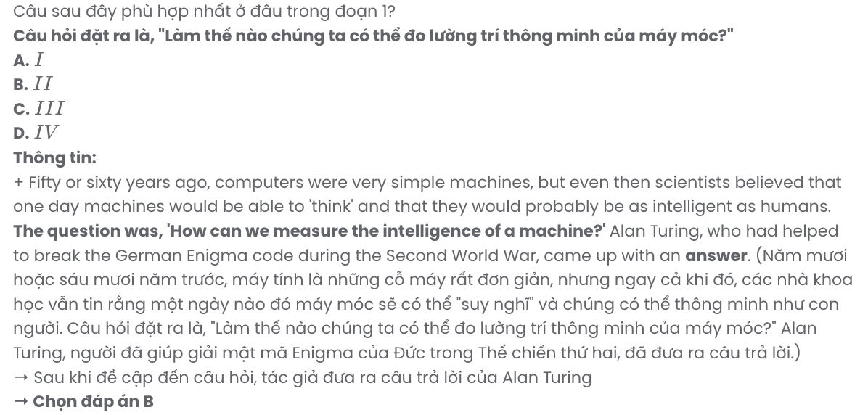
Question 32. The word they in paragraph 1 refers to .
A. computers B. judges C. messages D. humans
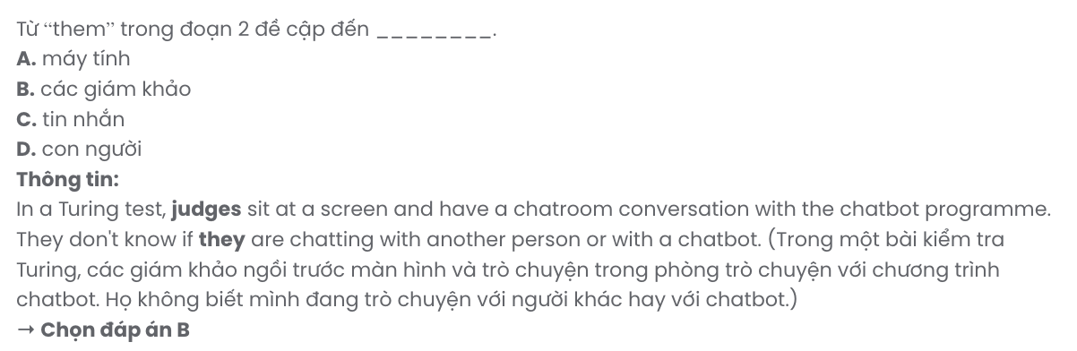
Question 33. What is indicated about judges in a Turing test in paragraph 1?
- They are kept in the dark about who they are talking with.
- They are unaware of the main purpose of the test.
- They are ignorant of how to chat with a machine.
- They are blind to the existence of intelligent machines.
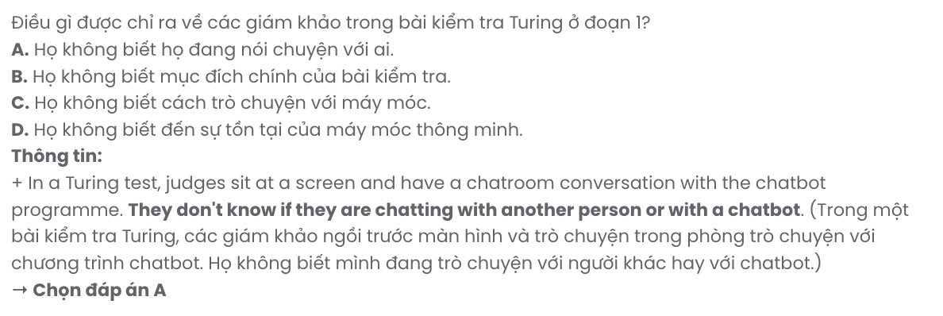
Question 34. The word fascinated in paragraph 2 is OPPOSITE in meaning to .
A. overloaded B. captivated C. discouraged D. objected
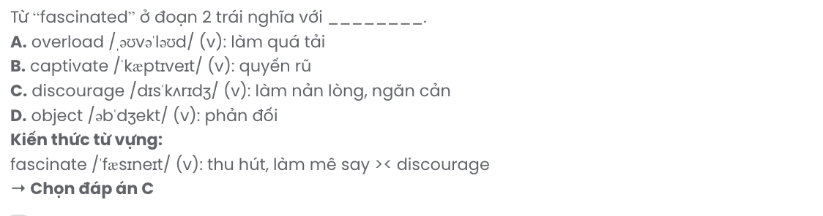
Question 35. Which of the following best paraphrases the underlined sentence in paragraph 2?
- Even though Mitsuku didn't win the $100,000, it may take some time before a chatbot can convince the Loebner judges that it is a human being.
- Although Mitsuku did not secure the $100,000 prize, it won't be long before a chatbot can deceive the Loebner judges into believing it is a real person.
- Despite failing to win the $100,000, Mitsuku shows that a chatbot’s ability to trick the Loebner judges into thinking it is a real person is impressive.
- While Mitsuku didn’t achieve the $100,000, a chatbot is unlikely to fool the Loebner judges into thinking it is a human anytime soon.
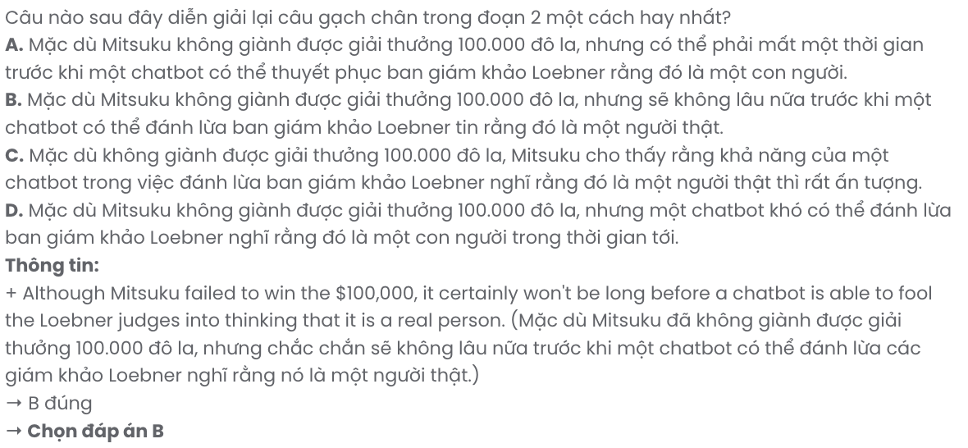
Question 36. The word imitating in paragraph 3 can be best replaced by .
A. stimulating B. pretending C. simulating D. mimicking
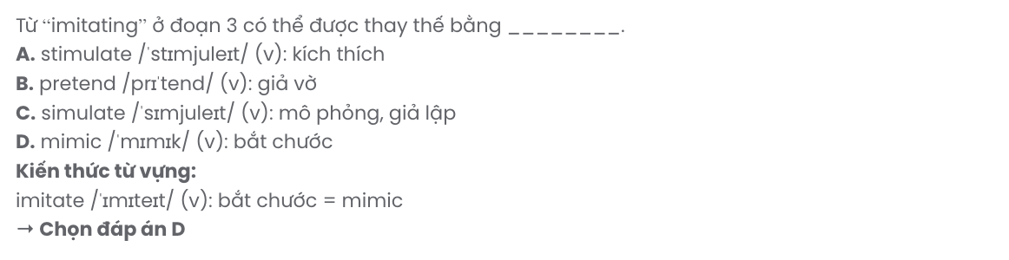
Question 37. Which of the following best summarises paragraph 3?
- The Turing test is criticised for not accurately measuring machine intelligence compared to human capabilities.
- Critics believe the Turing test effectively evaluates machines' ability to imitate human conversation.
- Turing's test focuses on speech, but critics highlight machines' impressive abilities beyond human imitation.
- Critics argue that human speech is the best indicator of machine intelligence in the Turing test.
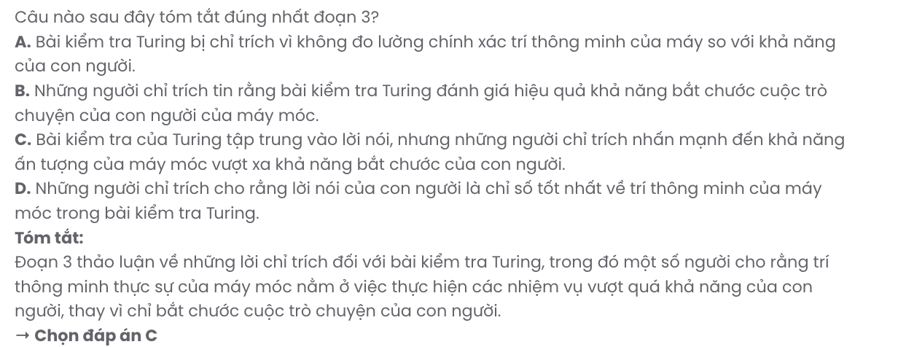
Question 38. Which of the following is NOT true according to the passage?
- Google has an impressive ability to search a wide range of websites in a very short period of time.
- The experience of breaking code during the Second World War helped Alan Turing come up with testing machines’ intelligence.
- The Loebner judges haven’t been taken for a ride by any chatbots for believing that they are humans.
- Fans of the Turing test hold similar opinions with critics on its effectiveness to test if a machine is intelligent.
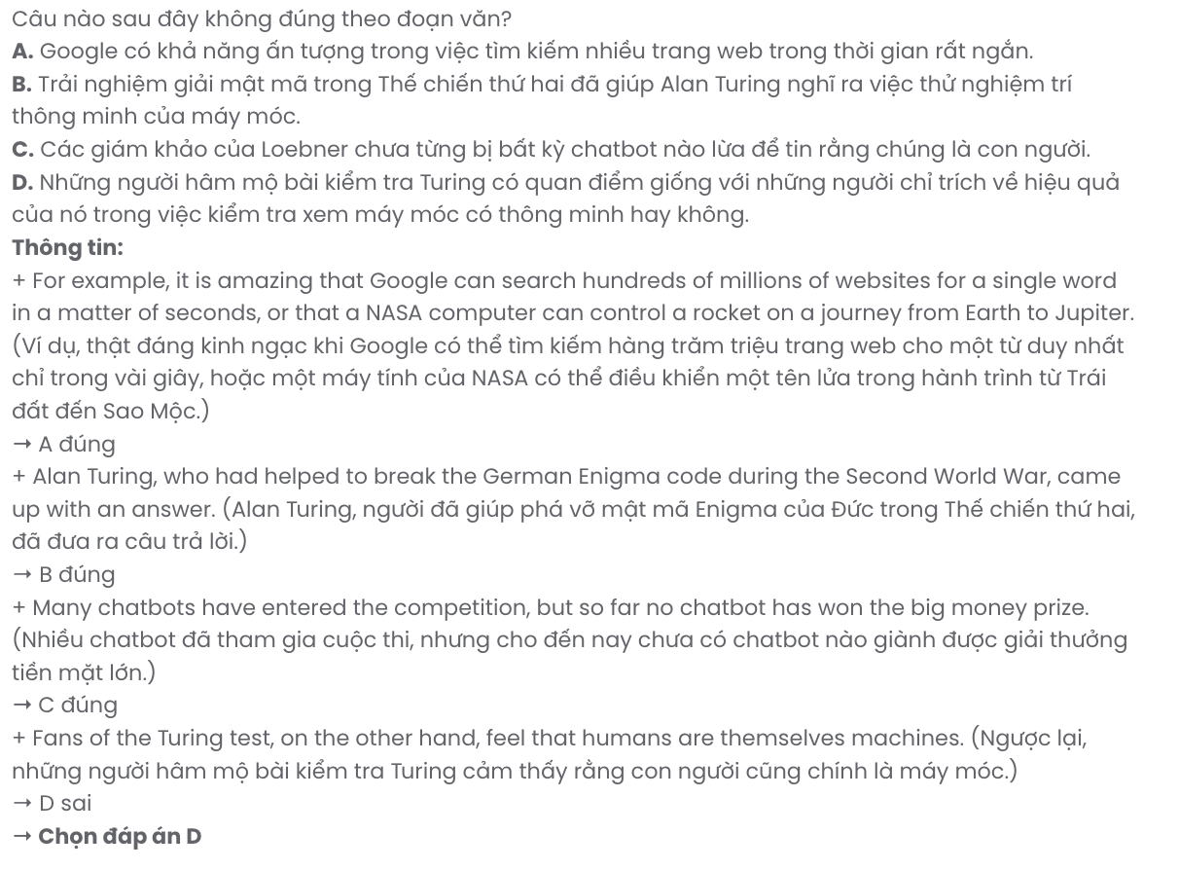
Question 39. It can be inferred from the passage that .
- the complexity in humans’ brains will soon be overtaken by intelligent machines
- humans might possess machine-like qualities in terms of consciousness
- creating a robot that is as intelligent as humans is not a feasible task
- the ability to speak sets humans apart from intelligent machines

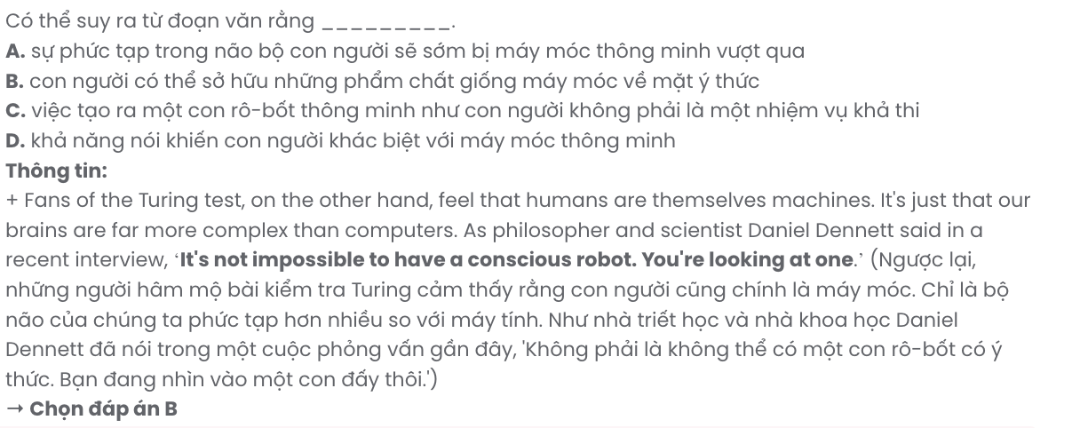
Question 40. Which of the following best summarises the passage?
- The Turing test, created by Alan Turing to evaluate machine intelligence, assesses whether chatbots can genuinely think or merely imitate humans, while critics question its effectiveness in measuring true intelligence.
- Established to evaluate machines' capacity for human imitation, the Turing test has yet to be convincingly passed by any chatbot in competition, despite extensive attempts and the allure of a substantial cash prize.
- Alan Turing formulated the Turing test to gauge machine intelligence, incentivising the challenge with a cash prize for the first chatbot to successfully pass, though no contender has achieved this notable feat thus far.
- Many experts contend that the Turing test serves as a reliable metric for assessing machine intelligence, with increasing optimism that advancements will soon enable machines to exhibit behaviours and thoughts akin to humans.

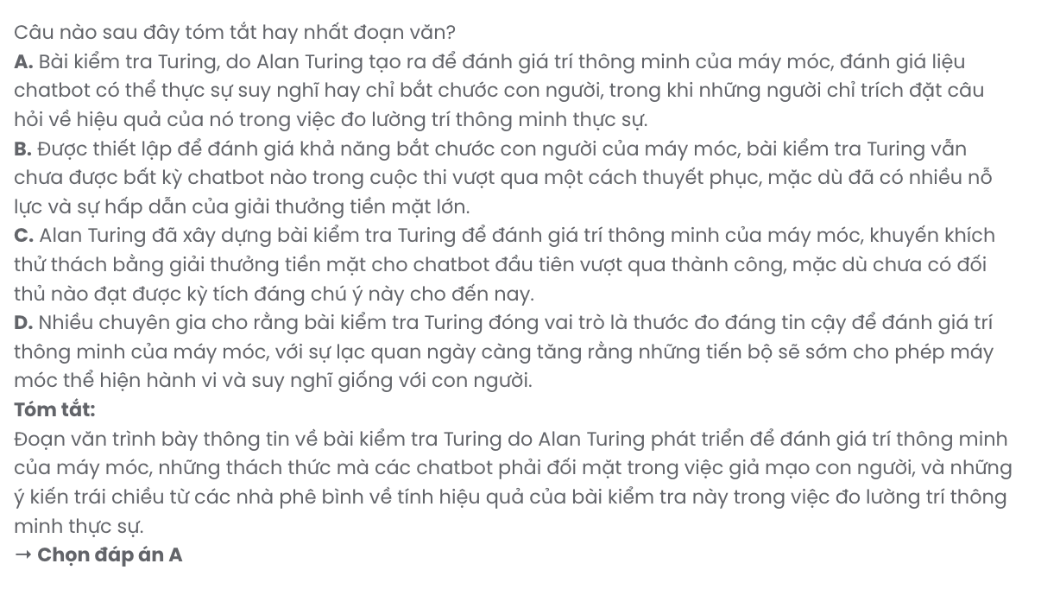

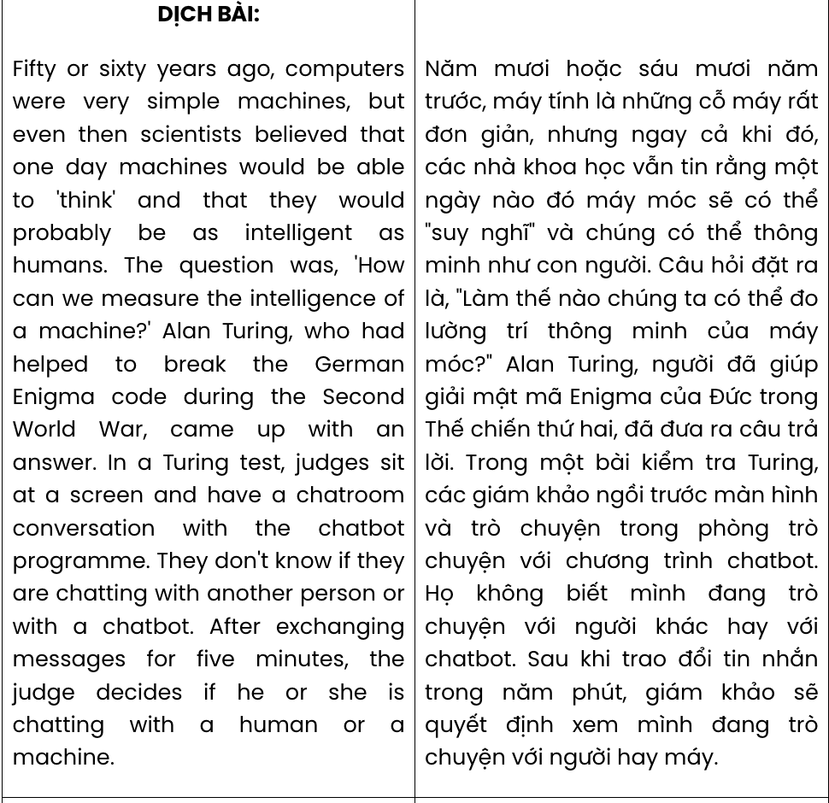

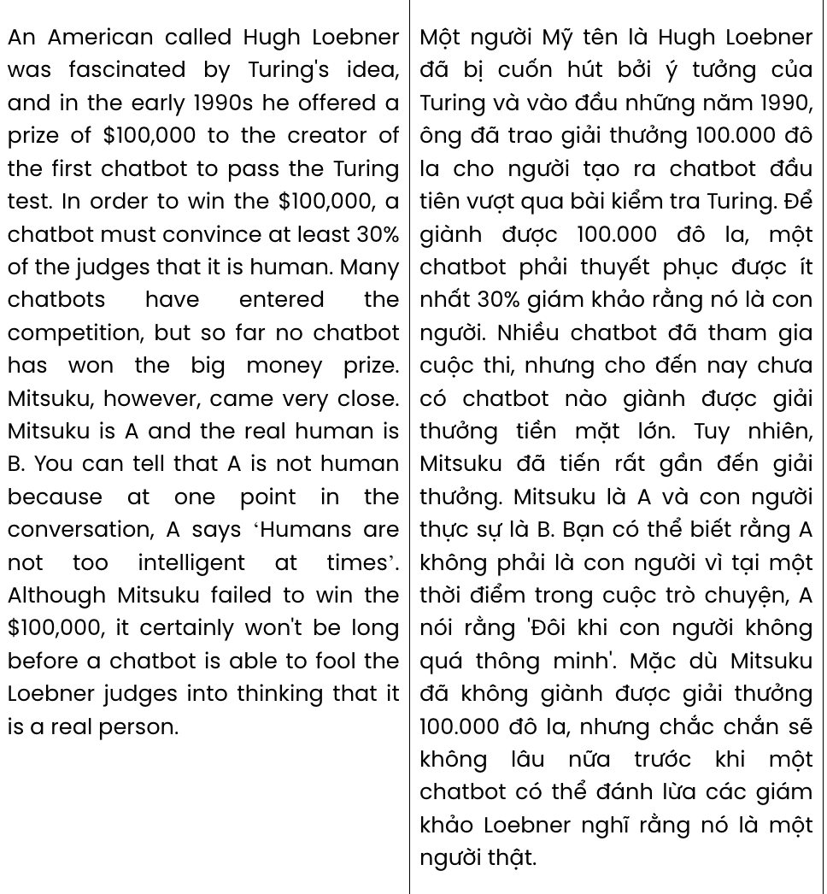

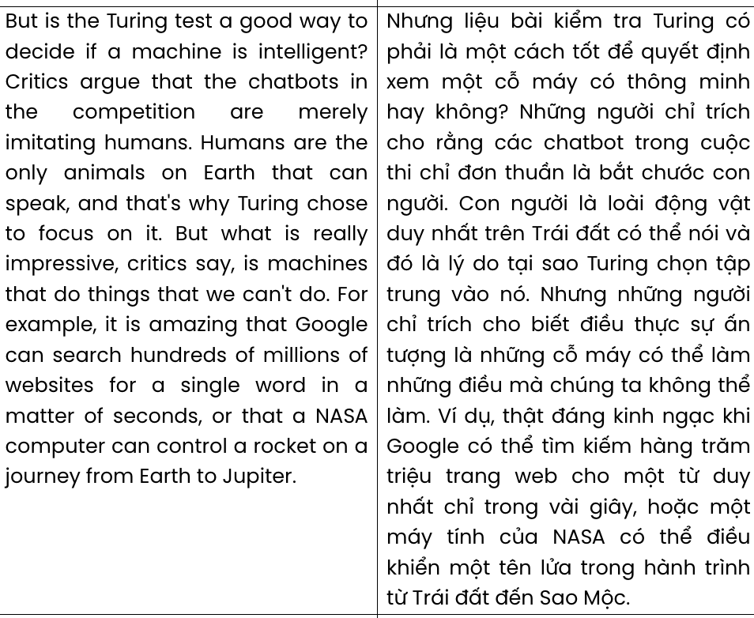

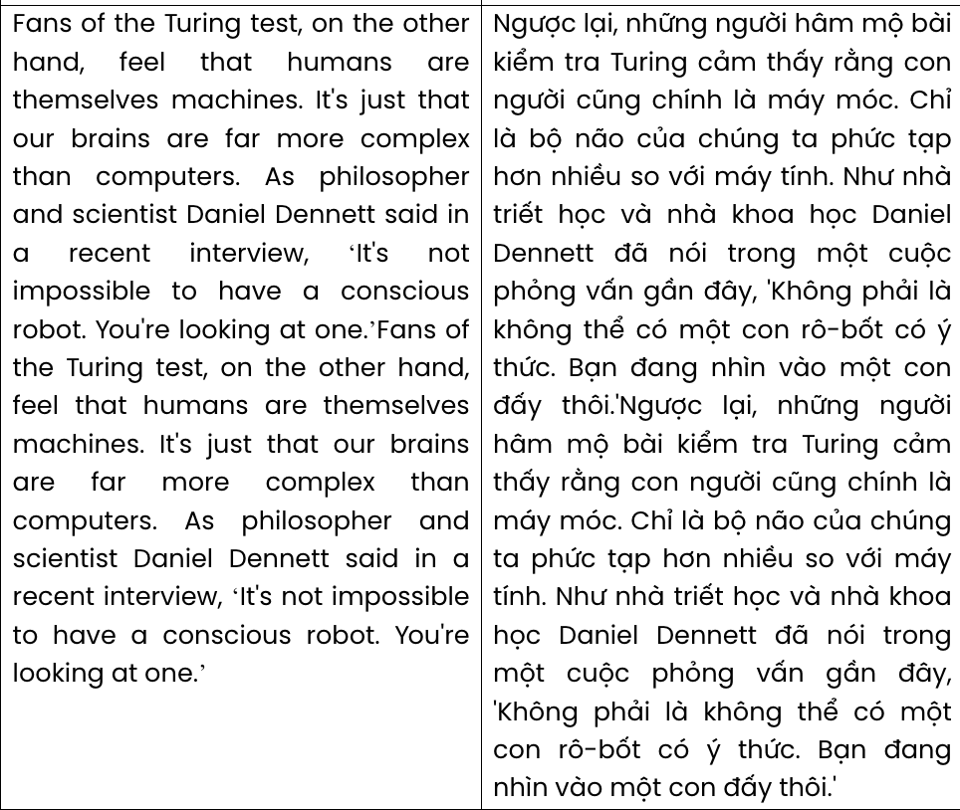

BẢNG TỪ VỰNG
STT | Từ vựng | Từ loại | Phiên âm | Nghĩa
1 | field trip | n | /ˈfiːld trɪp/ | chuyến đi thực địa
2 | magnificent | adj | /mæɡˈnɪfɪsnt/ | tráng lệ
3 | science | n | /ˈsaɪəns/ | khoa học
4 | museum | n | /mjuːˈziːəm/ | bảo tàng
5 | opportunity | n | /ˌɒpəˈʧuːnəti/ | cơ hội
6 | fascinating | adj | /ˈfæsɪneɪtɪŋ/ | hấp dẫn
7 | exhibit | n | /ɪɡˈzɪbɪt/ | triển lãm
8 | hands-on | adj | /ˌhændz ˈɒn/ | thực hành
9 | amazed | adj | /əˈmeɪzd/ | ngạc nhiên
10 | interactive | adj | /ˌɪntəˈræktɪv/ | tương tác
11 | experiment | n | /ɪkˈsperɪmənt/ | thí nghiệm
12 | energized/  energised | adj | /ˈenəʤaɪzd/ | tràn đầy năng lượng
13 | memorable | adj | /ˈmemərəbl/ | đáng nhớ
14 | experience | n | /ɪkˈspɪəriəns/ | trải nghiệm
15 | administration | n | /ədˌmɪnɪˈstreɪʃn/ | ban quản lý
16 | culinary | adj | /ˈkʌlɪnəri/ | ẩm thực
17 | recipe | n | /ˈresɪpi/ | công thức
18 | variety | n | /vəˈraɪəti/ | đa dạng
19 | practical | adj | /ˈpræktɪkl/ | thực tiễn
20 | transform | v | /trænsˈfɔːm/ | biến đổi
21 | takeout | n | /ˈteɪkaʊt/ | đồ ăn mang về
22 | delightful | adj | /dɪˈlaɪtfl/ | vui vẻ, rạng rỡ
23 | usual | adj | /ˈjuːʒuəl/ | thông thường
24 | technique | n | /tekˈniːk/ | kỹ thuật
25 | feature | n | /ˈfiːtʃə(r)/ | tính năng
26 | quality | n | /ˈkwɒləti/ | chất lượng
27 | resource | n | /rɪˈsɔːs/ | tài nguyên
28 | engaging | adj | /ɪnˈɡeɪdʒɪŋ/ | hấp dẫn
29 | dependable | adj | /dɪˈpendəbl/ | đáng tin cậy
30 | ordinary | adj | /ˈɔːdnri/ | bình thường
31 | fair | n | /feə/ | hội chợ
32 | diet | n | /ˈdaɪət/ | chế độ ăn
33 | essential | adj | /ɪˈsenʃl/ | thiết yếu
34 | junk food | n | /ˈdʒʌŋk fuːd/ | đồ ăn vặt
35 | tempting | adj | /ˈtemptɪŋ/ | hấp dẫn

36 | tutorial | n | /tjuːˈtɔːriəl/ | hướng dẫn
37 | appreciate | v | /əˈpriːʃieɪt/ | đánh giá cao
38 | recommendation | n | /ˌrekəmenˈdeɪʃᵊn/ | việc giới thiệu
39 | cuisine | n | /kwɪˈziːn/ | ẩm thực
40 | enthusiasm | n | /ɪnˈθjuːziæzəm/ | niềm đam mê
41 | communication | n | /kəˌmjuːnɪˈkeɪʃn/ | sự giao tiếp, truyền thông
42 | rewarding | adj | /rɪˈwɔːdɪŋ/ | bổ ích, đáng giá
43 | graphic design | np | /ˌɡræfɪk dɪˈzaɪn/ | thiết kế đồ họa
44 | excel | v | /ɪkˈsel/ | xuất sắc
45 | agency | n | /ˈeɪdʒənsi/ | công ty truyền thông
46 | innovative | adj | /ˈɪnəvətɪv/ | sáng tạo
47 | collaborate | v | /kəˈlæbəreɪt/ | hợp tác
48 | client | n | /ˈklaɪənt/ | khách hàng
49 | dynamic | adj | /daɪˈnæmɪk/ | năng động
50 | artistic | adj | /ɑːˈtɪstɪk/ | thuộc nghệ thuật
51 | expression | n | /ɪkˈspreʃn/ | sự thể hiện
52 | adjustment | n | /əˈʤʌstmənt/ | sự điều chỉnh
53 | concept | n | /ˈkɒnsept/ | ý tưởng
54 | worthwhile | adj | /ˌwɜːθˈwaɪl/ | xứng đáng
55 | satisfied | adj | /ˈsætɪsfaɪd/ | hài lòng
56 | align | v | /əˈlaɪn/ | phù hợp
57 | passion | n | /ˈpæʃn/ | niềm đam mê
58 | undergo | v | /ˌʌndəˈɡəʊ/ | trải qua
59 | remarkable | adj | /rɪˈmɑːkəbl/ | đáng chú ý
60 | commercial | adj | /kəˈmɜːʃl/ | thương mại
61 | expansion | n | /ɪkˈspænʃn/ | sự mở rộng
62 | population | n | /ˌpɒpjəˈleɪʃn/ | dân số
63 | resident | n | /ˈrezɪdənt/ | cư dân
64 | traffic | n | /ˈtræfɪk/ | giao thông
65 | vibrant | adj | /ˈvaɪbrənt/ | sôi động
66 | parking lot | n | /ˈpɑːkɪŋ lɒt/ | bãi đậu xe
67 | urbanization/  urbanisation | n | /ˌɜːbənaɪˈzeɪʃn/ | đô thị hóa
68 | retail | n | /ˈriːteɪl/ | bán lẻ
69 | bustling | adj | /ˈbʌslɪŋ/ | nhộn nhịp
70 | well-being | n | /ˈwel biːɪŋ/ | sức khỏe, sự hạnh phúc
71 | platform | n | /ˈplætfɔːm/ | nền tảng

72 | exacerbate | v | /ɪɡˈzæsəbeɪt/ | làm trầm trọng thêm
73 | inadequacy | n | /ɪnˈædɪkwəsi/ | bất lực
74 | anxiety | n | /æŋˈzaɪəti/ | lo lắng
75 | isolation | n | /ˌaɪsəˈleɪʃn/ | cô lập
76 | depression | n | /dɪˈpreʃn/ | trầm cảm
77 | responsibility | n | /rɪˌspɒnsɪˈbɪləti/ | trách nhiệm
78 | overwhelming | adj | /ˌəʊvəˈwelmɪŋ/ | choáng ngợp
79 | self-care | n | /ˌself ˈkeə(r)/ | chăm sóc bản thân
80 | workload | n | /ˈwɜːkˌləʊd/ | khối lượng công việc
81 | burnout | n | /ˈbɜːnˈaʊt/ | kiệt sức
82 | precarious | adj | /prɪˈkeəriəs/ | bấp bênh
83 | peer pressure | np | /ˈpɪə preʃə(r)/ | áp lực đồng trang lứa
84 | drug | n | /drʌɡ/ | ma túy
85 | tumultuous | adj | /tjuːˈmʌltʃuəs/ | hỗn loạn
86 | foster | v | /ˈfɒstə/ | nuôi dưỡng
87 | physicist | n | /ˈfɪzɪsɪst/ | nhà vật lý
88 | chemist | n | /ˈkemɪst/ | nhà hóa học
89 | radiation | n | /ˌreɪdiˈeɪʃn/ | bức xạ
90 | coin | v | /kɔɪn/ | đặt ra, tạo ra
91 | illustrate | v | /ˈɪləstreɪt/ | minh họa
92 | describe | v | /dɪˈskraɪb/ | miêu tả
93 | radioactivity | n | /ˌreɪdiəʊækˈtɪvəti/ | phóng xạ
94 | recognition | n | /ˌrekəɡˈnɪʃn/ | sự công nhận
95 | fossil | n | /ˈfɒsl/ | hóa thạch
96 | geology | n | /ʤiˈɒləʤi/ | địa chất
97 | marine | adj | /məˈriːn/ | thủy sinh
98 | reptile | n | /ˈreptaɪl/ | bò sát
99 | extinct | adj | /ɪkˈstɪŋkt/ | tuyệt chủng
100 | evidence | n | /ˈevɪdəns/ | bằng chứng
101 | discrimination | n | /dɪˌskrɪmɪˈneɪʃn/ | sự phân biệt đối xử
102 | willingness | n | /ˈwɪlɪŋnəs/ | sự sẵn lòng
103 | bias | n | /ˈbaɪəs/ | sự thiên vị
104 | press | n | /pres/ | báo chí
105 | housewife | n | /ˈhaʊswaɪf/ | bà nội trợ
106 | represent | v | /ˌreprɪˈzent/ | đại diện
107 | measure | v | /ˈmeʒə/ | đo lường
108 | judge | n | /ˈʤʌʤ/ | giám khảo

109 | chat room | np | /ˈtʃæt ruːm/ | phòng trò chuyện
110 | exchange | v | /ɪksˈʧeɪnʤ/ | trao đổi
111 | convince | v | /kənˈvɪns/ | thuyết phục
112 | critic | n | /ˈkrɪtɪk/ | nhà phê bình
113 | imitate | v | /ˈɪmɪteɪt/ | bắt chước
114 | stimulate | v | /ˈstɪmjuleɪt/ | kích thích
115 | pretend | v | /prɪˈtend/ | giả vờ
116 | simulate | v | /ˈsɪmjuleɪt/ | giả lập, mô phỏng
117 | mimic | v | /ˈmɪmɪk/ | bắt chước
118 | complex | adj | /ˈkɒmpleks/ | phức tạp
119 | interview | n | /ˈɪntəvjuː/ | cuộc phỏng vấn
120 | conscious | adj | /ˈkɒnʃəs/ | có ý thức

BẢNG CẤU TRÚC
STT | Cấu trúc | Nghĩa
1 | engage in | tham gia vào
2 | would like somebody to do something | muốn ai làm gì
3 | make sure | đảm bảo làm gì
4 | miss out on | bỏ lỡ
5 | sign up | đăng ký
6 | look for | tìm kiếm
7 | turn down | từ chối
8 | make up | chiếm
9 | take over | tiếp quản
10 | spice up | làm mới lạ
11 | rely on | phụ thuộc vào
12 | guide somebody through | hướng dẫn ai qua điều gì
13 | focus on | tập trung vào
14 | give up | từ bỏ
15 | come to life | trở thành hiện thực
16 | struggle with something | vật lộn với điều gì
17 | make a contribution | có đóng góp

