UNIT
FESTIVAL IN VIET NAM
(CÁC LỄ HỘI Ở VIỆT NAM)

05
A. VOCABULARY
New words | Meaning | Picture | Example
Archway  /'ɑ:tʃwei/  (n) | Mái vòm | 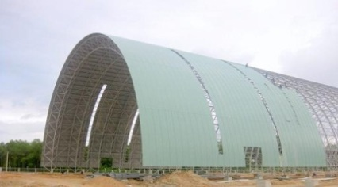 | We will enter the yard after going through an archway.  Chúng ta sẽ tiến vào sân sau khi đi qua mái vòm.
Bamboo  /bæm'bu:/  (n) | Cây tre | 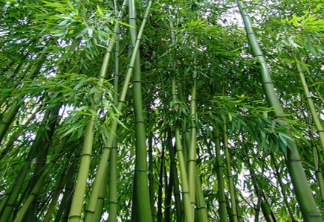 | Local craftsmen can make many things from bamboos.  Những người thợ thủ công địa phương có thể tạo ra nhiều thứ từ cây tre.
Carnival  /'kɑ:nivəl/  (n) | Lễ hội(hoá trang) | 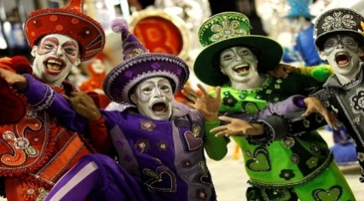 | Will you join in the carnival tomorrow?  Bạn sẽ tham gia vào lễ hội hoá trang ngày mai chứ?
Coconut  /'koukənʌt/  (n) | Quả dừa | 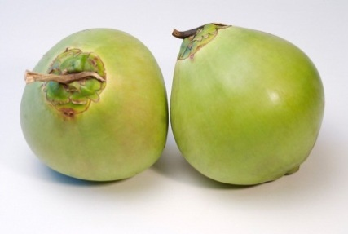 | Coconut candy is a. speciality of Ben Tre Province.  Kẹo dừa là một đặc sản của tỉnh Bến Tre.
Commemorate  /kə'memə'reiʃn/  (v) | Kỉ niệm | 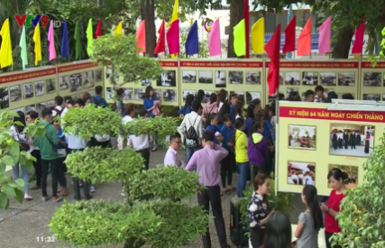 | An exhibiton will be held to commemorate his death.  Một buổi triển lãm sẽ được tổ chức kỉ niệm cái chết của ông ấy.

Fortune  /'fɔ:tʃn/  (n) | Vận may |  | I had good fortune of working with a brilliant coworker.  Tôi có may mắn làm việc với một đồng nghiệp xuất sắc
Green rice flake  /gri:n rais fleik/ | Cốm | 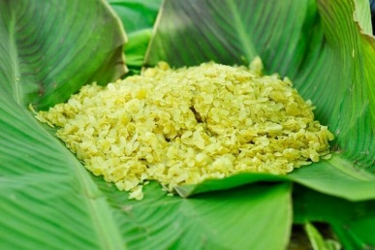 | Green rice flake is a special dish of Viet Nam.  Cốm là một món ăn đặc biệt của Việt Nam.
Hero  /'hiərou/  (n) | Người anh hung |  | He was one of the national heroes.  Ông là một trong những người anh hùng dân tộc.
Incense  /'insens/  (n) | Hương | 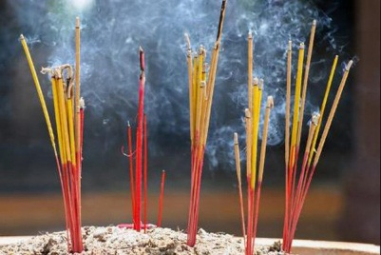 | People burnt incense to honour and commemorate the victims of war.  Mọi người thắp hương để thể hiện sự tôn trọng và tưởng nhớ những nạn nhân của chiến tranh.
Invader  /in'veidə/  (n) | Kẻ xâm lược | 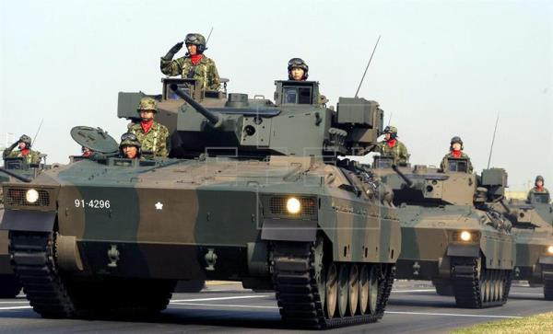 | They was about to rebel the invaders.  Họ đã chuẩn bị chống lại kẻ xâm lược.
Lantern  /'læntən/  (n) | Đèn lồng,đèn trời,đèn thả sông |  | You can see many floating lanterns along this river on special occasions.  Bạn có thể nhìn thấy nhiều đèn lồng trôi dọc theo dòng song này vào những dịp đặc biệt.
Preserve  /pri'zə:v/  (v) | Giữu gìn,bảo tồn | 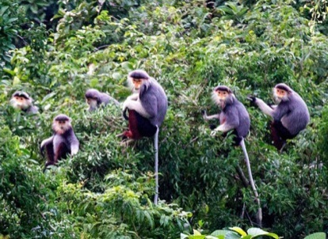 | People should preserve their traditional customs.  Mọi người nên giữ gìn những phong tục truyền thống.
Procession  /procession/  (n) | Đám rước,đoàn người | 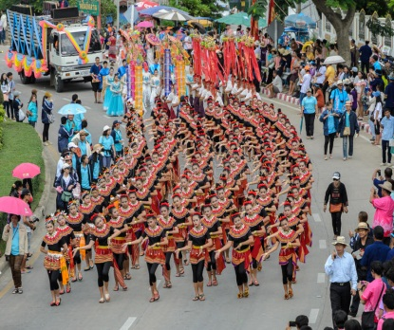 | A procession of visitors came into the building.  Một đoàn khách tham quan đã tiến vào toà nhà.
Reunion  /'ri:'ju:njən/  (n) | Sự đoàn tụ |  | I really long for the family reunion on Tet holiday.  Tôi thực sự trông đợi gia đình đoàn tụ vào dịp Tết.
Wrestler  /'reslə/  (v) | Đô vật |  | The two wrestlers are trying to beat the other.  Hai đô vật đang cố gắng để đánh bại đối thủ.
B GRAMMAR
I.ÔN TẬP CÂU ĐƠN(SIMPLE SENTENCES)
Định nghĩa | Câu đơn là câu chỉ có 1 mệnh đề chính, gồm có 1 chủ ngữ và 1 động từ.  Hoặc câu có thể có chủ ngữ là 2 danh từ nối bằng ‘and’ hoặc có 2 động từ nối bằng ‘and’ nhưng vẫn là 1 câu đơn.
Ví dụ | I went to the supermarker yesterday. (Tôi đã đi đến siêu thị ngày hôm qua.)  Mary and Tom are playing tenis.(Mary và Tom đang chơi tenis.)  My broather ate a sandwich and drank beer. (Anh trai tôi đã ăn sandwich và uống bia.)
II. ÔN TẬP CÂU GHÉP (COMPOUND SENTENCES)
1.Định nghĩa và cấu trúc câu ghép
Định nghĩa | -Là câu có 2 hay nhiều mệnh đề độc lập về ý nghĩa.  -Được kết nối với nhau bởi một liên từ kết hợp hay còn gọi là lien từ đẳng lập như: and,or,but,so…
Cấu trúc | Mệnh đề 1 + (,) + liên từ + mệnh đề 2.  Ví dụ:  You should eat less fast or you can put on weight. (Bạn nên ăn ít đồ ăn nhanh hơn hoặc bạn có thể tang cân đấy.)  I wasn’t very hungry, but I ate a lot. (Tớ không đói lắm, nhưng tớ đã ăn rất nhiều.)  My mother does exercise every day, so she looks very young and fit. (Mẹ tớ tập thể dục hang ngày, vì vậy mà trông mẹ rất trẻ và khoẻ.)
Lưu ý | Chúng ta cần phải sử dụng dấu “,” trước lien từ so, con với các lien từ and/or/but thì có thể có dấu phẩy hoặc không.
2. Các liên từ kết hợp thường gặp
Liên từ | Ví dụ
And(và): dùng để bổ sung thêm thông tin | (The Japanese eat a lot of fish, and they eat a lot of tofu too.( Người Nhật ăn rất nhiều cá, và họ cũng ăn rất nhiều đậu phụ nữa.)
Or(hoặc): dung khi có sự lựa chọn | You can take thí medicine, or you can drink hot ginger tea. (Con có thể uống thuốc này hoặc con có thể uống trà gừng nóng.)
But(nhưng): dung dể nói 2 mệnh đề mag ý nghĩa trái ngược, đối lập nhau. | She doesn’t eat much, but she’s still fat. (Cô ấy không ăn nhiều, những cô ấy vẫn béo.)
So(nên/vì vậy mà/vậy nên): dung để nói về một kết quả của sự việc được nhắc đến trước đó. | My mother eats healthily, so she is very strong.  (Mẹ tớ ăn uống rất lành mạnh, nên bà ấy rất khoẻ.)
III CÂU PHỨC (COMPLEX SENTENCES)
1.Định nghĩa
Định nghĩa | -Câu phức là câu bao gồm một mệnh đề độc lập (independent clause) và ít nhất 1 mệnh đề phụ thuộc (dependent clause) liên kết với nhau.Hai mệnh đề thường được nối với njau bởi dấu phẩy hoặc các liên từ phụ thuộc (Subordinating Conjuntions).
Ví dụ |  | He always takes time to play with his daughter even though he is extremely busy.  Mệnh đề độc lập Mệnh đề phụ thuộc  (Anh ấy luôn dành thời gian để chơi với con gái mặc dù anh ấy rất bận rộn.)  Even though he is busy,he always takes time to play with his daughter.  Mệnh đề phụ thuộc Mệnh đề độc lập  (Mặc dù anh ấy bận rộn,nhưng anh ấy vẫn dành thời gian để chơi với con gái.)  You should think about money saving from now if you want to study abroad.  Mệnh đề độc lập Mệnh đề phụ thuộc  (Bạn nên nghĩ về việc tiết kiệm tiền từ bây giờ nếu bạn muốn đi du học.)  If you want to study abroad, you should think about money saving from now.  Mệnh đề phụ thuộc Mệnh đề độc lập  (Nếu bạn muốn đi du học,bạn nên nghĩ về việc tiết kiệm tiền từ bây giờ.)
Lưu ý |  | -Mệnh đề đi liền với liên từ trong câu phức chính là mệnh đề phụ thuộc (dependent clause).  -Nếu mệnh đề phụ thuộc(dependent clause) nằm phía trược mệnh đề độc lập (independent clause) thì giữa hai mệnh đề phải có dấu phẩy còn lại thì không.
2. Một số lien từ phụ thuộc thường gặp
After  (sau khi) | Although  (mặc dù) | As  (bởi vì/khi) | As if  (như thế là) | As long as  (miễn là) | In oder to  (cốt để mà)
Before  (trước khi) | Even if  (mặc dù) | Because  (bởi vì) | As though  (như thế là) | As much as | So that  (cốt để mà)
Once  (một khi) | Even though  (mặc dù) | Whereas  (trong khi đó) | If  (nếu) | As soon as  (ngay khi) | Unless  (trừ phi)
Since  (kể từ khi/bởi vì) | Though  (mặc dù) | While  (trong khi đó) | In case  (phòng khi) | When  (khi) | Until  (cho đến khi)
■ BÀI TẬP VẬN DỤNG CƠ BẢN
Bài 1: Điền S (Simple) trước những câu đơn, điền C (compound) trước những câu ghép và CC (Complex) trước những câu phức.
___C__ 1. My bike is broken, so I have to walk to school.
__S__2. My mother bought me a new pair of shoes and made me a cake on my birthday.
__S___ 3. I didn’t expect Jim to come to the meeting yesterday.
___C__ 4. Peter had an accident last week but now he is fine.
____CC_ 5. When I came home, my sister was watching TV.
____CC_ 6. If you want to succeed in life, you have to work harder.
___C__ 7. My sister fancies rock music and she always wants to go to a rock concert.
CC 8. My grandfather and my grandmother first met each other when they were very young.
__CC___ 9. I didn’t know his address until Mary told me.
__CC___ 10. Although she tried her best, she didn’t get the job.
__S___ 11. In spring, there are various festival throughout country.
__CC___ 12. Jame never eats junk food because it’s bad for his healthy.
_S_ 13. There are several parks around the city.
__CC___ 14. You may have a sore throat if you drink cold water.
__S___ 15. They are going to hold a party to celebrate their wedding anniversary.
Bài 2: Khonh tròn vào liên từ thích hợp để hoàn thành những câu ghép dưới đây.(and,or,but,so)
1. My father is an engineer,_____ he often has to work away from home.
A.and B. or C.but D.so
2.This year the Mid-Autumn Festival falls on the next Sunday,_____ I can go home and reunite with my family.
A.and B. or C.but D.so
3.I have never joined in a carnival,_____ I am very curious about it.
A.and B. or C.but D.so
4.My mother is occupied in her job,_____ she tries to make time for me.
A.and B. or C.but D.so
5.Do you wwant to join us_____ do you want to leave now?
A.and B. or C.but D.so
6.I loves cats,_____ my mother doesn’t allow me to have one.
A.and B.or C.but D.so
7.Mary wants to go abroad,_____ she saves money from now.
A.and B.or C.but D.so
8.They used to be friends,_____ now they are not.
A.and B.or C.but D.so
9.This event is help to commemorate the national heroes,_____ it teacher children to respect and be grateful to the heroes.
A.and B.or C.but D.so
10.You can take a seat,_____ you can go around and take a look.It’s up to you.
A.and B.or C.but D.so
Bài 3: Điền một liên từ thích hợp để hoàn thành những câu ghép sau.
1. My father wants me to become a doctor,_BUT__ I want to become a designer.
2. It is a challenging task,_SO__ it takes me a lot of time to do it.
3. Should I stay in and watch TV__OR___ should I hang out with friends today?
4. There are many festival in Vietnam_AND__ many of them are held in the spring.
5. Did you stay at home last night_OR____ did you go out with your friends?
6. I broke my glasses yesterday,_SO____ I didn’t see things clearly.
7. My brother doesn’t socialize much,_SO____ he has very few friends.
8. A new camera is all I want now,__BUT___ I don’t have enough money.
9. Mary looks small and thin,_BUT____ she owns great strength.
10. I have many things to do tonight,_SO____ I reject my friend’s invitation to her party.
11. My computer is brand new,__BUT___ I en counter some problems when I use it.
12. This is a complex problem,_SO____ we need to work together to find the solution.
13. Peter doesn’t feel today,__SO___ he is absent from school.
14. They thought they won the match,_BUT__ it turned out that they were losers.
15. My siblings and I don’t share many similarities,_BUT_ we are in harmony with each other.
Bài 4: Nối hai câu đơn sau thành câu ghép.
1. My best friend is studying abroad, so it is impossible for us to meet each other now.
2. They are going to build a new bridge across this river, so traveling will be much more convenient.
3. It has been ages since our last encounter but I still remember him clearly.
4. I went down with flu last week so I had to postpone my work.
5. I think the festival will be full of fun and many people will enjoy it.
6. Students can choose to carry out a project on environmental issues or they can conduct research on the topic of renewable energy.
7. My mother started a business trip last week but she hasn’t returned home yet.
8. My brother has grown up into an adult but he still enjoys playing with Lego.
Bài 5: Khoanh tròn vào liên từ thích hợp để hoàn thành những câu phức dưới đây.
1.It will be a great fortune (if/unless) I can join upcoming carnival.
2.I will lend you my book (as long as/as soon as) you promise to keep it clean.
3.I will call you (as long as/as soon as) I arrive there.
4.(When/While) I came, Jim was having dinner.
5. Catherine was shocked (when/until) she found out the truth.
6. They have worked at this company (when/since) they graduated.
7. At 8 pm last night, I was doing my homework (when/while) my sister was playing with her toys.
8. (Before/After) I had eaten my breakfast , I went to school by bus.
9. (Although/Despite) Mary looks thinner than me, she is much stronger than me.
10. They didn’t come to the party (since/as soon as) they were too busy.
11. You should bring your raincoat (unless/in case) it rains.
12.I didn’t realize her new hair (when/until) she told me.
13.I won’t accept this job (even if/if) the offer me high salary.
14.My father will buy me a book (even though/as long as) I pass the exam.
15.I like her (when/even though) she’s annoying sometimes.
Bài 6: Nối những mệnh đề ở cột A với cột B để tạo thành một câu ghép hoàn chỉnh.
A | B
1.They won’t let you in | a.he failed to persuade her.
2.They were having a small talk | b.once I have enough money to buy one.
3.Even though he tried his best, | c.until I pointed it out for him.
4.Jame didn’t realize his fault | d.unless you have the invitation letter.
5.Although Sarah can sing very well , | e.when I came in the room.
6.Today Peter doesn’t attend class | f.when you visit temples or pagodas.
7.I will move to a bigger apartment | g.as he is suffering from a headache.
8.You shouldn’t wear short skirts | h.she rarely performs in front of people.
1-_d____ 2-__e___ 3-_a__ 4-_c____
5-__h___ 6-__g___ 7-_b__ 8-_f___
Bài 7: Điền những liên từ cho sẵn vào chỗ trống để hoàn thành những câu phức dưới đây.
whereas | unless x2 | since | before x2 | if x2
even though |  | while
1.__EVEN THOUGH___ Jame is my friend, I can’t accept his arrogance.
2. My brother is a bookworm,_WHEREAS____ I don’t like reading books.
3. At midnight, my parents were sleeping_WHILE____ I was cramming for exams.
4._IF____ you have any questions, you ask me after the lesson.
5. We won’t go camping_UNLESS____ the weather is fine.
6. You shouldn’t skip classes_UNLESS____ you really have to.
7. What did you do_BEFORE____ you went to bed last night?
8. In some cultures, you have to pray_BEFORE____ you eat.
9. We are very familiar with this areas__SINCE___ we moved here 15 years ago.
10._IF____ you travel from the North to the South of Vietnam, you will experience many interesting customs.
Bài 8: Viết lại hai câu đơn thành một câu phức.
1. Dog is my favorite animal BECAUSE they are good companions of people.
2. I don’t like jazz, WHEREAS a friend of mine is a fan of it.
3. ALTHOUGH they were stuck in the traffic for hours, they managed to get there on time.
4. WHEN I came to the party, everyone was leaving.
5. This time Jane works very hard BECAUSE she doesn’t want to fail the exam again.
6. I seldom do exercises ALTHOUGH doing exercises is good for health.
7. ALTHOUGH my computer is old-fashioned, it functions very smoothly.
8. I didn’t known her real name BECAUSE people always called her by her nickname.
■ BÀI TẬP TỔNG HỢP NÂNG CAO
Bài 9: Đánh dấu [V] trước câu đúng.Đánh dấu [X] trước câu trả lời sai và sửa lại cho đúng.
_X_ 1.I love the Mid-Autumn festival. Since there are a variety of interesting activities during the festival.
Sửa festival since: mệnh đề phụ thuộc đứng sau since không thể tách riêng thành 1 câu.
_X_ 2.While the Mid-Autumn festival is also called “Children’s festival” in Vietnam, it is ẹnjoyed by people of all ages.
Sửa although: lien từ while k phù hợp trong trường hợp này.
__V___ 3.On this special occasion, family members often reunite and celebrate the festival.
__X___ 4.Many people choose to go out and enjoy the exciting atmosphere, however others want to stay in and have time with their family.
Sai: However
Sửa: whereas
__X_ 5.The festival is help on the 15th day of the 8th month of the lunar calendar when the full moon.
Sai: the full moon
Sửa: the moon is full
__X_ 6.Moon cakes are very important as if making and sharing moon cakes is the hallmark tradition of this festival.
Sai: as if vì as if k phù hợp để diễn tả quan hệ nguyên nhân kết quả
Sửa: because
__X___ 7.In Chinese culture, a round shape symbolizes completeness and reunion so the eating of round moon cakes among family members signifies the unity of families.
Sai: so
Sửa: , so phải có dấu , trước so
___X__ 8.Unless you visit Vietnam in autumn, you should join in this special festival.
Sai; unless
Sửa: if
Bài 10: Dựa vào những từ cho sẵn, viết câu ghép hoàn chỉnh với các liên từ and, so, but”.
1. I/visit/my neighbors/yesterday/no one/be/home.
I visited my neighbors yesterday but no one was at home
2. They/recently/buy/new/house/they/throw/party/tomorrow.
They have recently bought a new house, so they will throw a party tomorrow.
3. You/face/a lot of/difficulties/in the future/career/you/should/never/give/up.
You will face a lot of difficulties in the future career but you should never give up.
4. You/like/cup/of/coffee/you/like/glass/of/water?
Do you like a cup of coffee or do you like a glass of water?
5. Mr. Smith/seem/nice/man/he/be/selfish.
Mr Smith seems nice but he is selfish.
6. Mr. Brown /be/dedicated/teacher/many people/respect/him.
Mr Brown is a dedicated teacher, so many people respect him.
7.My students/be/hard-working/and/well-behaved/I not/have to/worry/much/about/them.
My students are hard-working and well-behaved, so I don’t have to worry much about them.
8.Ann/want/lose/weight/she/go/the gym/regularly.
Ann wants to lose weight, so she goes to the gym regular.
9.The new radio/cost/me/a lot of/money/its/quality/br/poor.
The new radio costs me a lot of money but its quality is poor.
10. This movie/be/praised/by/critics/I/not/really/like/it.
This movie is praised by critics but I don’t really like it.
Bài 11: Điền liên từ thích hợp vào ô trống để hoàn thành những câu sau:
1. They haven’t eaten anything since the morning BECAUSE/SINCE/AS they were too busy to eat.
2. James is very excited now BECAUSE/SINCE/AS he is going abroad next month.
3. ALTHOUGH/THOUGH/ EVEN THOUGH it may be very challenging for you to do it, you can give it a try.
4. I was going home yesterday WHEN I came across my old friend.
5. UNLESS you often an apology to Jane, she won’t forgive you.
6. BECAUSE/ SINCE/AS Mr. Smith doesn’t like traditional folk songs, he rarely listen to them.
7. Will you hang out with your friends OR will you reunite with your family on the Mid-Autumn festival?
8. IF you want to visit a foreign country, you have to apply for a visa first.
9. Tony has lived in Vietnam for 2years, BUT he doesn’t know much about the countries festival.
10. Normally our family prefers staying at home and having dinner together on weekends, BUT this week we want to do something else.
Bài 12: Khoanh tròn đáp án đúng.
Nghinh Ong Festival
In Vietnam, there are many unique fastivals The Nghinh Ong Festival opened in Lai Son commune, Kien Hai district, the Mekong Delta province of Kien Giang on November14 as part of the “National Tourism Year 2016 - Phu Quoc – Mekong Delta”. The Nghinh Ong Festival aims to (1)_____ the solidarity of fishermen at sea (2) _____ they fish and safeguard the country’s sovereignty over sea and islands.The festival is a (3) _____ identity of the coastal locality,which has been preserved and passed through generation.It (4) _____ to enriching the country’s culture (5) _____ it allows Kien Hai district to introduce cultural values,natural resources and typical tourism products.Through the festival, Kien Hai district expects to leave a strong impress on tourists (6) _____ encouraging local people to join hands in developing tourism.
1. A. honor B. show C. comemorate D. celebrate
2. A. When B. because C. if D. in case
3. A. cultural B. customary C. traditional D. historical
4. A. helps B. contributes C. makes D. continues
5. A. or B. and C. but D. so
6. A. while B. when C. although D. but
Bài 13: Đọc đoạn văn sau và trả lời câu hỏi.
Huong Pagoda Festival
Together with Bai Dinh and Yen Tu Pagoda Festival, Huong Pagoda Festival is among the greatest Buddhist festivals in northern Vietnam. Huong Pagoda Festival plays an important role in the spiritual life of Vietnamese people in general and Vietnamese Buddhists in particular.
Huong Pagoda is located in My Duc District, 70 kilometers away from Hanoi to the south, This festival lasts for three months from the first to the third month in Lunar Calendar. In fact, the official opening day for the festival is on the 6th day of the first Lunar month. As other festivals in Vietnam, Huong Pagoda Festival is divided into two parts: The ceremonies and the entertaining activities. Ceremonial rituals consist of incense offering procession and Zen ceremony. In this ceremony, Monks and Buddists offer incense, flowers, candles and fruits. During the ceremony, two monks perform beautiful and flexible dances. There are also entertaining activities. Visitours can enjoy boat cruise along Yen Stream for watching picturesque scenery, climb mountain and explore holy caves. It is believed that climbing up the top of Huong Tich Mountain will bring you fulfillment and great success in life. Coming to Huong Pagoda Festival, touists have chance to taste three famous delicacies which are bamboo shoot, Sang vegetables and grinding roots. Coming at the beginning of Huong Pagoda Festival, tourists will be overwhelmed by the white color of apricot flowers covering the entire area of Huong Son mountain; and at the end of festival, you will have chance to taste the fresh flavor of apricot juice.
The Huong pagoda festival is imbued with national identity in which people are oriented towards Truth, Beauty, and Goodness.
- Where is Huong Pagoda located?
IN MY DUC DISTRICT
- How long does Huong Pagoda festival last?
THREE MONTHS
- What happens during the Zen ceremony?
MONKS AND BUDDHISTS OFFER INCENCE, FLOWERS, CANDLES AND FRIUTS; TWO MONKS PERFORM BEAUTIFUL AND FLEXIBLE DANCES.
- What are some entertaining activities in Huong Pagoda Festival?
BOAT CRUISE, MOUNTAIN CLIMBING AND CAVE EXPLORING.
- What is believed to bring you fulfillment and great success in life?
CLIMBINGUP THE TOP OF HUONG TICH MUONTAIN
- When will tourists have chance to taste the fresh flavor of apricot juice?
AT THE END OF FESTIVAL

FOLK TALES
(TRUYỆN DÂN GIAN)
UNIT
06
- VOCABULARY
New words | Meaning | Picture | Example
Cheerful  /'tʃjəful/  (adj) | Vui mừng |  | She welcomed her guests with a cheerful smile.  Cô ấy chào đón khách hang bằng một nụ cười vui vẻ.
Cruel  /'kruili/  (adj) | Độc ác | 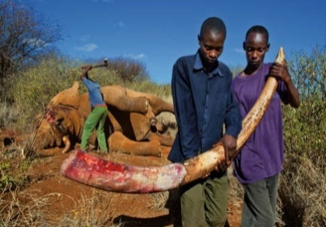 | Some people are very cruel to animals.  Một vài người rất độc ác với động vật.
Cunning  /'kʌniɳ/  (adj) | Xảo quyệt,gian xảo |  | Josh was as cunning as a fox.  Josh xảo quyệt như một con cáo.
Eagle  /'i:gl/  (n) | Đại bàng |  | Eagles are birds of prey.  Đại bàng là loài chim săn mồi.

Emperor  /'empərə/  (n) | Hoàng đế | 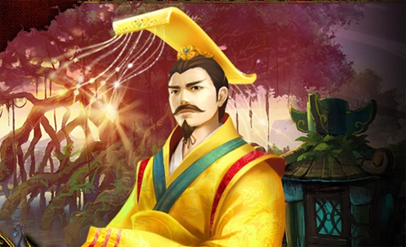 | The country suffered from poverty because of that emperor.  Đất nước đã phải chịu sự ngèo đói bởi vì vị Hoàng đế đó.
Evil  /'i:vl/  (adj) | Độc ác,xấu xa về mặt đạo đức |  | I was frightened of his evil smile.  Tôi sợ nụ cười độc ác của anh ta.
Fable  /'feibl/  (n) | Truyện ngụ ngôn | 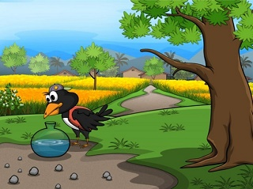 | My country is a land rich in fable.  Quê hương tôi là một vùng đất có nhiều câu truyện ngụ ngôn.
Fierce  /fiəs/  (adj) | Dữ dằn |  | This dog isn’t as fierce as its look.  Con chó không dữ dằn như vẻ bên ngoài của nó.
Folk tale  /fouk teil/  (n) | Truyện dân gian | 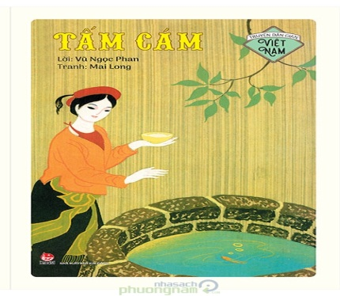 | Folk tales were passed from people to people in aspoken form.  Truyện dân gian được truyền từ người này sang người khác dưới dạng nói.
Genre  /ʤỴ:ɳr/  (n) | Thể loại | 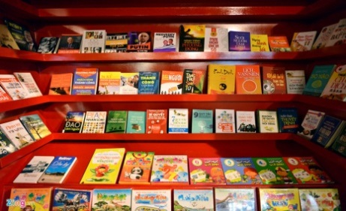 | Which genre of book do you like?  Bạn thích thể loại sách nào.

Giant  /'dʤaiənt/  (n,adj) | Khổng lồ |  | In stories, the giants are often cruel and stupid.  Ở những câu chuyện, người khổng lồ thường độc ác và ngốc nghếch.
Greedy  /'gri:di/  (adj) | Tham lam |  | They stared at the treasure with greedy eyses.  Họ nhìn chằm chằm vào kho báu với ánh mắt tham lam.
Hare  /heə/  (n) | Con thỏ rừng |  | Have you ever seen a hare?  Bạn đã bao giờ nhìn thấy con thỏ rừng chưa?
Imaginary  /i'mædʤinəri/  (adj) | Tưởng tượng |  | I used to have an imaginary friend when I was a child.  Tôi đã từng có một người bạn tưởng tượng khi tôi còn bé.
Knight  /nait/  (n) | Hiệp sĩ | 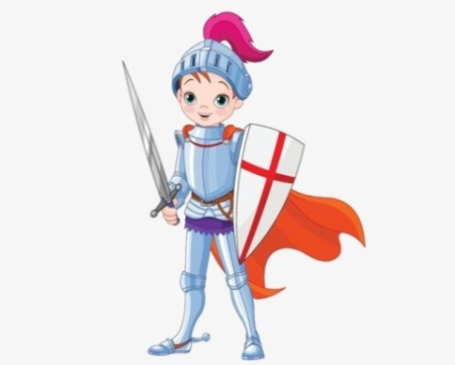 | My grandmother told me tales about brave knights.  Bà của tôi đã kể cho tôi câu chuyện về những hiệp sĩ dũng cảm.
Legend  /'ledʤənd/  (n) | Huyền thoại |  | He is a legend in the world of music  Anh ấy là một huyền thoại trong thế giới âm nhạc.
Mean  /mi:n/  (adj) | Bủn xỉn,bần tiện |  |  | Don’t be so mean with your friends.  Đừng quá bủn xỉn với bạn của bạn.
Moral  /'mɔrəl/  (adj) | Thuộc về đạo đức | 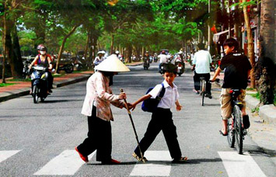 |  | Our ancestors taught us moral lessons via fables.  Tổ tiên của chúng ta dạy chúng ta những bài học đạo đức qua truyện ngụ ngôn.
Ogre  /'ougə/  (n) | Yêu tinh |  |  | Orges are just imaginary characters in stories.  Yêu tinh chỉ là những nhân vật tưởng tượng trong truyện.
Plot  /plɔt/  (n) | Cốt truyện | 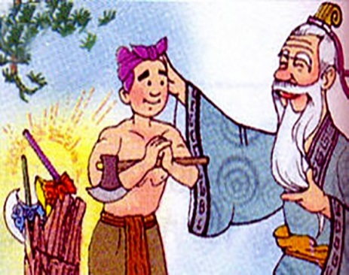 |  | Folk tales don’t often have complicated plots.  Truyện dân gian không thường có cốt truyện phức tạp.
Tortoise  /'tɔ:təs/  (n) | Con rùa |  |  | Do you know a story of a hare and a tortoise?  Bạn có biết câu về một con thỏ rừng và một con rùa không?
Wicked  /'wikid/  (n) | Xấu xa,độc ác |  |  | That was a wicked thing to do!  Đó là một điều độc á để làm.
Witch  /'wit /  (n) | Phù thuỷ |  |  | He was turned into a frog by a with.  Anh ấy bị biến thành một con ếch bởi một phù thuỷ.
Woodcutter  /'wud,kʌtə/  (n) | Tiều phu | 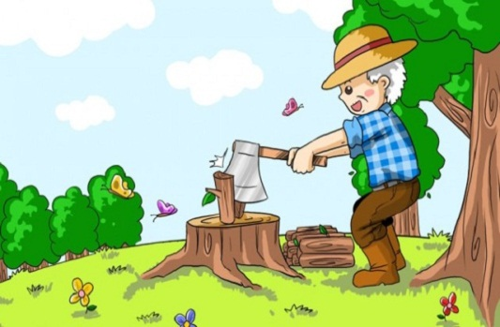 |  | There is a woodcutter in that village.  Có một người tiều phu trong ngôi làng đó.
B GRAMMAR
I ÔN TẬP THÌ QUÁ KHỨ ĐƠN(THE PAST SIMPLE)
1.Cách dùng
Cách dung | Ví dụ
Diễn tả hành động hay sự việc đã xảy ra và kết thúc tại một thời điểm xác định trong quá khứ. | I met her last summer. (Tôi đã gặp cô ấy vào mùa hè năm ngoái.)
Diễn tả hành động thường làm hay quen làm trong quá khứ | She often went swimming every day last year. (Năm ngoái mỗi ngày cô ấy thường đi bơi.)
2.Cấu trúc của thì quá khứ đơn
a.Với động từ ‘to be” (was/were)
Thể khẳng định |  |  | Thể phủ định
I/He/She/It/  Danh từ số ít | Was | +danh từ/tính từ | I/He/She/It/  Danh từ số ít | Was not/wasn’t | +danh từ/tính từ
You/We/They/  Danh từ số nhiều | Were |  | You/We/They/  Danh từ số nhiều | Were not/weren’t
Ví dụ:  -He was tired. (Anh ấy đã rất mệt.)  -They were in the room. (Họ đã ở trong phòng.) |  |  | Ví dụ:  -He wasn’t at school yesterday. (Hôm qua anh ấy đã không ở trường.)  -They weren’t in the park. (Họ đã không ở trong công viên.)
- Lưu ý: khi chủ ngữ trong câu hỏi là “ you “ ( bạn ) thì câu trả lời phải dùng “I“ ( tôi ) để đáp lại.
b, với động từ thường ( Verb/V )
Thể khẳng định |  |  |  | Thể phủ định
I/you/we/they  Danh từ số nhiều |  | + V-ed |  | I/you/we/they  Danh từ số nhiều |  | + did not/ didn’t |  | + V nguyên mẫu
He/she/it  Danh từ số it |  |  |  | He/she/it  Danh từ số ít
Ví dụ:  -She went to school yesterday. ( Hôm qua cô ấy đã đi học. )  -He worked in this bank last year. ( Năm ngoái anh ấy đã làm việc ở ngân hàng này. ) |  |  |  | Ví dụ:  -My mother didn’t buy me a new computer last year. ( Năm ngoái mẹ tôi đã không mua cho tôi một chiếu máy tính mới. )  -He didn’t meet me last night. ( Anh ta đã không tới gặp tôi tối qua. )  -Mr.Nam didn’t watch TV with me. ( Ông nam đã không xem TV với tôi. )
Thể nghi vấn |  |  |  |  | Câu trả lời ngắn
Did | I/you/we/they/ danh từ số nhiều  He/she/it/ danh từ số ít |  | + V nguyên mẫu? |  | Yes, |  | I/you/we/they/ danh từ số nhiều  He/she/it danh từ số ít |  | Did.
 |  |  |  |  | No, |  |  |  | Didn’t.
Ví dụ:
- Did she work there? ( Có phải cô ấy làm việc ở đó không? )
- Yes, she did/ No, she didn’t.
- Did you go to Ha Noi last month? ( Có phải bạn đã đi Hà Nội tháng trước không? )
- Yes,I did/ No,I didn’t.
3. Dấu hiệu nhận biết:
Trong câu ở thì quá khứ đơn thường có sự xuất hiện của các trạng từ chỉ thời gian như:
- yesterday ( hôm qua)
- last night/ week/ month ….
- ago ( cách đây)
- in + thời gian trong quá khứ ( in 1990)
- when ( khi) trong câu kể
BÀI TẬP VẬN DỤNG CƠ BẢN :
Bài 1: Chia động từ trong ngoặc ở thì quá khứ đơn để hoàn thành câu chuyện ngụ ngôn:
THE FOX AND THE GRAPES
Long, long year ago there (1. Live) _LIVED___ a fox who loved to eat. He lived close to a vineyard and he used to stare at the lovely grapes that hung there.
“ How juice they look. Oh I am sure these are stuff that metl in the mouth when you have them. If only I could reach them.” On sunny day, the fox (2. Wake)_WOKE_ up and (3.see)_SAW______ the grapes glistening by the sunlight. The vineyard (4.look)__LOOKED____ heavenly and the grapes looked so luscious that the famished fox could no longer control itself. He (5.jump)_JUMPLED____ to reach them but fell down.
He jumped again. No, they (6.be)_WERE___ much higher.
He jumped even more. But they were still out of reach.
He jumped and (7.stretch) STRETCHED and (8.hop) HOPPED but no avail. Those yummy grapes (9.hang) HUNG/HANGGED higher than the fox could reach. No matter hard he (10.try) TRIED, the fox could not reach the grapes. He (11.pant) PAINTED and (12.begin) BEGAN to sweat out of exhaustion. Giving up finally, he looked up in contempt and (13.say) SAID as he (14.walk) WALED away, “those grapes surely must be sour. I wouldn’t eat them even if they were served to me on a golden dish.”
It’s easy to despise what you cannot have.
Baì 2: sắp xếp từ cho trước thành câu hoàn chỉnh:
1. year/ did/ you/ Where/ travel/ last/ to ?
Where did you travel to last year?
2. me/ difficult/ for/ it/ learn/ to/ was/ English.
It was difficult for me to learn English.
3. small/ When/ I/ ,/ mother/ me/ was/ reads/ often/ to/ my.
When I was small, my mother often reads to me.
4. well-behaved/ be/ He/ to/ used/ a/ child.
He used to be a well-behaved child.
5. local/ at/ school/ the/ they/ Were/ students/ secondary?
Were they students at the local secondary school?
6. age/ Daisy/ to/ the/ an/ piano/ early/ at/ learnt.
Daisy learnt to play the piano at an early age.
7. cars/ streets/ 10/ ago/ There/ not/ year/ were/ so/ many/ in.
There were not many cars in the street 10 years ago.
8. friends/ ,/ Last/ my/ and/ to/ cinema/ the/ went/ week.
Last week, my friends and I went to the cinema.
9. didn’t /me/ use/ allow/ knife/ My/ to/ father.
My father didn’t allow me to use knife.
10. Did/ leave/ you/ party/ the/ early/ night/ last?
Did you leave the party early last night?
Bài 3:
Đánh dấu [V] trước câu đúng, đánh dấu [X] trước câu sai và viết lại câu đúng.
- Was you give me a ring yesterday? X -> DID YOU GIVE ME A RING YESTERDAY?
- Who did the first person to come to the class? X -> WHO WAS THE FIRST PERSON COME TO THE CLASS?
- Jim hurted himself when he prepared the dinner. X -> HURT
- Last week, there was a folk music concert at the lock park. V
- When I was small, I am the naughtiest child in my village. X -> WHEN I WAS SMALL, I WAS THE NAUGHTIEST CHILD IN MY VILLAGE.
- Did he used to be a renowned author? X -> USE
- I didn’t know who broke the vase. V
- Did you were born in Japan? X -> WERE YOU BORN IN JAPAN?
- The first time I met him were 2 years ago. X -> THE FIRST TIME I MET HIM WAS 2 YEARS AGO.
- They didn’t came to class yesterday. V
2. Cấu trúc thì quá khứ tiếp diễn.
Cấu trúc | Ví dụ
Thể khẳng định  I/He/She/It+ was+ V-ing  We/You/They+ were+ V-ing | I was thinking about him last night.  We were just talking about it before you arrived.
Thể phủ định  I/He/She/It+ was not/wasn’t+ V-ing  We/You/They+ were not/ weren’t+ V-ing | I wasn’t thinking about him last night.  We were not talking about it before you arrived.
Thể nghi vấn  Was+ I/he/She/it + V-ing?  Were + We/You/They + V-ing?  Câu trả lời:  (+) Yes, I/He/She/It was.  Yes,We/You/They were.  (-) No, I/he/she/it wasn’t.  No, we/you/they weren’t. | Were you thinking him last night?  What were you just talking about before I arrived.
3. Dấu hiệu nhận biết.
Trong câu có các trạng từ chỉ thời gian trong quá khứ kèm theo thời điểm xác định.
- at + giờ + thời gian trong quá khứ ( at 12 o’clock last night, ….)
- at this time + thời gian trong quá khứ ( at this time two week ago,…)
- in + năm (in 2000, in 2005)
- in the past (trong quá khứ)
-trong câu có “ when ” khi diễn tả một hành động đang xảy ra và một hành động khác xen vào. -while (trong quá khứ)
BÀI TẬP VẬN DỤNG CƠ BẢN
Bài 4:
Chia động từ trong ngoặc ở thì quá khứ tiếp diễn để hoàn thành câu sau.
1. When I called my mother, she (drive) WAS DRIVING .
2. Yesterday at six I (prepare) WAS PREPARING dinner.
3. The Smiths (eat) WERE EATING dinner in the restaurant when I saw them.
4. Nina (look) WAS LOOKING for a job at this time last year
5. My friends (wait) WERE WAITING for the bus I saw them.
6. WAS TIM WRITING (Tim /write) a letter when you came in his room?
7. What WERE MARY AND PETER MAKING (Mary and peter)?
8. The children (play) WERE PLAYING in the playground when it suddenly began to rain.
9. What WERE YOU DOING (you/do) at this time yesterday?
10. I (play) WAS PLAYING video game when my father came home.
11. We (sleep) WERE SLEEPING all day.
12. While Aaron (work) WAS WORKING in his room, his friends (play) PLAYED in the garden.
13. I tried to tell them the truth but they (not listen) WERE NOT LISTENING .
14. Where WERE THEY GOING (they/go) at 5pm yesterday?
15. Most of the time we (sit) WERE SITTING in the room and (talk) WERE TALKING with others.
Bài 5:
Dựa vào các từ cho sẵn, viết thành câu hoàn chỉnh.
- They/ work/ their/ project/ at 2pm/ yesterday.
They were working their project at 2 pm yesterday.
2. We/ study/ English/ at this time/ last week.
We were studying English at this time last week.
- Which/ dress/ she/ wear/ at the party/ last night?
Which dress was she wearing at the party last night?
- No one/ sleep/ at/ this time/ yesterday.
No one was sleeping at this time yesterday.
- Some girls/ argue/ outside/ the shop/ yesterday.
Some girls were arguing outside at the shop yesterday.
- Jim/ read/ book/ or/ he/ watch/ TV/ at 4pm yesterday?
Was Jim reading bookor he was watching TV at 4 pm yesterday?
- My parents / look/ forward/ to/ a vacation/ at this time/ last year.
My parents were looking forward to a vacation at thiss time last year.
- My bother/ and/ I/ build/ tree house/ this time/ last year.
My brother and I were building a tree house at this time last year.

Hoàn thành câu, sử dụng quá khứ tiếp diễn của các động từ cho sẵn.
Bài 6:
Enjoy | Paint | rest | Read | study
Play | Walk | speak | Take | vacuum
1. We saw a lot of rubbish when we were walking along that street.
2. I was enjoying the meal when I spotted a fly in my shop.
3. Jim was taking a shower when his brother came home.
4. They were playing badminton from 4pm till 6pm yesterday.
5. Mrs. Brown was resting the stairs when her husband came home.
6. My neighbors were painting the windows when I visited them.
7. Was he studying all day yesterday? I didn’t see him anything.
8. My father was reading a newspaper when I entered
9. Jane was speaking to her classmates but they didn’t listen.
10. The student was vacuuming very hard when the teacher entered.
Bài 7:
Viết câu hỏi cho phần gạch chân trong các câu dưới đây.
- Mary was making a birthday cake for her grandmother.
What was Mary making for her grandmother?
- He found a silver coin when he was digging his garden.
When did he find a silver coin?
- When you telephoned, I was looking after my sister.
What were you doing when I telephoned?
- They were talking with Josh’s wife.
Whom they were talking with?
- The kids were listening to the radio when I saw them.
What were the kids doing when you saw them?
- Peter was mowing the lawn while his wife was watering the trees.
What was Peter doing whiel his wife was watering the trees?
- Jane was singing a folk song at this time yesterday.
Who was singing a folk song at this time yesterday?
- Josh was walking slowly when he was hit by a motorbike.
What was Josh doing when he was hit by a motorbike?
- BÀI TẬP TỔNG HỢP NÂNG CAO.
Bài8
Gạch chân lỗi sai và sửa lại cho đúng.

An ant and the grasshopper
In a field one summer’s day a Grasshopper was hopping about, chirping and sang to its heart’s. An Ant was passing by and he bearing along with toil an ear of corn he was taking to the nest. “Why not come and chat with me,” saying the Grasshopper, “instead of toiling and moiling in that way?”
“I am helping to lay up food for the winner,” said the Ant, “and the recommend you to do the same.”
“Why bother about winner?” said the Grasshopper; “We have got plenty of food at present.” But the Ant went on its way and was continuing its toil.
When the winner was coming the Grasshopper was having no found itself dying of hunger- while it was seeing the ants distributing every day corn and grain from the stores they had collected in the summer. Then the Grasshopper was knowing : It is best to prepare for days of need.
Lỗi sai | Sửa | Lỗi sai | Sửa
Sang | Singing | come | came
Was passing | Passed | have | had
Corn | The corn | seeing | saw
Saying | Said | knowing | Knew
continuing | continued
Bài 9:
Chia động từ trong ngoặc ở thì quá khứ đơn hoặc thì quá khứ tiếp diễn sao
1. I got to the supermarket just before it closed and (buy) BOUGHT milk.
2. We invited Sarah to the party, but she (not come) DIDN’T COME
3. Jack lost his job because he (be) WAS too irresponsible for his work.
4. Ted (listen) WERE LISTENING to music at half past seven yesterday night.
5. Everyone (know) KNEW that it was Bill’s fault, but nobody said anything.
6. Karen (take) TOOK the key from the coffee table and stormed out of the door.
7. At midnight, I (sleep) WAS SLEEPNG, but Jane (do) WAS DOING her assignment.
8. Luke (stand) WAS STANDING outside the bank when suddenly two robbers (run) RAN past him.
9. I was bored, so Mum (take) TOOK me to a drama workshop with her.
10. Do you remember the time we (go) WENT to England on holiday?
11. When we (be) WERE in Canada, we (go) WERE GOING skiing almost every day.
12. About four years ago, I (decide) DECIDED to become a chef.
BÀI 10: Dựa vào những từ cho sẵn, viết thành câu hoàn chỉnh.
1. We/ have/ breakfast/ when/ the mailman/ arrive.
WE WERE HAVING BREAKFAST WHEN THE MAILMAN ARRIVED.
2. While/ everyone/ sleep/ Paul/ watch/TV.
WHILE EVERYONE WAS SLEEPNG, PAUL WATCHED TV.
3. I/ dream/ about/ long/ vacation/ when/ the alarm clock/ go/ off.
I WAS DREAMING ABOUT A LONG VACATION WHEN THE ALARM CLOCK WENT OFF.
4. While/ I/ practice/ the piano/ late/ last night,i/ hear/ strange/ noise.
WHILE I WAS PRACTICING THE PIANO LASST NIGHT, I HEARD STRANGE NOISE.
5. The sheep/ graze/ in/ the/ filed/ when/ they/ be/ scared/ by/ the/ noise.
THE SHEEP WERE GRAZING IN THE FIEL WHEN THEY WERE SCARED BY THE NOISE.
6. What/ you/ do/ when/ the earthquake/ happen/ yesterday?
WHAT DID YOU DO WHEN THE EARTHQUAKE WAS HAPPENING YESTERDAY?
7. I/ run/ to/ catch/ the bus/ when/ I/ see/ Jim.
I WAS RUNNING TO CATCH THE BUS WHEN I SAW JIM.
8. When/ you/ meet/ James/ last night/ ,/ what/ he/ wear?
WHEN YOU MET JAMES LAST NIGHT, WHAT WAS HE WEARING?
9. Some people/ chat/ while/ others/ play/ games/ at/ the party/ last/ night.
SOME PEOPLE WERE CHATTING WHILE OTHERS WERE PLAYING GAMES AT THE PARTY LAST NIGHT.
10. It/ rain/ at this time/ yesterday/ so/ we/ cancel/ the barbecue
IT WAS RAINING AT THIS TIME YESTERDAY SO WE CANCELED THE BARCUE.

Khoanh tròn đáp án đúng.
Bài 11:
A beautiful day
Yesterday was so nice a day. Jane (1)_________ up so early. The sun (2) _______ brightly and the bids (3) ___________ on the tree. Jane was so happy because today she went to meet her old friend. Jane’s friend invited her to his new apartment with some other friends. When Jane came, everyone was sitting in the living room and (4)_________ passionately with each other. As she walked in, she (5) ________by her friend. They had a lot to tell the other (6)________they had not met for ages. Jane came home with a smile on her face since her friend (7)_________ to contact regularly.
1. A. woke B. was waking C. stayed D. was staying
2. A. shone B. was shining C. was shone D. shined
3. A. twitters B. twittered C. was twittering D. were twittering
4. A. talked B. talking C. talks D. was talked
5. A. welcomed B. was welcoming C. welcomes D. was welcomed
6. A. although B. because C. however D. so
7. A. promised B. was promising C. promise D. was promised
Đọc bài đọc dưới đây và điền T (True) trước câu trả lời đúng với nội dung bài đọc, điền F (False) trước câu trả lời không đúng với nội dung bài đọc.
Bài 12:
What are myths, legends and folk tales
Once upon a time, long, long ago, there lived some really great storytellers. Their stories have been passed down, retold, translated, adapted and, more recently, written down, because everyone loves good stories. These stories probably include, myths and folktales.
A legend is usually based on a true event in the past. Legend usually have a real hero at the centre of the story and they are often set in fantastic place. The story will have been passed on from person to person, sometimes over a very long period of time.
A myth is not quite the same as a legend. Sometimes a myth is loosely based on a real event but, more often than not, it is a story that has been created to teach people about something very important and meaningful. Myths are often used to explain the world and major events, which, at the time, people were not able to understand- earthquakes, floods, volcanic, eruptions, the rising and setting of the sun, illness and death.
Folktales are usually stories that have been passed down from generation to generation in spoken from. Often we do not know who was the original author and it is possible that some stories might have been concocted author a campfire by a whole group of people. It is quite normal to discover that are many version of the tale, some very similar but others may have only one or two characters in common and take place in totally different settings.
__T___ 1.In legends, heroes are set in fantastic places.
_F____ 2.Amongst legends, myths and folktales, only legends are based on true event in the past.
__F___ 3.Myths are created only for entertainment.
_T____ 4.Earthquakes, floods and volcanic eruptions are explained in myths.
_T____ 5.Folktales may be invented around a campfire by a whole group of people.
_F____ 6.Folk tales have only one version.
__F___ 7.Folktales are usually passed in written form.

