Period
LESSON PLAN
TIẾNG ANH 10 FRIENDS GLOBAL
UNIT 4: OUR PLANET
LESSON 4C: LISTENING – EYEWITNESS
I. OBJECTIVES:
By the end of the lesson, Ss will be able to:
1. Knowledge:
- Vocabulary: eyewitness, blizzard, earthquake, tornado, tsunami, wildfire, etc.
- Strategy to listen for clues to identify the context of the listening
2. Ability:
- main skills: listening and speaking skills
- sub skills: reading and writing skills
- Use the strategy to better listening skills
3. Quality:
- Have positive attitude in English language learning so that they can participate enthusiastically in all classroom activities, especially with the topic conducted by the teacher
- Keen on studying English
II. TEACHER AIDS AND LEARNING MATERIALS:
Lesson plan, PPT slides, student’s book, workbook, notebook, personal computer (if any), projector/TV, speakers, IWB software.
III. PROCEDURES:
A. Warm-up (5’)
a) Objective: Introduce the new lesson and set the scene for Ss to acquire new language; get students' attention at the beginning of the class by means of enjoyable and short activities as well as to engage them in the steps that followed.
b) Content: Warm-up game
c) Outcomes: Students can gain more confidence and interest in the lesson.
d) Competence: communication, collaboration, critical thinking
e) Organisation of the activity:

TEACHER’S ACTIVITIES | STUDENT’S ACTIVITIES | CONTENTS
WARM-UP. T-Ss/ S-S/ Indiv.  Warm-up game  - Give students 30s to look and remember details in the picture  - Then students have to listen to the description and point out some mistakes.  - If students get the correct answer, they can get bonus.  - Ask: “What disaster does the photo show?”  - Lead in the lesson | - Play in individual  - Volunteer to answer. With one correct answer, that student can get one bonus.  - Listen to the teacher and open the book page 49 | 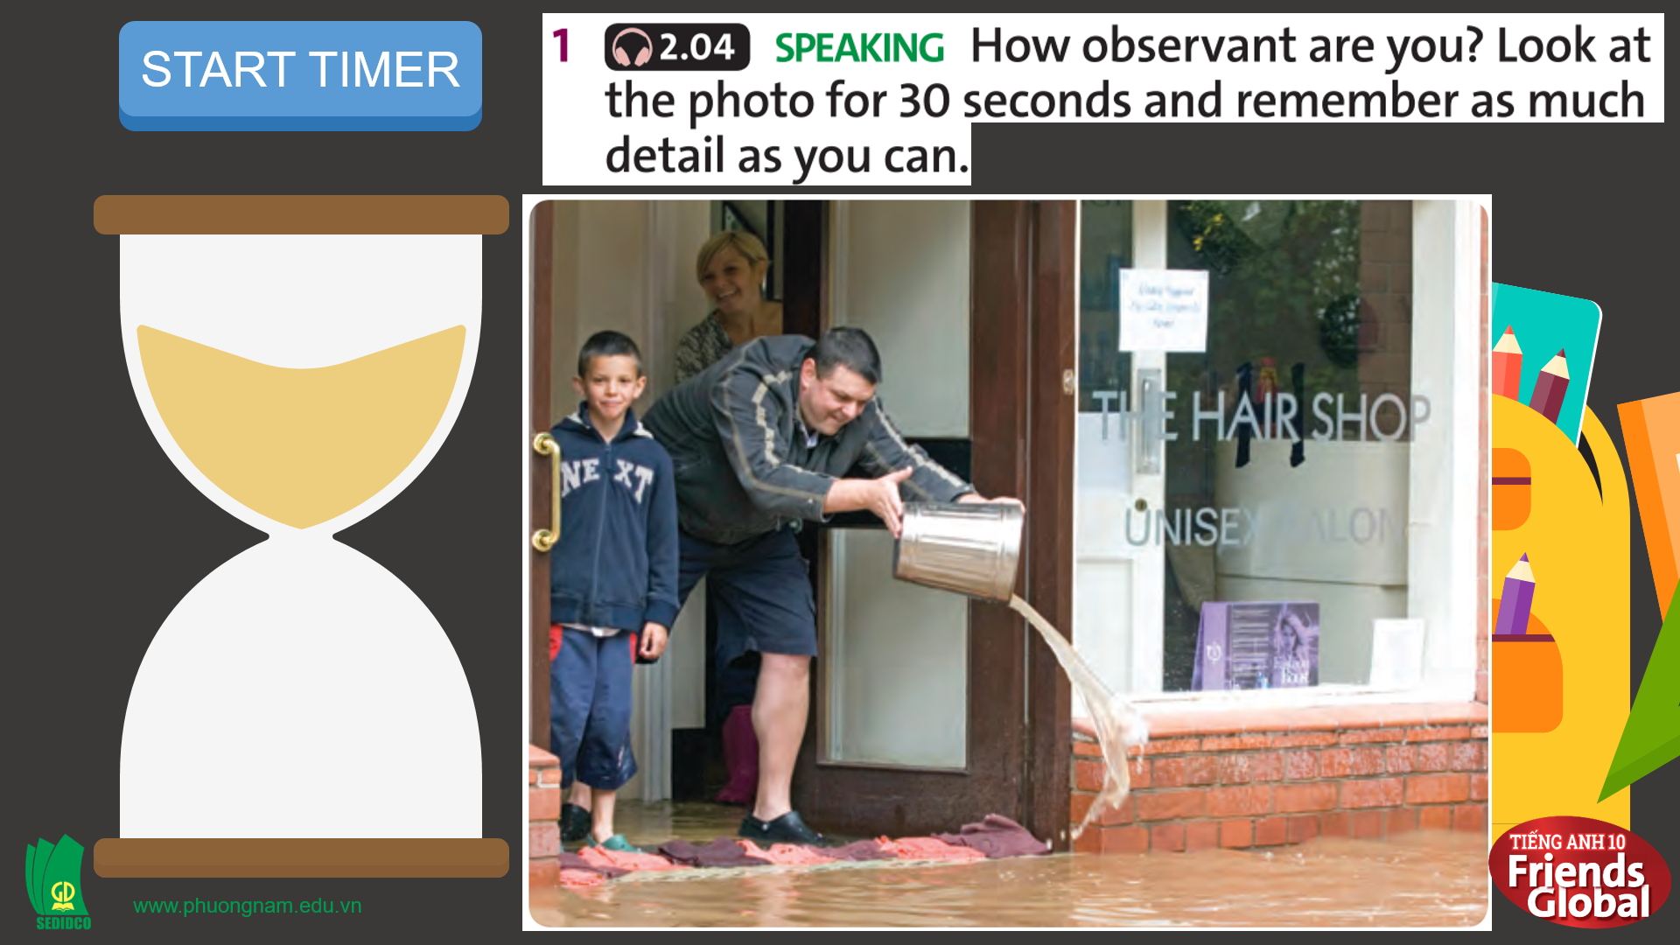  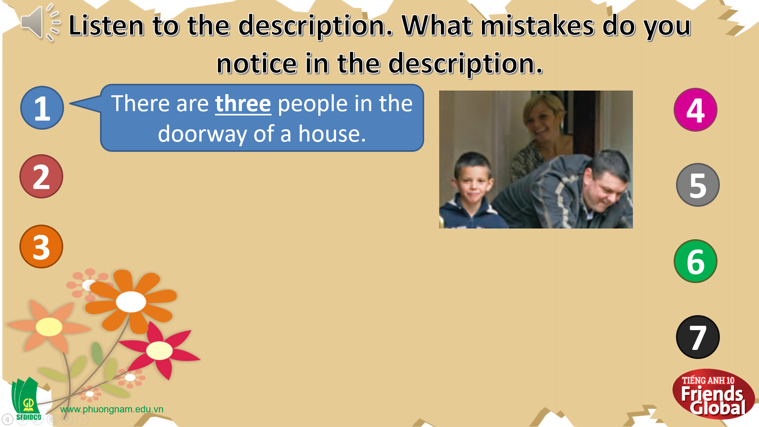  Suggested answers:  a flood  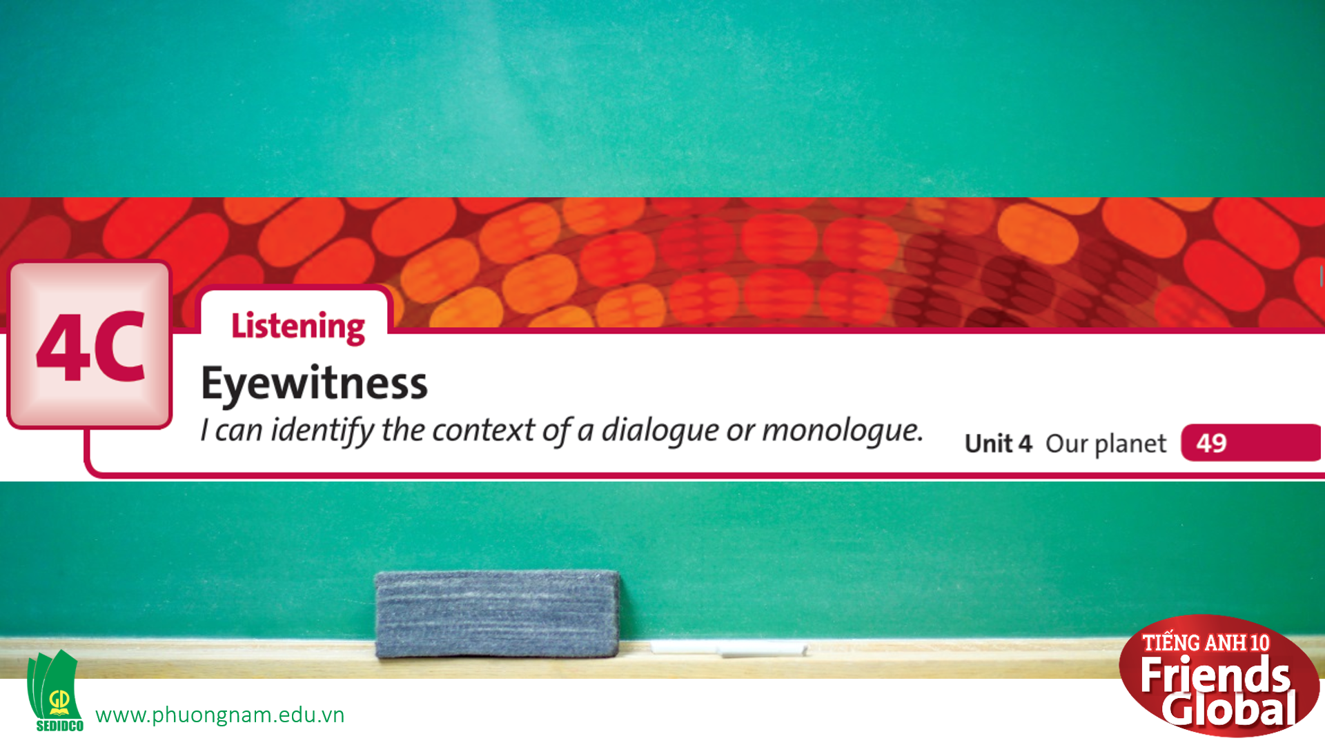

B. New lesson (35’)
- Activity 1: Presentation (5’)
a) Objective: Students know some new words and phrases
b) Content:
Vocabulary study
Speaking
c) Outcomes: Students know how to pronounce words correctly and use them in appropriate contexts.
d) Competence: communication, presentation
e) Organisation of the activity:
TEACHER’S ACTIVITIES | STUDENT’S ACTIVITIES | CONTENTS
PRESENTATION. T-Ss/ S-S/ Indiv.  Teach new vocabulary: (4’)  - Use gestures, GIFs and short explanation to present new words  - Have students practice their pronunciation drills  New words:  eyewitness (n)  blizzard (n)  earthquake (n)  tornado (n)  tsunami (n)  wildfire (n) | - Look, listen, and repeat in chorus in whole class and individuals  - Take notes | 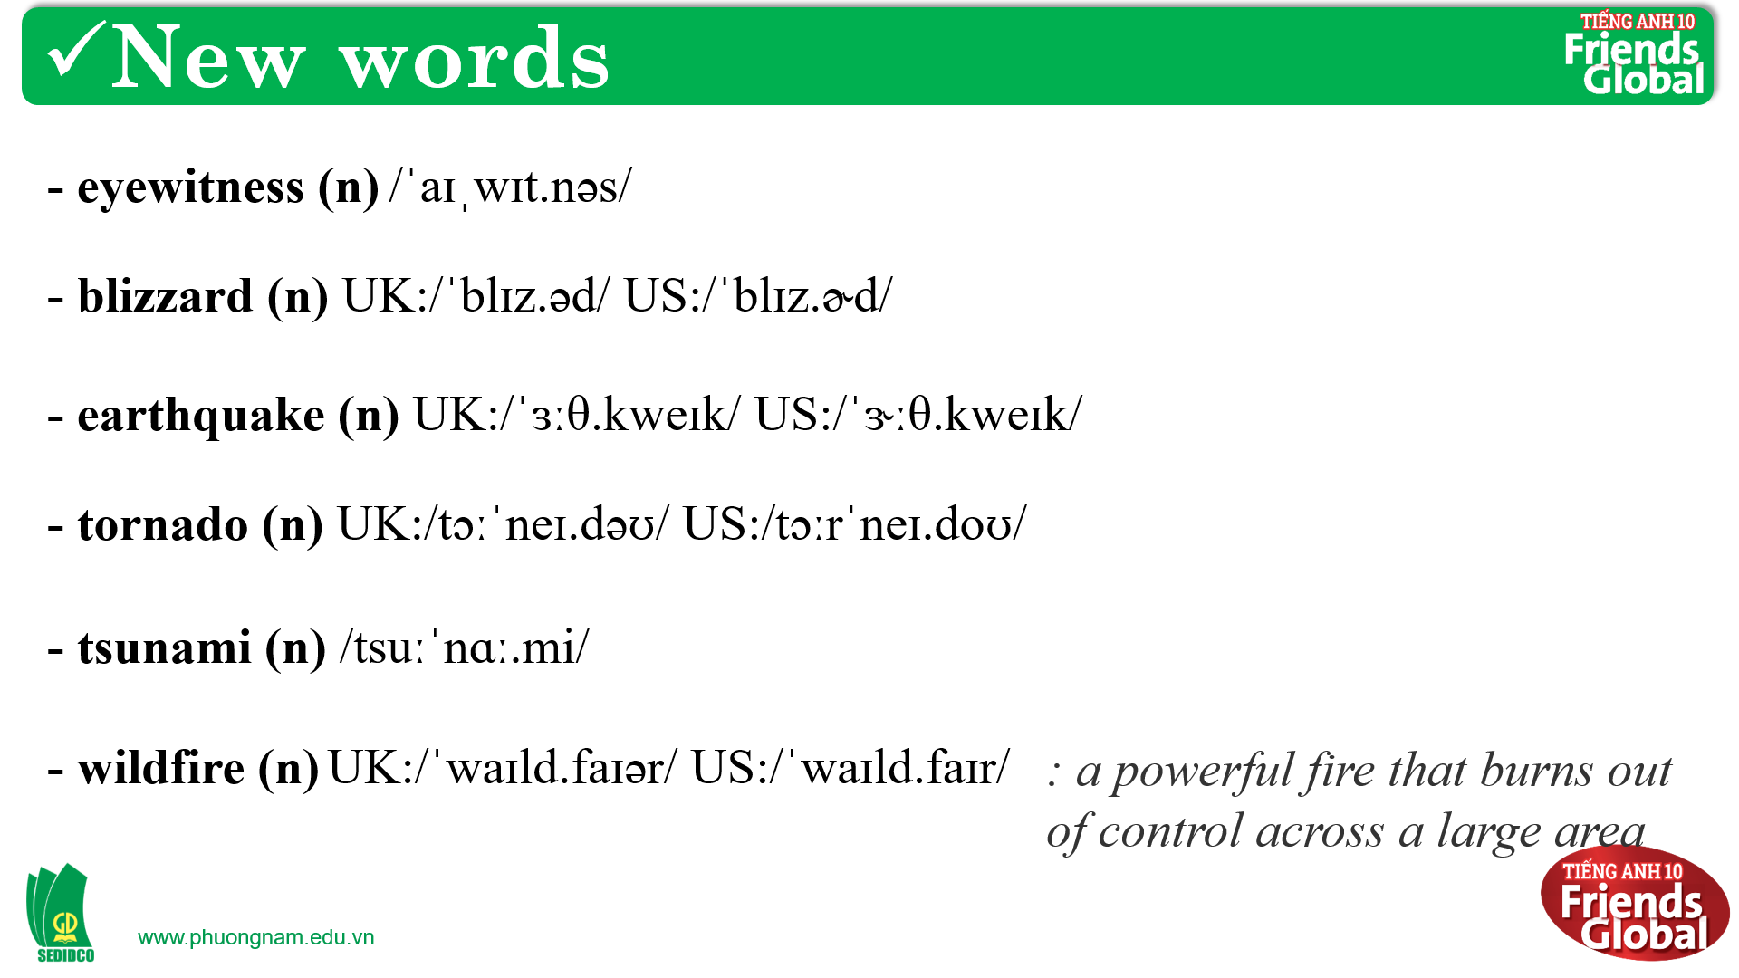
- Activity 2 Practice (15’)
a) Objective: Students can answer the questions to critical thinking, and they can finish the tasks in the textbook. Critical thing skills (guessing/ reasoning) and communication can also be practiced.
b) Content: Students read and choose the correct answer, practice speaking.
Listening
Speaking
c) Outcomes: Students read and listen, and they can apply the useful language in everyday conversations.
d) Competence: communication, collaboration, presentation
e) Organisation of the activity:

TEACHER’S ACTIVITIES | STUDENT’S ACTIVITIES | CONTENTS
PRACTICE. T-Ss/ S-S/ Indiv.  Activity 1 (5’): Exercise 2 page 49  - Ask students to read the Listening Strategy and think about it carefully  - Play the recording for students to answer the questions  - Check answers as a class  - Ask: How did you find the correct answers  Activity 2 (5’): Exercise 3 page 49  - Ask the students to listen to the dialogue and complete the task  - After students finish, teacher play the audio again for students to check their answers.  Activity 3 (5’): Exercise 4 page 49  - Ask students to listen again and finish the task  - Check answers as a class | - Read the Listening Strategy and underline some important information if needed  - Answer the questions  - Check the answers with the teacher  - Discuss the question given in pairs and take notes  - Listen to the audio and complete the task  - Listen again to check the answers  - Listen again and complete the task  - Check the answers with the teacher and take notes | 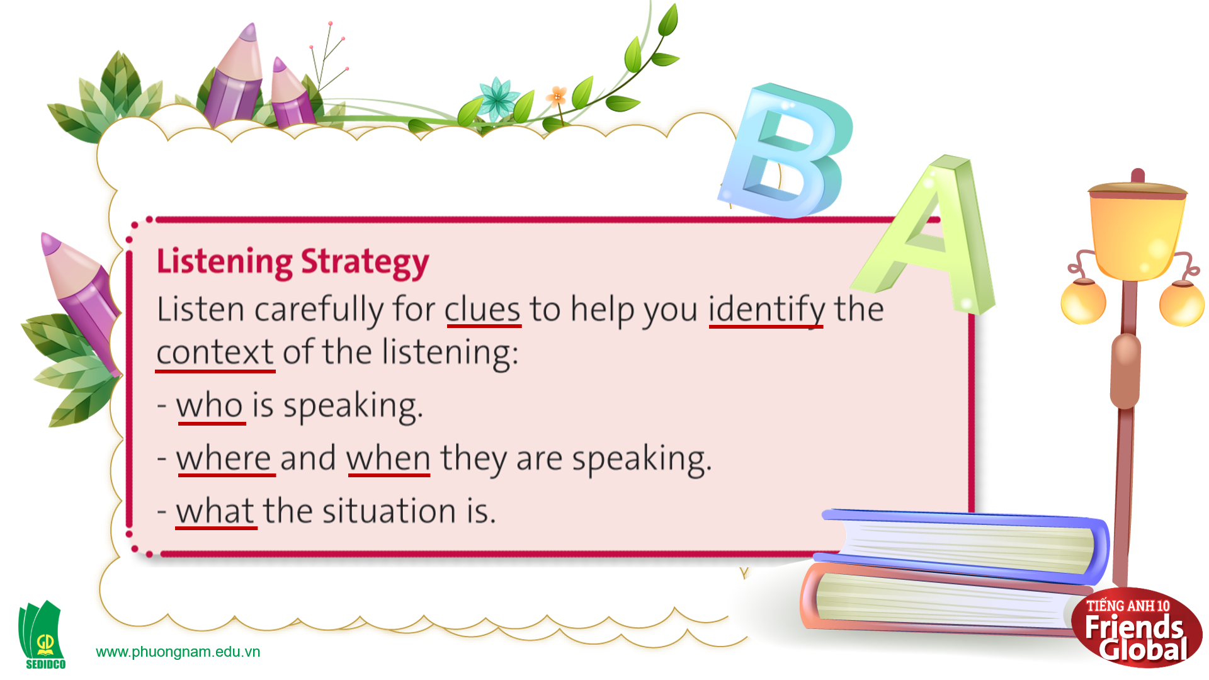  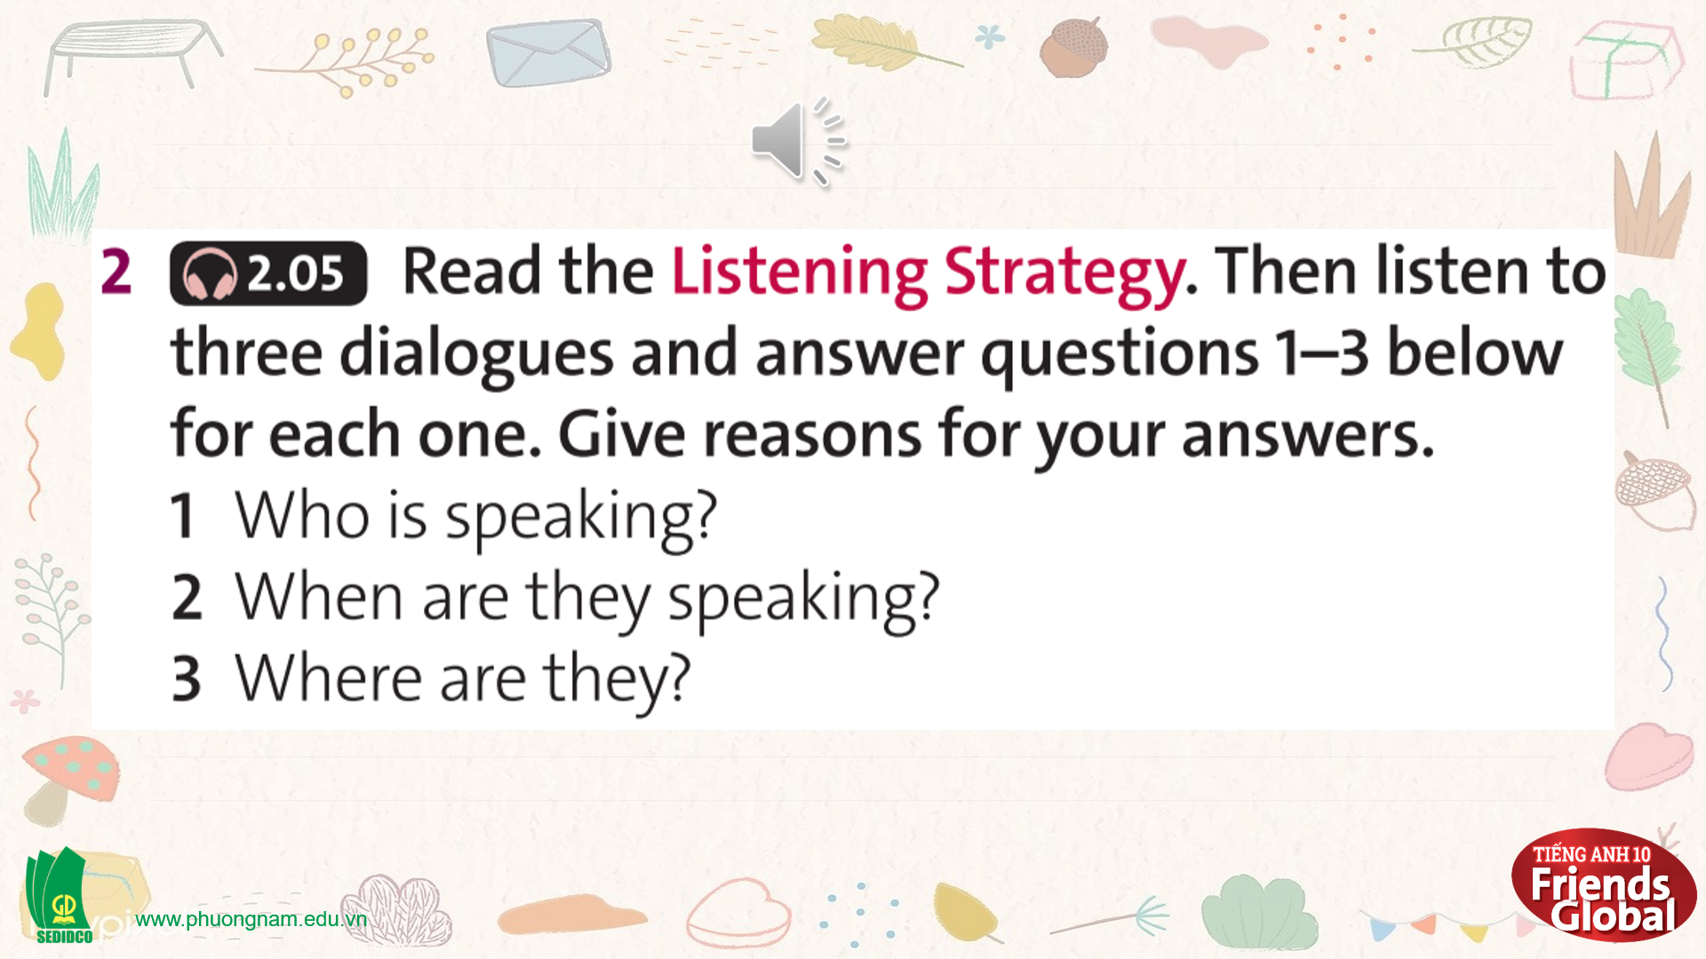  Answers:  Dialogue 1:  1. A boy and his mother  (he says ‘Bye, Mum!’)  2. In the morning  (he’s on his way to school)  3. At home  (he says, ‘I’m off to school now.’)  Dialogue 2:  1. A couple / husband & wife  (she says ‘Bye, Darling!’)  2. Around lunchtime  (he says, ‘And what about your lunch?’)  3. At home  (he says they can take cover in the cellar)  Dialogue 3:  1. Two children / a brother & sister  (she says ‘Where’s the money Mum gave you’)  2. In the morning  (she say, ‘I’m still full from breakfast.’)  3. At the beach / a swimming pool  (he says, ‘Shall we go for a swim?’)  Answers:  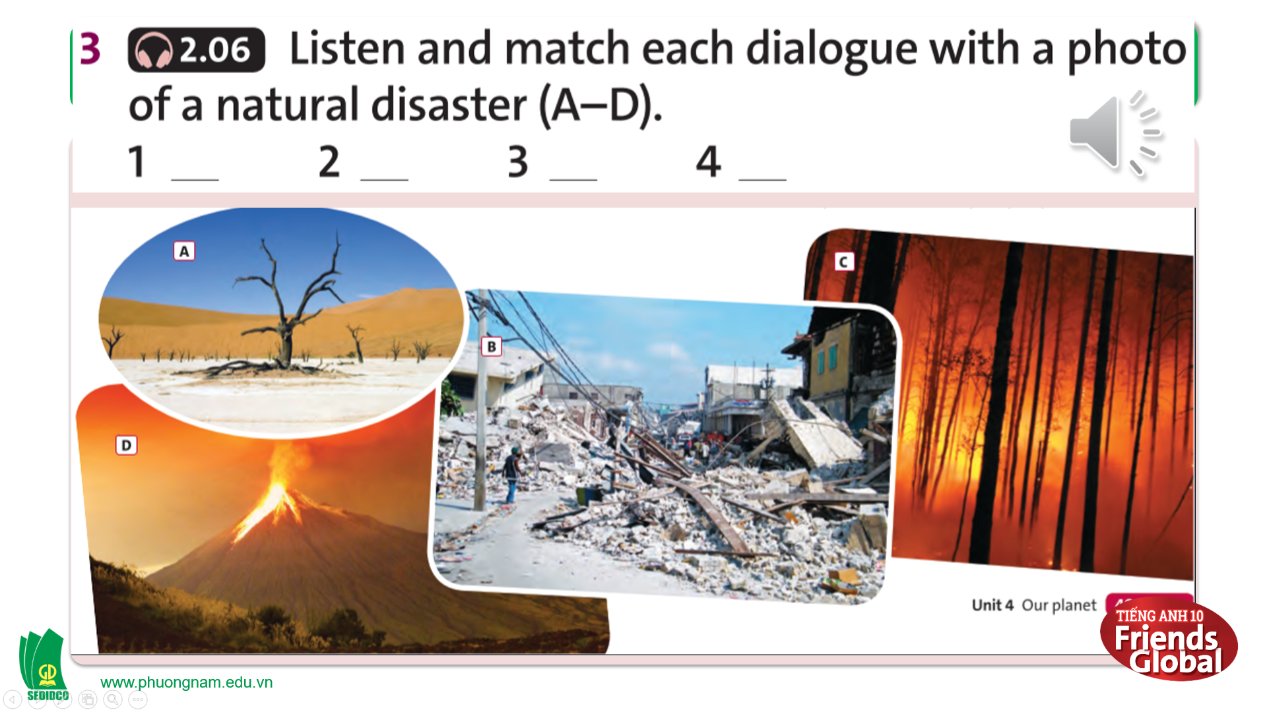  Answers:  1. b 2. a 3. c 4. d  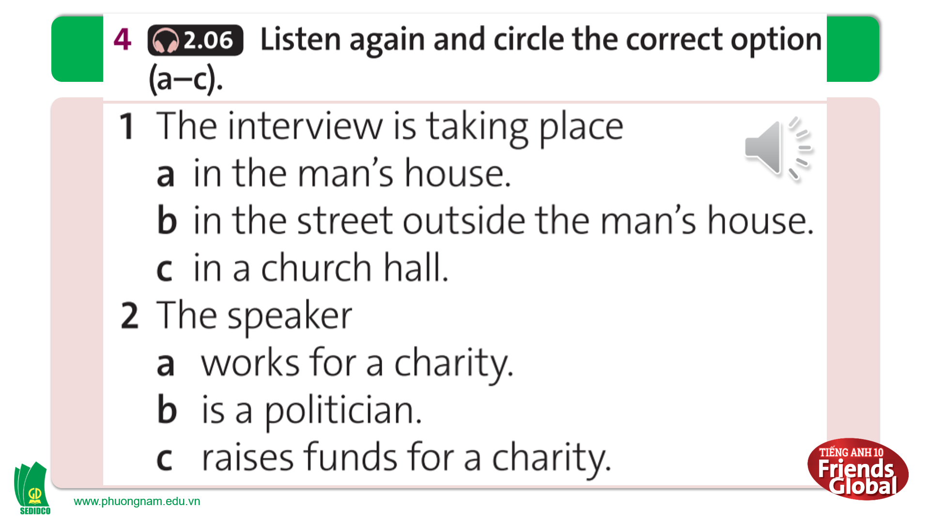  Answers:  1. c 2. a 3. b 4. c

- Activity 3: Outcomes (15’)
a) Objective: Ss play the Lucky Wheel game to review all vocabulary they have learnt in this lesson.
b) Content: Ss review all vocabulary in this lesson through the game.
c) Outcomes: Ss remember and know how to pronounce words correctly and use them in appropriate contexts.
d) Competence: Collaboration, communication
e) Organisation of the activity:
TEACHER’S ACTIVITIES | STUDENT’S ACTIVITIES | CONTENTS
PRODUCT. T-Ss/ S-S/ Indiv.  Pair work (5’): Exercise 5 page 49  - Ask students to work in pair and write a dialogue with their own ideas  - Monitor and help with grammar and vocabulary where necessary  - Give students some hints to help  - Ask some pairs to act out to the class  Review (10’): Game “Lucky Wheel”  - Go through the instructions together and make sure students understand what they have to do  - Students have to call out the word match with the picture show on the slide  - If students get the correct answer, they can get bonus | - Work in pairs and complete the task in a limited time  - Listen to the teacher and take notes  - Act out the dialogue to the class  - Play in individuals  - Volunteer to answer. With one correct answer, that student can get one bonus. | 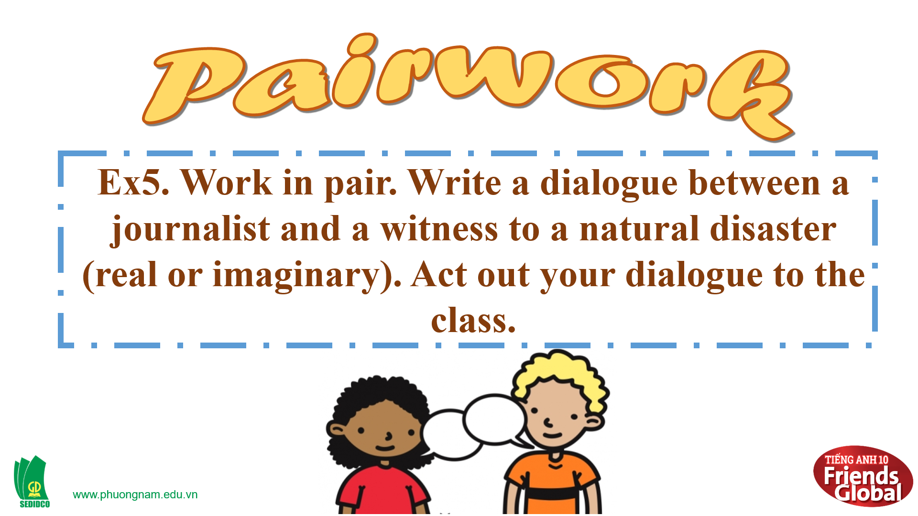  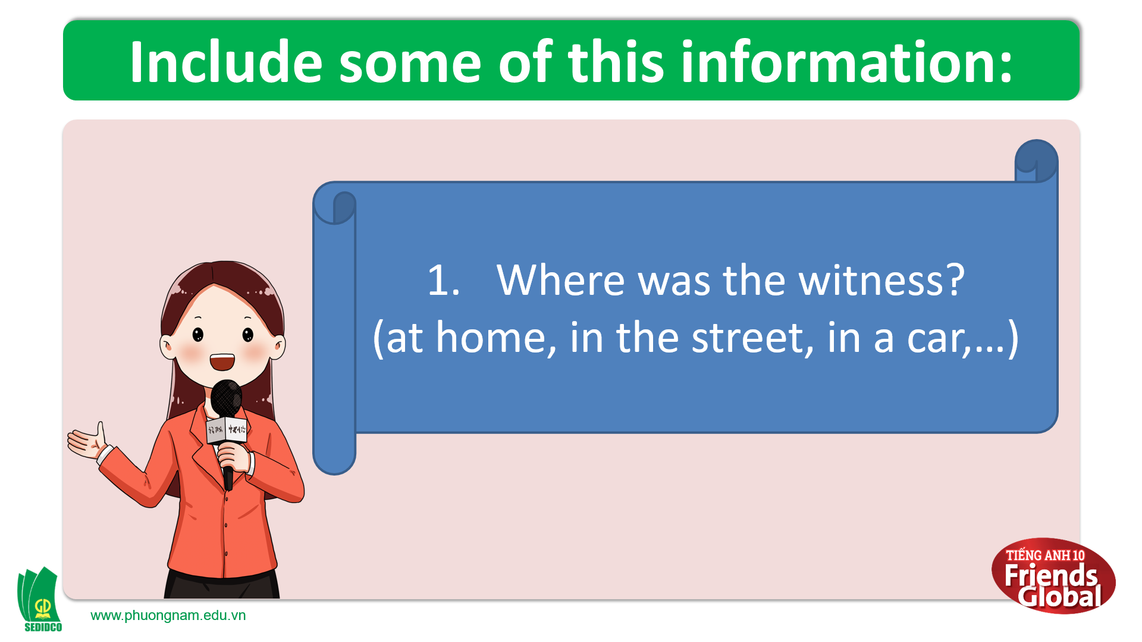  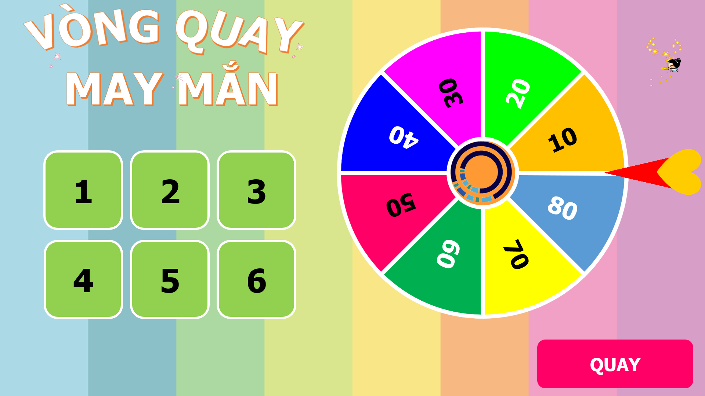  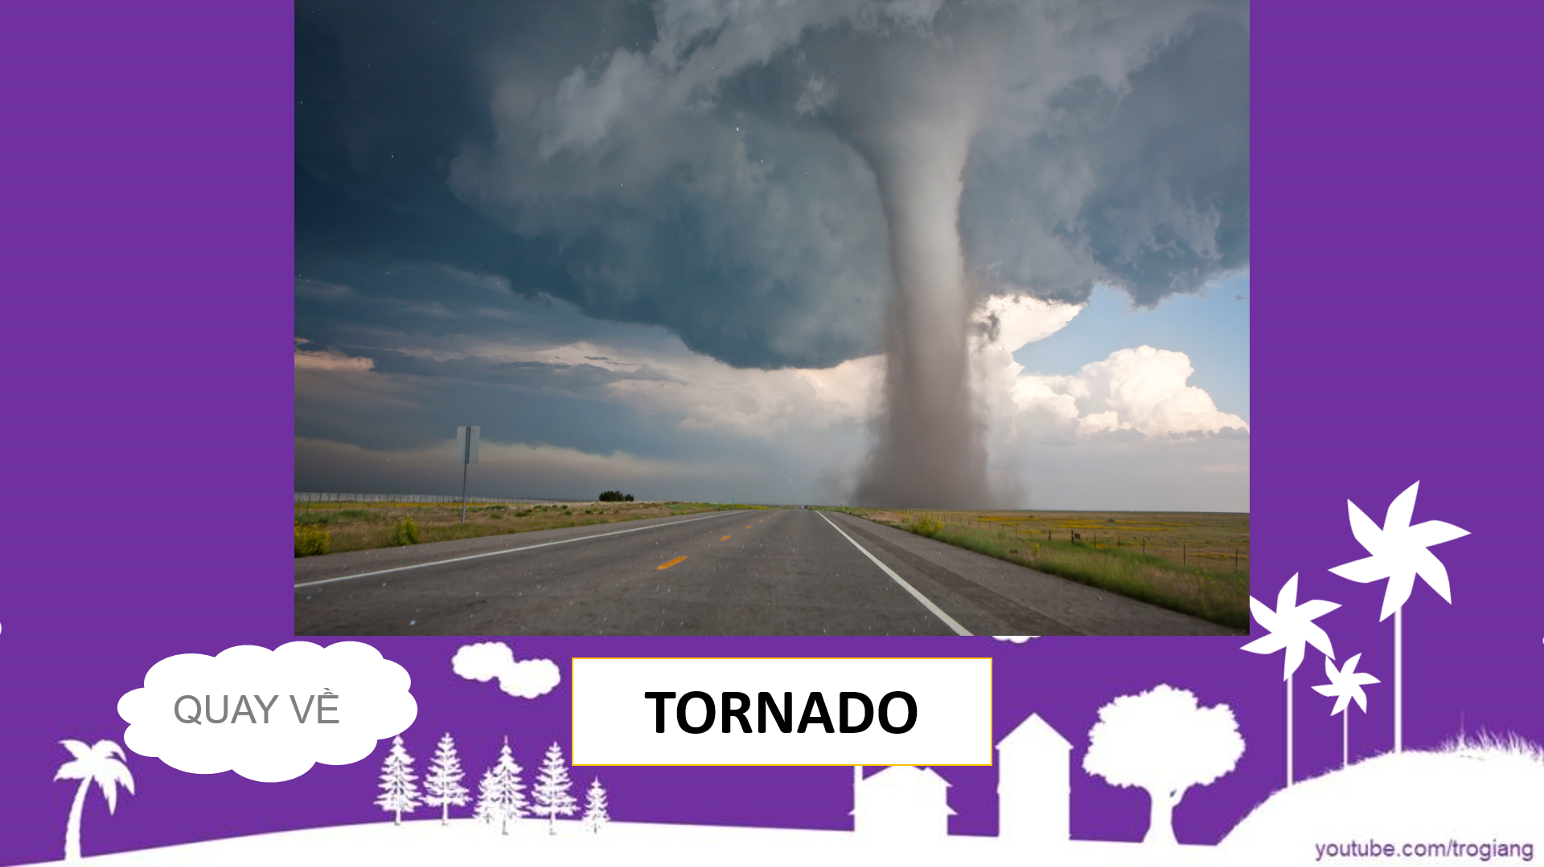
C. Consolidation (3’)
Vocabulary: eyewitness, blizzard, earthquake, tornado, tsunami, wildfire, etc.
- Strategy to listen for clues to identify the context of the listening
D. Homework (2’)
- Learn by heart new words
- Finish all the tasks
- Prepare: Unit 4D: Grammar (page 50 – SB)

