|  |  |
| --- | --- |
|  | *Thời gian làm bài: 40 phút (Không kể thời gian giao đề)*  *-------------------------* |

**Họ tên thí sinh: .................................................................**

**Số báo danh: ......................................................................**

**Mã Đề: 007.**

**Câu 1.** What is the discount amount when buying two shirts?

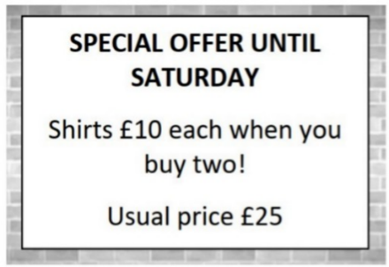

**A.** £5 off each shirt  **B.** £15 off each shirt

**C.** £10 off each shirt  **D.** £25 off the total purchase

**Câu 2.** What is the purpose of the charity event on November 10 at the Hilton Hotel?

You're invited to join us for our charity event on November 10 at 7 pm at the Hilton Hotel. We'll have a silent auction, live music, and cocktails, with all proceeds going towards supporting the homeless in our community. We hope you can make it!

**A.** To raise money for a political campaign  **B.** To promote a new product

**C.** To celebrate the end of the year  **D.** To support the homeless in the community

**Câu 3.** What is the minimum price for a car wash?

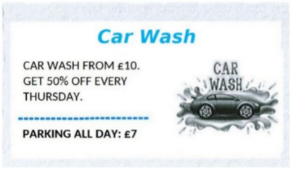

**A.** £15  **B.** £7  **C.** £10  **D.** £5

**Câu 4.** How many trains per hour will be running during the weekend?

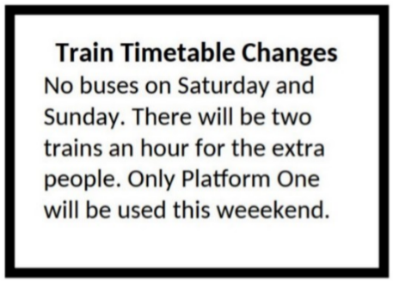

**A.** Four  **B.** Three  **C.** Two  **D.** One

**Câu 5.** What is true about the announcement from the library?

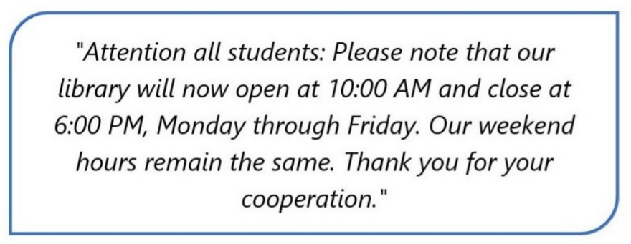

**A.** Change in the library's hours on weekends.

**B.** Change in the library's phone number.

**C.** Change in the library's opening and closing times on weekdays.

**D.** Change in the library's location.

**Câu 6.** What are students asked to do after using the kitchen?

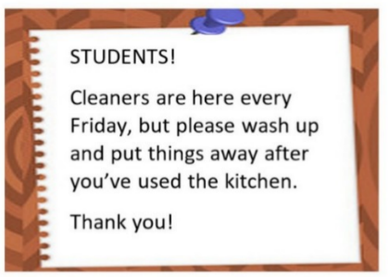

**A.** Leave everything as it is  **B.** Deep clean the entire kitchen

**C.** Wash up and put things away  **D.** Call the cleaners

**Câu 7.** What is the name of the new summer drink being offered at Andy's Coffee?

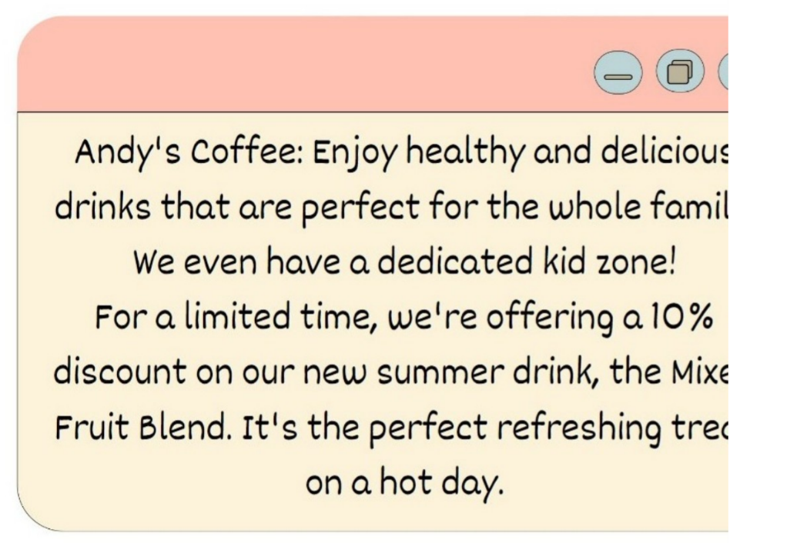

**A.** Hot Chocolate  **B.** Mixed Fruit Blend  **C.** Caramel Latte  **D.** Iced Coffee

**Câu 8.** What is the current promotion at the store?



**A.** 50% discount on everything on Saturday  **B.** 10% discount on everything on Saturday

**C.** 20% discount on everything on Sunday  **D.** 20% discount on everything on Saturday

**Câu 9.** What does Emma offer to do?

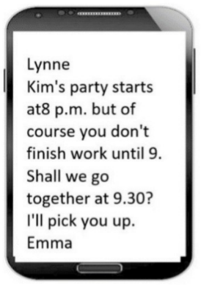

**A.** Pick Lynne up  **B.** Meet Lynne at the party

**C.** Help Lynne finish work early  **D.** Drive Lynne to work

**Câu 10.** What activity is being proposed in the message?

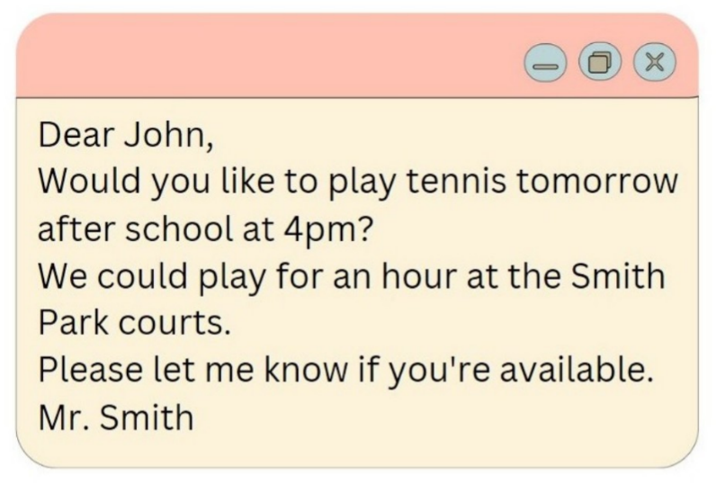

**A.** Going swimming  **B.** Playing basketball  **C.** Going for a run  **D.** Playing tennis

**----HẾT---**