|  |  |
| --- | --- |
| **Mã đề 6.2.72** | **ĐỀ KIỂM TRA GIỮA HỌC KÌ II**  **Môn: Tiếng Anh 6**  ***Thời gian làm bài 60 phút*** |

**A.Listening (2 points)**

***I. You will hear five short conversations you will hear conversations twice. There is one question for each conversation. For questions 1-5 put a tick v under the right answer. (1pt)***

**Example:**

1. **How many people were there at the meeting?**

|  |  |  |
| --- | --- | --- |
| 13 | 300 | 30 |

**A B**

**1. When is the party? (NB)**

|  |  |  |
| --- | --- | --- |
| **Kết quả hình ảnh cho tuesday** | **Kết quả hình ảnh cho wednesday** | **Kết quả hình ảnh cho thursday** |

**A B C**

2. **Where is the glasses? (NB)**

|  |  |  |
| --- | --- | --- |
| Kết quả hình ảnh cho cái bàn  Kết quả hình ảnh cho cái kính | Kết quả hình ảnh cho cái kínhKết quả hình ảnh cho cái bàn | Kết quả hình ảnh cho cái kính  Kết quả hình ảnh cho cái ghế |

**A B C**

**3. How much are the shoes? (TH)**

|  |  |  |
| --- | --- | --- |
| Kết quả hình ảnh cho shoes  **$ 10** | Kết quả hình ảnh cho shoes  **$ 16-50** | Kết quả hình ảnh cho shoes  **$ 15-60** |

**A B C**

**4. What will the weather be like in the afternoon? (TH)**

|  |  |  |
| --- | --- | --- |
| Kết quả hình ảnh cho dam may | Kết quả hình ảnh cho troi nang | Kết quả hình ảnh cho dam may |

**A B C**

**5. What time will she take the train? (VD)**

|  |  |  |
| --- | --- | --- |
| a quarter to four | four fifty | five ten |

**A B C**

***II. Listen and write. There is an example. (1pt)***

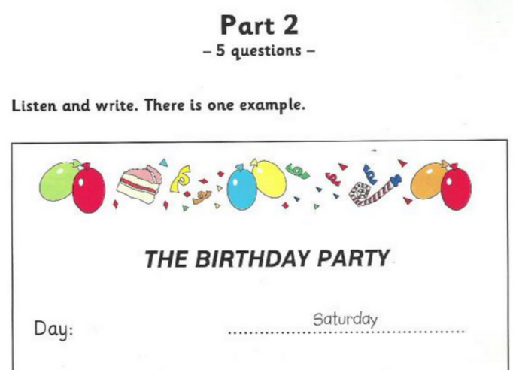

Day: ………….Saturday……………………

Place: The…(1)………………………..……Café **(NB)**

Number of children: ………(2)………………………………… **(NB)**

Where they sat: Table...(3)………………………………… **(TH)**

Food: Cake,…(4)…………………and ice cream. **(TH)**

Drinks: Lemonade and…(5)………………....juice **(VD)**

**B. Language (2pts)**

***I. Choose the word which has the underline pattern pronounced different from the others***

1. A. think B. father C. mother **(NB)**

2. A. played B. arrived C. cooked **(NB)**

***II. Choose the best option to complete the sentences.***

3. There is a lake in front…….the house. **(NB)**

A. in B. on C. of

4. It is …….in the winter. **(TH)**

A. cold B. hot C. warm

5. Albert Einstein was a/an ………..physicist. **(TH)**

A. English B. British C. German

6. Whose book is this? This book is……. **(VD)**

A. my B. I C. mine

7. What are you doing now? – I am ………to music in the living room. **(NB)**

A. listening B. to listen C. listen

8. There are……seasons in a year. **(TH)**

A. two B. three C. four

9. Lan is ………than Mai. **(TH)**

A. taller B. the tallest C. more tall

10. We………keep the campsite clean. **(VD)**

A. have to B. has to C. doesn’t have to

**C. Reading (3pts)**

***I. Read the passage and then choose the correct answer to each question. (1 pt)***

Oak city is a great city. There’s so (1) ………………to do! There are cinemas, parks and discos. It’s got some great clothes and music shops, (2) …………. . Oak city is very modern and beautiful. There aren’t any (3) ………………buildings and there’s some beautiful (4) ………………around the city. Is there any pollution in the Oak city? There isn’t much pollution because there isn’t much traffic. Everyone travels (5) ……………… bike and walks, so there aren’t many accidents. No one works, so everyone has got a lot of free time. Are there any unfriendly people in Oak city? – No, so come and spend a little time here.

1. A. much B. many C. some D. any **(NB)**
2. A. neither B. either C. too D. so **(NB)**
3. A. beautiful B. ugly C. pretty D.unpleasant **(TH)**
4. A. scenery B. scene C. view D. sight **(VD)**
5. A. by B. in C. on D. of **(NB)**

***II. Read the passage and answer the questions below****.* ***(1 pt)***

Mai often plays sports; so she is tall and strong. Her favorite sport is swimming. She goes swimming every day. She likes badminton and table-tennis, too. She often plays badminton and table-tennis in the afternoon. She sometimes does aerobics, too. At weekends, she sometimes has a picnic or goes fishing with some friends. She never goes to the zoo but she goes to the movies once a month. Now she is listening to music at home.

**1. *What does Mai often do?* (NB)**

A. Goes to the zoo B. Goes shopping C. Plays sports

***2. What is her favorite sport?* (NB)**

A. Swimming B. Badminton C. Fishing

***3. How often does she go swimming?* (TH)**

A. 5 days a week B. 6 days a week C. 7 days a week

***4. Where doesn't she go?* (VD)**

A. The movies B. The zoo C. The park

***5. What is she doing at the moment?* (NB)**

A. Listening to music B. Playing badminton C. Doing aerobics

**D. Writing (2pts)**

***I. Find out the mistake in each following sentence.* (0.4 pt)**

1. There are a lot of book in the library, so we read every day. **(NB)**

A B C D

2. They are play games on the playgroud at the moment. **(NB)**

A B C D

***\* Reorder the words to make complete sentences* (0.4 pt)**

3. Hanoi/ than / is / smaller / Ho Chi Minh city. **(TH)**

=>………………………………………………………………………….

4. Lan / going / is / the / zoo / to / tomorrow. **(TH)**

=>………………………………………………………………………….

***II. Rewrite the following sentences as directed ( using the suggested words) so that the meanings stay the same. (0.4pt)***

5. I intend to visit the museum. **(VD)**

🡪 I am going…………………………..

6. I am interested in swimming. **(VD)**

🡪 I like ……………………………….

***IV.* *Complete the following sentences using the given words(0.8pts)***

7. Lan/ watch / TV / now. **(VD)**

=>………………………………………………………………………….

8. My sister / going / visit / grandma. **(VD)**

=>………………………………………………………………………….

9. She / not/ have to /work / weekend.

=>………………………………………………………………………….

10. He /like/ learn/English

|  |  |
| --- | --- |
| =>…………………………………………………………………………. | **KEY** |

|  |  |  |  |
| --- | --- | --- | --- |
| **CÂU** | **NỘI DUNG** | | **ĐIỂM** |
| 1. **Listening (2pt)** | I.(1 pt)  1. C 2. A 3. C 4. A 5. B | | 0,2 pts/ each correct answer |
| 1. Paris 2. 18 3. Outside 4. Sandwiches 5. lime | | 0,2 pts/ each correct answer |
| 1. **Language**   **(2pts)** | 1. A 2. C 3. C 4. A 5. C | 1. C 2. A 3. C 4. A 5. A | 0,2 pts/ each correct answer |
| 1. **Readning (2pts)** | I.(1pt)  1. A 2. C 3. B 4. A 5. A  II.(1pt)  1. A 2. C 3. B 4. A 5. A | | 0,2 pts/ each correct answer  0,2 pts/ each correct answer |
| 1. **Writing (2pts)** | 1. B  2. A  3. Hanoi is smaller than HCM city.  4. Lan is going to the zoo tomorrow.  5. I am going to visit the museum.  6. I like swimming.  7. Lan is watching TV now.  8. My sister is going to visit our grandma.  9. She doesn’t have to work on the weekend.  10.He likes learning English. | | 0,2 pts/ each correct answer |