SỞ GD&ĐT BẮC GIANG  TRƯỜNG THPT TÂN YÊN SỐ 2  (Đề thi có 04 trang) | ĐỀ KIỂM TRA ĐỊNH KÌ GIỮA HỌC KÌ 1  NĂM HỌC 2023 - 2024  MÔN: TIẾNG ANH -LỚP 10  Thời gian làm bài: 60 phút, không kể thời gian giao đề
 |  | Mã đề thi: 369
Lưu ý: - Thí sinh làm trực tiếp vào đề, tô phần trắc nghiệm vào phần phiếu trả lời trắc nghiệm
- Phần NGHE bắt đầu từ câu 26 đến câu 35
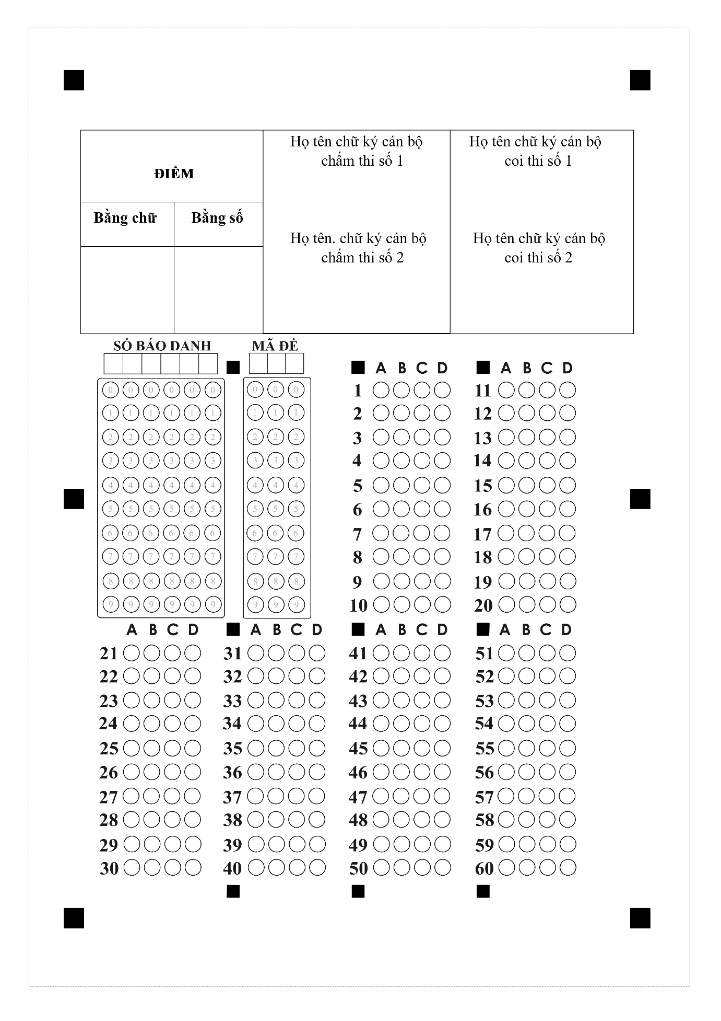
Họ tên: ……………………….….. Lớp: ……… SBD: ……….

I. PHẦN TRẮC NGHIỆM (6,0 điểm):
Mark the letter А, B, C, or D on your answer sheet to indicate the word whose underlined part differs from the other three in pronunciation in each of the following questions.
Question 1. A. shops B. chores C. friends D. sounds
Question 2. A. involved B. organized C. impressed D. carried
Question 3. A. taste B. phase C. waste D. plastic
Mark the letter A, B, C, or D on your answer sheet to indicate the word that differs from the other three in the position of stress in each of the following questions.
Question 4. A. enjoy B. hobby C. famous D. music
Question 5. A. student B. perform C. combine D. depend
Mark the letter A, B, C or D on your answer sheet to indicate the correct answer to each of the following questions.
Question 6. In my family, my father always _____ charge of doing the heavy lifting.
A. takes B. taking C. take D. took
Question 7. He lost the key, ____ he couldn't get into the house.
A. but B. and C. or D. so
Question 8. He advised us___________our old house immediately.
A. selling B. sold C. to sell D. sell
Question 9. We should turn off the _________appliances when they are not used
A. housewife B. household C. housework D. homework
Question 10. When all members of the family share housework, the family _________ will become stronger.
A. happiness B. joys C. bonds D. life
Question 11. In my family, my mother is responsible for ______ for groceries.
A. putting B. doing C. shopping D. taking
Question 12. Don’t___________used items because we can recycle them to make new products
A. clean up B. break down C. set up D. throw away
Mark the letter A, B, C, or D on your answer sheet to indicate the option that best completes each of the following exchanges.
Question 13. Peter and Mary are talking about a green lifestyle
Peter: “I want to adopt a green lifestyle. Do you have any suggestions?”
Mary: “_____________buying oganic food?”
A. Not at all B. That’s right C. How about D. You’re welcome
Mark the letter A, B, C, or D to indicate the word CLOSEST in meaning to the underlined word in each of the following questions.
Question 14. Student are reminded to pick up litter that they see on the ground.
A. rubbish B. sugar C. air D. gas
Mark the letter A, B, C, or D to indicate the word OPPOSITE in meaning to the underlined word in each of the following questions.
Question 15. We should buy products that are grown using more natural and organic methods.
A. artificial B. normal C. normal D. regular
Read the passage and choose the best answer for each of the numbered blanks.
What are the benefits of a green lifestyle?
In addition to the health benefits already mentioned, such as increased exercise, healthier eating and better breathing, a green lifestyle has been shown to have a positive (16) _______ on mental health. A green lifestyle can foster people’s need for a closer connection to nature, (17) ______stimulating positive emotions, leading to a lighter and happier mood. This closer connection to nature, such as through increased outdoor activities, can actually help people suffering from mental health issues find comfort: A report conducted by Natural England concluded that people (18) ______ participate in nature-based activities suffer less stress, anxiety and depression. When a more (19) _______lifestyle leads to losing excess weight or simply getting in better shape, it can also lead to stronger self-esteem in addition to physical health. Consuming less, reusing and recycling more, while raising (20) __________ of important climate changes can help prioritize. Gaining this awareness, taking responsibility for our environment.
Question 16. A. affect B. choice C. impact D. chance
Question 17. A. but B. yet C. so D. or
Question 18. A. whom B. which C. where D. who
Question 19. A. acttively B. activity C. active D. action
Question 20. A. hand B. salary C. price D. awareness
Read the following passage and choose the most suitable answer.
Plastic and the environment
Plastic is a material we use every day. The first plastics were made more than 100 years ago from parts of plants. Plastics are now made from oil, coal and natural gas. We are using up these things so fast that the Earth’s supplies may run out. Because of this, scientists are investigating new ideas for making plastics from plants such as sweet potato, bamboo and flax.
Things made from plastic can be useful for people but bad for the planet. Some plastics can last for a long time without wearing out, and can be difficult to get rid of when they are not needed. They can remain in rubbish dumps called landfill sites for hundreds of years. Landfills can be smelly, ugly, and harmful to our planet.
Recycling is a good way to get rid of unwanted plastics. Recycled waste materials can be used again to make new products. This can be difficult as different types of plastic need to be recycled in different ways. Some kinds of plastics can be melted down and used to make new things such as bags and bottles. Others can be made into fibres (strands of material) for clothing.
Another way to protect the environment is to use canvas bags for shopping rather than plastic ones. A lot of plastic objects can also be reused. Plastic bottles can be refilled many times, rather than throwing them away once they are empty. Unwanted plastic goods such as CDs and toys can be sold or given away to charity shops.
Question 21. What is the passage mainly about?
A. The history of plastic and its usefulness..
B. Materials that plastic is made of..
C. Plastic: effects and solutions to the problem.
D. The ways to reduce the harm of plastics on the environment
Question 22. The phrase “get rid of” in paragraph 2 is closest in meaning to ________.
A. make B. create C. keep D. remove
Question 23. According to the passage, things made from plastic are bad for our environment because ______.
A. they are a danger to marine life such as whales, turtles and so on.
B. plastics can exist for a long time without decomposing.
C. people reuse plastic objects before recycling them.
D. they are very convenient for people to use in different purposes.
Question 24. The word “They” in paragraph 2 refers to ________.
A. things B. plastics C. rubbish dumps D. people
Question 25. According to the passage, which of the following is TRUE?
A. Plastics and plastic objects can be recycled or reused.
B. The history of plastic and its usefulness.
C. Some kinds of plastics can be melted down, then released into the river.
D. Plastic objects are useful for people without negative impacts.

Listening
Part 1: Listen to the recording and mark the letter A, B, C or D on your answer sheet to indicate the appropriate answer. You will listen TWICE.
Question 26. Duncan stayed in a hotel ________.
A. in a town B. in the mountain C. by the river D. near the sea
Question 27. What is his teacher's nationality?
A. English B. Canadian C. French D. Scott
Question 28. How much did Duncan pay for the course?
A. £250 B. £265 C. £205 D. £185
Question 29. What did he buy himself before the course?
A. shoes B. ball C. clothes D. racket
Question 30. What did you do in the evening?
A. watching TV B. watching football matches
C. dancing and singing D. playing tennis

II. PHẦN TỰ LUẬN (4,0 điểm)
Listening
Part 2: You will hear a woman giving information on the radio about a theatre school. Listen and fill in the blanks.
Information about the theatre school
- Every week courses for children between (31) ___________ and 16 years old.
- It costs (32) £ ______________ for children over 14.
- The special show takes place on (33) ______________ afternoon.
- The first summer course starts on July (34) _______________.
- The phone number for booking form: (35) _______________.
Give the correct tense/ form of the verbs in the brackets.
Question 36. She (do)_________________the laundry at the moment.
Question 37. I think she (pass) _______________the exam because she is a hard-working student.
Question 38. My parents have made their holiday plans. They (travel)______________to the USA.
Question 39. Jackson wants (go) _____________________ to the music festival on Saturday.
Question 40. His teacher won’t let the students (use) __________________ their smartphones in the class.
Complete the second sentence so that it means the same as the sentence provided.
Question 41. My father takes care of the household chores.
The household chores _____________________________________________________.
Question 42. Companies will develop eco-friendly products next month.
Eco-friendly products _____________________________________________________.
Question 43. His mother will take him to the zoo next Sunday.
His mother promised ______________________________________________________.
Question 44. Don’t allow your children to go to the music festival.
Don’t let ________________________________________________________________.
Question 45. John wants to watch his favourite TV program. He has a Physics exam on that day. (BUT)
________________________________________________________________________.

Write a short paragraph (about 70 words) about a music event you attended to share your experience.
_________________________________________________________________________________________________________________________________________________________________________________________________________________________________________________________________________________________________________________________________________________________________________________________________________________________________________________________________________________________________________________________________________________________________________________________________________________________________________________________________________________________________________________________________________________________________________________________________________________________________________________________________________________________________________________________________________________________________________________________________________________________________________________________________________________________________________________________

-------------- THE END --------------

