School: …………………………………….. | Date: ……………………………..
Class: …………………………..................... | Period: …………………….........

UNIT 6: EDUCATION
Lesson 2.2 - Grammar (Page 48)

I. OBJECTIVES
By the end of the lesson, Ss will be able to:
1.1. Language knowledge and skills
- listen to and understand a short conversation between 2 people talking about feeling.
- use subordinating conjunction “because” and intensifiers “so”, “really” correctly.
1.2. Competences
- improve speaking, listening and writing skills.
- improve the use of English.
1.3. Attributes
- overcome studying pressure and negative feelings.
- have a balance between studying and relaxing.

II. TEACHING AIDS AND LEARNING MATERIALS
1. Teacher’s aids: Student book and Teacher’s book, class CDs, Digital Book (DCR phần mềm tương tác SB, DHA (từ vựng/ cấu trúc) phần mềm trò chơi tương tác), projector/interactive whiteboard / TV (if any), PowerPoint slides, handouts.
2. Students’ aids: Student’s book, workbook, notebook.

III. ASSESSMENT EVIDENCE
Performance Tasks | Performance Products | Assessment Tools
- Listen and repeat. | - Ss’ performance. | - T’s feedback.
- Study the grammar box. | - Ss’ task. | - T’s observation.
- Unscramble the sentences. | - Ss’ answers. | - T’s feedback/Peers’ feedback.
- Write sentences using the pictures and the prompts. | - Ss’ answers. | - T’s feedback/Peers’ feedback.
- Talk about how you feel at school and why. Use the adjectives in the box. | - Ss’ performance/ presentation. | - T’s observation, T’s feedback/Peers’ feedback.

IV. PROCEDURES
A. Warm up: (5’)
a) Objective: Introduce the new lesson and set the scene for Ss to acquire new language; get students' attention at the beginning of the class by enjoyable and short activities as well as to engage them in the follow-up steps.
b) Content: Review words about feelings / Introduce: because.
c) Expected outcomes: Ss review old knowledge and have general ideas about the grammar point they are going to study in the new lesson.
d) Organization of the activity:
TEACHER’S ACTIVITIES | STUDENTS’ ACTIVITIES
- Option 1: Introduce “because”  - Have Ss do the matching exercise: Match the consequences with the causes.  - Call Ss to give answers.  - Check Ss’ answers, correct Ss’s answers if necessary  - Have Ss think of a word / phrase to connect clause of consequences with clause of causes.  - Lead to the new lesson: We use subordinating conjunction “because” to join consequences and causes clauses.  *Illustration:  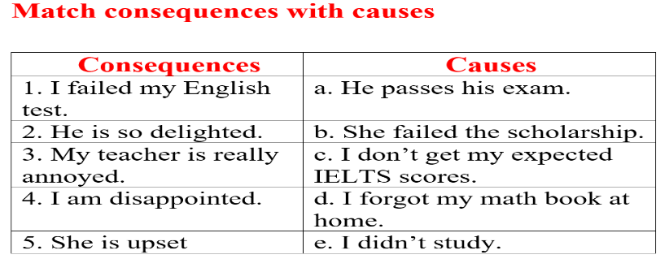  - Option 2: Review vocabularies about feelings  - Give some adjectives about feelings Ss have learnt in the previous lesson, have some volunteers express that feeling by using body language in front of the class.  - Have the whole class guess the adjectives.  - Call Ss to give answers.  - Give feedback and evaluation.  - Lead to the new lesson.  *Suggested adjectives: annoyed, delighted, surprised, pleased, upset, disappointed | - Work in groups.  - Give answers.  - Listen.  Answers keys  1e 2a 3d 4c 5b  - Do the task.  - Give answers.

B. New lesson (35’)
- Activity 1: Presentation (10’)
a) Objective: Introduce “because”, “so” and “really”.
b) Content:
- Listen and repeat.
- Introduce the grammar point: “because”, “so” and “really”.
c) Expected outcomes: Ss know how to use “because”, “so” and “really” to do some following exercises.
d) Organization of the activity:
TEACHER’S ACTIVITIES | STUDENTS’ ACTIVITIES
Task a. Listen and repeat  - Have Ss look at the picture using DCR.  - Play audio (CD1 – Track 65) and have Ss listen and read the speech bubbles.  - Play the audio again and have Ss listen and repeat.  Grammar box  - Have Ss look at the grammar explanation and read: Because  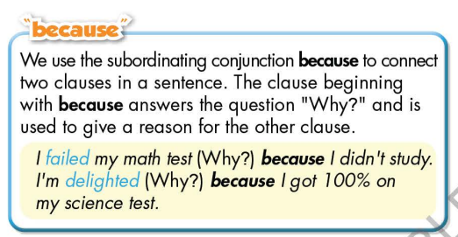  - Have Ss look the grammar explanation and read: Intensifiers  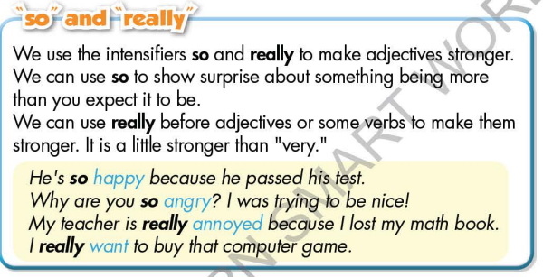  - Briefly explain the grammar point.  - Ask Ss to make sentences with “because”, “so” and “really”. | - Look.  - Listen, then read.  - Listen and repeat.  - Look and read.  - Look and read.  - Listen and take notes.  - Make sentences, using “because”, “so” and “really”.
- Activity 2: Practice (19’)
a) Objective: Students can use “because”, “so” and “really” correctly.
b) Content:
- Unscramble the sentences.
- Write sentences using the pictures and the prompts.
c) Expected outcomes: Students can use “because”, “so” and “really” in their speaking.
d) Organization of the activity:

TEACHER’S ACTIVITIES | STUDENTS’ ACTIVITIES
Task b. Unscramble the sentences  - Demonstrate the activity on DCR, using the example.  - Have Ss unscramble the sentences.  - Have Ss work in pairs to check each other’s work.  - Have some Ss share their answers with the whole class.  - Give feedback, correct Ss’ answers if necessary.  Task c. Write sentences using the pictures and the prompts  - Demonstrate the activity on DCR, using the example.  - Have students write sentences using the pictures and the prompts.  - Have Ss check answers with their partners.  - Call Ss to read or write answers.  - Check Ss’ answers, give feedback. | - Look and listen.  - Work individually.  - Work in pairs.  - Write answers on the board.  Answer keys  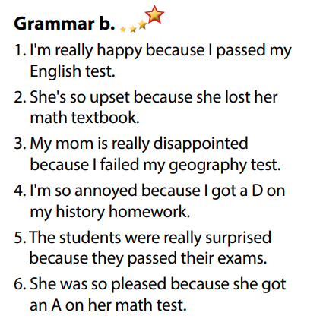  - Look and listen.  - Work individually.  - Work in pairs.  - Read or write answers.  Answer keys  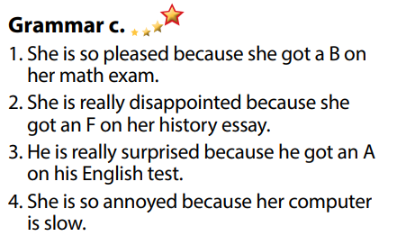

- Activity 3: Production (6’)
a) Objective: Students master the grammar point they study in the lesson.
b) Content: Speaking: Talk about how you feel at school and why. Use the adjectives in the box.
c) Expected outcomes: Ss produce the new language successfully, and they can apply the grammar point they have learnt in speaking and writing.
d) Organization of the activity:
TEACHER’S ACTIVITIES | STUDENTS’ ACTIVITIES
Task d. Talk about how you feel at school and why. Use the adjectives in the box.  - Divide class into pairs.  - Have Ss ask and answer, explain.  - Have some pairs demonstrate the activity in front of the class.  - Give feedback and evaluation. | - Work in pairs.  - Have conversation in pairs.  - Present.  - Listen.  Suggested idea  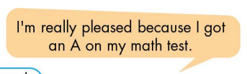

C. Consolidation and homework assignments (5’)
*Consolidation
- Because
- Intensifiers
.
* Homework:

- Make 3 sentences, use “because”, “so” and “really”.
- Do the exercises in WB: Grammar (page 35).
- Complete the grammar notes in Tiếng Anh 7 i-Learn Smart World Notebook (page 39).
- Play consolation games in Tiếng Anh 7 i-Learn Smart World DHA App on www.eduhome.com.vn
- Prepare: Lesson 2.3 – Pronunciation and Speaking (page 49 – SB).

D. Reflection
a. What I liked most about this lesson today:
…………………………………………………………………………………………
- What I learned from this lesson today:
…………………………………………………………………………………………
c. What I should improve for this lesson next time:
…………………………………………………………………………………………

