Period
LESSON PLAN
TIẾNG ANH 10 FRIENDS GLOBAL
UNIT 2: ADVENTURE
LESSON 2B: GRAMMAR – PAST CONTINUOUS
I. OBJECTIVES:
By the end of the lesson, Ss will be able to:
1. Knowledge:
- Review the usages of the simple continuous tense
- Grammar: simple past continuous
2. Ability:
- main skills: reading and writing skills
- sub skills: listening and speaking skills
- Use the past continuous properly in exercises as well as everyday conversations.
3. Quality:
- have positive attitude in English language learning so that they can participate enthusiastically in all classroom activities, especially with the topic conducted by the teacher
- know how to use the tense precisely
II. TEACHER AIDS AND LEARNING MATERIALS:
Lesson plan, PPT slides, student’s book, workbook, notebook, personal computer (if any), projector/TV, speakers, IWB software.
III. PROCEDURES:
A. Warm-up (7’)
a) Objective: Introduce the new lesson and set the scene for Ss to acquire new language; get students' attention at the beginning of the class by means of enjoyable and short activities as well as to engage them in the steps that followed.
b) Content: Students listen to the story of exercise 1 and answer the question.
c) Outcomes: Students can gain more confidence and interest in the lesson.
d) Competence: communication, collaboration, critical thinking
e) Organisation of the activity:

TEACHER’S ACTIVITIES | STUDENT’S ACTIVITIES | CONTENTS
WARM-UP. T-Ss/ S-S/ Indiv.  Activity 1 (5’): Task 1 page 24.  There are 2 slides with the same pictures describing the story in task 1. The first slide contains music. Teacher can choose freely between these two to excite the class.  - Play the recording of exercise 1. The pictures will be played automatically.  - Ask students answer the question.  - Give the answer to the class.  Activity 2 (2’): Underline all the past continuous forms in the text.  - Ask students to scan the text and underline all the past continuous forms.  - Invite some students to share their answers.  - Give the answers to the class.  - Lead to the lesson “Do you know what tense we are going to study?” | - Read the text silently and answer the question.  - Check the answers with the teacher.  - Scan the text and underline.  - Volunteer to answer.  - Check the answers with the teacher.  - Students answer: “Past continuous” and open book page 24. |   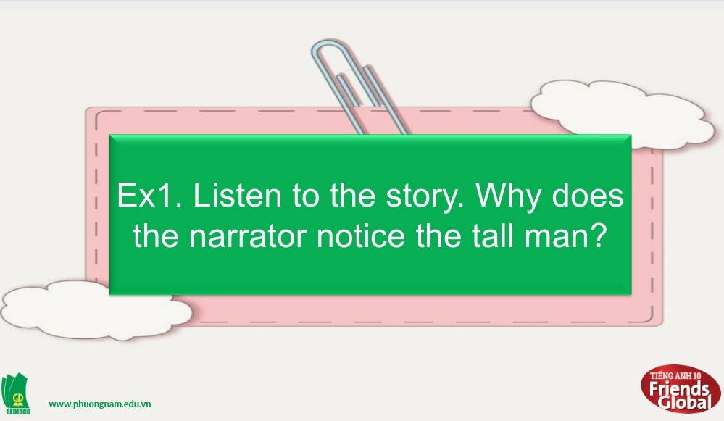  Question: “Why does the narrator notice the tall man?”  Answer: Because the tall man is standing very still, wearing summer clothes, and staring at the narrator.  Answers:  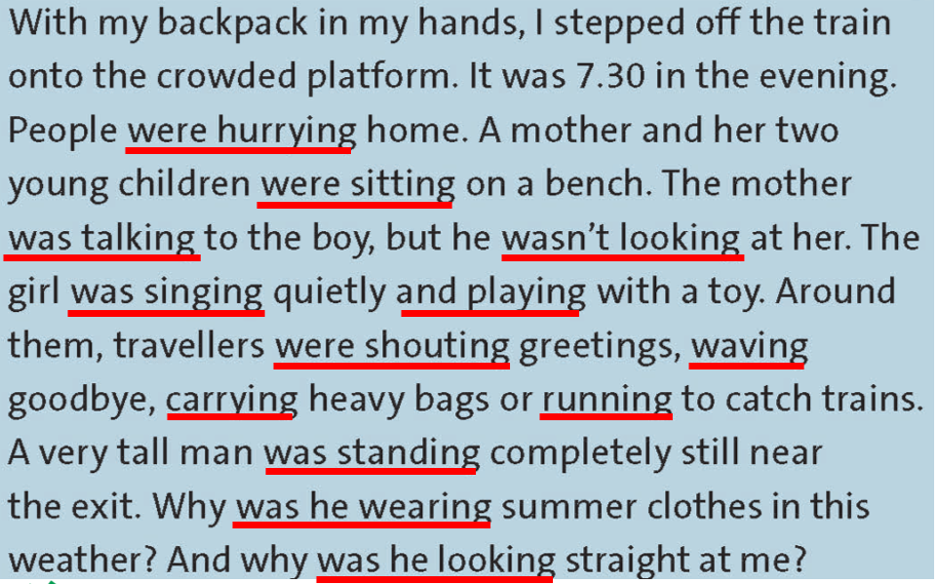

B. New lesson (33’)
- Activity 1: Presentation (8’)
a) Objective: Remind past continuous tense for students
b) Content: Students review how to use past continuous in affirmative and negative forms. Besides that students know how to answer Yes/No questions with past continuous.
c) Outcomes: Students can apply the useful language in everyday reading and writing.
d) Competence: communication, presentation
e) Organisation of the activity:
TEACHER’S ACTIVITIES | STUDENT’S ACTIVITIES | CONTENTS
PRESENTATION. T-Ss/ S-S/ Indiv  - Remind students some usages of the tense. Give examples.  - Show affirmative and negative forms. Highlight the structures of each form. Give examples.  - Present the questions structure with past continuous and how to answer. Give examples. | - Listen carefully to the teacher and take notes.  - Listen to the teacher.  - Listen and raise hand if students have any questions. | 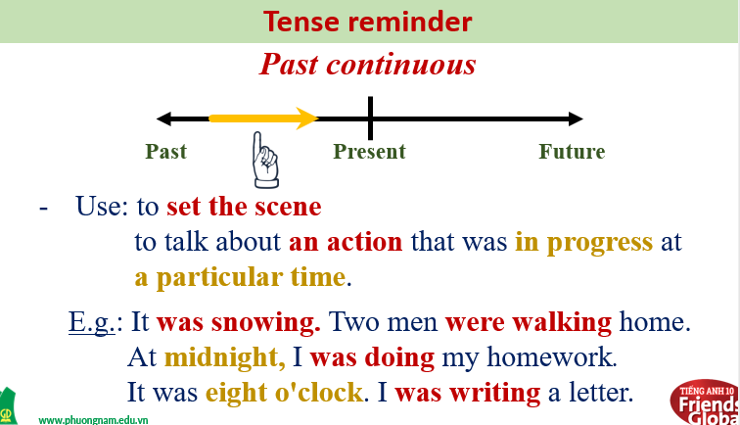  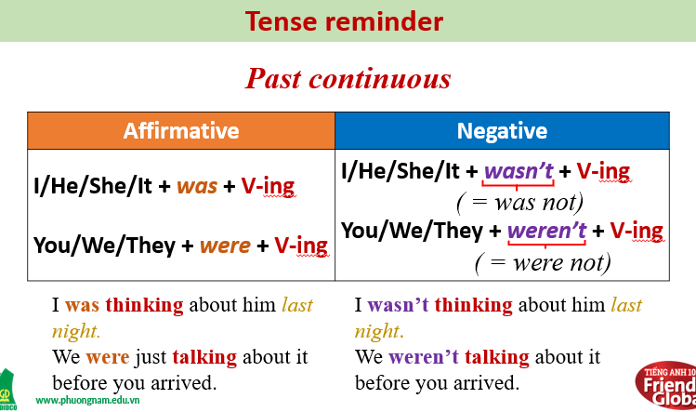  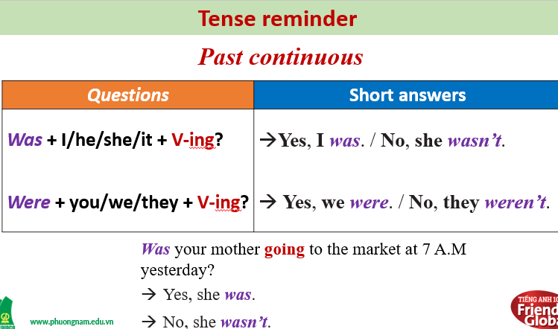
- Activity 2 Practice (18’)
a) Objective: Students know more about past continuous tense and use it properly.
b) Content:
Grammar study
Speaking
c) Outcomes: Ss how to use irregular and regular verbs in past simple properly.
d) Competence: communication, collaboration, presentation
e) Organisation of the activity:
TEACHER’S ACTIVITIES | STUDENT’S ACTIVITIES | CONTENTS
PRACTICE. T-Ss/ S-S/ Indiv.  Activity 1 (3’): Task 3 page 24.  - Ask students to complete the paragraph below with the past continuous form of the verbs in brackets.  - Check the answers.  - Ask the students to read the text aloud.  Activity 2 (6’): Work in pairs. Task 4 page 24.  - Ask students to work in pairs.  - Have them ask and answer questions about the characters in the texts in exercises 1 and 3.  - Invite some pairs to answer the questions. Give bonus.  - Give the answers to the class.  Activity 3 (6’): Group discussion.  - Ask students to work in groups to play a small game ‘Who’s Faster?’.  - Tell students the rules of the game: work in groups and use suggested words on the left and right columns to form a sentence. Give the example.  - Time limit is 5 minutes. Click on “START TIMER” to start time. Go around to make sure every student engages in the game.  - If any group get the fastest and the most correct answers, give them bonus.  - Correct students’ answers.  Activity 4 (3’): Task 6 page 24.  - Ask students to choose five of the sentences from the game above and write a question about each one using the past continuous.  - Invite some students to share their ideas.  - Correct students’ answers. | - Complete the task.  - Check the answers with the teacher.  - Students read the text.  - Work in pairs.  - Take turns to ask and answer the questions.  - Volunteer to answer.  - Check the answer with the teacher.  - Work in groups and play game. Make some sentences using suggested words.  - Volunteer to answer.  - Choose five sentences from the above game and write a question about each one using the past continuous.  - Volunteer to present the answers.  - Listen carefully to the teacher and take notes. | Answers:  1. was shining  2. was rising  3. were carrying  4. was lying  5. wasn’t sleeping  6. were sitting  7.sharing  8. were they listening  Answers:  2. What was the boy doing?  He wasn’t looking at his mother.  3. What was the girl doing?  She was singing quietly and playing with a toy.  4. What were the other travelers doing?  They were shouting greetings, waving goodbye, carrying heavy bags or running to catch train.  5. What was the tall man doing?  He was standing completely still near the exit.  6. What were the café owners doing?  They were carrying tables outside.  7. What was the dog doing?  It was lying on the pavement nearby.  8. What was the teenage girls doing?  They were sitting on a bench sharing headphones.  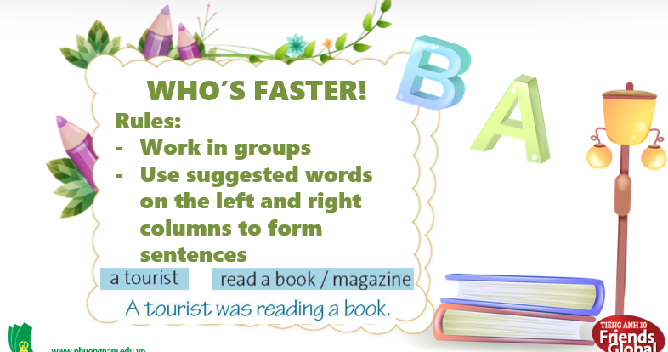  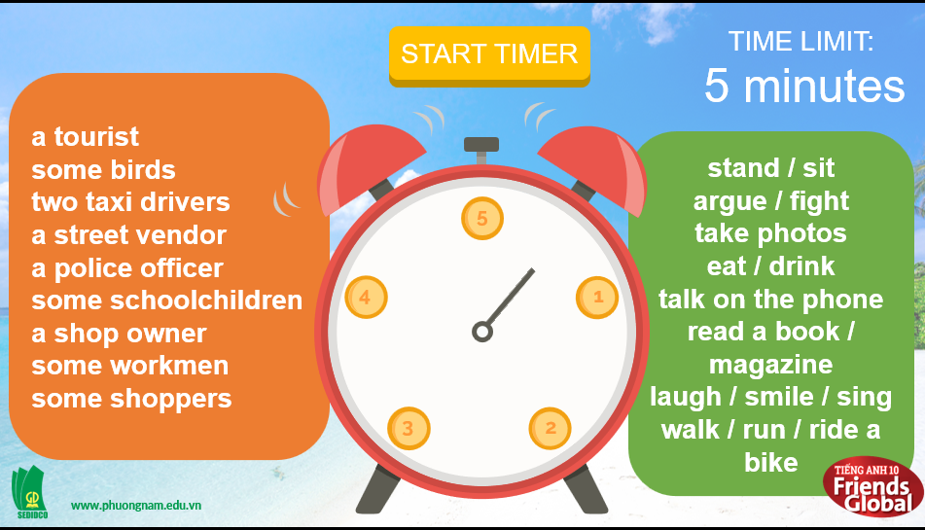  Suggested answers:  Some birds were eating bread.  A shop owner was smiling at me.  Two taxi drivers were arguing very loudly.  A street vendor was talking on the phone.  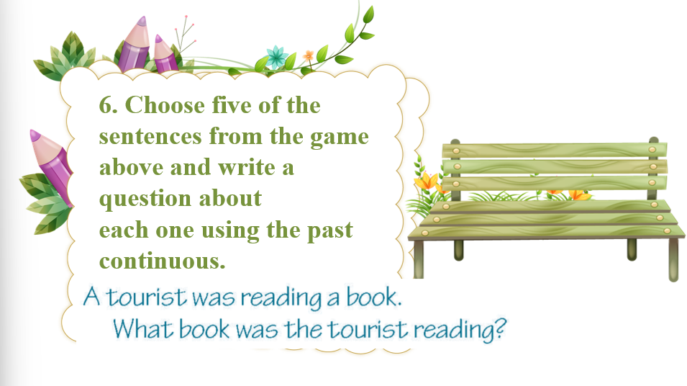

- Activity 3: Outcomes (7’)
a) Objective: Ss can answer questions to describe feelings in some situations in the past. Communication is also be practiced.
b) Content: Students work in pairs, take turns to ask and answer the questions they wrote in exercise 6.
c) Outcomes: Ss speak and listen mutually, they can apply the structure of past simple or some adjectives to their conversations.
d) Competence: Collaboration, communication, guessing
e) Organisation of the activity:
TEACHER’S ACTIVITIES | STUDENT’S ACTIVITIES | CONTENTS
PRODUCT. T- Ss/ S-S  - Ask students work in pairs. Students ask and answer the questions they wrote in exercise 6.  - Correct students’ answers. | - Work in pairs.  - Take turn to ask answer the questions. | 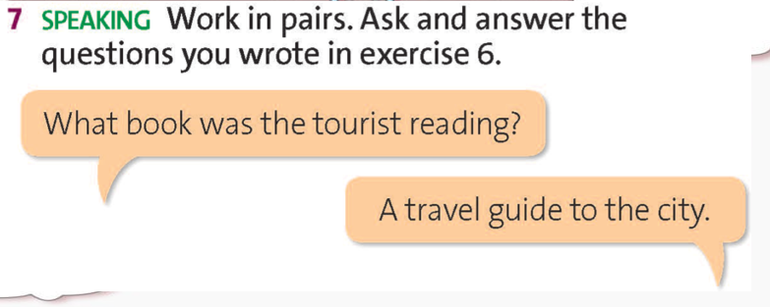
C. Consolidation (3’)
Grammar: Past Continuous
D. Homework (2’)
- Learn by heart all past continuous forms.
- Write the opening paragraph of a story using ideas from the game and exercise 7.
- Do exercise
- Prepare: Unit 2 – C-Listening (page 25 – SB)

