READING
PART 1
Look at the picture. Read the words. Which words go with the picture? Fill in the correct circles on your answer sheet.
1.

(A) The boy is drawing a picture. | (B) The boy is taking a photo. | (C) The boy is talking on the phone.

The answer is "B." Fill in "B" on your answer sheet.
2.

What does the arrow show?
The boy with the arrow is ahead of the other boy.
(A) Ahead | (B) Beside | (C) Under
The answer is "A." Fill in "A" on your answer sheet.

3.
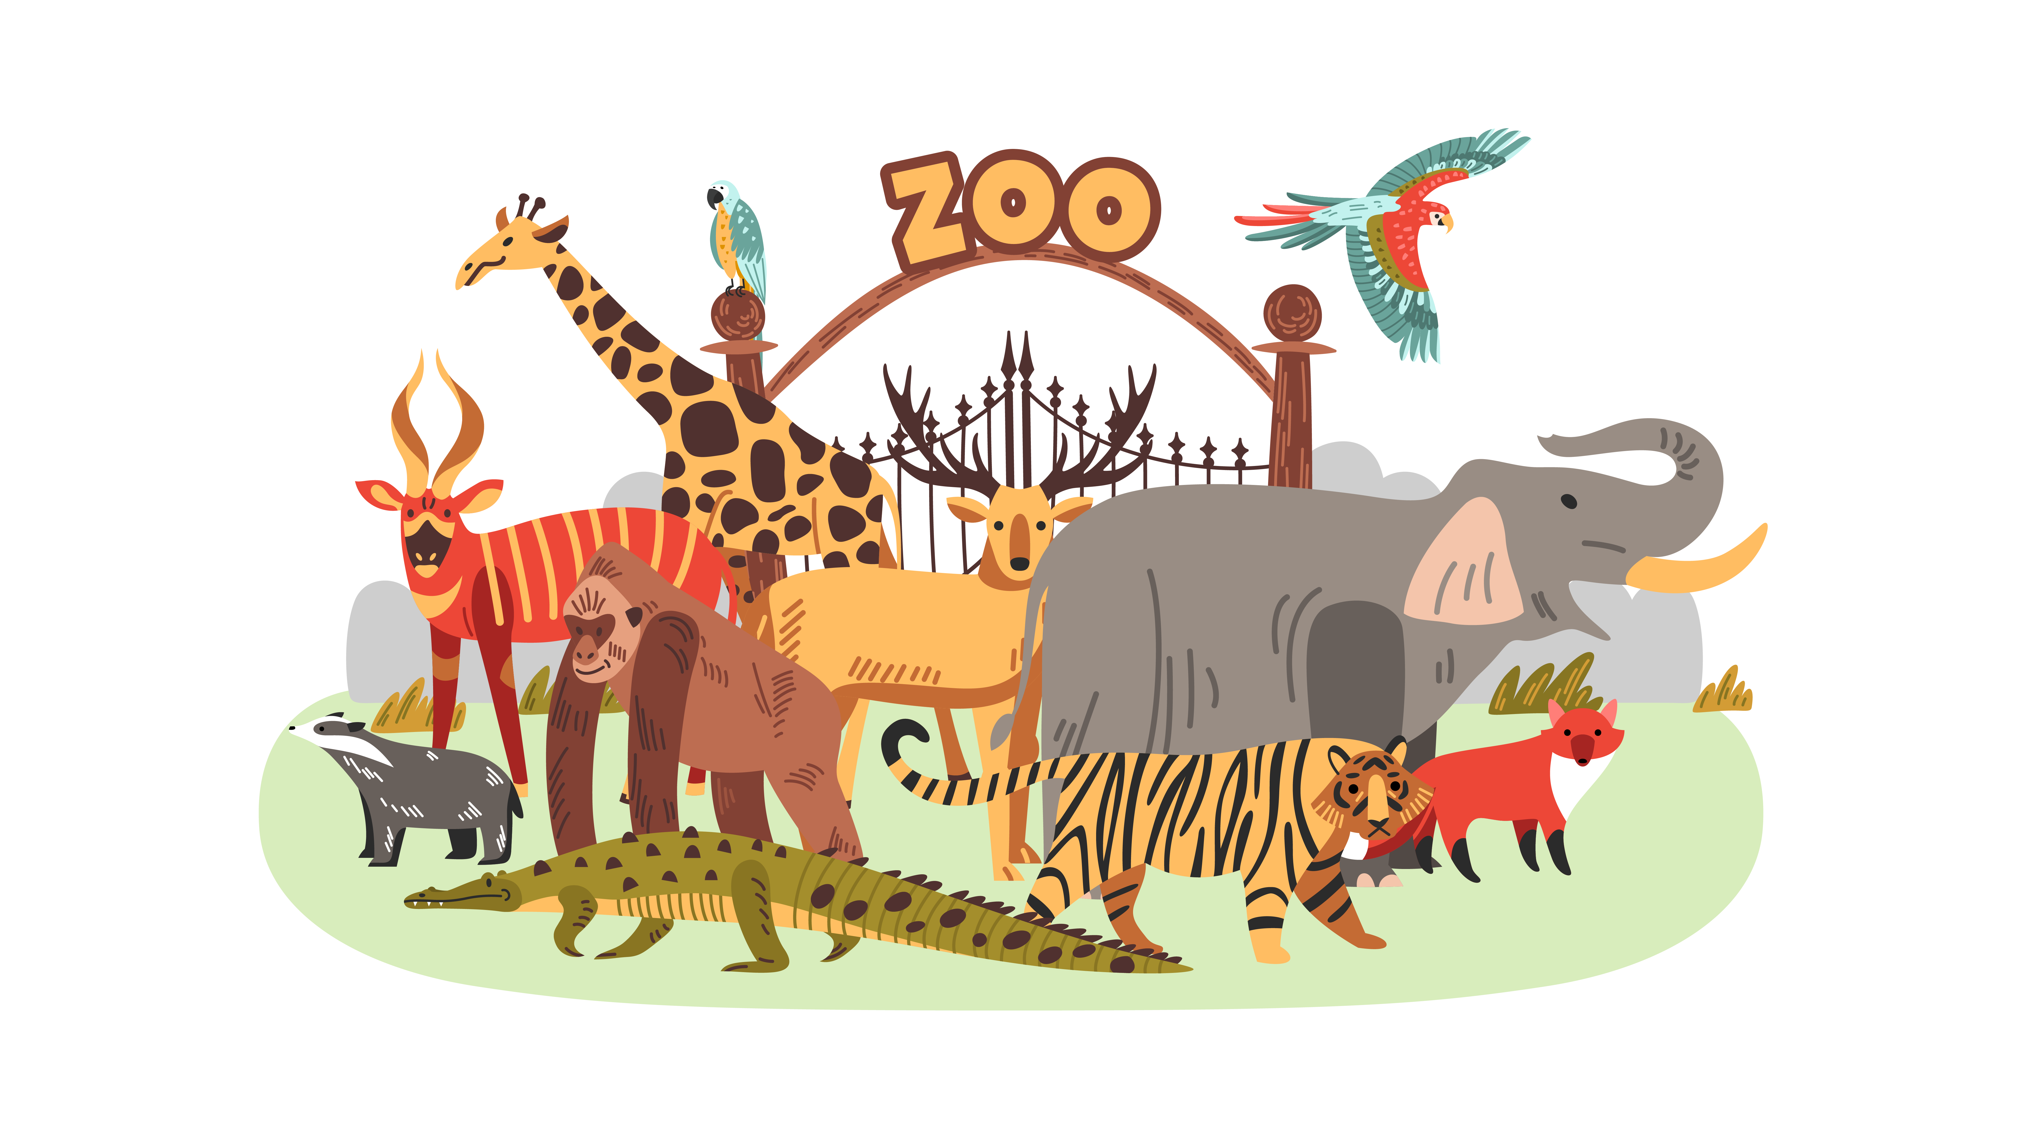
(A) Monkey | (B) Zoo | (C) Animal
4.

(A) Truck | (B) Bike | (C) Train
5.
 | 
(A) Hippo | (B) Squirrel | (C) Zebra
6.
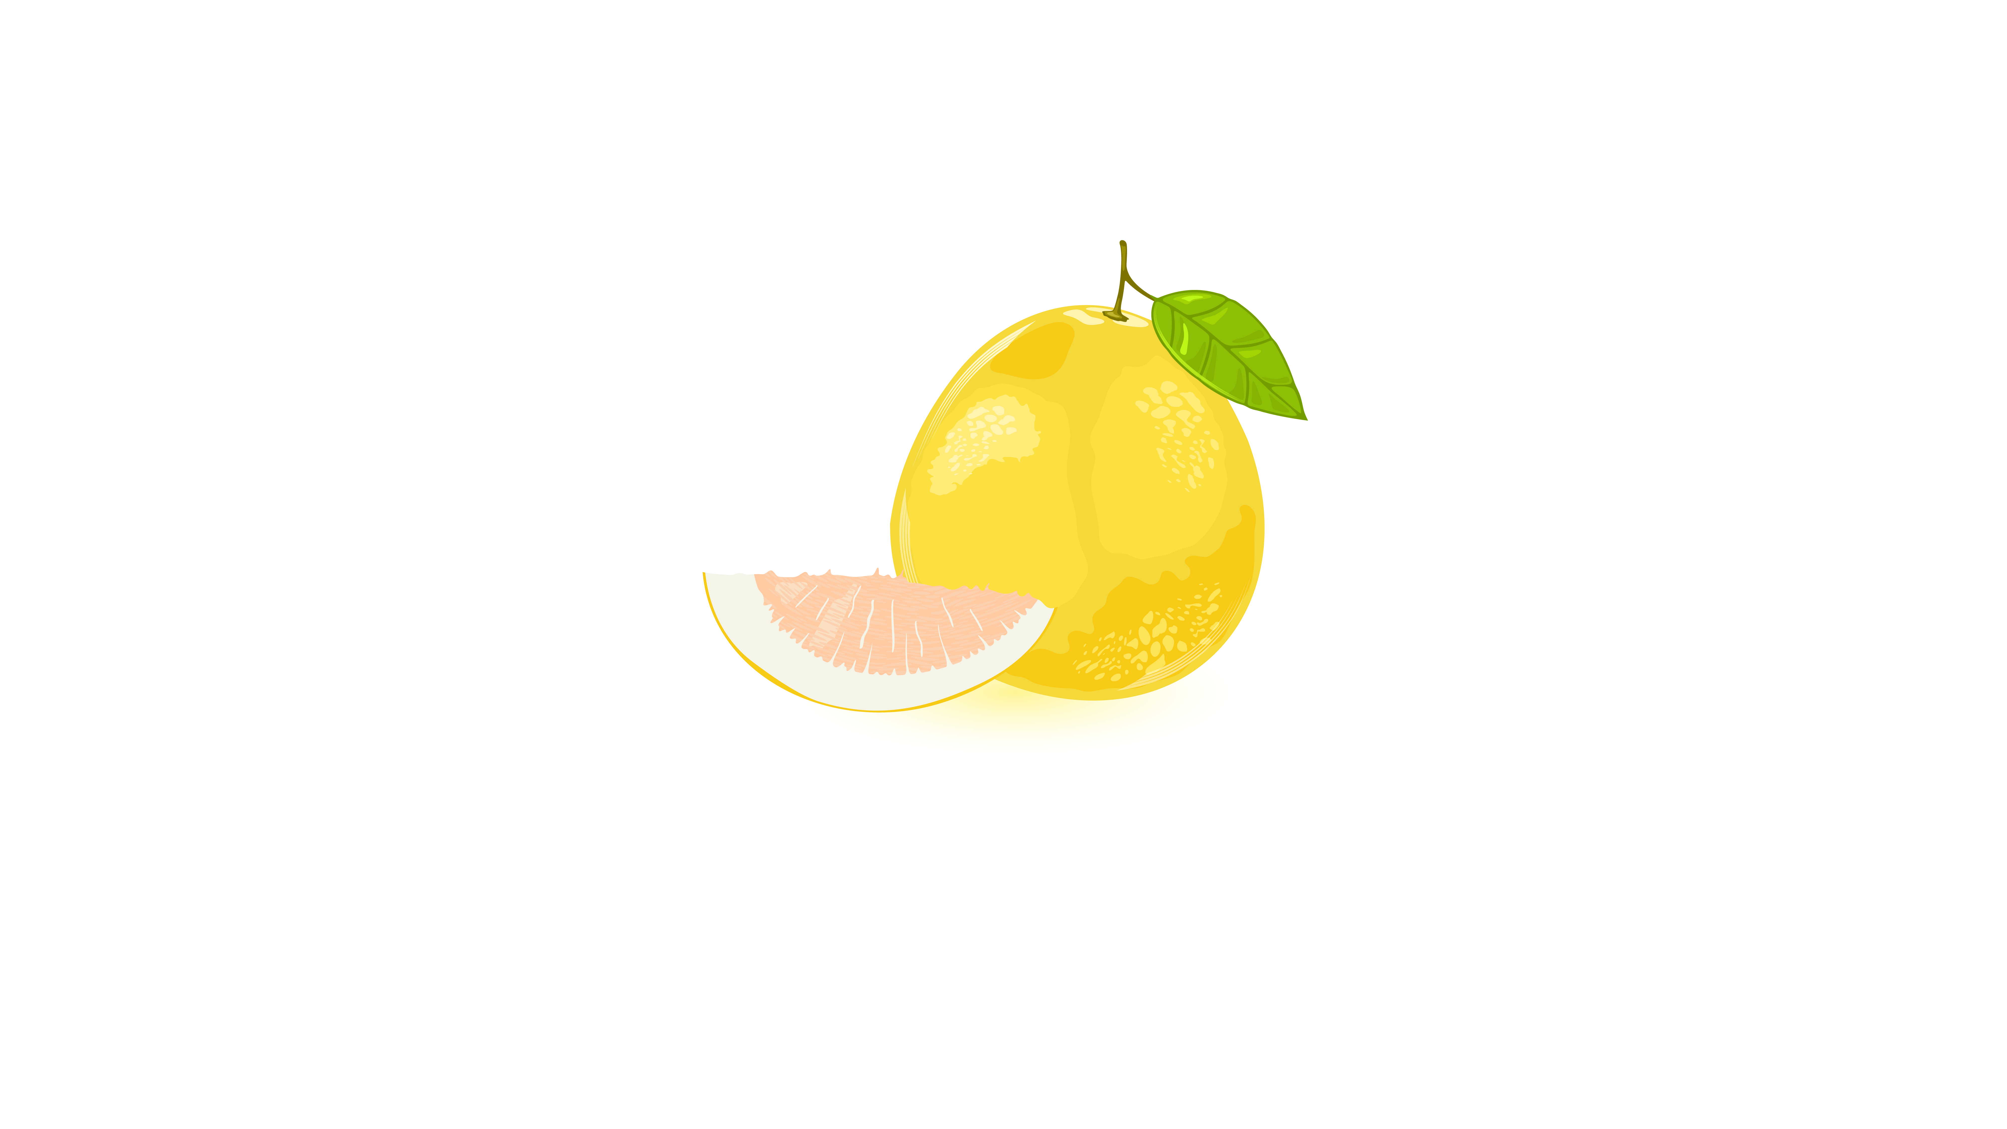
(A) Pomelo | (B) Orange | (C) Jackfruit
7.
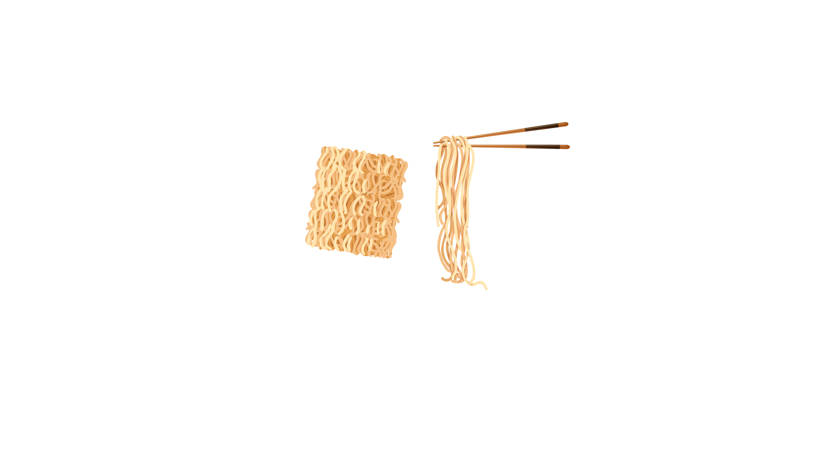
(A) Noodles | (B) Sausage | (C) Hamburger
8.
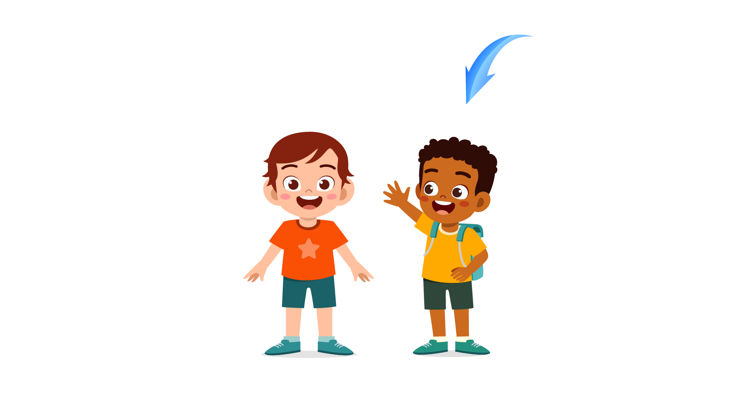
(A) straight | (B) curly | (C) bald
9.

(A) Shirt | (B) T-shirt | (C) Polo shirt
10.

(A) They are playing soccer. | (B) They are holding the ball. | (C) They are reading books.
11.
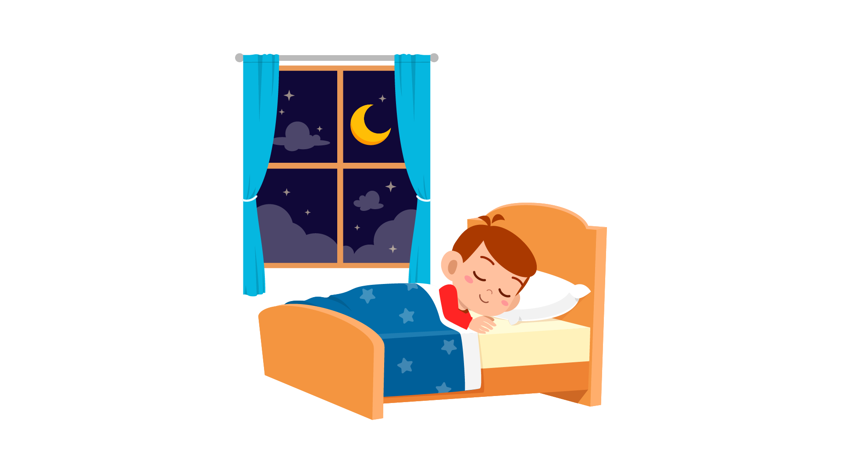
(A) The boy is sleeping. | (B) The boy is playing. | (C) The boy is sitting.
12.
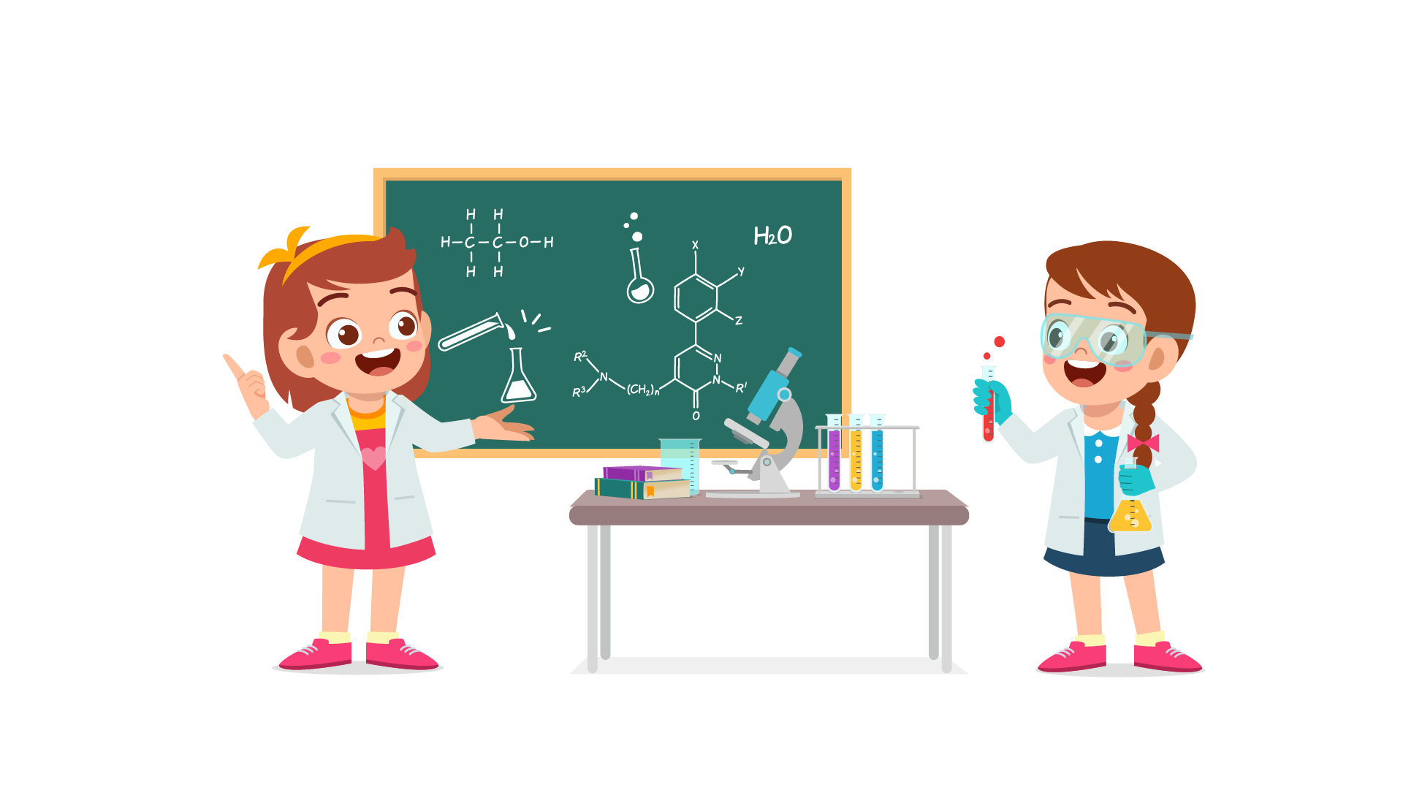
(A) The girls are in the Literature class. | (B) The girls are in the Chemistry class. | (C) The girls are in the P.E class.
13.
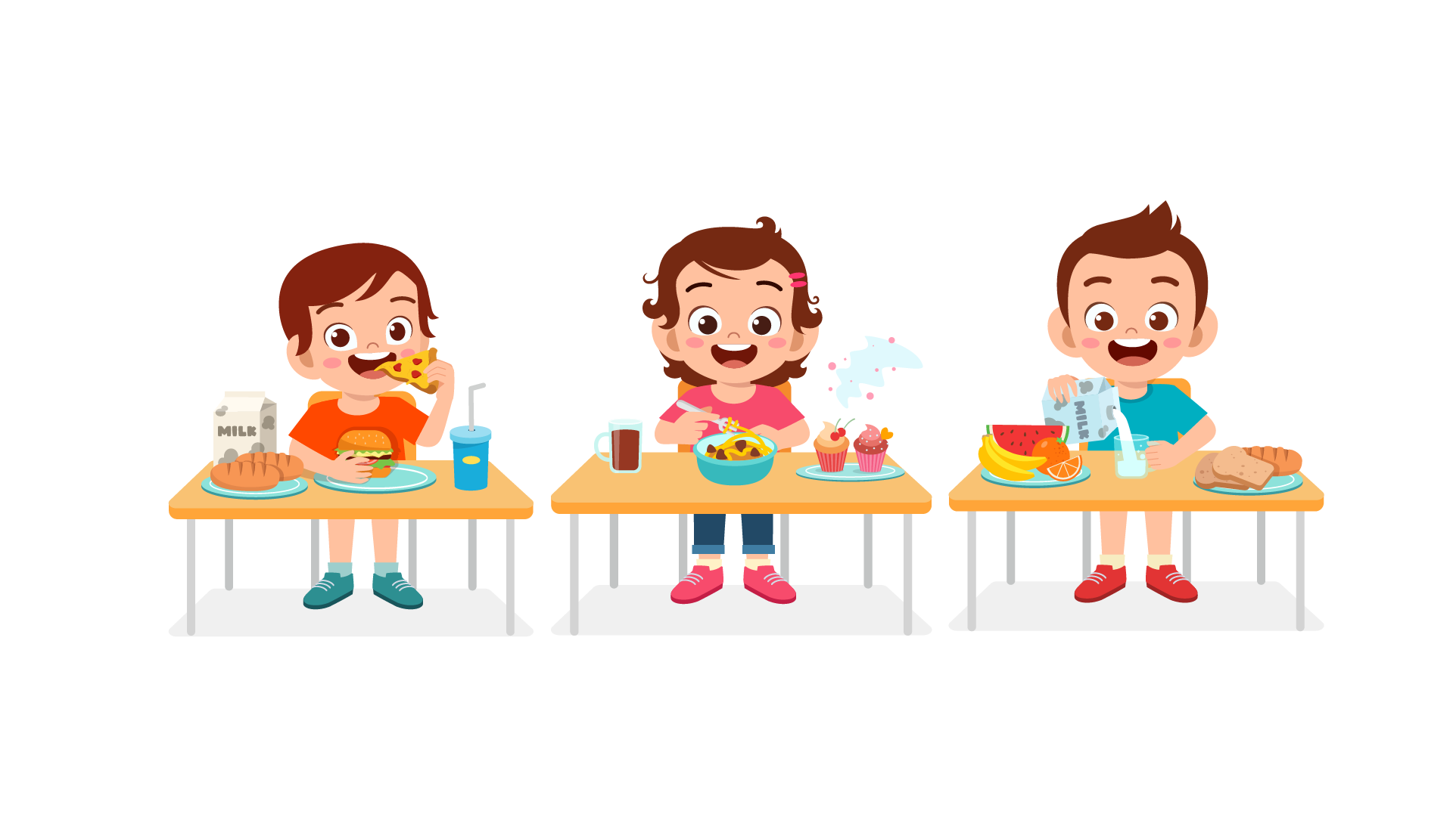
(A) They are in the canteen. | (B) There are in the cinema. | (C) They are in the classroom.
14.

(A) The boy is doing a crossword puzzle. | (B) The boy is sitting quietly. | (C) The boy is making a presentation.
15.
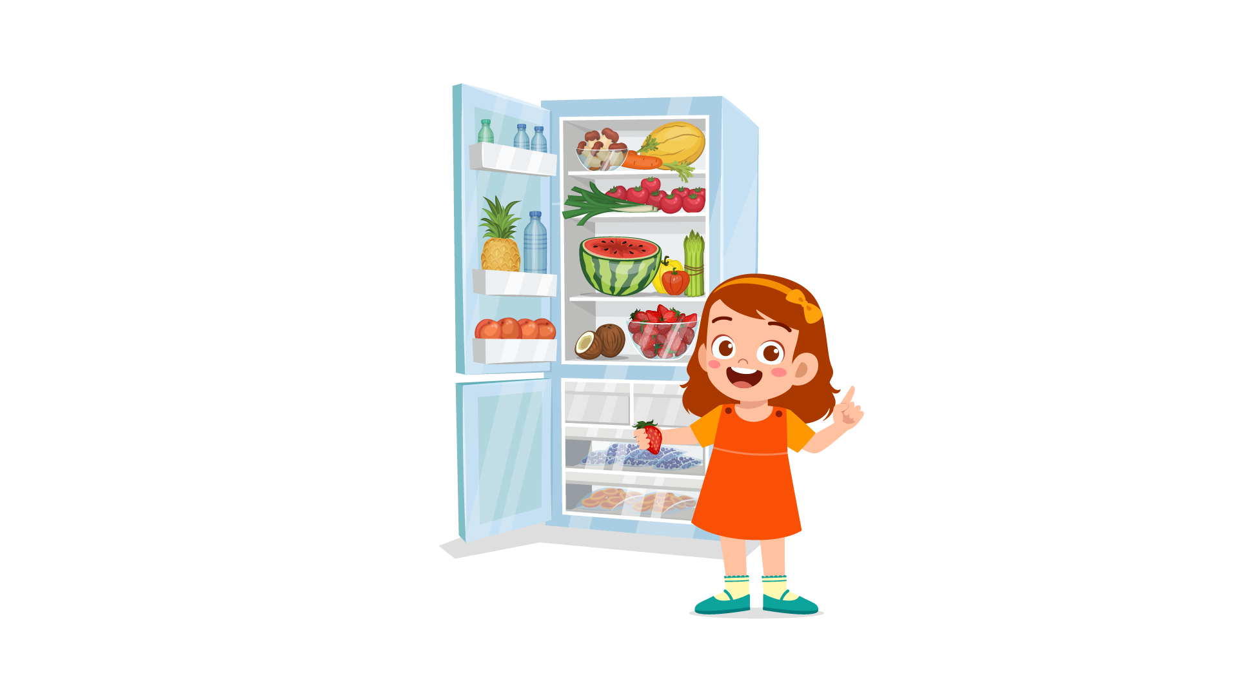
(A) She took food from the oven. | (B) She took food from the fridge. | (C) She took food from the supermarket.
16.
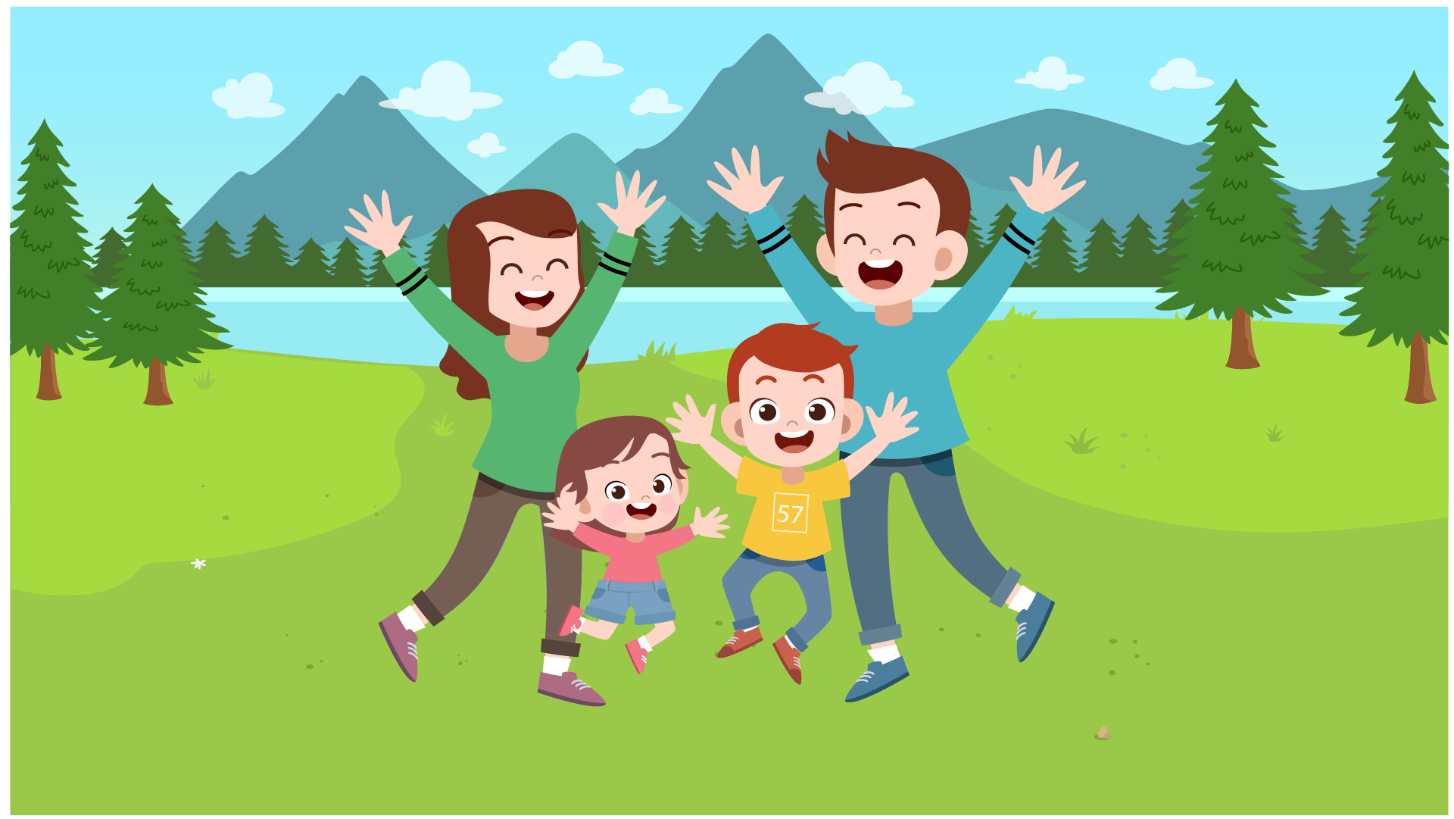
(A) The family is playing in the park. | (B) The family is going shopping. | (C) The family is moving their house.
17.

(A) Her hair is shorter than his hair. | (B) His hair is longer than her hair. | (C) Her hair is longer than his hair.

PART 2
Read and find the answer.
Fill in the correct circles on your answer sheet.
Let’s do an example.
- Students go to class here. Teachers work here. It has many desks. What is it?
  - (A) A house
  - (B) A school
  - (C) A bank
The correct answer is a school. Fill in "B" on your answer sheet.

- It is a big place. Postmen work here. They deliver letters.
Where is it?
(A) A post office
(B) A factory
(C) A hospital

- This is a long, narrow school object. It is used to draw straight lines.
What is it?
(A) A ruler
(B) A pencil sharpener
(C) A pencil case

- An underground, electric railroad is called __________________.
(A) A tram
(B) A subway
(C) A boat

- You have pain in the inside part of your ear. You have a/an _________.
(A) headache
(B) earache
(C) stomachache

- If a boy goes to school on foot, he _________ to school.
(A) walks
(B) runs
(C) flies

- Lan is going out. She takes an umbrella. It is ______________ outside.
(A) snowy
(B) windy
(C) rainy

- Stella has a lot of money. She can buy anything she wants. She is ______________.
(A) noisy
(B) rich
(C) wealthy

PART 3
Read the sign. Answer questions 26 to 29.
Fill in the correct circles on your answer sheet.
Peter, Alex, Eden, Kelly and Ana go to the school campus. They read this sign at the campus.
Guide to the School campus

- Peter wants to do some chemistry experiments. He goes to the ____________.
(A) ground floor
(B) building A
(C) building E

- Ana needs some advice on her courses. She goes to the ____________.
(A) building A
(B) building B
(C) building D

- Eden wants to practice playing violin. She goes to the____________.
(A) building C
(B) building D
(C) building E

29. Alex is hungry. He goes to the____________.
(A) ground floor
(B) building C
(C) building D

Read about how students share classroom duty. Answer questions 30 to 33.
 | Tuesday | Wednesday | Saturday
Clean the windows | Monica | Jay | David
Water the plants | David | Rosie | Monica
Check the paper | Jay | David | Rosie
30. What does Jay do on Tuesday?
(A) Water the plants
(B) Clean the windows
(C) Check the paper

31. When does Mom clean the windows?
(A) Tuesday
(B) Wednesday
(C) Saturday

32. Who empties the trash on Wednesday?
(A) Brother
(B) Sister
(C) Mom

33. When does brother wash dishes?
(A) Tuesday
(B) Wednesday
(C) Saturday

Read the email. Answer questions 34 to 35.

Hi Carolina,
I just wanted to write and say thank you for everything.
You and your family were amazing hosts. I had a great time at your house. Thank you for making me feel at home. I'm sure my English improved a lot because of all your help too! Also, thank you for all the wonderful cooking you did. Now I can tell everyone English food is not as bad as they say.
If you ever come to Sri Lanka, I hope you will stay with me and I can show you my city too.
Keep in touch!

Pradeep.

34. Why does Pradeep write to Carolina?
(A) To invite her to Sri Lanka
(B) To say thanks for her help
(C) To talk about her experience in England
35. What is probably NOT true about Pradeep?
(A) She tried delicious English food.
(B) She made improvement in English.
(C) She had a house in England.

Read the email. Answer questions 36 to 37.
Dear Ascot Hotel,
I would like to have a room for two nights with breakfast on the 22 and 23 of April. Could I have a quiet room, please?
I will arrive at about 10 p.m. and I have an early meeting the next morning, so please wake me up at 8 a.m. Can you please prepare the breakfast for me? I would like to have some bread and a cup of tea in the morning.
Please could you confirm the booking? Let me know if you need any further information.
Many thanks.
With kind regards,
David Mathews
36. Why does David Mathews write to Ascot Hotel?
(A) To inform about his schedule
(B) To confirm the price of the room
(C) To book a hotel room

37. What does David need for his room?
(A) breakfast
(B) ironing board
(C) clothes for the early meeting

Read the email. Answer questions 38 to 39.
To: Jon
From: Sue
Subject: Great presentation!
Hi Jon
I'm just writing to say well done on your presentation this morning. It was not an easy task and I'm glad it went well.
You were well prepared. The content was relevant and easy to follow. You also thought about the questions people would have. I think they were impressed! I'm sure everyone feels happier about the new system now.
If you have time, please could you listen to my presentation for next week?
See you later
Sue
38. Why does Sue write to Jon?
(A) To get advice for her presentation
(B) To congratulate Jon on his presentation
(C) To give feedback about Jon’s presentation
39. What does Sue say about Jon’s presentation?
(A) The content was easy to understand.
(B) It had a new structure.
(C) It included impressive questions.

You finished the reading test.
LISTENING
PART 1
Listen to the words. Look at the pictures.
Fill in the correct circles on your answer sheet.
1.
 | 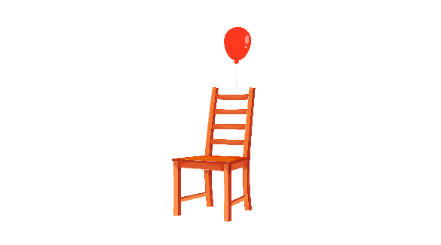 | 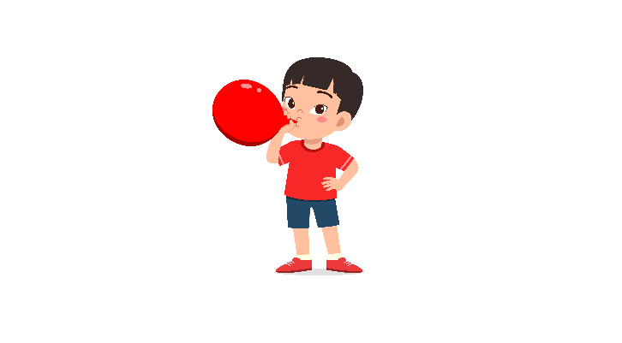
(A) | (B) | (C)
2.
 |  | 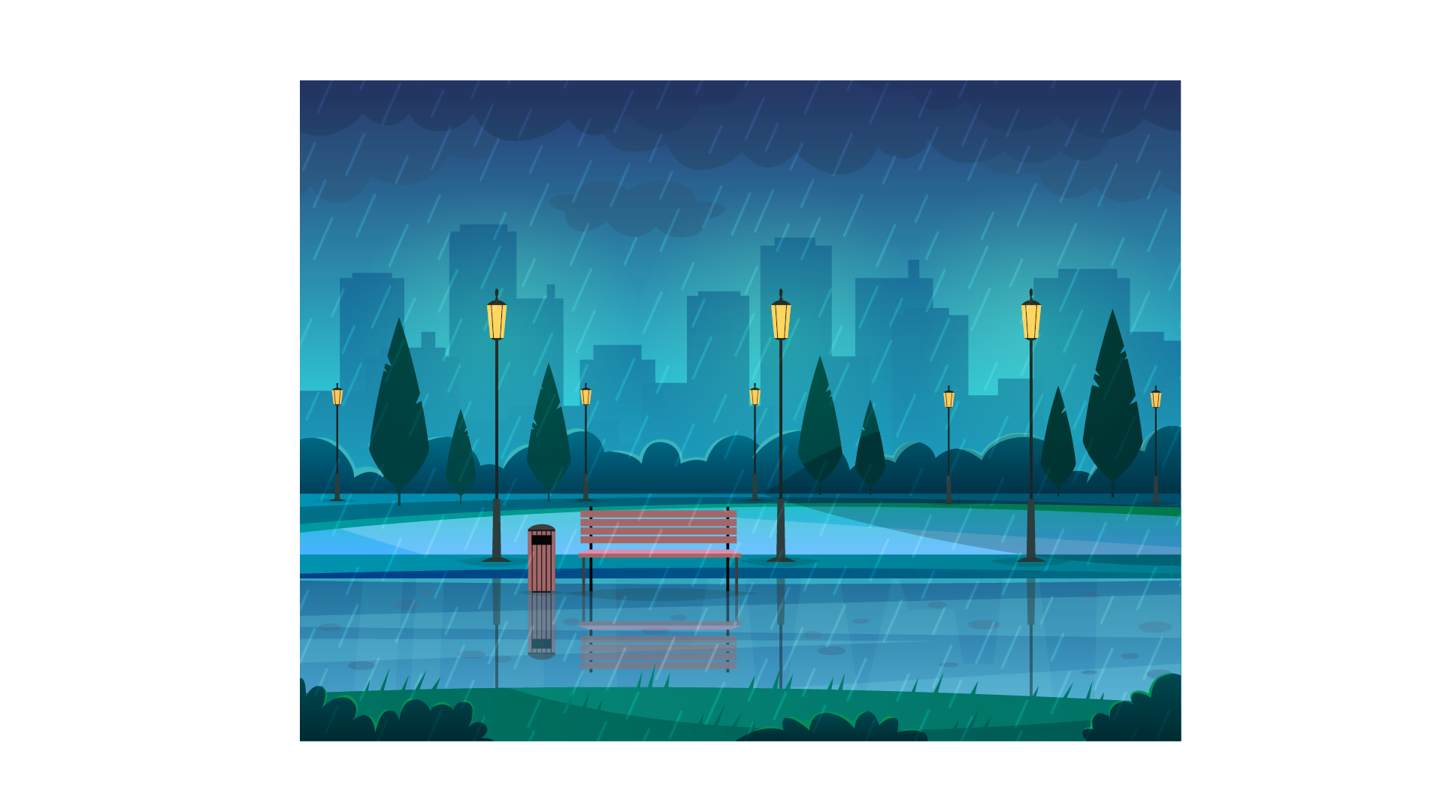
(A) | (B) | (C)
3.
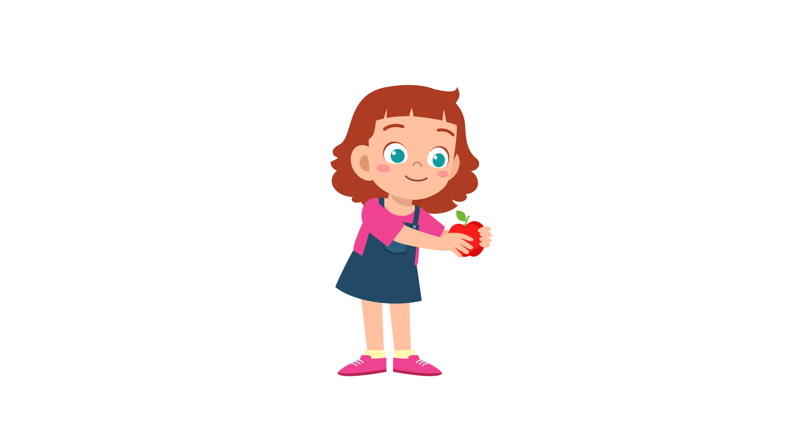 | 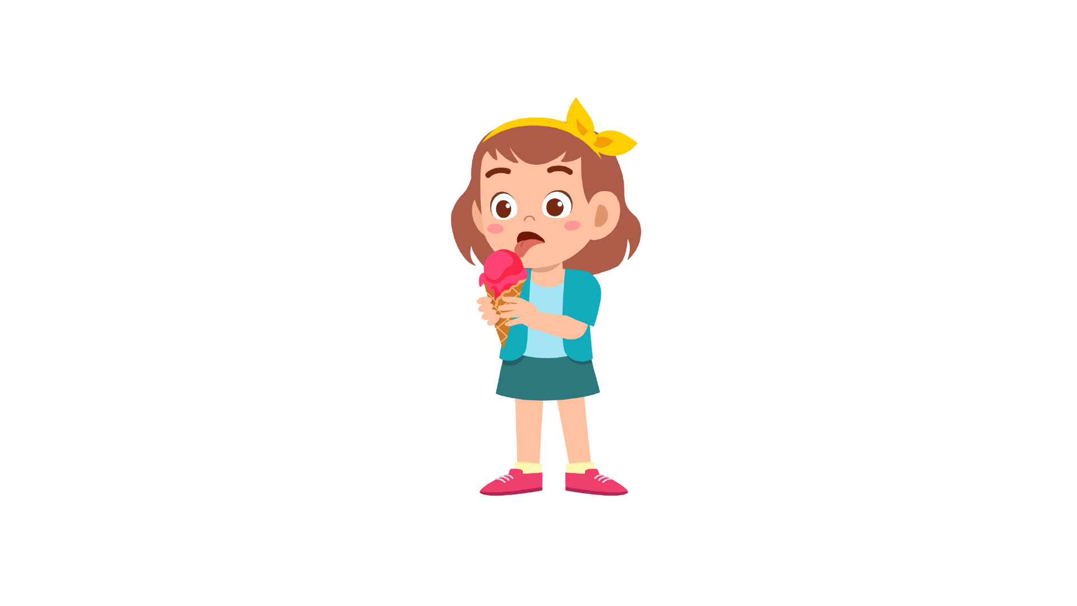 | 
(A) | (B) | (C)
4.
 | 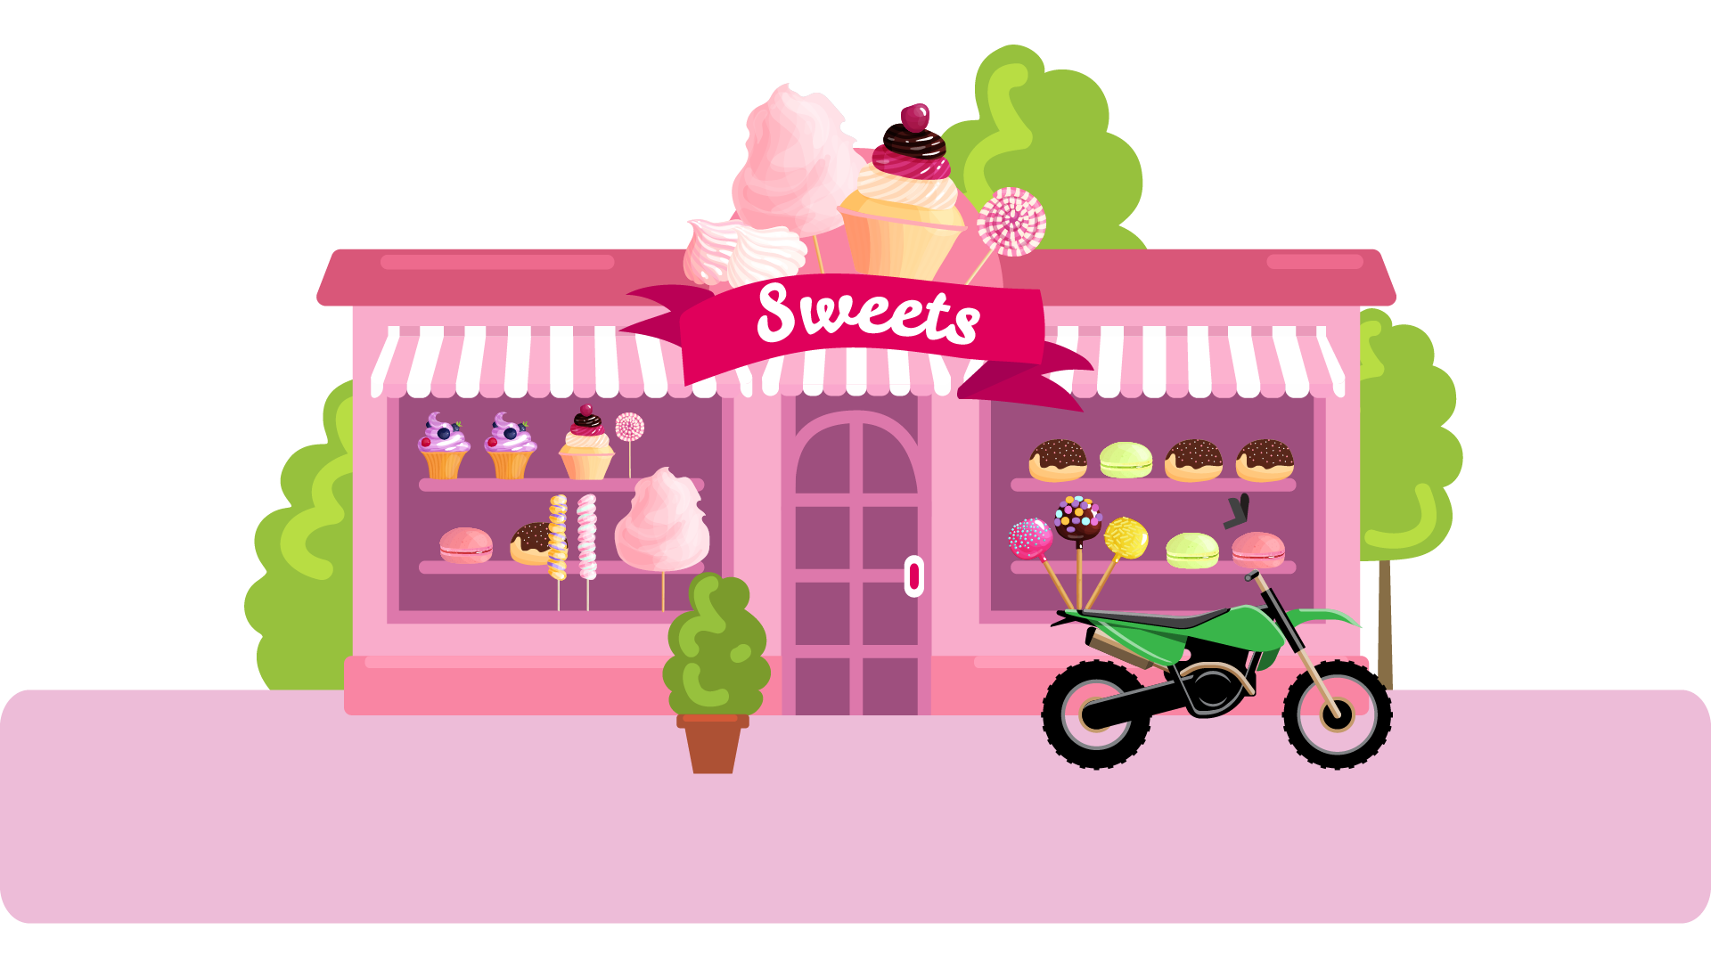 | 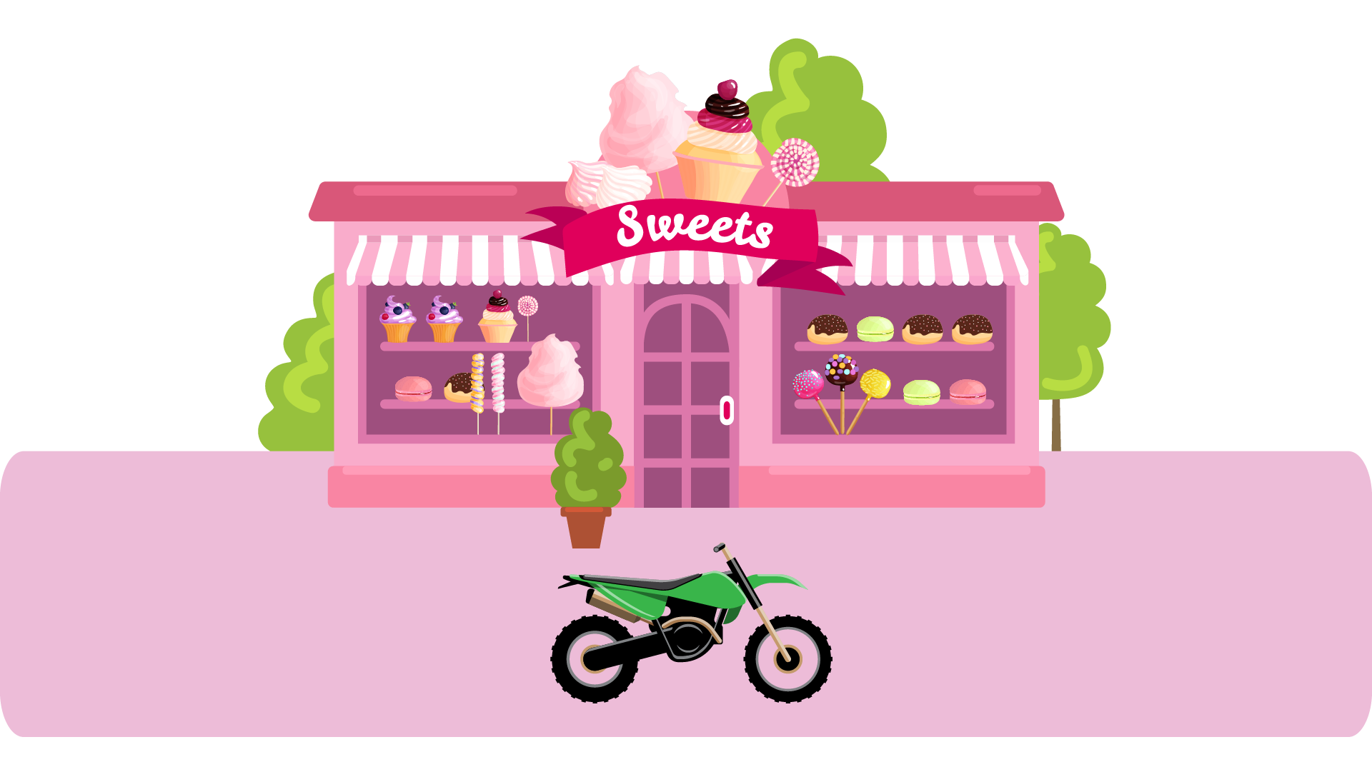
(A) | (B) | (C)
5.
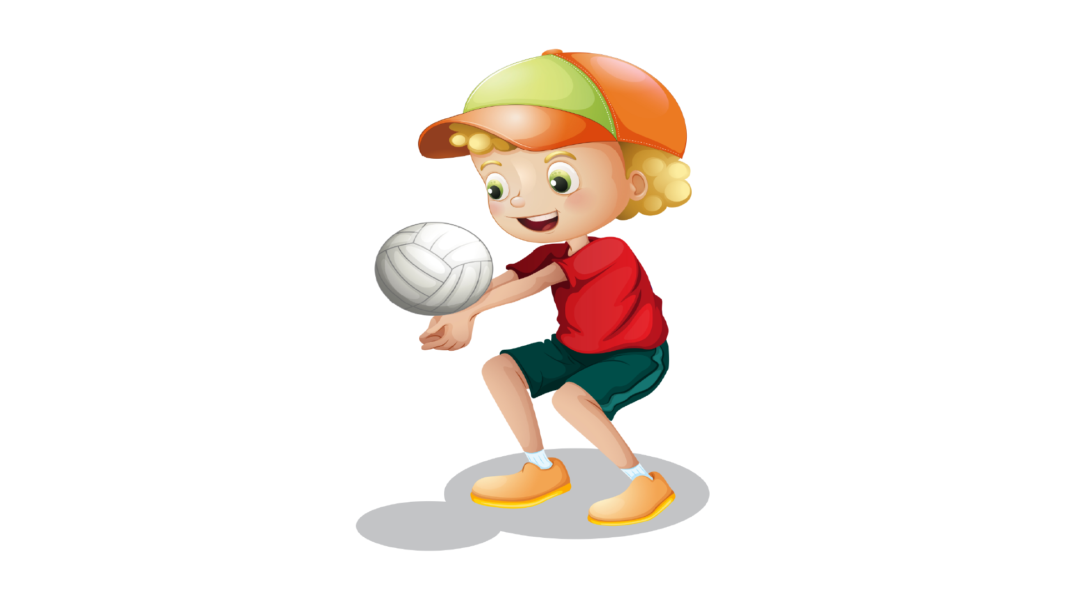 |  | 
(A) | (B) | (C)
6.
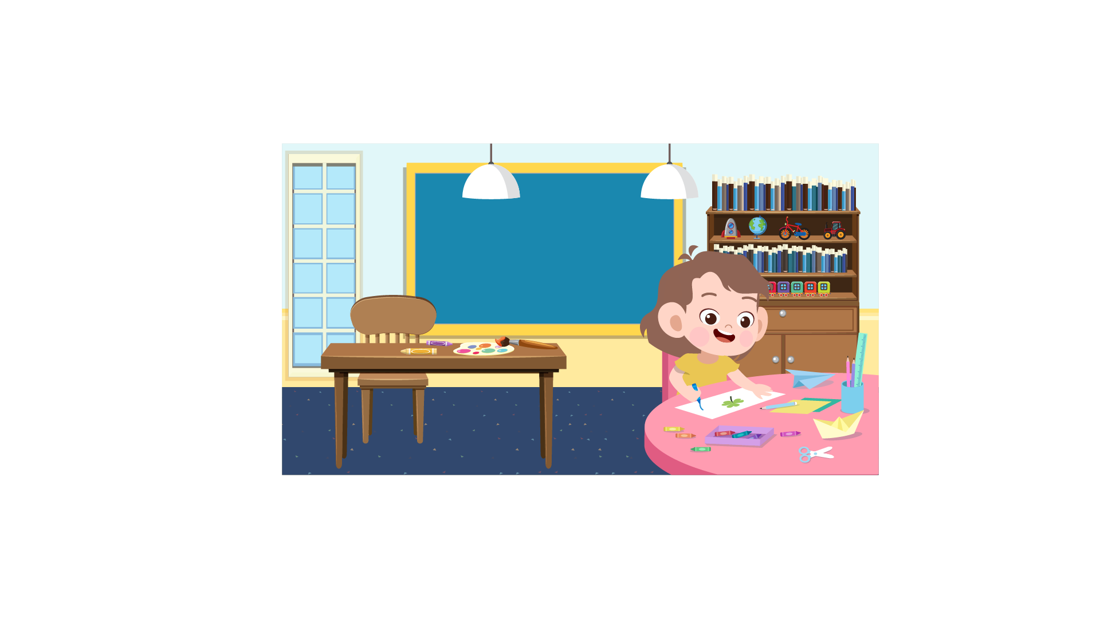 | 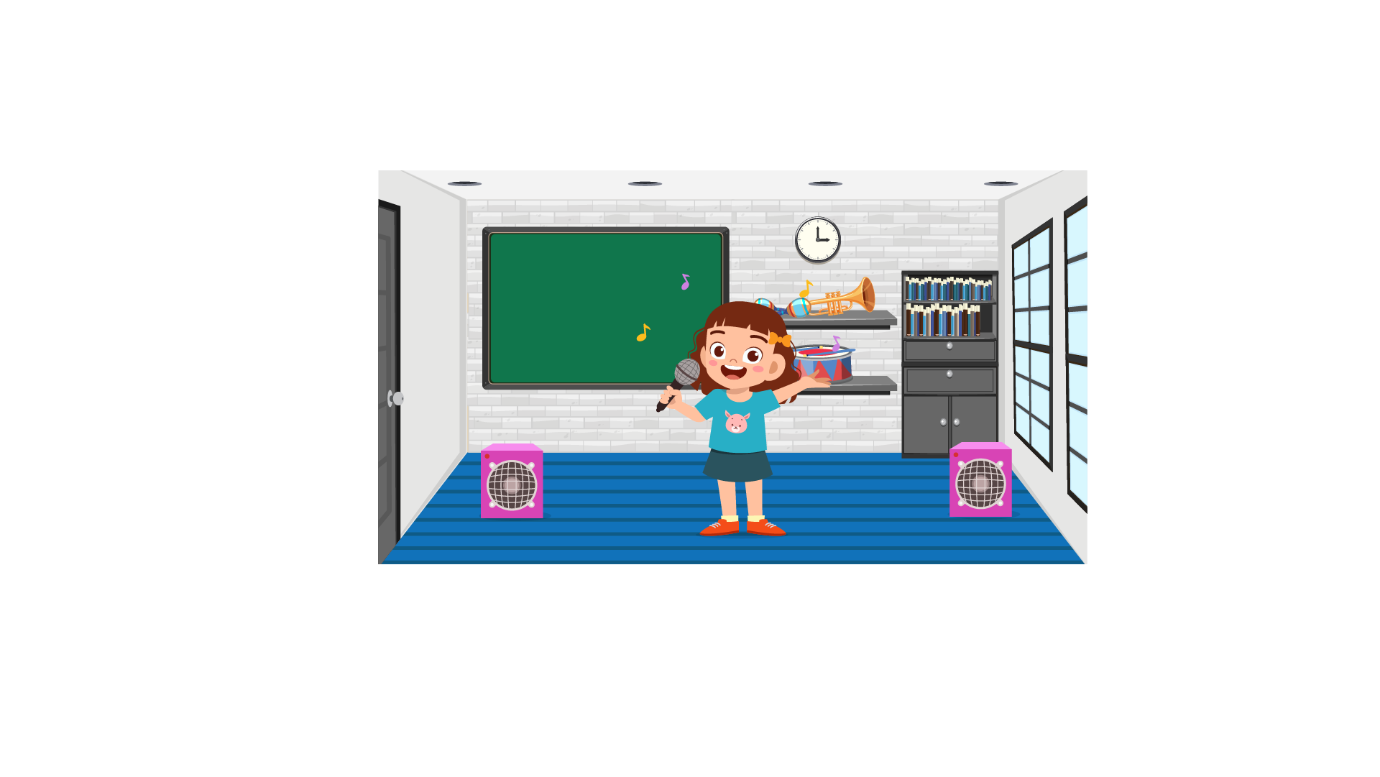 | 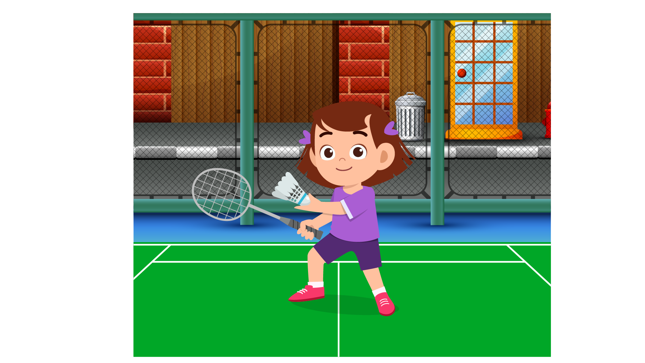
(A) | (B) | (C)
7.
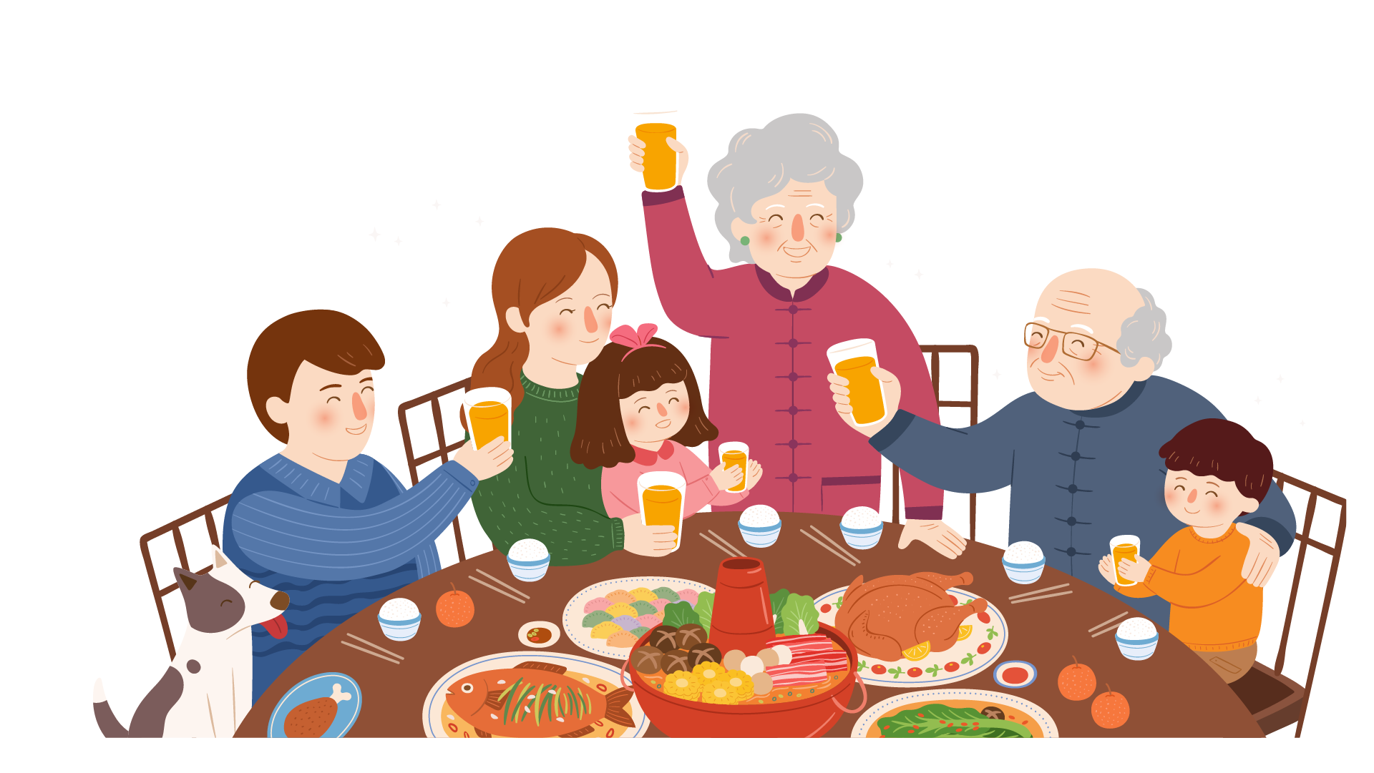 | 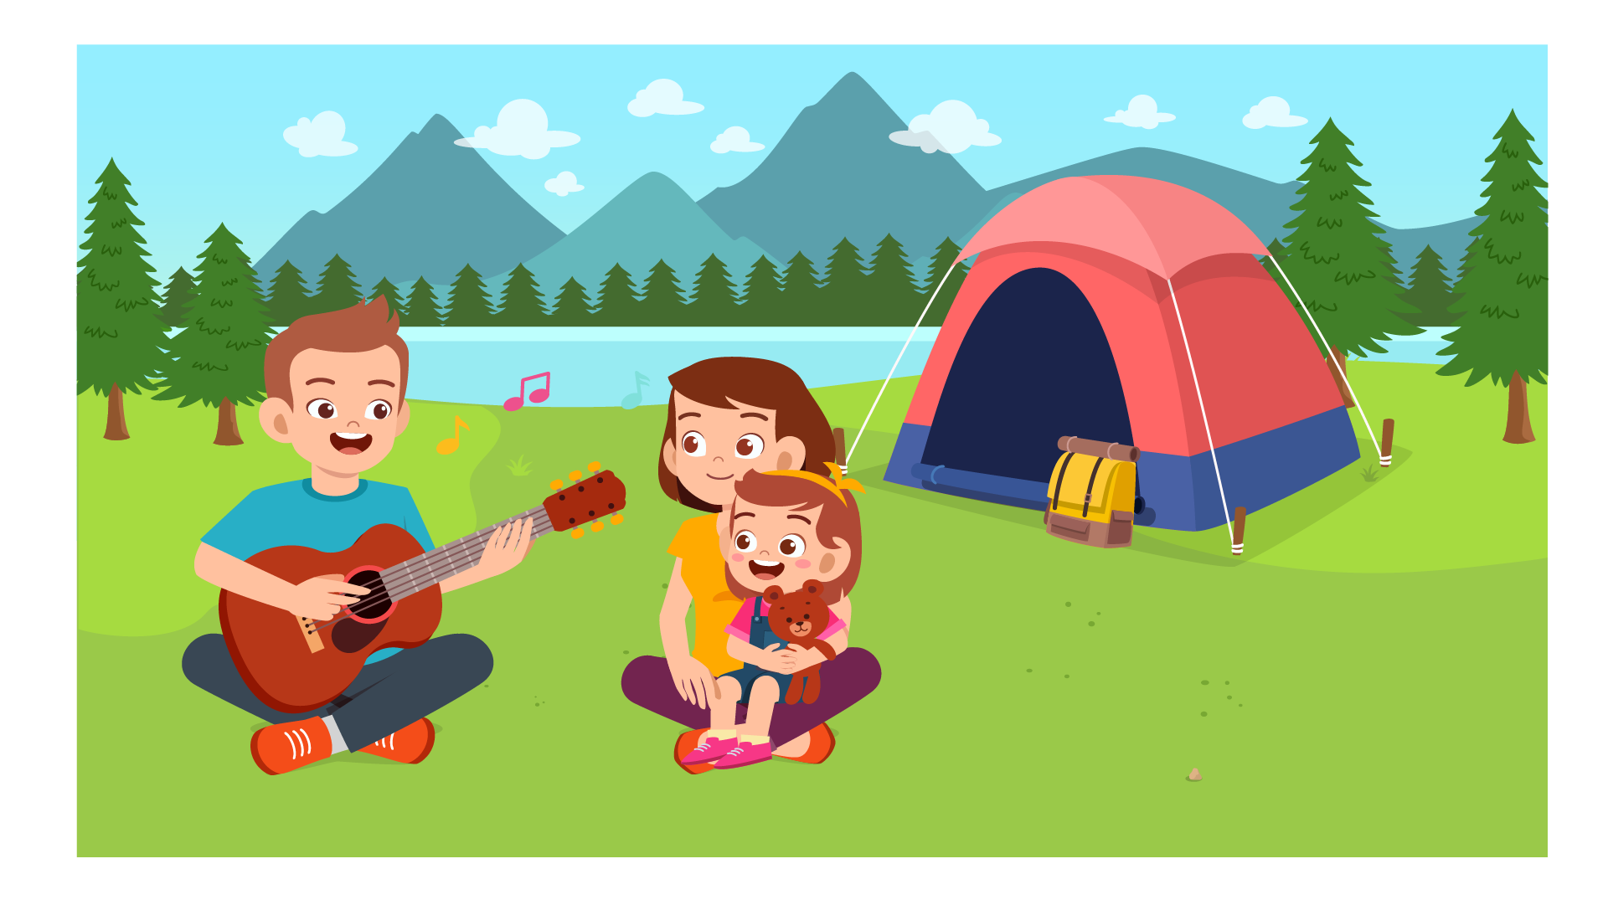 | 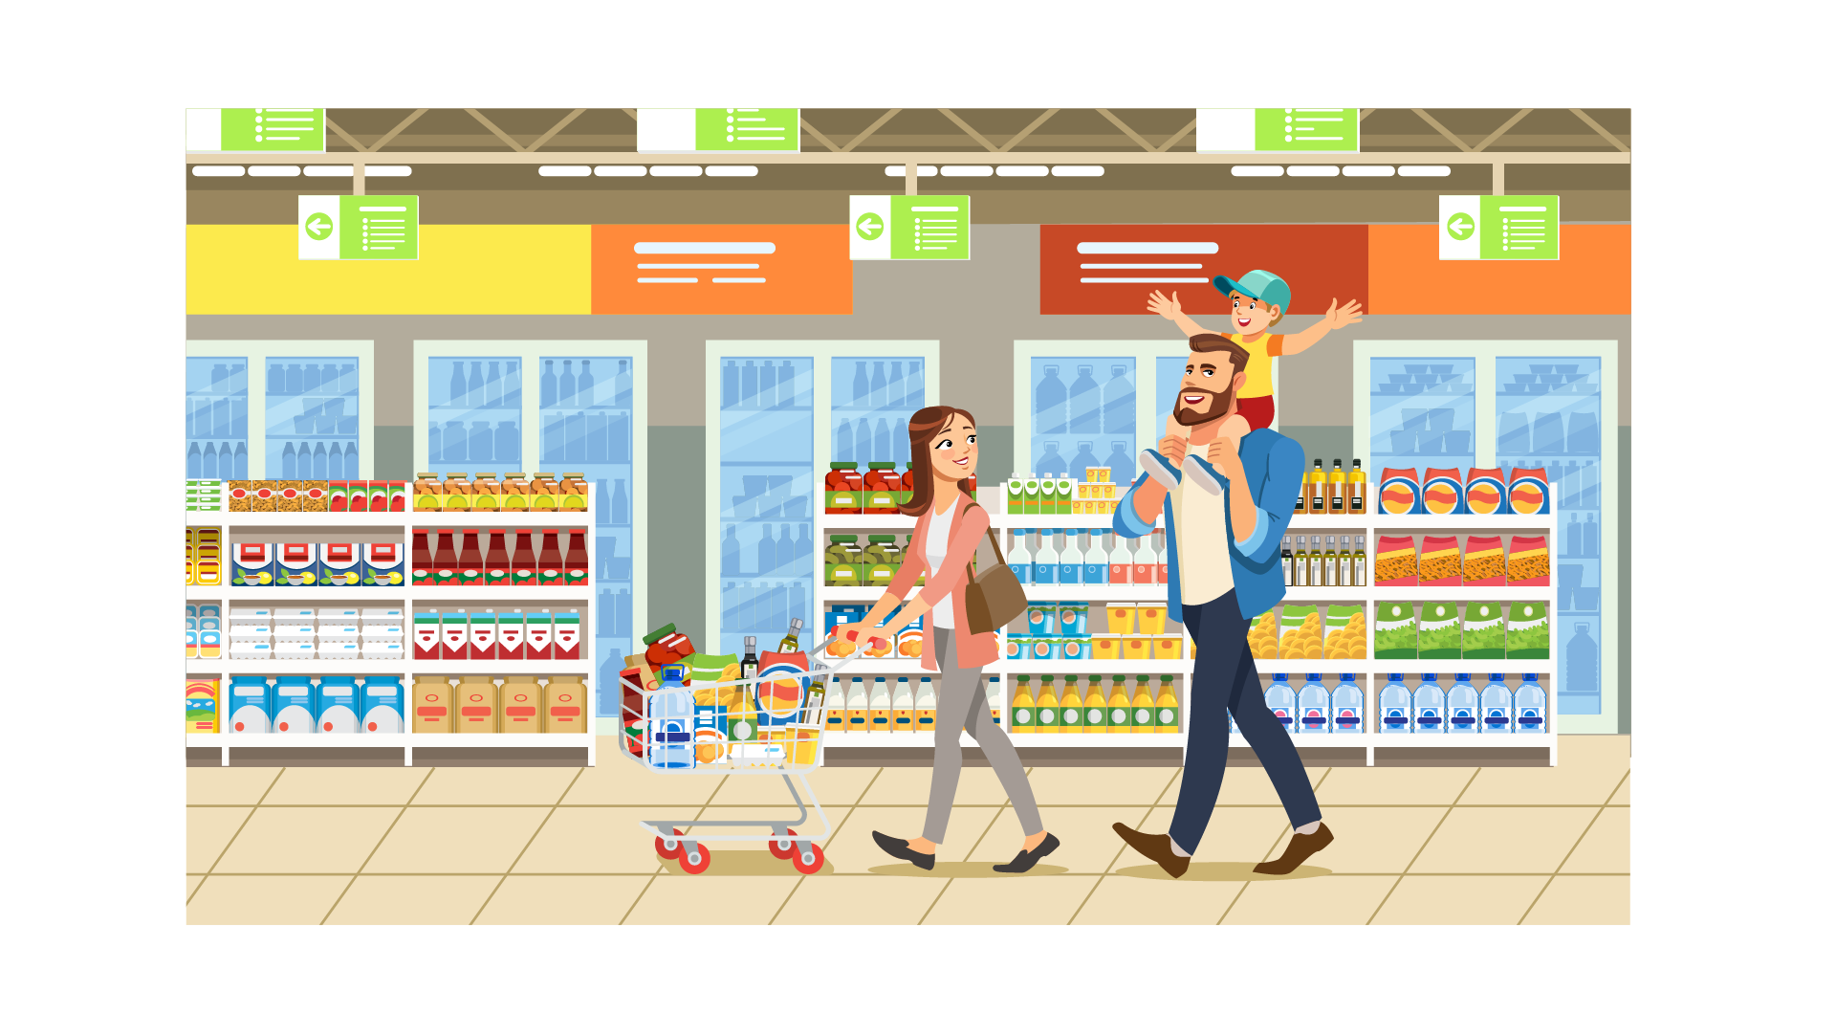
(A) | (B) | (C)
8.
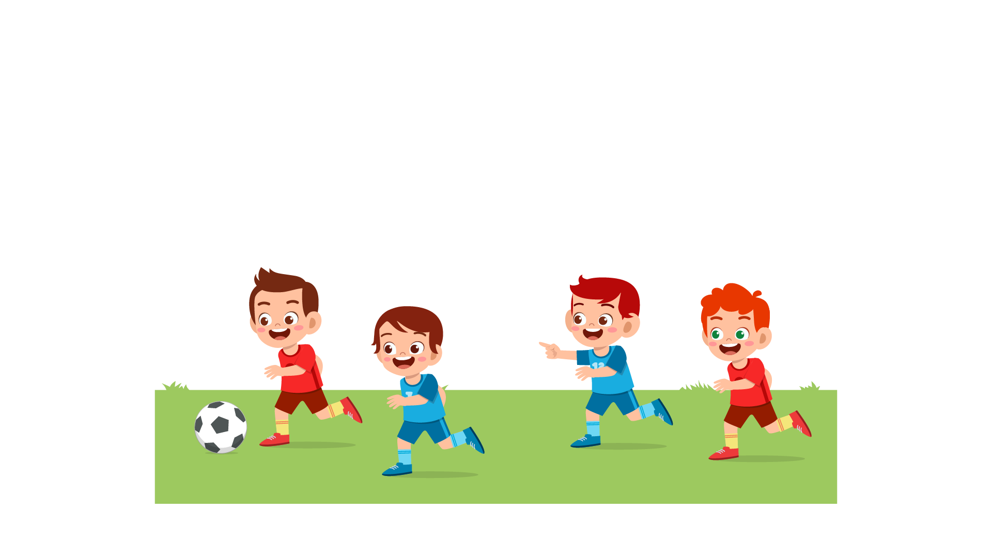 |  | 
(A) | (B) | (C)

PART 2
Fill in the correct circles on your answer sheet.

9.
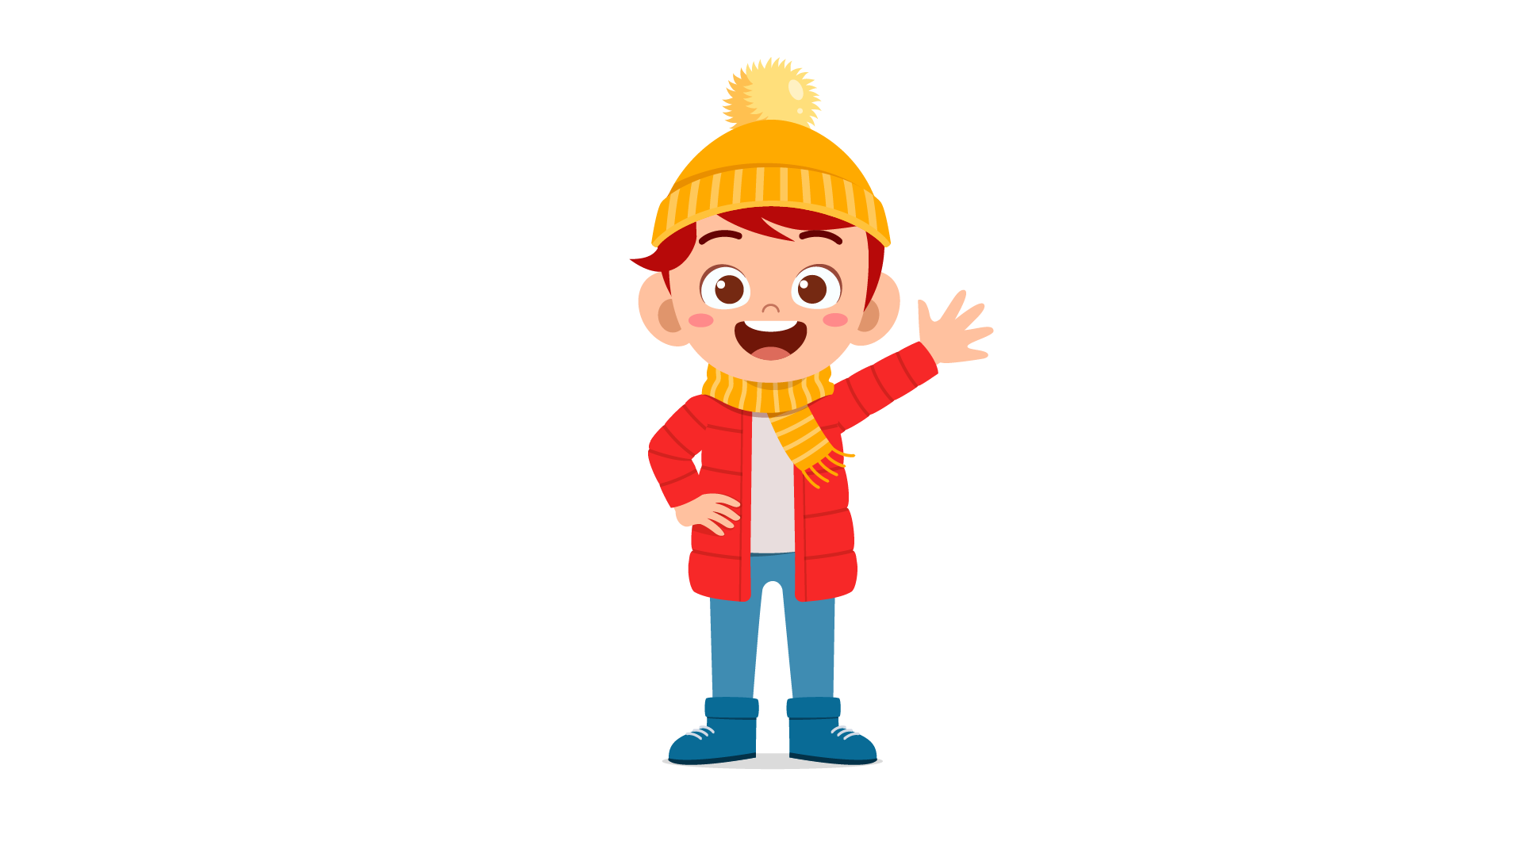 | 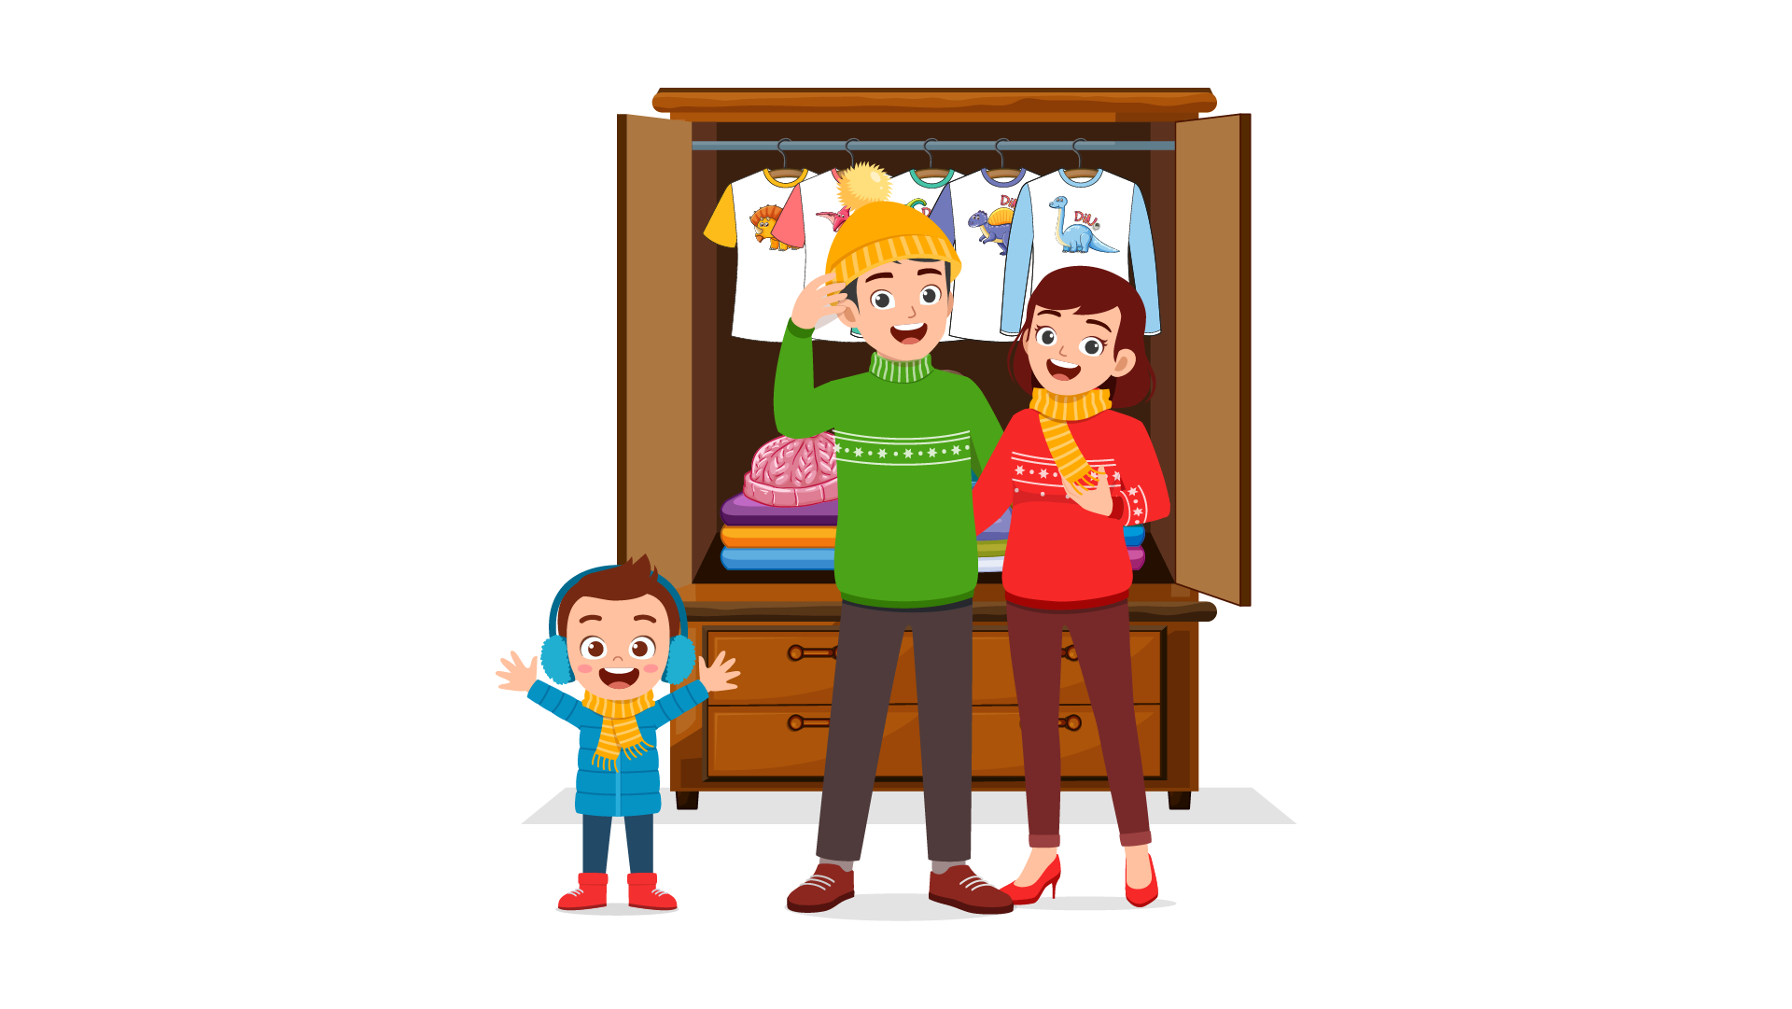 | 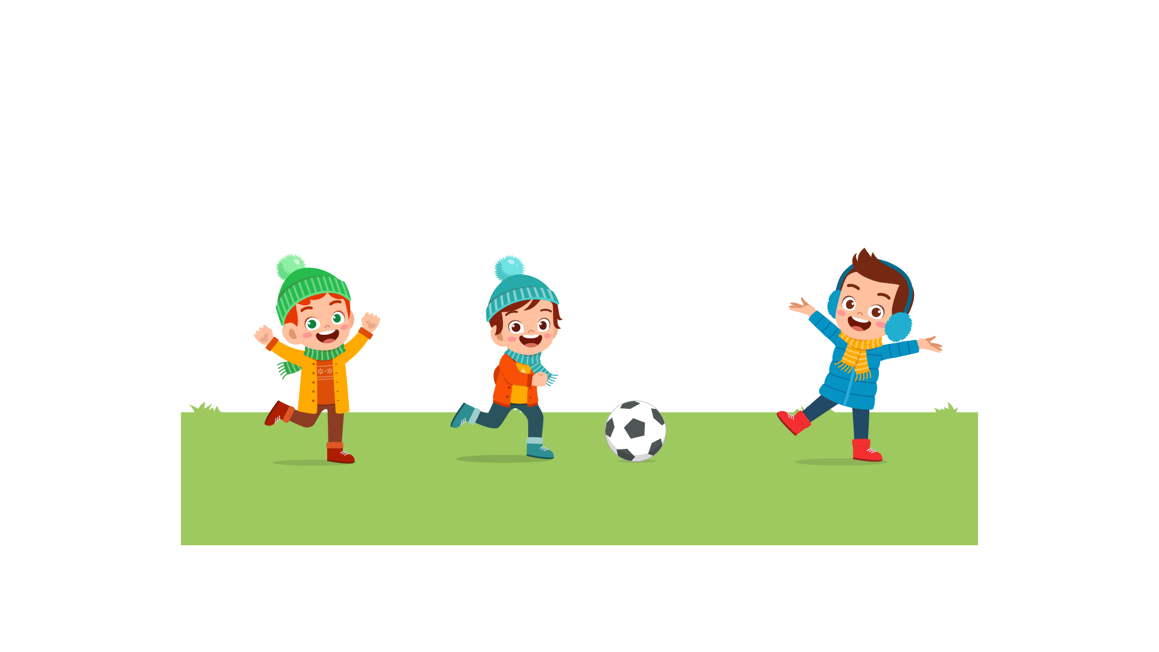
(A) | (B) | (C)
10.
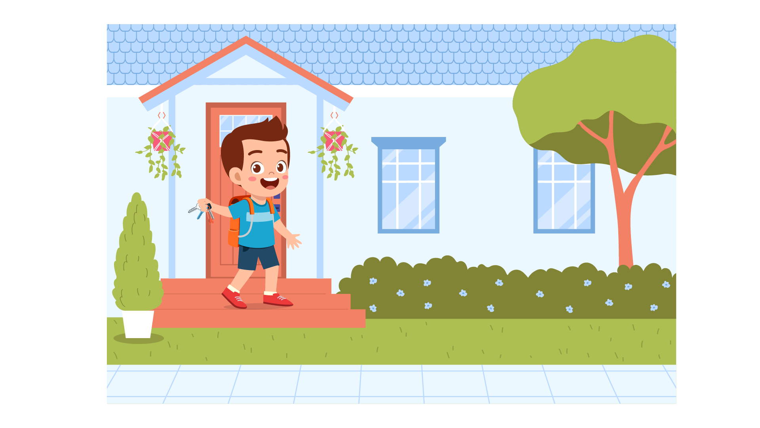 | 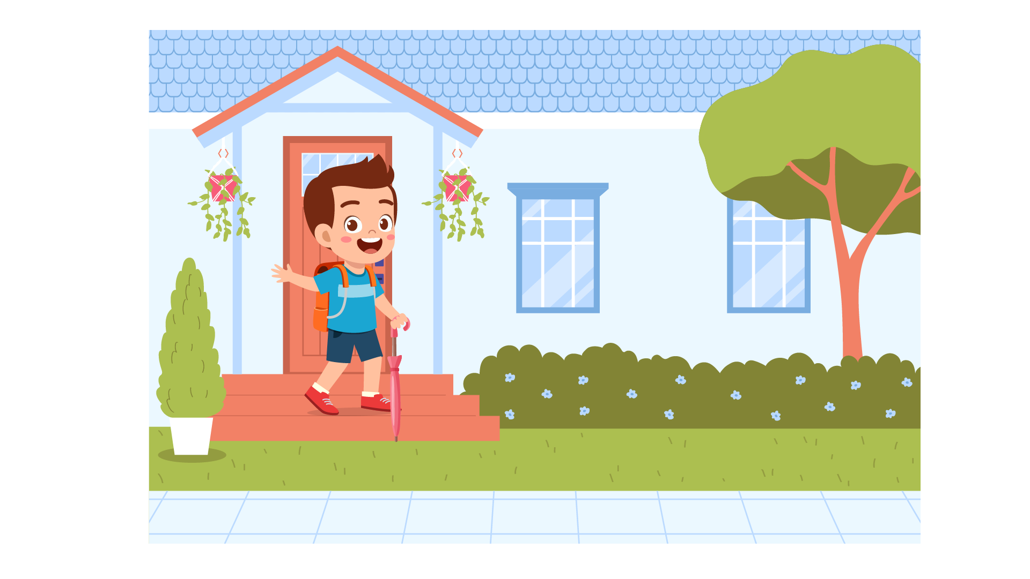 | 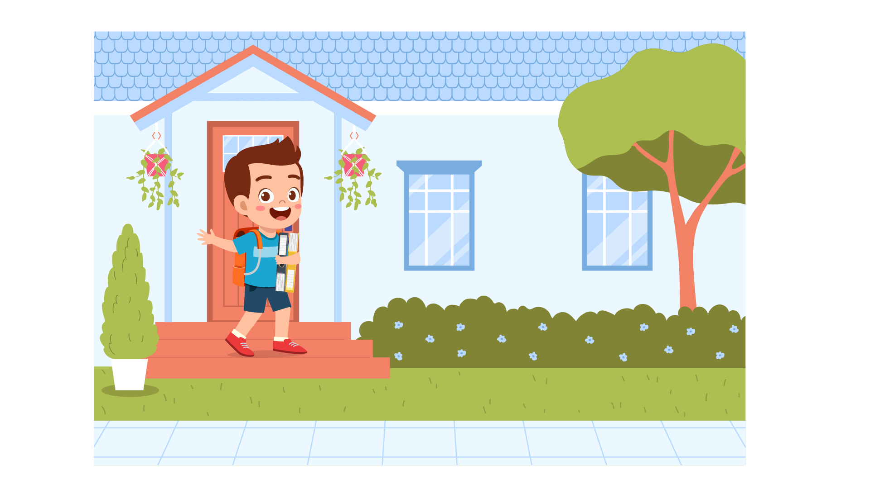
(A) | (B) | (C)
11.
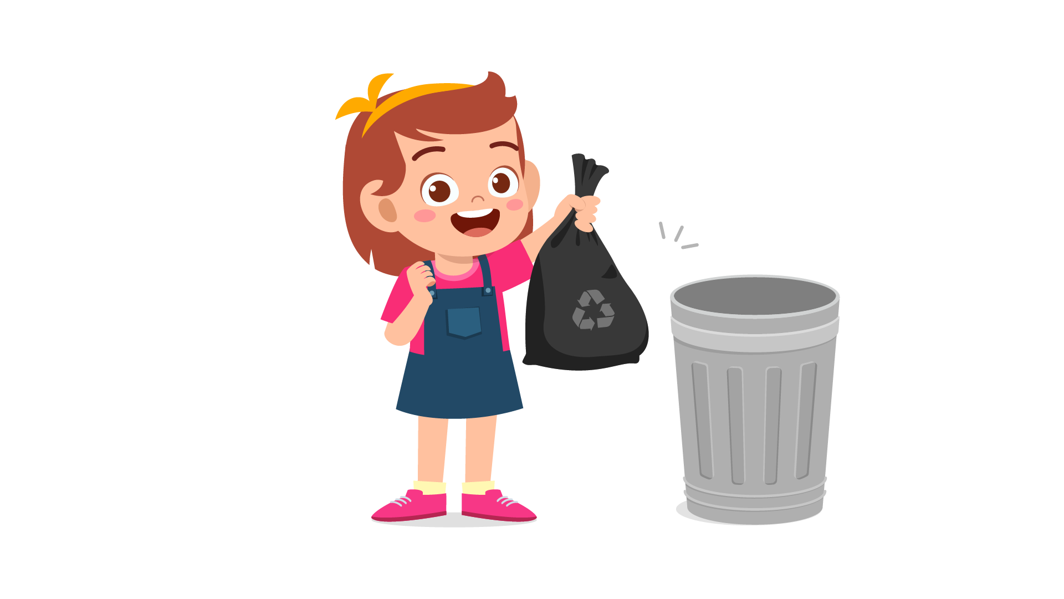 | 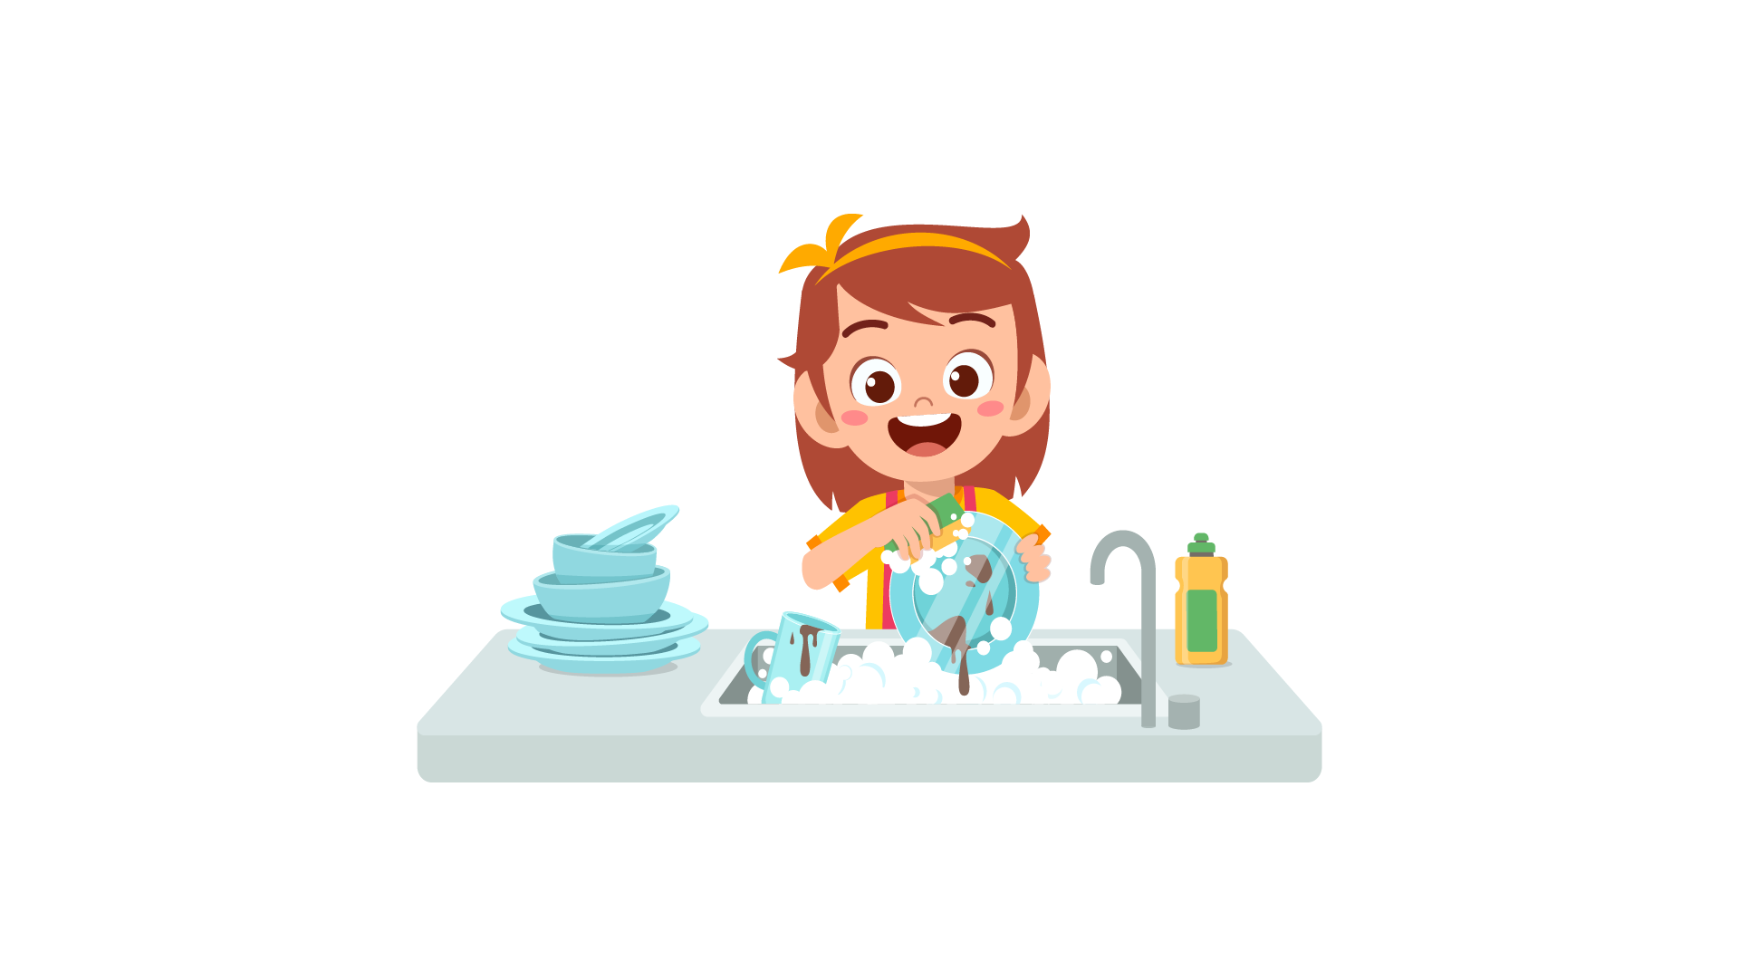 | 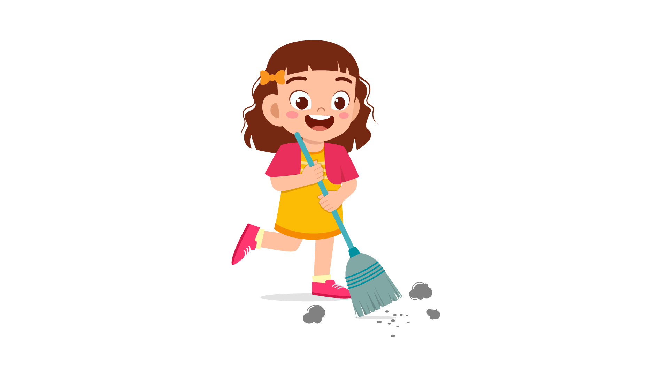
(A) | (B) | (C)
12.
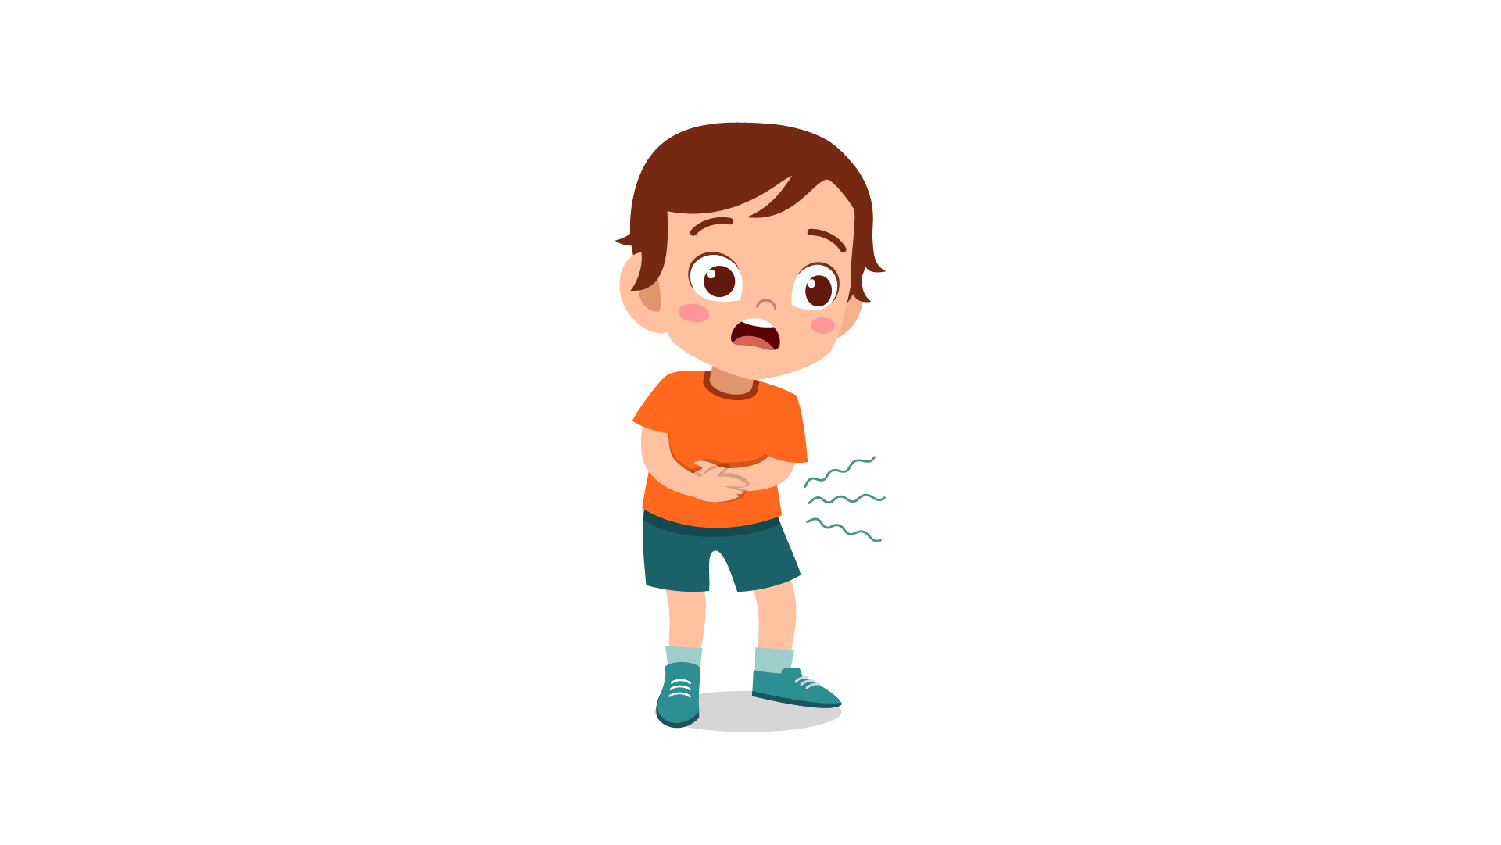 | 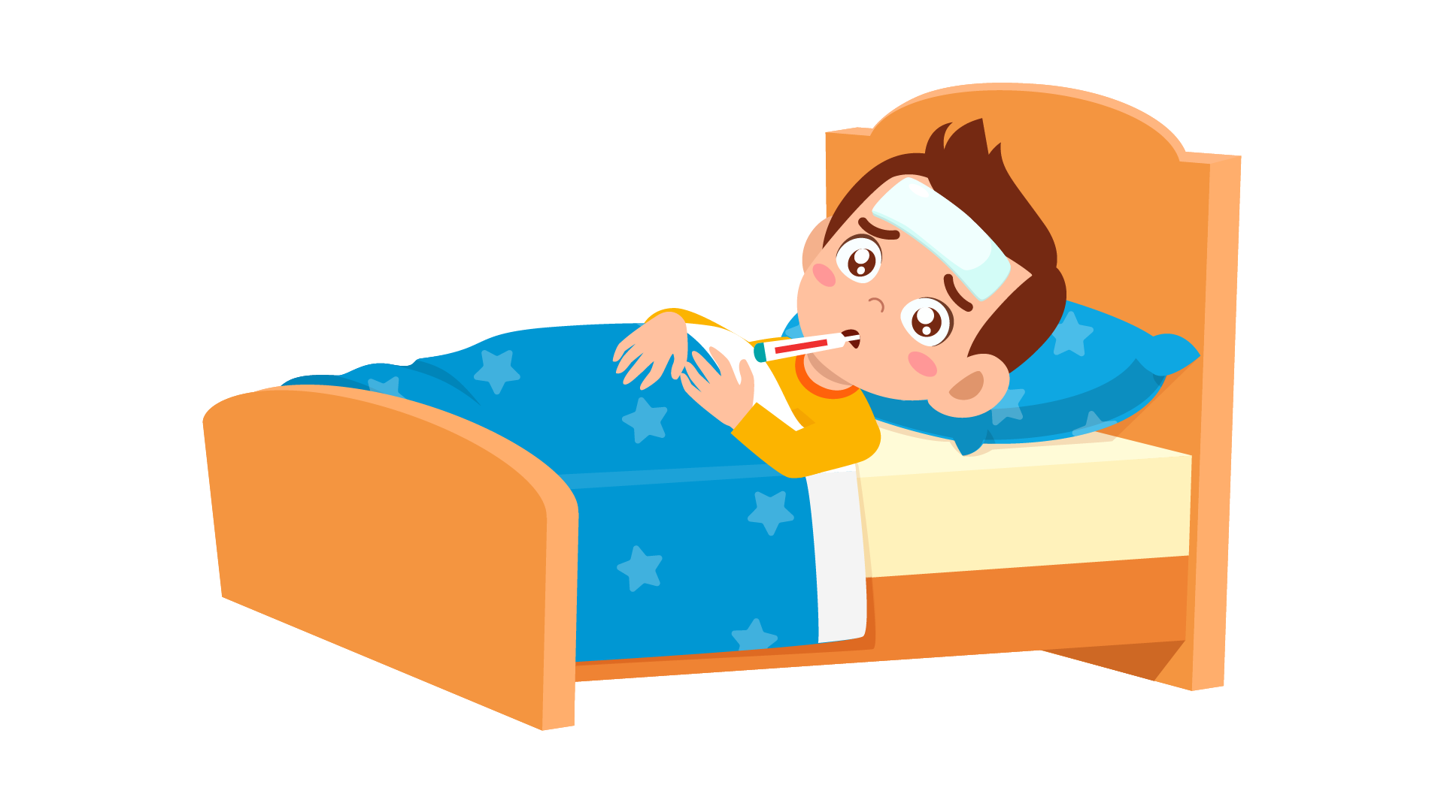 | 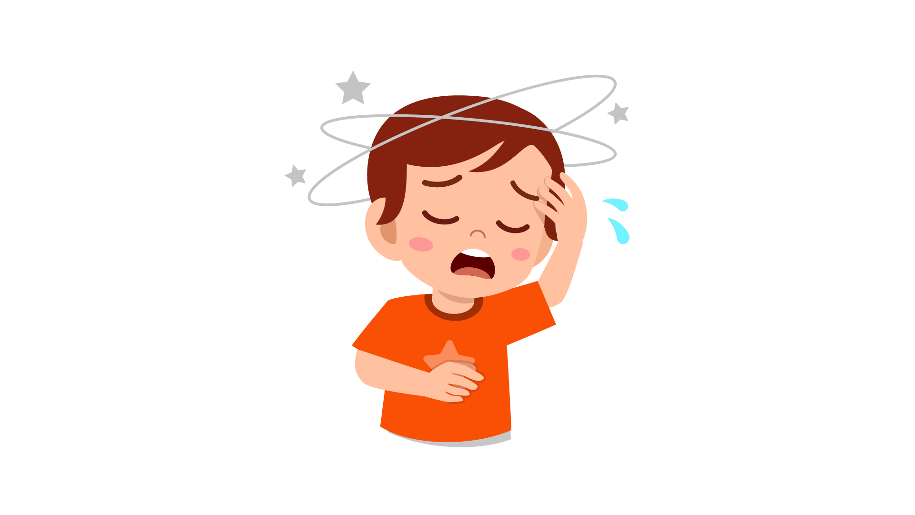
(A) | (B) | (C)
13.
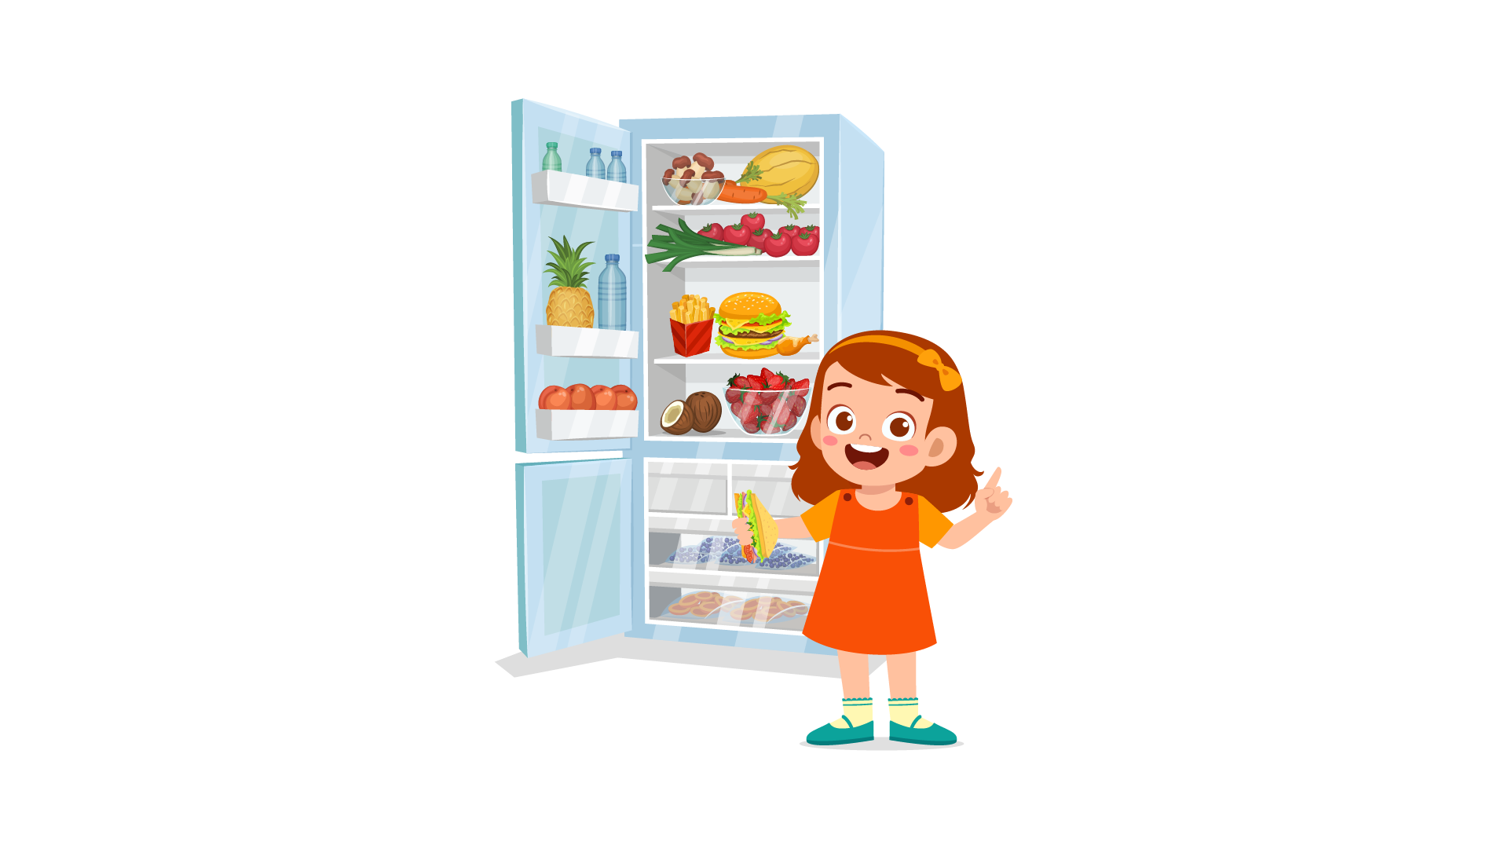 | 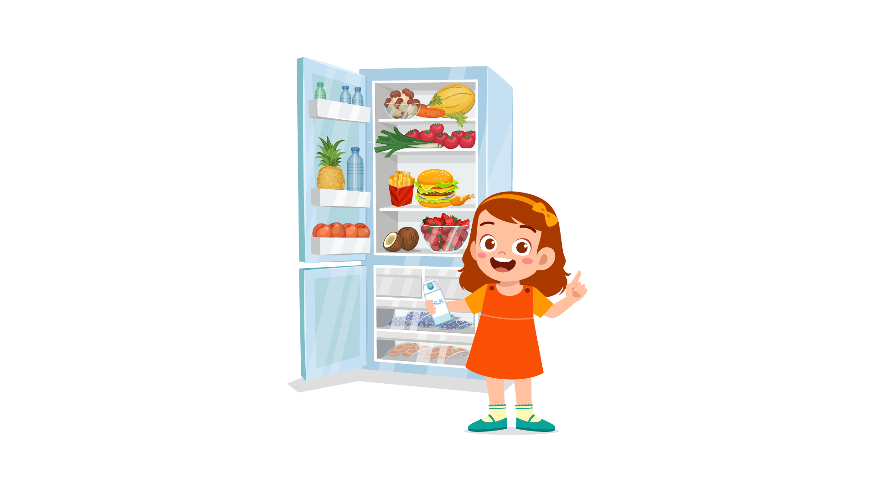 | 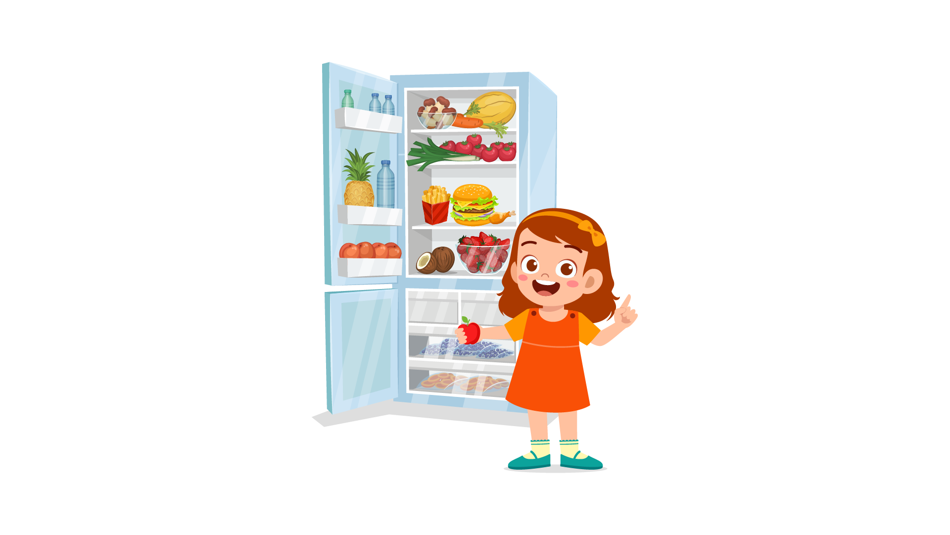
(A) | (B) | (C)
14.
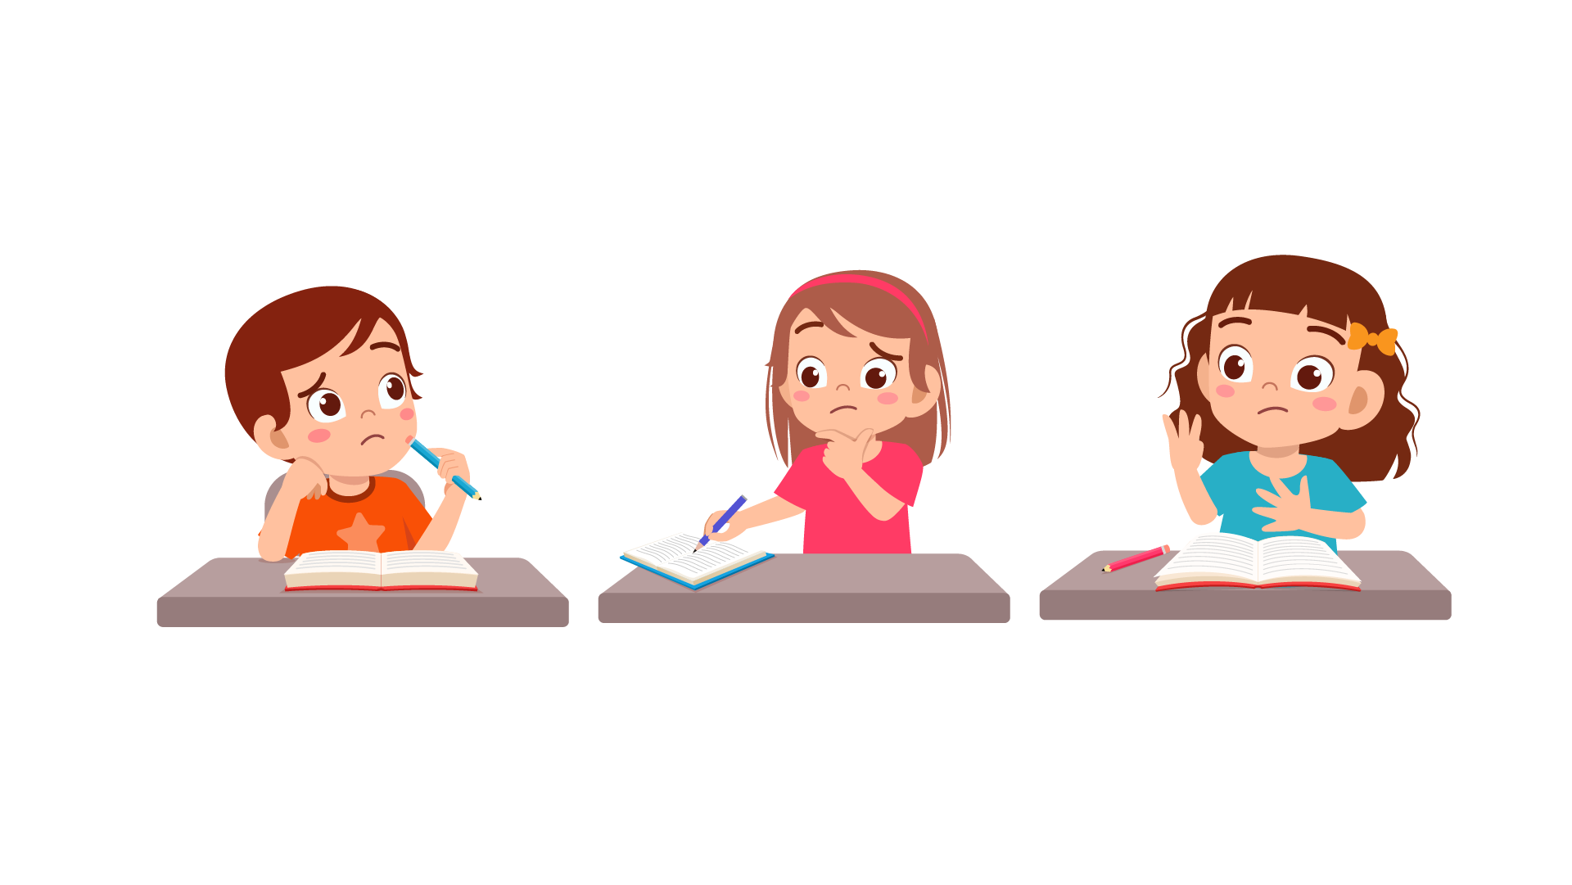 |  | 
(A) | (B) | (C)
15.
 |  | 
(A) | (B) | (C)
16.
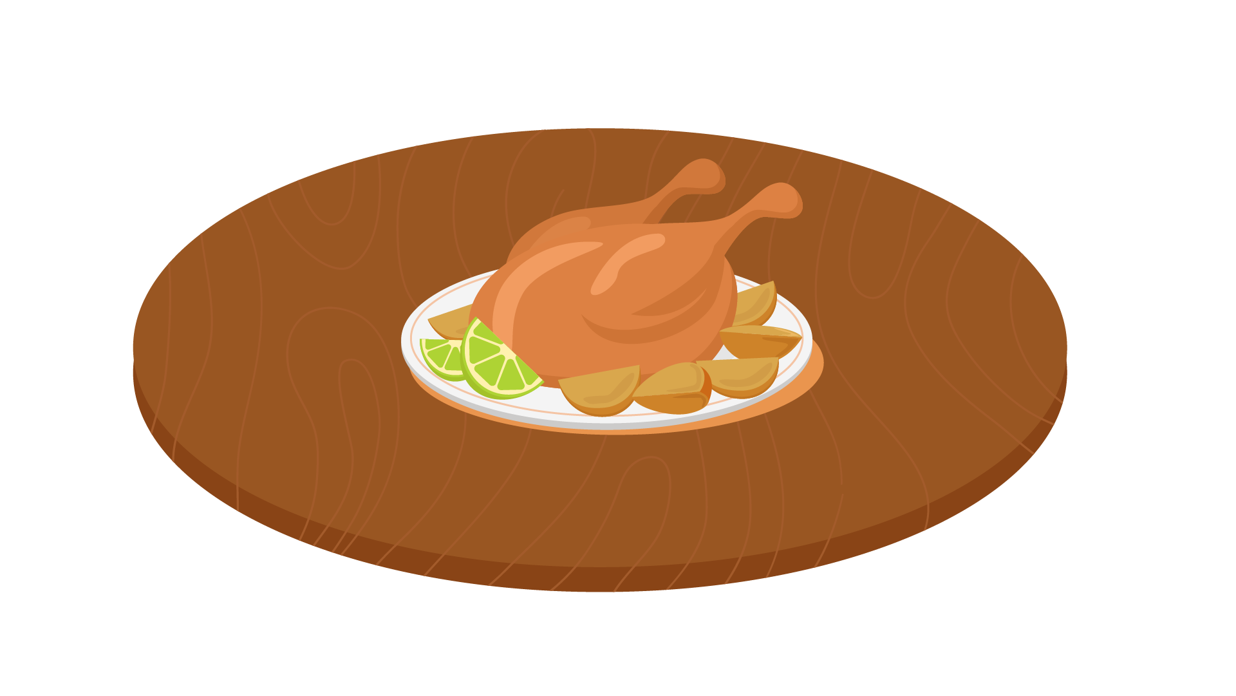 | 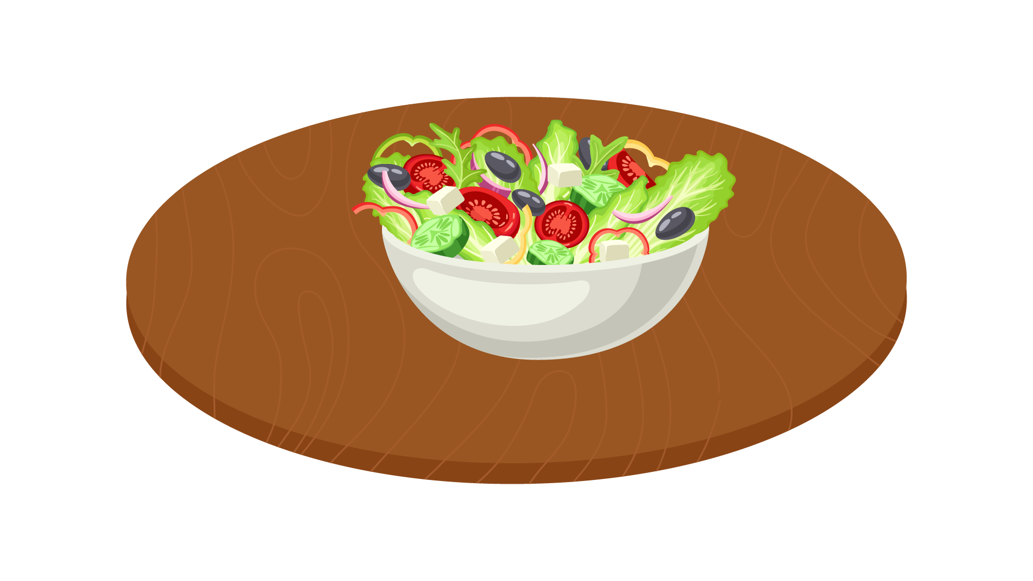 | 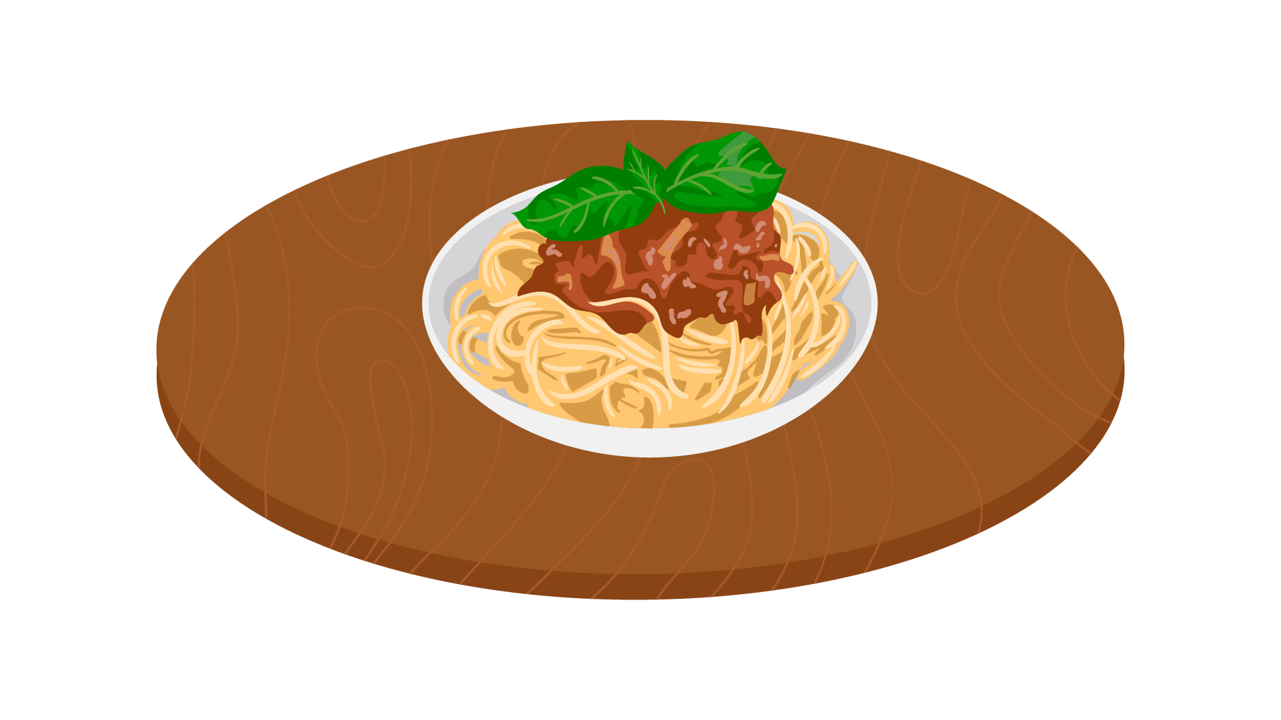
(A) | (B) | (C)
17.
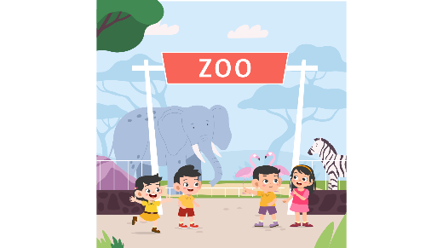 | 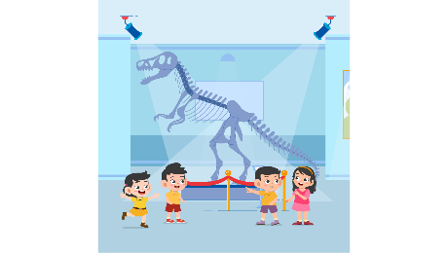 | 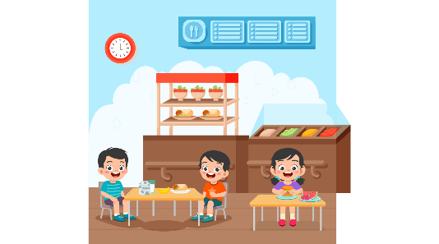
(A) | (B) | (C)
PART 3
Fill in the correct circles on your answer sheet.
Look at your answer sheet. Listen to a conversation. Which conversation sounds correct?
Let’s do an example.
(Narrator): A
(Boy): Hello. What’s your name?
(Girl): I’m fine, thanks.
(Narrator): B
(Boy): How are you today?
(Girl): I’m six years old.
(Narrator): C
(Boy): Nice to meet you!
(Girl): Nice to meet you, too!
The answer is "C." Fill in "C" on your answer sheet. Now, you do it.
18.
(A) | (B) | (C)
19.
(A) | (B) | (C)
20.
(A) | (B) | (C)
21.
(A) | (B) | (C)
22.
(A) | (B) | (C)
23.
(A) | (B) | (C)
24.
(A) | (B) | (C)
25.
(A) | (B) | (C)
26.
(A) | (B) | (C)
27.
(A) | (B) | (C)

PART 4
Listen to a conversation and answer the question. Fill in the correct circle on your answer sheet.
Let’s do an example.
28. When is the girl's party?
(A) Tonight
(B) Next week
(C) This weekend
The answer is "C." Fill in "C" on your answer sheet. Now, you do it.
29. . What did the boy do last weekend?
(A) Go to the cinema
(B) Play basketball
(C) Go shopping
30. What does the customer buy?
(A) A white shirt
(B) A blue T-shirt
(C) A blue shirt
31. What will the boy do this summer holiday?
(A) visit his grandparents
(B) go to another country
(C) go camping
32. What does the teacher tell the boy to do?
(A) write an essay
(B) make a presentation
(C) draw some pictures
33. What does the girl need to do?
(A) call her grandparents
(B) prepare some fruits
(C) cook some food
34. What do the friends want to do?
(A) eat in the canteen
(B) go to a local food store
(C) go to a restaurant

PART 5
Listen and answer the question.
Fill in the correct circle on your answer sheet.
Let’s do an example.
- What did Mike call about?
(A) Homework
(B) A movie
(C) A library book
The answer is "B." Fill in "B" on your answer sheet. Now, you do it.

36. Why did Kate’s mother call?
(A) To remind her of cooking dinner
(B) To inform about the dinner at Uncle Tom’s house
(C) To ask her to buy some cakes
37. Why did Jessie call?
(A) To talk about animals
(B) To have advice on her picture
(C) To invite Daisy to go to the zoo
38. Why did Cathy call?
(A) To choose a film
(B) To suggest another option
(C) To ask Mike to buy something
39. Why did the teacher call?
(A) To invite Lucy to the speaking club
(B) To make an arrangement
(C) To ask Lucy about the topic of her presentation
40. Why did the shop assistant call?
(A) To tell Dan to come and get notebooks
(B) To tell Dan to come and get back his wallet
(C) To tell Dan to come and get back the notebooks
41. Why did Laura call?
(A) To ask information about a country
(B) To ask Kimmie about time
(C) To share Geography knowledge

