ĐỀ SỐ 16  FORM 2026 | ĐỀ THI CUỐI KỲ I MÔN TIẾNG ANH 8 GLOBAL SUCCESS  Thời gian: 60 phút

Mark the letter A, B, C or D on your answer sheet to indicate the word whose underlined part differs from the other three in pronunciation in each of the following questions.
1. A. cattle B. city C. country D. collect
2. A. worked B. watched C. relaxed D. crowded
Mark the letter A, B, C or D on your answer sheet to indicate the word that differs from the other three in the position of primary stress in each of the following questions.
3. A. hospitable B. concentrate C. picturesques D. generous
4. A. ingredient B. activity C. connect D. recipe
Mark the letter A, B, C or D on your answer sheet to indicate the correct answer to each of the following questions.
5. ___________ did the Mitchells spend their summer holiday, Paris or Rome?
A. What B. Where C. Which D. When
6. The combine harvester helps farmers complete work ___________ usual.
A. faster than B. faster C. more fast than D. fast
7. The teacher asks the whole class to _______ on studying to prepare well for the midterm exam.
A. advise B. focus C. connect D. coach
8. Hurry up! We will have to walk home we miss the las bus.
A. if B. when C. while D. because
9. There were lots of interesting folk games, _________ Kenny stayed a little longer to join them.
A. but B. because C. so D. however
10. There are only _________ villagers who know how to use the combine harvester.
A. a few B. many C. a little D. much
11. After the meal, he left the waitress with a large ___________.
A. money B. cash C. tip D. payment
12. Luke: ‘You should bring a gift if you’re invited to a Swede’s home'
Ashley: ‘Wow! _____________’
A. This looks so cute! B. I didn’t know that. C. I remember. D. Certainly!

Read the following announcement and mark the letter A, B, C or D on your answer sheet to indicate the correct option that best fits each of the numbered blanks from 13 to 16.
CALL FOR VOLUNTEERS: IMPROVING OUR COMMUNITY!
Dear Residents,
We are organizing a special community clean-up day to make our neighbourhood a better place for everyone. Our goal is to address common issues in our (13) such as litter and public spaces.
The clean-up will focus on the local park and streets, where a lot of rubbish (14)
seen recently. All necessary tools and safety equipment (15) provided on the day. Your participation is vital! If you're looking for a way to contribute to your community, this is a perfect opportunity. The event will take place next Saturday. We believe that a clean environment will bring more happiness to all residents (16) live here.
Question 13. A. city B. country C. community D. village
Question 14. A. is B. are C. was D. were
Question 15. A. are B. will be C. have been D. were
Question 16. A. which B. where C. who D. what
Question 17: Put the sentences (a-c) in the correct order, then fill in the blank to make a logical text.
Getting enough sleep is crucial for your overall health. _________
a. Lack of sleep can lead to various health problems, including obesity and heart disease.
b. It also helps improve your memory and concentration.
c. Additionally, good sleep can boost your immune system and help you fight off illnesses.
A. c-a-b
B. b-a-c
C. a-c-b
D. b-c-a
Question 18: Choose the sentence that you can end the text (in Question 17) most appropriately.
A. Therefore, it’s important to establish a regular sleep schedule.
B. You should aim to get at least 7-8 hours of sleep each night.
C. Don’t forget that good sleep habits contribute to a healthy lifestyle.
D. A good night’s sleep is just as important as a healthy diet and exercise.
Read the following passage and mark the letter A, B, C or D on your answer sheet to indicate the correct option that best fits each numbered blank from 19 to 24.
Lion Dance and Tet Traditions
Tet is Vietnam’s most important festival, and it is full of color, music, and traditions. One exciting part of Tet is the lion dance, which is believed to (19) ___________ bad spirits and bring good luck. Dancers dress up in lion costumes and move through the streets. The dance is fun to watch, especially for children.
Before Tet, families clean their homes and (20) ___________ them with red items and flowers like peach blossoms or apricot blooms. This helps create a warm and lucky (21) ___________ for the new year. People also prepare an (22) ___________ for the Kitchen Gods, who travel to Heaven to report on each family’s behavior.
During Tet, families often have a (23) ___________ to eat special food, share stories, and give lucky money to children. It’s also a time to (24) ___________ for health, success, and happiness in the new year.
19. A. raise B. admire C. chase away D. look forward
20. A. decorate B. decorating C. decorated D. decorates
21. A. atmosphere B. item C. square D. spirit
22. A. contestant B. offering C. decorative D. equipment
23. A. martial art B. bamboo pole C. family reunion D. table manners
24. A. mark B. wish C. pray D. take

Mark the letter A, B, C or D on your answer sheet to indicate the sentence that is closest in meaning to the original sentence in each of the following questions.
25. Why don’t we eat this traditional Korean dish?
A. What about we eat this traditional Korean dish?
B. How about eating this traditional Korean dish?
C. Why about eating this traditional Korean dish?
D. What about to eat this traditional Korean dish?
26. She spent a lot of time decorating the house for the festival.
A. It took her a lot of time decorate the house for the festival.
B. It took her a lot of time to decorating the house for the festival.
C. It took her a lot of time to decorate the house for the festival.
D. It took a lot of time for decorating the house for the festival.
Mark the letter A, B, C or D on your answer sheet to indicate the sentence that is made from the given cues in each of the following questions.
27. We / have / family / reunion / next week.
A. We have family reunion next week.
B. We has a family reunion next week.
C. We will have family reunion next week.
D. We have a family reunion next week.
28. You / learn / Vietnamese table manners.
A. You shouldn’t to learn Vietnamese table manners.
B. You should learn Vietnamese table manners.
C. You shouldn’t learning Vietnamese table manners.
D. You should learned Vietnamese table manners.
Read the following sign or notice and mark the letter A, B, C or D on your answer sheet to indicate the correct answer to each of the following questions.
29: What is the meaning of the sign below?
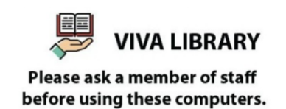
A. You have to be a member of staff in order to use the computers.
B. You must ask for a computer when you go to Viva Library.
C. A member of staff will give you a computer.
D. You need to ask for permission when you want to use the computer.
30: What activity is being proposed in the message?
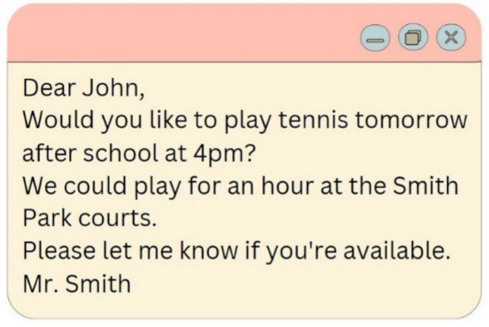
A. Playing tennis B. Going swimming C. Playing basketball D. Going for a run
Read the following passage and mark the letter A, B, C or D on your answer sheet to indicate the correct answer to each of the following questions from 31 to 36.
The country is more beautiful than a town and more pleasant to live in. Many people think so, and go to the country for the summer holidays though they cannot live there all the year round. Some have a cottage built in a village so that they can go there whenever they can find the time.
English villages are not all alike, but in some ways they are not very different from one another. Almost every village has a church, the round or square tower of which can be seen from many miles around. Surrounding the church is the church yard, where people are buried.
The village green is a wide stretch of grass, and houses or cottages are built round it. Country life is now fairly comfortable and many villages have running water brought through pipes into each house. Most villages are so close to some small towns that people can go there to buy what they can't find in the village shops.
31. When do city people often go to the country?
A. At the weekends. B. All the year round.
C. At Christmas. D. The summer holidays.
32. What is the advantage of city people when they have a cottage built in the village?
A. They can have their houses rented. B. They can go to the country at weekends.
C. They can go to the country whenever they can find the time. D. All are correct.
33. What is the common feature of English villages?
A. They have a church. B. They have a church with a tall tower, and a village green.
C. They have a village green. D. They have running water.
34. The word “pleasant” in the passage is CLOSEST in meaning to ________.
A. noisy B. peaceful C. busy D. excited
35. The word “comfortable” in the passage is OPPOSITE in meaning to ________.
A. problem B. disadvantage C. hard D. difficulty
36. What is NOT mentioned in the life of English villages?
A. The village green B. The church
C. Running water D. The Internet
Four phrases/ sentences have been removed from the text below. For each question, mark the letter A, B, C or D on your answer sheet to indicate the correct option that best fits each of the numbered blanks from 37 to 40.

(37) _________. Firstly, sitting all day in front of the computer can cause health problems such as eye-tiredness and obesity. (38) _________. Besides, if you use the computer sparingly, (39) _________. In short, (40) _________

A - computers should only be used for a limited time.
B - you will not have time for your family and friends
C - Using the computer as your hobby can harm your health and social life
D - Secondly, you may get irritated easily
37 _ _ _ _ _ 38 _ _ _ _ _ 39 _ _ _ _ _ 40 _ __ _ _
Giaoandethitienganh.info có rất nhiều tài liệu tiếng anh file word hay, chất lượng, mời bạn đăng ký tài khoản ( chỉ 100k/ năm) để chủ động hoàn toàn việc tải tài liệu bất cứ lúc nào bạn cần!

