UNIT 1
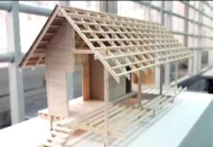  1 |   2 |   3 | 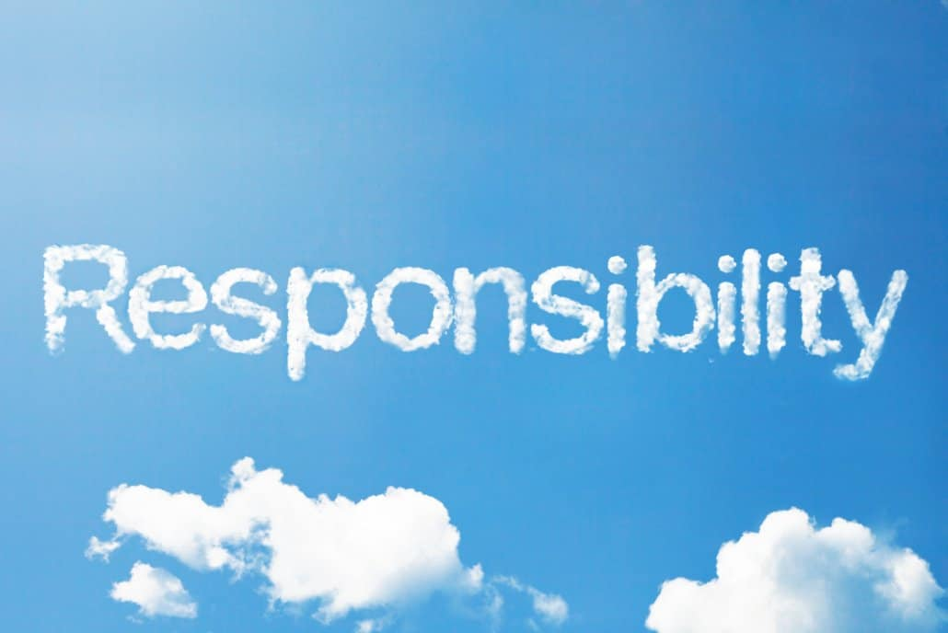  4
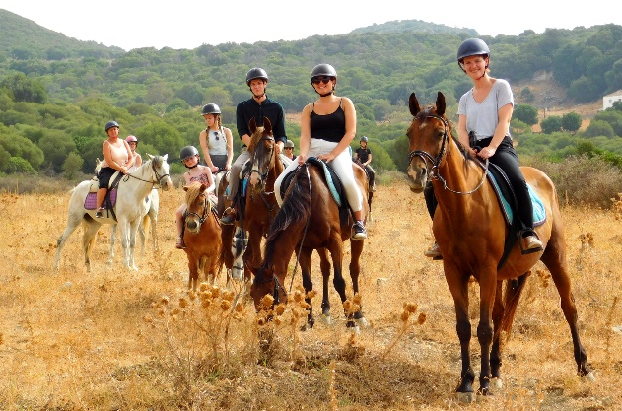  12 | - What is her/his hobby?  - What does/ do (she /he/they) like doing?  - What does/ do she /he/they like doing in the summer/spring?  - It’s an activity that helps your hands and eyes work well together.  - It is an activity that helps you learn about flowers, fruits, vegetables and insects.  - It is a noun that means ‘ the duty of taking care of something’ |  | 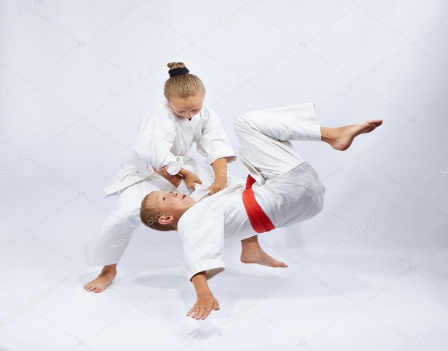  5
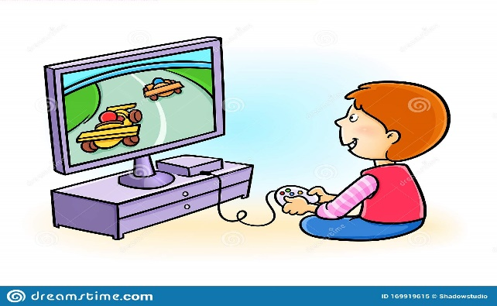  11 |  |  | 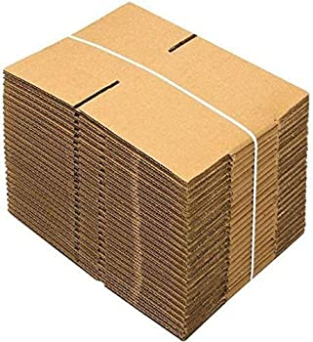  6
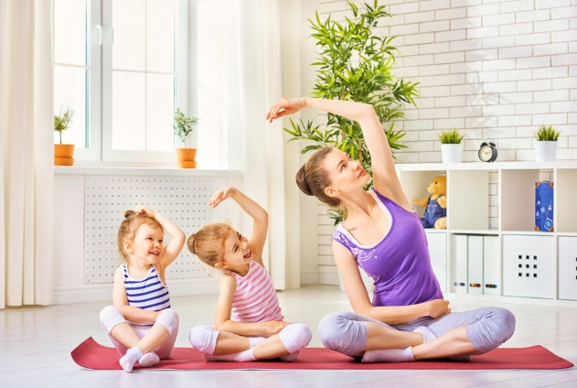  10 | 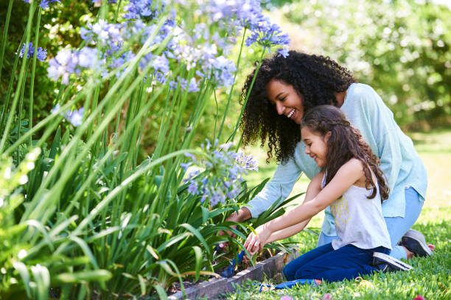  9 |   8 | 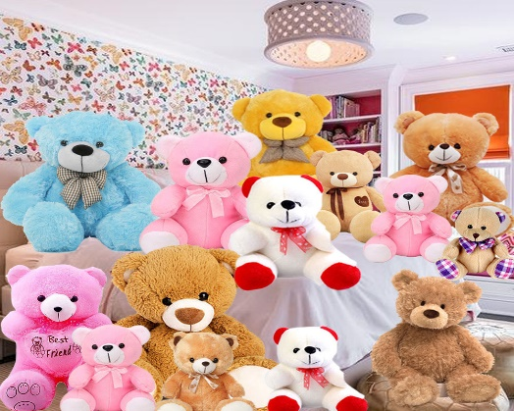  7

