|  |  |
| --- | --- |
| **Tiếng Anh 8 Friends Plus** | **FP 8 - UNIT 4 - TEST 1**  **Test for Unit**  *Thời gian làm bài: 40 phút (Không kể thời gian giao đề)*  *-------------------------* |

**I. Pronunciation (1-4)**

**Câu 1.** Which word has the underlined part pronounced differently from that of the others?

**A.** prov**i**de  **B.** conv**i**nce  **C.** k**i**nd  **D.** unl**i**ke

**Đáp án đúng**: B

**Câu 2.** Which word has the underlined part pronounced differently from that of the others?

**A.** g**e**t  **B.** **e**njoy  **C.** b**e**nefit  **D.** dev**e**lop

**Đáp án đúng**: B

**Câu 3.** Which word has a different stress pattern from that of the others?

**A.** provide  **B.** driving

**C.** recycle  **D.** consumerism

**Đáp án đúng**: B

**Câu 4.** Which word has a different stress pattern from that of the others?

**A.** picture  **B.** manipulate

**C.** establish  **D.** persuade

**Đáp án đúng**: A

**II. Choose the answer (A, B, C or D) that best fits the space in each question. (5-14)**

**Câu 5.** We should exchange books with each other to save money, shouldn’t we?

**A.** Yes, the more the merrier.

**B.** I have three books at home.

**C.** No, my favourite book is Harry Porter.

**D.** Yes, it's a great way to save money and explore different books.

**Đáp án đúng**: D

**Câu 6.** Environmental activists try to ________ people to make sustainable choices.

**A.** run out of  **B.** waste

**C.** throw away  **D.** convince

**Đáp án đúng**: D

**Câu 7.** You're leaving soon, _______ ?

**A.** am not you  **B.** are you not

**C.** aren't you  **D.** doesn't you

**Đáp án đúng**: C

**Câu 8.** He can sing very well, _______?

**A.** can't he  **B.** can he  **C.** he sings  **D.** he can't

**Đáp án đúng**: A

**Câu 9.** You haven't finished yet, _______?

**A.** don't you  **B.** have you

**C.** hasn't you  **D.** has you

**Đáp án đúng**: B

**Câu 10.** The need to constantly buy new things is known as ________.

**A.** persuasion  **B.** pollution

**C.** product  **D.** consumerism

**Đáp án đúng**: D

**Câu 11.** They arrived early, _______?

**A.** didn't they  **B.** did they not

**C.** have not they  **D.** hasn't they

**Đáp án đúng**: A

**Câu 12.** Irresponsible use of resources can ________ the environment.

**A.** build  **B.** develop  **C.** view  **D.** pollute

**Đáp án đúng**: D

**Câu 13.** Air pollution from factories can ________ forests and wildlife.

**A.** produce  **B.** deal with  **C.** damage  **D.** convince

**Đáp án đúng**: C

**Câu 14.** Scientists are working to ________ renewable sources of energy.

**A.** recycle  **B.** waste  **C.** persuade  **D.** develop

**Đáp án đúng**: D

**III. Look at the signs/ messages. Choose the best answer (A, B, C or D). (15-16)**

**Câu 15.**

What is the unique feature of the sports smartwatch?

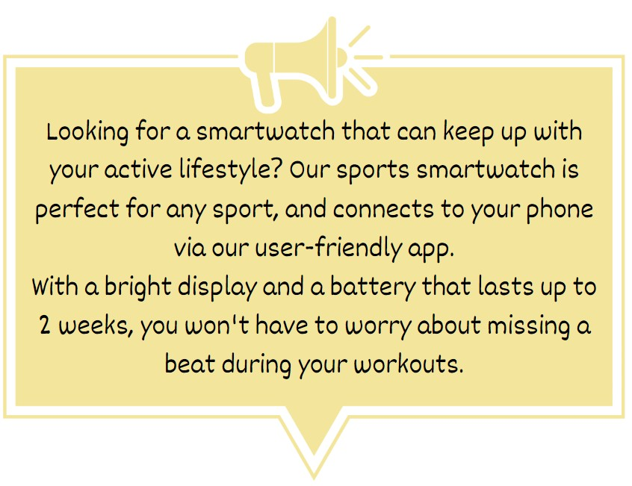

**A.** It can last up to 2 years without charging

**B.** It has a built-in camera

**C.** It can connect to your laptop

**D.** It is perfect for any sport

**Đáp án đúng**: D

**Câu 16.**

What is the name of the new summer drink being offered at Andy's Coffee?

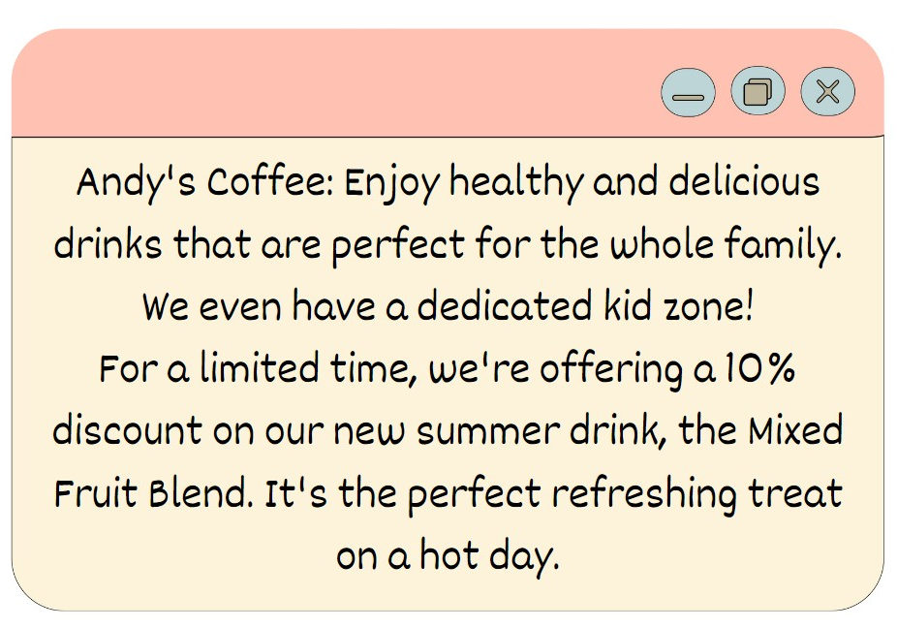

**A.** Mixed Fruit Blend  **B.** Iced Coffee

**C.** Caramel Latte  **D.** Hot Chocolate

**Đáp án đúng**: A

**IV. Read the following passage and do as direct. (17-22)**

Protecting the environment is important for the health of our planet. We can all contribute by using products that are eco-friendly. One way to do this is by using reusable bags instead of plastic bags when we go shopping. Reusable bags are strong and can be used many times, which helps reduce waste.

Another way to protect the environment is by using energy-efficient light bulbs. These bulbs use less electricity, which helps conserve energy and reduces greenhouse gas emissions. It's a small change that can make a big difference.

We can also choose to buy products that are made from recycled materials. When we buy recycled products, we support the recycling process and help reduce the need for new raw materials.

Let's all do our part to protect the environment. By making simple choices like using reusable bags, energy-efficient light bulbs, and buying recycled products, we can help create a cleaner and healthier planet for ourselves and future generations. Together, we can make a positive impact on the environment.

**Câu 17.** Using reusable bags instead of plastic bags helps reduce waste.

**A.** False  **B.** True

**Đáp án đúng**: B

**Câu 18.** Energy-efficient light bulbs use more electricity compared to regular light bulbs.

**A.** True  **B.** False

**Đáp án đúng**: B

**Câu 19.** Buying products made from recycled materials supports the recycling process.

**A.** False  **B.** True

**Đáp án đúng**: B

**Câu 20.** Protecting the environment has no impact on future generations.

**A.** False  **B.** True

**Đáp án đúng**: A

**Câu 21.** Which of the following helps reduce waste and protect the environment?

**A.** Using plastic bags  **B.** Using energy-efficient light bulbs

**C.** Using reusable bags  **D.** Using single-use disposable items

**Đáp án đúng**: C

**Câu 22.** What is one benefit of using energy-efficient light bulbs?

**A.** They help conserve energy and reduce greenhouse gas emissions.

**B.** They emit more heat than regular light bulbs.

**C.** They use more electricity than regular light bulbs.

**D.** They contribute to increased waste production.

**Đáp án đúng**: A

**V. Choose the word (A, B, C or D) that best fits the blank space in the following passage. (23-28)**

I bought a new smartphone. It is very nice **____23____** a big, colourful screen. It is very thin and light in hand. The camera takes good, clear **____24____** and videos. My friends like the photos I send on WhatsApp.

The phone comes with many pre-installed apps. I use it to watch videos, listen to music, and read the news. The battery **____25____** long, and I only have to charge it every two days. The touch screen responds quickly to my finger. The phone **____26____** finds answers to all my questions on the Internet.

There are only a few problems. The price of the phone is high. The computer programs crash a few **____27____**. The storage memory fills up quickly, but I delete old photos. Also, after a few months, the phone becomes slow and doesn't respond as fast as when it was new.

Overall, I am happy with my new smartphone and would **____28____** it. It has an excellent design, a good camera, and works well for social media and the apps I need. For a normal user like me, it does all the essential jobs well, and having the latest technology is nice.

**Câu 23.** I bought a new smartphone. It is very nice ____

**A.** with  **B.** for  **C.** to  **D.** about

**Đáp án đúng**: A

**Câu 24.** The camera takes good, clear ____.

**A.** clothes  **B.** photos  **C.** books  **D.** food

**Đáp án đúng**: B

**Câu 25.** The battery ____ long.

**A.** lasts  **B.** weakens  **C.** weighs  **D.** shortens

**Đáp án đúng**: A

**Câu 26.** The phone quickly ____.

**A.** loses all my contacts

**B.** breaks when I drop it

**C.** finds answers to all my questions on the Internet

**D.** runs out of battery

**Đáp án đúng**: C

**Câu 27.** The computer programs crash a few ____.

**A.** times  **B.** trees  **C.** buildings  **D.** cars

**Đáp án đúng**: A

**Câu 28.** Overall, I am happy with my new smartphone and would ____ it.

**A.** eat  **B.** bury

**C.** throw away  **D.** recommend

**Đáp án đúng**: D

**VI. Supply the correct form of the word given in each sentence. (29-34)**

**Câu 29.** The company is ________ free training for all employees. [provide]

**Đáp án đúng**: providing

**Câu 30.** The city has seen a lot of ________ in recent years. [develop]

**Đáp án đúng**: development

**Câu 31.** She gave a very ________ argument in favour of the proposal. [persuade]

**Đáp án đúng**: persuasive

**Câu 32.** The factory has increased its ________ to meet demand. [product]

**Đáp án đúng**: production

**Câu 33.** The hurricane caused widespread ________ in the area. [destroy]

**Đáp án đúng**: destruction

**Câu 34.** I managed to ________ my parents to let me go on the trip. [conviction]

**Đáp án đúng**: convince

**VII. Rearrange the groups of words in a correct order to make complete sentences. (35-36)**

**Câu 35.** shouldn’t we? / practice for / the show, / We should

…

**Đáp án đúng**: We should practice for the show, shouldn’t we?

**Câu 36.** too many / films in / the competition. / There are

…

**Đáp án đúng**: There are too many films in the competition.

**VIII. Rewrite each of the following sentences in another way so that it means almost the same as the sentence printed before it. (37-40)**

**Câu 37.** How much does this book cost? (price)

What …

**Đáp án đúng**: What is the price of this book?

**Câu 38.** Many teenagers enjoy playing soccer after school. (interested)

Many teenagers …

**Đáp án đúng**: Many teenagers are interested in playing soccer after school.

**Câu 39.** Can Marry speak Spanish? (tag question)

Marry can ___________________________ , _____________?

**Đáp án đúng**: Marry can speak Spanish, can't she?

**Câu 40.** Lisa goes to the library because she needs some English books.

Lisa goes to the library so as …

**Đáp án đúng**: Lisa goes to the library so as to get some English books.

**IX. Listening: listen and do as direct.**

**Câu 41.** Tom liked the black and white striped shirt for $29.99.

**A.** False  **B.** True

**Đáp án đúng**: B

**Câu 42.** John found the blue checked shirt for $34.95 too loose.

**A.** False  **B.** True

**Đáp án đúng**: B

**Câu 43.** Tom suggested a smaller size for the blue checked shirt.

**A.** True  **B.** False

**Đáp án đúng**: B

**Câu 44.** The grey shirt cost less than the blue checked shirt.

**A.** True  **B.** False

**Đáp án đúng**: A

**Câu 45.** John decided to buy the black and white striped shirt.

**A.** True  **B.** False

**Đáp án đúng**: B

**Câu 46.** How much was the black and white striped shirt?

**A.** $29.99  **B.** Not mentioned

**C.** $27.50  **D.** $34.95

**Đáp án đúng**: A

**Câu 47.** What did John think of the material of the black and white striped shirt?

**A.** Not mentioned  **B.** Comfortable

**C.** Soft  **D.** Rough

**Đáp án đúng**: B

**Câu 48.** Why didn't John buy the blue checked shirt?

**A.** The price  **B.** The style

**C.** The fit  **D.** The colour

**Đáp án đúng**: C

**Câu 49.** How much was the grey shirt?

**A.** $34.95  **B.** $29.99

**C.** $27.50  **D.** Not mentioned

**Đáp án đúng**: C

**Câu 50.** In the end, which shirt did John decide to buy?

**A.** John didn't decide to buy a shirt  **B.** The blue checked shirt

**C.** The grey shirt  **D.** The black and white striped shirt

**Đáp án đúng**: C

**----HẾT---**