**LỚP HỌC THẦY (CÔ) ___________________________** **ĐỀ ÔN TẬP: READING SIGNS/ NOTICES – A2**

**Test 13**

*Thời gian làm bài: [Time]*

Họ và tên: ________________________________________________ Lớp: 9/___

**Nội dung:**

**Question 1:** 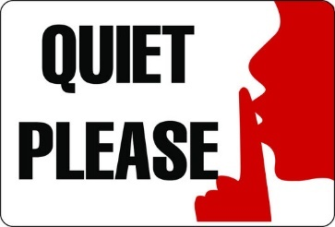What does this sign mean?  
**A.** Noise is not allowed**.**  
**B.** Noise is encouraged here.  
**C.** Noise is allowed at times.  
**D.** Please keep noise low.

**Question 2:** Read the sentences in italics. Then choose the correct meaning.

Please try to return books to the correct shelf.

Thank you.

A Put books back in the correct place.

B Bring books back at the correct time

**C.** Leave the books on the floor after using them.

**D.** Return books to any shelf, as it does not matter where.

**Question 3:** 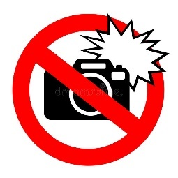What does this sign mean?  
**A.** Flash photography is allowed**.**  
**B.** Flash photography is encouraged here.  
**C.** Flash use is not allowed at certain times.  
**D.** Taking pictures with a flash is not allowed**.**

**Question 4:** Read the sentences in italics. Then choose the correct meaning.

Please keep the area clean and tidy. Thank you.

**A.** The area will be cleaned by someone else. **B.** Leave the area messy as it is not important.

**C.** Clean the area only once a week. **D.** Make sure the area is neat and free of trash.

**Question 5:** 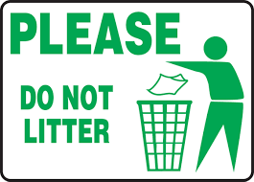What does this sign mean?

**A.** Throwing trash on the ground is allowed**.**

**B.** The area is clean.

**C.** Littering is allowed at times.

**D.** Please use the bins to keep the area clean.

**Question 6:** Read the sentences in italics. Then choose the correct meaning.

Remember to switch off the lights when you leave.

**A.** Keep the lights on until someone tells you otherwise.

**B.** Leave the lights on for safety.

**C.** Only switch off the lights at night.

**D.** Turn off the lights before you go.

**Question 7:** What does this sign mean?

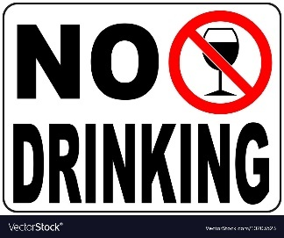**A.** "The sign means that you are not allowed to drink here."

**B.** "The sign means that you are allowed to drink in this area**.**"

**C.** "The sign means that drinking is allowed only at certain times here."

**D.** "The sign means that drinking is encouraged and you are welcome to drink here."

**Question 8:** Read the sentences in italics. Then choose the correct meaning.

Please use the designated bins for recycling.

**A.** Dispose of all waste in any available bin. **B.** Mix recyclables with regular trash.

**C.** Throw recyclables in the specific bins provided**.** **D.** Recycle only glass and plastic bottles.

**Question 9:** What does this sign mean?

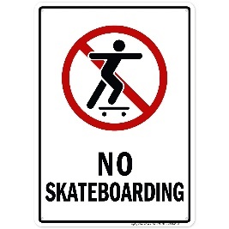**A.** Skateboarding is allowed, meaning you can skateboard here.

**B.** Skateboarding is not allowed, meaning you cannot skateboard here.

**C.** Skateboarding is not allowed at specific times, meaning you cannot skateboard here at any time.

**D.** Skateboarding is encouraged, meaning you are welcome to skateboard here.

**Question 10:** Read the sentences in italics. Then choose the correct meaning.

Please keep your noise level low in this area**.**

**A.** Only reduce noise during office hours. **B.** Speak loudly so everyone can hear you.

**C.** Make sure to be quiet and not disturb others. **D.** Noise level does not matter in this area**.**

**[HẾT]**