Full name: .............................................................

School: ..................................................................

Class: .....................................................................

Mark:

**Speaking Test – Unit 2**

Now let's talk about your home. Are you ready?

**TASK 1**

1. How many people are there in your family?
2. Do you live in a large or a small house?
3. Name three things in your kitchen.
4. What is your favourite room in your house? Why?

Each of you will now receive a card. On the card there is a picture and clues for five questions. You should use the words to make questions and ask your friends. Your friend will answer the questions based on the picture he/ she has.

**TASK 2**

|  |  |
| --- | --- |
| **Card A** |  |
| *Use the words given below to make questions. Ask your friend about his/ her picture and listen to the answers.* |  |
| 1. How many/ people? 2. Where/ they? 3. What/ next to/ kid? 4. What/ on/ walls? 5. How often/ you/ spend/ time/ family? | *Now, your friends will ask you questions about your picture. Answer his/ her questions.* |

60

|  |  |
| --- | --- |
| **Card B** |  |
| *Use the words given below to make questions. Ask your friend about his/ her picture and listen to the answers.* |  |
| 1. How many/ people? 2. Where/ they? 3. What/ on/ table? 4. What/ behind/ sofa? 5. Do/ you/ like/ spend/ time/ outdoors/ or/ indoors? | *Now, your friends will ask you questions about your picture. Answer his/ her questions.* |

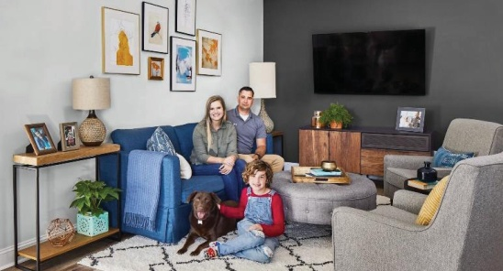

61