Date of preparing: ………………………………….
Date of teaching: ………………………………….

Period …
UNIT 1: HOME
Lesson 1 - Part 3 (Page 8) – Pronunciation and Speaking

I. OBJECTIVES
By the end of the lesson, Ss will be able to…
1. Knowledge
- use intonation for Yes / No questions.
- ask and answer about home.
- conduct a survey about home.
2. Ability
- improve speaking skills.
3. Quality
- have positive attitude in English language learning so that they actively participate in all classroom activities.
- love their home and family.

II. TEACHING AIDS AND LEARNING MATERIALS
Lesson plan, PPT slides, student’s book, workbook, notebook, personal computer (if any), projector/TV, speakers, DCR & DHA on EDUHOME, handouts…

III. PROCEDURES
A. Warm up: (5’)
a) Objective: Introduce the new lesson and set the scene for Ss to acquire new language; get students' attention at the beginning of the class by means of enjoyable and short activities as well as to engage them in the steps that follow.
b) Content: Revision of vocabulary about homes.
c) Product: Ss remember vocabularies in the previous lessons and use them in other speaking activities.
d) Competence: Collaboration, observation, critical thinking.
e) Organization of the activity:
Teacher’s Activities | Students’ Activities
- Give greetings  - Check attendance  - Option 1: Game “BINGO”  - Explain The rules of the game: T gives each S / each pair a small piece of paper containing 15 words. T can prepare as many pieces of paper with different words as possible  - Show word by word on the screen (randomly)  - Have Ss use a red pen to check whether the words on the screen are the same as those in their paper  - The first student / pair to get all 5 words from the screen in a horizontal line will say “BINGO” and be the winner of the game  - Give a small gift to the winner  - Lead to the new lesson  Illustration:  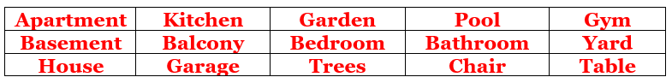  - Option 2: Game: “CHAIN GAME”  - Give a sentence, have Ss add more information to the sentence to make it longer  - The group that can make the sentence the longest with correct grammar and spelling will be the winner  Lead to the new lesson | - Greet T  - Take part in the game as a whole class  - Say “BINGO” when have all 5 words in a horizontal line  - Listen and say all the words together  - Take part in the game  Suggested sentences  T’s sentence: My house has a gym.  Ss’ sentences: My house has a gym and a garage.  Ss’ sentences: My house has a gym and a garage. The garage is very big.  Ss’ sentences: My house has a gym and a garage. The garage is very big. There are 3 cars in the garage.  Ss’ sentences: …

B. New lesson (35’)
- Activities 1: Pronunciation (10’)
a) Objective: Ss know how to use intonation for Yes / No questions.
b) Content:
- Recognizing the tone in Yes / No questions
- Listening and checking, finding mistakes
- Saying them
c) Products: Ss can use intonation to improve their speaking skill.
d) Competence: Communication, collaboration, listening
e) Organization of the activity:
Teacher’s Activities | Students’ Activities
a + b. Listen to the sentences and focus on the intonation  - Play the recording (CD1, track 06)  - Ask Ss to listen and pay attention to the intonation  - Call Ss to make their comments on the intonation of the Yes/No question they’ve just listened to  - Give feedback, explain the pronunciation feature: intonation for Yes/No question goes up  - Play the recording again, have Ss listen and repeat with a focus on the pronunciation feature  c + d. Listen and cross out the one with the wrong intonation, then read the sentences with the correct intonation  - Play the recording (CD 1 – Track 07), have Ss listen and cross out the option that doesn’t use the correct intonation  - Call Ss to give answers  - Play the recording again and check answers as a whole class  - Then have Ss practice saying the sentences with a partner, using the correct intonation, encourage Ss to use their own idea  - Call some pairs to read in front of the class  - Give feedback if necessary | - Listen  - Comment  - Listen  - Listen again and repeat  - Listen and cross out  - Give answers  - Listen again and check  - Work in pairs  - Present
- Activity 2: Practice (10’)
a) Objective: Ss can ask and answer questions about home.
b) Content: Pointing, asking and answering, then practicing.
c) Products: Ss practice and produce the target language successfully.
d) Competence: Collaboration, communication, creativity.
e) Organization of the activity:
Teacher’s Activities | Students’ Activities
a. Point, ask and answer.  - Demonstrate the activity by asking and answering with a student  - Have Ss work in pairs, point to the pictures, ask and answer  - Have pairs ask and answer, using the pictures  - Have some pairs demonstrate the activity in front of the class  b. Practice with your own ideas  - Have pairs practice the conversation with their own ideas, then swap roles  - Call some pairs to demonstrate the activity in front of the class  - Give feedback and evaluation | - Listen  - Work in pairs  - Present  - Work in pairs  - Present  Suggested questions  - Do you live in an apartment?  - Does your house have a gym?  - Is there a yard?  - Is there a pool in your house?  - Is there a garage in your house?  - Is there a basement / balcony in your house?
- Activity 3: Speaking – Do you live in a house? (15’)
a) Objective: Ss can conduct a survey about home.
b) Content: Asking questions, then filling in the survey.
c) Products: Ss produce the new language successfully.
d) Competence: Collaboration, communication, creativity, group & time management.
e) Organization of the activity:
Teacher’s Activities | Students’ Activities
a. Add two more words in the table, then complete the survey about your home. After that, ask 3 friends about theirs  - Demonstrate the activity by practicing role-play with a student  - Have Ss fill complete the table with information about their home  - Have Ss work in groups to ask their friends about their home  - Observe, give help if necessary  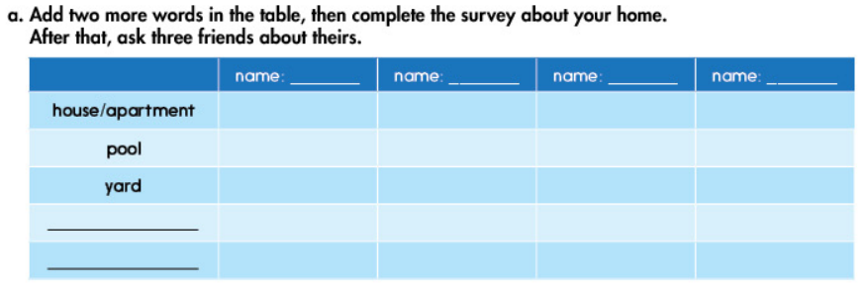  b. Report to the class about your group  - Have Ss report to the class about their group, follow this example:  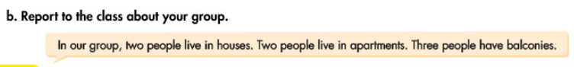  - Give feedback and evaluation | - Add 2 more words about things/places in/around home  - Work in groups  - Present  - Listen

C. Consolidation (3’)
* Intonation: Intonation for Yes / No questions goes up.
* Asking and answering about homes/ things in or around homes.
Do you live in …?
Does your house have a …?
Is there a … in your house?

D. Homework (2’)
- Practice using intonation for Yes / No questions.
- Complete the survey for those who haven’t finished it in class.
- Prepare: Lesson 2 – New Words and Reading (page 9 – SB).

