School: ……………………………………….. | Date: ……………………………..
Class: ……………………………..................... | Period: ………………………......

UNIT 7: TRANSPORTATION
Lesson 1.1 – New words and Listening (page 52)

I. OBJECTIVES
By the end of the lesson, Ss will be able to:
1.1. Language knowledge and skills
- know more words relating to personal belongings and places in the airport (luggage, boarding pass, backpack, suitcase, passport, customs, baggage claim).
- describe and identify personal belongings.
- listen to and understand a conversation of two people in an airport (for general and specific details).
- know how to ask for confirmation.
1.2. Competences
- improve communication, collaboration, and critical thinking skills.
1.3. Attributes
- take care of personal belongings.
- carefully prepare for any trip.

II. TEACHING AIDS AND LEARNING MATERIALS
1. Teacher’s aids: Student book and Teacher’s book, class CDs, Digital Book (DCR phần mềm tương tác SB, DHA (từ vựng/ cấu trúc) phần mềm trò chơi tương tác), projector/interactive whiteboard / TV (if any), PowerPoint slides.
2. Students’ aids: Student’s book, workbook, notebook.

III. ASSESSMENT EVIDENCE
Performance Tasks | Performance Products | Assessment Tools
- Number the pictures. | - Ss’ answers. | - T’s feedback/Peers’ feedback.
- Listen and repeat. | - Ss’ presentation. | - T’s feedback/Peers’ feedback.
- Discuss adjectives you could use for these items: suitcase, backpack, and luggage. | - Ss’ presentation / answers. | - T’s feedback/Peers’ feedback.
- Listen to Jenny and Fred at the airport. What are they doing? | - Ss’ answers. | - T’s feedback/Peers’ feedback.
- Listen and fill in the blanks. | - Ss’ answers. | - T’s feedback/Peers’ feedback.
- Speak: What type of luggage do you like to travel with? Why? | - Ss’ answers/ presentation. | - T’s observation and feedback.

IV. PROCEDURES
A. Warm up: (5’)
a) Objective: Introduce the new lesson and set the scene for Ss to acquire new language; get students' attention at the beginning of the class by enjoyable and short activities as well as to engage them in the follow-up steps.
b) Content: Introduce words about personal belongings.
c) Expected outcomes: Ss get to know some new words they are going to study in the lesson.
d) Organization of the activity:
TEACHER’S ACTIVITIES | STUDENTS’ ACTIVITIES
- Option 1: Number the pictures. Listen and repeat.  - Use the “New words” part a– page 52 for the warm-up activity.  - Show words and pictures using DCR, have Ss look and number the pictures (in pairs).  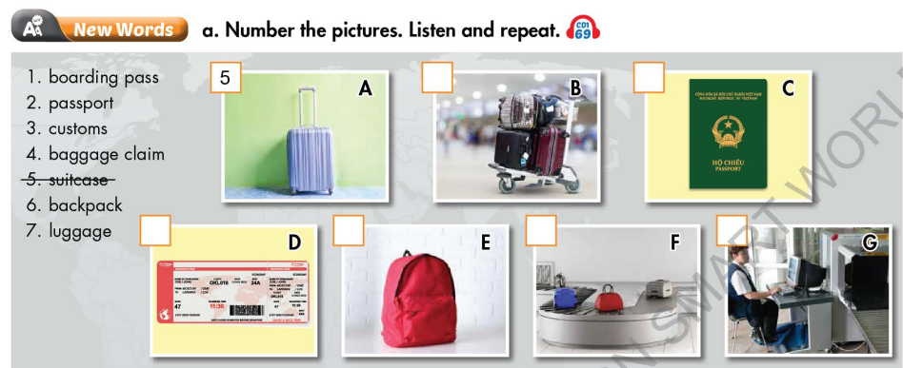  - Call Ss to give answers.  - Give feedback and show correct answers using DCR.  - Lead to the new lesson.  - Play the audio (CD1 – Track 69), have Ss listen and repeat.  - Correct Ss’ pronunciation if necessary.  - Option 2:  - Divide class into 4-5 groups.  - Have Ss work in groups to list things people often need when they travel abroad (in about 1-2 minutes).  - Have a representative in each group write answers on the board.  - Check Ss’s answers and give feedback.  - The group with the most correct answers will be the winner.  - Lead to the new lesson. | - Work in pairs to number the pictures.  - Give answers.  - Listen.  - Listen and repeat.  Answer keys  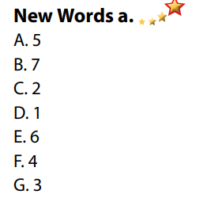  - Take part in the class’s activity.  - Write answers.  - Listen.  Suggested answers: passport, luggage, boarding pass, headphone, earphone, backpack, phone and device chargers, daily medication, clothes, water,…

B. New lesson (35’)
- Activity 1: Pre-Listening (Vocabulary) (12’)
a) Objective: Ss get to know words about personal belongings.
b) Content:
- Vocabulary study (luggage, boarding pass, backpack, suitcase, passport, customs, baggage claim).
- Speaking: Discuss adjectives you could use for these items: suitcase, backpack, and luggage.
c) Expected outcomes: Ss know how to pronounce the new words correctly and use them when they do some listening tasks.
d) Organization of the activity:
TEACHER’S ACTIVITIES | STUDENTS’ ACTIVITIES
Task a. Number the pictures. Listen and repeat.  - Option 1 (If the teacher hasn’t used this part for the Warm-up activity.)  - Demonstrate the activity on DCR, using the example.  - Have Ss number the pictures.  - Divide class into pairs and have them check their answers with their partners.  - Call Ss to give answers.  - Check answers as a whole class using DCR.  - Play audio (CD1 – Track 69). Have Ss listen and repeat.  - Correct Ss’ pronunciation.  - Option 2: (If the teacher has used part a for the warm-up activity.)Matching  - Have Ss match the words they have known in Task a (from Warm up activity) by matching words with their definitions.  - Have Ss give answers and tell the meaning of words / phrases again.  - Check answers as a whole class.  - Call some Ss to read the words again.  - Correct Ss’ pronunciation if necessary.  *Illustration:  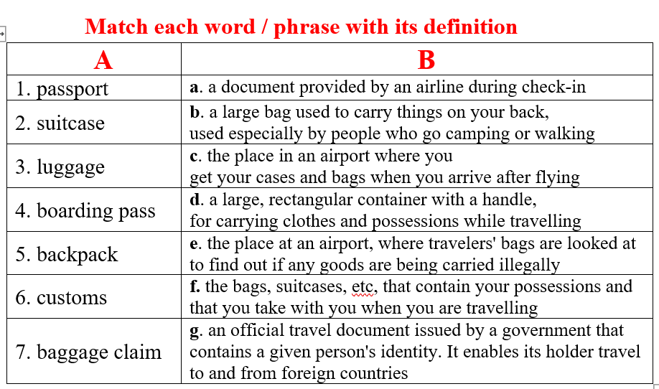  Task b. In pairs: Discuss adjectives you could use for these items: suitcase, backpack, and luggage.  - Have Ss work in pairs to discuss adjectives they could use for these items: suitcase, backpack, and luggage.  - Go round and give help if necessary.  - Have some pairs demonstrate the activity in front of the class.  - Give feedback and evaluation. | - Look and listen.  - Work individually.  - Work in pairs.  - Give answers.  - Listen and repeat.  Answer keys  - Work in pairs.  - Give answers, meaning.  - Read.  Answer keys  1 g  2 d  3 f  4 a  5 b  6 e  7 c  - Work in pairs to discuss.  - Present.  Sample answers  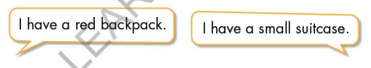
- Activity 2: While - Listening (17’)
a) Objective: Students can develop their listening skill.
b) Content:
- Listen to Jenny and Fred at the airport. What are they doing?
- Listen and fill in the blanks.
c) Expected outcomes: Ss can listen to and understand a conversation of two people in an airport (for general and specific details).
d) Organization of the activity:
TEACHER’S ACTIVITIES | STUDENTS’ ACTIVITIES
Task a. Listen to Jenny and Fred at the airport. What are they doing?  - Have Ss read the question, guess the answer.  - Play audio (CD1 - Track 70).  - Have Ss listen and circle the correct answer.  - Check answers as a whole class using DCR.  Task b. Now, listen and fill in the blanks  - Have Ss read the through the content of Task b, underline the key words.  - Play the audio again (CD1 - Track 70).  - Have Ss listen and fill in the blanks.  - Have Ss check answers with their partners.  - Call Ss to give answers.  - Give feedback and show correct answers using DCR. | -Work individually.  - Listen.  - Circle the correct answers.  Answer keys  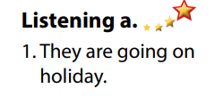  - Read, underline the key words.  - Do the task.  - Exchange answers.  Answer keys  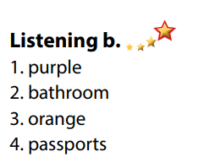

- Activity 3: Post - Listening (6’)
a) Objective: Students can use the vocabulary and the content in listening part to develop their speaking skill.
b) Content: Speaking: What type of luggage do you like to travel with? Why?
c) Expected outcomes: Students can talk about their personal belongings for travelling.
d) Organization of the activity:
TEACHER’S ACTIVITIES | STUDENTS’ ACTIVITIES
Conversation skill  - Have Ss look at the Conversation skill box and read (using DCR).  - Play audio (CD 1 - Track 71), have Ss listen and repeat.  - Ask Ss to find more ways to ask for confirmation.  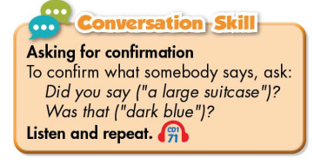  Task c. In pairs: What type of luggage do you like to travel with? Why?  - Have Ss work in pairs to discuss.  - Observe and give help if necessary.  - Call some pairs to share their ideas with the class  - Give feedback and evaluation. | - Look and read.  - Listen and repeat.  - Give answers.  - Work in pairs.  - Present.

C. Consolidation and homework assignments (5’)
* Consolidation:
- Words relating to personal belongings and places in the airport. (luggage, boarding pass, backpack, suitcase, passport, customs, baggage claim…).
- Language for asking for confirmation: Did you say …? / Was that …?

* Homework
- Learn the new words by heart.
- Practice talking about things you need when traveling abroad.
- Do the exercises in WB: New words and Listening (page 38).
- Do the vocabulary exercise in Tiếng Anh 7 i-Learn Smart World Notebook (page 42).
- Play consolation games in Tiếng Anh 7 i-Learn Smart World DHA App on www.eduhome.com.vn
- Prepare: Lesson 1.2 – Grammar (page 53 – SB).

D. Reflection
a. What I liked most about this lesson today:
…………………………………………………………………………………………
- What I learned from this lesson today:
…………………………………………………………………………………………
c. What I should improve for this lesson next time:
…………………………………………………………………………………………

