UNITS | VOCABULARY | GRAMMAR
Unit 4  ALL THINGS HIGH-TECH | - Devices  - High-tech jobs  - Computers  - Video/PC/Mobile games | - Modals  - Infinitive (to-infinitive, infinitive without to)  - -ing form
Unit 5 (A – B – C)  TRAVEL & TRANSPORTATION | - Shops & Services  - Transportation in the future  - Travel & Transport | - Comparative  - Superlative
Tiếng Anh 7 – RIGHT ON

SEMESTER 2 - MIDTERM TEST
Note: Each correct answer earns 0.2 points.

I. PRONUNCIATION (0.8 points)
A. Choose the word whose underlined part is pronounced differently.
1. A. design B. repair C. service D. express
2. A. games B. drones C. consoles D. messages
B. Choose the word that has a different stressed syllable from the rest.
3. A. canoe B. manage C. software D. speakers
4. A. electric B. underground C. department D. mechanic

II. VOCABULARY AND GRAMMAR (2.4 points)
Choose the best option (A, B, C or D) to complete each of the following questions.
5. I think it’s easier to write emails with a __________ than on a touchscreen.
A. tower B. keyboard C. router D. USB flash drive
6. We went to the new __________ on Saturday because I needed a new dress and my mum wanted to buy some make-up.
A. department store B. clothes shop C. hairdresser’s D. chemist’s
7. Online gaming is __________ hobby for teenage boys.
A. popular B. more popular C. the most popular D. much popular
8. I prefer using my tablet to watch films because the screen is __________ a smartphone screen.
A. the biggest B. big C. as big as D. bigger than
9. How many text messages do you usually __________ in a day?
A. send B. make C. take D. interact
10. People can drive __________ the Thủ Thiêm Tunnel to get to the other side of the Sài Gòn River.
A. over B. onto C. across D. through
11. Last year, I travelled around the Greek islands by ______. It was really nice to sit on the deck, see the blue sea and enjoy the fresh air.
A. train B. ship C. bus D. helicopter
12. The children were really excited when they saw the plane __________ and flew higher and higher.
A. got off B. sailed off C. took off D. logged off
13. I think we should __________ a taxi because it might be difficult to find a parking spot near the theatre.
A. get on B. take C. drive D. ride
14. Person A: Excuse me, could you tell me how to get to the nearest bank?
Person B: _________
A. I don’t like going to the bank.
B. You shouldn’t catch a bus.
C. There’s a bank in my neighbourhood.
D. Go along King Street. The bank is on your right, next to the post office.
15. What does the sign mean?
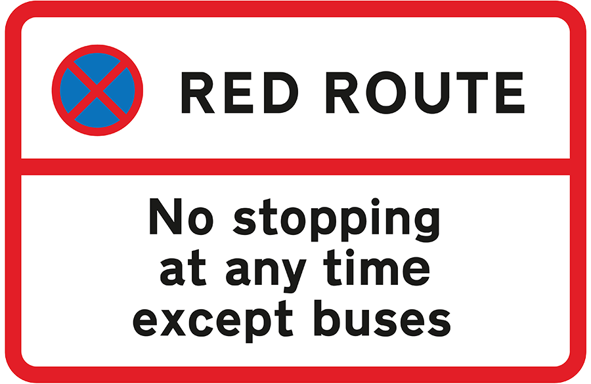 | A. No vehicle can stop in this area.  B. Only buses can stop here to pick up and drop off passengers.  C. Drivers must stop along the red route.  D. People can stop their vehicles when the route is red.

16. What does the sign mean?
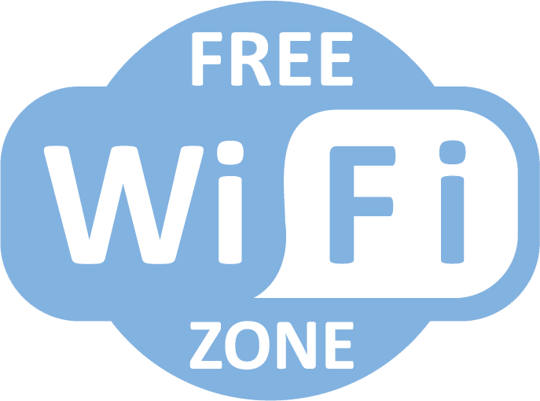 | A. You can get wireless internet access here, free of charge.  B. You shouldn’t pay to use the Wi-Fi here.  C. You have to ask for free internet connection.  D. You need to use the free Wi-Fi network here.

III. WORD FORMATION (1.2 points)
Write the correct form of the words in brackets.
17. Students must ask for ___permission_______ before they use the printer in the library. (PERMIT)
18. Drones were very __useful________ during the Covid pandemic. People used them to monitor public spaces and delivered medical supplies. (USE)
19. I’m totally into virtual ____reality_______ games because they give me the impression of actually being inside the games. (REAL)
20. There are some basic internet ___safety_______ tips that you need to follow whenever you go online. (SAFE)
21. I think students should ride their bikes to school because it’s more _environmentally_________ friendly. (ENVIRONMENT)
22. You should take the double-decker bus. It’s the best way to visit famous tourist __attractions________ in Hà Nội, such as Thăng Long Imperial Citadel, Hồ Chí Minh Mausoleum, etc. (ATTRACT)

IV. LISTENING (2 points)
A. You will listen to Jordan talking about his unusual journey to go to school. Decide whether the following statements are True (T) or False (F) .

23. Jordan lives far away from his school. False
24. It takes 20 minutes for Jordan to get to school. False
25. During his boat trip, he enjoys talking to other passengers. False
26. Jordan will have to live at his secondary school on weekdays. True
27. Jordan can go to his new school by boat or by plane. True

B. You will hear Josh talking about different technological devices. For each question, complete the notes with the correct information. Write NO MORE THAN TWO WORDS.

28. Josh does many things with his ___mobile/ mobile phone_________.
29. Josh ____rarely________ makes phone calls, but he texts a lot.
30. Josh’s grandfather prefers making video calls from a computer because it has got a(n) ___bigger screen/ big screen_________.
31. Josh’s father works as a(n) ___IT technician_________.
32. Josh wants to have a(n) ___smartwatch_________ when he grows up.

V. READING (2 points)
A. Read the following passage. For each question from 33 to 37 choose the correct option A, B, C or D.

My name is Sylvia and my favourite gadget is my e-book reader, Kindle. I got it on my last birthday. It’s smaller and lighter than a tablet. The battery even lasts longer. In fact, it can run for weeks on a single charge. Besides, it hasn’t got an LCD colour display like a tablet or smartphone, so it doesn’t cause eye strain even when you read for long hours. I love my Kindle because I always have lots of books to read on the bus. I can store up to 1,500 books on it, but I only have forty-five. I’m never bored with my Kindle. Last Christmas, my grandparents gave my brother and me a hoverboard. It’s like an electronic skateboard, which is really cool. At first, it was difficult for me to keep my balance on the hoverboard. My brother rode it better than me. We use it to travel around the neighbourhood and in the park. Hoverboards work better on flat and straight surfaces than on gravel, grass or dirt. You have to wear a helmet when riding a hoverboard to avoid injuries. And it’s not a good idea to travel by hoverboard when it’s rainy because it is very dangerous. My mum said she would give me a games console if I pass my exam, so I’m doing my best.

33. What does Sylvia like most?
A. the tablet B. the hoverboard C. the e-book reader D. the games console
34. Sylvia’s Kindle _____.
A. was a birthday present
B. is as light as a tablet
C. has got 1,500 books on it
D. causes eye strain when she uses it for a long time
35. Who gave Sylvia the hoverboard?
A. her brother B. her mother C. her parents D. her grandparents
36. The hoverboard ______.
A. is difficult to keep balance on B. runs better on flat and straight surfaces
C. doesn’t work on grass or dirt D. can cause injuries
37. You shouldn’t _____.
A. wear a helmet when riding the hoverboard
B. use the hoverboard on a rainy day
C. use the hoverboard on a gravel surface
D. travel by hoverboard in the park

B. Read the following passage. Complete each question from 38 to 42 with a suitable word in the box. There are THREE words that you don’t need.

BUT RANDOM LINKS THEREFORE
USE KEEP EASY INSTALL

Like computers, your smartphone is an incredibly useful tool. You use it to do online shopping, entertain, (38) ___keep______ in touch with family and friends, and store important stuff like photos, contacts and financial information – all at the touch of a few buttons. (39) __Therefore_______, it’s important to know how to protect your smartphone. Firstly, (40) __install_______ firewall software and anti-virus software on your phone to protect it, set it to perform regular scans, and make sure you update it on schedule. Viruses can’t attack your computer with the right protection. Secondly, you mustn’t tell anyone your password and you must create a strong password. For example, use letters, numbers and special characters that are important to you, and make it as (41) ___random______ as you can. You can also use facial recognition or a fingerprint to access your device. Besides, public Wi-Fi can provide an opportunity for hackers to access your device. You should use a public network you know and trust, and never send personal or sensitive details via text messages. You shouldn’t open attachments, click (42) _links________ from unknown sources. If you are in doubt, ask a grown-up to help you.

VI. WRITING (1.6 points)
A. Rewrite the following sentences without changing their meaning. Use the given word(s) if any.
43. I never take the bus because buses are slower than any other transport in my city.
→ I never take the bus because buses are the slowest transport in my city.
44. It’s the rule to wear a helmet when you travel by motorbike. (RIDE)
→ You have to wear a helmet when you ride a motorbike.
→ You must wear a helmet when you ride a motorbike.
45. I advise you not to share your personal information online.
→ You shouldn’t share your personal information online.
→ You should not share your personal information online.
46. Michael’s dream is becoming a mechanic when he grows up.
→ Michael wants to become a mechanic when he grows up.
B. Use the given words or phrases to make complete sentences.
47. Travel / train / for long distances / comfortable / than / bus.
→ Travelling by train for long distances is more comfortable than by bus.
48. You / have / type in / username / password / log in / account.
→ You have to type in your username and password to log in to your account.
→ You have to type in the username and password to log in to your account.
49. I / prefer / use / tablet / because / it / light / than / laptop.
→ I prefer using a tablet because it is lighter than a laptop.
50. Mr. Davison / decide / buy / the / expensive / smartphone / the shop.
→ Mr. Davison decided to buy the most expensive smartphone in the shop.
→ Mr. Davison has decided to buy the most expensive smartphone in the shop.

***End – Of – Test***

Audio scripts:
Listening 1:
Interviewer: Hi, Jordan. Is it true that you travel by bike, boat and bus every day to get to your school?
Jordan: Yes, that’s true.
Interviewer: Is your school very far away?
Jordan: No, it isn’t. Actually, I can see my school from my garden. It’s just a few kilometres away, but I live on Egilsey in the Orkney Islands, Scotland, and my school is on Rousay – a nearby island.
Interviewer: So, tell us about your journey to school?
Jordan: First, I cycle to the harbour. At the harbour, I catch a ferry to Rousay island. The boat trip lasts twenty minutes. Then, I take a bus to school.
Interviewer: Interesting! Do you enjoy your journey to school?
Jordan: I don’t really like travelling by boat. The boat is very small. It has got space for just a few passengers and cars. Sometimes, I was the only passenger on the boat. But the crew are very friendly and helpful. I like talking to them. Next year, I’m going to start secondary school on the mainland of Orkney. It is a much bigger island, and it’s also farther from my home. In fact, it’s too far away to travel there daily, so I will stay at school all week and come home at the weekend.
Interviewer: How will you get to your new school?
Jordan: By boat, of course. I can fly there, too. It’s only a short flight, but a flight ticket costs more than a ferry ticket.

Listening 2:
My name is Josh. I don’t think I could live without my mobile. I do everything with it. I use it every day to visit social networking sites, update my profile, check emails, chat online and play games. I never feel lonely because I’m always in touch with my friends. I rarely talk on the phone, but I send text messages about 20 times a day. My grandfather has got a mobile, too, but he doesn’t often use it. He prefers chatting with other people face-to-face. He only uses it to call us when he goes out. If he wants to video chat with my aunt and uncle in Australia, he uses my computer; it has got a bigger screen. My dad is an IT technician. Whenever I have a problem with my computer, he always helps me fix it. He has got a laptop, a smartphone and a smartwatch. He lets me borrow his laptop when I need to do projects at school. I think his smartwatch is cool. You just say a command, and it does what you want. It also looks great on your wrist. I hope I can have one when I’m older.

