ĐỀ VIP 8+ SỐ 3
Chỉ 100k/12 tháng, bạn tải rất nhiều tài liệu tiếng anh file word hay tại: Giaoandethitienganh.info Mong bạn ghé ủng hộ !

Read the following advertisement and mark the letter A, B, C or D on your answer sheet to indicate the option that best fits each of the numbered blanks from 1 to 6.

'EcoCrunch Organic Snack': Your Healthy Choice
Introducing 'EcoCrunch Organic Snack', the best healthy snack to support your (1) ! 'EcoCrunch', (2) from fruits, nuts, and superfoods, is perfect for those who want a nutritious snack without sacrificing flavour or health goals.
'EcoCrunch', rich (3) protein and fibre, fuels your body and keeps you feeling full longer. Say goodbye to artificial ingredients and hello to natural energy that supports your (4) lifestyle with our snack.
Whether you're at the gym, at work, or on the go, 'EcoCrunch' always serves as a great option. Our product will allow you (5) the taste while (6) in shape and maintaining your fitness goals with every bite.
Choose EcoCrunch Organic Snack – where taste meets health!
Question 1. | A. fitness personal journey  C. journey personal fitness |  | B. fitness journey personal  D. personal fitness journey
Question 2. | A. made | B. making | C. was made | D. is made
Question 3. | A. by | B. on | C. in | D. to
Question 4. | A. act | B. active | C. action | D. actively
Question 5. | A. to enjoying | B. enjoy | C. enjoying | D. to enjoy
Question 6. | A. staying | B. taking | C. breaking | D. putting
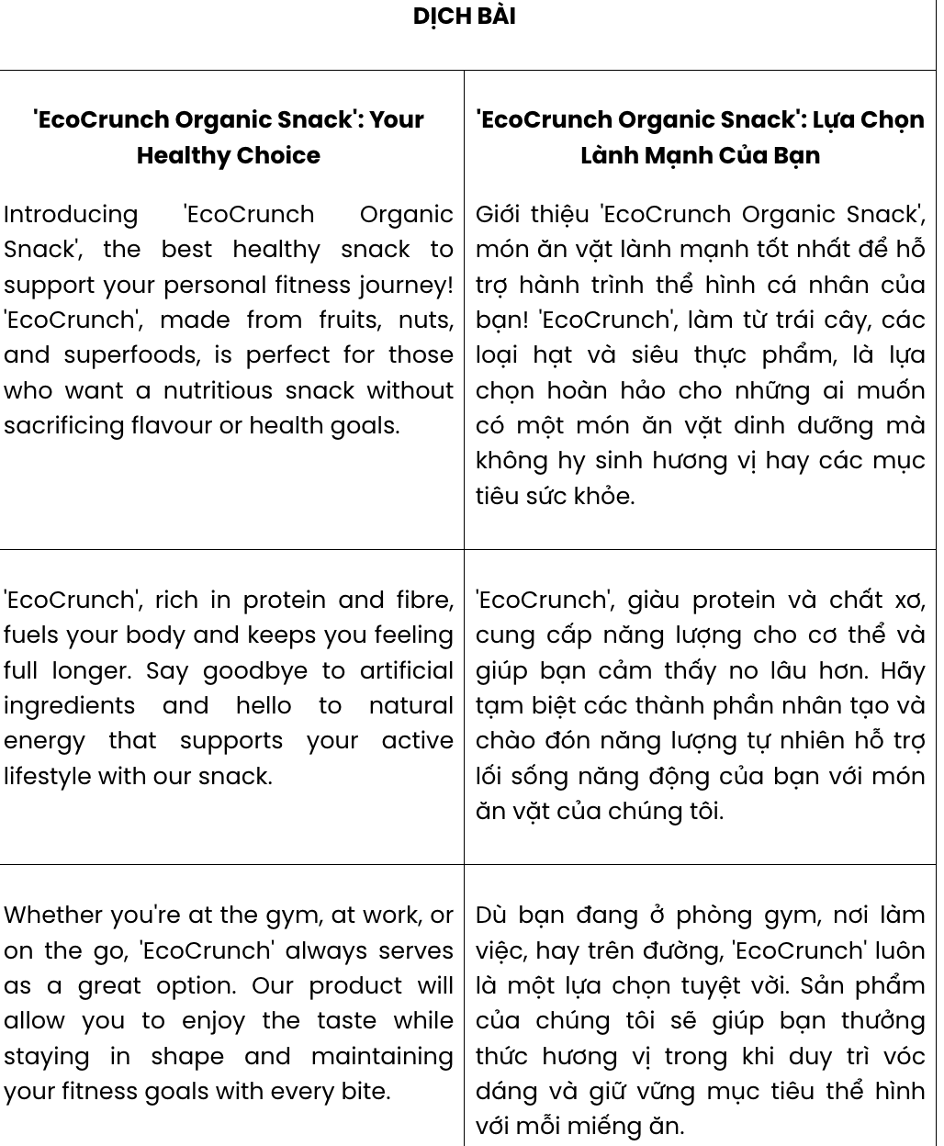
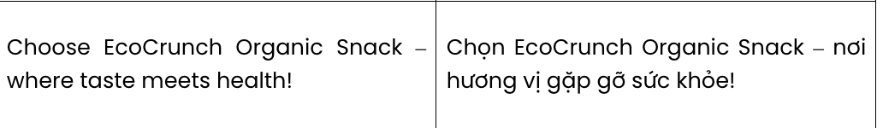
GIẢI CÂU 1:

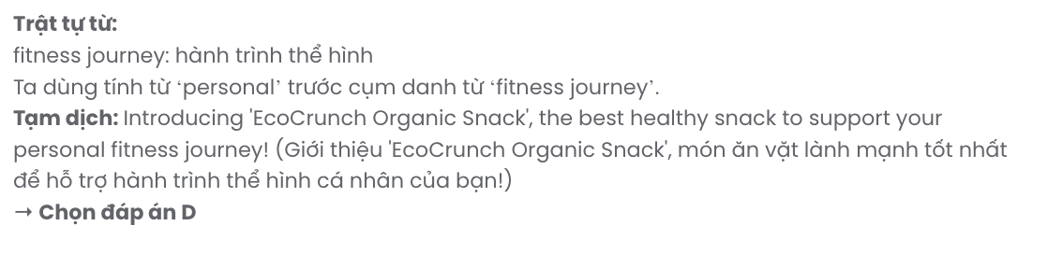
GIẢI CÂU 2:
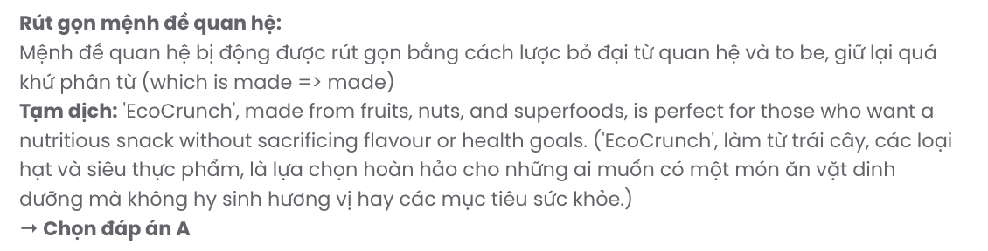
GIẢI CÂU 3:

GIẢI CÂU 4:
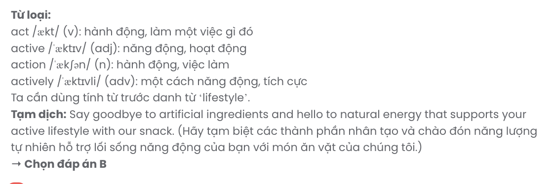
GIẢI CÂU 5:
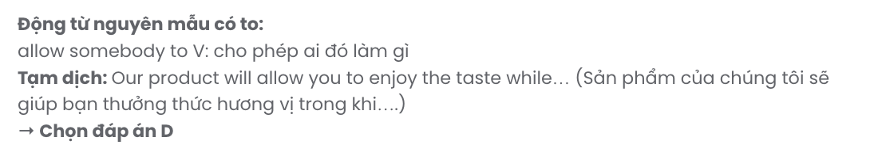
GIẢI CÂU 6: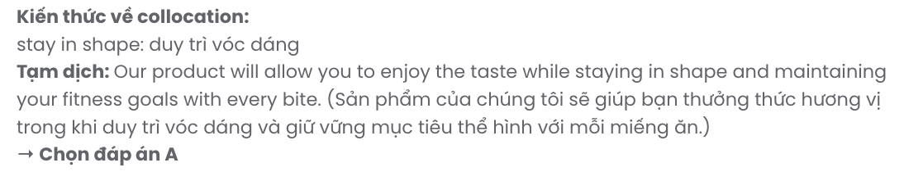

Read the following leaflet and mark the letter A, B, C or D on your answer sheet to indicate the option that best fits each of the numbered blanks from 7 to 12.

Adopt a Pet and Your Responsibility
Learn the benefits and the responsibilities when you raise an animal.

+◆*L Benefits of adopting and having a pet:
When having a pet, you will get rid of (7) and enjoy the companionship of a loving animal. This is because a wide (8) of studies have shown that pets can reduce stress and boost mental health. Additionally, (9) your adoption, you provide a better home for an animal while supporting shelters in creating space for (10) pets in need.

+L*◆ Your responsibility:
- Ensure your pet is well cared for by (11) regular vet visits.
- Look after their nutrition, grooming, and exercise needs.
- (12) time for training and bonding to promote positive behaviour.
- Remember, adopting a pet is a long-term commitment requiring patience and love.
Take on the responsibility and experience the joy of having a furry friend!

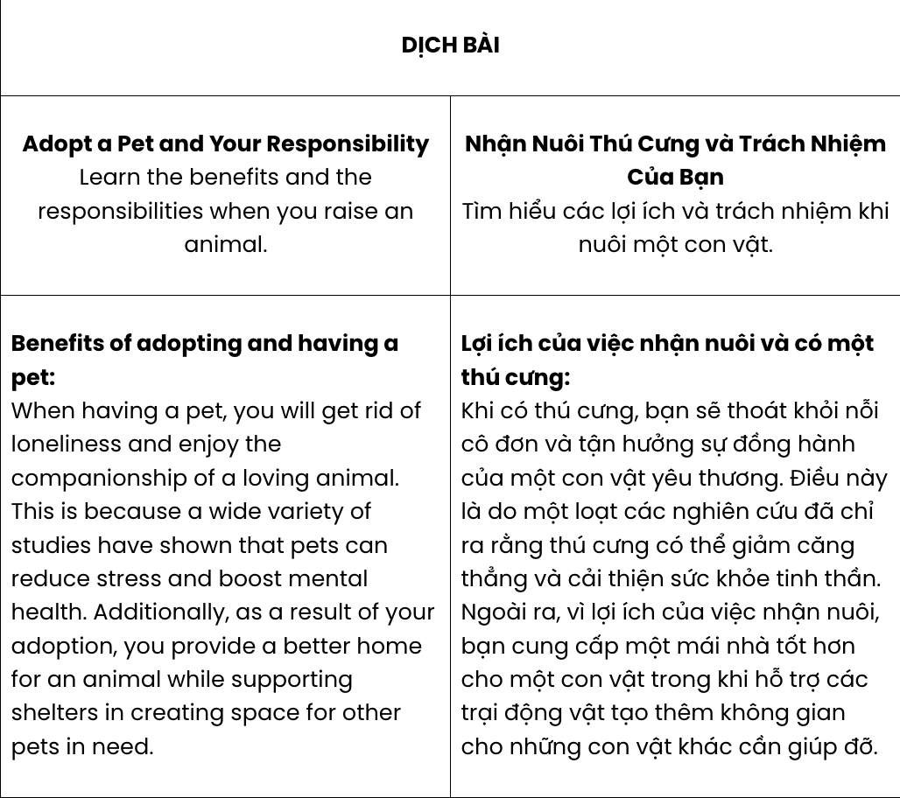

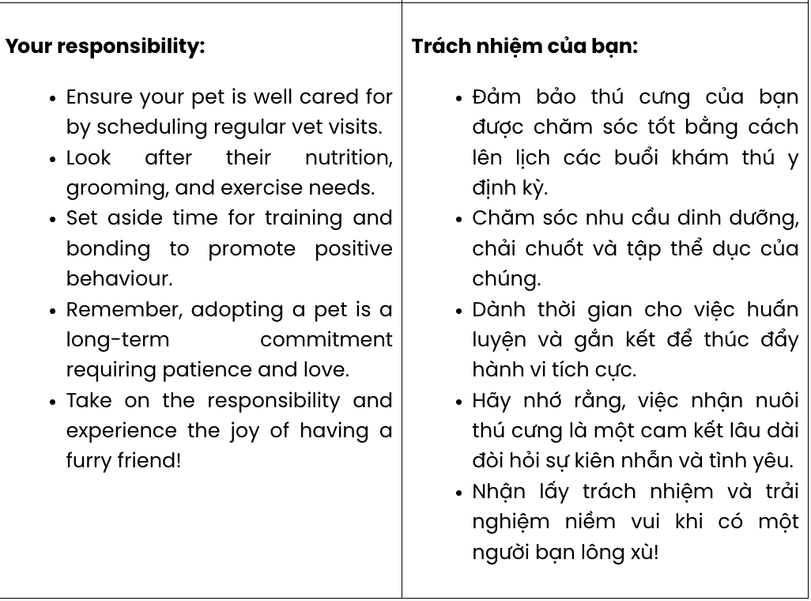

Question 7. | A. personality | B. loneliness | C. motivation | D. disappointment
Question 8. | A. level | B. deal | C. amount | D. variety
Question 9. | A. as a result of | B. in spite of | C. instead of | D. in contrast to
Question 10. | A. others | B. another | C. other | D. the others
Question 11. | A. paying | B. scheduling | C. complimenting | D. creating
Question 12. | A. Break down | B. Take off | C. Make up | D. Set aside
GIẢI CÂU 7:
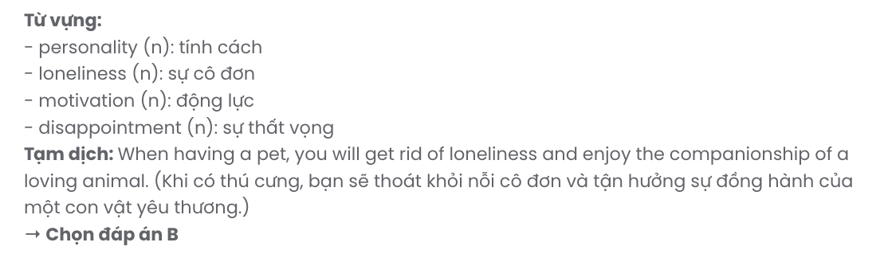
GIẢI CÂU 8: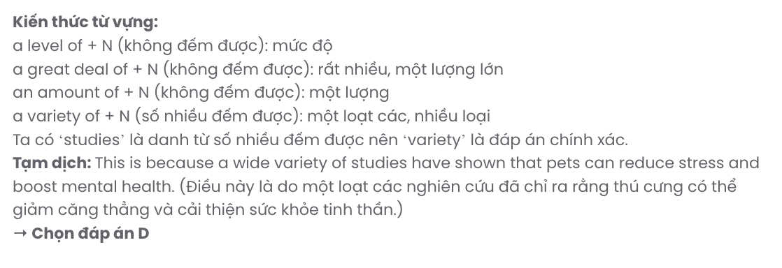
GIẢI CÂU 9:
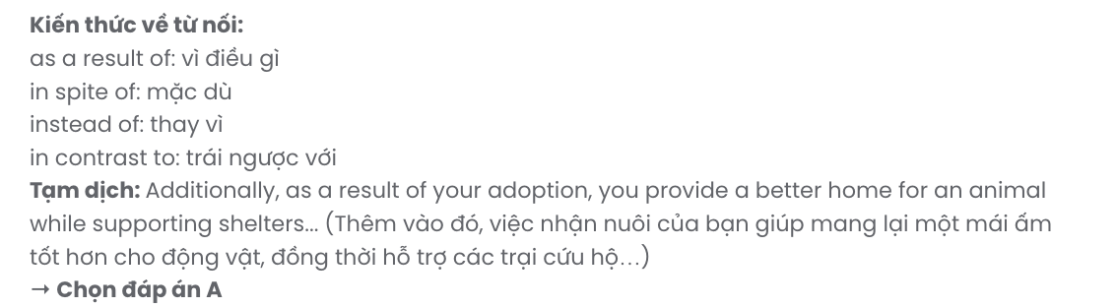
GIẢI CÂU 10:
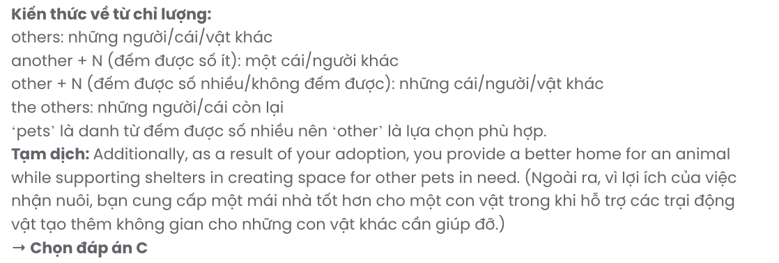
GIẢI CÂU 11:
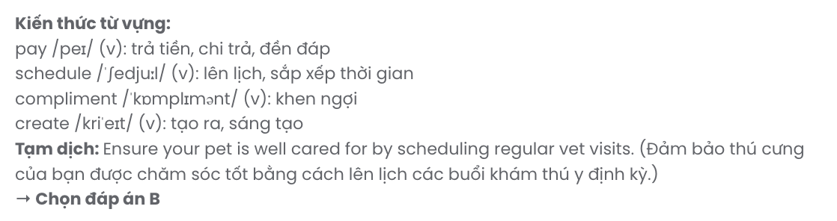
GIẢI CÂU 12:

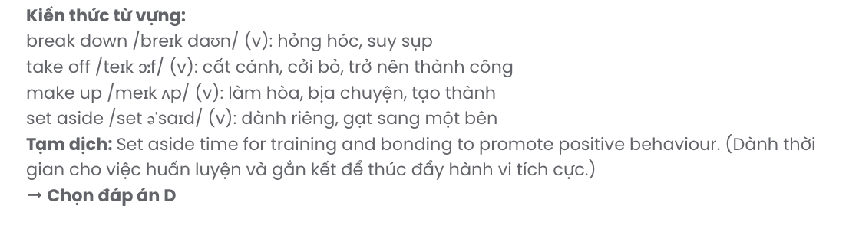
Mark the letter A, B, C or D on your answer sheet to indicate the best arrangement of utterances or sentences to make a meaningful exchange of text in each of the following questions from 13 to 17.

Question 13.
- Sarah: Hey, James! Yes, I was on a short vacation to recharge. It was amazing!
- James: That sounds great! I should probably plan one soon, too.
- James: Hi, Sarah! I haven't seen you around the office for a while. Is everything okay?
A. c – a – b B. b – a – c C. c – b – a D. a – b – c
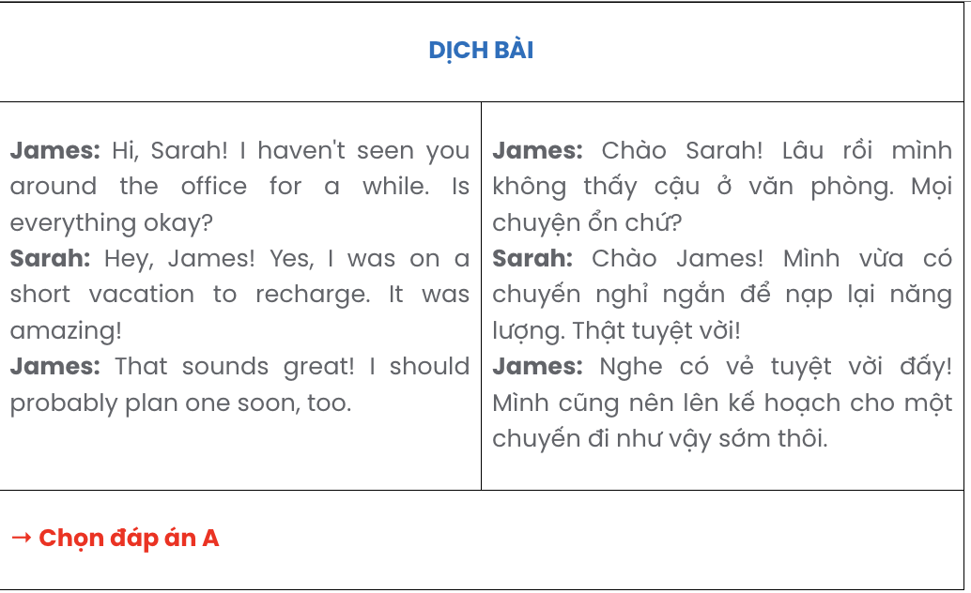

Question 14.
- Sam: Hi, Mia! It’s going well, but sometimes I get stuck for ideas.
- Mia: Hi, Sam! How’s the book you’re writing coming along?
- Mia: That’s a smart approach. Can’t wait to read your book!
- Mia: What do you do when that happens?
- Sam: I usually go for a walk or listen to music to clear my mind.
A. d – e – c – a – b B. b – e – d – a – c C. c – e – b – a – d D. b – a – d – e – c
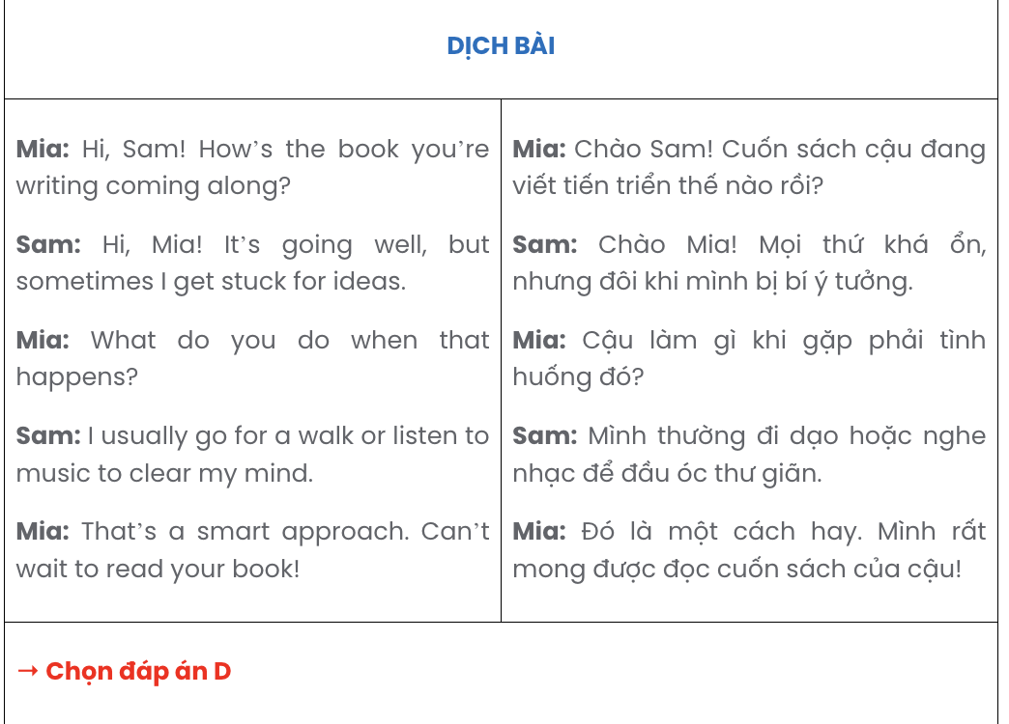

Question 15.
Hi Alex,
- The views were breathtaking, and I managed to take some great photos.
- It would be nice to plan a weekend trip together sometime soon; let me know your thoughts.
- By the way, do you know any good spots for camping nearby?
- I’d love to go back and try the other trails you mentioned.
- I recently checked out the hiking trail near your place – it was truly amazing! Best,
Ella
A. d – e – c – a – b B. e – a – d – c – b C. b – e – a – c – d D. e – d – c – a – b


Question 16.
- Every morning, streets are packed with cars and motorcycles, turning short commutes into long, stressful journeys.
- Until city commuters are made aware of this solution, traffic congestion will remain a persistent urban problem.
- Traffic congestion has become a daily struggle for many city residents.
- Encouraging more public transport use is perhaps the most effective solution to the issue; however, private vehicles often win because of convenience.
- One major cause of this problem is the rapid increase in vehicle ownership without adequate expansion of road infrastructure.
A. a – e – c – d – b B. c – a – e – d – b C. c – e – a – b – d D. c – d – e – a – b

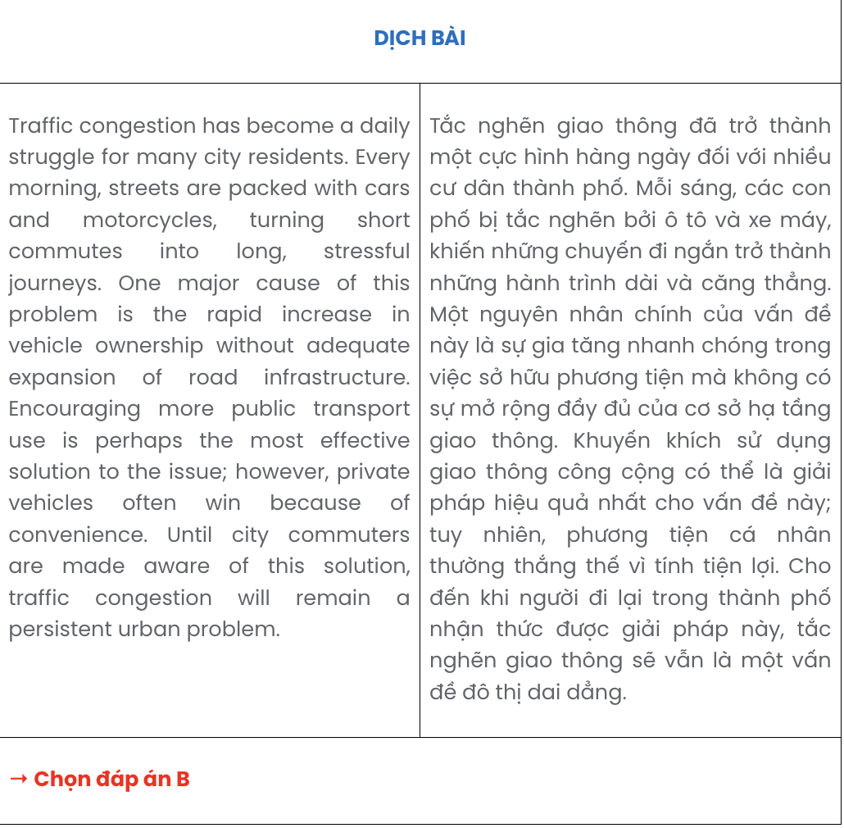
Chỉ 100k/12 tháng, bạn tải rất nhiều tài liệu tiếng anh file word hay tại: Giaoandethitienganh.info Mong bạn ghé ủng hộ !

Question 17.
- The drought has left millions facing food insecurity, crop failure, and livestock deaths, making their lives even more difficult.
- Although international organisations have provided relief efforts, the situation remains dire, and climate change continues to threaten the future of this region.
- This region has experienced consecutive failed rainy seasons, leading to significant water shortages.
- Prolonged drought in the Horn of Africa has had severe consequences over the past decade.
- Local communities, heavily reliant on agriculture and livestock, have been forced to migrate in search of water and food, putting immense pressure on cities and receiving areas.
A. d – a – c – b – e B. d – e – b – a – c C. d – b – e – c – a D. d – c – a – e – b

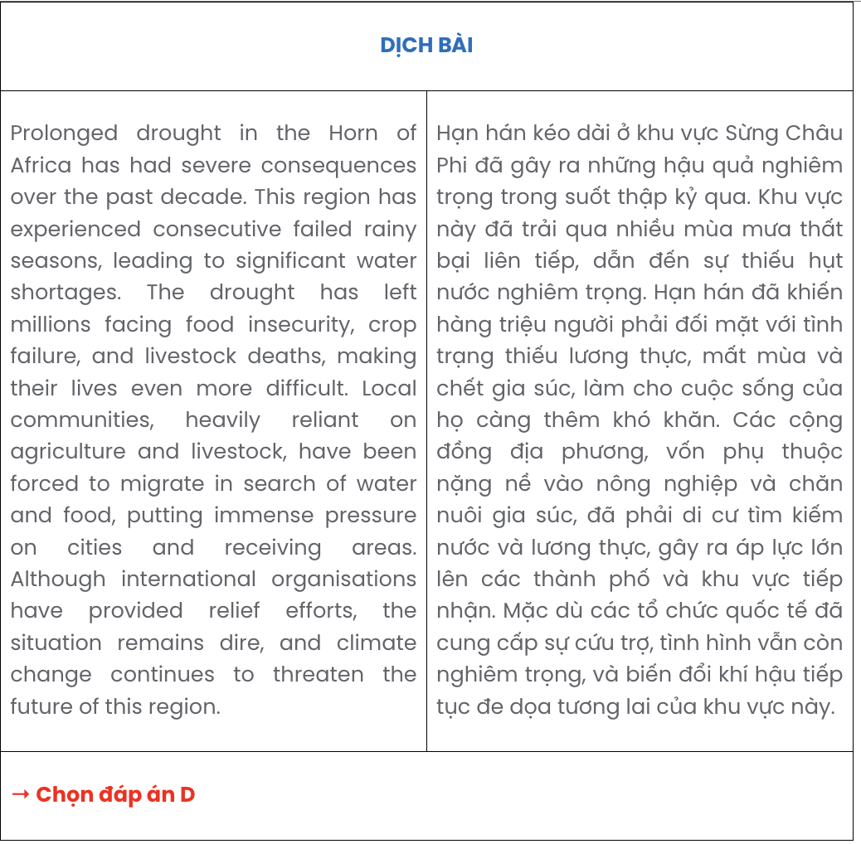
Read the following passage and mark the letter A, B, C, or D on your answer sheet to indicate the correct option that best fits each of the numbered blanks from 18 to 22.
Conservation centres play a crucial role in nurturing endangered animals before reintroducing them into their natural habitats. These centres, which specialise in the care and rehabilitation of threatened species,
(18) . This process ensures that the animals are strong enough to survive in the wild.
Releasing these animals back into the wild, however, presents many challenges. One major issue is that animals (19) may struggle to adapt to their natural habitats. For example, they might not know how to hunt or find food independently, skills essential for survival. As a result, (20) . Additionally, conflicts with existing wild populations can occur, as territorial disputes may arise.
Despite these difficulties, the efforts are worthwhile. Reintroduced to natural habitats, (21) . Successful cases, such as those involving large predators like wolves or big cats, have proven that with thorough planning, conservation projects can contribute to healthier environments. In conclusion, (22)

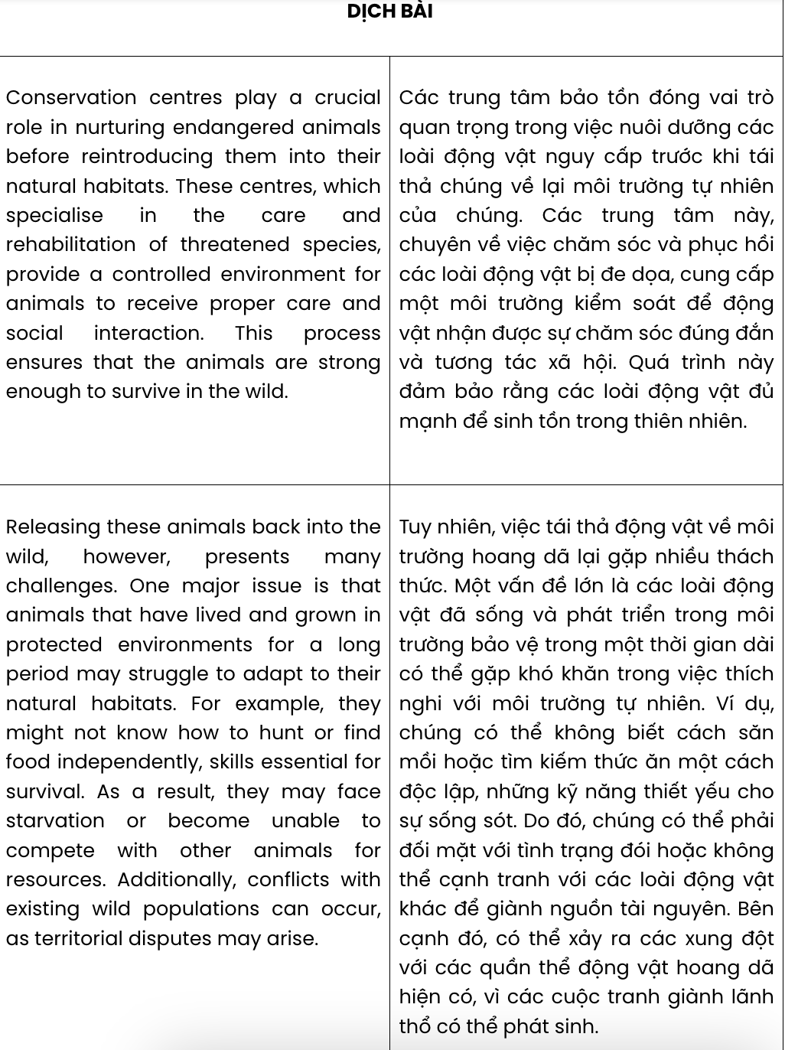
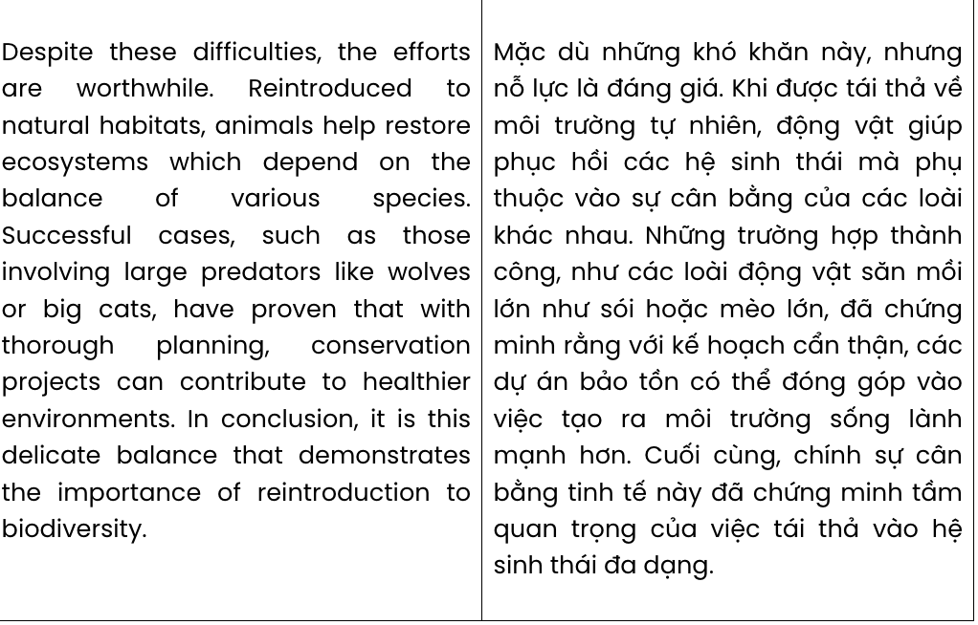

Question 18.
A. and provide animals with a controlled environment, proper care and social interaction
B. animals receive proper care and social interaction in the controlled environment provided
C. which provide animals with a controlled environment, receive proper care and social interaction
D. provide a controlled environment for animals to receive proper care and social interaction
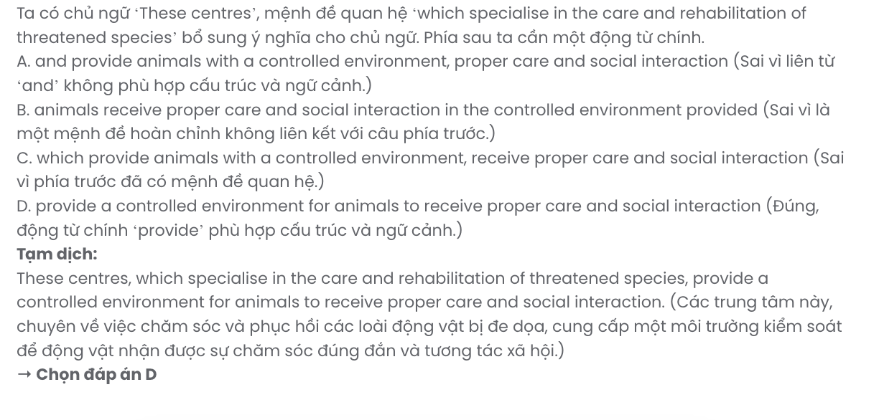

Question 19.
A. which having lived and grown for a long period in protected environments
B. that have lived and grown in protected environments for a long period
C. in protected environments they have lived and grown for a longer period than in others
D. have lived and grown with humans under controlled conditions for a long period
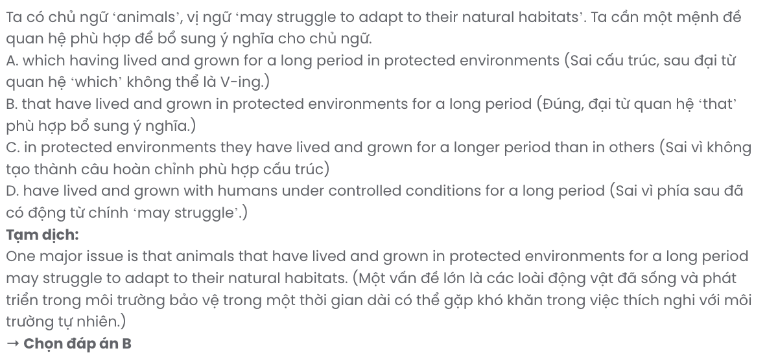

Question 20.
A. high competition for resources in the habitat leads to starvation and even death
B. the well-being and survival of animals is threatened when resources are already scarce
C. they may face starvation or become unable to compete with other animals for resources
D. natural competition will select the strongest warriors and eliminate the weaker ones
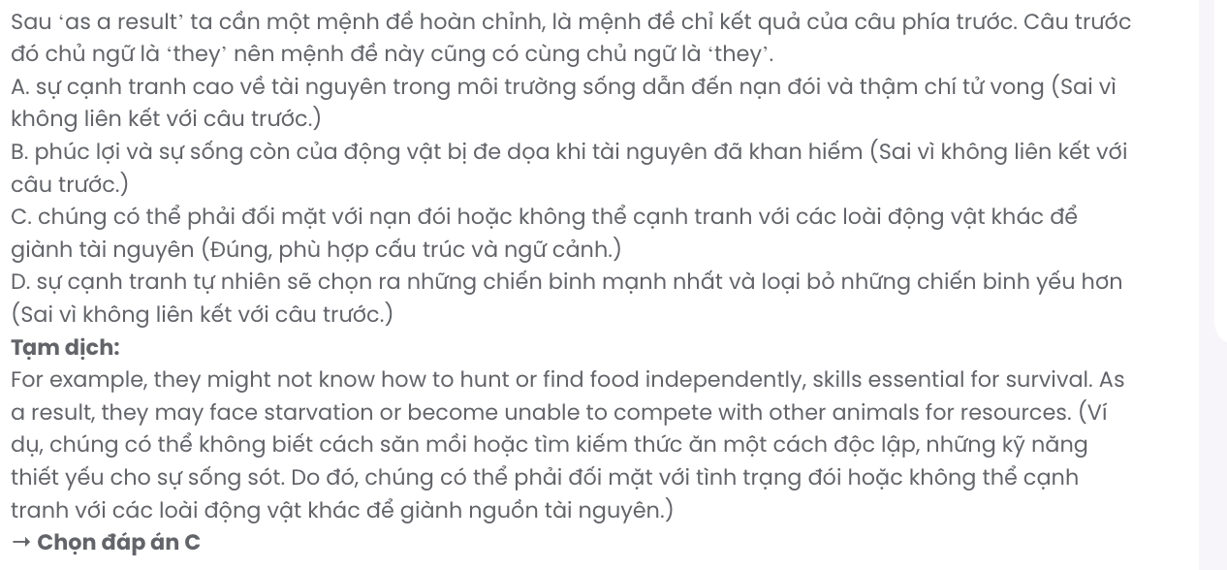

Question 21.
A. animals help restore ecosystems which depend on the balance of various species
B. humans contribute to the restoration of ecological balance and biodiversity
C. the ecosystem is restored thanks to the balance that these animals unintentionally bring
D. the ecosystem regains its balance, beneficial for the long-term survival of the other species

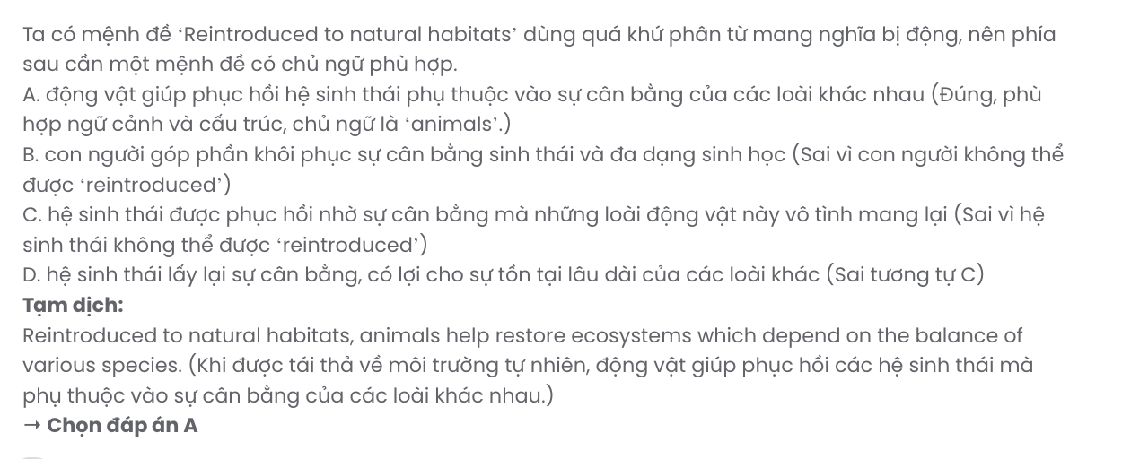

Question 22.
A. it is urgent for governments to make more efforts to slow the extinction of endangered species
B. the significance of reintroducing endangered species remains unproven and unconvinced
C. it is this delicate balance that demonstrates the importance of reintroduction to biodiversity
D. people must work together to protect animals, and report illegal acts that affect their welfare
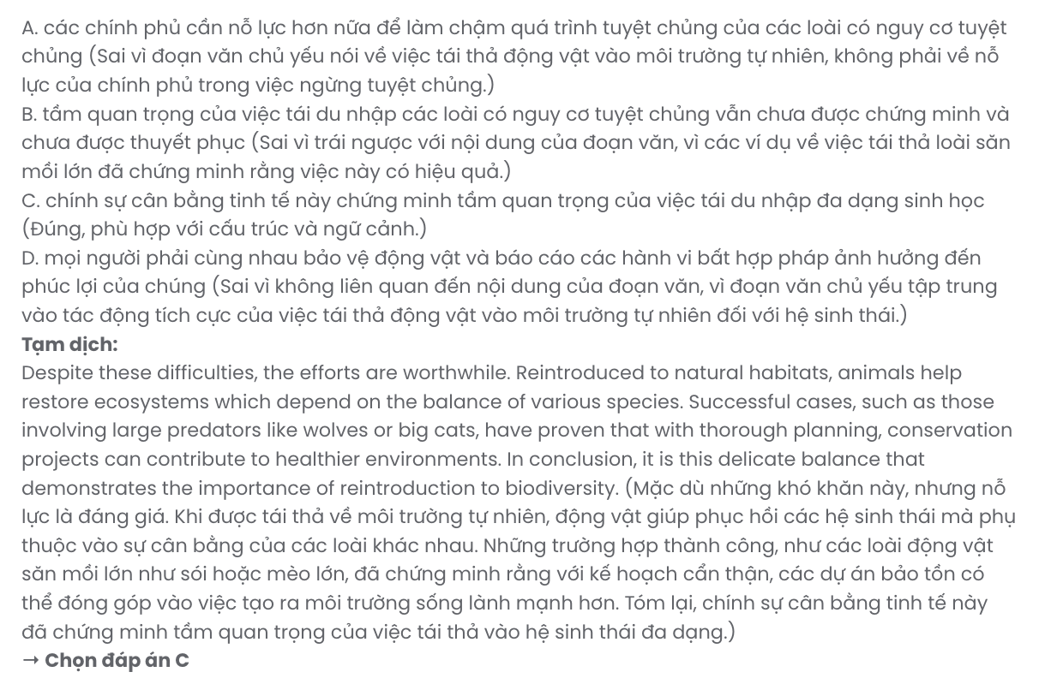
Read the following passage and mark the letter A, B, C, or D on your answer sheet to indicate the best answer to each of the following questions from 23 to 30.

A guide to school-leavers’ planning for the future
When you leave secondary school, you have different options, including going to a university or a vocational school, getting a job, or taking a gap year. Sometimes choices may make you confused, so you should examine all your options before making any plans for the future. Below are some things you may like to try before making your decision.
If there are teachers you really love or look up to, you can ask them for some advice. Your teachers have been observing you for months, so they know your strengths, talents, and personality. You may share your dreams and concerns with them and ask them to give you an honest opinion about what option may be suitable for you.
If possible, you can talk to a career adviser when you are still undecided about your future plans and ask for their advice. If you can't find a career adviser, you can take some career-matching tests online. These tests are typically created by career experts and psychologists, so they can help you make an informed decision.
Visiting a college or university campus is also important. This will make you think about whether you can see yourself there or not. Usually, educational institutions have orientation days for secondary school students to experience university life first-hand. You could even contact the university. So try following the above suggestions, and you will certainly make a more informed decision about your future plans.
(Adapted from English Workbook 12 – Global Success)
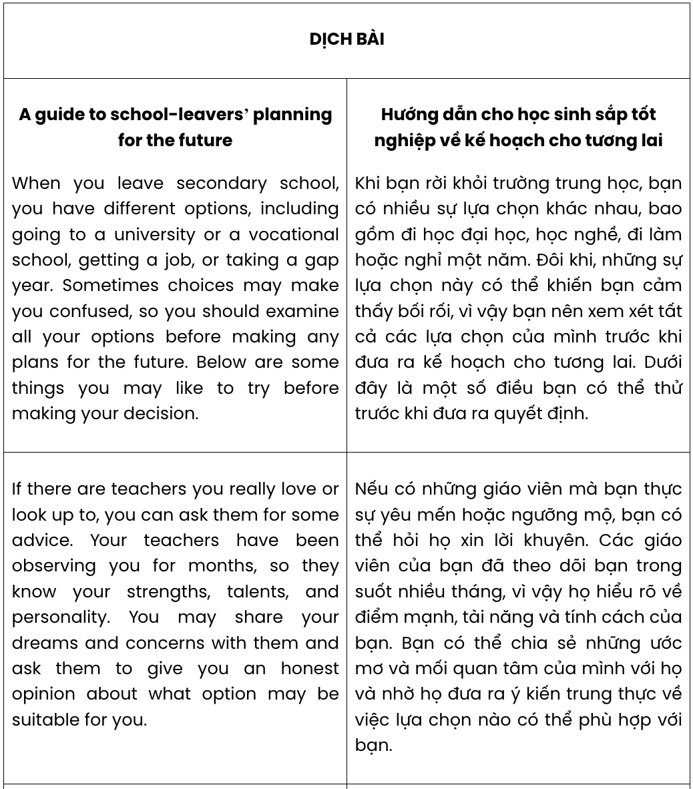
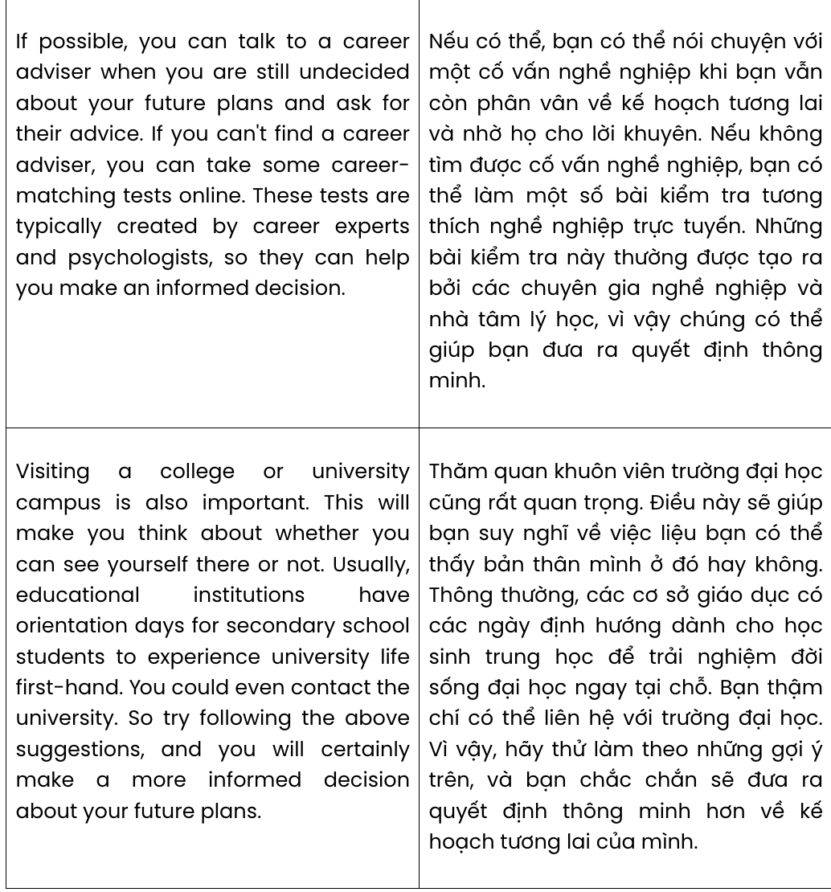
Question 23. Which of the following is NOT mentioned as one of the choices possible after graduating from secondary school?
A. going to work B. staying at school for a year
C. pursuing higher education D. attending vocational school
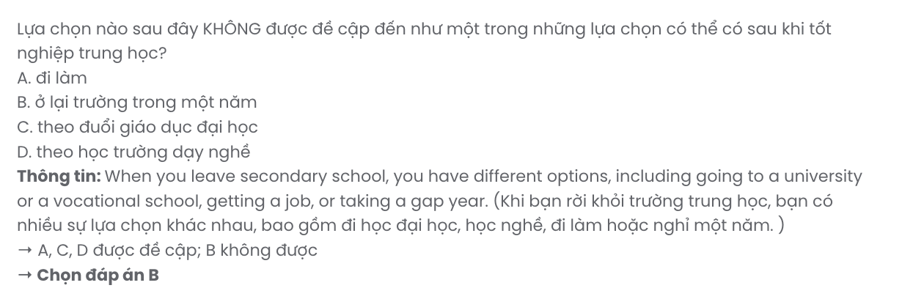
Question 24. The word informed in paragraph 3 is OPPOSITE in meaning to .
A. ignorant B. relevant C. obsolete D. credible
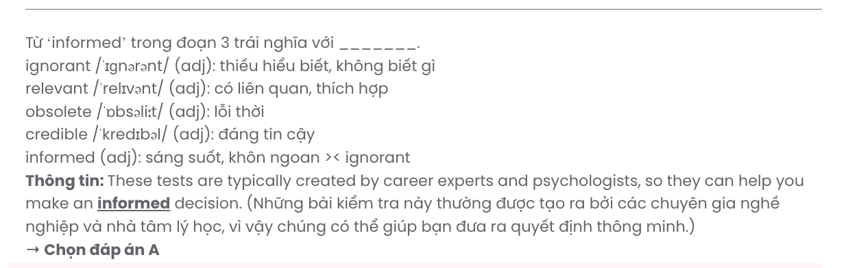
Question 25. The word them in paragraph 2 refers to .
A. months B. teachers C. talents D. dreams
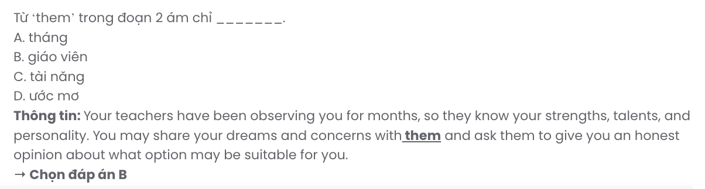
Question 26. The word strengths in paragraph 2 can be best replaced by .
A. vacancies B. qualifications C. interests D. advantages
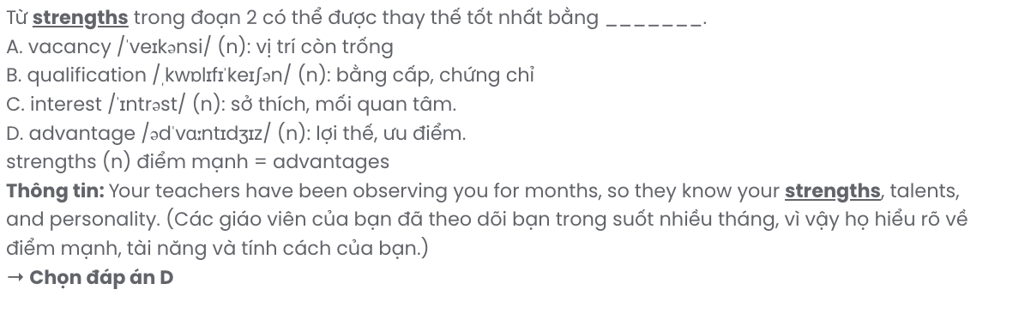
Question 27. Which of the following best paraphrases the underlined sentence in paragraph 4?

This will make you think about whether you can see yourself there or not.
A. By doing this, you are more likely to make the right decision in the future.
B. You will be able to decide if the environment is healthy or toxic.
C. Doing it will help you reflect on whether that place feels right for you.
D. You will have to consider this to make appropriate future decisions.

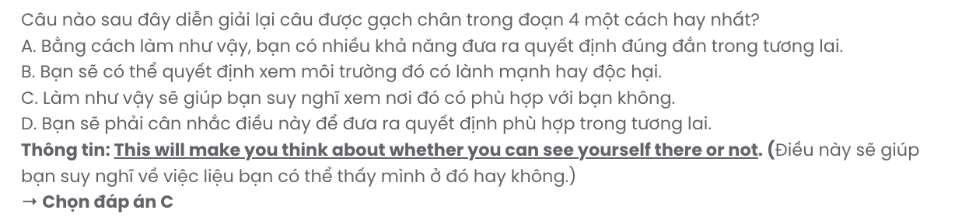
Question 28. Which of the following is TRUE according to the passage?
A. If you are still unsure about your career, a career counsellor can make a decision for you.
B. Teachers understand their students' traits and abilities as they have followed them over time.
C. Although there are many options after high school, going to college is still the best.
D. Visiting to experience universities gives you a clear picture of the wonderful impact of education.
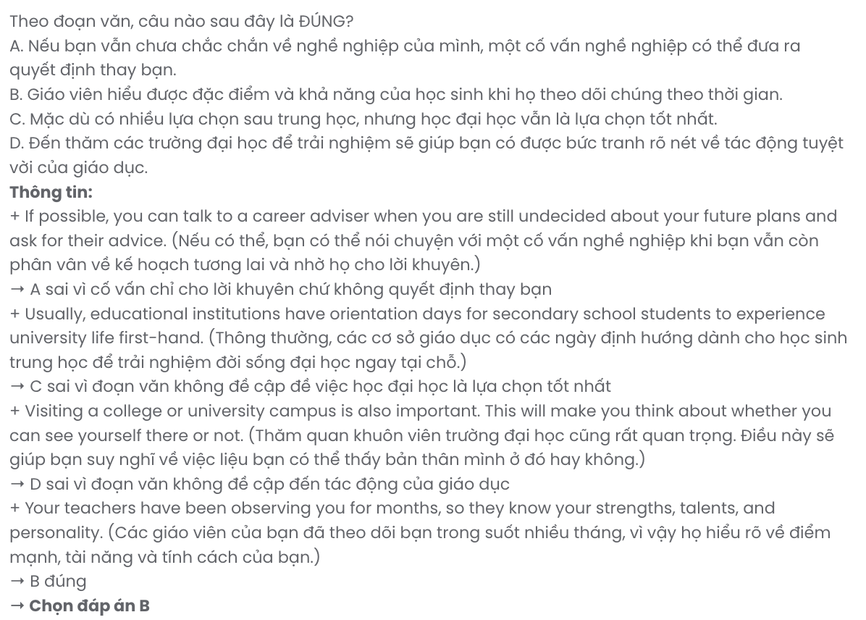
Question 29. In which paragraph does the author mention seeking help from professionals?
A. Paragraph 1 B. Paragraph 2 C. Paragraph 3 D. Paragraph 4
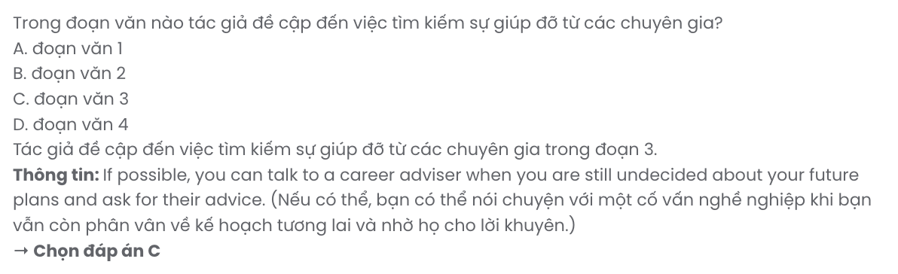
Question 30. In which paragraph does the author advise readers to think carefully before making any decisions?
A. Paragraph 1 B. Paragraph 2 C. Paragraph 3 D. Paragraph 4
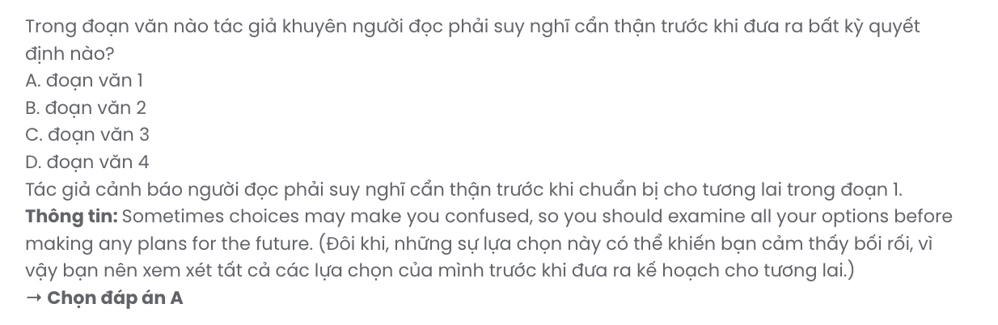
Read the following passage and mark the letter A, B, C, or D on your answer sheet to indicate the best answer to each of the following questions from 31 to 40.
Lifelong learning is defined as the process of continuous learning to keep our knowledge and skills updated. However, there are some obstacles to adult learning that can interrupt the process.
[I] First, ageing is a natural process and will start in early adulthood and middle age. [II] Older people will probably experience some of the effects of ageing such as worsening vision and hearing, and poor memory. [III] Ageing is believed to affect the capacity for participating in learning activities. [IV] Moreover, as it had been a long time since they had studied, older adults require more time to recall their existing knowledge and skills and gain new ones.
The second challenge to lifelong learners, especially older adults, is that each of them has their particular life situation including work or family responsibilities. Many people are in full-time employment, and, in addition, they may be in charge of childcare so they may find it hard to make time for classes or assignments. Those who live with extended family often take on more responsibilities and sometimes become overloaded. Some people may also face financial difficulties in their lives, so earning a living must be their priority. Although they may want to continue learning, they will be more concerned about how to make ends meet.
Finally, the decisive factor affecting people’s lifelong learning is the motivation and purposes of learning. Older adults will be willing to continue their studies if they need to update their knowledge and skills. Moreover, when they study with other people, they will feel like they belong to a community of learners sharing the same interests and will have a strong motivation to learn. Motivation is also the key factor that helps people overcome many difficulties and continue learning throughout their lives.
(Adapted from English Workbook 12 – Global Success)

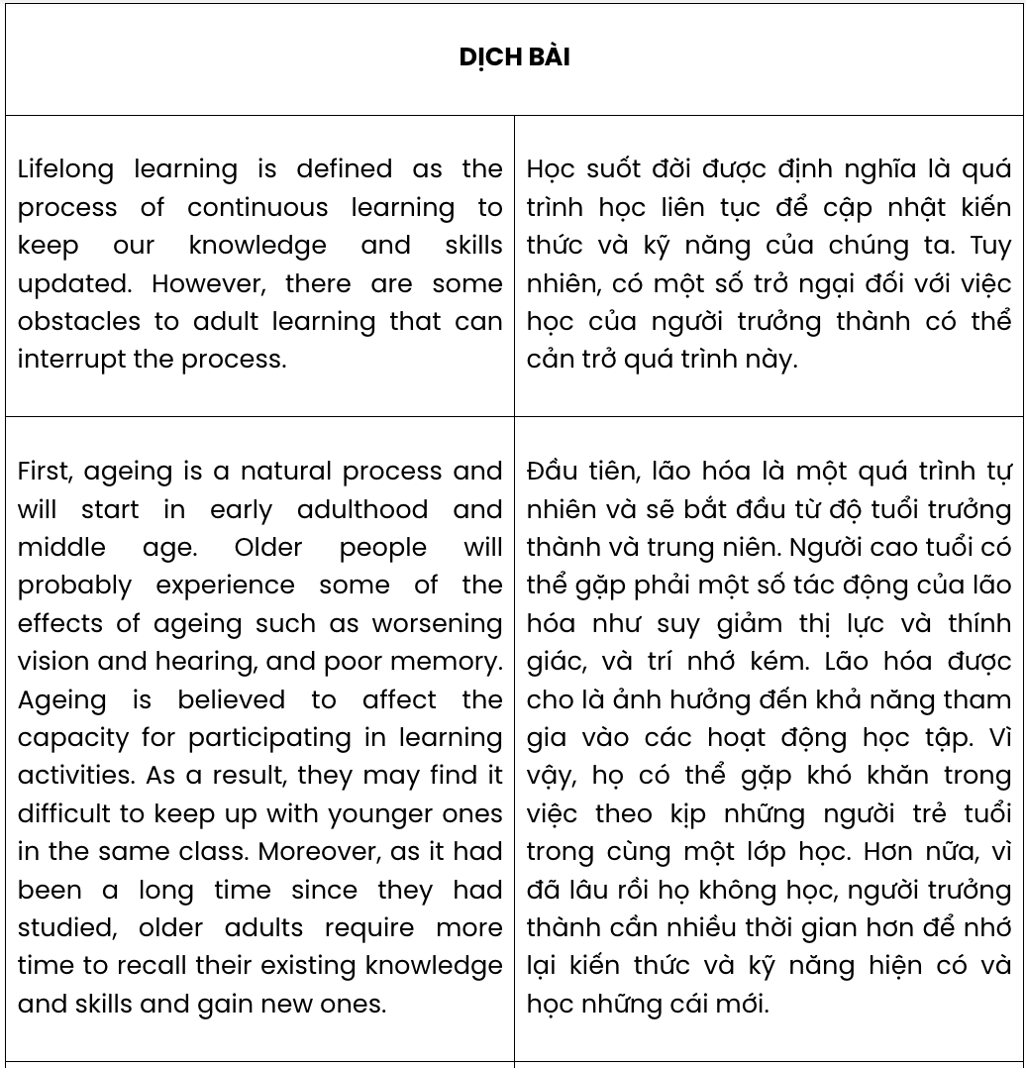
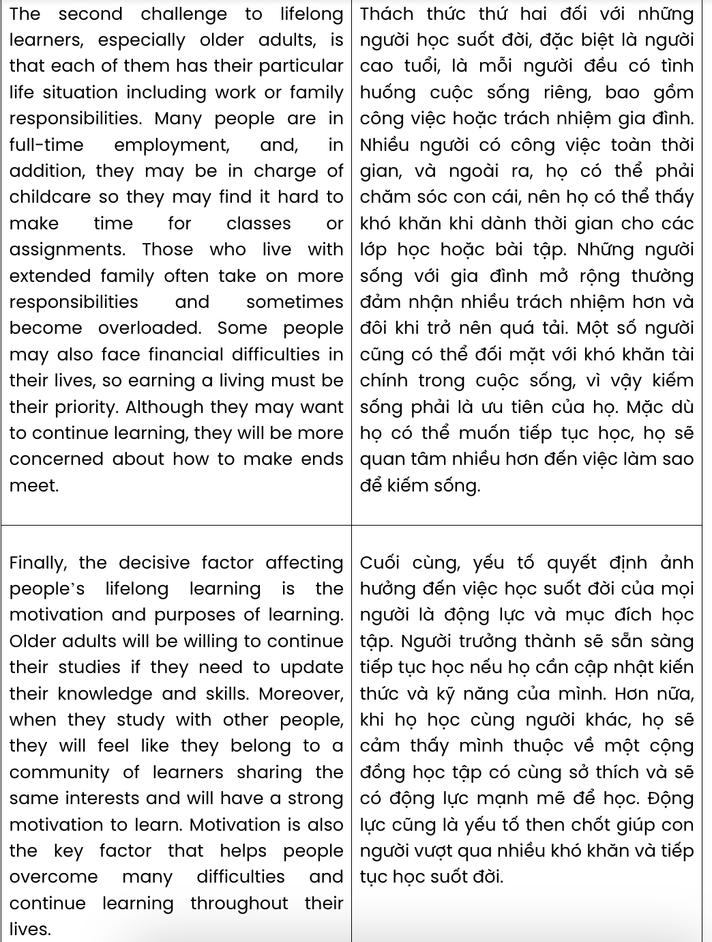
Question 31. Where in paragraph 2 does the following sentence best fit?

As a result, they may find it difficult to keep up with younger ones in the same class.
A. [I] B. [II] C. [III] D. [IV]

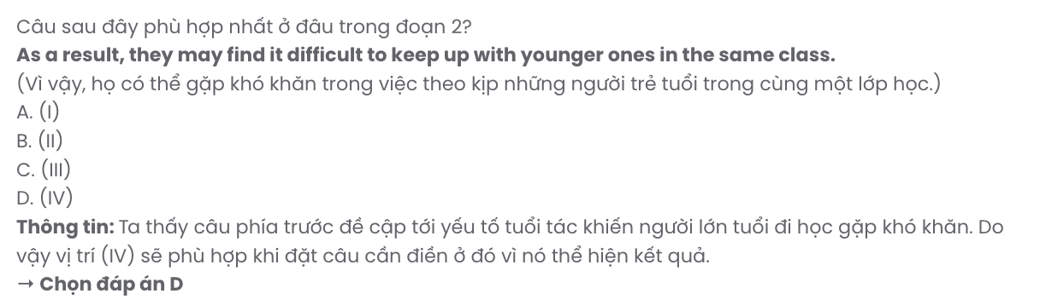
Question 32. The phrase make ends meet in paragraph 3 could be best replaced by .
A. earn enough money to live B. arrange schedules
C. balance aspects of life D. earn as much as possible
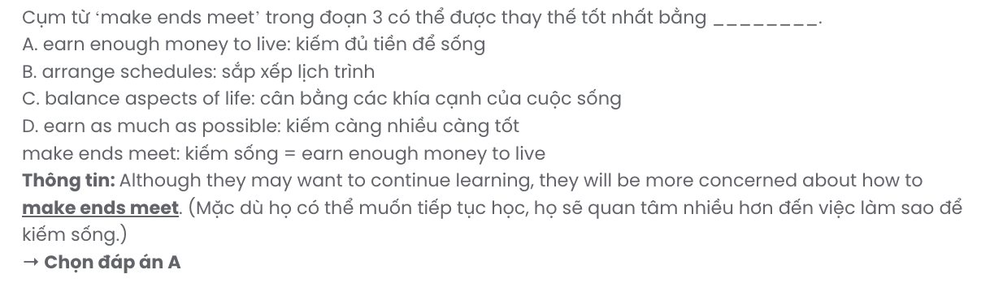
Question 33. The word they in paragraph 4 refers to .
A. studies B. skills C. purposes D. older adults
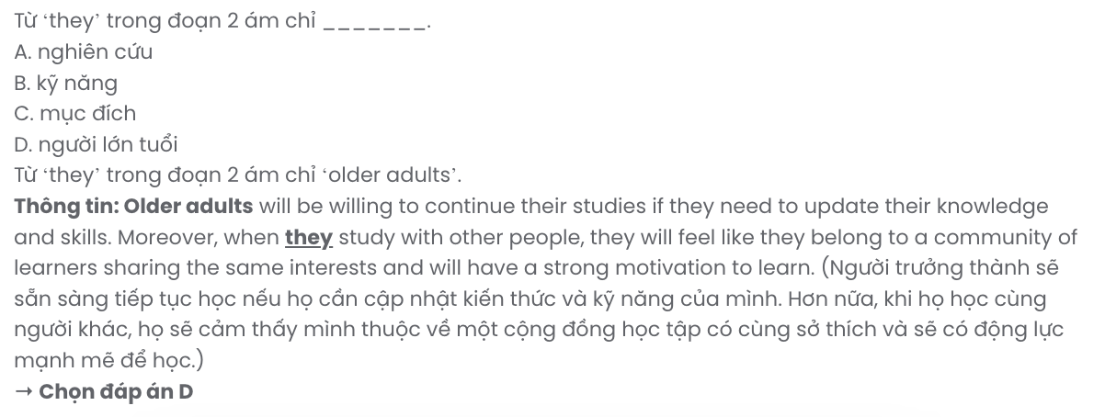
Question 34. Which of the following is NOT mentioned as one of the challenges facing adult learners?
A. their motivation to learn B. their old age
C. their previous achievements D. their other duties in life

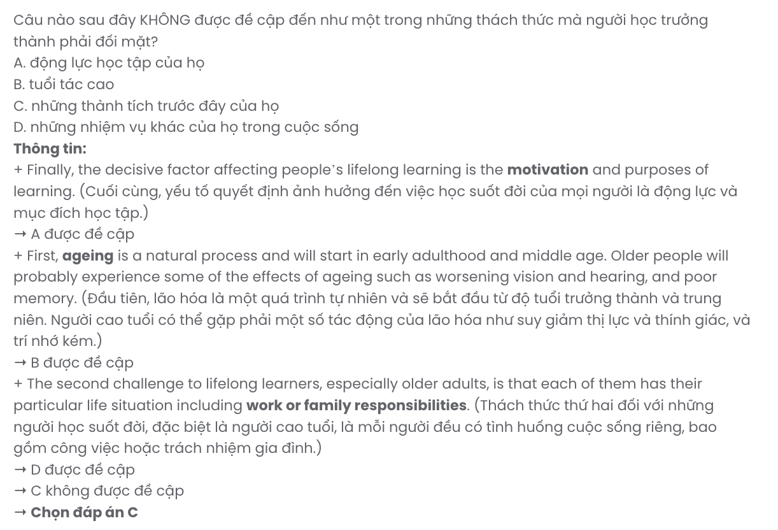
Question 35. Which of the following best summarises paragraph 4?
A. Motivation plays a crucial role in encouraging lifelong learning among older adults.
B. Older adults often face challenges in continuing their studies due to lack of resources.
C. Lifelong learning is primarily influenced by environmental and social factors.
D. Learning communities are the primary reason to motivate older learners to study.
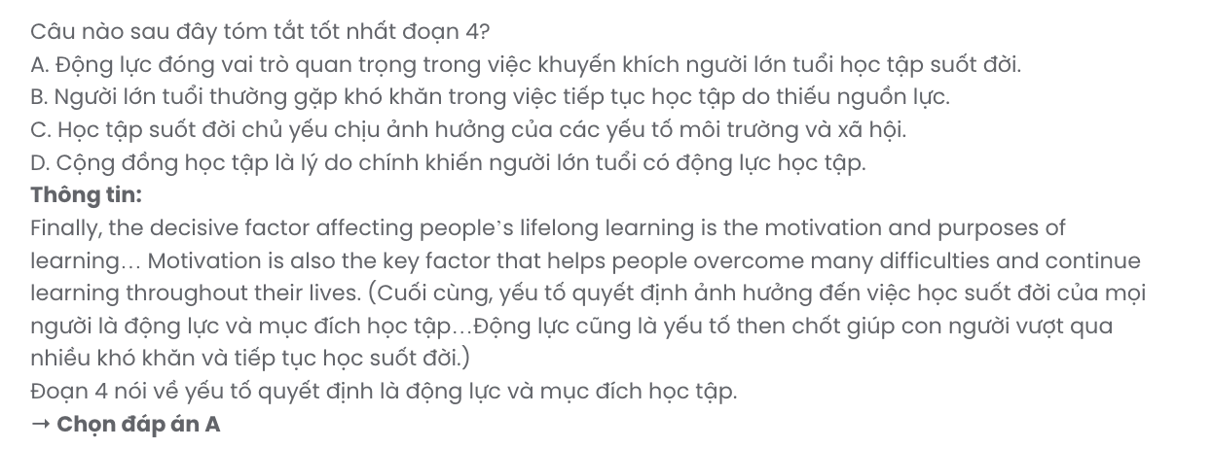
Question 36. The word decisive in paragraph 4 is OPPOSITE in meaning to .
A. essential B. effortless C. rewarding D. insignificant
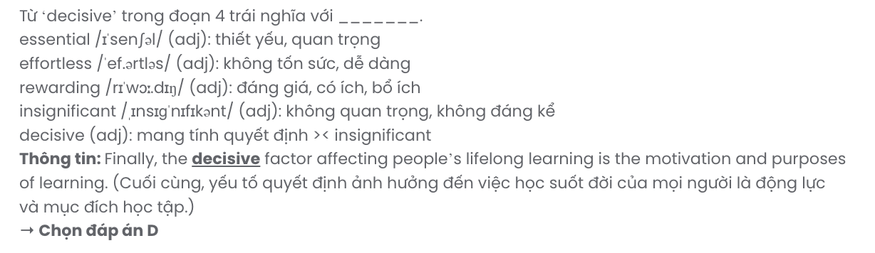
Question 37. Which of the following is TRUE according to the passage?
A. All older adults experience difficulties with memory when learning new things.
B. Full-time employees often have plenty of time for lifelong learning activities.
C. Adults living in multi-generational families are further hampered in their learning.
D. Older adults are less affected by financial issues when continuing their studies.
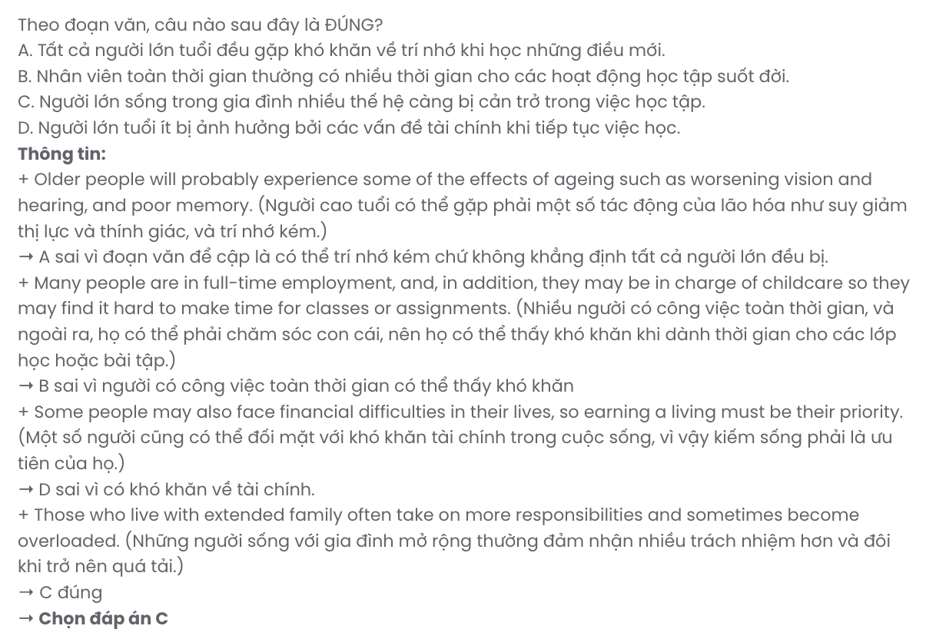
Question 38. Which of the following best paraphrases the underlined sentence in paragraph 4? Motivation is also the key factor that helps people overcome many difficulties and continue learning throughout their lives.
A. People can get over numerous obstacles on their lifelong learning journey once motivated.
B. Motivating others plays an important role in facing the challenges faced by lifelong learners.
C. Many people find it hard to have motivation when dealing with difficulties in lifelong learning.
D. Facing challenges in lifelong learning is always inevitable, even with strong motivation.
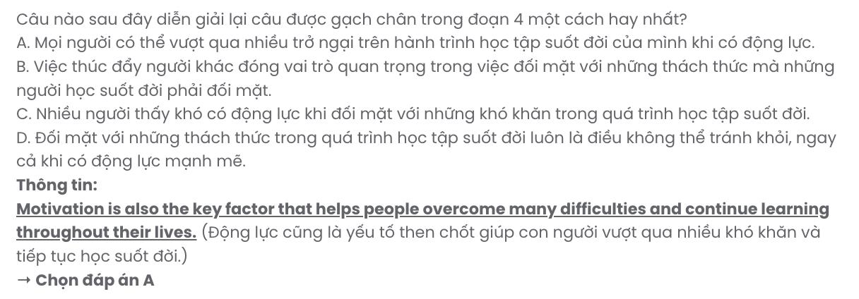
Question 39. Which of the following can be inferred from the passage?
A. Middle-aged adults are generally affected the least by function and ability decline as they continue learning.
B. Financial stability allows most older adults to prioritise lifelong learning over other responsibilities.
C. Most older adults find managing both learning and full-time work commitments at the same time impossible.
D. Older adults will become more motivated to continue studying if they desire to remain competitive in their careers.
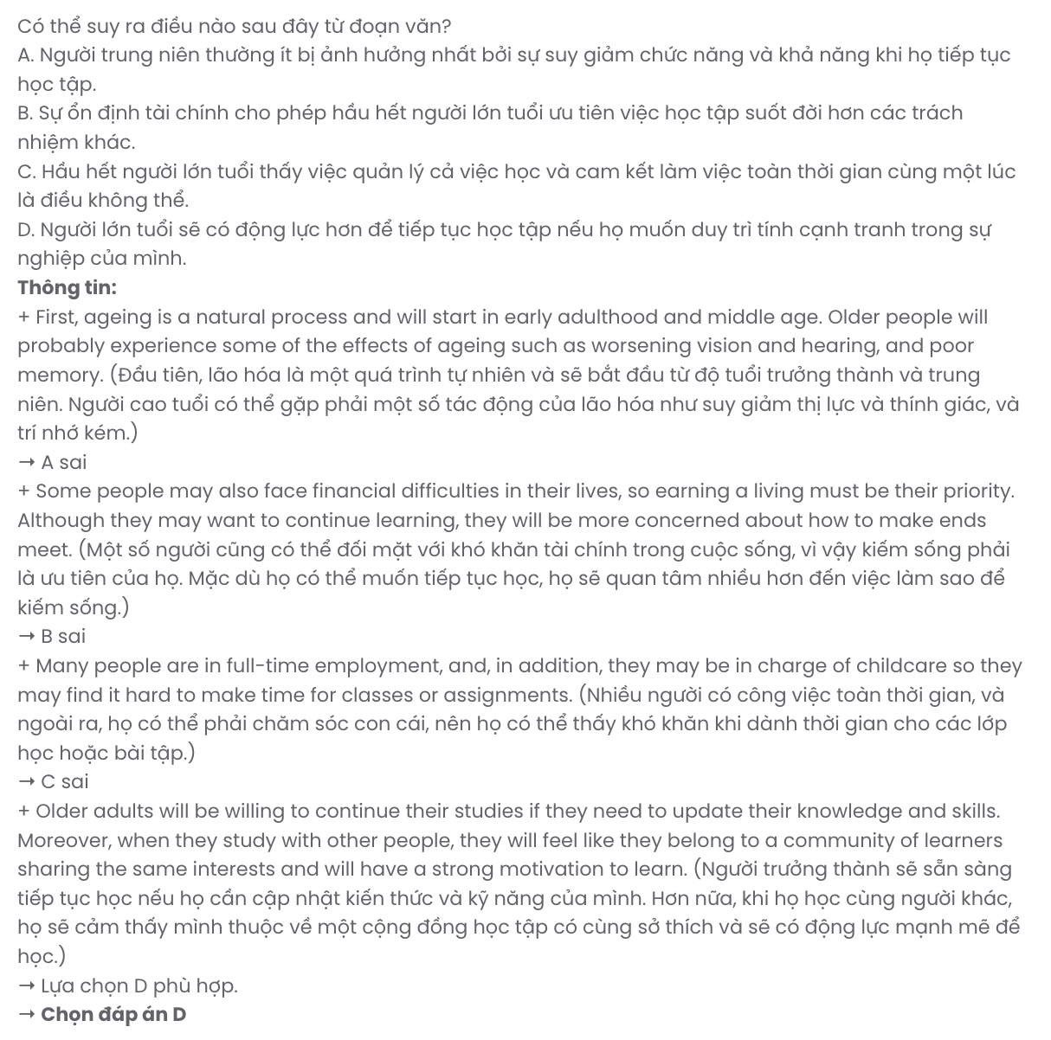
Question 40. Which of the following best summarises the passage?
A. Lifelong learning is essential, but older adults often face challenges related to health, time, and motivation.
B. Older adults often delay their studies due to health problems, the lack of motivation and the need to focus on careers.
C. Ageing provides older adults with ample time to gain new knowledge and reconnect with learning, but they are less motivated.
D. Motivated adults frequently find that studying together creates fewer obstacles to lifelong learning and helps them overcome hardships.

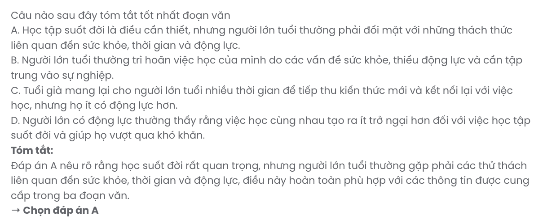

BẢNG TỪ VỰNG
STT | Từ vựng | Từ loại | Phiên âm | Nghĩa
1 | nutritious | adj | /njuːˈtrɪʃəs/ | bổ dưỡng
2 | flavour / flavor | n | /ˈfleɪvə(r)/ | hương vị
3 | goal | n | /ɡəʊl/ | mục tiêu
4 | artificial | adj | /ˌɑːtɪˈfɪʃl/ | nhân tạo
5 | ingredient | n | /ɪnˈɡriːdiənt/ | thành phần
6 | fitness | n | /ˈfɪtnəs/ | thể dục, sự khỏe mạnh
7 | loneliness | n | /ˈləʊnlinəs/ | sự cô đơn
8 | companionship | n | /kəmˈpænjənʃɪp/ | tình bạn, sự đồng hành
9 | reduce | v | /rɪˈdjuːs/ | giảm
10 | adoption | n | /əˈdɒpʃn/ | sự nhận nuôi
11 | nutrition | n | /njuːˈtrɪʃn/ | dinh dưỡng
12 | long-term | adj | /ˌlɒŋ ˈtɜːm/ | dài hạn
13 | personality | n | /ˌpɜːsəˈnæləti/ | tính cách
14 | motivation | n | /ˌməʊtɪˈveɪʃn/ | động lực
15 | disappointment | n | /ˌdɪsəˈpɔɪntmənt/ | sự thất vọng
16 | recharge | v | /ˌriːˈtʃɑːdʒ/ | nạp lại năng lượng
17 | probably | adv | /ˈprɒbəbli/ | có lẽ
18 | congestion | n | /kənˈdʒestʃən/ | sự tắc nghẽn
19 | resident | n | /ˈrezɪdənt/ | cư dân
20 | commute | v | /kəˈmjuːt/ | đi lại
21 | ownership | n | /ˈəʊnəʃɪp/ | quyền sở hữu
22 | adequate | adj | /ˈædɪkwət/ | đủ, phù hợp
23 | commuter | n | /kəˈmjuːtə(r)/ | người đi làm
24 | remain | v | /rɪˈmeɪn/ | còn lại, vẫn còn
25 | persistent | adj | /pəˈsɪstənt/ | kiên trì, liên tục
26 | drought | n | /draʊt/ | hạn hán
27 | consequence | n | /ˈkɒnsɪkwəns/ | hậu quả
28 | region | n | /ˈriːdʒən/ | vùng, khu vực
29 | consecutive | adj | /kənˈsekjətɪv/ | liên tiếp
30 | shortage | n | /ˈʃɔːtɪdʒ/ | sự thiếu hụt
31 | insecurity | n | /ˌɪnsɪˈkjʊərəti/ | sự bất an
32 | failure | n | /ˈfeɪljə(r)/ | sự thất bại
33 | threaten | v | /ˈθretn/ | đe dọa
34 | livestock | n | /ˈlaɪvstɒk/ | gia súc
35 | immense | adj | /ɪˈmens/ | mênh mông, to lớn
36 | conservation | n | /ˌkɒnsəˈveɪʃn/ | sự bảo tồn
37 | crucial | adj | /ˈkruːʃl/ | quan trọng

38 | reintroduce | v | /ˌriːɪntrəˈdjuːs/ | tái du nhập
39 | specialize/ specialise | v | /ˈspeʃəlaɪz/ | chuyên về
40 | rehabilitation | n | /ˌriːəˌbɪlɪˈteɪʃn/ | sự phục hồi
41 | interaction | n | /ˌɪntərˈækʃn/ | sự tương tác
42 | struggle | v | /ˈstrʌɡl/ | vật lộn, chật vận
43 | independently | adv | /ˌɪndɪˈpendəntli/ | một cách tự lập
44 | starvation | n | /stɑːˈveɪʃn/ | sự chết đói
45 | territorial | adj | /ˌterəˈtɔːriəl/ | thuộc lãnh thổ
46 | dispute | n | /dɪˈspjuːt/ | tranh chấp
47 | worthwhile | adj | /ˌwɜːθˈwaɪl/ | đáng giá
48 | predator | n | /ˈpredətə(r)/ | động vật ăn thịt
49 | demonstrate | v | /ˈdemənstreɪt/ | chứng minh, trình bày
50 | biodiversity | n | /ˌbaɪəʊdaɪˈvɜːsəti/ | đa dạng sinh học
51 | vocational | adj | /vəʊˈkeɪʃənl/ | thuộc về nghề nghiệp
52 | confused | adj | /kənˈfjuːzd/ | bối rối
53 | examine | v | /ɪɡˈzæmɪn/ | kiểm tra
54 | concern | n | /kənˈsɜːn/ | mối quan tâm
55 | suitable | adj | /ˈsuːtəbl/ | phù hợp
56 | educational | adj | /ˌedʒuˈkeɪʃənl/ | thuộc về giáo dục
57 | orientation | n | /ˌɔːriənˈteɪʃn/ | sự định hướng
58 | first-hand | adj | /ˌfɜːst ˈhænd/ | trực tiếp
59 | contact | n | /ˈkɒntækt/ | liên lạc, sự tiếp xúc
60 | define | v | /dɪˈfaɪn/ | xác định
61 | continuous | adj | /kənˈtɪnjuəs/ | liên tục
62 | interrupt | v | /ˌɪntəˈrʌpt/ | gián đoạn
63 | adulthood | n | /ˈædʌlthʊd/ | tuổi trưởng thành
64 | capacity | n | /kəˈpæsəti/ | khả năng, sức chứa
65 | concerned | adj | /kənˈsɜːnd/ | lo lắng, quan tâm
66 | decisive | adj | /dɪˈsaɪsɪv/ | quyết đoán
67 | essential | adj | /ɪˈsenʃl/ | cần thiết
68 | effortless | adj | /ˈefətləs/ | dễ dàng
69 | rewarding | adj | /rɪˈwɔːdɪŋ/ | bổ ích
70 | insignificant | adj | /ˌɪnsɪɡˈnɪfɪkənt/ | không đáng kể
71 | inevitable | adj | /ɪnˈevɪtəbl/ | không thể tránh khỏi
72 | decline | n/v | /dɪˈklaɪn/ | sự suy giảm; suy giảm
73 | financial | adj | /faɪˈnænʃl/ | thuộc về tài chính
74 | overcome | v | /ˌəʊvəˈkʌm/ | vượt qua

BẢNG CẤU TRÚC
STT | Cấu trúc | Nghĩa
1 | stay in shape | duy trì vóc dáng
2 | as a result of | vì, là kết quả của điều gì
3 | set aside | tiết kiệm, dành ra thời gian, gạt sang một bên
4 | break down | hỏng hóc, suy sụp
5 | take off | cất cánh, cởi bỏ, thành công
6 | make up | trang điểm, bịa chuyện, làm hoà, chiếm
7 | aware of | nhận thức về
8 | reliant on | phụ thuộc vào
9 | put pressure on | tạo áp lực lên
10 | play a crucial role in | đóng vai trò quan trọng trong
11 | struggle to do something | vật lộn làm gì
12 | adapt to | thích nghi với
13 | contribute to | đóng góp, góp phần
14 | make an informed decision | đưa ra quyết định đúng đắn
15 | be undecided about | chưa quyết định được về
16 | suitable for | phù hợp với
17 | make ends meet | kiếm đủ sống

