School: ……………………………………….. | Date:……………………………………..
Class: ……………………………..................... | Period: 18

UNIT 2: LIFE IN THE COUNTRY
Lesson 3.1 – Reading & Writing, pages 22 & 23
1. Objectives
By the end of this lesson, students will be able to…
1.1. Language knowledge/ skills
- practice reading for main ideas and specific information/ detail
- learn how to write long-form announcements
1.2. Competences
- improve Ss’ communication, collaboration, analytical, critical thinking skills.
1.3. Attributes
- love their country more
- proud of the country’s festivals
2. Teaching aids and materials
- Teacher’s aids: Teacher’s aids: Student’s book and Teacher’s book, class CDs, DCR– Phần mềm tương tác trực quan, DHA – Ứng dụng trò chơi tương tác, projector / interactive whiteboard /TV (if any), PowerPoint slides.
- Students’ aids: Student’s book, Workbook, Notebook.
3. Assessment Evidence
Performance Tasks | Performance Products | Assessment Tools
- Read the announcement and figure out its main purpose.  - Read and write True, False, or Doesn't say.  - Share ideas about Tet activities they like best.  - Read the announcement for the Tết Festival again and underline the place, time, cost, activities, and food for the event.  - Reorder the parts of the announcement | - Ss’ answers.  - Ss’ answers.  - Ss’ answers.  - Ss’ answers.  - Ss’ answers. | - Observation.  - Observation.  - Observation.  - Observation.  - Observation.
4. Procedures
A. Warm up: 5’
a. Objective: to introduce the topic.
b. Content: Let’s talk.
c. Expected outcomes: Ss can talk about famous festivals in their country.
d. Organization
Teacher’s activities | Students’ activities
Let’s talk! In pairs: Look at the pictures. What traditional festivals can you see? What are some other activities people do during these festivals?  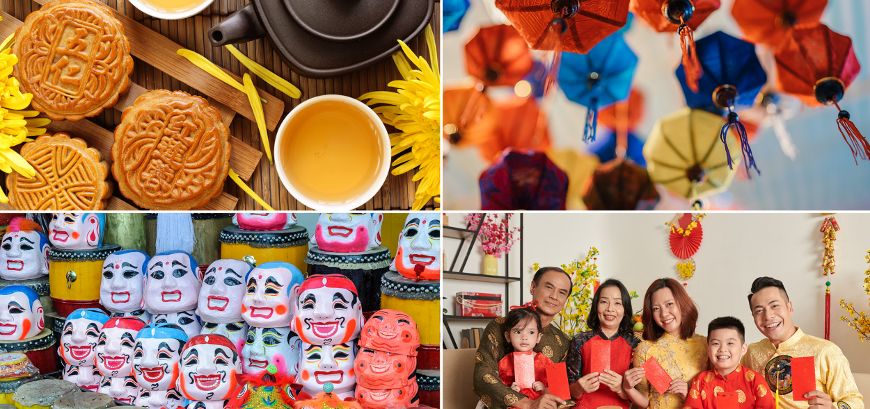  - Ask Ss to work in pairs, look at the picture and answer the questions:  What traditional festivals can you see?  What are some other activities people do during these festivals?  - Call some pairs to give their answers.  - Give feedback. | - Work in pairs, look at the picture and answer the questions.  -Share their ideas.  Ss’ own answers.
B. New lesson (35’)
1. Reading: 20’
a. Objectives: to help Ss improve their reading skills.
b. Content: tasks a, b, c and d.
c. Expected outcomes: Ss can read for specific details and have general idea about the text.
d. Organization
Teacher’s activities | Students’ activities
Pre-reading:  - Ask Ss to look at the picture and the title of the announcement, then guess its main purpose.  - Pick some Ss to give their answers.  - Write their guesses on the board.  Task a: Read the announcement. What is the main purpose of it?  1. Say when and where the festival will be.  2. Say what you can do at the festival.  - Ask Ss to read the announcement and choose the best main purpose.  - Let Ss check the answer with their partners.  - Pick some Ss to give their answers.  - Check the answer.  Vocabulary:  - take place (v phr) /teɪk pleɪs/ xảy ra  - People’s Committee (n phr) /ˈpiːpəlz kəˈmɪti/ ủy ban nhân dân  - Eve (n) /iːv/ ngày hoặc đêm trước lễ hội  - candied (a) /ˈkændid/ tẩm ướp đường  - Ask Ss to read the text and underline the words above.  - Get Ss to try to guess their meanings in the context first.  - Explain the meanings of the words.  - Ask Ss to listen and repeat chorally and individually.  - Check Ss’ remembering.  While-reading  Task b: Now, read and write True, False, or Doesn't say.  - Use DCR to show the task.  - Ask Ss to read the statement carefully and underline the key words.  - Get Ss to scan the text to find the key words.  - Ask Ss to write True, False, Doesn’t say next to the statements based on the information they find in the text.  - Set the time and monitor the class.  - Pick some Ss to give their answers and give evidence.  - Check Ss’ answers (using the DCR).  1. The announcement is for the 2020 Tết festival in Hiền Lương Village. _______  2. The festival will be on Lê Duẩn Street. _______  3. The festival is only free for children. _______  4. You can enjoy music performances from famous Vietnamese singers. _______  5. The festival will have some types of traditional Tết food like candied fruit and bánh chưng. _____  Task c: Listen and read.  - Play the CD and ask Ss to listen and read.  - Pick some Ss to read the passage and correct their pronunciation if necessary. | - Read the announcement and choose the best main purpose.  - Check the answer with their partners.  - Give their answers  Answer Keys:  2. Say what you can do at the festival.  - Read the text and underline the words.  - Try to guess their meanings in the context.  - Listen to the teacher and take notes the meanings of those words.  - Listen and repeat chorally and individually  - Answer the teacher.  - Read the statement carefully and underline the key words.  - Scan the text to find the key words.  Answer keys:  1. The announcement is for the 2020 Tết festival in Hiền Lương Village.  2. The festival will be on Lê Duẩn Street.  3. The festival is only free for children.  4. You can enjoy music performances from famous Vietnamese singers.  5. The festival will have some types of traditional Tết food like candied fruit and bánh chưng.  - Read the text again and write True, False, Doesn’t say next to the statements.  Answer Keys:  1. False (2023 Hiền Lương Village Tết Festival)  2. True (the 2023 Hiền Lương Village Tết Festival will take place on Lê Duẩn Street from January 21st to January 29th from 8 a.m. to 10 p.m.)  3. False (This is a free event for everyone.)  4. Doesn't say (Enjoy activities like street  music performances and lion dances.)  5. True (Enjoy different types of traditional Tết food like bánh chưng or candied fruit.)  -Listen and read.
Post – reading  Task d: In pairs: Which Tết activities do you like best? Why?  - Ask Ss to work in pairs to answer the questions.  - Monitor the class and help them if necessary.  - Pick some Ss to share their ideas. | - Work in pairs to answer the questions.  - Share their ideas.  Sample answer:  I like playing games with my family  and friends because it's fun!
2. Writing: 15’
a. Objective: to help Ss know the structure of a long-form announcement and what to write in each part.
b. Content: task a and b.
c. Expected outcomes: Ss can order sentences to make a complete long-form announcement.
d. Organization
Teacher’s activities | Students’ activities
Read about writing long-form announcements. Then, read the announcement for the Tết Festival again and underline the place, time, cost, activities, and food for the event.  - Ask Ss to read about writing long-form announcements and answer the questions below in pairs:  a) How many parts are there in a long-form announcement?  b) What is the function of each part?  - Pick some Ss to give their answers.  - Check the answer.  Writing skill  Writing long-form announcements  To write a long-form announcement, you should:  1. Write a heading. Say what the event is.  The 2024 Culture Festival  2. Write a summary sentence about what, where, and when the festival is.  We are excited to announce the 2024 Culture Festival will take place at King Park on Saturday,  October 8th from 1 p.m. to 10 p.m.  3. Give a call to action. Ask the readers to take part or join in.  Come and celebrate the 2024 Culture Festival…  4. Say the cost.  This is a free event for everyone; Tickets to the festival cost 50,000 VND.  5. Say the different activities and food at the festival.  Enjoy activities like…, Take part in…, Eat many types of traditional food like…  - Ask Ss to read the announcement for the Tết Festival again and underline the place, time, cost, activities, and food for the event.  - Let Ss check with their partners.  - Pick some Ss to give their answers.  - Check the answer.  Task b: Reorder the parts of the announcement. Use the Writing skill box to help you.  - Ask Ss to number the sentences (1–5).  - Set the time and go around to help.  - Let Ss check with their partners.  - Pick some Ss to write their answers on the board.  - Check the answers.  Tickets to the festival cost 25,000 VND.  Take part in activities like a lantern parade.  The 2024 Mid-Autumn Festival  Come and take part in the 2024 Mid-Autumn Festival.  We are happy to announce the 2024 Mid-Autumn Festival will take place on Nguyễn Huệ Street on Tuesday, September 21st from 1 p.m. to 9 p.m. | - Read about writing basic descriptive passages and answer the questions in pairs.  - Give their answers  Answer Keys:  a) There are five parts: a heading, a summary sentence, a call to action, the cost, the different activities and food.  b) A heading: say what the event is.  A summary sentence: say what, where, and when the festival is.  A call to action: ask the readers to take part or join in.  The cost: say how much a ticket is  Activities and food :say the different activities and food at the festival.  - Read the announcement for the Tết Festival again and underline the place, time, cost, activities, and food for the event.  - Check with their partners.  - Give their answers.  Answer keys:  Place: Lê Duẩn Street  Time: from January 21st to January 29th from 8 a.m. to 10 p.m.  Cost: free  Activities and food:  - Street music performances and lion dances.  - Watch the amazing fireworks show  - Enjoy different types of traditional Tết food like bánh chưng or candied fruit.  - Number the sentences (1–5).  - Check with their partners.  - Write their answers on the board.  Answer keys:  1. The 2024 Mid-Autumn Festival  2. We are happy to announce the 2024 Mid-Autumn Festival will take place on Nguyễn Huệ Street on Tuesday, September 21st from 1 p.m. to 9 p.m.  3. Come and take part in the 2024 Mid-Autumn Festival.  4. Tickets to the festival cost 25,000 VND.  5. Take part in activities like a lantern parade.
C. Consolidation and homework assignments: 5 minutes
- Vocabulary: take place, People’s Committee, Eve, candied.
- Do exercises in workbook on page 12.
- Prepare the next lesson: Lesson 3.2 – Speaking & Writing, page 23.
- Do the exercises in Tiếng Anh 8 i-Learn Smart World notebook (page 18).
5. Reflection

a. What I liked most about this lesson today:
…………………………………………………………………………………………
b. What I learned from this lesson today:
…………………………………………………………………………………………
c. What I should improve for this lesson next time:
…………………………………………………………………………………………

