Period
LESSON PLAN
TIẾNG ANH 10 FRIENDS GLOBAL
UNIT 3: ON SCREEN
LESSON 3E: WORD SKILLS – NEGATIVE ADJECTIVE PREFIXES
I. OBJECTIVES:
By the end of the lesson, Ss will be able to:
1. Knowledge:
- form and use adjectives with negative prefixes
- discuss about a problem in groups
2. Ability:
- main skills: reading and writing skills
- sub skills: listening and speaking skills
- discuss and share ideas about privacy
3. Quality:
- have positive attitude in English language learning so that they can participate enthusiastically in all classroom activities, especially with the topic conducted by the teacher
- keen on studying English
II. TEACHER AIDS AND LEARNING MATERIALS:
Lesson plan, PPT slides, student’s book, workbook, notebook, personal computer (if any), projector/TV, speakers, IWB software.
III. PROCEDURES:
A. Warm-up (5’)
a) Objective: Introduce the new lesson and set the scene for Ss to acquire new language; get students' attention at the beginning of the class by means of enjoyable and short activities as well as to engage them in the steps that followed.
b) Content: Task 1 page 39
c) Outcomes: Students can gain more confidence and interest in the lesson.
d) Competence: communication, collaboration, guessing
e) Organisation of the activity:
TEACHER’S ACTIVITIES | STUDENT’S ACTIVITIES | CONTENTS
WARM-UP. T-Ss/ S-S/ Indiv  Activity 1 (3’): Discussion  - Ask students to discuss with their partners about “privacy”  - Invite some students to give the answers  - Explain the meaning of “privacy” for students to understand deeply and give them some extra information  Activity 2 (2’): Exercise 1 page 39  - Ask students to read the notices  - Ask them: “What are these notices warning you not to do?”  - Lead in the lesson: Negative adjective prefixes | - Discuss with their partners  - Volunteer to answer  - Listen to the teacher and take notes if needed  - Read the notices  - Volunteer to share ideas  - Open the course book page 39 | 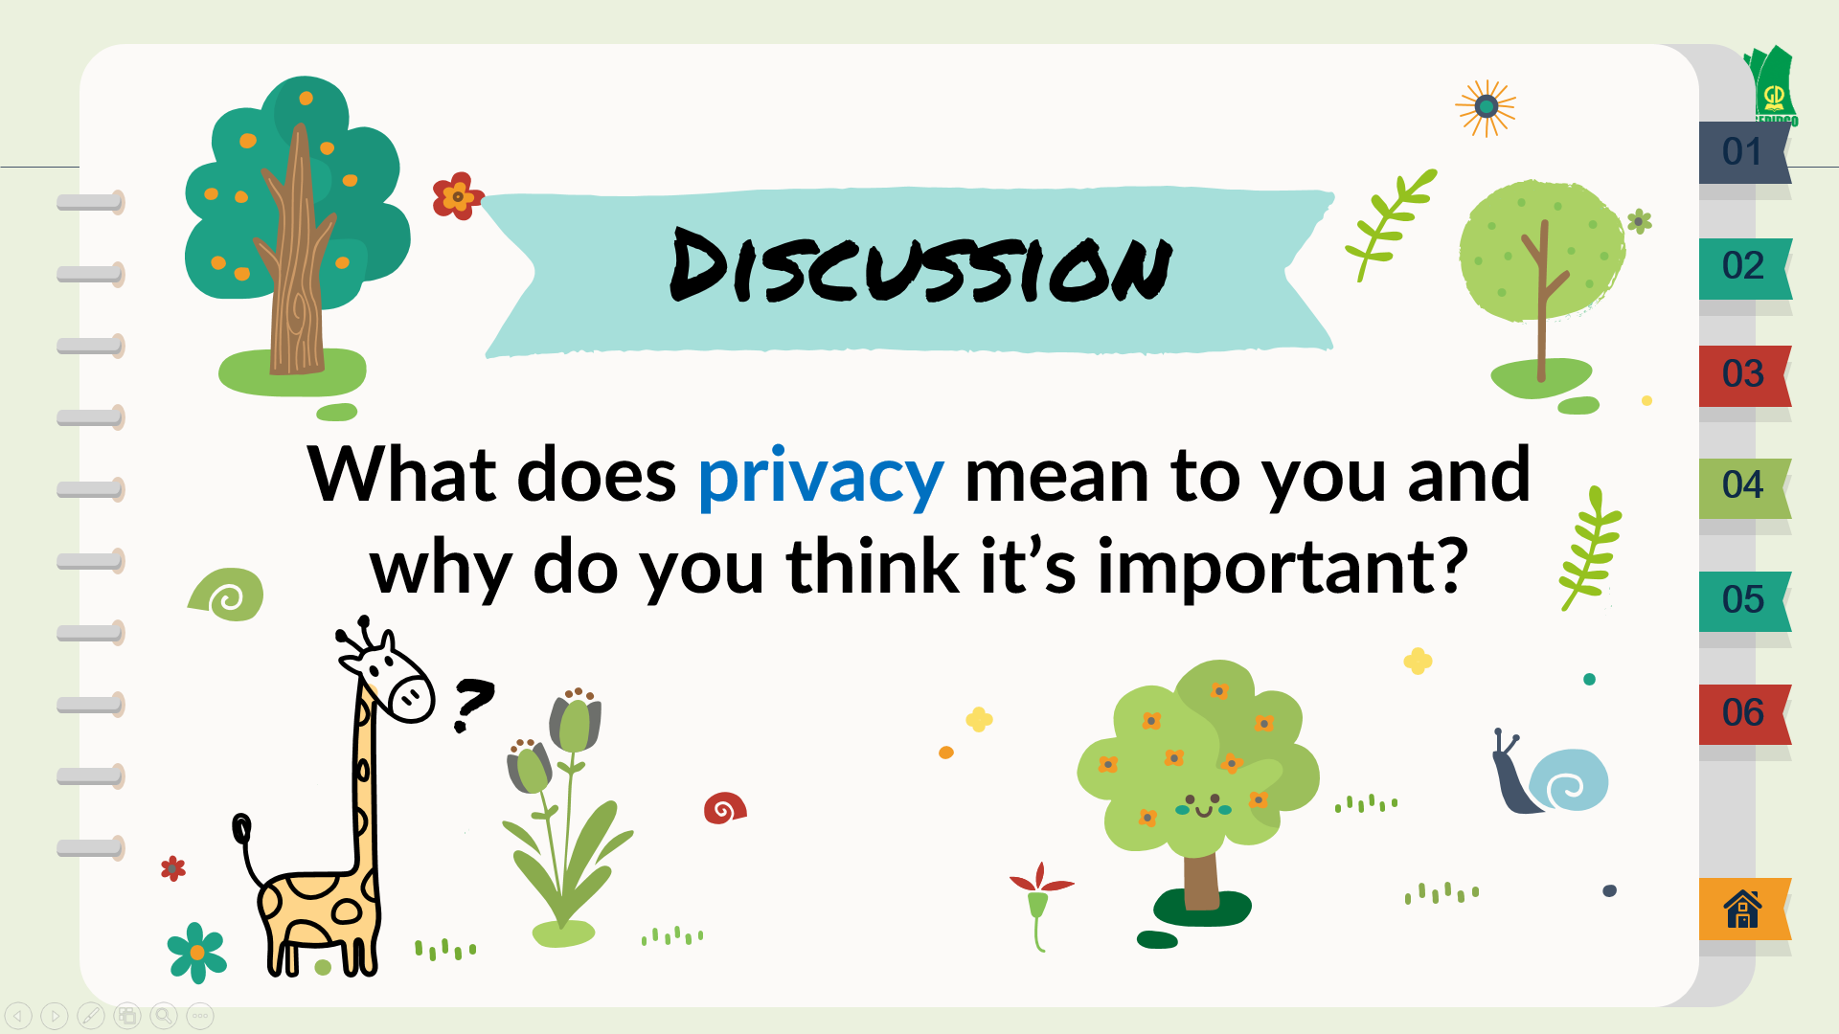  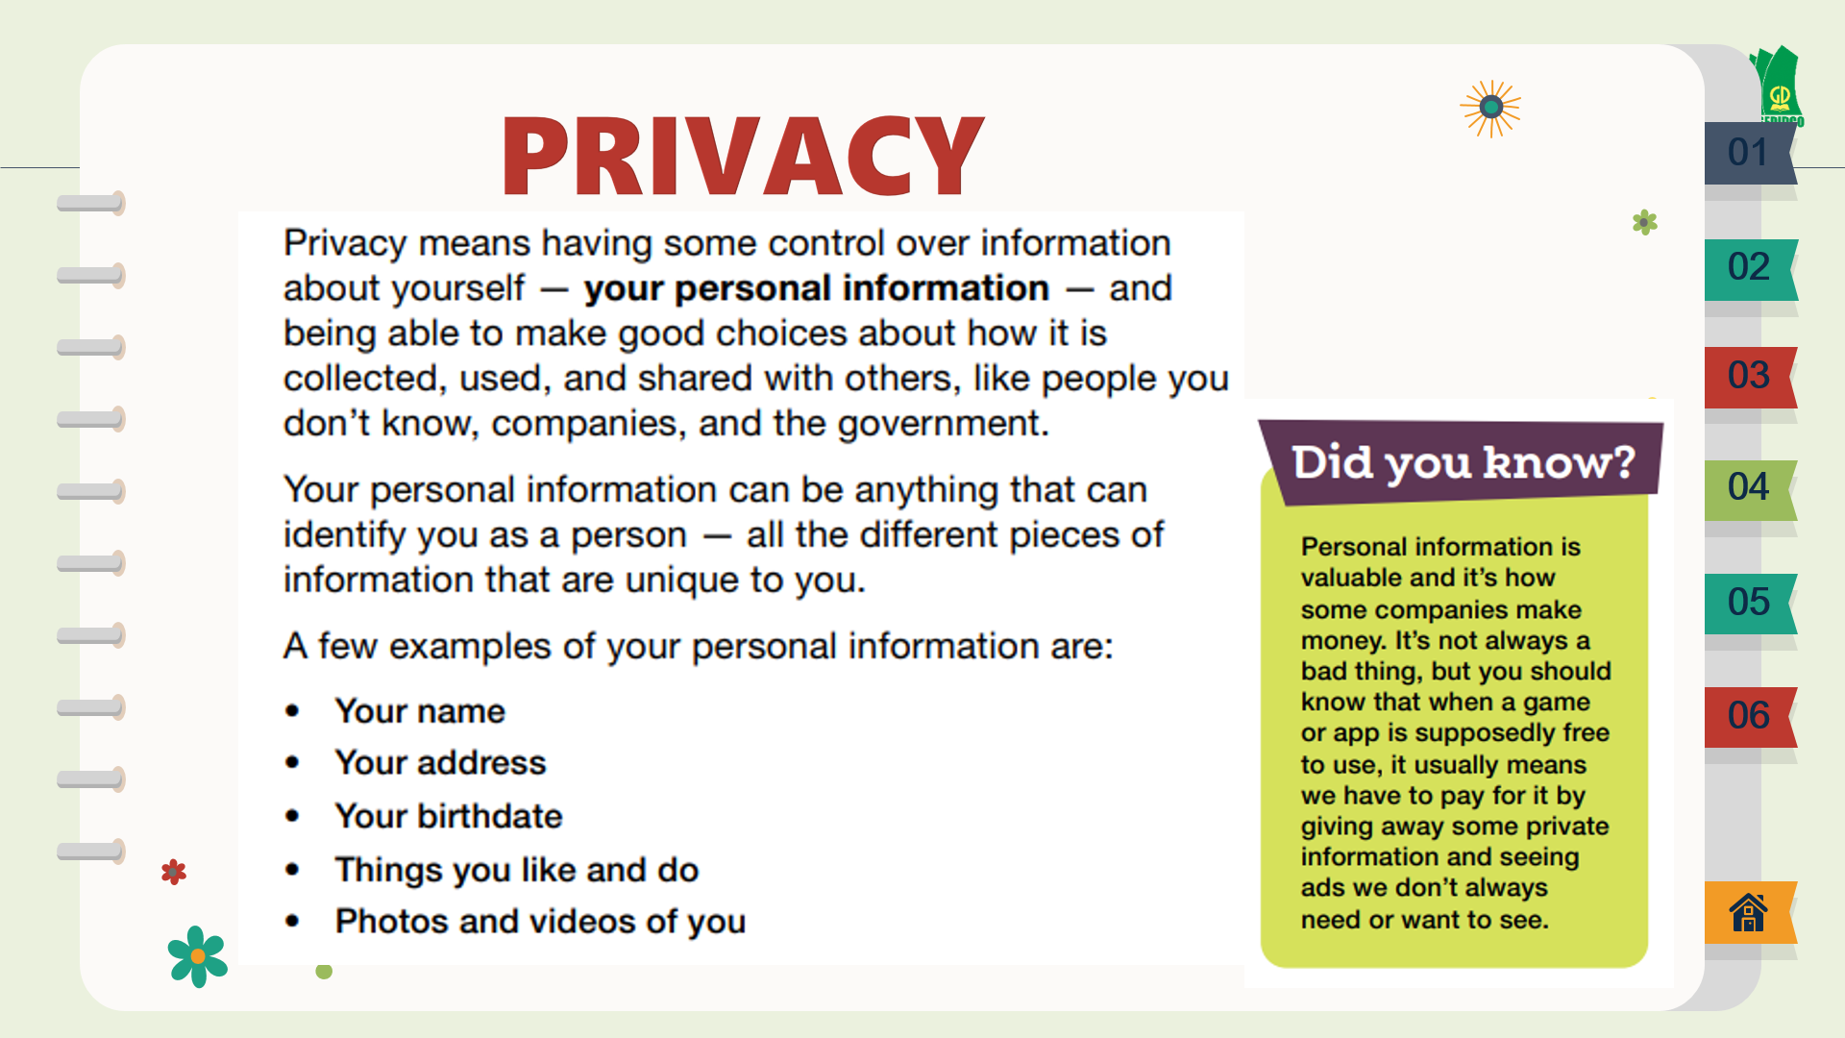    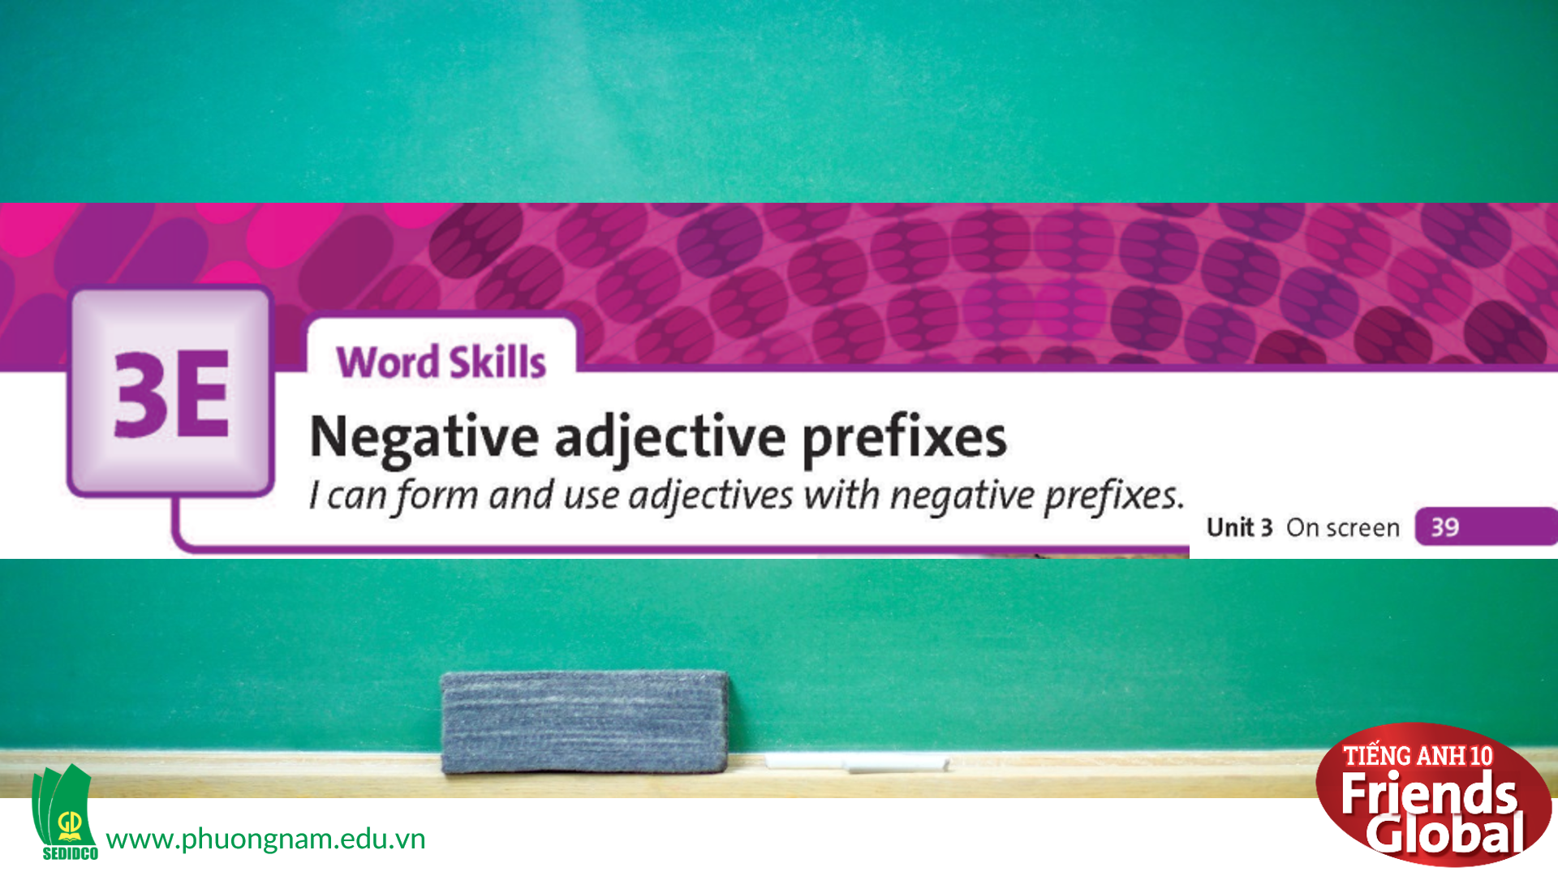

B. New lesson (35’)
- Activity 1: Presentation (5’)
a) Objective: Students learn some new adjectives
b) Content:
Grammar
Reading
c) Outcomes: Students know how to pronounce the new words precisely and use them in appropriate contexts.
d) Competence: communication, presentation
e) Organisation of the activity:

TEACHER’S ACTIVITIES | STUDENT’S ACTIVITIES | CONTENTS
PRESENTATION. T-Ss/ S-S/ Indiv  Teach new vocabulary  - Use GIFs and short explanation to present new words  - Have students practice their pronunciation drills  New words:  acceptable (a)  dependent (a)  visible (a)  responsible (a)  legal (a) | - Some students will answer the question in order to learn new words.  - Listen to the teacher and repeat in whole class and individuals | 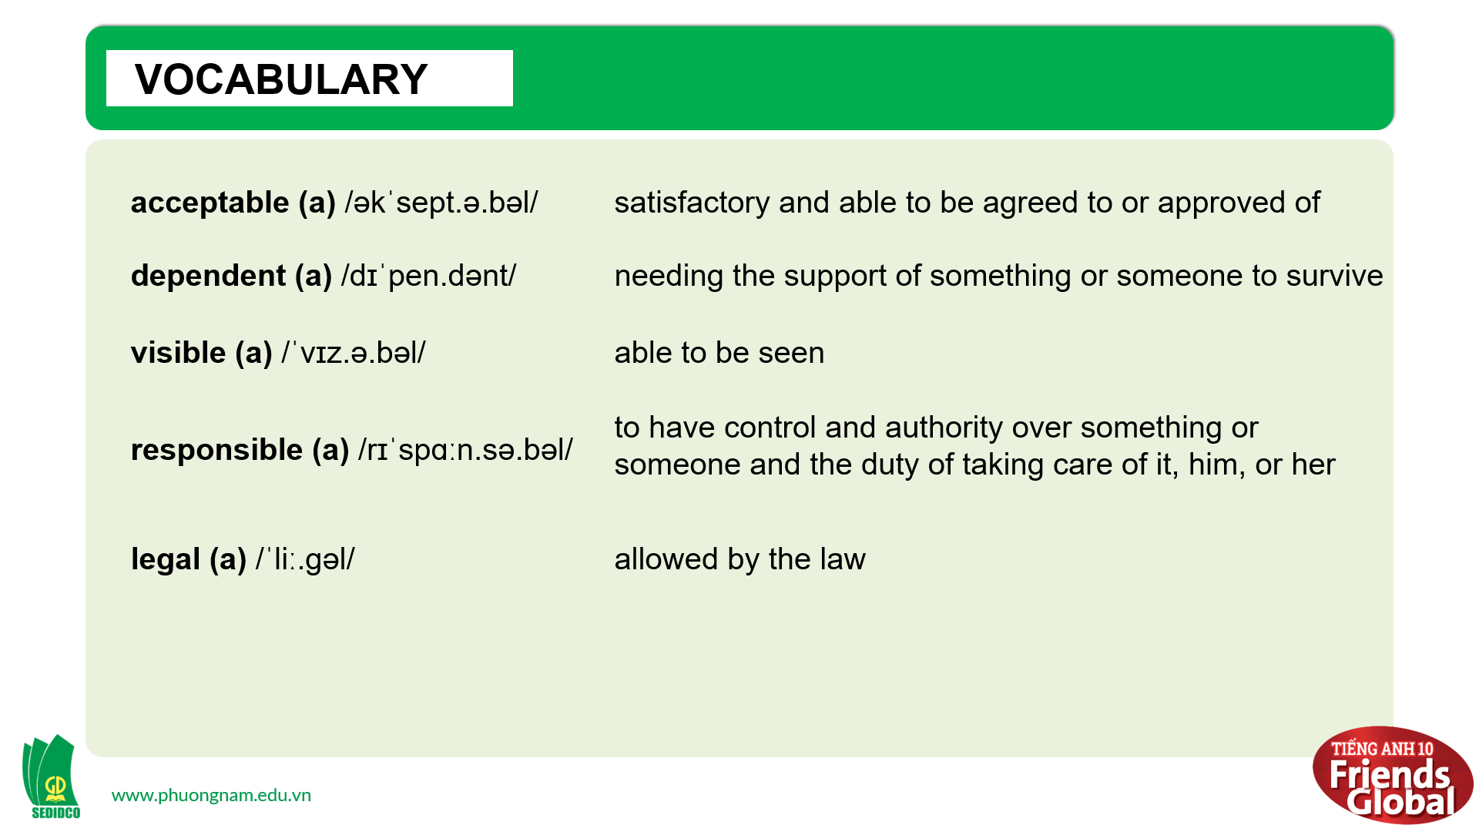
- Activity 2: Practice (20’)
a) Objective: Students can answer the questions to critical thinking, and they can finish the tasks in the textbook. Critical thing skills (guessing/ reasoning) and communication can also be practiced.
b) Content: Students learn more about synonyms and antonyms of adjectives, they also learn how to form and use adjectives with negative prefixes.
c) Outcomes: Students know how to form and use adjectives with negative prefixes in complete sentences.
d) Competence: communication, collaboration, presentation
e) Organisation of the activity:
TEACHER’S ACTIVITIES | STUDENT’S ACTIVITIES | CONTENTS
PRACTICE. T-Ss/ S-S/ Indiv  Activity 1 (3’): Task 2 page 39  - Ask students to read the text about the view of some teenagers and answer questions  - Check the answers  Activity 2 (4’): Task 3 page 39  - Go through the Learn this! box with students and highlight main ideas  - Ask students to find the opposites of the adjectives in the text in ex2  - Check answers as a class  Activity 3 (3’): Task 4 page 39  - Ask students to read the Dictionary Skill Strategy underline main ideas  - Then study the dictionary entry and answer questions  - Check the answers  Activity 4 (5’): Task 5 page 39  - Ask students to rewrite the sentences using the adjectives in blankets with a negative prefix  - Students can use a dictionary for help.  - Give the answers to class  Activity 5 (5’): Task 6 page 39  - Ask students to complete the sentences with adjectives with the opposite meaning  - Check the answer | - Read the text and answer questions  - Check the answers with the teacher.  - Read the Learn this! box and highlight main ideas  - Work in pairs to complete the task  - Check the answers with the teacher  - Understand what to do.  - Read the Dictionary Skill Strategy and underline main ideas  - Work in pairs to complete the task  - Check the answers with the teacher  - Complete the task  - Students can use a dictionary if necessary.  - Check the answers with the teacher  - Complete the task  - Check the answers with the teacher | 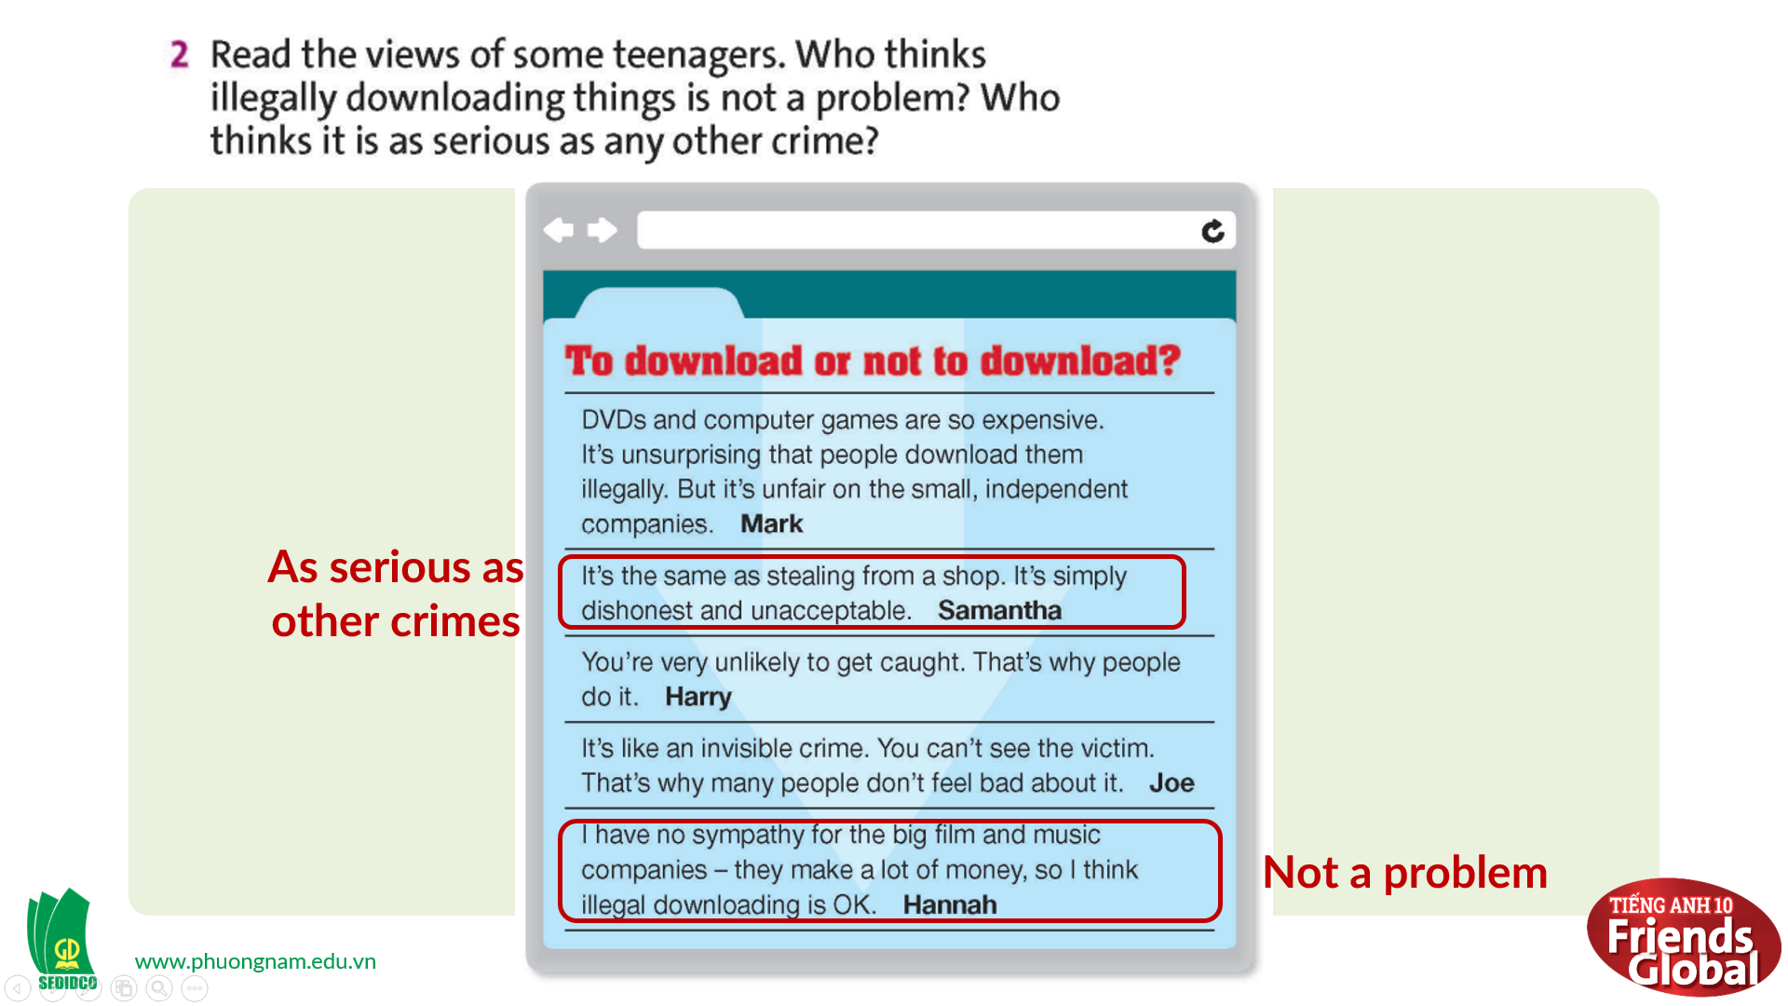  Answers:  Samantha: As serious as other crimes  Hannah: Not a problem  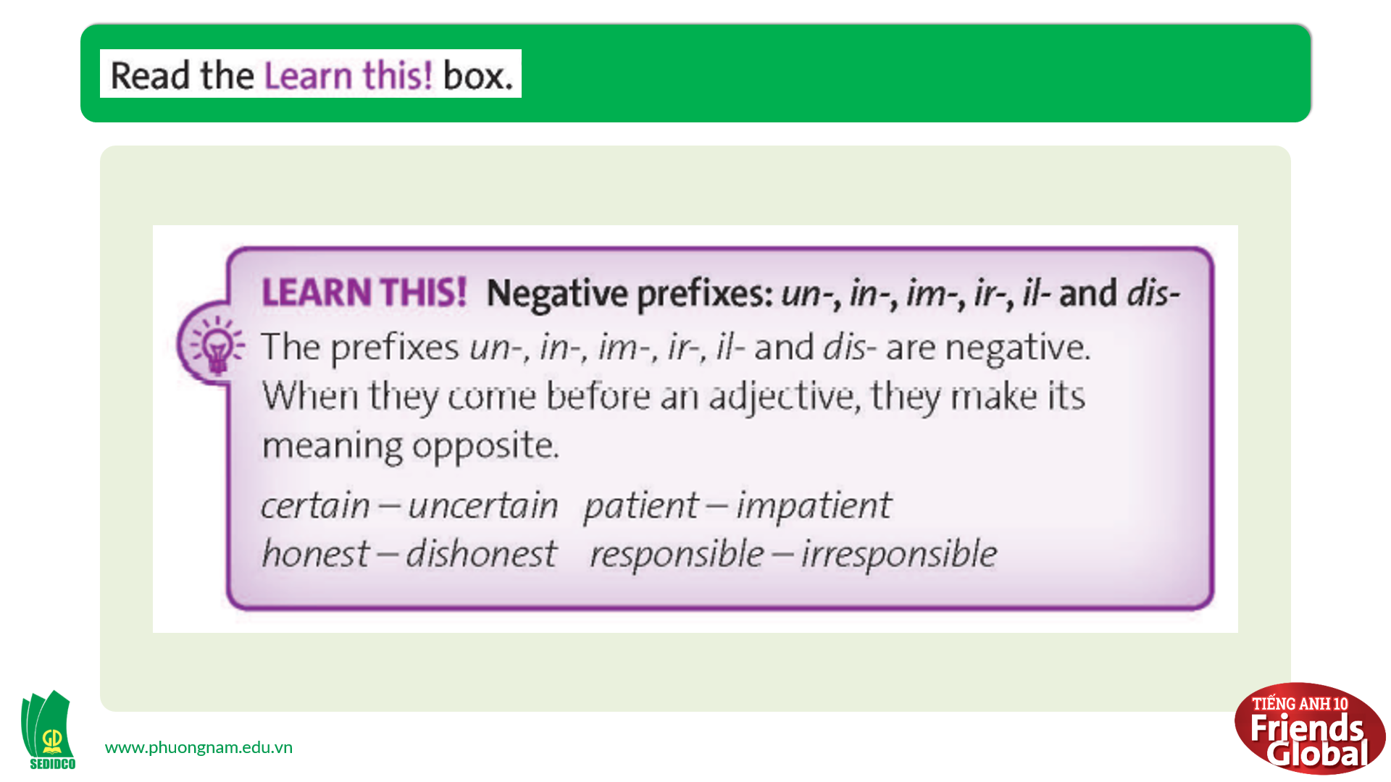  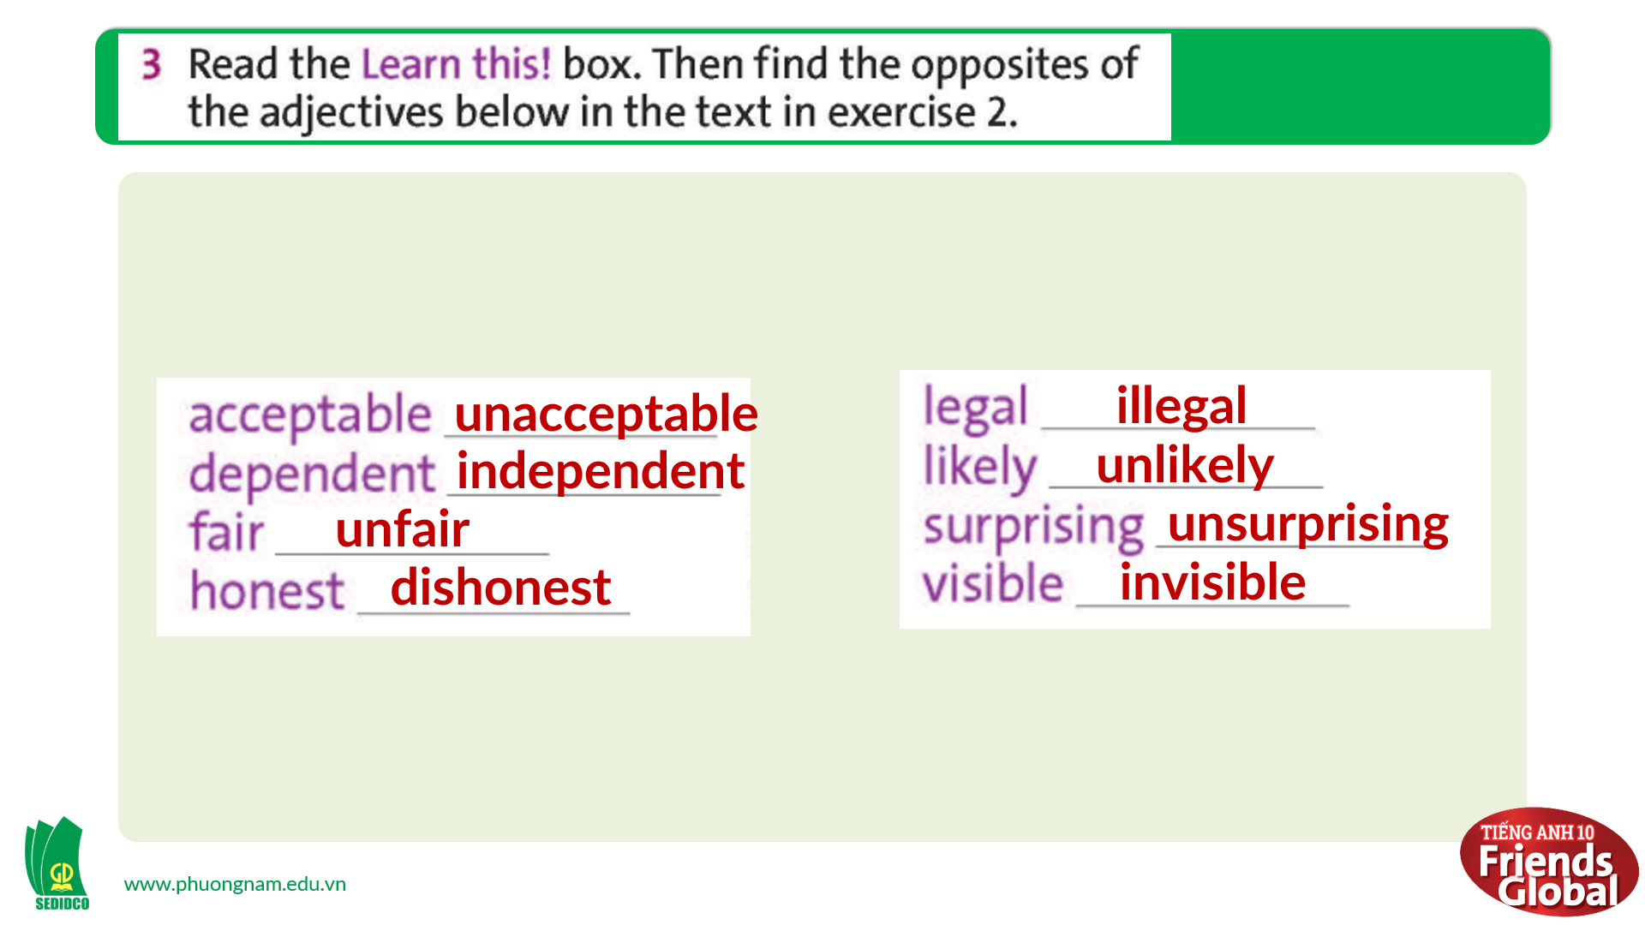  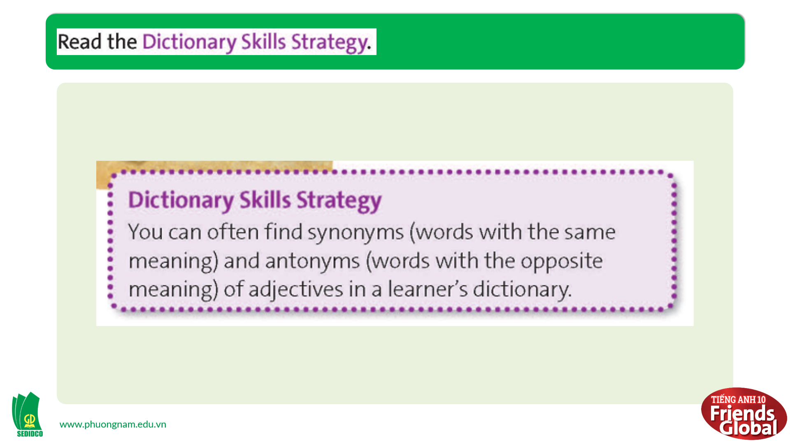  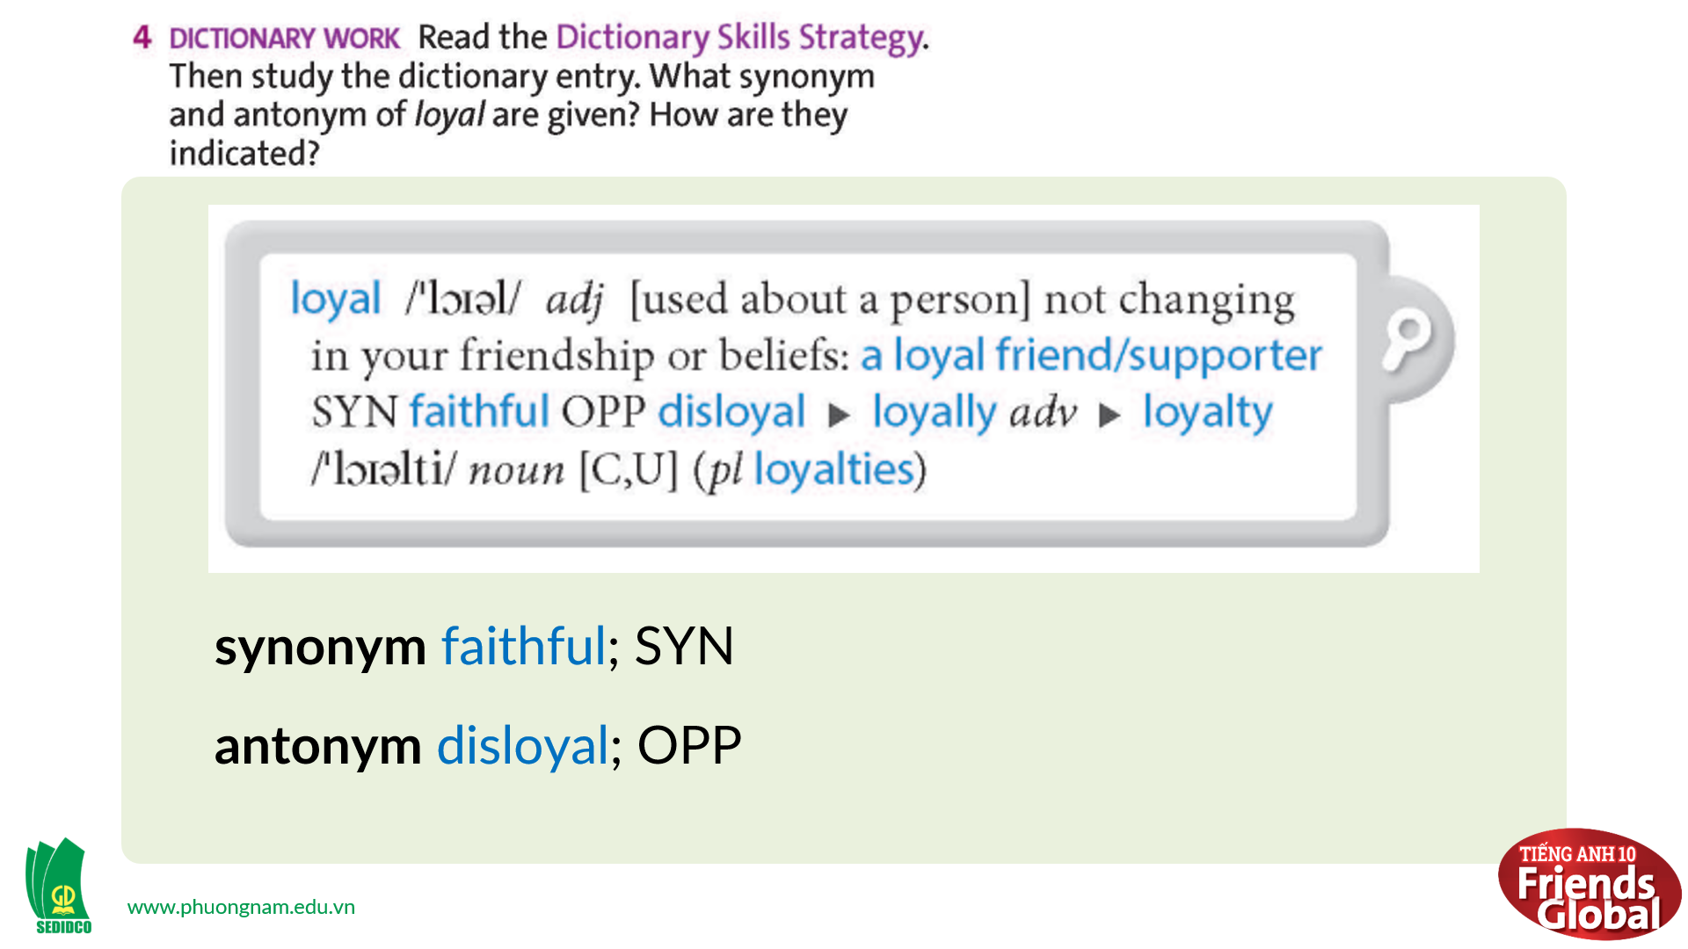  Answers:  synonym faithful; SYN  antonym disloyal; OPP  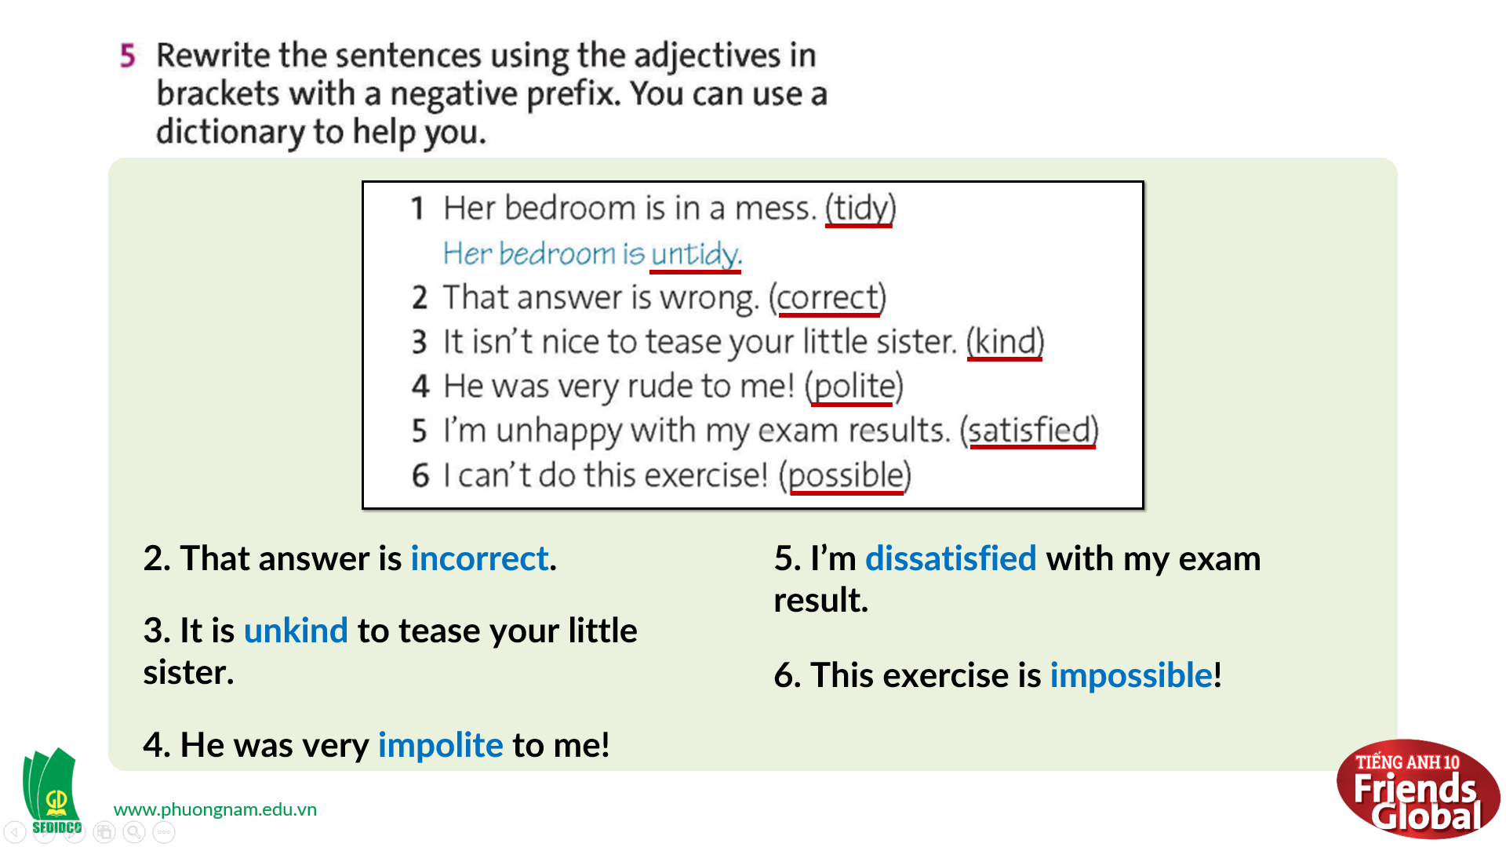  Answers:  2. That answer is incorrect.  3. It is unkind to tease your little sister.  4. He was very impolite to me!  5. I’m dissatisfied with my exam result.  6. This exercise is impossible!  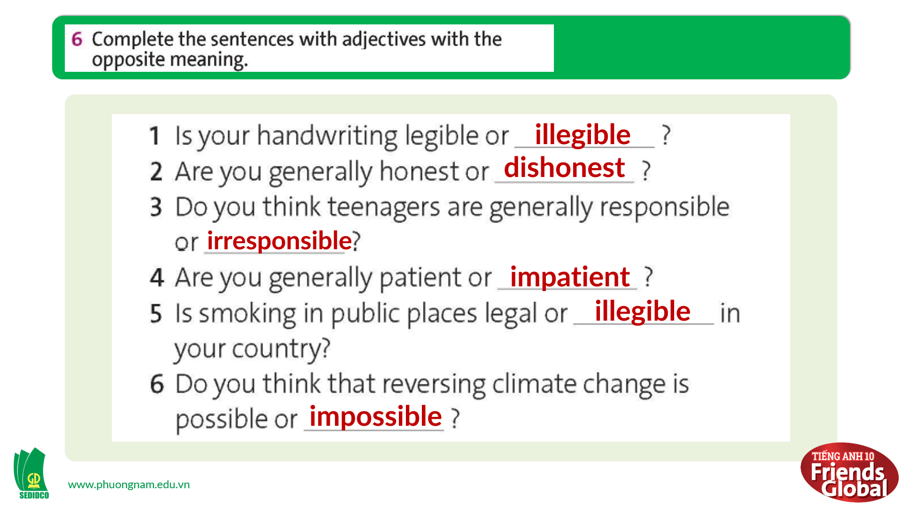  Answers:  1. illegible  2. dishonest  3. irresponsible  4. impatient  5. illegible  6. impossible

- Activity 3: Outcomes (10’)
a) Objective: Students can answer the questions to critical thinking. Communication can also be practiced.
b) Content: Students work in pairs and discuss the sentences in exercise 6.
c) Outcomes: Students practice speaking and apply some structures they learnt in discussion.
d) Competence: Collaboration, communication, guessing
e) Organisation of the activity:
TEACHER’S ACTIVITIES | STUDENT’S ACTIVITIES | CONTENTS
PRODUCT. T-Ss/ S-S/ Indiv  Task 6 page 39  - Ask students to work in pairs, take turns to ask and answer the questions they have completed above  - Invite some pairs to share their ideas  - Correct students’ pronunciation and give feedbacks | - Work in pairs and practice speaking  - Volunteer to share their ideas  - Take notes if needed | 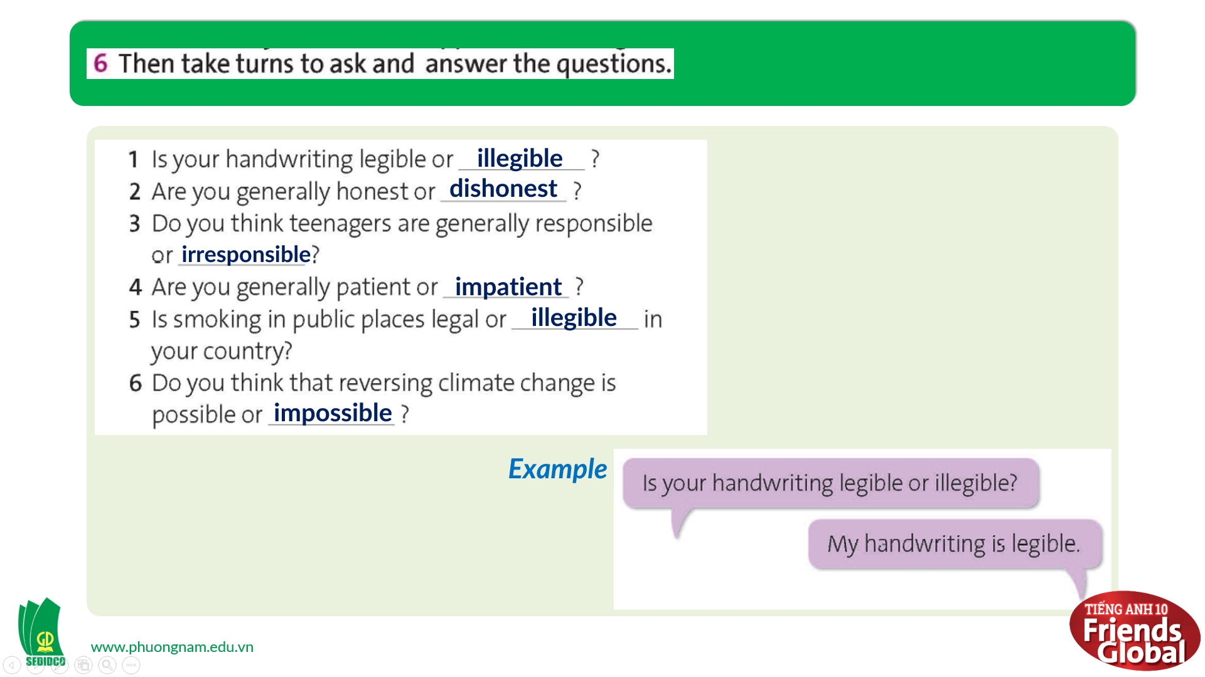
C. Consolidation (3’)
- Students learn some new adjectives with their synonyms and antonyms.
- Students can form and use adjectives with negative prefixes to discuss a problem.
D. Homework (2’)
- Review and practice using dictionary to look up words
- Learn by heart all negative prefixes’ rules
- Do exercise
- Prepare: Unit 3F: Reading (page 40&41 – SB)

