School: ……………………………………….. | Date: …………………………………..
Class: ……………………………..................... | Period: ………………………….........

UNIT 6: EDUCATION
Lesson 2.3 – Pronunciation and Speaking (page 49)

I. OBJECTIVES
By the end of the lesson, Ss will be able to:
1.1. Language knowledge and skills
- distinguish and put stress on intensifiers for emphasis correctly.
- talk about feelings.
- act out the situations for partners to guess how they feel and give reason.
1.2. Competences
- improve listening and speaking skills.
1.3. Attributes
- overcome studying pressure and negative feelings.
- have a balance between studying and relaxing.

II. TEACHING AIDS AND LEARNING MATERIALS
1. Teacher’s aids: Student book and Teacher’s book, class CDs, Digital Book (DCR phần mềm tương tác SB, DHA (từ vựng/ cấu trúc) phần mềm trò chơi tương tác), projector/interactive whiteboard / TV (if any), PowerPoint slides, handouts.
2. Students’ aids: Student’s book, workbook, notebook, pens, pencils, crayons.

III. ASSESSMENT EVIDENCE
Performance Tasks | Performance Products | Assessment Tools
- Listen to the sentences and focus on the underlined word. | - Ss’ performance and answers. | - T’s observation.
- Listen and cross out the sentence that doesn’t follow the note in “a”. | - Ss’ answers. | - T’s feedback/Peers’ feedback.
- Read the sentences with the sentence stress noted in “a” to a partner. | - Ss’ performance. | - T’s feedback/Peers’ feedback.
- Practice the conversation. Swap roles and repeat. | - Ss’ performance. | - T’s feedback/Peers’ feedback.
- Practice with your own ideas. | - Ss’ performance. | - T’s feedback/Peers’ feedback.
- You're at school and want to know why your friend feels good or bad. In pairs: Take turns acting out the situations in the pictures while your partner guesses how you feel and why | - Ss’ performance /  Presentation. | - T’s observation, T’s feedback/Peers’ feedback.
- Join another pair and a play again using your own ideas. | - Ss’ performance /  Presentation. | - T’s observation, T’s feedback/Peers’ feedback.

IV. PROCEDURES
A. Warm up: (5’)
a) Objective: Introduce the new lesson and set the scene for Ss to acquire new language; get students' attention at the beginning of the class by enjoyable and short activities as well as to engage them in the follow-up steps.
b) Content: Review: Intensifiers / Review words about feelings in studying.
c) Expected outcomes: Ss remember old knowledge and use them in other speaking activities.
d) Organization of the activity:
TEACHER’S ACTIVITIES | STUDENTS’ ACTIVITIES
- Option 1: Error recognition  - Give some sentences, have Ss read the sentences and circle a word / phrase in each sentence that needs correcting.  - Have Ss try to make the sentences right.  - Call Ss to read answers or write answers on the board.  - Give feedback.  - Lead to the new lesson:  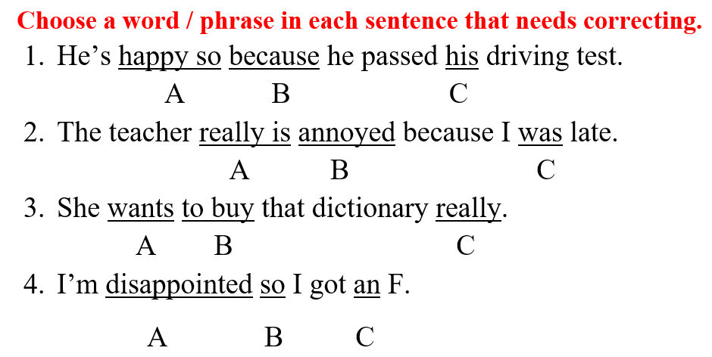  - Option 2: Review words about feelings in studying.  - Have Ss close all books.  - Show 6 pictures, have Ss look at the pictures and use an adjective to describe the feeling of the person in each picture.  - Call Ss to give answers.  - Give feedback.  - Lead to the new lesson.  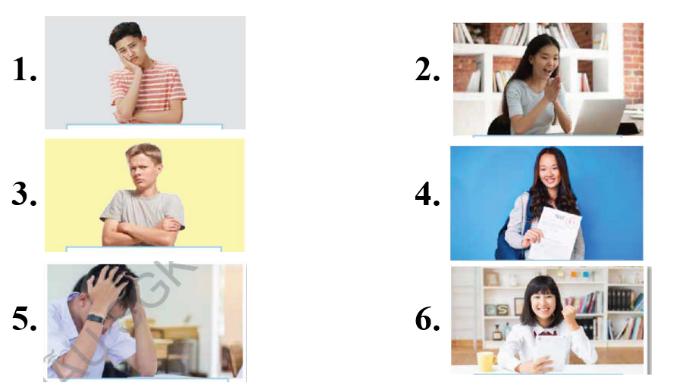 | - Work in pairs, then give answers.  Answer keys  1A: so happy  2A: is really  3C: She really wants to buy that dictionary.  4B: because  - Close books.  - Observe and give answers.  Answer keys  1 upset  2 surprised  3 annoyed  4 pleased  5 disappointed  6 delighted  The answers may vary.

B. New lesson (35’)
- Activity 1: Pre-Speaking: Pronunciation (8’)
a) Objective: Introduce stress on intensifiers for emphasis.
b) Content:
- recognize: stress on intensifiers for emphasis.
- listen and check, cross out the sentence that doesn’t follow the note in “a”.
- practice.
c) Expected outcomes: Ss distinguish and put stress on intensifiers for emphasis correctly in their speaking.
d) Organization of the activity:
TEACHER’S ACTIVITIES | STUDENTS’ ACTIVITIES
Task a + b. Listen to the sentence and focus on the underlined words.  - Play the recording (CD1, track 66).  - Ask Ss to listen and focus on the stress of the underlined words.  - Play the recording again, have Ss listen and repeat with a focus on the stress feature.  Task c + d. Listen and cross out the sentence that doesn’t follow the note in “a”.  - Play the recording (CD 1 – Track 67), have Ss listen and cross out the option that doesn’t follow the note in “a”.  - Call Ss to give answers.  - Play the recording again and check answers as a whole class using DCR.  - Give feedback and evaluation. | - Listen.  - Listen again and repeat.  - Listen and give answers.  Answer keys  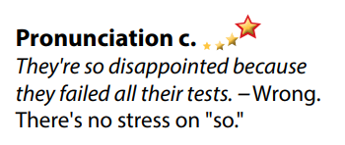
- Activity 2: While-speaking (22’)
a) Objective: Students can talk about feeling and express their feelings in studying.
b) Content:
- Practice the conversation. Swap roles and repeat.
- You're at school and want to know why your friend feels good or bad. In pairs: Take turns acting out the situations in the pictures while your partner guesses how you feel and why.
c) Expected outcomes: Ss produce the new language successfully.
d) Organization of the activity:

TEACHER’S ACTIVITIES | STUDENTS’ ACTIVITIES
PRACTICE  * Task a. Practice the conversation. Swap roles and repeat.  - Demonstrate the activity by practicing the role-play with a student.  - Divide the class into pairs.  - Have pairs practice the conversation.  - Swap roles and repeat using the ideas on the right.  - Have some pairs demonstrate the activity in front of the class.  - Give feedback and evaluation.  * Task b. Practice with your own ideas.  - Have students practice the conversation with their own ideas. Swap roles.  - Have some pairs demonstrate the activity in front of the class.  - Give feedback and evaluation.  SPEAKING: What’s Up?  Task a. You're at school and want to know why your friend feels good or bad. In pairs: Take turns acting out the situations in the pictures while your partner guesses how you feel and why.  - Demonstrate the activity by practicing the activity with a student.  - Divide the class into pairs.  - Have Ss take turns choosing one of the pictures and acting out the situation.  - Have the other student try to guess how they feel and why.  - Observe, give help if necessary. | - Observe, listen.  - Work in pairs.  - Swap the roles and repeat.  - Present.  - Work in pairs.  - Present.  - Observe and listen.  - Work in pairs.  - Do the task.  - Guess.

- Activity 3: Production (5’)
a) Objective: Students can have a free talk about their feelings in studying.
b) Content: Join another pair and play again using your own ideas.
c) Expected outcomes: Ss produce the new language successfully in everyday speaking and writing.
d) Organization of the activity:
TEACHER’S ACTIVITIES | STUDENTS’ ACTIVITIES
SPEAKING: What’s Up?  Task b. Join another pair and play again using your own ideas.  - Have pairs join another pair and continue to act out.  - Have some pairs act out the situation in front of the class.  - Give feedback and evaluation. | - Join another pair and continue acting out the situation.  - Present.

C. Consolidation and homework assignments (5’)
* Consolidation: Stress on intensifiers for emphasis.
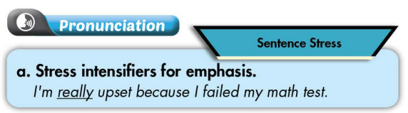

* Homework:
- Practice: putting tress on intensifiers for emphasis.
- Review words about feelings.
- Prepare: Unit 6 - Lesson 3 –Listening and Reading (page 50 – SB).
- Review the vocabulary and grammar notes in Tiếng Anh 7 i-Learn Smart World Notebook
(pages 38 & 39).
- Play consolation games in Tiếng Anh 7 i-Learn Smart World DHA App on www.eduhome.com.vn

D. Reflection
a. What I liked most about this lesson today:
…………………………………………………………………………………………
- What I learned from this lesson today:
…………………………………………………………………………………………
c. What I should improve for this lesson next time:
…………………………………………………………………………………………

