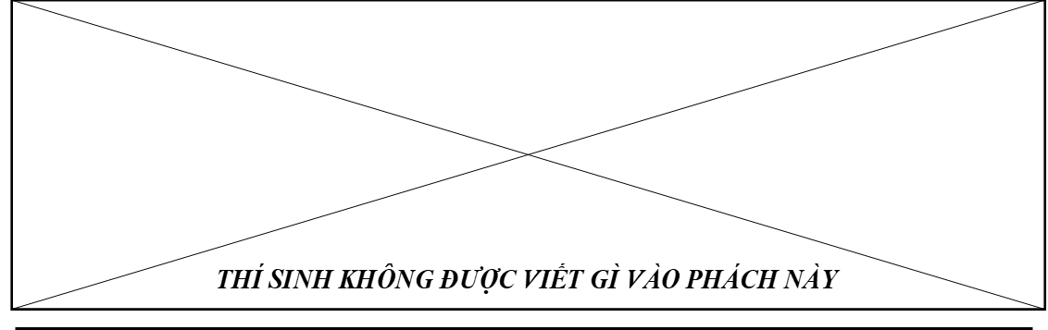
V. Use the correct form of the word given in each sentence. (1.5 pts)
29/ They are _____________ in their business because they can afford expensive cars. (unsuccess)
30/ I haven’t seen him since I _______________ a student. (be)
31/ She needs to ______________her Spanish pronunciation. (improvement)
32/ Jasmine _______________ to Vietnam since 2010. (be)
33/ People in the country are often more _____________than people in the city. (friend)
34/ Internet is now an _____________forum for exchanging opinions and ideals. (importance)

Thí sinh phải viết từ cần điền vào Phần trả lời (Answer) dưới đây.
Answer: 29/___________________ 30/ ____________________ 31/___________________
32/___________________ 33/ ____________________ 34/___________________

VI. Rearrange the groups of words in a correct order to make complete sentences. (0.5 pt)
35/ at least 1,5 m / Keeping distance / protecting / is / and your family. / yourself /
36/ the classroom. / Both boys / to be outside / but / they prefer / enjoy school, /
Thí sinh viết tiếp các nhóm từ và dấu câu theo đúng trình tự vào Phần trả lời để hình thành câu hoàn chỉnh.
Answer:
35/________________________________________________________________________________________
36/________________________________________________________________________________________

VII. Rewrite each of the following sentence in another way so that it means almost the same as the sentence printed before it. (1.0 pt)
37/ He started to learn French when he was nine years old.
He has _________________________________________________________________________________
38/ Susan turns on the TV. She wants to watch cartoon.
Susan turns on the TV so _________________________________________________________________
39/ Mother said: “Please bring this box upstairs, Lyn”
Mother asked ___________________________________________________________________________
40/ I usually stayed up late to watch football matches last year, but now I don’t.
I used __________________________________________________________________________________

Thí sinh viết tiếp những câu trên theo đúng yêu cầu của đề dẫn vào Phần trả lời (Answer) dưới đây.
Answer:
37/ He has _________________________________________________________________________________
38/ Susan turns on the TV so __________________________________________________________________
39/ Mother asked ___________________________________________________________________________
40/ I used __________________________________________________________________________________
Page 4
THE END OF THE TEST
PHÒNG GIÁO DỤC VÀ ĐÀO TẠO QUẬN 12  TRƯỜNG TRUNG HỌC CƠ SỞ  NGUYỄN CHÍ THANH |  | KÌ THI KIỂM TRA CUỐI KÌ I NĂM HỌC 2021-2022  NGÀY: ………/………/………  MÔN THI: TIẾNG ANH 8  Thời gian làm bài: 60 phút  (Không kể thời gian phát đề)
Họ và tên thí sinh:  …………………………………………………………  Lớp: ……………………………………………………  Số báo danh: ……..…………………………………… |  | Chữ ký giám thị 1 | Chữ ký giám thị 2 | SỐ THỨ TỰ CỦA MỖI BÀI  Do Giám thị ghi
 |  | Chữ ký giám thị 1 | Chữ ký giám thị 2 | SỐ PHÁCH  Do CT HĐ chấm thi ghi
Điểm bằng số | Điểm bằng chữ | Chữ ký giám khảo 1 | Chữ ký giám khảo 2 | SỐ PHÁCH  Do CT HĐ chấm thi ghi
SỐ THỨ TỰ CỦA MỖI BÀI
Do Giám thị ghi

LƯU Ý QUAN TRỌNG: Đề thi gồm 4 trang. Thí sinh làm bài ngay trên đề thi này. Thí sinh phải làm đúng theo hướng dẫn cách ghi câu trả lời ở mỗi phần. Bài làm chỉ được chấm ở các Phần trả lời (Answer). Mọi cách ghi khác đều không được chấm điểm.

I. Choose the word / phrase (A, B, C or D) that best fits the space in each sentence. (3.5 pts)

1/ Young children do not understand that many __________ objects are dangerous.
A. housework B. homeless C. homework D. household
2/ We __________ the Adventures on TV last year.
A. watch B. watches C. watched D. watching
3/ TV is bringing not __________ information __________ also entertainment.
A. not/but B. only/and C. only/but D. also/but
4/ “Why don’t we have a picnic this weekend?” – “__________”
A. Sounds great. B. Thank you. And you?
C. I hate it. D. A cup of tea, please.
5/ I usually volunteer to take__________ children at the local orphanage.
A. care B. care in C. care of D. care on
6/ _________is studying again something that you have learnt before an exam.
A. Experiment B. Revision C. Practice D. Semester
7/ He immediately falls in love __________ that lovely girl.
A. to B. belong C. of D. with
8/ She __________ to Paris for a week. She’ll __________ back next Wednesday.
A. have gone/be B. has gone/is C. has gone/be D. have gone/am
9/ These shelves are __________
A. too high for reaching B. too high to reach
C. too high for you to reaching D. higher to reach
10/ Could you do me a favor, please? – “__________”
A. You’re welcome. B. Thank you.
C. Sure. What can I do for you? D. Yes, you could.

Thí sinh chỉ viết mẫu tự (A, B, C or D) đại diện cho câu trả lời đúng vào Phần trả lời (Answer).

Answer: 1/_____ 2/_____ 3/_____ 4/_____ 5/_____

6/_____ 7/_____ 8/_____ 9/_____ 10/_____
Page 1

11/ Find the word which has a different stress pattern from that of the other.
A. amazing B. typhoon C. revision D. beautiful
12/ Find the word which has a different stress pattern from that of the other.
A. interest B. explain C. comfortable D. handsome
13/ Find the word which has the underlined part pronounced differently from that of the other.
A. used B. voluntary C. unite D. usually
14/ Find the word which has the underlined part pronounced differently from that of the other.
A. worked B. laughed C. washed D. invited

Thí sinh chỉ viết mẫu tự (A, B, C or D) đại diện cho câu trả lời đúng vào Phần trả lời (Answer).

Answer: 11/_____ 12/_____ 13/_____ 14/_____

II. Look at the sign. Choose the best answer (A, B, C or D) for questions 15 and 16. (0.5 pt)
15/ What does this sign say?   | A. Turn left  B. Bus prohibited  C. One-way  D. Farm vehicle crossing
16/ What does this sign say?  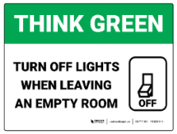 | A. All lights must be turned on.  B. You must turn off lights to use other devices.  C. Turn off lights when you are the last person to go out.  D. Lights will turn off themselves.

Thí sinh chỉ viết mẫu tự (A, B, C or D) đại diện cho câu trả lời đúng vào Phần trả lời (Answer).

Answer: 15/_____ 16/_____

III. Read the following passage. Decide if the statements from 17 to 20 are True or False, and choose the correct answers (A, B, C or D) for questions 21 and 22. (1.5 pts)

Once a beautiful princess had a golden ball. Unfortunately, one day, she dropped her ball into the water. She was unhappy and started crying. Suddenly, a green frog appeared and offered to help her if she let him live with her in the palace. The princess agreed. Then the frog helped her and gave her the ball. She took the ball and forgot all about her promise. The frog was angry and told his story to the King. The King asked his daughter to take the frog to her room and look after him carefully. The princess cried again, but she took the frog and put him on her bed. The frog asked her to kiss him, so she did. Immediately, the frog turned into a handsome prince. Of course, he and the princess fell in love. And they lived happily ever after.

17/ The princess dropped her ball into the water.
18/ A cat appeared and offered to help her.
19/ The King asked his son to take the frog to his room.
20/ The frog turned into a handsome prince.
21/ What did the frog ask the princess to do when she took the frog and put him on her bed?
A. to help him write a letter B. to kiss him
C. to give him some food D. to dance with him
22/ What was the end of the story?
A. The prince went back to his country. B. The King wanted the prince to be his son.
C. The princess & the prince lived happily ever after. D. The prince turned back into the frog.

Từ câu 17 đến câu 20, thí sinh phải viết đầy đủ từ True hoặc False vào ô trả lời. Mọi cách ghi khác đều không được chấm điểm. Đối với câu 21 và 22, thí sinh chỉ viết mẫu tự (A, B, C or D) đại diện cho câu trả lời đúng vào Phần trả lời (Answer).

Answer:
17/__________ 18/__________ 19/__________ 20/__________ // 21/_____ 22/_____

IV. Choose the word / phrase (A, B, C or D) that best fits the blank space in the following passage. (1.5 pts)
HUE CITADEL
Bach Thien, September 7
Hue Citadel is one of the most famous (23)________ in Vietnam.
There used to be many citadels in Vietnam, but now there are only a few left. A citadel is similar (24)________ a castle. They were homes for kings and queens. Hue Citadel (25)________ the home of many kings and their families. It was built in the (26)________ century and was made mainly made from wood and bricks. The walls were made from strong bricks to keep the kings and their families (27)________. It doesn’t have any dungeons, but it does have a moat around it.
Every year, thousands of people visit the Citadel and (28)________ the beautiful rooms and gardens.

23/ A. building B. build C. builds D. buildings
24/ A. to B. at C. in D. with
25/ A. be B. was C. is D. were
26/ A. 19th B. 19 C. nineteenth D. A&C are correct.
27/ A. safety B. safely C. safe D. unsafe
28/ A. explored B. explore C. exploring D. explores

Thí sinh chỉ viết mẫu tự (A, B, C or D) đại diện cho câu trả lời đúng vào Phần trả lời (Answer).
Page 2
Answer: 23/_____ 24/_____ 25/_____ 26/_____ 27/_____ 28/_____
Page 3

TIẾNG ANH 8
ĐÁP ÁN ĐỀ 1
I.
1. D
2. C
3. C
4. A
5. C
6. B
7. D
8. C
9. B
10. C
11. D
12. B
13. B
14. D

II.
15. D
16. C

III.
17. TRUE
18. FALSE
19. FALSE
20. TRUE
21. B
22. C

IV.
23. D
24. A
25. B
26. D
27. C
28. B

V.
29. successful
30. was
31. improve
32. has been
33. friendly
34. important

VI.
35. Keeping distance at least 1,5m is protecting yourself and your family.
36. Both boys enjoy school, but they prefer to be outside the classroom.

VII.
37. He has learned/learnt French since he was nine years old.
38. Susan turns on the tv so as to watch cartoon.
39. Mother asked Lyn to bring that heavy box upstairs.
40. I used to stay up late to watch football matches last year.

