REVIEW 1 (UNITS 1+2+3)

Lesson 1: Language

  - I. Objectives
By the end of this lesson, students will be able to

1. Knowledge
- Use the words related to the topic My New School;
- Use the combinations: to play + Noun, to do, to have, to study;
- Pronounce the sounds /ɑ:/ and /ʌ/ correctly;
- Use the present simple;
- Use the adverbs of frequency;
- Use the words for types of house, rooms and furniture;
- Pronounce the final sounds /s/ and /z/ at the end of the words correctly;
- Use possessive case to describe possession;
- Use prepositions of place to describe where people or things are;
- Use the words for body parts, appearance and personality;
- Pronounce the sounds /b/ and /p/ correctly;
- Use the present continuous to talk about things happening now.

2. Core competence
- Develop communication skills and creativity
- Be collaborative and supportive in pair work and team work
- Actively join in class activities

3. Personal qualities
Develop self-study skills

II. Materials
- Grade 6 textbook, Review 1
- Computer connected to the internet
- Projector/ TV/ pictures and cards
- hoclieu.vn

III. Language analysis

Anticipated difficulties | Solutions
1. Students may find the lesson boring due to a large number of language exercises. | - Encourage students to work in pairs, in groups so that they can help each other.  - Design as many exercises as games as possible.  - Provide feedback and help if necessary.
2. Some students will excessively talk in the class. | - Define expectation in explicit detail.  - Have excessive talking students practise.  - Continue to define expectations in small chunks (before every activity).

Board Plan
Date of teaching
Review 1
Lesson 1: Language
* Warm-up
Memory game: Complete the chart.
I. Practice
* Pronunciation
Task 1: Choose the word whose underlined part is pronounced diﬀerently.
Task 2: Write the names of school things and furniture in the house which begin with /b/ and /p/.
* Vocabulary
Task 3: Complete the words.
Task 4: Solve the crossword puzzle.
* Grammar
Task 5: Look at the picture of a classroom. Choose the best answer A, B, or C.
Task 6: Complete the sentences with the present simple or the present continuous form of the verbs in brackets.
* Homework

Procedures

Stage | Stage aim | Procedure | Interaction | Time
Warm-up | To revise the language that students have learnt in Units 1+2+3. | * Memory game  - Teacher draws/sticks an unfinished chart which summarizes the language that students have learnt in Units 1, 2, 3 on the board.  - Teacher divides the class into 2 teams and asks students to run in a relay to complete the chart:  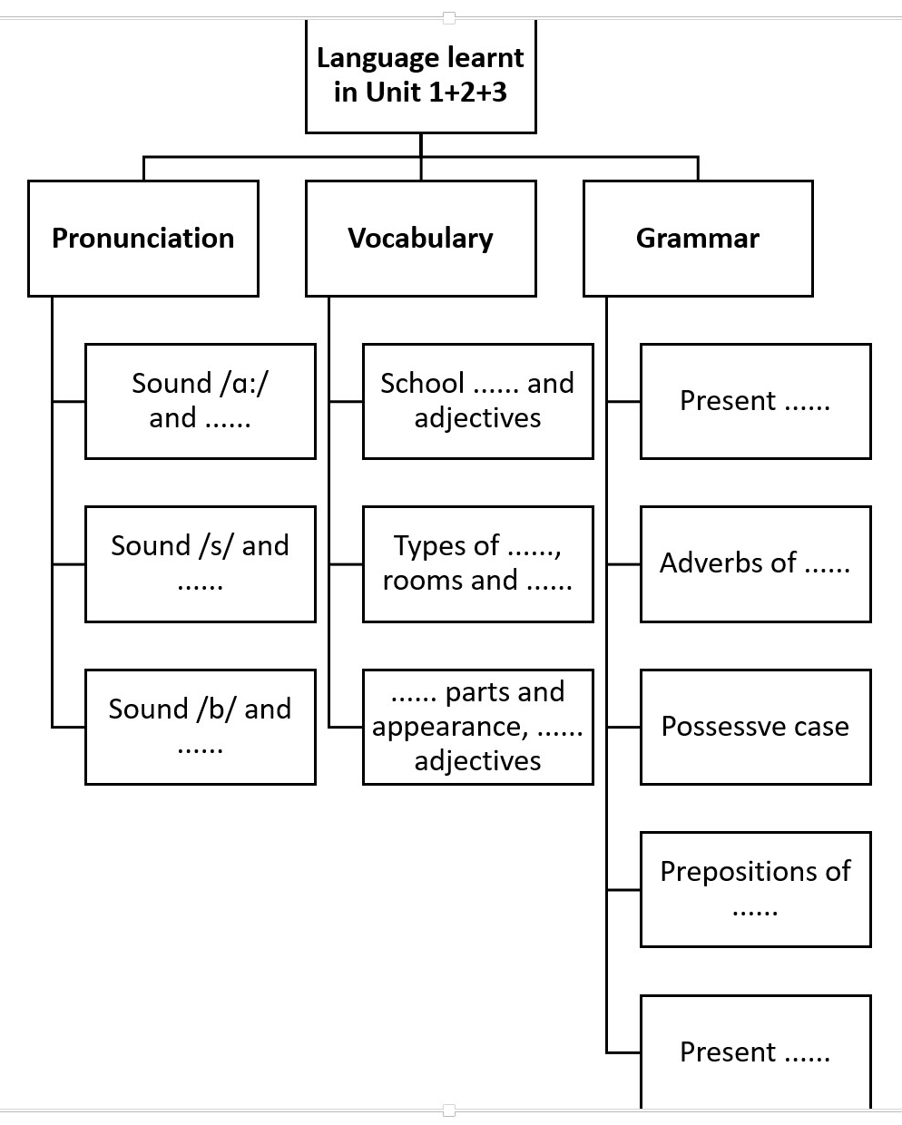  - The team with the most correct answers will be the winner.  Suggested answer:  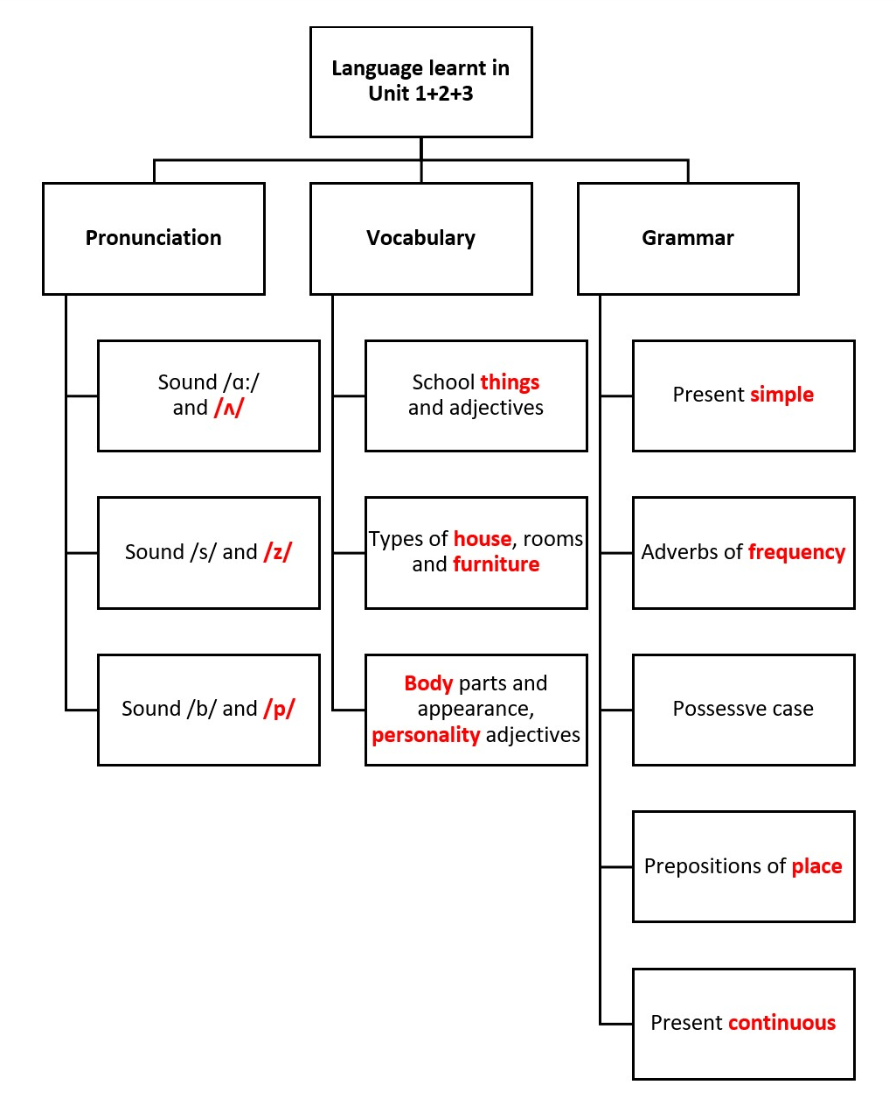 | Team work | 5 mins
Practice | To help students review the pronunciation of the sounds learnt in Units 1-2-3: /ɑ:/ and /ʌ/; /s/ and /z/ correctly.  To help students review the pronunciation of the sounds /b/ and /p/ in words.  To help students review the word groups used with “play, have, do” and “study”.  To help students review the personality adjectives, the words related to body parts, rooms and types of house.  To help students review grammar elements taught in Units 1-2-3: prepositions of place, possessive  case and present continuous. | * PRONUNCIATION  Task 1: Choose the word whose underlined part is pronounced diﬀerently.  - Teacher elicits the rules of pronouncing final -s if needed.  - Students do this exercise individually then share their answers with their partners.  - Teacher gives feedback and confirms the answers.  Answer key:  1. C  2. A  3. B  4. A  5. B  Task 2: Write the names of school things and furniture in the house which begin with /b/ and /p/.  - Teacher organizes this task as a game.  - Students do this task in pairs. The pair that finds the most words will go to the board and write their answers.  - Other pairs may want to add more words. Write other words on the board.  - Teacher gives feedback and confirms the answers.  Suggested answers:  /b/  book, bag, bed…  /p/  pen, pencil, picture, poste…  * VOCABULARY  Task 3: Complete the words.  - Teacher has students do this task individually and then share their answers with their partners.  - Teacher calls one or two students to write their answers on the board.  - Teacher checks and confirms the correct ones.  Answer key:  1. English  2. homework  3. lunch  4. sports  5. badminton  🡪 play: sports, badminton 🡪 have: lunch  🡪 do: homework  🡪 study: English  Task 4: Solve the crossword puzzle.  - Teacher sticks the crossword puzzle on the board.  - Teacher divides the class into 2 teams and asks students to run in a relay to complete the crossword puzzle.  - The team with the most correct answers will be the winner.  Answer key:  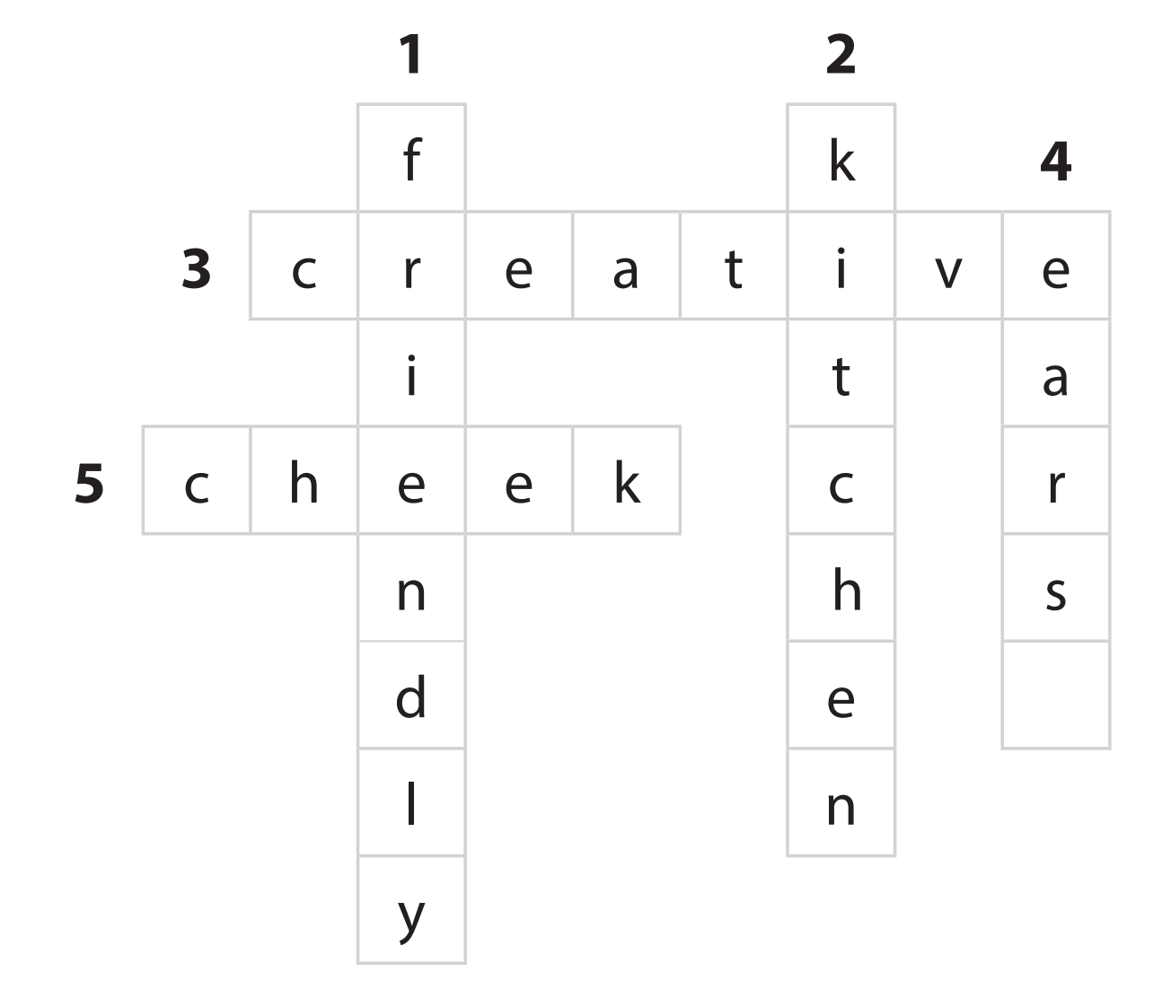  * GRAMMAR  Task 5: Look at the picture of a classroom. Choose the best answer A, B, or C.  - Teacher has students look at the picture of a classroom and complete the sentences.  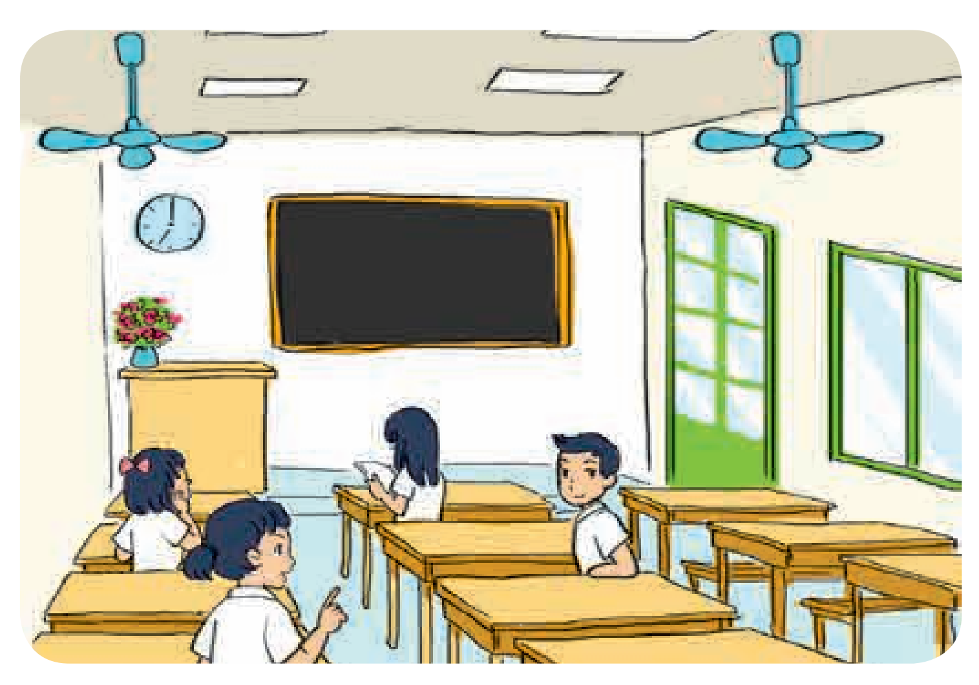  - Students compare their answers with a classmate.  - Teacher checks and confirms the correct answers.  Answer key:  1. B  2. A  3. A  4. B  5. C  Task 6: Complete the  sentences with the present simple or the present continuous form of the verbs in brackets.  - Teacher elicits form and usage of the present simple and the present continuous.  - Teacher asks students to do the exercise individually before calling one or two students to write their answers on the board.  - Teacher checks students’ answers and asks them for explanation if necessary  Answer key:  1. is / ’s raining  2. do you have  3. Is she studying  4. likes  5. is not / isn’t cooking; is reading | T-Ss  S  Ss-Ss  T-Ss  Pair work  T-Ss  S  T-Ss  Team work  T-Ss  Ss-Ss  T-Ss  T-Ss  S  T-Ss | 35 mins
Consolidation | To consolidate what students have learnt in the lesson. | Teacher asks students to talk about what they have learnt in the lesson. | T-Ss | 4 mins
Homework | To prepare for the next lesson. | Prepare for Review 1 - Lesson 2: Skills. | T-Ss | 1 min

REVIEW 1 (UNITS 1+2+3)

Lesson 2: Skills

  - I. Objectives
By the end of this lesson, students will be able to

1. Knowledge
- Introduce someone to someone else;
- Read for general and specific information about schools;
- Talk about the type of school one would like to go to;
- Listen for specific information about school activities;
- Write a paragraph about one’s school;
- Give suggestions;
- Read for specific information about rooms and furniture;
- Describe houses, rooms and furniture;
- Listen for specific information about some one’s house;
- Write an email to a friend describing a house;
- Ask about appearance and personality;
- Read for specific information about friends and summer camps;
- Talk about friends and summer camps;
- Listen for specific information about best friends;
- Write a diary entry about best friends.

2. Core competence
- Develop communication skills and creativity
- Be collaborative and supportive in pair work and team work
- Actively join in class activities

3. Personal qualities
Develop self-study skills

II. Materials
- Grade 6 textbook, Review 1
- Computer connected to the internet
- Projector/ TV/ pictures and cards
- hoclieu.vn

III. Language analysis

Anticipated difficulties | Solutions
1. Students may find the lesson boring due to a large number of language exercises. | - Encourage students to work in pairs, in groups so that they can help each other.  - Design as many exercises as games as possible.  - Provide feedback and help if necessary.
2. Some students will excessively talk in the class. | - Define expectation in explicit detail.  - Have excessive talking students practise.  - Continue to define expectations in small chunks (before every activity).

  - Board Plan
Date of teaching
Review 1
Lesson 2: Skills
* Warm-up
Chatting
I. Practice
* Reading
Task 1: Choose A, B, or C for each blank in the email below.
Task 2: Read the text and answer the questions.
* Speaking
Task 3: Interview two of your classmates about what they like and dislike about your school. Report their answers.
* Listening
Task 4: An and Mi are talking on the phone. Listen and fill each blank with one word.
* Writing
Task 5: Write an email of about 50 words to your friend. Tell him/ her about a family member. Use these questions as cues.
* Homework

Procedures

Stage | Stage aim | Procedure | Interaction | Time
Warm-up | To increase students’  interest and lead them into the  lesson. | * Chatting:  - Teacher asks students some questions to lead them into the lesson:  - Do you have any pen pals?  - How do you communicate with your pen pal?  - Do you often write emails to your pen pal?  - Teacher lead in the reading part of the lesson. | T-Ss | 5 mins
Practice | To help students practise reading for specific information.  To help students practise reading for general information.  To help students practise asking and answering about what they like and dislike about their school  and the reasons why.  To help students review listening for specific information.  To help students complete a guided paragraph of 40-45 words about a student’s family member. | * READING  Task 1: Choose A, B, or C for each blank in the email below.  - Students do these exercises individually.  - Students check their answers with their partners before they give the answers to teacher.  - Teacher confirms the correct answers.  Answer key:  1. A  2. C  3. C  4. B  5. B  Task 2: Read the text and answer the questions.  - Students do these exercises individually.  - Students check their answers with their partners before they give the answers to teacher.  - Teacher confirms the correct answers.  Answer key:  1. It’s in a quiet place not far from the city center.  2. They are hard-working and kind.  3. They are helpful and friendly.  4. There are five clubs.  5. Because it’s a good school.  * SPEAKING  Task 3: Interview two of your classmates about what they like and dislike about your school. Report their answers.  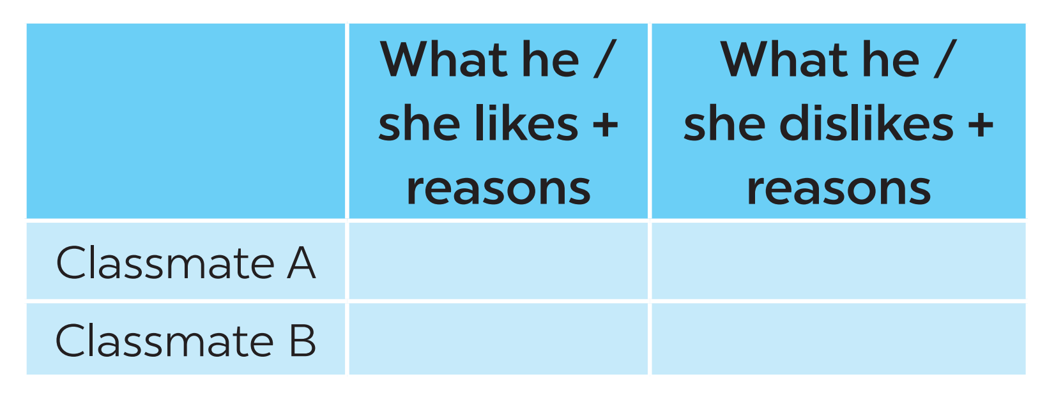  - Teacher has students work in groups of three. One interviews the other two about what they like and  dislike about their school and the reasons why.  - Teacher tells students to write their group members’ answers in their notebooks and report them to the class.  - Teacher summarizes students’ ideas.  * LISTENING  Task 4: An and Mi are talking on the phone. Listen and fill each blank with one word.  - Teacher has students read the sentences.  - Teacher plays the recording for the first time.  - Teacher asks students to listen and complete the sentences. Ask for their answers and writes them on the board.  - Teacher plays the recording the second time for students to check their answers.  - Teacher checks students’ answers.  - Teacher plays the recording the last time if necessary, stopping at diﬀerent places where students got the wrong answers.  Answer key:  1. home  2. plants  3. living  4. sleeping  5. TV  Audio script:  An: Why is it so quiet, Mi? Are you home alone?  Mi: No. Everybody is here, but they are in diﬀerent rooms.  An: Where’s your mum? Is she cooking in the kitchen?  Mi: No. She’s watering the plants in the garden.  An: And where’s your dad?  Mi: He’s in the living room.  An: What’s he doing?  Mi: He’s listening to the radio.  An: What about your younger brother? Is he with your mum?  Mi: No. He’s sleeping in my bedroom. My cousin, Vi, is here too.  An: What’s she doing?  Mi: She’s watching TV.  * WRITING  Task 5: Write an email of about 50 words to your friend. Tell him/ her about a family member. Use these questions as cues.  - Teacher elicits the parts of an email.  - Teacher asks students to discuss and answer the questions in pairs.  - Teacher then has them write their emails  individually.  - Teacher asks one student to write the email on the board.  - Other students and teacher comment on the email on the board.  - Teacher then collects some emails to give feedback at home. | S  Ss-Ss  T-Ss  S  Ss-Ss  T-Ss  Group work  T-Ss  T-Ss  T-Ss  Ss | 35 mins
Consolidation | To consolidate what students have learnt in the lesson. | Teacher asks students to talk about what they have learnt in the lesson. | T-Ss | 4 mins
Homework | To prepare for the next lesson. | Prepare for Unit 4. | T-Ss | 1 min

