UNIT 7: TELEVISION

Lesson 1: Getting started – What’s on today?

  - I. Objectives
By the end of this lesson, students will be able to:

1. Knowledge
- Gain an overview of the topic Television
- Use lexical items related to the topic, including TV programmes and people

2. Core competence
- Develop communication skills and creativity
- Be collaborative and supportive in pair work and team work
- Actively join in class activities

3. Personal qualities
- Develop self-study skills

II. Materials
- Grade 6 textbook, Unit 7, Getting started
- Computer connected to the Internet
- Projector/ TV/ pictures and cards
- hoclieu.vn

Language analysis

Form | Meaning | Pronunciation | Vietnamese equivalent
1. talent (n) | a natural ability to do something well | /ˈtælənt/ | tài năng
2. programme (n) | something that people watch on television | /ˈprəʊɡræm/ | chương trình
3. animated (adj) | made to look as if they are moving | /ˈænɪmeɪtɪd/ | hoạt hình, hoạt họa
4. prefer (v) | to like one thing or person better than another | /prɪˈfɜːr/ | thích hơn
5. character (n) | ​a person or an animal in a book, play or film | /ˈkærəktər/ | nhân vật
6. educational (adj) | connected with education | /ˌedʒuˈkeɪʃənl/ | thuộc về giáo dục

Anticipated difficulties | Solutions
1. Students may lack of knowledge and experiences about the topic. | Prepare some handouts in which the key language of describing children TV programme is presented.
2. Students may have underdeveloped listening,  speaking and co-operating skills. | - Play the recording many times if necessary.  - Encourage students to work in pairs,in groups so that they can help eachother.  - Provide feedback and help if necessary.
  - Board Plan

Date of teaching

Unit 7: Television

Lesson 1: Getting started

* Warm-up

Spider web completion

I. Vocabulary

talent (n)

programme (n)

animated (adj)

prefer (v)

character (n)

educational (adj)
II. Practice
Task 1: Listen and read.
Task 2: Choose the correct answer A, B, or C.
Task 3: Read the conversation again and match the names with suitable
descriptions.
Task 4: Find and write the adjectives in the conversation which describe the programmes and characters.
III. Production
Task 5: Game – Find someone who…
* Homework

Procedure

Stage |  | Stage aim |  | Procedure | Interaction |  | Time
Warm-up | To introduce the topic. |  | * Spider web  completion:  - Teacher draws a spider web on the board with the word TELEVISION in the middle.  - Teacher asks students to give any words they know relating to the topic.  - Students give their  answers.  - Teacher writes down the answers on the board.  Suggested answer:  TELEVISION  channel  ...  news  cartoon  TV show |  | T-Ss  Ss  T-Ss | 5 mins
Lead-in | To lead in the topic of the unit. |  | - Teacher draws  students’ attention to the title of the  conversation and the picture in the textbook and asks them questions like:  - What do you think they are talking about?  - Do you like watching TV? Why/ Why not?  - How many hours a day do you watch TV?  - What channel do you like best?  Suggested answers:  - They are talking about TV shows.  - Yes, I do. I love watching TV because it’s fun.  - I spend about thirty minutes/ one hour a day watching TV.  - I like Cartoon Network/ VTV3/ VTV1. |  | T-Ss | 2 mins
Presentation  (Vocab-  pre-teach) | - To introduce the vocabulary  appearing in the text.  - To help students well-prepared for the listening and reading tasks. |  | VOCABULARY  - Teacher introduces the vocabulary by:  + providing the pronunciation of the words.  + providing the definition of the words.  talent (for) (n) [definition]  programme (n) [definition]  animated (adj) [definition]  prefer (v) [definition]  character (n) [definition]  educational (adj) [definition] |  | T-Ss | 5 mins
Practice | To have students get to know the topic.  To have students get specific  information of the text.  To help students get further  comprehension of the text.  To check  students  understanding of the  conversation and help  students use the words in contexts. |  | Task 1: Listen and read.  - Teacher plays the recording, asks students to underline the words they have learned in the  vocabulary part.  - Teacher can play the recording more than once.  - Students listen and read.  - Teacher invites some pairs of students to read the  dialogue aloud.  Task 2: Choose the correct answer A, B, or C.  - Teacher asks students to read the questions  carefully and choose the correct answers.  Encourage them not to look back at the conversation first.  - Teacher allows students to share their answers before discussing as a class.  - Teacher checks their answers as a class and shows students where to find the answer in the conversation.  Answer key:  - C  - A  - A  - A  Task 3: Read the conversation again and match the names with suitable descriptions.  - Teacher encourages students to do the task without looking back at the conversation. If they cannot, let them read the conversation again to find the answers.  - Students work independently.  - Teacher allows students to share their answers before discussing as a class.  - Teacher checks the answers as a class and asks if any students have watched these programmes.  Answer key:  1. c  2. a  3. e  4. b  5. d  Task 4: Find and write the adjectives in the  conversation which describe the programmes and  characters.  - Teacher guides students to look back at the conversation and find where the names of the programmes/ characters appear. The answers they need are around.  - Students can work in pairs to complete this task.  - Teacher calls a student to write the answers on the board.  - Teacher asks if other students have other answers and checks as a class.  Answer key:  - interesting  - wonderful  - clever  - educational |  | T-Ss  S  T-Ss  T-Ss  Ss-Ss  Ss  T-Ss  T-Ss  Ss-Ss  T-Ss | 20 mins
Production | To check  students’  vocabulary and improve group work skill. |  | Task 5: Game – Find someone who…  - Teacher gives each student a copy of the worksheet (Appendix 1).  - Teacher goes through how to construct “Do you like…?” questions and short answers “Yes, I do. / No, I don’t.” with the class.  Example:  A: Do you like sports programmes on TV?  B: Yes, I do. / No, I don’t.  - Students use the prompts on their worksheet to ask “Do you like …?” questions to their classmates in 3 minutes.  - When a classmate answers “Yes, I do.”, the student writes their names in the “Name” column next to the item.  - When a student finishes, ask him/her to say “Bingo”. Three fastest students will present their findings and get marks for their presentation.  Model answer:  Ask other students Name(s)  1. … like sports programmes on TV. …Hung…  Question: Do you like sports programmes on TV?  2. … like music talent shows. …Lan…  3. … like animated films. …Binh…  4. … like cartoons. …Khoi…  5. … like English programmes. …Hoa…  Now present your information about five students to the whole class.  e.g. Hung likes sports programmes on TV. Lan likes music talent shows. Binh likes animated films and Khoi likes  cartoons. Hoa likes  English programmes. |  | T-Ss  Ss-Ss | 10 mins
Wrap-up | To consolidate what students have learnt in the lesson. |  | Teacher asks students to talk about what they have learnt in the lesson. |  | T-Ss | 2 mins
Homework | To revise what they have learnt in the lesson. |  | Write about 5 sentences to describe a TV  programme you like (name, type, channel, character(s) and characteristics…) |  | T-Ss | 1 min

UNIT 7: TELEVISION

Lesson 2: A closer look 1

  - I. Objectives
By the end of this lesson, students will be able to:

1. Knowledge
- Use the lexical items related to the topic Television
- Use the vocabulary and structures to talk about TV programmes
- Pronounce and recognize the sounds /θ/ and /ð/.

2. Core competence:
- Be collaborative and supportive in pair work and team work
- Access and consolidate information from a variety of sources
- Actively join in class activities

3. Personal qualities
- Develop self-study skills

II. Materials
- Grade 6 textbook, Unit 7, A closer look 1
- Computer connected to the internet
- Projector/ TV/ pictures and cards
- hoclieu.vn

  - Language analysis

Form | Meaning | Pronunciation | Vietnamese equivalent
1. comedy (n) | a play, film or TV show that is intended to be funny,  usually with a happy ending | /ˈkɑːmədi/ | hài kịch, phim hài
2. viewer (n) | a person watching television or a video on the Internet | /ˈvjuːər/ | người xem
3. performer (n) | a person who performs for an audience in a show,  concert, etc | /pərˈfɔːrmər/ | người biểu diễn
4. popular (adj) | liked or enjoyed by a large number of people | /ˈpɑːpjələr/ | phổ biến, được yêu thích
5. live (adj) | ​given or made when people are watching, not recorded | /laɪv/ | trực tiếp
6. boring (adj) | not interesting | /ˈbɔːrɪŋ/ | chán, không hấp dẫn

Anticipated difficulties | Solutions
1. Students may lack knowledge about some lexical items. | Provide students with the meaning and pronunciation of some lexical items.
2. Students may have underdeveloped listening, speaking and co-operating skills. | - Play the recording many times if necessary.  - Encourage students to work in pairs, in groups so that they can help each other.  - Provide feedback and help if necessary.
3. Some students will excessively talk in the class. | - Define expectations in explicit detail.  - Have excessive talking students practise.  - Continue to define expectations in small chunks (before every activity).

  - Board Plan

Date of teaching

Unit 7: Television

Lesson 2: A closer look 1

* Warm-up

Matching

I. Vocabulary
1. comedy (n)
2. viewer (n)
3. performer (n)
4. popular (adj)
5. live (adj)
6. boring (adj)
Task 1: Write the words/ phrases in the box next to the definition.
Task 2: Complete the sentences with the words/ phrases in the box.
Task 3: Complete the sentences with the adjectives in the box.
II. Pronunciation
Task 4: Listen and repeat the words.
Task 5: Tongue Twister. Take turns to read the sentences quickly and correctly.
III. Production
Game: Tongue Twister Race.
* Homework

Procedure

Stage | Stage aim | Procedure | Interaction | Time
Warm-up | - To activate  students’ prior knowledge and vocabulary related to the topic.  - To enhance students’ skills of cooperating with team mates. | * Matching  - Teacher divides students into 4 group and delivers a set of 6 pictures about famous TV programmes for children.  - Teacher asks students to work in groups and match the names of TV  programmes with suitable pictures.  - The fastest group will say “Bingo” and stick their work on board.  - Teacher checks the answers and gives a small gift to the winning group.  * SET OF PICTURES:  Talent shows    The Voice Kids  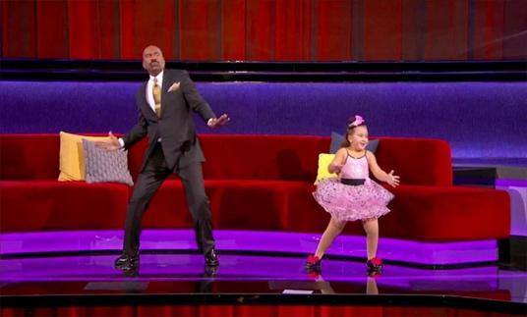  Little Big Shots  Educational shows  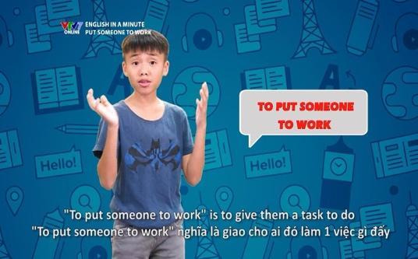  English in a Minute  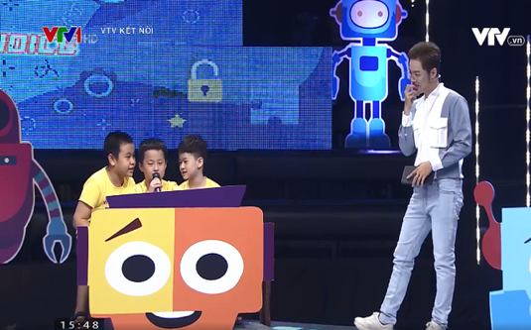  Alo English  Animated films    The Lion King    Moana | T-Ss  Ss-Ss  T-Ss | 5 mins
Lead-in | To lead in the lesson about vocabulary and pronunciation. | - Teacher leads student into the lesson by telling them that “In today lesson, we are going to learn more  words to talk about TV programmes and two sounds /θ/ and /ð/”. | T-Ss | 2 mins
Presentation  (Vocab-  pre-teach) | To teach students some nouns and  adjectives to talk about TV programmes. | VOCABULARY  - Teacher introduces the  vocabulary by:  + providing the definition of the words;  + providing the pictures of the words.  - comedy (n): [picture]  - viewer (n): [picture]  - performer (n): [picture]  - popular (adj) [definition]  - live (adj) [definition]  - boring (adj) [antonym] interesting    comedy    viewer    performer | T-Ss | 5 mins
Practice | To teach students some words/ phrases related to  television.  To give students further practice on how to use some words/ phrases in context.  To teach students more adjectives to describe  television programmes and characters. | Task 1: Write the words/ phrases in the box next to the definition.  - Teacher asks students to read the words/ phrases in the box first  and see if they can remember some of them from the previous lesson.  - Teacher reminds students of the words/ phrases they do not  remember.  - Students read the definition and do the task.  - Teacher calls some students to give their answers.  - Teacher gives feedback and corrections (if necessary).  Answer key:  - character  - educational programme  - comedy  - talent show  - viewer  Task 2: Complete the sentences with the words/ phrases in the box.  - Teacher asks students to work in pairs and use the words/ phrases in the box to complete the sentences.  - Students work in pairs and do the task.  - Teacher calls some pairs to share their answers with the whole class.  - Teacher gives feedback and corrections (if necessary).  Answer key:  - channel  - character  - animated films  - game show  - comedies  - viewers  Task 3: Complete the sentences with the adjectives in the box.  - Teacher asks students to use the given adjectives to complete the sentences.  - Students work independently.  - Teacher allows students to share their answers before discussing as a class.  - Teacher asks some students to share the answers and gives corrections (if  necessary).  Answer key:  - popular  - boring  - cute  - live  - funny  - educational | T-Ss  S  T-Ss  T-Ss  Ss-Ss  T-Ss  T-Ss  S  Ss-Ss  T-Ss | 15 mins
Presentation  (Pre-teach the sounds /θ/ and /ð/.) | To help students have concept and identify the sound /θ/ and /ð/. | PRONUNCIATION  - Teacher introduces 2 sounds /θ/ and /ð/ to students and lets them watch a video about how to pronounce these two sounds.  - Teacher asks students to give some words they know containing these sounds.  Suggested answers:  - /θ/: think, thank, throw, theatre, third.  - /ð/: this, that, these, those, there, father. | T-Ss | 4 mins
Practice | To help students  identify and practise the /θ/ and /ð/ sounds.  To help students  pronounce the sounds /θ/ and /ð/ correctly in context. | Task 4: Listen and repeat the words.  - Teacher asks students to read the words first as they are familiar with students.  - Teacher plays the recording and asks  students to listen carefully and check if they have pronounced them correctly.  - Teacher plays the recording again.  Students listen and repeat.  - Teacher calls some students to read the words individually.  Task 5: Tongue Twister. Take turns to read the sentences quickly and correctly.  - Teacher allows students to work in pairs and practice reading the tongue twister: slowly at first, then faster and faster.  - Teacher asks some students to read the Tongue Twister aloud. | T-Ss  Pair work  T-Ss | 5 mins
Production | To give students a chance to apply what they have learnt. | Game: Tongue Twister Race.  - Teacher writes two tongue twisters on the board and first practices the tongue twister with the students.  - Teacher lets students practice in pairs, then asks students to line up in two teams.  - Teacher lets the first team say the first tongue twister, one student at a time and see how long it takes them to say the tongue twister correctly as a team. After, write the total time taken on the board.  - Now the second team says the second tongue twister, one student at a time as quickly as they can.  - The team who says the tongue twister quicker wins.  * Tongue Twister sentences  - The first thing that they think of is this.  - These things finish sooner than you think. | T-Ss  Pair work  Team work | 6 mins
Wrap-up | To consolidate what students have learnt in the lesson. | Teacher asks students to talk about what they have learnt in the lesson. | T-Ss | 2 mins
Homework | To revise what they have learnt. | Revise the words in Vocabulary and find 5 more words with /θ/ and 5 more words with /ð/. | T-Ss | 1 min

UNIT 7: TELEVISION

Lesson 3: A closer look 2

Wh-questions & Conjunctions in compound sentences

  - I. Objectives
By the end of this lesson, students will be able to:

1. Knowledge
- Use Wh-questions and conjunctions in compound sentences: and, but, so correctly.

2. Core competence
- Develop communication skills
- Be collaborative and supportive in pair work and team work
- Actively join in class activities

3. Personal qualities
- Develop self-study skills

II. Materials
- Grade 6 textbook, Unit 7, A closer look 2
- Computer connected to the Internet
- Projector/ TV/ pictures and cards
- hoclieu.vn

  - Language analysis

Form | Meaning | Example
When | A question word used to ask  information about time. | When does the film start?
How many | A question word used to ask  information about numbers. | How many programmes does this channel have?
How  often | A question word used to ask  information about repetition. | How often do you watch movies?
What | A question word used to ask  information about things. | What kind of movies do you prefer?
Where | A question word used to ask  information about a place. | Where do you go to see a movie?
Who | A question word used to ask  information about people. | Who do you often go to see a movie with?
Why | A question word used to ask  information about reason. | Why do you like this film?
but | A conjunction used to combine two contrast clauses into a  compound sentence. | I like the plot of this film but I don’t like the actors.
so | A conjunction used to show the reason for something. | I am free this weekend so I can go to the cinema with you.
and | A conjunction used to combine two clauses into a compound sentence. | I like watching films and news programmes.

Anticipated difficulties | Solutions
1. Students may lack knowledge and experiences about the target grammatical points. | Prepare some hand-outs in which key grammatical points are presented.
2. Some students will excessively talk in the class. | - Define expectations in explicit detail.  - Have excessive talking students practise.  - Continue to define expectations in  small chunks (before every activity).

  - Board Plan

Date of teaching

Unit 7: Television

Lesson 3: A closer look 2

* Warm-up

Word cloud
I. Grammar focus
1. Wh-questions
Task 1: Read the conversation and underline the question words.
Task 2: Match each question word with the information it needs.
2. Conjunctions in compound sentences: and, but, so
II. Practice
Task 3: Use the question words in the box to complete the conversations.
Then listen and check your answers.
Task 4: Match the beginnings with the endings.
III. Production
Task 5: Quizizz game
* Homework

Procedure

Stage | Stage aim | Procedure | Interaction | Time
Warm-up | - To activate and  anticipate students’ knowledge of the questions they are  familiar with.  - To enhance students’ skills of using technology to interact with the lesson. | * Word cloud (menti.com)  - Teacher creates a request “Name all the question words that you know” on menti.com.  - Link:  https://www.mentimeter.com/s/24c25f2cb5a01e41b5bc5cab067a17eb/6bc323ea42ce/edit  - Teacher allows students to use their mobile devices to answer and  interact with the question online.  - Teacher gives clear instructions for students to fully understand how to answer the question on menti.com.  - Go to menti.com  - Enter the CODE  - Type your answers (provide as many  answers as possible)  - See the word cloud form  - Teacher provides the CODE and allows  students’ access to the game.  - Students type their answers.  - Teacher shows the result  Suggested answers:  Name all the question words that you know  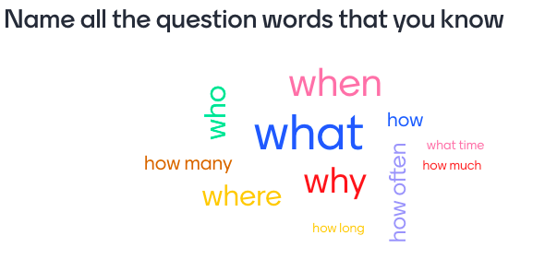 | T-Ss  Ss | 5 mins
Lead-in | To introduce targeted grammar of Wh-questions and  conjunctions: but, so, and. | - Teacher draws students’ attention to the question words they are going to learn in the lesson: when, how many, how often, what, where, who and why and informs students of conjunctions: but, so, and.  - Teacher leads in the lesson. | T-Ss | 2 mins
Presentation | - To have students get to know about the question words.  - To help  students  understand the use of the question words.  - To help  students identify the functions of different question words.  To help students  revise the use of possessive pronouns. | 1. Wh-questions:  Task 1: Read the conversation and underline the question words.  - Teacher has students complete the task individually.  - Teacher checks the answers as a class.  Answer key:  What are you doing  tomorrow?  Where is it?  How long is it on?  Task 2: Match each question word with the information it needs.  - Teacher allows students to do the matching in pairs.  - Teacher checks their answers as a class.  - Teacher explains if students have any  difficulty understanding how to use the question words.  Answer key:  When – time  How many – number  How often – repetition  What – thing  Where – place  Who – people  Why – reason  2. Conjunctions: but, so, and  - Teacher writes the example in the  Remember! Box (page 10) on the board and circles the conjunction in the sentence.  - Teacher underlines the clauses before and after the conjunction.  - Teacher draws students’ attention that  conjunctions are used to connect two clauses into a compound sentence.  Example:  I enjoy sports, so I spend a lot of time outdoors.  - Teacher introduces the focused conjunctions: but, so, and.  - Teacher asks students to work in groups of 4 and make 3 compound  sentences using three target conjunctions.  Suggested answers:  - It is still painful, so I go to see a doctor.  - She is tall, but her sister is short.  - I like music, and I like watching TV, too. | S  T-Ss  Pair work  Ss-Ss  T-Ss  T-Ss  Group work | 15 mins
Practice | To give students more practice with question words.  To help students identify the meaning and the position of a  conjunction. | Task 3: Use the question words in the box to complete the conversations. Then listen and check your answers.  - Teacher has students work on the exercise individually before they compare answers with each other.  - Teacher plays the recording and asks  students to listen and check their answers. Also remind students to pay attention to the tune of the wh-questions (falling at the end).  - Teacher gives feedback as a class discussion.  Answer key:  - How often, What  - Who  - When, Where  Task 4: Match the beginnings with the  endings.  - Teacher has students work in pairs.  - Teacher asks students to read the clauses in the beginning column  carefully and find clues in the ending column for matching.  - Teacher checks students’ answers as a class.  - Teacher calls some students to read the complete sentences out loud.  Answer key:  - c  - a  - e  - b  - d | Ss-Ss  T-Ss  Pair work  T-Ss | 10 mins
Production | To give students some practice on the use of conjunctions. | Task 5: Quizizz game.  Use and, but and so to complete the questions in the game.  - Teacher uses Exercise 5 (p. 10) to create questions in the Quizizz game.  - Teacher allows students to use their mobile devices to answer and interact with the questions online.  - Teacher gives clear instructions for students to fully understand how to play Quizizz quiz online.  - Go to joinmyquiz.com.  - Enter the game CODE.  - Type your name.  - Use and, but and so to complete each sentence appearing on the screen.  - See who will be the winner.  - Teacher provides the game CODE and allow students’ access to the game.  - Students type the word and, but or so to  complete each sentence appearing on the screen.  - Teacher gives compliments or good marks to the winner of the game.  Answer key:  - so  - but  - so  - but  - and | T-Ss  S  T-Ss | 10 mins
Wrap-up | To consolidate what  students have learnt in the lesson. | Teacher asks students to talk about what they have learnt in the lesson. | T-Ss | 2 mins
Homework | Reactivate the knowledge that students have gained in the lesson. | Do Exercise 5, write the answers on your  notebooks. Make 7 questions using 7 question words in Exercise 2 and answer the questions. | T-Ss | 1 min

UNIT 7: TELEVISION

Lesson 4: Communication

  - I. Objectives
By the end of this lesson, students will be able to:

1. Knowledge
- Ask for and give information about TV programmes
- Recognise and have knowledge about some famous TV programmes in some countries.

2. Core competence
- Develop creativity and communication skills
- Be collaborative and supportive in pair work and team work
- Actively join in class activities

3. Personal qualities
- Develop self-study skills

II. Materials
- Grade 6 textbook, Unit 7, Communication
- Computer connected to the internet
- Projector/ TV/ pictures and cards
- hoclieu.vn

  - Language analysis

Anticipated difficulties | Solutions
1. Students may lack knowledge about some TV programmes. | Provide students with information about the TV programmes they do not know.
2. Students may have  underdeveloped speaking and  co-operating skills. | - Encourage students to work in pairs, in groups so that they can help each other.  - Provide feedback and help if necessary.
3. Some students will excessively talk in the class. | - Define expectations in explicit detail.  - Have excessive talking students practise.  - Continue to define expectations in small chunks (before every activity).

  - Board Plan

Date of teaching

Unit 7: Television

Lesson 4: Communication

* Warm-up

Question forming

I. Everyday English

* Asking for and giving information about TV programmes
Task 1: Listen and read the conversation. Pay attention to the highlighted words.
Task 2: Work in pairs. Make a similar conversation about your favourite TV programmes.
II. TV programmes
Task 3: Work in groups. Discuss and complete the facts with the countries in the box.
Task 4: Read about two TV programmes and tick the correct programme in the table.
Task 5: Work in groups. Tell your group which programme in Task 4 you prefer and why.
* Homework

Procedure

Stage | Stage aim | Procedure | Interaction | Time
Warm-up | To activate students’ knowledge of forming  questions to ask for information about a TV  programme. | * Question forming:  - Teacher draws a spider web on the board with the word TV PROGRAMME in the middle and question words in branches.  - Teacher asks students to form the questions to ask for information about a TV programme using the given question words.  - Students give their answers.  - Teacher writes down the answers on the board.  TV PROGRAMME  What....  ...  How often...  What time...  Why...  Suggested answer:  1. What’s your favourite TV programme?  2. Why do you like it?  3. What time is it on?  4. How often do you watch it? | T-Ss | 5 mins
Lead-in | To lead in the lesson about communication. | Teacher leads students into the lesson by telling them that they are going to learn how to ask for and give information about TV programmes and some famous programmes in other countries. | T-Ss | 2 mins
* EVERYDAY ENGLISH
Presentation | To introduce a sample  conversation about a TV  programme. | Task 1: Listen and read the conversation. Pay  attention to the highlighted words.  Teacher plays the recording and asks students to look at the conversation and read it while listening. | T-Ss | 5 mins
Practice | To practice asking for and giving  information about TV  programmes. | Task 2: Work in pairs. Make a similar conversation about your favourite TV programme.  - Teacher asks students to work in pairs and make a similar conversation about their favourite TV programme. Encourage students to add the questions in Warm-up in their conversation.  - Students do the task in pairs.  - Teacher calls some pairs to act out their  conversations in front of the class.  - Teacher checks and corrects if needed.  Suggested answers:  A: What’s your favourite TV programme?  B: The sports programme.  A: Why do you like it?  B: Because I am a big fan of sports.  A: What time is it on?  B: It’s on at 7:30 p.m. on VTV3.  A: How often do you watch it?  B: I watch it every weekend. | T-Ss  Pair work  T-Ss | 10 mins
* TV programmes
Practice | - To allow students to  explore some interesting facts about TV in other countries.  - To introduce to students some TV  programmes for children. | Task 3: Work in groups. Discuss and complete the facts with the countries in the box.  - Teacher asks students to work in groups and help one another find the answers/ make guesses.  - Teacher calls some students for the  answers.  - Teacher reminds students of the correct way to give their answers/ make guesses.  E.g., Pokemon cartoons are from Japan. (They know the answer.)  - We think Pokemon cartoons are from  Japan. (They make a guess.)  - Teacher confirms the answers with the whole class.  Answer key:  - Japan  - Viet Nam  - Iceland  - the USA  * Note:  - Pokemon cartoons: Japanese television  animation series, typically aimed at adults as well as children.  - Iceland: Before 1981, there was no TV in July; before 1986, there was no TV on Thursday. It comes from the opinion that you could do without TV once a week! Spend it with your family. Spend it outdoors.  - Discovery Channel: an American pay  television network. It creates the highest quality content and remains one of the most dynamic media companies in the world. | Group work  T- Ss | 7 mins
 |  | Task 4: Read about two TV programmes and tick the correct programme in the table.  - Teacher asks students to read the passages and do the task. Remind them that some facts may refer to both programmes.  - Students do the task individually.  - Teacher calls some students to give their answers and checks as a class.  Answer key:  - Both programmes  - Let’s Learn  - Hello Fatty  - Let’s Learn  - Hello Fatty | T-Ss  S  T-Ss | 5 mins
Production | To allow students an  opportunity to practice with the information from the TV programmes in Task 4. | Task 5: Work in groups. Tell your group which programme in Task 4 you prefer and why.  - Teacher asks students to work in groups of four, read the two programmes again, then tell their friends which one they prefer and why.  - Teacher calls some students to speak in front of the class.  - Teacher asks other students to give  comments and gives more feedback if needed. | Group work  T-Ss | 8 mins
Wrap-up | To consolidate what students have learnt in the lesson. | Teacher asks students to talk about what they have learnt in the lesson. | T-Ss | 2 mins
Homework | To revise what they have learnt and prepare for the next lesson Skills 1. | - Write a paragraph to describe a programme you prefer in your notebook.  - Prepare for the next lesson (Skills 1). | T-Ss | 1 min

UNIT 7: TELEVISION

Lesson 5: Skills 1

  - I. Objectives
By the end of this lesson, students will be able to:

1. Knowledge
- Read for specific information about television
- Talk about one’s favourite TV program, the reasons for that

2. Core competence
- Develop communication skills and creativity
- Be collaborative and supportive in pair work and team work
- Develop presentation skill
- Actively join in class activities

3. Personal qualities
- Develop self-study skills

II. Materials
- Grade 6 textbook, Unit 7, Skills 1
- Computer connected to the internet
- Projector/ TV/ pictures and cards
- hoclieu.vn

  - Language analysis
Form | Meaning | Pronunciation | Vietnamese equivalent
1. compete | to take part in a contest or game | /kəmˈpiːt/ | thi đấu
2. plant | a living thing that grows in the earth and usually has a stem, leaves and roots,  especially one that is smaller than a tree or bush | /plɑːnt/ | cây cảnh

Anticipated difficulties | Solutions
1. Students may lack knowledge about some lexical items. | Provide students with the meaning and pronunciation of words.
2. Students may have underdeveloped reading, speaking and co-operating skills. | - Let students read the text again (if needed).  - Create a comfortable and encouraging environment for  students to speak.  - Encourage students to work in pairs, in groups so that they can help each other.  - Provide feedback and help if necessary.
3. Some students will excessively talk in the class. | - Define expectations in explicit detail.  - Have excessive talking students practise.  - Continue to define expectations in small chunks (before every activity).

  - Board Plan

Date of teaching

Unit 7: Television

Lesson 5: Skills 1

* Warm-up

Guessing game: TV channels
I. Reading
Vocabulary
1. compete (v)
2. plant (n)
Task 1: Read the first two columns of the TV guide and answer the questions.
Task 2: Read the TV guide in Task 1 and write the programmes that these
people may choose to watch.
Task 3: Work in groups. Share your table in Task 2 with your group and see if they agree with you.
II. Speaking
Task 4: Work in groups. Tell your group about your favourite TV programme.
* Homework

Procedure

Stage | Stage aim | Procedure | Interaction | Time
Warm-up | - To create a friendly and active atmosphere in the class before the lesson.  - To lead in the topic of the reading text. | * Guessing game: TV  channels  - Teacher shows some pictures which illustrate the logos of some famous TV channels. These logos are missing some parts or in the reversed position.  - Students have to guess the name of the TV channels.          - Teacher provides feedback and confirms the answers:    Discovery Channel    Disney Channel  Cartoon Network  CNN | T-Ss | 5 mins
Lead-in | To lead in the text about TV guides. | - Teacher asks students questions to lead in the reading text:  T: Among these four  channels, which one do you like best?  S: I like Discovery  Channel best because I can learn a lot about the world around us. I often read the TV guide  everyday to choose the programs or the contents I want to see.  T: What about you? Do you often read the TV guide before watching TV? | T-Ss | 2 mins
Pre-Reading (Pre-teach  vocabulary) | To provide students with some lexical items before reading the text. | - Teacher introduces the vocabulary by:  + providing the pictures of the words;  + providing the definition of the words.  - compete (v): [definition]  - plant (n)[definition] & [picture].    comedy    plant | T-Ss | 5 mins
While-  Reading | To teach students how to read a TV guide.  To show students how to find a  suitable TV programme for a person. | Task 1: Read the first two columns of the TV guide and answer the questions.  - Teacher asks students to have a quick look at the TV guide and answer questions like:  1. What information do you see? (the time, the name of the programme and its content)  2. What information comes first? What comes next?  3. What do you look at when you are choosing a programme to watch?  - This task should be done carefully as it helps do Task 2.  - Teacher explains to students so that they can distinguish the name of the programme (e.g. Sports) and the name of the specific event / show/ film, etc. on that programme (e.g. The Pig Race).  - Teacher allows students some time to read the TV guide and answer the questions.  - Teacher checks their answers as a class.  Answer key:  1. (It’s) Cuc Phuong Forest.  2. Yes, it is.  3. It’s on at 10.30.  4. No, we can’t.  5. (It’s about) dolphins.  Task 2: Read the TV guide in Task 1 and write the programmes that these people may choose to watch.  - Teacher asks students to read the information about each person carefully, underline the key word(s) showing what each person likes in order to help them find the answer.  - Teacher allows students some time to do the task individually.  - Teacher asks some students to share their answers before checking as a class.  Answer key:  1. Phong: Children are Always Right  2. Bob: The Fox Teacher  3. Nga: Cuc Phuong Forest  4. Minh: The Pig Race  5. Linh: The Dolphins | T-Ss  T-Ss  S  T-Ss | 10 mins
Pre-Speaking | To allow students to talk about what they have done in Reading Task 2. | Task 3: Work in groups. Share your table in Task 2 with your group and see if they agree with you.  - Teacher lets students work in groups and share their answers in Task 2 to the groups.  - Teacher encourages other students to say if they agree or disagree with the answers and explain their partners’ choice.  - Teacher calls some students to demonstrate it in front of the class.  Example:  A: I think the best  programme for Phong is the game show "Children are always right".  B: I agree. He wants to know more about pets. | Group work  T-Ss | 5 mins
While-  Speaking | To teach students how to talk about their favourite TV programmes. | Task 4: Work in groups. Tell your group about your favourite TV programme.  - Teacher asks students to read the instructions carefully and allow them some time to prepare their answers.  - Teacher tells students the suggested structure can help them arrange their ideas.  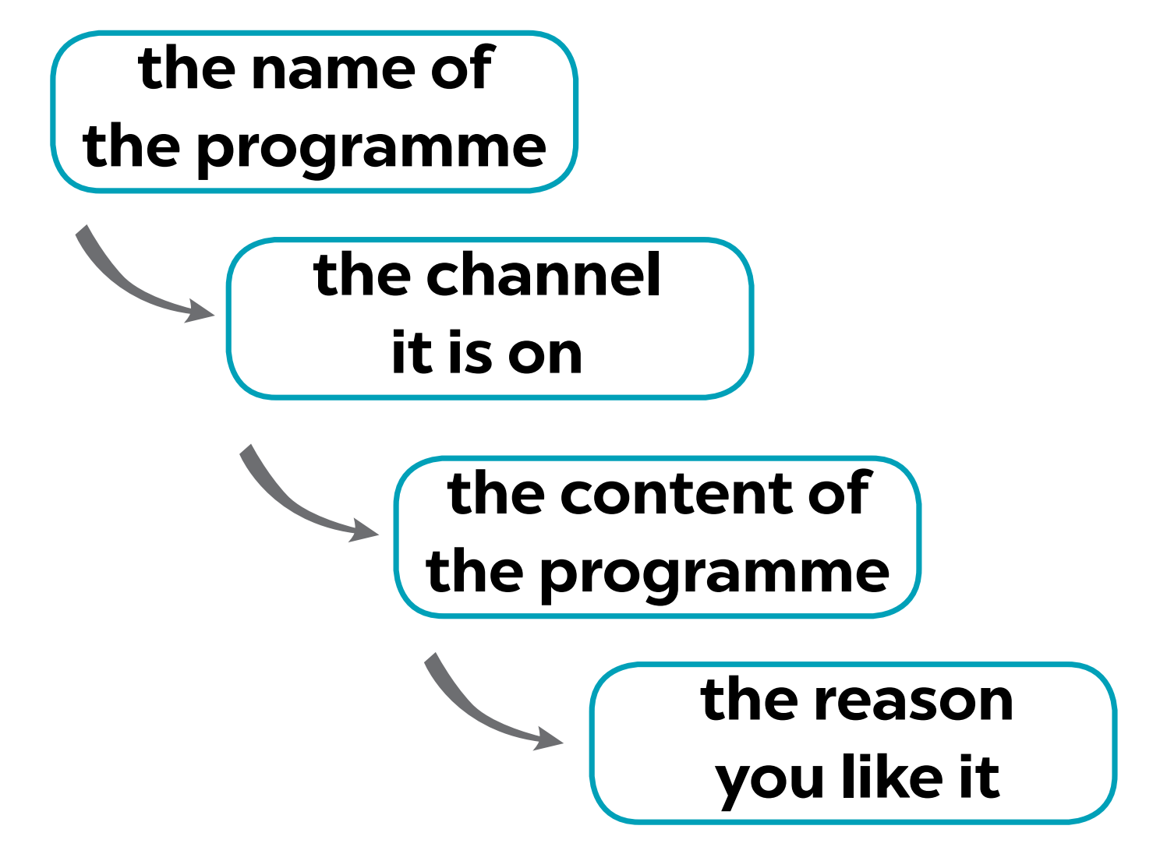  Suggestions:  - My favourite programme is...  - It’s on ...  - It’s about ...  - I like it because it ...  - Teacher lets students share their answers in groups before calling some students to present their answers to the class.  - Teacher corrects later if they make any mistakes. | T-Ss | 10 mins
Post-Reading and Speaking | - To help students  improve next time.  - To help some  students enhance presentation skill. | - Teacher allows students to give comments for their friends and vote for the most interesting and informative presentation.  - Teacher gives feedback and comments. | Ss-Ss  T-Ss | 5 mins
Wrap-up | To consolidate what  students have learnt in the lesson. | Teacher asks students:  + what they have learnt in the lesson with the two skills;  + what words/ phrases/ sentences describing television they can remember;  + how to talk about a TV programme they like. | T-Ss | 2 mins
Homework | To prepare for the next lesson. | Prepare for the next lesson: Skills 2. | T-Ss | 1 min

UNIT 7: TELEVISION

Lesson 6: Skills 2

  - I. Objectives
By the end of this lesson, students will be able to:

1. Knowledge
- Listen to get specific information from a recommended TV schedule
- Write a short guided passage about one’s watching TV habits

2. Core competence
- Develop communication skills and creativity
- Be collaborative and supportive in pair work and team work
- Actively join in class activities

3. Personal qualities
- Develop self-study skills

II. Materials
- Grade 6 textbook, Unit 7, Skills 2
- Computer connected to the internet
- Projector/ TV/ pictures and cards
- hoclieu.vn

Language analysis

Anticipated difficulties | Solutions
1. Students may have underdeveloped listening, writing and co-operating skills. | - Play the recording many times if necessary.  - Encourage students to work in pairs, in groups so that they can help each other.  - Provide feedback and help if necessary.
2. Some students will excessively talk in the class. | - Define expectations in explicit detail.  - Have excessive talking students practise.  - Continue to define expectations in small chunks (before every activity).

  - Board Plan

Date of teaching

Unit 7: Television

Lesson 6: Skills 2

Warm-up
Kim’s game
I. Listening
Task 1: Listen and tick the correct channel for each programme.
Task 2: Listen again and tick T (True) or F (False).
Summary: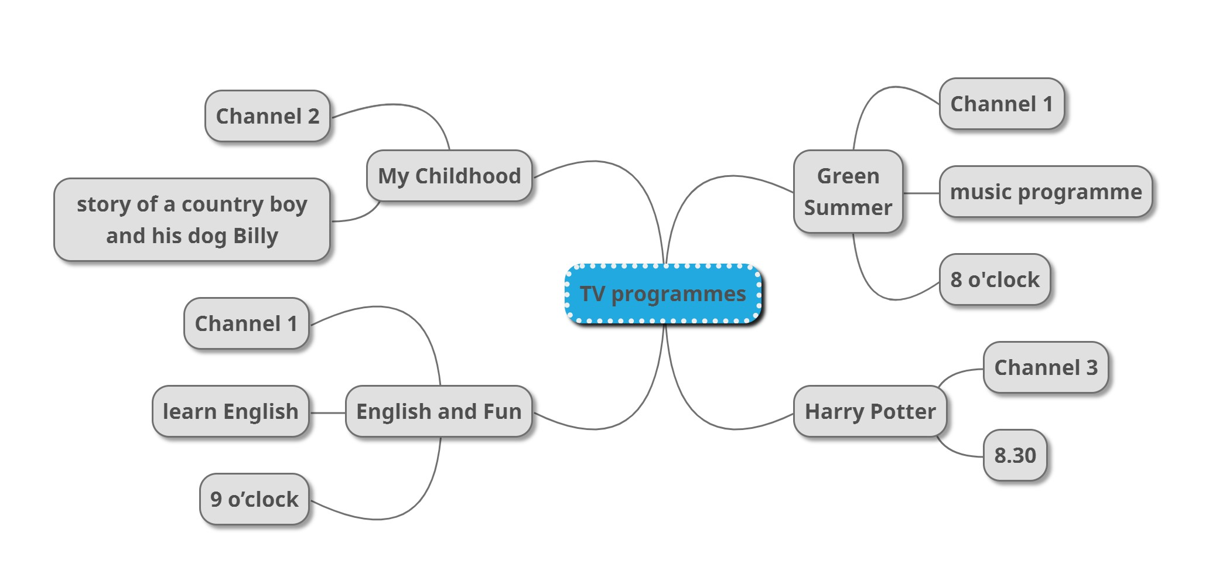
II. Writing
Task 3: Read and answer.
Task 4: Write a paragraph of about 50 words about your TV-viewing habits. Use your answers in Task 3.
* Homework

Procedure

Stage | Stage aim | Procedure | Interaction | Time
Warm-up | - To create a friendly and active atmosphere in the class before the lesson.  - To lead in the topic of the listening tasks.  - To set the context for the listening part. | * Kim’s game  - Teacher shows some pictures of TV programmes.  - Teacher asks students to look carefully at them for about thirty seconds. Then take the pictures away and ask them to call out what they can remember.    Year End Meeting    News    Who is the millionaire?    Rap Viet    Who is Single? | T-Ss | 5 mins
Lead-in | To lead in the listening tasks. | - Teacher asks students some questions to lead in the listening tasks:  + What programme did you watch last night?  + What was it about?  + What did you like about it?  + What didn’t you like about it?  + Why did you like/ dislike it? | T-Ss | 2 min
Pre-Listening | To draw students’  attention to the keyword of the listening task. | - Teacher allows students some time to read the programmes in the table.  - Teacher asks them to focus only on the  information they need: the channel.  “We are going to read a schedule of some  programmes on TV.  First, I would like you to read it, underline the  important key words (“the channel”), then  listen to tick which channel it belongs to.”  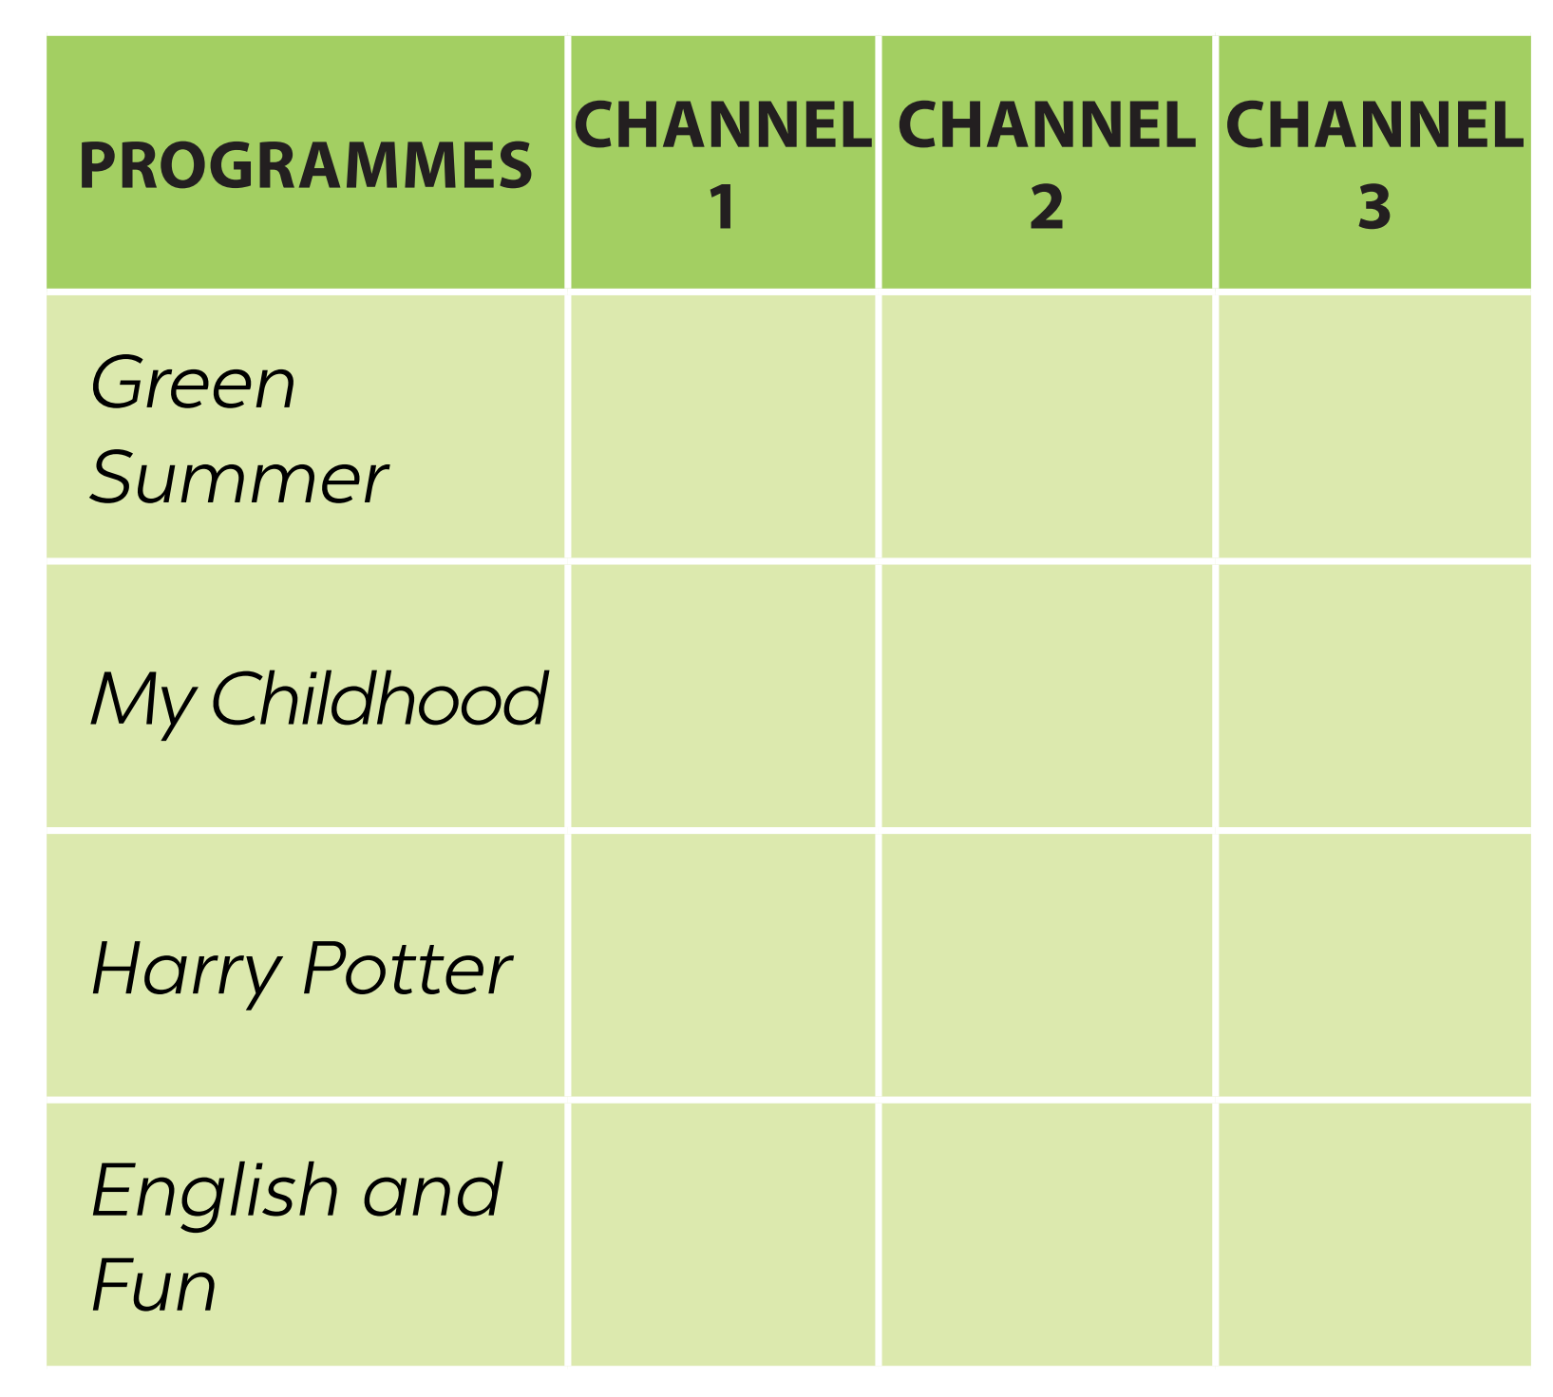 | T-Ss  Ss | 1 min
While-  Listening | To help students  develop their listening skill for specific  information.  To help students develop their listening skill for specific  information (True – False). | Task 1: Listen and tick the correct channel for each programme.  - Teacher plays the recording.  - Students listen and tick.  - Teacher checks their answers as a class.  Answer key:  Programme Channel 1 Channel 2 Channel 3  Green Summer ✓  My Childhood ✓  Harry Potter ✓  English and Fun ✓  Task 2: Listen again and tick T (True) or F (False).  - This activity requires students to listen more carefully for details.  - Teacher allows students some time to read the statements first and see if they can answer any of them based on the previous listening.  - Teacher draws students’ attention to the fact that almost all the questions start with the names of the programmes. They are signals that the answers are coming.  - Teacher plays the recording.  - Students listen and tick.  - Teacher checks their answers as a class. If students have difficulty in catching the information, determine their answers, pause the recording after each  sentence where the information appears.  Audio script:  Here are some interesting TV programmes for you. Green Summer, a music programme, is on Channel 1. It starts at eight o’clock. My Childhood is on  Channel 2. It’s the story of a country boy and his dog Billy. On Channel 3, you will watch Harry Potter at 8.30. Children all over the world love this film. If you like to learn English, you can go to English and Fun on Channel 1. It’s at nine o’clock. We hope you can choose a programme for yourself. Enjoy and have a great time. | T-Ss  T-Ss | 10 mins
Post-Listening | To summarize the key  information in the  listening tasks. | Teacher asks students questions to complete the mind map about the content of the previous listening tasks.  Suggested answers: | T-Ss | 5 mins
Pre-Writing | To guide and prepare  students with information for their  writing in Task 4. | Task 3: Read and answer.  - Students have to answer a questionnaire about TV-watching habits.  - Teacher lets students read the questions and tick the most appropriate answers for themselves.  - Teacher asks them to think of a TV programme they like and write the answer to Question 5. | T-Ss | 5 mins
While-Writing | To guide students how to write a paragraph about TV-watching habits. | Task 4: Write a paragraph of about 50 words about your TV-viewing habits. Use your answers in  Task 3.  - Teacher lets students work individually.  - Teacher asks them to refer to the questions and their answers in 3 while they are writing. These questions are a very good guide of how to form a sentence and what information they need to complete the sentence.  - Teacher tells students that the information in the questions in Task 3 has been arranged in a logical order and they can organise their writing by referring to their answers one after another.  - Teacher goes round and oﬀer help if needed.  - If time allows, ask some students to share their writing with the class. If not, collect some students’ writings to correct at home.  Sample answer:  I like watching TV, about one hour a day. I only watch TV in the evening. During the day, I go to school. On Saturday and Sunday, I watch more. Sometimes I watch TV when I’m eating, but I never watch TV when I’m studying. I watch Da Vinci most. It has interesting educational programmes for children. | S | 10 mins
Post-Writing | To peer check, cross check and final check students’ writing. | - Teacher asks students to exchange their textbooks to check their friends’ writing.  - Teacher then gives feedback as a class discussion. | T-Ss  Ss-Ss | 4 mins
Wrap-up | To consolidate what  students have learnt in the lesson. | Teacher asks students to talk about what they have learnt in the lesson. | T-Ss | 1 mins
Homework | To revise students’ writing. | Teacher asks students rewrite the paragraph. | T-Ss | 1 min

UNIT 7: TELEVISION

Lesson 7: Looking back & Project

  - I. Objectives
By the end of this lesson, students will be able to:

1. Knowledge
- Review the vocabulary and grammar of Unit 7
- Apply what they have learnt (vocabulary and grammar) into practice through a project

2. Core competence
- Develop communication skills and creativity
- Develop presentation skill
- Develop critical thinking skill
- Be collaborative and supportive in pair work and team work
- Actively join in class activities

3. Personal qualities
- Be more creative when doing the project
- Develop self-study skills

II. Materials
- Grade 6 textbook, Unit 7, Looking back & Project
- Computer connected to the internet
- Pictures, A0 paper
- Projector/ TV
- hoclieu.vn

Language analysis

Anticipated difficulties | Solutions
1. Students may have underdeveloped speaking, writing and co-operating skills when doing projects. | - Encourage students to work in pairs, in groups so that they can help each other.  - Provide feedback and help if necessary.
2. Some students will excessively talk in the class. | - Define expectations in explicit detail.  - Have excessive talking students practise.  - Continue to define expectations in small chunks (before every activity).

  - Board Plan

Date of teaching

Unit 7: Television

Lesson 7: Looking back & Project

* Warm-up

Mini-talk
I. Looking back
Vocabulary
Task 1: Put the words in the box in the correct column. Add more words if you can.
Task 2: Use the words in the box to complete the text.
Grammar
Task 3: Complete each question with a suitable question word.
Task 4: Use the conjunctions provided to connect the sentences.
II. Project
Task 5: How important is TV to you?
* Homework

Procedure

Stage | Stage aim | Procedure | Interaction | Time
Warm-up | - To activate students’ prior knowledge and  vocabulary related to the topic.  - To revise the vocabulary about television and lead in the lesson. | * Mini-talk  - Teacher asks students some questions to lead in the lesson:  “Last lesson, we learnt so many TV programmes, now I would like to ask you a few questions about them.  + What is your favourite TV programme?  + Can you tell me what it is about?  + Could you give me some adjectives to describe it?” | T-Ss | 5 mins
Looking back | To help students  revise the vocabulary about television.  To help students  revise the vocabulary about television in context.  To help students revise the use of question words.  To help students revise the use of conjunctions. | VOCABULARY  Task 1: Put the words in the box in the correct  column. Add more words if you can.  - Teacher asks students to do the task individually.  - Teacher allows students some time to read the list of the words and write them in the correct place in the table.  - Teacher lets students swap their answers for double check.  - Teacher calls on some students to read aloud their answers before checking them as a class.  Answer key:  Programmes Adjectives  sports wildlife English in a Minute animated films educational interesting popular funny  Task 2: Use the words in the box to complete the text.  Notes:  * This activity is for the revision of the vocabulary, not as single vocabulary but in a  contextualized situation.  * Students have to be able to recognise the  relationship of the target words and their neighbours, the context in which they appear.  - Teacher asks students to do the task individually.  - Teacher lets students swap their answers for double check.  - Teacher calls on some students to read aloud their answers before checking them as a class.  Answer key:  1. viewers  2. animal  3. sports  4. funny  5. educational  GRAMMAR  Task 3: Complete each question with a suitable question word.  - Teacher asks students to look at the answers and underline the missing  information from the questions so that they can decide which question words to be used.  - Teacher goes round and oﬀer help if needed.  - Teacher checks their answers as a class.  Answer key:  1. How many  2. What  3. Why  4. Who  5. How much  Task 4: Use the  conjunctions provided to connect the sentences.  - Teacher asks students to read the two sentences in each question and use the conjunctions provided to connect them.  - Mind that in most sentences, the conjunctions are used to replace the stop mark and connect the two sentences.  - Teacher checks their answers as a class.  Answer key:  1. Ocean Life is on at 7.30, and Laughing out Loud comes next at 8.00.  2. I liked The Seven Kitties very much, so I watched it many times.  3. BBC One is a British Channel, but VTV6 is a Vietnamese Channel.  4. Along the Coast is a famous TV series, but I don’t like it.  5. I have a lot of homework tonight, so I can’t watch Eight Feet Below. | S  Ss-Ss  T-Ss  S  Ss-Ss  T-Ss  T-Ss  T-Ss  T-Ss | 16 mins
Project | To introduce to students a new way of learning and practising their learnt language outside the class. | Task 5: How important is TV to you?  Notes:  * This project introduces to students a new way of learning and practising their learnt language outside the class.  * Teacher organises the activity in a way that students will be able to go out and ask questions to find out how important TV is to their friends, to take notes of the answers, and to  report the results to other people (their classmates).  - Teacher divides students into groups of four or five and instructs them on what they have to do.  - Teacher encourages them to reach further out of the classroom (interviewing their  parents, siblings, neighbours, etc.).  - Teacher asks students to share their findings with the class. If there is time, teacher can use the results of the project for the class discussion to see how much TV watching is enough/ good/ bad and the role of TV for children. | Group work  T-Ss | 20 mins
Wrap-up | To consolidate what  students have learnt in the lesson. | Teacher asks students to talk about what they have learnt in the lesson. | T-Ss | 3 mins
Homework | To prepare for the next lesson. | Prepare for the next  lesson: Unit 8 – Getting started. | T-Ss | 1 min
*Pictures' source: From Internet

