**Mã đề 6.2.42**

**ĐỀ KIỂM TRA GIỮA HỌC KÌ II**

**MÔN: TIẾNG ANH LỚP 6**

*Thời gian làm bài: 60 phút*

**SECTION A. LISTENING (2pts)**

**Part 1. You will hear five conversations. You will hear each conversation twice. You choose the best answer for each question.(1pt)**

1. What does Daisy want for supper?

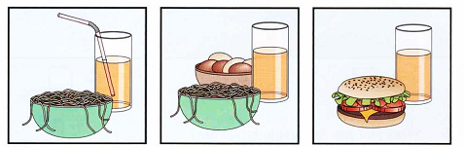

A  B  C

2. What did Sally get for her birthday?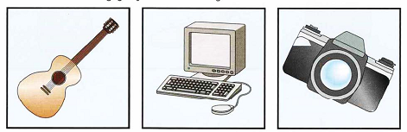

A  B  C

3. Where did Peter go at the weekend? 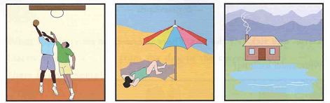

A  B  C

4. What was the matter with Mary? 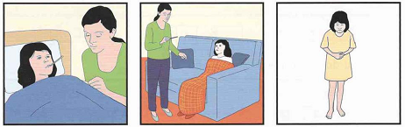

A  B  C

5. What fruit has Fred got in his garden? 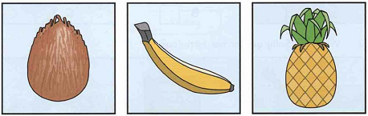

A  B  C

**Part 2. Listen and fill in the missing information(1pt)**

Here are some (1) ............... TV programmes for you. Green Summer, a music programme, is on Channel 1. It (2) ............... at eight o'clock. My Childhood is on Channel 2. It's the story of a country boy and (3) ............... dog Billy. On Channel 3, you will watch Harry Potter at (4) ............... Children all over the world love this film. If you like to learn English, you can go to English and Fun on Channel 1. It's at nine o'clock. We hope you can (5) ............... a programme for yourself. Enjoy and have a great time.

**SECTION B: LANGUAGE (3 POINTS)**

**I. Choose the word whose underlined part pronounced differently from that of the others by circling A, B, C or D (0,5point)**

1. A. postcard B. cold C. tower D. joking

2. A. thing B. them C. their D. then

**II. Choose the best option (A, B, C or D) to complete these sentences. (2,5points)**

1. Football is an ……………….game.

A. outdoor B. indoor C. individual D. team

2. Kien is not very …………………. He never plays games.

A. sport B. sporting C. sporty D. sporter

3. Thanh likes ………………weather because he can go swimming.

A. hot B. cold C. rainy D. cool

4. I.................fishing with my uncle in the afternoon last summer.

A. go B. went C. goes D. going

5. The house will have a super mart TV to…………….the e-mails.

A. send and post B. get and take C. send and receive D. receive and get

6. – “…………” do you go to the gym?” – “By bus”

A. What B.Why C.Where D. How

7. – “…………..watch TV too much” - “ I see.”

A. Not B. Do C. Don’t D. Did

8. She was tired, …………….she went to bed early.

A. but B. or D. because D. so

9. The comedy is so……………. . It makes me laugh a lot.

A. funny B. clumsy C. skillful D. intelligent

10. Jonh and Liz are very rich. …………house is big.

A. Theirs B. They C. Their D. Them

**SECTION C: READING (2,5pt)**

**I. Choose the correct answer A, B, C or D for each gap to complete the passage. (1pt)**

My favourite sports star is Michael Jordan. He was a famous basketball player in American National Basketball Association (NBA). He (1) _______ 15 seasons in the NBA, winning six championships with the Chicago Bulls. The NBA website writes: “... Michael Jordan is the greatest basketball player (2) _______all time.”

The spirit of Michael Jordan (3) _______ that he never gave up. It may be one of the secrets of the success for Michael Jordan. Such a spirit makes a difference in our lives, so we (4) _______ try our best if we want to be successful. He is also a very (5) _______ and generous person because he uses his money to help those who need his help.

1. A. played                          B. did                    C. took D. made

2. A. in                                  B. of C. on                    D. at

3. A. was                               B. had                    C. made D. were

4. A. could                               B. may C. must D. should

5. A. fine                                B. nice                    C. well D. badly

**II. Read the following passage and mark the letter A, B, C, or D on your answer sheet to**

**indicate the correct answer to each of the questions. (1,5pts)**

Ha Tinh is a disaster-prone province in the central of Viet Nam. Since the beginning of 2015, this province has experienced three massive floods, causing devastating property damage. The floods razed thousands of homes, damaged numerous irrigation works, roads, schools and healthcare centres. Ms. Nga Tran, a local resident, recalled the last flood, “The flood in June was normal, but the one in September was awful. Water from Ngan Pho River began to submerge the floor, while outside it was still raining heavily. After a while the water was about one meter. I had no choice but to climb up to the attic and stay there for two days.” Like many other residents, all of Ms Nga’s furniture was covered in mud, some was completely damaged for having been soaked in the water for too long. But what worried her most was the loss of her rice crop. Three months after the flood, lots of farmers still struggled with finding enough food to eat. If there is no aid from the government, the situation in this province will get worse.

1. What does disaster-prone mean?

A. having no disasters B. likely to have disasters

C. have very few disasters D. have few disasters

2. What is NOT mentioned as consequences from the floods?

A. loss of life B. loss of property

C. loss of crop D. loss of houses

3. When was the flood as recalled by Ms. Nga Tran?

A. January B. June C. September D. December

4. How long did Ms. Nga Tran stay in her attic?

A. for the whole week B. four months

C. three months D. two days

5. What is the biggest worry of Ms. Nga and other residents?

A. lack of food B. lack of accommodation

C. lack of aid D. medicine

**SECTION D. WRITING (2,5pts)**

**I. Mark the letter A, B, C, or D on your answer sheet to indicate the underlined part that needs correction in the following questions. (0,5pt)**

1. Namlikes watching cartoons, so his father likes watching sports.

A B C D

2. There is an interesting film on TV last night.

A B C D

**II. Rewrite the sentences without changing the meaning. (1 pt).**

1. I have a computer.

→ This is ………………………………………………………………...

2. Nam likes football most .

→ Nam 's favourite………………………………………………………………

3. Hoa is not as interested in music as her brother is .

→ Hoa 's brother………………………………………………………………

4. The girl is very beautiful.

→ What……………………………………………………………………….!

**III. Use the given words to make complete sentences about it. (1 pt)**

**Here is an example.**  
 0. Ngoc/usually/play/badminton/Sunday.  
 Answer: 0. Ngoc usually plays badminton on Sundays.

1. She/like /this programme/ because /it/ very interesting / useful.

→………………………………………………………………………………….

2. Nam/not/play football /yesterday.

→………………………………………………………………………………….

3. The people here/very friendly/helpful.

→………………………………………………………………………………..

4. What/you/do/your free time?

→………………………………………………………………………………….

**************************************************************************

**Mã đề 6.2.42**

**ANSWER KEY**

**SECTION A. LISTENING (2pts)**

**Part 1. You will hear five conversations. You will hear each conversation twice. You choose the best answer for each question.(1pt)**

1. A 2. C 3. C 4. B 5. C

**Part 2. Listen and fill in the missing information(1 pt)**

Here are some (1) **....... interesting........** TV programmes for you. Green Summer, a music programme, is on Channel 1. It (2) ......**starts**......... at eight o'clock. My Childhood is on Channel 2. It's the story of a country boy and (3) ......**his**......... dog Billy. On Channel 3, you will watch Harry Potter at (4) ......**8.30**......... Children all over the world love this film. If you like to learn English, you can go to English and Fun on Channel 1. It's at nine o'clock. We hope you can (5) ......**choose**......... a programme for yourself. Enjoy and have a great time.

**SECTION B: LANGUAGE (3 TS)**

**I. Choose the word whose underlined part pronounced differently from that of the others by circling A, B, C or D (0,5point)**

**1.C 2. A**

**II. Choose the best option (A, B, C or D) to complete these sentences. (2,5points)**

**1. A 2. C 3. A 4. B 5. C**

**6. D 7. C 8. D 9. A 10. C**

**SECTION C: READING (2,5pt)**

**I. Choose the correct answer A, B, C or D for each gap to complete the passage. (Chọn đáp án đúng A, B, C hoặc D cho mỗi chỗ trống để hoàn thành bài đọc) (1pt)**

**1. A 2. C 3. A 4. D 5. B**

**II. Read the following passage and mark the letter A, B, C, or D on your answer sheet to**

**indicate the correct answer to each of the questions. (1,5pts)**

**1.B 2. B 3. C 4. D 5. A**

**SECTION D. WRITING (2,5pts)**

**I. Mark the letter A, B, C, or D on your answer sheet to indicate the underlined part that needs correction in the following questions. (0,5pt)**

**1. C 2. A**

**II. Rewrite the sentences without changing the meaning. (1 pt).**

**1.** This is my computer.

2. Nam 's favourite sport is football.

3. Hoa 's brother is more interested in music than Hoa.

4. What a beautiful girl!

**III. Use the given words to make complete sentences about it. (1 pt)**

1. She likes this programme because it’s very interesting and useful.

2. Nam didn’t play football yesterday.

3. The people here are very friendly and helpful.

4.What do you doin your free time?