*
4

UNIT
DISASTERS

VOCABULARY

ENGLISH | TYPE | PRONUNCIATION | VIETNAMESE
avalanche | (n) | /ˈævəlæntʃ/ | tuyết lở
blizzard | (n) | /ˈblɪzərd/ | trận bão tuyết
disaster | (n) | /dɪˈzæstər/ | thảm họa
disastrous | (adj) | /dɪˈzæstrəs/ | thảm khốc
drought | (n): | /draʊt/ | hạn hán
earthquake | (n): | /ˈɜ:rθkweɪk/ | động đất
flood | (n): | /flʌd/ | lũ lụt
flooded | (adj): | /ˈflʌdɪd/ | bị ngập, úng
heat wave | (n): | /ˈhi:t weɪv/ | đợt nóng
landslide | (n): | /ˈlændslaɪd/ | sạt lở đất
tsunami | (n): | /tsu:ˈnɑ:mi/ | sóng thần
typhoon | (n): | /taɪˈfu:n/ | bão nhiệt đới
wildfire | (n): | /ˈwaɪldfaɪər/ | cháy rừng
battery | (n): | /ˈbætəri/ | pin
board up | (phr v): | /bɔ:rd ˈʌp/ | bịt kín (cửa, cửa sổ,…) bằng gỗ
fire extinguisher | (n): | /ˈfaɪər ɪkˌstɪŋɡwɪʃə/ | bình cứu hỏa
emergency service | (n): | /ɪˈmɜ:rdʒənsi ˌsɜ:rvɪs/ | dịch vụ cấp cứu, cứu hộ
escape plan | (n): | /ɪˈskeɪp plæn/ | sơ đồ thoát hiểm
stock up | (phr) | /stɑ:k ʌp/ | dự trữ
first aid kit | (n) | /ˌfɜ:rst ˈeɪd kɪt/ | bộ sơ cứu
flashlight | (n) | /ˈflæʃlaɪt/ | đèn pin
supply | (n) | /səˈplaɪ/ | sự cung cấp
supply | (v) | /səˈplaɪ/ | cung cấp
supplier | (n) | /səˈplaɪə/ | nhà cung cấp
task | (n) | /tæsk/ | nhiệm vụ
supplies | (n, pl) | /səˈplaɪz/ | nhu yếu phẩm
expect | (v) | /ɪkˈspekt/ | dự báo, cho là, kỳ vọng
expectation | (n) | /ˌekspekˈteɪʃən/ | sự kỳ vọng
immediate | (adj) | /ɪˈmi:diət/ | tức thời
immediately | (adv): | /ɪˈmi:diətli/ | ngay lập tức
inform | (v) | /ɪnˈfɔ:rm/ | thông báo
informative | (adj) | /ɪnˈfɔrmətɪv/ | cung cấp nhiều
information | (n) | /ˌɪnfərˈmeɪʃən/ | thông tin
warn | (v) | /wɔ:rn/ | cảnh báo
warning | (n) | /ˈwɔ:rnɪŋ/ | sự cảnh báo

Task 1. Look at the pictures and complete the blanks.

earthquake | landslide | flashlight | avalanche
volcanic eruption | fire extinguisher | tropical storm | thunder
supplies | tsunami | typhoon | first aid kit

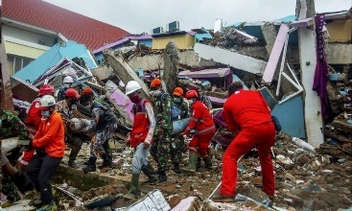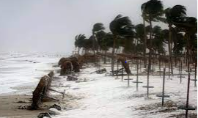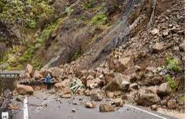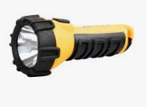

3landslide ……………………………………………

4flashlight ……………………………………………

2 tropical storm ……………………………………………

1earthquake ……………………………………………

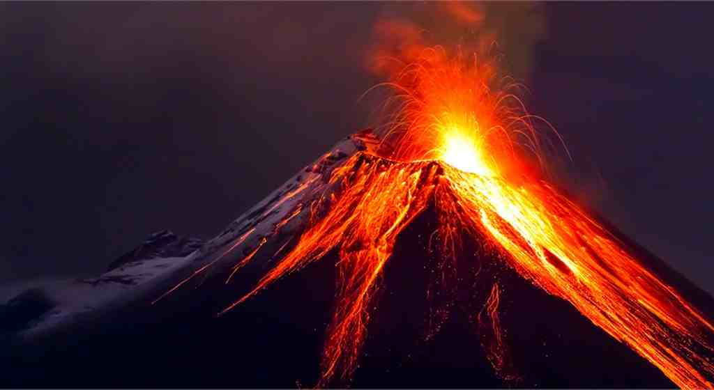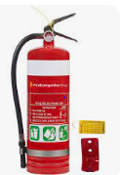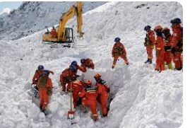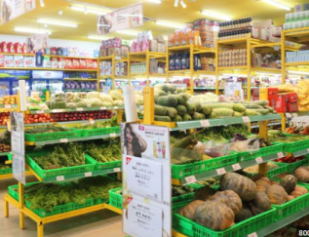

5volcanic eruption …………………

8supplies……………………………………………

7…avalanche…………………………………………

6fire extinguisher ……………………………………………

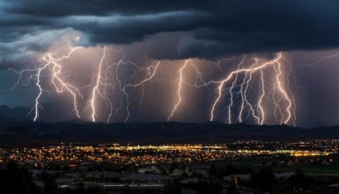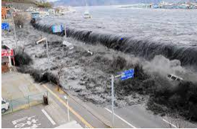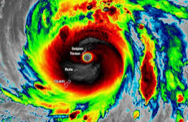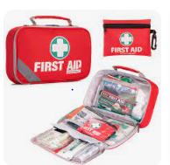

9…thunder………………

12…first aid kit…………………………………………

11typhoon……………………………………………

10tsunami……………………………………………

Task 2. Match the natural disasters with their definitions.

- flood | 1-d | - shaking of the surface of earth, caused by sudden movement in the Earth’s crust.
- drought | 2-e | - a storm in which the air moves very quickly in a circle.
- Wildfire | 3-c | - a fire in an area of combustible vegetation that occurs in the countryside or rural area.
- Typhoon | 4-b | - Natural occurrences where an area or land that is become submerged in water.
- Tsunami | 5-g | - Period of time when an area experiences below normal precipitation
- Landslide | 6-j | - molten rock, ash and steam pour through a vent in the earth’s crust
- Earthquake | 7-a | - a series of waves in a water body caused by the displacement of a large volume of water
- Volcanic eruption | 8-f | - a lot of rocks and earth fall down a hill.
- tornado | 9-k | - A mass of snow, ice, and rock that falls down the side of a mountain
- avalanche | 10-i | - A large amount of wet earth that suddenly falls down a hill.
- mudslide | 11-h | - A very strong wind that goes quickly round in a circle or funnel.
- blizzard | 12-l | - a snowstorm with powerful wind

Task 3. Choose the correct answers.

1. | The waves of the_________ were so huge that it destroyed everything on the beach.
A. tornado |  | B. hurricane | C. tsunami | D. earthquake
2. | Five skiers are missing after the_________ in the Alps.
A. drought |  | B. landslide | C. flood | D. avalanche
3. | After the_________ all the houses were left under water.
A. flood |  | B. tornado | C. typhoon | D. mudslide
4. | It took firefighters five days to put out the_________.
A. hurricane |  | B. forest fire | C. tsunami | D. drought
5. | A period of 3- 4 months without rain will cause a severe_________.
A. typhoon |  | B. earthquake | C. drought | D. flood

- The_________ picked up the car and threw it 100 meters into the air. That’s an incredibly strong wind!

A. tornado B. volcanic eruption C. landslide D. typhoon

- The_________ shook parts of the region around Tokyo on Saturday. It was 5 on the Richter Scale.

A. hurricane B. flood C. earthquake D. tornado

- _________ occur when a large amount of water causes the rapid erosion of soil on a steep slope.

A. Tsunamis | B. Tornados | C. Avalanches | D. Mudslides
9. A big storm in the Pacific is known as a_________.
A. avalanche | B. typhoon | C. tsunami | D. tornado
10. Mount Merapi in Indonesia is a famous_________.
A. landslide | B. typhoon | C. volcano | D. tornado

Task 4. Complete the sentences with the words from the box.

debris | tornadoes | disasters | accommodation | havoc
victims | mudslide | property | supplies | flood

1.The__ flood_______ was overwhelming and the City was soon drowned.
- The___ disasters______ was overwhelming and the City was soon drowned.

- Teams of people are still clearing the__ debris_______ from damaged trees and houses after the tornado.

- Temporary housing can be provided to victims when natural floodstrike.

- The storm wreaked__ havoc_______ in the garden, uprooting trees and blowing a fence down.

- Tornadoes_________can destroy buildings, flip cars, and create deadly flying debris.

6. Four people were reported killed when a buried their house.
- Many people lost their homes due to the earthquake and are staying in temporary

accommodation_________ until their houses are rebuilt.

- Food, clean water and medical__ supplies_______ arrived three days after the typhoon.

- A natural disaster can cause loss of life or damage to__ property_______.

- The government is sending aid to flood_ victims________.
Task 5. Use the correct form of the words in brackets.

- Earthquakes cause the ground to move and shake_violently________. (violent)
- Warnings of natural disasters need to be correct, simple and useful. (warn)
- Mount Mayon volcano caused a major_________ in the Philippines. (erupt)
- The disastroustyphoon last year made thousands of people homeless. (disaster)
- Emergency announcementfrom the National Weather Service are very important to local people during disasters. (announce)
- Despite all the modern technology available to us, we’re still_ helpless________ against earthquakes. (help)
- The remove of___scattered______ debris can be rapidly finished by machines. (scatter)
- We assisted them with the__providing_______ of food and clothing. (provide)
- Linda was the most_destructive________ typhoon to ever hit Southern Vietnam. (destroy)
- Medical__supplies_______ were sent to the earthquake victims yesterday. (supply)


GRAMMAR

Wh-questions (Câu hỏi với từ để hỏi bắt đầu bằng Wh-)
– Chúng ta sử dụng câu hỏi với từ để hỏi Wh- khi muốn hỏi về thông tin chi tiết của một hành động hoặc sự việc.
Từ để hỏi | Cách dùng | Ví dụ
What | Hỏi về sự vật, sự việc | Whatwas the biggest earthquake? – It was the Great Chilean Earthquake.
Where | Hỏi về nơi chốn | Wherewere the biggest wirefires? – They were in Siberia, Russia.
When | Hỏi về thời gian | Whenwas the worst avalanche? – It was in 1970.
How wide | Hỏi về chiều rộng | How widewas the typhoon? – It was 200 miles wide.
How tall | Hỏi về chiều cao | How tall was the tsunami? – It was 50 meters tall.
How long | Hỏi về chiều dài/khoảng thời gian | How longwas the drought? – It lasted two years.
How many | Hỏi về số lượng (với danh từ đếm được) | How many houses did the typhoon damage? – 20,000 houses.
How much | Hỏi về lượng (với danh từ không đếm được) | How muchdamage did the flood cause?

Prepositions of place (Giới từ chỉ vị trí)
Giới từ chỉ vị trí được dùng để nói về vị trí của một đồ vật hoặc một người.
in front of /ɪnˈfrʌntəf/: phía trước | Let’s meet in front ofthe movie theater.
behind /bɪˈhaɪnd/: phía sau | Shall we meet behindthe market?
next to /ˈnekstə/: bên cạnh | The water park is next to the supermarket.
near /nɪər/:gần | Keep your phone near you at all times.
opposite /ˈɑ:pəzɪt/: đối diện | The bowling alley is oppositethe ice rink.
under /ˈʌndər/: ngaybên dưới | The cats are under the bridge.
below /bɪˈloʊ/: ở vị trí thấp hơn | The kitchen is below her bedroom.
above /əˈbʌv/: ở vị trí cao hơn | The new room is above the garage.
inside /ɪnˈsaɪd/: bên trong | Keep children and pets inside the house.
outside /aʊtˈsaɪd/: bên ngoài | You shouldn’t go outside of your house.
*Ôn lại cách sử dụng 3 giới từ in, on at
*Lưu ý:
Sự khác biệt giữa in front of và opposite:
– Dùng in front of để miêu tả vị trí trước, sau của hai sự vật.
– Dùngopposite khi hai sự vật được nói đến bị phân cách bởi một sự vật khác ở giữa.
Cách đọc giới từ to
– Trước phụ âm /tə/, e.g. next to me /ˈnekstəˌmi/
– Trước nguyên âm /tu/, e.g. next to us /ˈnekstuˌ_{(w)}ʌs/
Prepositions of movement (Giới từ chỉ sự chuyển động)
Giới từ chỉ sự chuyển động được dùng để nói sự di chuyển từ nơi này sang nơi khác.
to /tə/: đến, về hướng | Move to higher ground.
into /ˈɪntə/: vào trong | Don’t drive or walk into flood water.
onto /ˈɑ:ntə/: lên trên | The dog jumped onto the chair.
across /əˈkrɔ:s/:từ bên này sang bên kia (đường) | She walked across the road.
along /əˈlɔ:ŋ/: dọc theo | We walked along the beach collecting small crabs in a bucket.
out of /ˈautəv/: ra khỏi | They got out of the car and come into the house.
over /ˈoʊvə/: bên trên, bên kia (cầu, sông…) | She climbed over the wall.
through /θru:/: xuyên qua | They walked slowly through the woods.

Task 1.Complete the sentences with inside, under, outside, out, to and up.

- Go__inside___the house! The winds are getting stronger.
2. You shouldn't go__outside ____on a stormy day.
3. If your house was on fire, you should get out of the house really fast and move__to___safe place.
4. During an earthquake, try to get____under_____things such as a table, a desk or a bed.
5. People climbed_____up____ the hill to avoid the tsunami.
6. You should seek shelter____out_____ a strong table or desk until the shaking stops.
7. People should work from home instead of going__to ______ work on a stormy day.
8. Run___up___ the hill before the tsunami arrives.
9. Due to the road conditions, the authority warned people not to drive__into_____ flood water.
10 Stay__inside____ your house during a blizzard.
11.During an earthquake, you should get __under____ a desk because something could fall on you.
12. People living near the beach should move __to___ a safe place before a typhoon hits.

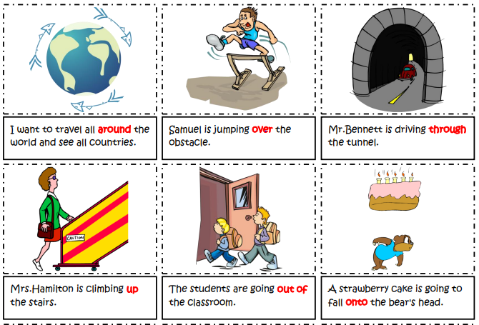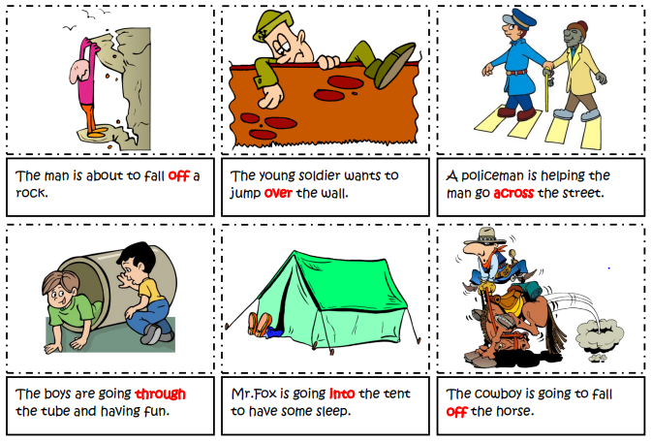
Task 2.Fill in blank with with into, onto, over, around, up, out of, across, off or through

- I want to travel all around the world and see all countries.
- Samuel is jumping over the obstacle.
- Mr.Bennett is driving through the tunnel.
- Mrs.Hamilton is climbing up the stairs.
- The students are going out of the classroom.
- A strawberry cake is going to fall onto the bear's head.
- The man is about to fall off a rock.
- The young soldier wants to jump over the wall.
- A policeman is helping the man go across the street.
- The boys are going through the tube and having fun.
- Mr.Fox is going into the tent to have some sleep.
- The cowboy is going to fall off the horse
Task 3. Circle the correct options.

- Kate: ________ did th tsumina destroy?- Jack: The whole village.
- Where | - Which | - What | - Why
- Jim:________ was the wave? – Ann: About 10 meters tall.
- How much | - How many | - How long | - How tall
- Alex: __________ did the earthquake hit the city?- Tom: At midnight
- When | - What | - Where | - How
- Kim: ___________ was the biggest wildlife?- Ted: In Western Montana, the US.
- Which | - Where | - What | - How
5. Ben: _________did the blizzard cause across the city?- Roisie: A powerful cut.
A. Which | B. How | C. What | D Why
- ________was the biggest earthquake? – It was the Great Chilean Earthquake
A. When | B. How | C. What | D Why

- _________were the biggest wirefires? – They were in Siberia, Russia.
A. Which | B. How | C. What | D Where

- _____________ was the worst avalanche? – It was in 1970.
A. Which | B. When | C. What | D Why

- _____________was the typhoon? – It was 200 miles wide.
A. How wide | B. How tall | C. How long | D. How heavy

10. ______________was the tsunami? – It was 50 meters tall.
A. How wide | B. How tall | C. How long | D. How heavy

11._______________was the drought? – It lasted two years.
A. How wide | B. How tall | C. How long | D. How heavy

12.____________houses did the typhoon damage? – 20,000 houses.

A. How wide | B. How much | C. How long | D. How many

13.______________ damage did the flood cause?
A. How wide | B. How much | C. How long | D. How many

Task 4. Circle one mistakes in each sentence and corect it

1. We should keep fire extinguishersona safe place.
A B C D
2.Stayinsidea building when it is on fire.
A B C D
3. You shouldmoveup a safe place during a heavy flood.
A B C D
4.Stockinon emergency items such as first aid kits and supplies.
A B C D
5. Stay on a table to protect yourself when an earthquake happens.
A B C D
6. Howmuch damage did the avalanche caused?
A B C D
7. How much people gothurt in the tsunami?
A B C D
8. Whatwas you doing when the earthquakehit the city?
A B C D
9. Ann:"How tallwas the wave?"- Ted: "It was over 20 meters long."
A B C D
10. Andy:"Howmanydidit takes to stop the fire?"- Ben: "About 3 hours.
A B C D
10. Andy:"Howmanydidit takes to stop the fire?" - Ben: "About 3 hours.
A B C D
11. How many people have to leave their houses because ofthe earthquake last week?
A B C D
12. If there's an earthquake, remember to get inthe desk to stay away from fallen things.
A B C D
13.If you arein danger,callingthe emergency service, they can help you.

A B C D

LISTENING

Task 1. Listen to teacher and tick (V) the words you hear.

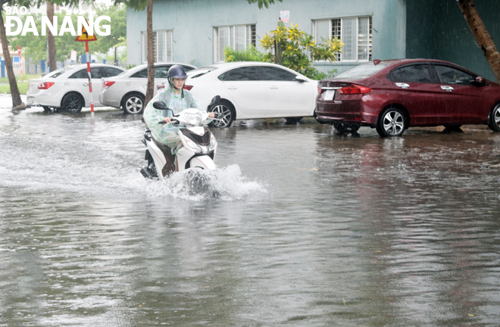 | 1. A flood is land .. covered............. by water that is not usually covered by water.  2. A flood which causes severely ........ financial.... damage or loss of life to ... humans......or livestock is considered a significant flood.  3. Floods are among the most ....... catastrophic.....of natural disasters.  4. Flood often results in property …and cause emotional trauma  5. Even if people have not been directly affected by the loss of life, losing property., houses, or land can cause physiological damage.
Task 2. Listen again and decide if the statements are True ( T) or False(F)

1.

  - A flood is land covered by water that is not usually covered by water. ___T____
  - Unless a flood causes some kind of financial damage or loss of life to humans or livestock, it’s not considered a significant flood. ___T__
  - Floods is the most catastrophic of natural disasters. ___F____
  - Flood often cause loss of life and cause emotional trauma. ___T____
  - Floods affect not only human life but also destroy property. ___T____

Tape:
A flood is land covered by water that is not usually covered by water. This means that any time a river, lake, or other body of water overflows its banks, it’s technically flooding. However, most people think of the more catastrophic types of floods, as those are the type that cause widespread damage and loss of life. Unless a flood causes some kind of financial damage or loss of life to humans or livestock, it’s not considered a significant flood.
Because so much of the damage inflicted by floods has long-lasting consequences, floods are among the most catastrophic of natural disasters. Flood often results in loss of life and cause emotional trauma for those who have gone through it. Even if people have not been directly affected by the loss of life, losing property, houses, or land can cause physiological damage. Especially if the people affected are unable to rebuild due to the houses being too badly damage, farm land being inundated with salt water, or lack of resources to rebuild, many find the recovery to be more than just physical.

SPEAKING

Task 1.Match the questions and answers. Then practice.

1. Which natural disaster can produce the fastest winds on earth? | 1-I | A.On September 28, 2018
2. In what country did the strongest earthquake  on record occur? | 2- C | B. 53 people are dead, thousands are still missing and many buildings were destroyed.
3.How high were the tsunami waves that touched Indonesia in 2011? | 3-E | C.Chile
4.When did the earthquake strike the Indonesian island of Sulawesi? | 4-A | D.Human activities and deforestation
5.How many people died in Nigeria floods? | 5-H | E.30 meters
6.How strong was the Papua New Guinea earthquake? | 6-G | F. Tornado
7.What caused the Amazon rainforest wildfires in Brazil? | 7-D | G. 7.2 on the Richter scale
8.What are the effects of Hurricane Dorian in the Bahamas? | 8-B | H. More than 100
9.Where do most tsunamis occur? | 9-J | I. Wind Speed
10. What determines the category number of a hurricane? | 10-F | J. In the Pacific and Indian Oceans in the Ring Of Fire.
Task 1.Make questions for the underlined words.

- __________________________________________________________________

If I knew a tornado was Corning, I would immediately and safe shelter.

- __________________________________________________________________

Earthquakes are becoming more frequent these days because of excess use of undergroundmaterials.

- __________________________________________________________________

Dozens ofpeople were buried under a massive landslide in Natonin town.

- __________________________________________________________________

Rescue crewshave helped people from flooded homes and cars.

- __________________________________________________________________

A 6.9 magnitude earthquake struck the Indonesian island of Lombok on August5.

- __________________________________________________________________

Hurricane Dorian is currently hurtling towards Florida.

- __________________________________________________________________

These eruptions have lasted from a few hours to 145 days.

- __________________________________________________________________

Tornadoes generally travel at an average speed of 30 miles per hour.

- __________________________________________________________________

The Amazon is on fire as a result of illegal forest clearing to make more farms.

- __________________________________________________________________

When it rains for a long time, floods could happen.

- What would you do if you knew a tornado was Corning?
- Why are earthquakes becoming more frequent these days?
- How many people were buried under a massive landslide in Natonin town?
- Who have helped people from flooded homes and cars?
- When did a 6.9 magnitude earthquake strike the Indonesian island of Lombok?
- Where is hurricane Dorian currently hurtling towards?
- How long have these eruptions lasted?
- How fast do tornadoes generally travel?
- Why is the Amazon on fire?

- What could happen when it rains for a long time?

READING

Read and answer the questions.

Vietnam usually has a dozen storms every year from June through the end of November. November 2nd, 1997, however, was an unexpected day when the major storm Linda raged in the South. Linda was the worst typhoon in Southern Vietnam over 100 years. Formed in the sea of the Philippines, Linda strengthened as it moved westward. Later, it struck extreme Southern Vietnam with winds of 100 kilometres an hour. Over 3000 people were reported lost and died. Ca Mau province, suffered a direct hit by the storm, had the most damage. Gusts and heavy rainfalls caused flooding, destroyed crops, damaged about 200,000 houses and left about 383,000 people homeless. Linda later struck Thailand, causing flash flooding and at least 164 deaths. The storm also affected Myanmar, Indonesia, Malaysia, and Cambodia to a lesser degree.

- When is the typhoon season in Vietnam?

from June through the end of November___________________________________

- Where in Vietnam was struck by Typhoon Linda?

Southern Vietnam____________________________________

- What was the wind speed of Typhoon Linda when it hit Southern Vietnam?

It struck extreme Southern Vietnam with winds of 100 kilometres an hour.

- How many homes were destroyed in Typhoon Linda?

- about 200,000 houses.

- Where did Typhoon Linda pass over after striking Vietnam?

Formed in the sea of the Philippines, Linda strengthened as it moved westward. ________________________________________________________________

Task 2. Read the following text and use the words given in the box to fill in the blanks.

different | most | common | against | small
ago | region | storms | social | has
As South Texas continues to battle (1) _ against____________ Harvey's record rainfall, the people of Louisiana are marking a tragic anniversary. Twelve years (2) ______ago_______, on August 29, 2005, Hurricane Katrina made landfall near New Orleans. It was one of the (3) _____most________ devastating natural disasters to ever hit the United States, and the (4) _____ region________still bears its scars.
Hurricane Harvey and Hurricane Katrina are (5) _different____________ beasts, to be sure. Harvey's lingering wrath is very different than Katrina's swift and destructive turn, and the (6) __social___________ and infrastructural collapses that followed. So far, Harvey (7) _____has________ claimed a number of lives, but it is a (8) _small____________ fraction of Katrina's 1,800+ victims.
From a meteorological perspective, though, how do these (9) _____storms________compare? Other than timing - an interesting but easily explained coincidence - do they have anything in (10)____common _________ other than adjacent chambers in the nation's memory?
(Source: http://www. http://edition.cnn.com
Task 3. Read and do the tasks.

A tornado is a violently rotating column of air that extends from a thunderstorm to the ground and is often - although not always - visible as a funnel cloud. Lightening and hail are common in thunderstorms that produce tornadoes. Tornadoes cause extensive damage to structures and disrupt transportation, power, water, gas, communications, and other services in its direct path and in neighbouring areas. Related thunderstorms can cause heavy rains, flash flooding, and hail.
About 1,200 tornadoes hit the United States every year and every state is at risk. Most tornadoes in the United States occur east of the Rocky Mountains with concentrations in the central and southern plains, the Gulf Coast and Florida.
Tornadoes can strike in any season, but occur most often in the spring and summer months. They can occur at all hours of the day and night, but are most likely to occur between 3 p.m. and 9 p.m.
(Source: https://www.rendy.gov)
a. Answer the following questions.
1. What is a tornado?
It is a violently rotating column of air that is often visible as a funnel cloud________________________________________________________________
2. What is common in thunderstorms that produce tornadoes?
. Lightening and hail are common in thunderstorms that produce tornadoes________________________________________________________________
3. What can related thunderstorms cause?
Related thunderstorms can cause heavy rains, flash flooding, and hail________________________________________________________________
4. How many tornadoes hit the United States every year?
About 1,200 tornadoes hit the United States every year________________________________________________________________
5. Which seasons can tornadoes strike?
Tornadoes can strike in any season, but occur most often in the spring and summer months.________________________________________________________________
Put True (T) or False (F) at the beginning of the statements below.
6. ___T__________ A tornado extends from thunderstorm to the ground.
7. _____F________ Tornadoes cause slight damage to structures.
8. ____T_________ Every state in the US is at risk of being hit by tornadoes.
9. ____F_________No tornadoes in the United States occur east of the Rocky Mountains, the Gulf Coast and Florida.
10. ____F_________ Tornadoes occur between 3 p.m. and 9 p.m. only.
Task 4. Read the email from Chris to his friend, Luke. Choose the best word or phrase, A, B, C, or D, for each numbered space.

Hi Luke,
Did you watch that program about natural disasters last night? It was excellent! I was a bit bored at the beginning, because the first disaster was snow coming down a mountainside. I’m not sure that(1)____________are really disasters, but they are horrible for skiers.
After the first break, there was a sad story about a (2)____________in a part of India. It didn’t rain for nine months, and there was no water in any of the lakes or rivers. All the food plants died, and people brought things into the area by truck every day.
Next, we had a story about a kind of storm. It turns very fast over water and sometimes causes a lot of damage when it goes over land. It’s called a (3) ____________.
There’s another program next week about other natural disasters, but this program ended with some advice. The presenter said people need to be ready, but that is strange, because he also said there is often no(4)____________that a natural disaster will happen.
Next week, we will learn about the(5)____________of natural disasters, which will be very interesting. Do you want to come and watch it with me?
Best wishes,
Chris
1. | - blizzards | - avalanches | - landslides | - earthquakes
2. | - heat wave | - drought | - wildfire | - fire
3. | - typhoon | - tsunami | - wave | - wind
4. | - extinguisher | - kit | - plan | - warning
5. | - expects | - informs | - causes | - supplies


WRITING

Task 1.Reorder the words to make full sentences.

- the/ dangerous/ flood/ disasters/ in/ most/ world/ of/ the/ is/ one.

Flood is one of the most dangerous disasters in the world.___________

- many/ shelter/ had/ 9 o’clock/ their homes/ by/ people/ camps/ fled/ to/ already/ seek/ in.

By 9 o’clock, many people had already fled their homes to seek shelter in camps.

- be/ with/ people/ homeless/ will/ temporary/ provided/ accommodation.
Homeless people will be provided with temporary accommodation.

- a/ Friday/ by/ 6.9/ Indonesia/ magnitude/ was/ earthquake/ powerful/ on/ struck.

Indonesia was struck by a powerful 6.9 magnitude earthquake on Friday

- the earthquake/ hundreds/ completely/ of/ destroyed/ homes/ hit/ the City/ were/ when.

Hundreds of homes were completely destroyed when the earthquake hit the City.

- natural/ typhoons and floods/ the/ in/ most/ are/ frequent/ Vietnam/ disasters?

Are typhoons and floods the most frequent natural disasters in Vietnam?

- escape/ before/ people/ had/ to/ fire crews/ the fire/ arrived/ four/ managed.

Four people had managed to escape the fire before fire crews arrived.

- property/ people’s/ disasters/ devastate/ destroy/ their/ lives/ natural/ and.

Natural disasters devastate people’s lives and destroy their property.
- a safe place / An escape plan / you know / how to / will help / get outside / and go to / .
An escape plan will help you know how to get outside and go to a safe place.
- earthquake / tsunami / undersea / A large / started a /.
A large undersea earthquake started a tsunami.

Task 2. Turn these sentences into the passive voice.

1. When will you do the work?
When wil the work be done by you?
2. How many days did she spend to finish the work?
How many days were spent to finish the work by her?
3. How do you spend this amount of money?
How is this amount of money spent by you?
4. What books are people reading this year?
What books are being read this years?
5. How did the police find the lost man?
How was the lost man found by the police?
6. Who looked after the children for you?
Who were the children looked after?
7. How long have they waited for the doctor?
How long has the doctor been waited for?
8. What time can the boys hand in their papers?
What time can the papers be handed in by the boys?
9. Why didn’t they help him?
Why wasn’t him helped by them?
10.Who are they keeping in the kitchen?
Who are being kept in the kitchen?………

Task 3. Write about a natural disaster happened in Vietnam that you know (80 words)

- What type of natural disaster is it?
- When/ where did it occur?
- What were the effects of it?

……………………………………………………………………………………………………………………………………
……………………………………………………………………………………………………………………………………
……………………………………………………………………………………………………………………………………
……………………………………………………………………………………………………………………………………
……………………………………………………………………………………………………………………………………
……………………………………………………………………………………………………………………………………
……………………………………………………………………………………………………………………………………
……………………………………………………………………………………………………………………………………
……………………………………………………………………………………………………………………………………
……………………………………………………………………………………………………………………………………

- What was/ has been done to help the
victims of the disasters?



TEST FOR UNIT

.
Choose the word whose underlined part is pronounced differently from the other three in each question.
1.A. world B. worst C. work D. doctor
2. A. tsunami B. tooth C. without D. typhoon
3.A. extinguisher B. emergency C. disaster D. number
Choose the word which has a different stress pattern from the other three in each question.
4. A. biology B. psychology C. photography D. climatography
5. A. volcano B. eruption C. tropical D. apology

Choose the word or phrase that best completes each sentence below.
6.Tornadoes, very strong winds that move in a circle , can suck up anything that is in their ___.
A. road B. line C. eye D. path
7.The family succeeded in running out of the house before the walls__________.
A. damaged B. erupted C. collapsed D. felt
8.The mudslide the entire farm while the farmers were still working onthe farm.
A. collapsed B. buried C. broke D. killed
9. The local people had to move to public shelters after the volcano ____________.
A. erosion B. break C. eruption D. damage
10. The rescue workers set up a camp to aid for the flood victims.
A. provide B. call C. bring D. invest
11. They in a cave when the storm happened.
A. had shelter B. had shelters C. took shelters D. took shelter
12.Many villagers were to public shelters to avoid the volcanic eruption.
A. evacuated B. given C. brought D. provided
13. There was a heavy rain which supported to the forest fire.
A. put up B. put out C. give out D. give up
14. After the flood, many people in that village were homeless.
A. put B. felt C. given D. left
15. Despite all the modem technology available to us, we’re still helpless ______natural disasters.
A. against B. to C. with D. for
Choose the word or phrase that is CLOSEST in meaning to the underlined part in each of the following sentences.
16. Volunteers have given out food and blankets to homeless people in the flooded area.
A. properties B. aid C. helping D. technology -
17. After the earthquake, his building was used exclusively for the accommodation of the victims.
A. workplace B. houses C. markets D. office
18. By the next morning, several villages around Mount Sinabung were buried in ash and debris.
A. damaged B. carried C.covered D.collapsed
Choose the word or phrase that is OPPOSITE in meaning to the underlined part in each of the following sentences.
19. The winds were so strong that trees, cars and even houses were picked up and carried for miles.
A. stood still B.damaged C.put out D. made up
20. We cannot prevent natural disasters, but we can prepare for them.
A. avoid B.stop C.allow D. predict

Choose the word or phrase that best completes each sentence below.
21. If the area is hit by the storm, a lot of damage will be .
A. causing B. cause C. caused D. causes

22. Whenever I watch the news on TV, I see places that are ________ or________by drought.
- flood - affect C. flooded - affecting
- flooded - affected D. flooding – affected
23. _____________to deal with natural disasters?
A. Are we prepared C. Are we be prepared
B. Are we prepare D. Are we be prepare
24. Many things have been to help the victims of the disaster.
A. done B. do C. doing D. be done
25. People left homeless have been taken to sale areas, where temporary accommodation ____________ to house them.
A. will built B. will be build C. will be building D. will be built
26. Thousands of lives were ______________ thanks to the timely warning.
A. stored B. saved C. reserved D. limited

27. You __________ open the windows when there is a storm.
A. shouldn’t B. don’t have to C. should D. must
28. I very pleased because I had received a nice present.
A. had been B. am C. was D. have been
29. It was the third time she Canada.
A. has been to B. was to C. had been to D. goes to
30. The rescue workers were very tired because they____________ the villagers to the
safe places.(/i'vækjueit/: sơ tán/ di tản)
A. evacuated B. had evacuated C. evacuating D. evacuate
Choose the underlined part that needs correcting in each sentence below.
31. I think recent earthquakes(A) and tsunamis (B) just show how unprepare(C)we are to deal with (D) them.=>unprepared
32. It is also (A) important that (B) you put each other(C) an emergency supply kit (D).
=>together
33. Although Japan has (A) the most advanced warning system, there had been(B)no early(C) warning for this one and people were not preparing (D). => prepared
34. There wasn't(A) any damage about(B) property in Cua Lo, a coastal (C) town in (D) Nghe An.=>to
35. By the (A) time we arrived (B) at the canyon, it stopped (C)snowing (D).=>had stopped

Read the passage and then decide whether the sentences are True(T) or False(F).
WHAT IS A TSUNAMI
A tsunami is a string of large ocean waves. Some people call it a “wave train" or a "tidal wave." Tsunamis, unlike normal ocean waves, are not caused by tides. The word tsunami comes from the Japanese. Tsunamis are caused by a sudden, large motion on the ocean floor. They can be caused by an earthquake under the ocean. Sometimes an underwater landslide or volcano is the cause. When one of these things happens, the energy passes through the ocean water. Just like the ripples from a rock being thrown into a pond, the energy released by one of these motions spreads out in all directions.
The energy can travel many miles away. Tsunamis move at high speeds. Most tsunamis happen in the Pacific Ocean. In the deep waters, a tsunami may travel 450 miles per hour. Out in the ocean, a tsunami may be hard to see. As it comes close to shore, its speed slows down. The height of the wave builds. The tsunami may suddenly rise into a wave ten to one hundred feet high. These large waves are a disaster for coastal regions and people living there. Tsunami warning networks alert people living along coastlines in the Pacific Ocean. When a warning is sounded, people can move away from the coast to higher ground. The wavelength can be as long as 150 miles. This means the time (wave period) between the giant waves is long, too. Giant waves on shore can last for hours or even days after the earthquake or other disturbance.
(Adapted from Edhelper)
 |  | T | F
36. | “Wave train” or “tidal wave” is another term for tsunami. | √
37. | Tsunamis often come from Japan. |  | √
38. | A tsunami may be hard to see because it may travel 450 miles per hour. |  | √
39. | Only people living along coastlines in the Pacific Ocean are alerted with tsunami warning networks. |  | √
40. | Big waves on shore can last very long after the earthquake. | √
Read the following passage and choose the option (A, B, C or D) that best answers each of the questions below.
At the top of the list of the costliest natural disasters in the history of the United States is Hurricane Katrina. Hurricane Katrina was the third strongest hurricane ever to hit the U. S. It affected 90,000 square miles in Louisiana, Mississippi, Florida, and Alabama.
The hurricane formed over the Bahamas and turned into a Category 1 hurricane by the time it hit the southeastern tip of Florida. It got stronger as it traveled across the Gulf of Mexico. It made its second landfall off the coast of southeast Louisiana on Monday, August 29, 2005. It had become a category 4 hurricane by then. The storm surge that followed caused destruction from central Florida to Texas. New Orleans, Louisiana, experienced even more damage because its levees were breeched, letting water flood a large portion of the city.
The National Weather Service warned people of the tropical monster that was heading towards the southern coast. Residents were told to expect power outages. They were told they might lose their rooftops and to expect water shortages. The National Hurricane Director was very concerned. He personally called the governors of Louisiana and Mississippi. He even called President Bush at his ranch in Texas. He spoke directly with New Orleans mayor Ray Nagin. Nagin issued an evacuation order for his city. Most people left. About eighty percent of the population evacuated. The estimate was that around 100,000 people remained in
the metro area. Some were stranded tourists; others did not own a car and had no way out. Those who were not able to leave were instructed to go to the New Orleans Convention Center and the Superdome.
- What is the passage mainly about?
- The history of the United States hurricanes.
- A hurricane in the history of the United States.
C. Hurricanes in the world, especially in the United States.
D. What the United States does to prevent hurricanes.
- According to the passage, what is NOT true about Hurricane Katrina?
- It is the costliest natural disaster in the history of the United States.
- It is the third strongest hurricane ever to hit the US.
- It affected 90,000 square miles in Louisiana, Mississippi, Florida, and Alabama.
- It formed over the Bahamas.
- What can be true from the passage about Hurricane Katrina when it hit the southeastern tip of Florida?
- It was very weak. B. It was very strong.
C. It was not as weak as it started. D. It was not as strong as it started.
- What is NOT true about the National Hurricane Director?
- He called the governors of Mississippi.
- He called President Bush at his ranch in Texas.
- He spoke directly with the New Orleans mayor.
- He was very unconcerned.
- According to the passage, how many people were evacuated?
A. About 80,000 people. B. About 80% of the population.
C. Around 100,000 people. D. Around 20% of the population.

Choose the sentence (A, B, C or O) that is closest in meaning to the root sentence or best combines the two given sentences.
- Many people had been homeless before they were rescued by the volunteers.
- After they were rescued by the volunteers, many people had been homeless.
- After they had been rescued by the volunteers, many people were homeless.
- After they had been rescued by the volunteers, many people weren’t homeless.
- After they were rescued by the volunteers, many people hadn’t been homeless.
47. People had already left the flooded villages when rescue workers arrived.
- People had already left the flooded villages by the time rescue workers arrived.
- People had already left the flooded villages as soon as rescue workers arrived.
- People had already left the flooded villages at the time rescue workers arrived.
- People had already left the flooded villages after rescue workers arrived.
48. A garden party is going to be organised to raise money for the victims of the flood.
- They are going to organise a garden party to raise money for the victims of the flood.
- They are going to organised a garden party to raise money for the victims of the flood.
- They are going to organising a garden party to raise money for the victims of the flood.
- They are going to be organised a garden parly to raise money for the victims of the flood.
49. Is she making a big cake for the party?
- Is a big cake being made for the party?
- Is a big cake make for the party?
- Is a big cake being make for the party?
- Is a big cake be made for the party?
50. Many people believe that natural disasters are very dangerous.
- Natural disasters are believed very dangerous.
- Natural disasters are believed to be very dangerous.
- Natural disasters are believed to being very dangerous.
- Natural disasters are believed that very dangerous.
_____The end_____

