

Tiết thứ ....
UNIT 12: ENGLISH-SPEAKING COUNTRIES
Lesson 7: Looking back & project

Class | Date of teaching | Attendence
7A | ..../09/2022
7B | ..../09/2022
7C | ..../09/2022
I. OBJECTIVES: By the end of this unit, students will be able to gain the following things:
1. Knowledge:
- Review the vocabulary and grammar of Unit 12
- Apply what they have learnt (vocabulary and grammar) into practice through a project
a. Vocabulary: vocabulary on the topic “English-speaking countries”.
b. Grammar:
2. Competence:
a) General competencies:
- Students will be able to know more words and phrases about English speaking countries.
- Be collaborative and supportive in pair work and teamwork
- Actively join in class activities
b) Specific competencies:
- Group work and independent working, pair work, linguistic competence, cooperative learning and communicative competence.
- Sts can introduce themselves or one another fluently.
3. Qualities: The love of country; The awareness about importance of speaking English; Be ready to talk about English speaking countries.
- Develop self-study skills.
II. PREPARATIONS
Teacher: Grade 7 text book, laptop, TV, pictures and realia, Computer connected to the Internet, Sach mem.vn
Students: Text books, pencils, pics, blank papers, realia,….
III. PROCEDURE:
In each activity, each step will be represented as following:
* Task delivering
** Task performance
*** Report and discussion
 Judgement
Activity 1. WARM UP (5’-IW, GW)
* Aim:
- To revise the vocabulary related to the topic and lead in the next part of the lesson.
* Content: Video watching:
* Product: Having a chance to speak English and focus on the topic of the lesson.
* Implementation: Teacher’s instructions…
Teacher’s & Student’s activities | Content
Video watching:  How many English-speaking countries are there? What are they?  * Teacher lets students watch a video and ask them the questions:  - How many English-speaking countries are there in the video?  - What are they?  ** Students watch the video, note down the names and the number of English-speaking countries.  *** Teacher and students discuss the answers.   Teacher confirms the answers as a class. | Video watching:  How many English-speaking countries are there? What are they?  Video link: https://ejoy-english.com/go/intl/vi/video/6-english-speaking-countries/60729  Answer key:  1. There are 6 English-speaking countries in the video.  2. They are:  - The Philippines  - Australia  - Republic of Ireland  - Canada  - The USA  The UK
Activity 2. KNOWLEDGE FORMATION (10'- PW, IW)
* Aim:
To help students revise the vocabulary (nouns showing things and places) they have learnt in the unit.
* Content:
* Product: Ss learn how to use them.
* Implementation: Teacher’s instructions…
Teacher’s & Student’s activities | Content
VOCABULARY  Task 1: Look at the pictures and write the correct words or phrases to complete the sentences. (p. 132)  * Teacher asks students to work in pairs, has students read the sentences and see if they can find the equivalent words illustrated by the pictures.  ** Students do the task in pairs.  *** Students exchange their answers with their partners.   Teacher gives feedback as a class discussion. | VOCABULARY  Task 1: Look at the pictures and write the correct words or phrases to complete the sentences. (p. 132)  Answer key:  1. island  2. castle  3. boat ride  4. tattoos  5. coastline
Activity 3. PRACTICE (15’-IW, PW, GW)
* Aim:
To help students revise more key vocabulary they have learnt in the unit.
To help students revise the use of articles.
To help students recognise mistakes in the use of the articles and correct them.
* Product: Students’ answers.
* Implementation:
Teacher’s Student’s activities | Content
VOCABULARY  Task 2: Choose the best answer A, B, or C to complete each sentence. (p. 132)  * Teacher asks students to to complete the task individually.  ** Students do the task individually complete the sentences.  *** Students exchange their textbooks with their partners.   Teacher gives feedback as a class discussion.  GRAMMAR  Task 3: Complete the sentences with "a / an" or "the". (p. 132)  * Teacher encourages students to complete the task individually.  ** Students complete the passage with "a / an" or "the".  *** Students exchange their textbooks with their partners.   Teacher gives feedback as a class discussion.  Task 4: Underline and correct the article mistakes in the sentences below. (p. 132)  * Teacher asks students to do this exercise in pairs.  ** Students read each sentence carefully and discuss to find out which article is incorrect, then correct it.  *** Teacher then asks them to check their answers with a partner before discussing the answers as a class.   Teacher confirms the answers and explains if necessary. | VOCABULARY  Task 2: Choose the best answer A, B, or C to complete each sentence. (p. 132)  Answer key:  1. A  2. B  3. B  4. C  5. A  GRAMMAR  Task 3: Complete the sentences with "a / an" or "the". (p. 132)  Answer key:  1. the – the  2. A – a  3. the – the  4. a – the  5. An – an  Task 4: Underline and correct the article mistakes in the sentences below. (p. 132)  Answer key:  1. Ottawa is a capital of Canada. → the  2. He’s the Englishman. He lives in Oxford. → an  3. When people travel, they use an map to find their ways round. → a  4. Can you see a Big Ben from where you are standing? → the  5. Canadians love ice hockey, the winter sport. → a
Activity 4. APPLICATION (12’-IW, PW, GW)
* Aim:
To guide students how to find information for a poster introducing a place in an English-speaking country.
* Content:
* Product: Students’ answer.
* Implementation: Teacher’s instructions
Posters exhibition:  * Teacher has students work in groups and gives instructions to students as follow:  - Discuss and choose a place in an English-speaking country.  - Find information about it, including:  - its name  - its location  - its attractions  ** Students do the project in groups.  *** Students vote for the best poster.   Teacher gives feedback. | Posters exhibition:  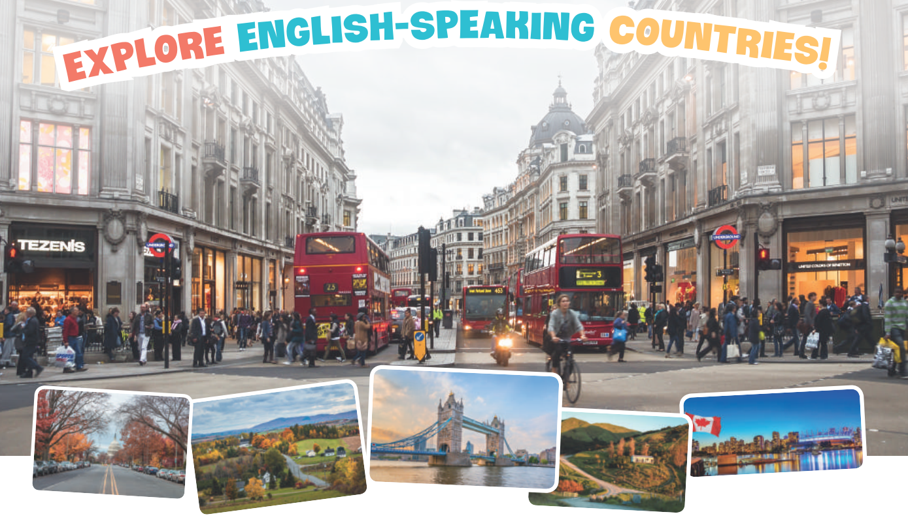
* Wrap up  - Teacher asks students to talk about what they have learnt in the lesson.  * Homework:  - To allow students finalize their paragraph after being checked by friends and the teacher. | * Wrap up  - Teacher asks students to summarise what they have learnt in the lesson.  - Teacher has them say out loud the articles.  * Homework:  - To prepare for the next lesson.
V. FEEDBACK:
With 7A ……………………………………………………………………………..…
With 7B …………………………...……………………………………..……………
With 7C ………………………………………………………………………….……

