Tiếng Anh 7 – RIGHT ON

SEMESTER 2 - FINAL TEST
Note: Each correct answer earns 0.2 points.

I. PRONUNCIATION (0.8 points)
A. Choose the word whose underlined part is pronounced differently.
1. A. donate B. grow C. yoghurt D. tower
2. A. decided B. managed C. protected D. created
B. Choose the word that has a different stressed syllable from the rest.
3. A. wonder B. engine C. advise D. damage
4. A. organise B. mechanic C. designer D. however

II. VOCABULARY AND GRAMMAR (2.4 points)
Choose the best option (A, B, C or D) to complete each of the following questions.
5. Nancy seldom travels by __________ because she’s scared of flying.
A. boat B. bus C. plane D. subway
6. In some parts of the world, animal transport is __________ as modern types of transport.
A. as popular B. more popular C. much popular D. most popular
7. I need a new __________ for my desktop computer. The ‘Enter’ key doesn’t work.
A. username B. keyboard C. mouse D. router
8. The train was late __________ there was a problem on the line.
A. however B. so C. although D. because
9. I’m getting up at 6:00 tomorrow because I don’t want __________ my bus. I can’t be late for the interview.
A. having B. taking C. to miss D. to catch
10. Nick __________ to Costa Rica tomorrow for six weeks to work on a turtle conservation project. Everything is ready.
A. goes B. is going C. will go D. went
11. David often ______ computer games in the evening, but he ______ out at the soup kitchen now.
A. plays/ helps B. is playing/ is helping
C. is playing/ helps D. plays/ is helping
12. My hometown isn’t __________ as it was five years ago. It’s much bigger and more modern.
A. the same B. like C. exactly D. similar
13. Energy-efficient light bulbs use __________ electricity than traditional bulbs, so they’re better for the environment.
A. more B. much C. less D. least
14. Student A: Governments should stop people from smoking in the parks.
Student B: _________
A. What can we do? B. That’s a great event.
C. Smoking is worse for your health. D. I think so, too.
15. What does the sign mean?
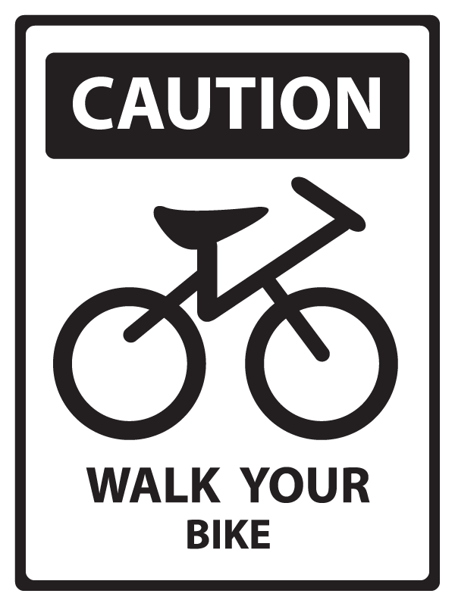 | A. You have to get off and walk your bike in this area.  B. You don’t have to use your bike here.  C. It’s dangerous for you to cycle here.  D. You must walk in this area without your bike.

16. What does the sign mean?

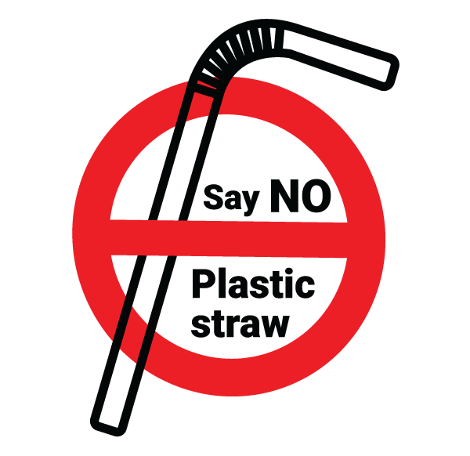 | A. There are no straws to use here.  B. You should stop using plastic straws.  C. You can’t make straws from plastic.  D. It’s necessary to say no when you use plastic straws.

III. WORD FORMATION (1.2 points)
Write the correct form of the words in brackets.
17. We can reduce air __________ by taking public transport, walking or cycling instead of driving. (POLLUTE)
18. Dr. Jane Goodall is famous for her __________ work to protect chimpanzees. (IMPRESS)
19. People are cutting down trees, and this destroys the natural environment of many ___________ animals. (DANGER)
20. One of the causes of global warming is __________. Humans are cutting down so many trees. (FOREST)
21. Yok Đôn is one of the biggest __________ parks in Vietnam. It is also home to wild elephants and leopards. (NATION)
22. One of the most popular tourist __________ in Scotland is the famous Edinburgh Castle. It’s the best place for sightseeing in the city. (ATTRACT)

IV. LISTENING (2 points)
A. You will listen to Rob and his mum talking about his birthday party. How will each person travel to the party? For each question, choose the correct letters from A-G. There are two extra letters.

People Transport
23. Brother A. Motorbike
24. Grandma B. Bike
25. Granddad C. Bus
26. Aunt Julia D. Subway
27. Uncle Ted E. Car
F. Taxi
G. Train

B. You will hear a teacher making an announcement. For each question, listen and complete the notes. Write NO MORE THAN TWO WORDS AND / OR A NUMBER.

THE RIVER CLEAN-UP

Date: (28) __________, 31st May.
Time: 9:00 – (29) ___________
Need: (30) ___________
Comfortable clothes
Hat
Activities: (31) ___________ litter
Repair fences and signs.
Lunch: Snacks, fruit juice, sandwiches and (32) ___________

V. READING (2 points)
A. Read the following passage on a travelling blog. For each question, write T if the statement is TRUE, F if the statement is FALSE and NI if there is NO INFORMATION on it.

Swansea is the second largest city in Wales (after Cardiff). It is located on Britain’s west coast, and is home to the famous Swansea Festival. The hotels in Swansea are cheaper than those in many other British cities. They are also clean and safe. There are many interesting places you can visit. Swansea market is at the heart of the city. It is the largest indoor market in Wales with more than 100 stalls selling everything from jewelry to vegetables. Everyone can find something nice to take home. The market opens every day except Sunday. You can also buy fashionable clothes at the Quadrant and St David’s shopping centres. There, you can find big department stores and many smaller shops. The Swansea Museum – the oldest museum in Wales – is well worth a visit. There are six galleries with collections of different kinds of objects. If you have time, you should take a walk in Clyne Gardens, or visit the Grand Theatre, one of Britain’s oldest theatres. Swansea has got an excellent network of public transport, cycle routes and walking routes, so there are multiple ways to explore Swansea without the need for a car.

33. Swansea is as big as Cardiff.
34. Visitors pay less for accommodation in Swansea than in many other places in Britain.

35. People can shop at Swansea market every day.
36. You need a lot of time to visit Clyne Gardens.
37. Travelling by car is the only way to get around Swansea.

B. Read the following email. For each question, choose the best option A, B, C or D.

Dear all students,
We want Saint Louis School to be greener. Therefore, we want all of you to follow these simple rules:
- Don’t (38) _________. Rubbish on the ground is unhealthy for people because it attracts animals like rats and flies and they spread diseases.
- Don’t throw away plastic bottles, paper, cardboard boxes and cans. Every class should sort the rubbish for recycling. Put all the plastic bottles and bags in the green bins. Batteries (39) _________ go in recycling bins or with normal rubbish. Place them in a separate box instead, and the school will collect them at the end of the month.
- Don’t throw away your food waste like banana (40) _________ or apple cores. Put them into the compost bin. We can use the compost to grow (41) _________ vegetables in our greenhouse.
- Bring your own reusable water bottles to school to get drinks and refill the water.
- Turn (42) _________ the lights when you leave the classroom. When the teacher isn’t using the computer or other electronic equipment, switch them off instead of leaving them on standby. You can save electricity this way.
Let’s make our school a greener place and help protect the environment. Our planet is in our hands!

38. A. waste B. garbage C. damage D. litter
39. A. cannot B. should C. needn’t D. have to
40. A. cover B. skins C. pot D. shell
41. A. natural B. fresh C. organic D. delicious
42. A. off B. on C. up D. down

VI. WRITING (1.6 points)
A. Rewrite the following sentences without changing their meaning.
43. Let’s install recycling bins in the school corridors.
→ Why ?
44. It’s against the rules to use mobile phones during lessons.
→ Students .
45. The Burj Khalifa is taller than any other buildings in the world.
→ The Burj Khalifa is the .
46. We know plastic bags damage the environment, but we continue using them every day. (ALTHOUGH)
→ .
B. Use the given words or phrases to make complete sentences.
47. you / prefer / travel / car / train?
→
48. My parents / agree / build / birdhouse / garden.
→
49. It / look / it / going / rain / so / let’s / take / taxi.
→
50. Oxford / start / 11th century / so / it / be / one / oldest universities / the world.
→

***End – Of – Test***

