Week 14
Period 39
Teaching date: 07/12/2021

UNIT 5: NATURAL WONDERS OF VIET NAM
LESSON 5: SKILLS 2
I.OBJECTIVES: By the end of the lesson, students will be able to:
1. Knowledge:
- Vocabulary: Review some words related to the topic “things in nature” and “travel items”
- Grammar: Review modal verbs
2. Competence: Ss can write a paragraph about a travel attraction they know .
3. Educational aims: To educate SS to love and conserve the nature .
II. TEACHING AIDS: Text books, laptop , smart TV , video clips
IV. PROCEDURES:
Contents |  |  |  | Teacher’s and Ss’activities
I.PRE-LISTENING: (7’)
To introduce about the destination in the conversation and to lead in
Look at the pictures and name the places in the pictures  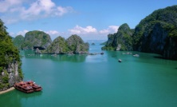  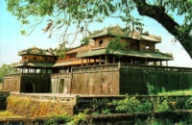  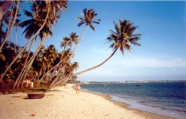  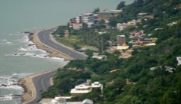  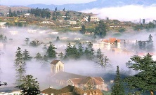  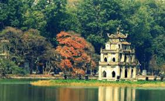  1. Ha Long Bay 2. Hue 3. Ha Noi  4. Mui Ne 5. Vung tau 6. Sa Pa  1.Work in groups. Discuss and answer the question.  “What do you know about PQ Island?”* |  |  |  | -T:encourages students to complete the task individually.  -T:asks Ss to name the places in the pictures.  -T: shows the answer and check.  → Lead in:  - T shows a picture on the screen and asks Guess the name of the destination “Phu Quoc Island”  => What do you know about PQ ?  →Today we are going to listen to a talk about a famous natural wonder of Viet Nam. It’s Phu Quoc Island  -T: Ss to work in groups to discuss suggested answers
II. WHILE- LISTENING: (10’)
To help students brainstorm about destination in the talk and develop listening skill for specific information (T / F).
* Answers:  - a beautiful island in Viet Nam.  - the night market,  - The food is delicious  - In Kien Giang province  2. Listen and tick True or False.  Answers:  1. T  2. F (It has beautiful beaches and green forest.)  3. T  4. F (Sailing and fishing are popular water sports.)  5. T |  | * Listen to the talk and check your answers.  - Ss: listen to the tape to check the suggested answers  - T: gives answers  -T: plays the recording once or twice.  -T:asks Ss to listen and tick the answers.  -T:asks Ss to compare their answers with the prediction made previously.  -T :calls on some Ss to read aloud their answers and correct the false one(s).  -T:checks students’ answers as a class.
III. POST-LISTENING:(5’)
Ss can tell some things about Phu Quoc .
* Tell some things about Phu Quoc . | - Ss: work in 4 groups  - T: calls a student form each group to tell it  -T: gives remarks
IV. PRE- WRITING :(5’)
To help Ss talk about a travel attraction they know and collect information for their later writing.
3. Fill each blank in the network with the information about a travel attraction you know.  * Suggested answers:  T: What is the name of the attraction?  S: It’s Ly Son island  T: Where is it?  S: It’s in Quang Ngai  T: How can you go there?  Ss: We can go there by ship .  T: What can you do there?  Ss: There we can enjoy great Vietnamese seafood; Especially King crab. We can go diving and swimming. We can join exciting activities.  T: What is special about it?  Ss: It’s one of the most famous natural wonders of Viet Nam and thousands of tourists visit it every year |  | -T: models the task by summarizing the information of the talk with a student using the questions in the network below:  -T: asks Ss to choose a travel attraction they know and individually brainstorm about that place using the network in Task 3.  -T:asks Ss to work in groups of four to introduce about their chosen places using the filled network.  - Teacher asks 1-2 students to stand up and talk about their chosen place then give them comments.
V. WHILE – WRITING:(10’)
To teach students how to write a paragraph of about 50 words about a travel attraction they know.
4.Write a paragraph of about 50 words about a travel attraction you know. Use the information in Task 3. |  |  | -T: asks Ss to work in groups  -Ss: write the paragraph on the extra board  -T: calls 2 groups to stick the tasks on the board  -Feed back- Correction
VI. POST-WRITING:(5’)
Ss can talk about a travel attraction they know .
* Talk about a travel attraction you know |  |  |  | - Individually  - Correction
IV.Home work: (3’)
- Rewrite a paragraph about 50 words about a travel attraction you know.
- Prepare Unit 5: Looking back + Project (Page 56, 57)

